A Survey on "Smart Farming: Key Technologies and Trends for Modern Agriculture"

# Abstract:

R.Naga Bhargav, Ms. Manisha das (Assistant Professor)

# The shift to smart farming drives a change in agriculture, heading toward a convergence of advanced technologies that ensure efficiency, productivity, and sustainability. At the core of this shift is the Internet of Things-IoT, which makes use of a mesh of sensors and devices in monitoring and analyzing soil conditions, crop health, and weather pattern changes in real-time. This data-driven approach makes it possible to manage resources with perfect accuracy and detect issues at an early stage. Complementary to IoT, drones and satellite imagery fill in high resolution answers from above to make the planting, fertilization, and control against pests an accurate process. Enlarging this are machine learning and AI through their analytics of complex data sets in order to generate predictive models for optimizing agricultural practice. On the other hand, automation and robotics are doing highly laborious activities like planting, weeding, and harvesting, therefore reducing human effort while increasing operational efficiency. These technologies raise productivity while at the same time fostering sustainable usage by reducing wastes and impacts on the environment. Smart farming is, therefore, one of the biggest revolutions in agriculture, consolidating the use of technology and data to meet modern food production challenges by ensuring a more robust and efficient food supply chain.

# Keywords:

*Sensors, Sensor phenomena and characterization; Temperature sensors; Wireless sensor networks; Smart agriculture; Climate..*

# Introduction:

ASmart farming, often referred to as precision agriculture, utilizes a range of innovations such as the Internet of Things (IoT), machine learning (ML), wireless sensor networks (WSNs), and automation to support data-driven decision-making. This approach enables farmers to monitor crop health, optimize resource use, and control equipment remotely, which not only boosts productivity but also enhances sustainability. The paper's review of 588 publications from IEEE highlights essential technologies that constitute the foundation of SF, identifying primary research themes in sensors, communication, big data analytics, actuators and machines, and data analysis.

The study acknowledges that while SF offers significant benefits, its implementation is challenging due to issues related to technology selection, energy management, data transmission, and network reliability. By using Cochrane systematic review methods, the authors provide an unbiased synthesis of current SF literature, focusing on both technological capabilities and practical challenges for SF practitioners. The paper concludes with an in-depth discussion on multi-technology systems, such as autonomous systems and intelligent decision-making platforms, which integrate multiple tools to maximize farm efficiency. This structured approach aims to guide technology integrators and farmers in selecting appropriate solutions, ultimately supporting the transition toward a more resilient and efficient agricultural sector​

# Literature Review:

This paper discusses advancements in pesticide efficiency through real-time adjustments in spraying parameters using plant protection drones, which reduce pesticide residues and improve it[1] effective in pesticide detection.

Mixed pixels**:** The ALMM addresses the challenge of mixed pixels in low-resolution satellite images.[2] The authors used random forest variable importance score to rank the importance of features and select the most relevant ones

It highlights different models [3] and frameworks, such as the use of EOR detectors, faster R-CNN, and YOLO networks, to improve weed identification accuracy and efficiency in real-world agricultural settings.

The paper [4] presents a 'greener' solution for smart farming, specifically focusing on spinach plants, by utilizing a Random Forest algorithm for automatic regulation of key parameters like water level, nutrient content, and temperature.

.

The paper also addresses technical, social, and economic barriers to widespread adoption and provides insights into future trends, including the rise of AI at the edge, vertical farming, and cybersecurity concerns in smart agriculture systems.[5] The authors use ANN to classify satellite images into different crop

Classification: Identifies whether a plant or leaf is diseased or healthy (binary or multi-class classification) [6]

Object Detection: Detects diseased regions within images, useful for cases with multiple diseases or large areas .

[7] The paper categorizes prevalent DL architectures, including convolutional neural networks (CNNs), vision transformers (ViTs), and memory-efficient models, exploring their applications in disease detection.

[8]To identify the most suitable algorithm for crop yield prediction: The authors aim to identify the algorithm that performs best in predicting crop yields, based on metrics such as accuracy, mean absolute error, root mean squared error, and standard deviation.

The paper "Predicting Tomato Plant Multiple Diseases Using Regression and Deep Learning" presents a study on predicting crop yields in India using machine learning and deep learning techniques [9] The results show that Random Forest and Convolutional Neural Network (CNN) perform better than other models in predicting crop yield.

This paper presents an IoT-enabled hybrid approach that integrates machine learning (ML) and artificial intelligence (AI) to optimize smart agriculture. [10] Using datasets like dry beans and soil type images, the authors apply ML models, including MLP, Naïve Bayes, and SVM, alongside deep learning architectures such as MobileNetV2, VGG16, and InceptionV3.

This paper provides a systematic review of machine learning (ML) techniques in agriculture, specifically focusing on banana crops [11] By reviewing various ML and deep learning (DL) models such as CNNs, SVMs, and k-means clustering, the paper highlights their effectiveness in classification tasks.

This paper introduces a deep learning image augmentation method tailored for the agricultural field to reduce the need for extensive manual labeling[12] The method uses synthetic images composed of crops, weeds, and soil, segmented by applying the Excess Green (ExG) index and minimum error threshold techniques..

The article presents a novel coordinate-based method for segmenting agricultural field plots from tractor towing an implement.[13] The algorithm can solve for challenging field-to-field segmentation cases

The IoU of object detection and semantic segmentation were 0.98 and 0.96, respectively.

The paper provides a comprehensive review of the technologies driving the shift towards smart farming[14]

It discusses the role of various technologies such as IoT, AI, robotics, and sensing technologies in improving agricultural productivity, efficiency, and sustainability.

AI and machine learning algorithms are being used to analyze data from various sources and make predictions about crop yields, disease detection, and pest control..

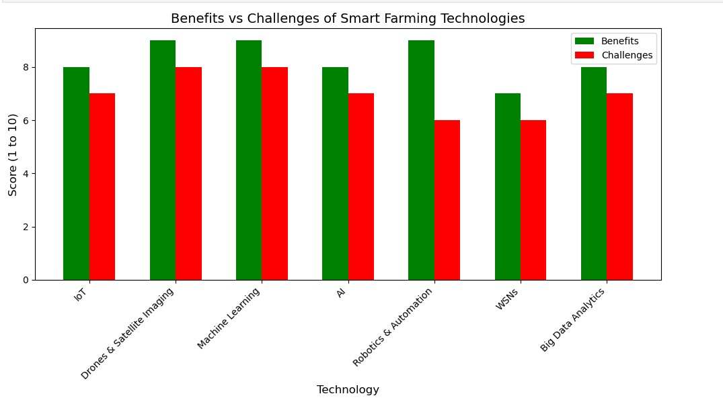

# Methodology:

1. **Input Collection**

The system begins by collecting input data related to crop symptoms. These inputs can be gathered from various sources, including farmers, agricultural experts, or sensors deployed in the field.

2**. Data Preprocessing**

The collected symptom data undergoes preprocessing to convert it into a structured format suitable for machine learning models.

Tokenization: Breaking down the symptom descriptions into individual words or tokens.

**Stop-word Removal**: Eliminating common words that do not contribute significantly to the meaning (e.g., "and," "the").

**K-Nearest Neighbors (KNN) Preprocessing**: Preparing data for KNN by organizing it into a format where symptoms can be compared effectively based on their characteristics.

**Machine learning models:**

* **K-Nearest Neighbours(KNN):** Similar data points are more likely to be found next to one another, according to the K-Nearest Neighbors (KNN) algorithm. KNN performs classification tasks by utilizing similarity between available features. New data points are given a value according on how closely they resemble the training data.
* **Support Vector Machine (SVM):** The fundamental purpose of the Support Vector Machine (SVM) technique is to locate hyperplanes in an n-dimensional space. For any classification task, a large number of hyperplanes can be considered. Maximizing the margin—the distance between data points that belong to different classes—is a crucial factor for choosing the best hyperplane. Hyperplanes are useful for defining boundaries between the dataset's various classifications.
* **Definition**: Gathering primary data from farmers and agricultural stakeholders regarding their experiences and perceptions of smart farming technologies.
* **Approach**: Designing structured questionnaires to quantify attitudes, adoption rates, and barriers.
* **Decision Tree**: In machine learning, a decision tree is a supervised learning technique that may be applied to both regression and classification problems. It creates a tree-like structure of decisions by dividing the dataset into subgroups according to the most important features. Based on a criterion like entropy, information gain (for classification), or mean squared error (for regression), the algorithm chooses the appropriate features.  
  In order to arrive at final classifications or predicted values at the leaf nodes, the dataset is recursively divided into subgroups, creating branches**.**

**NLP TECHNIQUES:**

**Prediction Generation**

Once the models are trained, they process the user-provided symptom inputs to generate predictions regarding potential crop diseases.

* **Tokenization:** A key stage in Natural Language Processing (NLP) is tokenization, which divides a text into smaller components known as tokens. Depending on the tokenization method, these tokens may represent words, sentences, or even characters. It is among the initial stages of text preprocessing, which aids in the model's comprehension and more effective processing of the input.
* **Stemming:** In Natural Language Processing (NLP), stemming is a text preprocessing method that eliminates prefixes and suffixes to return words to their base or root form. By reducing them to a single root form (such as "run"), stemming aims to regard many versions of a word (such as "running," "runner," and "ran") as one and the same.s

**Text Mining**

**Description:** Extracting useful information from large volumes of text data, such as research articles, reports, and online content**.**

**Application:** Identifying key terms, trends, and emerging technologies related to smart farming**.**

* **Sentiment Analysis**
* **Description:** Analyzing the sentiment expressed in texts to determine positive, negative, or neutral opinions**.**

**Application:** Understanding farmer and consumer perceptions of smart farming technologies based on reviews or social media discussions**.**

**Document Clustering**

**Description:** Grouping similar documents based on content to identify patterns or clusters of information**.**

**Application:** Organizing research articles into clusters that reflect various aspects of smart farming.

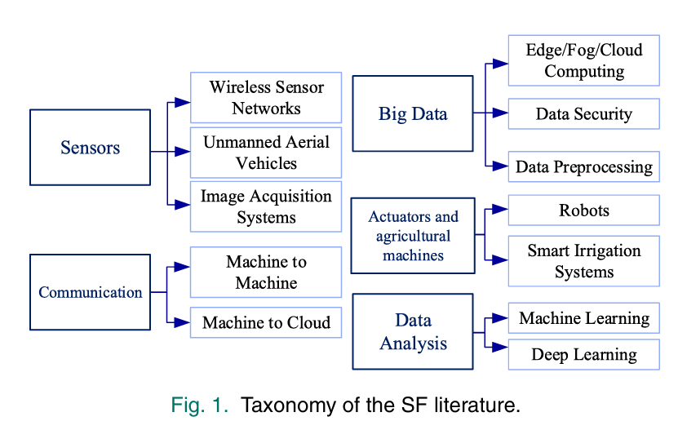

# Conclusion:

The paper " Smart Farming: Key Technologies and Trends for Modern Agriculture"" concludes by underscoring the transformative potential of smart farming (SF) technologies in addressing modern agricultural challenges. Through a comprehensive review, it identifies the critical role of technologies such as IoT, big data, machine learning, and robotics in enabling SF systems. These technologies contribute to increased productivity, optimized resource usage, and improved crop quality, all of which are essential to meet the rising global food demand.

Despite the numerous benefits, the paper highlights ongoing challenges that hinder the widespread adoption of SF, such as energy constraints, data handling issues, and the need for scalable, cost-effective solutions. It points out that each technology comes with trade-offs, making it crucial for practitioners to carefully consider factors like cost, power requirements, data volume, and network reliability when implementing SF systems.

# References:

[1] .N. ElBeheiry and R. S. Balog, "Technologies Driving the Shift to Smart Farming: A Review," IEEE Sensors Journal, vol. 23, no. 3, pp. 1752-1769, 1 Feb.1, 2023, doi: 10.1109/JSEN.2022.3225183..

[2].M. Wang *et al*., "Research on Flow Decision-Making Model of Plant Protection UAV Based on Feature Selection," in *IEEE Access*, vol. 12, pp. 13699-13710, 2024, doi: 10.1109/ACCESS.2023.3342923

[3] K. Dwivedi, A. K. Singh, D. Singh and H. Kumar, "Development of an Adaptive Linear Mixture Model for Decomposition of Mixed Pixels to Improve Crop Area Estimation Using Artificial Neural Network," in *IEEE Access*, vol. 11, pp. 5714-5723, 2023, doi: 10.1109/ACCESS.2023.3236665.

[4] D. G. Pai, R. Kamath and M. Balachandra, "Deep Learning Techniques for Weed Detection in Agricultural Environments: A Comprehensive Review," in *IEEE Access*, vol. 12, pp. 113193-113214, 2024, doi: 10.1109/ACCESS.2024.3418454.

[5] Y. V. Bhargava, P. K. Chittoor, C. Bharatiraja, R. Verma and K. Sathiyasekar, "Sensor Fusion Based Intelligent Hydroponic Farming and Nursing System," in *IEEE Sensors Journal*, vol. 22, no. 14, pp. 14584-14591, 15 July15, 2022, doi: 10.1109/JSEN.2022.3177777

[6] S. Qazi, B. A. Khawaja and Q. U. Farooq, "IoT-Equipped and AI-Enabled Next Generation Smart Agriculture: A Critical Review, Current Challenges and Future Trends," in *IEEE Access*, vol. 10, pp. 21219-21235, 2022, doi: 10.1109/ACCESS.2022.3152544

[7] V. Balafas, E. Karantoumanis, M. Louta and N. Ploskas, "Machine Learning and Deep Learning for Plant Disease Classification and Detection," in *IEEE Access*, vol. 11, pp. 114352-114377, 2023, doi: 10.1109/ACCESS.2023.3324722

[8] M. Tasfe, A. Nivrito, F. Al Machot, M. Ullah and H. Ullah, "Deep Learning Based Models for Paddy Disease Identification and Classification: A Systematic Survey," in *IEEE Access*, vol. 12, pp. 100862-100891, 2024, doi: 10.1109/ACCESS.2024.3419708.

[9] P. Sharma, P. Dadheech, N. Aneja and S. Aneja, "Predicting Agriculture Yields Based on Machine Learning Using Regression and Deep Learning," in *IEEE Access*, vol. 11, pp. 111255-111264, 2023, doi: 10.1109/ACCESS.2023.3321861.

[10] M. Umar, S. Altaf, S. Ahmad, H. Mahmoud, A. S. N. Mohamed and R. Ayub, "Precision Agriculture Through Deep Learning: Tomato Plant Multiple Diseases Recognition With CNN and Improved YOLOv7," in *IEEE Access*, vol. 12, pp. 49167-49183, 2024, doi: 10.1109/ACCESS.2024.3383154

[11] M. Aldossary, H. A. Alharbi and C. Anwar Ul Hassan, "Internet of Things (IoT)-Enabled Machine Learning Models for Efficient Monitoring of Smart Agriculture," in *IEEE Access*, vol. 12, pp. 75718-75734, 2024, doi: 10.1109/ACCESS.2024.3404651

[12] R. Rayhana, G. Xiao, and Z. Liu, "Internet of Things empowered smart greenhouse farming," IEEE J. Radio Freq. Identificat., vol. 4, no. 3, pp. 195-211, sep. 2020, doi: 10.1109/JRFID.2020.2984391

[13] P. Sahu, A. P. Singh, A. Chug and D. Singh, "A Systematic Literature Review of Machine Learning Techniques Deployed in Agriculture: A Case Study of Banana Crop," in *IEEE Access*, vol. 10, pp. 87333-87360, 2022, doi: 10.1109/ACCESS.2022.3199926

[14] S. J. Harkin *et al*., "Field-to-Field Coordinate-Based Segmentation Algorithm on Agricultural Harvest Implements," in *IEEE Transactions on AgriFood Electronics*, vol. 2, no. 1, pp. 91-104, March-April 2024, doi: 10.1109/TAFE.2024.3352480.

[15] M. Wang et al., "Research on Flow Decision-Making Model of Plant Protection UAV Based on Feature Selection," IEEE Access, vol. 12, pp. 13699-13710, 2024, doi: 10.1109/ACCESS.2023.33429