**A Review on Indoor Based Air Quality Monitoring System**

K.Srihari,

Department of CSE(AI&ML), GMR Institute of Technology, Rajam, India-532127

Dr. Sreejyothsna Ankam

Senior Assistant Professor, Department of CSE(AI&ML), GMR Institute of Technology, Rajam, India-532127

**Indoor Based Air Quality Monitoring System**

**ABSTRACT:**

Indoor air quality (IAQ) is crucial for health, especially since people spend about 90% of their time indoors. This paper introduces a simple and affordable indoor air quality monitoring system (IAQMS) that uses LoRa technology and the Internet of Things (IoT) to track important air quality factors. The system measures levels of carbon dioxide (CO2), particulate matter (PM2.5 and PM10), total volatile organic compounds (TVOC), formaldehyde (HCHO), as well as ambient temperature and humidity. I provide a clear overview of the hardware and software design, highlighting its ability to monitor air quality remotely and store data on the OneNET cloud platform for later analysis. Our experiments show that the system works reliably in different conditions, and also examine how the design of the sensor housing affects measurement accuracy. This IAQMS can be easily set up in various indoor spaces, allowing for real-time monitoring and alerts to help improve the health and comfort of occupants. These essential sensors for detecting temperature, humidity, carbon monoxide, PM2.5, PM10, TVOC, HCHO, and other parameters are integral to our IAQMS architecture. These sensors collect data, which is subsequently transmitted to the OneNet cloud platform for secure storage and straightforward analysis. we were able to improve sensor accuracy and guarantee consistent readings under a range of circumstances by taking into account multiple housing designs the system can be used in a variety of settings including homes workplaces and educational institutions as evidenced by experimental findings showing its dependability in a range of interior conditions by being educated and taking proactive steps to enhance air quality users can create healthier indoor environments with the help of an IAQMS which offers real-time data and alarms.

***Keywords: Machine Learning, Internet of Things, Air Quality, Lora Technology, Environmental Sensing.***

**1.INTRODUCTION:**

We were able to improve sensor accuracy and guarantee consistent readings under a range of circumstances by taking into account multiple housing designs. Results from experiments show that the technology is reliable in a variety of interior situations. enabling its deployment in various settings, including homes, workplaces, and educational institutions, through the usage of an IAQMS that offers real-time data and alerts By remaining aware and taking proactive steps to enhance air quality, people may create healthier indoor settings. Given that individuals spend up to 90% of their time indoors, indoor air pollution is a major global concern. This, indoor air quality monitoring has become crucial for public health. Earlier approaches that used manual air sampling for laboratory analysis made it difficult to gather data in real-time using IoT technologies. The IAQMS displayed here enables wireless sensor networks for remote and ongoing monitoring. WSNs can function well even in intricate architectural situations due to its long-range communication capabilities. In addition to being especially well-suited for this purpose, Lora's cloud storage allows for the retrieval of historical data, facilitating long-term study and advancements in indoor air quality control.

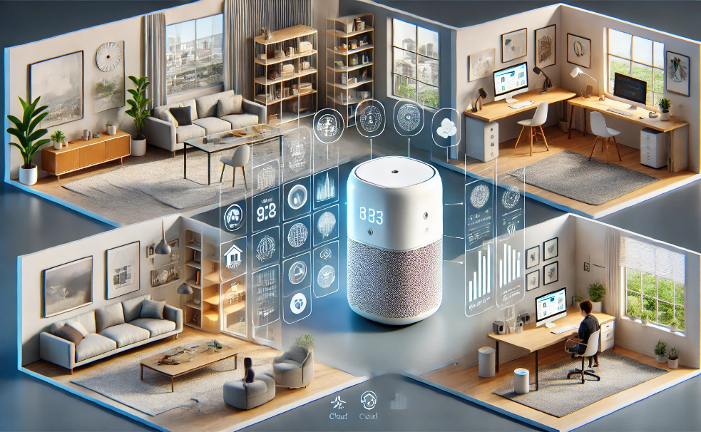

**Figure 1:overview of Indoor Based Air Pollution Monitoring**

The IAQMS' efficacy was evaluated in an office setting under various conditions, such as changes in temperature and air movement. The results demonstrated how precisely and consistently the system monitored variations in pollutant concentrations. An interesting finding that affected temperature, humidity, and particle measurements was the effect of an extra outer shell on sensor data. These findings demonstrate the IAQMS’ adaptability and robustness, underscoring the importance of sensor placement and device design in IAQMS performance. Future research will focus on applying machine learning techniques to enhance the systems' data accuracy and prediction skills for a variety of indoor situations. By improving prediction accuracy, the IAQMS could provide more comprehensive indoor air quality assessments, lowering the health risks associated with prolonged exposure to indoor contaminants. This improvement would enable proactive air quality management in a variety of settings, including workplaces, residence halls, and residential structures.

**II. LITERATURE REVIEWS:**

The effects of indoor air quality (IAQ) on human health and general well-being have made it a major topic of research, particularly in restricted and densely inhabited settings like homes, workplaces, and educational institutions. Various volatile organic compounds (VOCs), CO2, PM2.5, PM10, and other pollutants are becoming more and more common. To reduce IAQ concerns, trustworthy monitoring systems that can provide real-time data and insights are required. A thorough basis for creating an improved IAQ monitoring solution is provided by this review, which covers recent developments in IoT-based IAQ monitoring systems, such as sensor integration, data processing via cloud platforms, and machine learning-based predictive analytics.

**IoT and Sensor-Based Monitoring Systems:**

The creation of Internet of Things-based devices that can track several air quality indicators in real time has been the subject of recent research. Using LoRa technology and Internet of Things (IoT) frameworks, Pang et al. (2023) proposed a real-time indoor air quality monitoring system that measures temperature, humidity, CO2, PM2.5, PM10, TVOC, HCHO, and other contaminants. Although several design features, such as a shell container, impacted temperature and humidity readings, their results demonstrate that the system is reliable [1]. Similarly, an ESP32 microcontroller and sensors for temperature, humidity, dust particles, and pollutant gasses were used by Nasution et al. (2020) to create an IAQ system. Data was sent to the ThingSpeak Cloud platform for remote access [2].

By including features that monitor particulate matter and carbon monoxide levels, provide real-time notifications, and automatically activate ventilation systems when pollution levels surpass the threshold, Guerrero-Ulloa et al.'s IdeAir system from 2023 further expands IoT capabilities [3]. This adaptive response system demonstrates how the Internet of Things may provide automated, health-focused indoor treatments. Furthermore, the cloud-based IoT system developed by Liu and Xiao improves IAQ monitoring by offering a simple platform for managing household air quality and sending out real-time warnings to encourage user comfort and participation [4].

**Advanced Sensor Technologies and Detection Enhancements:**

More precise and targeted pollution detection in IAQ systems is now possible because to advancements in sensor technologies. A gas sensor array supplemented with gold nanoparticles was shown by Lee et al. (2021), increasing the sensitivity of detection for particular gases such as toluene and ammonia. The array effectively separated gases using principal component analysis (PCA), demonstrating how improved materials can enhance sensor performance [5]. According to these results, using high-performance sensors can help with more accurate IAQ measurement, which is crucial in settings with widely fluctuating pollutant concentrations.

**Machine Learning and Predictive Modeling in IAQ Monitoring:**

A key tool for evaluating IAQ data is machine learning, which offers predicted insights that can guide preventative actions. The use of artificial neural networks (ANNs) and other machine learning techniques in assessing air pollutants and thermal comfort parameters is highlighted in studies by Dimitroulopoulou et al. (2023) and Babich et al. (2023), underscoring the significance of predictive capabilities in tracking trends in IAQ [7, 8]. By allowing for real-time pollutant level predictions, these methods assist in alerting users to possible hazards and facilitating more efficient, data-driven reactions to variations in indoor air quality, Zafari et al. (2020) presented a three-phase air pollution monitoring system that is to navigation apps and user-accessible, consisting of an Android app and an Internet of Things kit that sends out pollution alarms based on real-time data [14]. Particularly in dynamic interior situations, machine learning might further improve such systems by offering context-specific recommendations and personalized alerts.

**Applications in Schools and Offices: Implications for Health and Productivity:**

Because people spend a lot of time in offices and classrooms where they are exposed to indoor pollutants, IAQ has a particularly significant impact there. The health hazards linked to low IAQ in educational settings are highlighted by studies by Sadrizadeh et al. (2022) and Ataei et al. (2022), where children's respiratory health and cognitive performance can be negatively impacted by insufficient ventilation [6, 9]. This emphasizes the necessity of energy-efficient, high-performance IAQ systems in these kinds of settings. According to Patil et al. (2020), maintaining productivity and avoiding illnesses like sick building syndrome in office environments depend on having an ideal indoor air quality. Achieving productive and healthy indoor settings requires specialized ventilation solutions, regular monitoring, and the elimination of pollution sources [10].

**Future Directions: Cost-Effective and Scalable Monitoring Solutions:**

Developing scalable, affordable IoT-based IAQ systems that can service a larger population without imposing significant operating costs is crucial, according to several research. According to Myllyvirta and Dahiya (2023), community-based monitoring and scalable IoT devices with inexpensive sensors can offer cost-effective and efficient IAQ monitoring solutions, especially in poor nations where resources may be scarce [11]. The possibility of democratizing IAQ monitoring is further supported by Varshney's (2020) investigation of open-source technology and wireless sensor networks, which promotes community-driven and grassroots approaches to environmental health [13].

**III. METHODOLOGY**: In this methodology it consists of 4 steps that can describe the Indoor Air Monitoring System. Those steps are:

**1.System Architecture**

**2.Hardware Design**

**3.Software Framework**

**4.Impact of shell design**

**1.System Architecture**:

* **Measurement Sites:** There are various measurement sites with multiple indoor air quality sensor nodes (named Measurement Site 1, Measurement Site 2, etc.). Numerous air quality metrics, including CO2, PM2.5, humidity, temperature, and other contaminants, are measured by these sensor nodes.
* **Sensor Nodes:** Multiple sensor nodes that gather information on air quality measures are present at each measurement site. Each site has a central sensor gateway to which these nodes are wirelessly connected.
* **Sensor Gateway**: Each measurement site's sensor gateway collects data from its individual sensor nodes. By combining the data and getting it ready for transfer to the primary server, the gateway serves as a hub. Depending on the network's availability, this data can be sent by Ethernet or Wi-Fi.
* **IoT Web Server**: The "WWW" sign in the image represents the central IoT web server to which the gateways from each measurement site deliver the data. The server serves as a data repository, managing and storing all of the air quality data from different locations.
* **Data Access for Remote Users**: Through an Internet of Things platform or web server, remote users can access the real-time air quality data gathered across several measurement locations. They may monitor the quality of the air from any location by viewing this data on a variety of devices, including laptops, tablets, and smartphones.
* **Connectivity and Data Transmission:** The picture shows how each measurement site is connected to the others and how data is sent from each measurement site to the main IoT server. To guarantee consistent data flow and dependable contact with the web server, each site makes use of Ethernet or Wi-Fi.

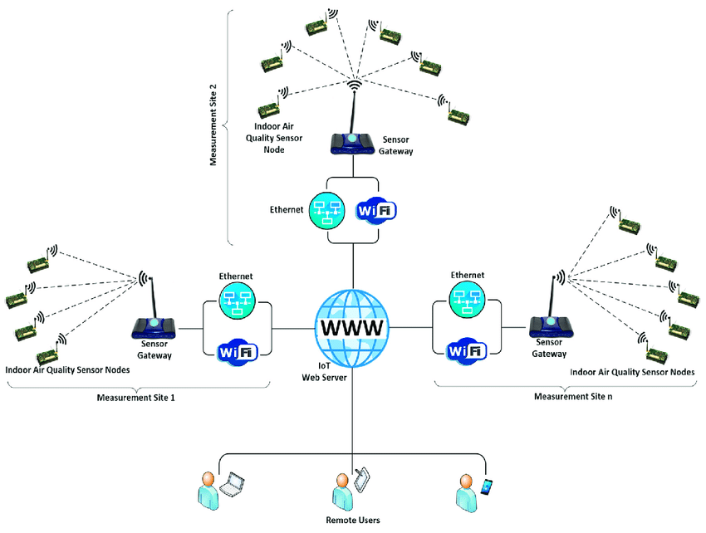

**Figure 2:Indoor Air Quality Architecture**

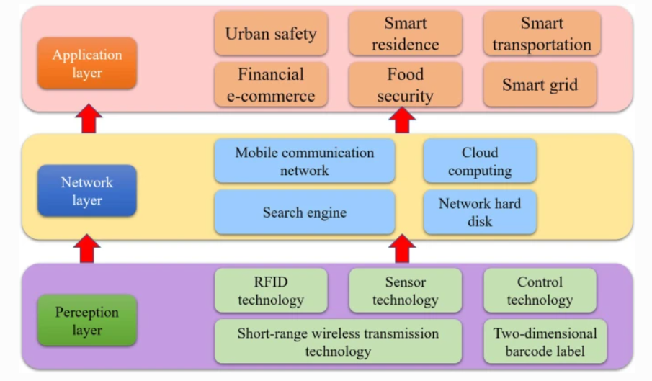

**Figure 3: Layers of System Architecture**

* **Perception Layer**: It is the fundamental layer in charge of using a variety of technologies to collect environmental data. It consists of short-range wireless transmission, sensor technology, control technology, and RFID (Radio Frequency Identification). The raw data that powers the entire system is provided by these parts working together to detect and record physical parameters, including temperature, humidity, motion, and other environmental elements.
* **Network Layer:** By acting as a communication link, the Network Layer sends the information gathered by the Perception Layer to higher levels for processing and use. Search engines, cloud computing, mobile communication networks, and network storage are components of this layer. The network layer enables continuous connectivity and effective information management throughout the system by facilitating real-time data processing, storage, and communication through various components.
* **Application Layer:** To provide useful services and insights in certain fields, the Application Layer analyzes and utilizes the data. Urban safety, smart homes, smart transportation, financial e-commerce, food security, and smart grids are just a few of the applications that fall under this layer. The Application Layer enables additional functionality and creative solutions in smart environments by utilizing the data gathered and transferred from lower layers, improving convenience, safety, and operational efficiency across a range of industries. These three layers work together to create an integrated framework that facilitates smooth data application, analysis, and flow in IoT-driven systems.

**2.Hardware Design:** The seven main air quality parameters that each IAQD sensor node is intended to measure are temperature, humidity, formaldehyde (HCHO), CO2, PM2.5, PM10, TVOC, and PM2.5. Because of its long-range capabilities, LoRa technology is used by the system to exchange data. Processing is managed by the STM32F103C8T6 microcontroller, and precise environmental data is gathered by a number of sensors, including the SHT31 (temperature and humidity) and PMS5003 (particulate matter). To guarantee stability and endurance, a protective casing is placed on top of each IAQD; the effect of the housing on sensor accuracy is given particular consideration.

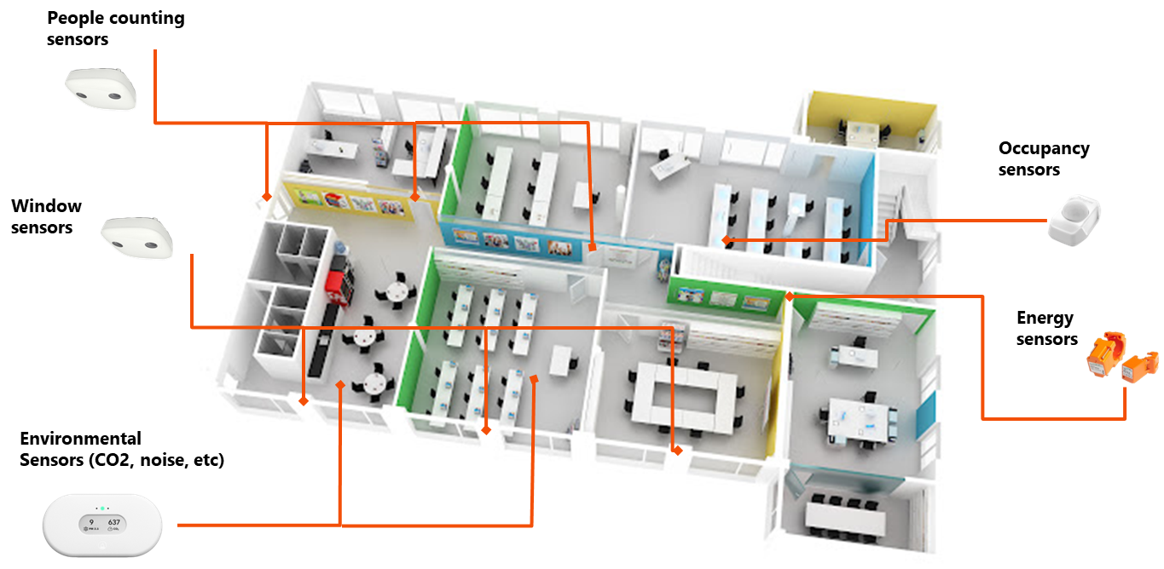

**Figure 4:Different type of sensors measured for air pollutants**

**3.Software Framework**: Seven key air quality metrics are intended to be tracked by each IAQD sensor node. The system uses Lora technology to communicate data because of its long-range capabilities. The STM32F103C8T6 microcontroller handles processing, and a number of sensors, including the PMS5003 particulate matter and the SHT31 temperature and humidity sensors, gather precise environmental data. To guarantee stability and endurance, a protective shell is placed on top of each IAQD, with particular attention given to how the housing affects sensor accuracy.

**4.Impact of Shell Design**: Despite having vents, the shell may alter the microclimate inside the IAQD, affecting the accuracy of temperature and humidity readings, according to experiments conducted under various operating conditions. The study evaluates how an outer shell impacts sensor measures, pointing out that variations in the internal microenvironment have an impact on temperature, humidity, and particle matter readings. These findings demonstrate how important it is to provide the best possible sensor housing in order to keep data fidelity, since this factor emphasizes the need for the best available sensor housing in order to preserve data accuracy in a variety of indoor conditions. According to the study, selecting the best sensor enclosure is crucial to obtaining consistent, reliable data in a variety of interior environments. This is especially important for applications where precise and real-time indoor air quality assessments are needed to comply with health and safety regulations. Maintaining adequate airflow while reducing outside impacts is also important to prevent disparities in readings that could result from housing design.

**Table 1 : Literature Review**

|  |  |  |  |
| --- | --- | --- | --- |
| **Parameter** | **With Outer Shell** | **Without Outer Shell** | **Impact on Measurements** |
| Temperature | Potential for slight microclimate shifts, affecting readings | More accurate, less affected by microclimate changes | Shell can trap heat, causing slight temperature variations. |
| Humidity | Humidity readings may fluctuate due to enclosed microenvironment | More accurate due to direct exposure to indoor air | Enclosure may retain moisture, impacting humidity accuracy. |
| Particulate Matter (PM) | May affect airflow to sensor, impacting PM readings | Direct exposure allows more accurate PM readings | Limited airflow with shell can reduce accuracy of PM measurements. |
| Vents in Outer Shell | Helps moderate microclimate but not entirely prevent shifts | N/A | Vents reduce but do not eliminate microclimate impact. |
| Best Use Scenario | Suitable for environments needing protection from damage but with moderate data accuracy | Optimal for high-accuracy needs in controlled settings | Without shell ideal for high precision, but with reduced  durability. |
| Overall Accuracy | May decrease due to internal microclimate changes | Higher accuracy with minimal housing interference | Shell design impacts temperature and humidity reliability. |

**IV. RESULTS AND DISCUSSIONS:**

The results of the study demonstrate the dependability and efficacy of the recommended indoor air quality monitoring system, IAQMS, in a variety of operational circumstances. Two days' worth of data revealed distinct trends in air quality metrics, particularly when it came to air circulation. For instance, even though IAQD-1 was not the closest to the occupants, it consistently reported higher CO2 concentrations than the other detectors during air-circulating circumstances (WC-i and WC-ii). In contrast, IAQD-2, which was covered and closest to the researcher, showed the highest CO2 levels. Four indoor air quality detectors (IAQDS) were placed in an office setting as part of the experimental setup. The analysis also concentrated on the calibration procedure of the sensors, which guarantees their accuracy for further testing, in environments without air circulation, illustrating the effects of both proximity and the presence of a cover. Following calibration, the temperature and humidity sensors displayed very few mistakes, demonstrating their dependability for real-time monitoring. The study also looked at how the external shell affected sensor performance and found that, even though the shell could change measurement data, the IAQMS remained consistent across a range of conditions. Overall, the results show how important it is to have real-time monitoring systems for evaluating indoor air quality in order to reduce health problems like headaches and respiratory problems linked to poor air quality and to improve the overall well-being of interior spaces. In conclusion the study emphasizes the effective creation and validation of an indoor air quality monitoring system (IAQMS) that uses internet of things (IoT) technology to gather and analyse data in real time.

**CONCLUSION:**

The system's precision and dependability in measuring important air quality indicators like CO2, PM25, PM10, TVO, temperature, and humidity were proven by tests carried out under a variety of operating situations. The calibration procedure improved the measurements' trustworthiness by ensuring that the sensors worked within the allowed error margins. The study also demonstrated how the shell design significantly affects the IAQ detectors' performance. Due to heat produced by interior components, the shell can change measures of temperature and humidity, although it has less of an impact on other metrics like CO2 and particulate matter. Overall, the research establishes the foundation for future developments by demonstrating that careful shell design consideration is required to enhance sensor performance in a variety of interior situations in monitoring the indoor air quality, which includes applying machine learning algorithms for predictive analysis and creating thorough techniques for assessing indoor air quality in a range of environments, such as homes and workplaces.

**Future Enhancements:**

**1.Enhanced Data Accuracy and Reliability:** In order to improve the accuracy of air quality forecasts and measurements over time, it is expected that the IAQMS would employ machine learning techniques. This might lead to a more precise identification of pollution sources and trends.

**2.Predictive Analytics**: The inclusion of advanced analytical approaches will enable the system to anticipate indoor air quality conditions using both historical data and real-time inputs. This forecasting ability can help with proactive measures to improve air quality before it reaches hazardous levels.

**3.Comprehensive Evaluation Methods:** The development of fuzzy comprehensive evaluation approaches will enable a more thorough assessment of indoor air quality. To give a more comprehensive picture of how air quality impacts comfort and health, this method will include a variety of factors and how they interact.

**4.Broader Application Across Environments:** Future research will primarily focus on applying the IAQMS in a variety of interior locations, such as homes, schools, and hospitals. This will evaluate the system's efficacy in many circumstances and further our understanding of indoor air quality issues.

**5.Health Impact :** research Future studies that relate indoor air quality data to health outcomes might provide crucial new insights into the relationship between air quality and well-being and productivity.

**References:**

[1]L. Pang, C. Luo, and W. Pan, “Research on the Impact of Indoor Control Quality Monitoring Based on Internet of Things,” *IEEE Access*, vol. 11, pp. 139614–139627, Jan. 2023, doi: <https://doi.org/10.1109/access.2023.3336706>.

[2]I. Rudavskyi, H. Klym, and A. I. Popov, “DESIGN OF INDOOR AIR QUALITY MONITORING SYSTEM,” *Measuring Equipment and Metrology*, vol. 84, no. 3, pp. 23–30, 2023, doi: <https://doi.org/10.23939/istcmtm2023.03.023>.

[3]G. Guerrero-Ulloa, A. Andrango-Catota, M. Abad-Alay, M. J. Hornos, and C. Rodríguez-Domínguez, “Development and Assessment of an Indoor Air Quality Control IoT-Based System,” *Electronics*, vol. 12, no. 3, p. 608, Jan. 2023, doi: <https://doi.org/10.3390/electronics12030608>.

[4]“Retracted: Intelligent Monitoring System of Residential Environment Based on Cloud Computing and Internet of Things,” *International Journal of Analytical Chemistry*, vol. 2023, pp. 1–1, Aug. 2023, doi: <https://doi.org/10.1155/2023/9858523>.

[5]J. Lee *et al.*, “High-performance gas sensor array for indoor air quality monitoring: the role of Au nanoparticles on WO3, SnO2, and NiO-based gas sensors,” vol. 9, no. 2, pp. 1159–1167, Jan. 2021, doi: <https://doi.org/10.1039/d0ta08743b>.

[6]C. Sahin, T. Rastgeldi Dogan, M. Yildiz, and S. C. Sofuoglu, “Indoor air quality and health in schools: A critical review for developing the roadmap for the future school environment,” *Indoor Air*, vol. 32, no. 7, Jul. 2022, doi: <https://doi.org/10.1111/ina.13068>.

[7] Frontczak M, Schiavon S, Goins J, Arens E, Zhang H, Wargocki P. Quantitative relationships between occupant satisfaction and satisfaction aspects of indoor environmental quality and building design. Indoor Air 2012;22:119–31.

[8]ANSI/ASHRAE - American Society of Heating, Refrigerating and Air-Conditioning Engineers. 2022. Standard 62.1. Ventilation and acceptable indoor air quality. Available at https://www.ashrae.org/technical-resources/bookstore/standards-62- 1-62-2. Accessed June 26, 2023.

[9]F. Babich, G. Torriani, J. Corona, and I. Lara-Ibeas, “Comparison of indoor air quality and thermal comfort standards and variations in exceedance for school buildings,” *Journal of Building Engineering*, vol. 71, p. 106405, Jul. 2023, doi: <https://doi.org/10.1016/j.jobe.2023.106405>.

[10]Fátima Felgueiras, Z. Mourão, A. Moreira, and Marta Fonseca Gabriel, “Indoor environmental quality in offices and risk of health and productivity complaints at work: a literature review,” pp. 100314–100314, May 2023, doi: <https://doi.org/10.1016/j.hazadv.2023.100314>.

[11]“INTERNET OF THINGS BASED AIR POLLUTION MONITORING SYSTEM,” *Journal of Xidian University*, vol. 14, no. 4, Apr. 2020, doi: <https://doi.org/10.37896/jxu14.4/376>.

[12]C. Shetty, B. J. Sowmya, S. Seema, and K. G. Srinivasa, “Chapter Eight - Air pollution control model using machine learning and IoT techniques.,” *Advances in computers*, vol. 117, pp. 187–218, Jan. 2020.

[13]B. H. Sudantha, M. MALSK, N. Premakumara, C. Shiranthika, C. Premachandra, and H. Kawanaka, “IoT Enabled an Open Framework for Air Pollution Monitoring System,” *IEEE Xplore*, Dec. 01, 2020. https://ieeexplore.ieee.org/document/9310838 (accessed Sep. 07, 2023).

[14]S. Dhingra, R. B. Madda, A. H. Gandomi, R. Patan, and M. Daneshmand, “Internet of Things Mobile - Air Pollution Monitoring System (IoT-Mobair),” *IEEE Internet of Things Journal*, vol. 6, no. 3, pp. 1–1, 2019, doi: <https://doi.org/10.1109/jiot.2019.2903821>.

[15]A. S. Moursi, N. El-Fishawy, S. Djahel, and M. A. Shouman, “An IoT enabled system for enhanced air quality monitoring and prediction on the edge,” *Complex & Intelligent Systems*, Jul. 2021, doi: <https://doi.org/10.1007/s40747-021-00476-w>.

‌

‌

‌

‌

‌

‌

‌

‌

‌

‌

‌

‌