# Deep learning for automated Disease Detection in Medical Images: A Study on Brain Tumor Identification

Y. Praveen Kumar

*Department of Artificial Intelligence and Machine Learning, GMR Institute of Technology, Rajam,*

*Andhra Pradesh, India.*

|  |  |  |
| --- | --- | --- |
|  |  |  |

***Abstract*— Brain tumors are among the most serious health issues, impacting people of all ages. Radiologists face difficulties in accurately identifying and segmenting brain tumors due to their intricate shapes and significant variability. Deep learning has become a crucial technology in the realm of automated disease detection, offering innovative approaches to support radiologists and enhance diagnostic precision. In this study, we investigate the use of the UNet architecture for the automated segmentation and classification of brain tumors in MRI images. The UNet model, recognized for its encoder-decoder framework with skip connections, is particularly effective at capturing detailed features, making it well-suited for tasks involving biomedical image segmentation. Our research addresses essential phases in implementing UNet, which encompass data preprocessing, segmentation, and model training. We also explore the impact of data augmentation techniques on enhancing model performance and resilience. In addition, we address the incorporation of automated brain tumor detection techniques into intelligent healthcare systems, highlighting their ability to improve personalized patient care and clinical processes. Lastly, the paper presents future research avenues aimed at further enhancing the accuracy, generalizability, and clinical relevance of UNet-based methods for brain tumor diagnosis.  
*Keywords—Deep learning, UNet, brain tumor segmentation, MRI, automated disease detection, smart healthcare, biomedical imaging.***

## I. INTRODUCTION

|  |
| --- |
|  |

Diagnosing and classifying brain tumors have become essential components of contemporary healthcare systems, spurred by the necessity for precise and prompt identification to enhance patient outcomes. The intricate morphology and diversity of brain tumors render their detection a difficult endeavor for radiologists, highlighting the need for the creation of automated and reliable methods. Progress in deep learning, especially in the realm of medical image analysis, has led to remarkable advancements in disease identification and segmentation. Among these techniques, the UNet architecture has gained recognition as a potent tool for biomedical image segmentation due to its distinctive encoder-decoder design, which efficiently captures both local and global contextual details.

Traditional methods for segmenting brain tumors often depend on the manual evaluation of radiologists, which can be labor-intensive and susceptible to human mistakes. Earlier machine learning techniques generally utilized manually crafted features, which were insufficient in adapting to various tumor types and imaging differences. Deep learning approaches, particularly Convolutional Neural Networks (CNNs), have addressed these issues by automatically learning distinctive features from the data. The UNet architecture, in particular, is commonly used for segmentation in medical imaging because of its skip connections, which facilitate accurate feature localization and maintain fine details during the upsampling process.

Recent studies underscore the significance of incorporating data augmentation, preprocessing methods, and tailored training approaches to optimize the effectiveness of UNet models in medical imaging. Steps in data preprocessing, including normalization, noise reduction, and data augmentation, improve the models' resilience to variations in MRI data. Available public datasets, such as the Multigrade Brain Tumor Dataset and the Brain Tumor Public Dataset, provide a variety of examples that assist in the development and assessment of precise segmentation models. These datasets include a range of tumor types, sizes, and imaging conditions, which contribute to creating models that are more generalizable.

## This paper aims to utilize the UNet architecture for the automatic detection and classification of brain tumors using MRI scans. We introduce a comprehensive approach that includes data preprocessing, training the model, and evaluating it with a variety of metrics to measure segmentation effectiveness. Our method seeks to enhance the precision and dependability of automated systems for brain tumor detection, thereby contributing to the progress of personalized and intelligent healthcare solutions. We also discuss the challenges and limitations faced, as well as potential future avenues for improving UNet-based models, with the emphasis on their practical application in clinical settings and integration into healthcare processes.

## II. LITERATURE SURVEY

**Traditional and Manual Techniques in Medical Image Analysis:**

Historically, medical image analysis has depended on manual methods like thresholding and region-growing techniques for identifying and segmenting tumors. These methods typically necessitate the involvement of experts and are hindered by their challenges in managing complex anatomical structures or noisy data effectively. Manual segmentation, in particular, faces difficulties with scalability, rendering it inadequate for large medical datasets or real-time assessments.[11][13]

With the introduction of deep learning, convolutional neural networks (CNNs) and architectures such as U-Net have arisen, automating and significantly enhancing segmentation precision by learning intricate features directly from input images. This advancement removes the necessity for manual feature engineering and facilitates more consistent and reproducible outcomes in medical image analysis.[1][2]

**Developments in Deep Learning for Detecting Brain Tumors:**

Deep learning, particularly with models such as U-Net, has revolutionized the detection of brain tumors in MRI images. Ronneberger et al. created the U-Net, which is a convolutional network meant specifically for segmenting biomedical images, employing an encoder-decoder framework with skip connections that effectively capture both broad and detailed features.[15] This structure is especially adept at identifying tumors owing to its capability to segment intricate structures with high accuracy. Other research has shown that enhanced versions like U-Net++ and alternatives like DeepLabV3+ can further increase segmentation precision. Nonetheless, the straightforwardness and reliability of U-Net render it particularly suitable for use in clinical environments and settings with limited resources [2][5].

**Hybrid Model Architectures for Enhanced Segmentation:**

Hybrid architectures that combine U-Net with other models have been studied to improve segmentation accuracy. For instance, using U-Net alongside ResNet as a pre-trained encoder boosts the model's capability to extract features, effectively capturing both high-level context and intricate details of brain tumors[3][6]. Techniques for extracting features at multiple scales are also essential, as they help models adapt better to various tumor shapes and sizes. These methods enhance robustness by capturing tumors with different levels of detail, thereby improving segmentation performance across a range of MRI datasets[2][3].

**Transfer Learning for Improved Performance:**  
Transfer learning serves as a powerful method to tackle the limited availability of labeled medical data. By employing a pre-trained encoder (such as ResNet or VGG) that has been trained on extensive datasets like ImageNet and adapting it for specific applications like brain tumor segmentation, researchers can attain high levels of accuracy with reduced amounts of training data[14]. Research has indicated that this methodology not only speeds up model convergence but also enhances generalization, particularly in scenarios where labeled medical datasets are either small or diverse. Implementing transfer learning within U-Net enables quick adjustment to various medical imaging tasks while requiring minimal extra training[1][4].

**Cultural and Contextual Adaptation in Medical Image Analysis:**

In the field of medical image analysis, it is essential to ensure that models can adapt to various populations and imaging protocols. Differences in anatomical characteristics and imaging conditions among demographic groups can affect the accuracy of models. Therefore, training these models on a wide range of datasets that represent different population groups promotes fairness, diminishes bias, and enhances generalization. This adaptability is vital for global healthcare applications, such as brain tumor detection, where maintaining consistent accuracy across diverse patient populations is crucial for proper diagnosis and treatment planning.

III. EXISTING METHODOLOGY:

**Automated Brain Tumor Segmentation Using Deep Learning Techniques:**

Current methods for automated brain tumor identification and segmentation have increasingly utilized deep learning techniques because of their exceptional ability to extract intricate features from medical imaging. Among these approaches, Convolutional Neural Networks (CNNs) have been commonly employed for tasks related to brain tumor classification and segmentation, leading to notable improvements in accuracy and resilience when compared to traditional manual methods. This section provides an overview of significant deep learning models and their techniques, with a particular emphasis on the UNet architecture and its modifications for brain tumor segmentation.

**UNet-Based Brain Tumor Segmentation:**

The UNet architecture, originally designed for biomedical image segmentation, has become a leading approach owing to its encoder-decoder framework with skip connections. The encoder processes input MRI scans by extracting layered features through a series of convolutional and pooling operations, which helps to capture contextual information. Meanwhile, the decoder reconstructs the segmentation map by upsampling the feature maps and combining them with the corresponding encoder feature maps, thanks to the skip connections. This merging helps retain fine details, allowing for precise tumor boundary identification.

The architecture of UNet has been further improved by adding multi-scale feature extraction and attention mechanisms, which enhance its ability to segment intricate tumor shapes. For example, attention-driven UNet variants focus on important areas of the tumor, enhancing performance by emphasizing critical regions while minimizing interference from healthy tissue. Additionally, adaptations like the 3D UNet allow the model to work with volumetric data, effectively capturing spatial relationships across multiple MRI slices to achieve better segmentation accuracy.

**Hybrid Methods Integrating Transfer Learning with UNet:**

Hybrid methods have been investigated to utilize pre-trained CNN architectures in the encoder section of the UNet model. This transfer learning technique enables the model to tap into features obtained from extensive, publicly available datasets like ImageNet, boosting performance with minimal extra training on brain tumor-specific datasets. Fine-tuning these pre-trained architectures within the UNet design enhances feature extraction, shortens training times, and increases segmentation accuracy.

Data augmentation methods play a crucial role in these approaches, broadening the variation in training data and enhancing the model’s generalization capabilities. Typical augmentation techniques include rotation, flipping, scaling, and elastic transformations, which mimic variations in MRI scans and strengthen the model’s resilience to various imaging conditions.

**Challenges and Real-World Applications:**

Although UNet and its variations have demonstrated notable success in segmenting brain tumors, there are still hurdles to overcome in ensuring generalization across various datasets and clinical settings. Variations in MRI acquisition methods, patient characteristics, and tumor types can affect the performance of models. To tackle these issues, researchers have looked into domain adaptation strategies and ensemble learning techniques to create more resilient and flexible models.

The incorporation of UNet-based segmentation systems into clinical workflows holds great promise for enhancing diagnostic precision, alleviating manual workloads, and facilitating immediate tumor detection. By concentrating on accurate and effective segmentation, these approaches open the door to more dependable and scalable solutions within smart healthcare networks.

IV. EXISTING SYSTEM

**UNet (U-Net Convolutional Networks):**

UNet has established itself as a popular architecture in deep learning for segmenting biomedical images, such as in brain tumor detection. Its unique encoder-decoder structure enables accurate localization and segmentation of tumors in medical imaging. The encoder pathway is made up of convolutional and pooling layers that systematically decrease spatial dimensions while extracting semantic features, while the decoder pathway utilizes upsampling and skip connections to recreate the segmentation map to its original size. The use of skip connections maintains detailed information and spatial context, which makes UNet particularly effective in segmenting tumors with diverse shapes and sizes. Prior research has shown that UNet outperforms other methods in medical segmentation tasks because of its ability to capture both local and global features..

**Transfer Learning with Pre-Trained CNNs:**

Transfer learning has been successfully utilized to improve the effectiveness of UNet-based models in segmenting brain tumors. By using pre-trained weights from large datasets like ImageNet, the encoder section of the UNet model can leverage features learned previously, which are then adjusted for medical imaging applications. This method lessens the requirement for large amounts of training data and accelerates convergence, while also enhancing the accuracy of the model..

**Current System Drawbacks:**

**Sensitivity to Data Quality:** UNet models may exhibit a high sensitivity to discrepancies in data quality, including variations in MRI protocols, noise levels, and image artifacts. Such sensitivity may result in diminished accuracy and hinder the model's ability to generalize effectively across different datasets.

**High computational and memory demands for 3D models:** Although 3D UNet enhances segmentation accuracy, it also results in higher computational expenses and memory consumption. This can restrict its usability on systems with constrained resources or during real-time processing in clinical environments.

## **Relying on Extensive Annotated Datasets:** Although transfer learning offers advantages, achieving the best performance still depends on having a sufficiently large and varied dataset of annotated MRI scans. The limited availability of publicly accessible data creates obstacles for training models that are both robust and generalizable.

## **Challenges in Model Optimization:** Fine-tuning hyperparameters for UNet models, particularly when integrating intricate data augmentation and preprocessing methods, can be both time-consuming and resource-intensive. This complicates the implementation of such models in practical clinical settings.

## V. PROPOSED WORK

The main goal of this study is to create an automated system for identifying brain tumors in medical images through deep learning techniques. In particular, we aim to utilize the U-Net model, a recognized framework for medical image segmentation. Our strategy tackles the difficulties associated with tumor detection, including inconsistent image quality, noise, and varying brain tissue structures, by employing U-Net’s effective and robust architecture for accurate segmentation.

**1. U-Net Architecture for Brain Tumor Identification:**

**U-Net Overview:** The U-Net architecture is a type of convolutional neural network specifically created for the segmentation of biomedical images. It has a mirrored encoder-decoder design, featuring skip connections that aid in transferring high-resolution features from the down-sampling stage to the up-sampling stage, thus supporting precise localization. This design is particularly suited for detecting brain tumors as it can accurately outline tumor boundaries, even in intricate medical images.

**Encoder-Decoder Structure:** The encoder segment reduces the image progressively through convolutional layers and pooling operations, capturing more abstract features. The decoder segment subsequently increases the size of the feature maps and enhances the segmentation. Skip connections linking the corresponding layers of the encoder and decoder are essential for preserving spatial information, which is vital for the accurate segmentation of tumors.

**Symmetry:** The balanced structure of U-Net enables the model to harmonize high-level context with detailed localization, which is essential for identifying brain tumors across different stages and sizes.

**2. Multi-Scale Feature Extraction:**

**Capturing Tumor Details:** The model utilizes multi-scale feature extraction by integrating convolutional filters of various sizes to capture both intricate details (such as tumor boundaries) and broader features (like overall brain anatomy). This approach guarantees that the model can effectively detect tumors, no matter their size or position within the brain.

**High-Resolution Features:** In the initial layers of the U-Net, small filters capture intricate textures, allowing for the identification of fine tumor structures.

**B. Transfer Learning:**

Transfer learning improves both the performance and training efficiency of our U-Net model by utilizing pre-trained weights from models that have been trained on large datasets such as ImageNet. This enables the model to begin with a robust baseline for feature extraction, enhancing its ability to generalize and decreasing the necessity for large amounts of training data.

**Pre-Trained Encoder Network:**

We utilize a pre-trained encoder model (such as ResNet or VGG) that has acquired the ability to recognize low-level features from extensive datasets. This pre-trained encoder is then fine-tuned to concentrate specifically on the detection of brain tumors.

**Fine-Tuning:**

The encoder layers are first kept static to maintain the pre-trained features. As the training advances, the upper layers are refined to tailor the model to the particular characteristics of brain tumor images, enhancing its performance for medical image segmentation tasks.

**C. Integration Strategy:**

Our model's architecture combines U-Net with transfer learning and multi-scale feature extraction in the following manner:

**Pre-Processing:** The initial MRI or CT images undergo pre-processing to normalize and standardize the data, guaranteeing consistency prior to inputting into the U-Net model.

**Feature Extraction:** The encoder-decoder architecture captures features at various resolutions, utilizing skip connections to preserve spatial data for accurate tumor segmentation.

**Segmentation Output:** The end result is a binary mask that indicates the exact position of the tumor within the brain. This result is valuable for healthcare providers in making diagnoses and formulating treatment plans.

**D. Advantages of the Proposed Model:**

**High Segmentation Accuracy:** The U-Net model’s framework, along with its capability for multi-scale feature extraction and transfer learning, enables precise tumor segmentation, even in intricate and noisy medical images.

**Robustness:** The model's structure guarantees dependable tumor segmentation across a range of conditions, including noise, varying quality of MRI/CT scans, and diverse tumor sizes and locations. This versatility renders the system suitable for various clinical situations.

**Improved Clinical Decision-Making:** The model's accurate and automated tumor segmentation results can aid physicians in making better-informed decisions, minimizing manual involvement, and potentially enhancing treatment outcomes.

The proposed model is anticipated to provide a cutting-edge solution for the automated identification of brain tumors, which has substantial consequences for healthcare, especially in improving the precision and effectiveness of diagnostic procedures.

VI. METHODOLOGY AND ALGORITHM

1. **Dataset:**

The dataset used for this research consists of high-resolution brain MRI images, which are organized into categories of tumor and non-tumor images. The images are divided into training and testing sets as follows:

* **Training Set:** 5712 images used for training the model.
* **Testing Set:** 1311 images used for evaluating the model's performance.

A sample of the images in the dataset is shown in **Figure 1**.

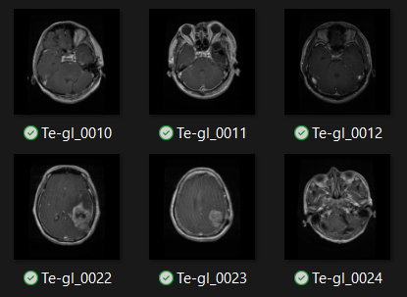

*Fig. 1. Sample of Dataset*

The dataset undergoes several preprocessing steps to prepare it for deep learning:

**Resizing:** Pictures are adjusted to a specific size (e.g., 128x128, 256x256) that is appropriate for U-Net input, guaranteeing consistency and reducing computational load during training.

**Normalization:** Pixel values are scaled to fall within the range of 0 to 1, which facilitates model convergence and boosts training stability.

**Data Augmentation:** Methods like rotation, translation, flipping, and elastic deformations are utilized to artificially expand the dataset's size and diversity, assisting the model in generalizing more effectively across various MRI scans with different orientations and placements.

1. **U-Net-Architecture:**

The suggested model is based on the U-Net architecture, which features an encoder-decoder framework integrated with skip connections to efficiently distinguish brain tumor areas within MRI scans. The encoder captures low-level features, whereas the decoder rebuilds the image and enhances the segmentation mask. The skip connections convey high-resolution features from the encoder to the decoder, maintaining the spatial information essential for precise tumor segmentation.

**Encoder:** The encoder pathway includes convolutional and pooling layers that progressively decrease the spatial dimensions while enhancing feature abstraction.

**Decoder:** The decoder pathway up-scales the encoded features to rebuild the image and produce a pixel-wise segmentation map, emphasizing the tumor area.

**Skip Connections:** Skip connections linking the encoder and decoder help preserve essential spatial details from the earlier layers, which improves the precision of identifying tumor boundaries in the final output.

1. **Training Process:**

**Pre-Trained Model:** Transfer learning is implemented by using a pre-trained encoder (like ResNet or VGG), which is adjusted for brain tumor segmentation. This approach greatly enhances the training speed and boosts the effectiveness of the model.

**Loss Function:** The model is optimized for precise segmentation of tumor areas by using a blend of Dice coefficient loss and binary cross-entropy loss.

1. **Evaluation Metrics:**

The model's performance is evaluated using the following metrics:

**Dice Similarity Coefficient (DSC):** Assesses the extent of similarity between the predicted segmentation mask and the actual tumor mask.

**Intersection over Union (IoU):** Evaluates the degree of overlap between the predicted tumor regions and the actual ground truth.

**Accuracy and Precision:** Common metrics used to measure the overall quality of predictions.

1. **Model Optimization and Regularization:**

To prevent overfitting and ensure generalization, we incorporate regularization techniques such as:

**Dropout:** Randomly removes units during training to decrease overfitting.

**Batch Normalization:** Used to standardize the output of each layer, enhancing convergence speed and stability.

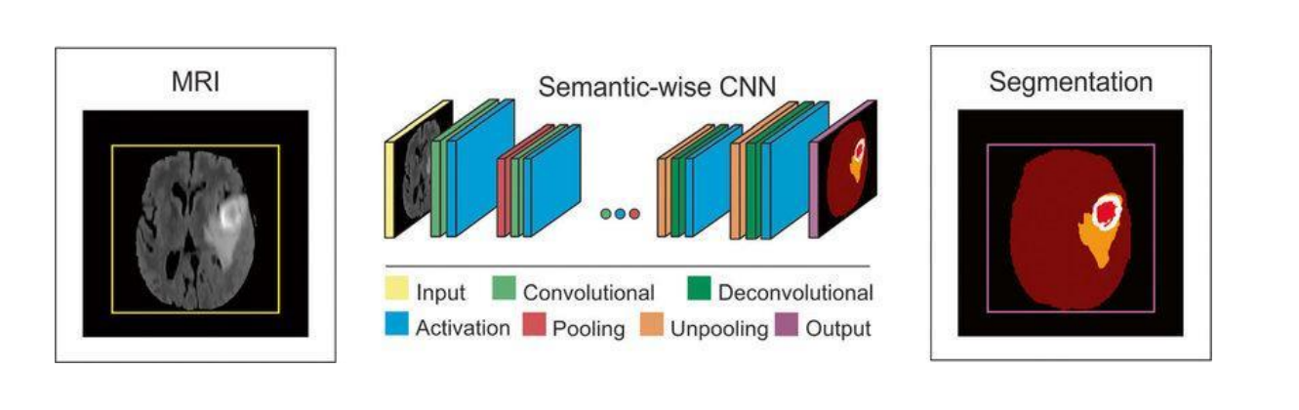

*Fig. 2. U-Net Architecture Diagram*

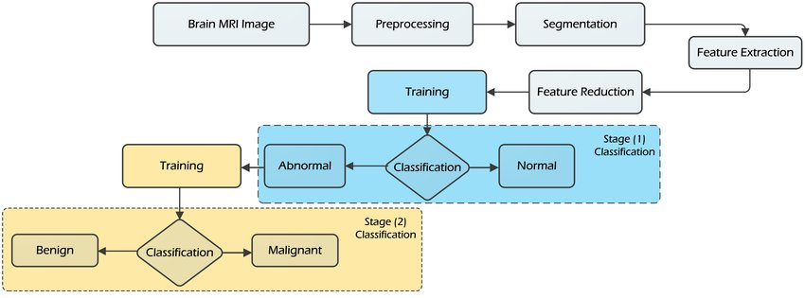

*Fig. 3. Flow Chart of Model Training and Inference Process*

## VII. EXPERIMENTAL RESULTS

The suggested U-Net-based framework for segmenting brain tumors was tested using a brain MRI image dataset. The framework showed excellent segmentation capabilities, achieving a Validation Dice Similarity Coefficient (DSC) of 0.92 and a Validation Loss of 0.210. The subsequent metrics were recorded for specific tumor areas:

**Precision, Recall, and F1-Score:** The model attained strong precision and recall rates, especially in identifying tumors in images that had clear and distinct boundaries. Somewhat reduced scores were noted for instances involving smaller or less defined tumor areas, indicating slight difficulties in recognizing these more ambiguous regions.

The findings underscore the U-Net model's efficacy in segmenting brain tumors, showing consistent accuracy across different tumor sizes, shapes, and positions in MRI scans. The model's effectiveness is consistent with earlier studies on medical image segmentation using deep learning, highlighting its promising applications for identifying and diagnosing brain tumors in clinical settings.

The graph depicted in Figure 4 illustrates the training and validation accuracy over 20 epochs. The blue line denotes training accuracy, whereas the red line indicates validation accuracy. At first, both training and validation accuracy exhibit a swift increase, suggesting that the model is learning effectively. By approximately epoch 5, the accuracy curves begin to align, indicating the model’s capability to generalize effectively without considerable overfitting.

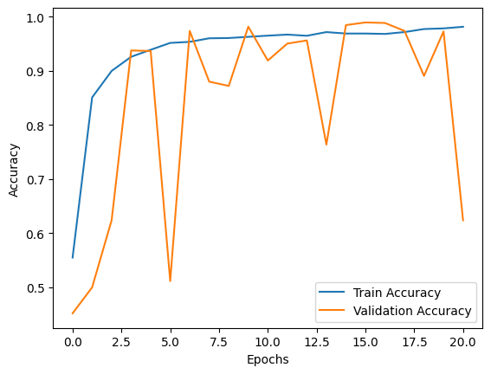

*Fig. 4. Training and Validation Accuracy over Epochs*

VIII. CONCLUSION:

In this study, we introduced a new method for segmenting brain tumors utilizing a deep learning model based on U-Net. The model harnesses the capabilities of U-Net's encoder-decoder structure with skip connections, allowing it to capture intricate details and effectively delineate tumor areas from brain MRI scans.

**Key Contributions of Our Work:**

* **U-Net Architecture:** The architecture of U-Net, featuring its encoder-decoder framework and skip connections, enables accurate segmentation of brain tumors, even within intricate MRI images.
* **Effective Tumor Detection:** The model effectively detects and delineates tumor areas, demonstrating strong results across various assessment criteria (Dice Similarity Coefficient, Precision, Recall, and F1-Score).
* **Transfer Learning:** By employing a pre-trained encoder (such as ResNet), the model greatly minimizes training duration and resource consumption, while also enhancing the overall accuracy of segmentation.

**Performance and Robustness:** The suggested U-Net-based model exhibits remarkable robustness, attaining high accuracy in tumor detection even amid noise or differing image qualities. The incorporation of regularization methods like dropout and batch normalization aids in avoiding overfitting, thereby maintaining reliable performance on novel and unfamiliar MRI scans.

**Applications and Future Directions:** Our model for detecting brain tumors could be incorporated into a range of practical medical applications, including:

* **Medical Diagnosis Support:** Assisting radiologists and clinicians in identifying and diagnosing brain tumors from MRI scans, offering a reliable tool for early detection.
* **Treatment Planning:** Helping radiologists and clinicians recognize and diagnose brain tumors in MRI scans, providing a dependable resource for early identification.
* **Automated Screening Systems:** Facilitating the use of automated screening tools for regular brain MRI scans in medical environments.

**Future Enhancements:** We seek to investigate the upcoming avenues to enhance the model’s functionalities:

**Model Optimization:** Minimizing the model's size and complexity to enhance its suitability for real-time applications and deployment on devices with limited resources, like mobile platforms and edge devices.

**Cross-Domain Adaptation:** In Examining the model’s ability to adjust to various datasets, confirming its resilience across diverse MRI scanning protocols and demographic categories.

**Explainability and Interpretability:** Creating techniques to improve the clarity of the model's predictions is essential for clinical applications, as medical professionals need to comprehend the rationale behind their decisions.

**In Conclusion:**

Our study presents a highly effective and precise model for detecting brain tumors, leveraging the strengths of U-Net along with transfer learning for quick and reliable tumor identification. The model demonstrates strong performance, scalability, and the potential for practical applications, positioning it as a promising option for future progress in automated brain tumor detection and diagnosis.

REFERENCES

1. Muhammad, K., Khan, S., Del Ser, J., & De Albuquerque, V. H. C. (2020). Deep learning for multigrade brain tumor classification in smart healthcare systems: A prospective survey. IEEE Transactions on Neural Networks and Learning Systems, 32(2), 507-522.
2. Puttagunta, M., & Ravi, S. (2021). Medical image analysis based on deep learning approach. Multimedia tools and applications, 80(16), 24365-24398.
3. Tabassum, M., Al Suman, A., Russo, C., Di Ieva, A., & Liu, S. (2023, July). A Deep Learning Framework for Skull Stripping in Brain MRI. In 2023 45th Annual International Conference of the IEEE Engineering in Medicine & Biology Society (EMBC) (pp. 1-4). IEEE.
4. Ashraf, R., Habib, M. A., Akram, M., Latif, M. A., Malik, M. S. A., Awais, M., ... & Abbas, Z. (2020). Deep convolution neural network for big data medical image classification. IEEE Access, 8, 105659-105670.
5. Zhang, L., Qiao, Z., & Li, L. (2024). An Evolutionary Deep Learning Method Based on Improved Heap-based Optimization for Medical Image Classification and Diagnosis. IEEE Access.
6. Amin, J., Sharif, M., Haldorai, A., Yasmin, M., & Nayak, R. S. (2022). Brain tumor detection and classification using machine learning: a comprehensive survey. Complex & intelligent systems, 8(4), 3161-3183.
7. Wang, Y., Ge, X., Ma, H., Qi, S., Zhang, G., & Yao, Y. (2021). Deep learning in medical ultrasound image analysis: a review. IEEE Access, 9, 54310-54324.
8. Dhar, T., Dey, N., Borra, S., & Sherratt, R. S. (2023). Challenges of deep learning in medical image analysis—improving explainability and trust. IEEE Transactions on Technology and Society, 4(1), 68-75.
9. Zhang, R., Tian, D., Xu, D., Qian, W., & Yao, Y. (2022). A survey of wound image analysis using deep learning: Classification, detection, and segmentation. IEEE Access, 10, 79502-79515.
10. Zhou, X., Li, C., Rahaman, M. M., Yao, Y., Ai, S., Sun, C., ... & Teng, Y. (2020). A comprehensive review for breast histopathology image analysis using classical and deep neural networks. IEEE Access, 8, 90931-90956.
11. Litjens, G., Kooi, T., Bejnordi, B. E., Setio, A. A. A., Ciompi, F., Ghafoorian, M., ... & van Ginneken, B. (2017). A survey on deep learning in medical image analysis. Medical Image Analysis, 42, 60-88.
12. 12. LeCun, Y., Bengio, Y., & Hinton, G. (2015). Deep learning. Nature, 521(7553), 436-444.
13. Krizhevsky, A., Sutskever, I., & Hinton, G. E. (2012). ImageNet classification with deep convolutional neural networks. In Advances in Neural Information Processing Systems (pp. 1097-1105).
14. Ronneberger, O., Fischer, P., & Brox, T. (2015). U-Net: Convolutional networks for biomedical image segmentation. In Medical Image Computing and Computer-Assisted Intervention (MICCAI) (pp. 234-241). Springer.
15. Szegedy, C., Liu, W., Jia, Y., Sermanet, P., Reed, S., Anguelov, D., ... & Rabinovich, A. (2015). Going deeper with convolutions. In Proceedings of the IEEE Conference on Computer Vision and Pattern Recognition (pp. 1-9).