**The Science of Vitamin C: A Detailed Review**

**Mr. Vashvi Kumar Sahu1, Ms. Nandani Chandra2**

1,2Bachelor Of Pharmacy, Kamla Institute of Pharmaceutical Sciences (Shri Shankaracharya

Professional University), Bhilai, Chhattisgarh, India.

**ABSTRACT**

Vitamin C, known as L-ascorbic acid, is an essential water-soluble vitamin in human health, which cannot be synthesized endogenously like most animals. It is crucial in the biosynthesis of collagen, L-carnitine, and neurotransmitters. Protein metabolism also requires vitamin C. Collagen is essential in connective tissue and healing wounds. It has antioxidant properties, capable of regenerating other antioxidants such as vitamin E. In this way, it is possibly helpful in preventing oxidative stress-related diseases, which includes certain cancers and cardiovascular diseases. Vitamin C supports the immune function and helps the absorption of nonheme iron from plant-based foodstuffs. A deficiency causes scurvy, with signs being fatigue, weakness of the connective tissue, and fragile capillaries.

Absorption of vitamin C is very tightly regulated; mechanisms include active transport and glucose transporters. The percentage absorbed at moderate intakes, 30–180 mg/day, is between 70–90%. With increasing intakes, absorption drops and excessive amounts are excreted in the urine. From pharmacokinetic studies, plasma levels increase with high intakes, such as 1.25 g/day. Vitamin C is concentrated in tissues like leukocytes, eyes, adrenal glands, and brain, whereas the concentration is less in extracellular fluids as plasma and saliva.

**Keywords:** L-ascorbic acid, Scurvy, Collagen, Antioxidants.

1. **INTRODUCTION**

Water-soluble vitamin C, sometimes referred to as L-ascorbic acid, is added to certain foods, found naturally in others, and accessible as a dietary supplement. Since humans cannot endogenously generate vitamin C like most animals can, it is a necessary dietary component.

Vitamin C is an essential catalyst in the biosynthesis of collagen, L-carnitine, and certain neurotransmitters and plays a role in the metabolism of proteins. Collagen is an integral part of connective tissue, essential to wound healing. Vitamin C also acts as a critical physiological antioxidant and has been shown to be involved in the regeneration of other antioxidants in the body, such as alpha-tocopherol, or vitamin E. In addition, research is in progress to determine whether vitamin C is sufficient an antioxidant to neutralize free radicals and prevent or delay the development of specific cancers, cardiovascular disease, and other diseases in which oxidative stress plays a causal role. In addition to biosynthetic and antioxidant functions, vitamin C is essential for proper functioning of the immune system, enhances absorption of nonheme iron, which is the type of iron in plant-based foods, deficiency leads to a disease known as scurvy characterized by fatigue or lassitude, diffuse weakness of connective tissues, and fragility of capillaries.

The intestinal absorption of vitamin C is regulated by at least one specific dose-dependent, active transporter. Vitamin C is absorbed by cells through a second specific transport protein. Some facilitated glucose transporters permit entry of oxidized vitamin C, or dehydroascorbic acid, into cells, where it is reduced within the cells to ascorbic acid. Uptake and contribution of dehydroascorbic acid to overall vitamin C economy is unknown.

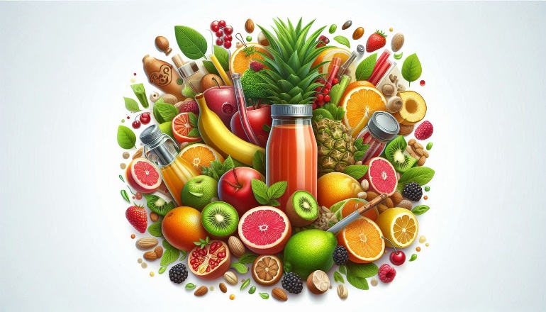

**Figure 1:** Sources of Vitamin C

Oral vitamin C does reach tissue and plasma levels that the body holds very tightly. Approximately 70%–90% of vitamin C is absorbed at modest intakes of 30–180 mg/day. However, absorption drops to less than 50% and absorbed, unmetabolized ascorbic acid is excreted in the urine when doses are above 1 g/day. From pharmacokinetic studies, it shows that oral dose 1.25 g/day of ascorbic acid yields mean peak plasma vitamin C concentrations, which is roughly about 135 micromol/L-about two times larger than when ingestion through ingesting vitamin C-rich foods at a dosage of 200–300 mg/day. Pharmacokinetic modeling suggests that even doses as high as 3 g of ascorbate, given every 4 hours, would attain only peak plasma concentrations of 220 micromol/L.

The total body content of vitamin C ranges from 300 mg-at near scurvy-to about 2 g. High concentrations of vitamin C in millimolar concentrations are maintained in cells and tissues and are particularly high in leukocytes, that is, white blood cells; eyes; adrenal glands; pituitary gland; and brain. Relatively low levels of vitamin C, that is, in micromolar concentrations, are found in extracellular fluids, such as plasma; red blood cells; and saliva.

1. **What is Vitamin C?**

**2.1 Definition and Chemical Properties**

Although vitamin C is the generic name of l-ascorbic acid, it has many other chemical names as ascorbate and antiscorbutic vitamin. l-Ascorbic acid molecule is formed of asymmetrical six-carbon atoms (C6H8O6) which structurally is related to glucose. Its molecular weight is 176 with melting point 190–192°C with decomposition and exhibits a density of about 1.65 g/cm3. l-Ascorbic acid freely soluble in water (300 g/L at 20°C), difficult in alcohol (20 g/L at 20°C) and insoluble in chloroform, ether and benzene. It forms a clear colorless to slightly yellow solution. It has two pKa values: 4.2 and 11.6. The pH of a 5% (w/v) solution in water is 2.2–2.5.

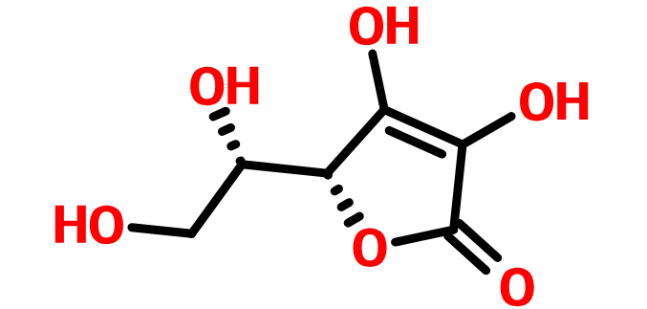

**Figure 2:** Vitamin C Molecular Structure

The chemical structure of ascorbic acid determines its physical and chemical properties. It is a weak, water soluble, unstable organic acid which can be easily oxidized or destroyed in light, aerobic condition (oxygen), high temperature, alkali, humidity, copper and heavy metals. Usually ascorbic acid may be found in white or slightly yellowish crystalline powder, which is chemically stable in dryness. However, L-ascorbic acid is highly soluble in water, shows great difficulty to be soluble in alcohol, chloroform, ether and benzene. It forms clear colorless slightly yellow solution, which is rapidly oxidized in water.

There are many derivatives of ascorbic acid as sodium L-ascorbate (sodium ascorbate), calcium L-ascorbate (calcium ascorbate), zinc-ascorbate, 6-palmityl-L-ascorbic acid (ascorbyl palmitate) and ascorbyl monophosphate calcium sodium salt (sodium calcium ascorbyl phosphate).

Ascorbic acid is produced by cation exchange from sodium ascorbate. Sodium ascorbate, on the other hand, is prepared by reaction of methyl-d-sorbosonate (or ketogulonic acid methyl ester) with sodium carbonate. Calcium ascorbate is produced through the action of ascorbic acid with calcium carbonate in water and ethanol which isolates and dries subsequently. Ascorbyl palmitate is prepared by treatment of ascorbic acid with sulfuric acid followed by esterification with palmitic acid. Sodium calcium ascorbyl phosphate was prepared by the reaction of ascorbic acid either alone or in combination with sodium ascorbate with calcium hydroxide and sodium trimetaphosphate. All the previously known ascorbic acid derivatives possess superior properties compared to ascorbic acid itself, including resistance to light and skin irritation.

**2.2 Sources of Vitamin C**

Vitamin C is produced only in non-humans as primate species, guinea pigs, fishes and birds. Though most of the animals have the ability to synthesize their needs of vitamin C, humans suffer from mutation in the DNA coding of gulonolactone oxidase which is the main enzyme responsible for ascorbic acid synthesis. Due to this mutation, an external supplement of vitamin C becomes a must.

Fruits and vegetables have been cited to be the main sources of vitamin C for human beings. Citrus fruits are the richest sources of vitamin C among others such as cantaloupe, water melon, berries, pineapple, strawberries, cherries, kiwi fruits, mangoes, and tomatoes. On the other hand, vegetables are considered as a major reservoir source of vitamin C because it contains more and is available for longer period throughout the year like cabbage, broccoli, Brussels sprouts, bean sprouts, cauliflower, mustard greens, peppers, peas, and potatoes.

* 1. **Functions of Vitamin C in the Body**

**2.3.1 Role in immune system and inflammation**

It plays a very significant role in maintaining a healthy immune system. Its deficiency causes immune insufficiency with multiple infections. Ascorbic acid level of many body fluids goes down during bacterial infections. Therefore, it is very commonly used as adjunctive treatment in many infectious diseases like hepatitis, HIV, influenza, and periodontal diseases.

Vitamin C administration modulates and enhances both the innate and adaptive immunity. It neutralises bacterial toxins especially endotoxins through blocking the critical signal for lipopolysaccharides (LPS) formation. However, LPS block the transit of ascorbic acid through blood brain barrier and inhibits uptake by many other cells.

Ascorbic acid enhances the phagocytic activities and functions of many immune cells such as neutrophils, natural killer cells, macrophages, and lymphocytes. Vitamin C also enhances the proliferation of lymphocytes and production of antibodies.

**2.3.2 Anti-oxidant property**

Oxidative stress/ROS play a major role in inflammatory diseases including periodontal diseases. The ROS are classified into 3 classes; the first are reactive free radicals as oxygen related radicals (superoxide, hydroxyl radical or peroxyl radicals). The second class is reactive species but not free radicals as hypochlorous acid. The third class is radicals resulted from the reaction with ascorbic acid. Antioxidants are also classified into enzymatic and non-enzymatic. The enzymatic antioxidants include catalase enzyme, thiol-containing agents such as cysteine, methionine, taurine, glutathione, and lipoic acid.

Amongst the nutritionally vital non-enzymatic anti-oxidants is vitamin C. The manner in which antioxidant action for vitamin C is found to occur through electron donation process in which, under normal conditions, vitamin C freely donate two electrons (reduction reaction) to other compounds in order to prevent its oxidation. In the first process of donating the first electron, ascorbic acid is oxidized into a free radical termed as ascorbyl radical, which acts as semi-dehydroascorbic acid. It is a relatively stable free radical and unreactive because of an unbound electron in its outer shell, but it has a very short lifetime (10–15 s). This radical is non-reactive, which makes this stuff harmless to the surrounding cells. This process is termed free radical scavenging or quenching. Once it donates the second electron, the outcome was dehydroascorbic acid. This stability could only last for a few minutes.

Vitamin C acts as a pro-oxidant when applied in low doses while at higher doses, it is an antioxidant. Yet again, the quantity of vitamin C applied to skin exposed to more ultraviolet radiation is less compared to the amount to be applied on exposure to lesser ones.

Vitamin C increases the antioxidant activity that enhances epidermal turn over as the movement of young cells towards the surface of the skin where they replace the old cells. Frank pointed in his study that RNA enhanced the ability of skin cells to utilize oxygen.

Ascorbyl free radical and dehydroascorbic acid are reversible agents that easily can rebound back as a result into ascorbic acid. These reversible agents can irreversibly transformed into 2,3-diketogulonic acid which is further metabolized to xylose, xylonate, lyxonate, and oxalate.

It is an effective anti-inflammatory agent since it suppresses many inflammatory mediators as tumor necrosis factor alpha. This property is exploited in treatment of postoperative erythema developed after CO2 laser in skin resurfacing. In 1987, Halliwell noted significant decrease in plasma levels of ascorbic acid in association with increased histamine in inflammatory diseases such as ulcerative colitis and rheumatoid arthritis. This was explained by the discovery of the anti-histaminic effect of vitamin C. It was also found that the higher ascorbic acid content in joints, the higher protection levels against damage which directed many physicians to use ascorbic acid in combination therapy with drugs aiming to joint protection as glucosamine.

It was discovered that vitamin C has an efficient chemotherapeutic effect. The cytotoxic effect of vitamin C is dose and route dependent. Tumour cells are far more sensitive to high intravenous (cytotoxic) levels of vitamin C compared with normal cells. The intravenous administration of 10 g of vitamin C increases the extracellular concentration to a marked value, with 1000 μmol/L which, through the action of ascorbyl radicals (free radical species), exerts a toxic effect on the cancer cells. On the contrary to the oxidative species causing damage to the cancer cells, the normal cells can compensate this damage. These mega doses of vitamin C are necessary in other diseases too such as diabetes, cataracts, glaucoma, macular degeneration, atherosclerosis, stroke and heart diseases.

Vitamin C enhances the immune system and its deficiency induces immune insufficiency and multiple infections. It was found that vitamin C modifies the behavior and activity of the immune cells; it also enhances the phagocytic properties of neutrophils and macrophages. Besides, vitamin C increases antibody production, the concentration of antibodies, and activates lymphocytes. It was established that the content of vitamin C in leukocytes is higher than its content in plasma as they are able to store it.

Vitamin C is considered adjunctive therapy for a number of infectious diseases, including hepatitis, HIV, common cold and influenza. This substance plays an essential role in antibacterial reactions that occur inside the human body in the form of the neutralization of bacterial toxins, primarily endotoxins. An inhibitory effect in the growth or bacteriostatic effect of bacteria can be expressed by ascorbic acid at concentrations of 100 μM/L.

An amount of vitamin C which is sufficient causes blockage of the signaling essential for lipopolysaccharides (LPS) formation. It also halts the production of ROS, especially reactive nitrogen species that is produced mainly during infections. In bacterial infections, the ascorbic acid level in various body fluids is less than normal which performs additional depression due to the action of LPS in blocking the passage of ascorbic acid through the blood brain barrier. LPS also retards the uptake of different cells to ascorbic acid.

The anti-aging action of vitamin C is attributed to its strong antioxidant activity, its stimulating activity to augment the formation of collagen, protection of the persistent collagen particularly elastin from damage and finally, prevents the cross-linking effect formed in wrinkles. It was discovered that the quantity of ascorbic acid changes with age. The younger the age, the more ascorbic acid is present. As early as 1934, Yavorsky et al. quantitatively analyzed the amount of ascorbic acid found in the different body organs at different ages.

1. **Dietary Sources of Vitamin C**

**3.1 Natural Sources**

Vitamin C is one of the most essential nutrients obtained through diet. The body requires vitamin C for growth and repair; it also plays a significant role in the body as an antioxidant to promote immunity to disease. In contrast to most mammals, humans are unable to synthesize vitamin C in their bodies, so they must obtain it through their diets. Since most fruits and vegetables contain the body's required vitamin content, oranges receive much publicity as the fruit to obtain vitamin C. Read ahead and get some knowledge on which other herbs possess vitamin C levels equal to-if not more than-the orange.

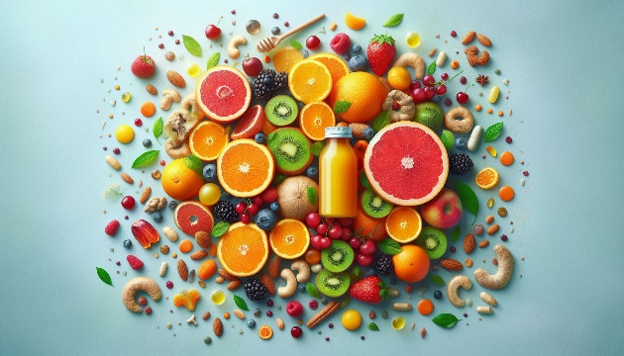

**Figure 3:** DifferentSources of Vitamin C

**1. Lemon**

Lemons are filled with ascorbic acid, a fancy term for vitamin C. The recommended daily allowance of vitamin C is 75 mg for females and 90 mg for males. One lemon provides about 30 mg of vitamin C. Lemons have more vitamin C in their juice. One cup of lemon juice contains about 95 mg.

**2. Rose**

Rose hips are the fruit of a rose plant; they slightly resemble berries and are usually reddish in color. Of their nutritional content, about 1.7% is vitamin C. Sounds minor, but rose hips are one of the richest known plant sources of the vitamin.

**3. Chilli Pepper**

Try adding chillis to a curry for a vitamin boost as well as a culinary one; one-eighth of a cupful of diced chillis contains around 45 mg of vitamin C. The quantity of ascorbic acid can vary by variety, but red hot chillis tend to have more.

**4. Spinach**

Spinach is best known as a good source of beta-carotene-that is, of vitamin A-but it is also a good source of vitamin C-8 mg per cupful raw or slightly more in cooked forms.

**5. Potato**

Perhaps most unexpectedly, one medium-sized potato contains 17 mg of vitamin C, and these are often considered the "starchy" vegetables. Potatoes do not pose much of a barrier to being utilized in many meals; therefore, potatoes are an easily accessible partial source of the otherwise suggested vitamin C.

**6. Wild Strawberry**

Wild strawberry fruits contain 85 mg of vitamin C per cupful. Even cultivated strawberries are full of this antioxidant vitamin. Fruit salads and desserts that mix both kinds of strawberry gain an interesting flavor, while also providing ample amounts of vitamin C.

**7. Cayenne**

Cayenne pepper, particularly the green ones, is quite high in ascorbic acid. Half cup of raw chopped Cayenne peppers yields around 60 mg of vitamin C. It adds a delectable crunch when served as a salad.

**8. Broccoli**

Broccoli is another large source of vitamin C and half a cooked cup of the vegetable provides 51 mg. Again, Brussels sprouts B. oleacea var. gemmifera- are a variant of the same species to which broccoli belongs contain 51 mg of vitamin C per cooked cupful. Broccoli and sprouts may be contentious vegetables in the regard of taste, but they cannot be dismissed as unimportant for their vitamin C.

**9. Camu Camu**

Camu camu is another fruit that comes from the Amazonian Rainforest. Although it is small, this fruit holds the most vitamin C content known to date; it has up to 30 to 50 times the amount of an orange. Such high ascorbic acid creates camu camu to be the most common cold and flu remedy in its native lands. It also contains powerful antioxidants due to its vitamin C and unique polyphenols, and it can be used to reduce inflammation.

**10.** **Cranberry**

For instance, one glass of cranberry juice provides approximately 23 mg of vitamin C. Part of the reason that this fruit has long been used to treat urinary tract infections is because of its content of ascorbic acid. In addition to treating existing infections, this fruit also prevents future infections of the urinary tract due to its inhospitable qualities for bacteria.

**3.2 Synthetic Sources and Supplements**

Synthetic vitamin C, also known as ascorbic acid, is a manufactured form of vitamin C that is identical to the vitamin C found naturally in fruits and vegetables. It is a white, crystalline powder that is soluble in water. Synthetic vitamin C is used in dietary supplements, fortified foods, and beverages.

There is some debate about whether synthetic vitamin C is as bioavailable as vitamin C from food sources. Bioavailability refers to the amount of a nutrient that is absorbed and used by the body. 1 Some studies suggest that synthetic vitamin C may be absorbed as well as vitamin C from food sources. However, there studies suggest that vitamin C from food sources may be more bioavailable.

Supplements of vitamin C are usually found in the form of ascorbic acid, which has the same bioavailability as the naturally occurring ascorbic acid found in foods, such as orange juice and broccoli. Other preparations of vitamin C supplements include sodium ascorbate; calcium ascorbate; other mineral ascorbates; ascorbic acid with bioflavonoids; and combination products like Ester-C, which contains calcium ascorbate, dehydroascorbate, calcium threonate, xylonate and lyxonate.

**Dietary supplements**

A few human studies examined whether bioavailability differed between the various forms of vitamin C. One study produced equivalent vitamin C plasma concentrations for Ester-C and ascorbic acid, but significantly higher vitamin C concentrations were produced in leukocytes 24 hours after ingestion with Ester-C. Plasma vitamin C levels and urinary excretion of vitamin C, however, were identical between the three sources studied: ascorbic acid, Ester-C, and ascorbic acid with bioflavonoids. In this study, ascorbic acid was reported to be the source of choice for supplemental vitamin C based on cost, which is relatively low.

1. **Recommended Daily Intake and Requirements**

**4.1 Dietary Recommendations by Health Organizations**

**Dietary supplements**

Intake recommendations for vitamin C and other nutrients are reported in the Dietary Reference Intakes (DRIs) established by the Food and Nutrition Board (FNB) of the Institute of Medicine (IOM) of the National Academies (formerly National Academy of Sciences). The general term to describe a set of reference values used for planning and assessing intake of nutrients by healthy people is DRI.

**These are summary values, which vary by age and gender, and include the following:**

**Recommended Dietary Allowance (RDA):** Average daily level of intake sufficient to meet the nutrient requirements of nearly all (97%–98%) healthy individuals; often used to plan nutritionally adequate diets for individuals

Adequate Intake (AI): Intake at this level is assumed to ensure nutritional adequacy; established when evidence is insufficient to develop an RDA.

Estimated Average Requirement (EAR) is an average daily level of intake estimated to meet the requirements of 50% of healthy individuals; it is often used to determine adequate intakes of nutrients for groups of people and to plan nutritionally adequate diets for them; sometimes used to evaluate the intakes of nutrients of individuals

**Tolerable Upper Intake Level (UL):** Maximum daily intake unlikely to cause adverse health effects.

For the case of vitamin C, its RDAs are built based on known physiological and antioxidant functions of this vitamin in white blood cells and are many times greater than the quantity needed to serve as a buffer against deficiency. The FNB established an AI for vitamin C for infants from birth through 12 months of age to be equivalent to the mean intake of vitamin C in healthy, breastfed infants.

**Table 1.** Recommended Dietary Allowances (RDAs) for Vitamin C

|  |  |  |  |  |
| --- | --- | --- | --- | --- |
| Age | Male | Female | Pregnancy | Lactation |
| 0–6 months | 40 mg* | 40 mg* |  |  |
| 7–12 months | 50 mg* | 50 mg* |  |  |
| 1–3 years | 15 mg | 15 mg |  |  |
| 4–8 years | 25 mg | 25 mg |  |  |
| 9–13 years | 45 mg | 45 mg |  |  |
| 14–18 years | 75 mg | 65 mg | 80 mg | 115 mg |
| 19+ years | 90 mg | 75 mg | 85 mg | 120 mg |
| Smokers | | Individuals who smoke require 35 mg/day more vitamin C than non-smokers. | | |

* Adequate Intake (AI)

**4.2 Factors Affecting Vitamin C Needs**

* **Poor Dietary Intake:** The most common cause of vitamin C deficiency is a diet lacking in fruits and vegetables. Processed foods, which are mostly nutrient-poor, consume much of what people eat nowadays; thus, vitamin C intake is deficient.
* **Chronic Diseases:** Conditions like Crohn's disease, ulcerative colitis, and other gastrointestinal conditions are known to compromise the assimilation of vitamin C. It is also said that patients who have chronic kidney disease and are undergoing dialysis require more vitamin C.
* **Smoking:** Smokers are more susceptible to vitamin C deficiency because smoking raises oxidative stress and enhances metabolic turnover of vitamin C. The smoker needs an additional 35 mg of vitamin C daily over that required by the non-smoker.
* **Alcoholism:** Vitamin C absorption and metabolism may be disrupted with excessive alcohol consumption, leading to deficiency.
* **Aged Population:** The elderly is at higher risk of deficiency due to various factors such as reduced mobility, poor dentition, and reduced appetite, which may lead to lower intakes of vitamin C.
* **Socioeconomic Factors:** Persons in poverty or those with poor access to fresh produce are also subject to a higher risk of vitamin C deficiency based on their dietary habits

1. **Deficiency of Vitamin C: Impact on Health**

**5.1 Scurvy: Symptoms and Treatment**

Scurvy is a disease caused by vitamin C deficiency. The signs and symptoms of scurvy can be anemia, exhaustion, spontaneous bleeding, limb pain with swelling, and sometimes ulceration of the gums and loss of teeth.

Scurvy occurs when the body lacks vitamin C, also known as ascorbic acid. The deficiency leads to symptoms such as weakness, anemia, gum diseases, and skin problems.

Since collagen is required in many connective tissues for structural and supportive functions in the body, including that of blood vessels, it requires vitamin C for its synthesis.

The lack of vitamin C affects the immune system, iron absorption, cholesterol metabolism, and other functions as well.

Symptoms

Vitamin C is an essential nutrient in the development process and helps absorb iron and produce collagen. If the body is unable to produce ample amounts of collagen, tissues will begin to degrade.

It is also crucial in synthesizing dopamine, norepinephrine, epinephrine, and carnitine, which are necessary for energy production.

Vitamin C deficiency symptoms typically present themselves after 8-12 weeks. Some of the early signs include loss of appetite, weight loss, fatigue, irritability, and lethargy.

**There may be the following signs in 1-3 months within presentation**:

* Anemia.
* Myalgia, or pain, which includes bone pain.
* Swelling, or edema.
* Petechiae, or small red spots resulting from bleeding under the skin.
* Corkscrew hairs.
* Gum disease and loss of teeth.
* Poor healing of wounds.
* Shortness of breath.
* Mood changes, and depression.

In due course of time, the patient will manifest generalized edema, severe jaundice, red blood cell destruction, or hemolysis, sudden and spontaneous bleeding, neuropathy, fever, convulsions. It is fatal in outcome.

Infants with scurvy will be anxious and irritable. They can feel the pain in the acute phase of the disease, assuming a frog-leg posture to find comfort.

There may also be subperiosteal hemorrhage, which is a type of bleeding that occurs at the ends of long bones.

Treatment

Treatment involves administering vitamin C supplements through the mouth or injectable.

**Dosage:** The required dose for adults is:

* 1,000 milligrams (mg) in a day for at least 1 week.
* 300-500 mg for 1 week.

Usually within 24-72 hours, symptoms such as fatigue, lethargy, pain, anorexia, and confusion should start to subside. Some may take a couple of weeks to resolve bone changes.

In most patients, complete recovery occurs within 3 months. Long-term consequences of the accident are unlikely but depend on the degree of dental damage.

**5.2 Other Conditions Linked to Vitamin C**

Vitamin C deficiency occurs when body lacks vitamin C. This might result from not consuming sufficient fruits and vegetables.

Vitamin C is a very vital vitamin; it ensures healthiness and ensures proper functioning of the body.

Recurrent (chronic) vitamin C deficiency results in a disease known as scurvy.

* **Early symptoms:**
  + The early symptoms of vitamin C deficiency include:
  + Tiredness and weakness.
  + Muscle and joint pains.
  + Easy bruising.
  + Spots that look like tiny, red-blue bruises on the skin.
* **Other symptoms:**
  + Dry skin.
  + Splitting hair.
  + Swelling and discoloration of the gums.
  + Sudden and unexpected bleeding from the gums.
  + Nosebleeds.
  + Poor healing of wounds.
  + Problems fighting infections.
  + Bleeding into joints, causing severe joint pains.
  + Changes in the bones.
  + Tooth loss.
  + Weight loss.

1. **The Role of Vitamin C in Disease Prevention and Management**

**6.1 Vitamin C as an Antioxidant**

Vitamin C's most important role is its antioxidant activity. An antioxidant is a substance that mops up free radicals. These are highly reactive molecules, causing damage to cells and DNA. Free radicals particularly have a detrimental effect on red blood cells; it is the destruction of the latter that exacerbates the symptoms of anemia. Vitamin C will donate electrons to stabilize the free radicals and hence prevent the premature destruction of red blood cells.

**6.2 Role in Collagen synthesis and tissue repair**

Besides its antioxidant effects, vitamin C is important in the production of collagen, a structural protein that forms an integral part of the integrity of blood vessels and tissues. This is significant for those suffering from anemia since damaged blood vessels may cause bleeding and exacerbate the condition. Vitamin C contributes to blood vessel repair and maintenance through the stimulation of collagen synthesis, thus lessening the chances of internal bleeding and contributing to the general health of the cardiovascular system.

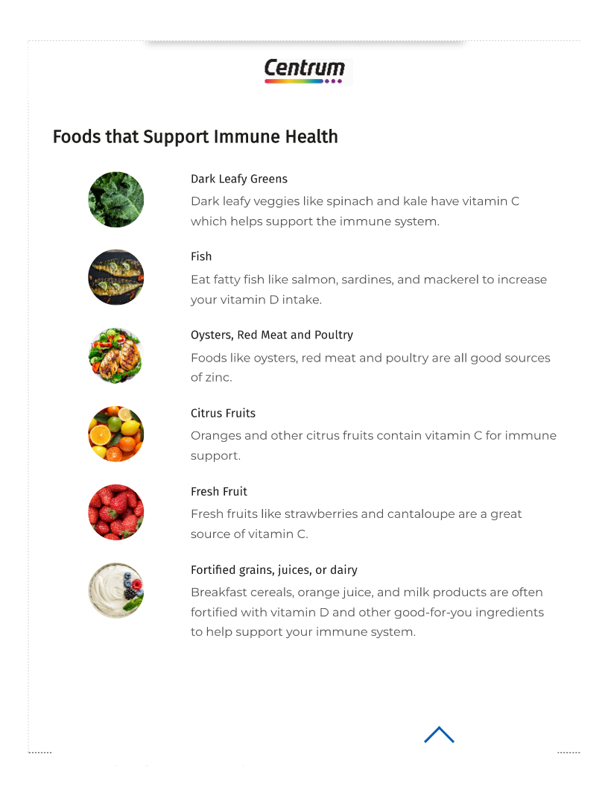

**Figure 4:** Foods that Support Immune Health [17]

**6.3 Immune System Support and Infection Prevention**

A healthy immune system must have many vitamins and nutrients in its system to work properly. Examples of vitamins that aid immune function are vitamins C, D, and A. Other vitamins also are vital. You can gain such essential contributors to good health for your immune system by the food you consume. However, if you cannot obtain all the vitamins needed from your diet, you might desire to have some daily multivitamin. Centrum multivitamins contain the vitamins and nutrients essential in supporting the immunity of your body-and health.

**6.4 Cardiovascular Health**

While extreme deficiency of vitamin C may lead to several forms of cardiovascular disease, adequate dietary intake of vitamin C has been demonstrated to support the integrity of the endothelium and prevent hypertension, atherosclerosis, and stroke. Endothelial function is an important component of vascular health, reducing the risk for hypertension. Vitamin C also supports local vasodilation during exercise, enhancing skeletal muscle blood flow and oxygen consumption.

Vitamin C also has an antioxidant function by scavenging oxygen reactive species of radicals that would otherwise accumulate in cells and cause oxidative stress. Previous research shows that the higher levels of oxidative stress are linked to the increase in cytokine production. It is these antioxidant properties from vitamin C that help prevent and treat cardiovascular diseases.

**6.5 Cancer Prevention and Treatment**

High doses of vitamin C are used as adjuvant treatment for cancer because of research findings that indicate that it could possibly slow the growth and proliferation of cancer cells in prostate, pancreatic, liver, and ovarian cancers, among others.

Though adequate evidence is absent, there are indications that very high levels of vitamin C also have a positive impact on the quality of life of the patients. It does not only ameliorate vomiting, nausea, tiredness, pain and anorexia but improves their mood and generates an overall improvement in the physical status of the patient.

It is also important to note that the response of cancer cells to vitamin C varies, possibly due to genotypic variations which determine the presence or absence of enzymes such as catalase, which confer resistance to the cytotoxic effects of vitamin C.

Vitamin C can be given either intravenously or orally. Intravenous administration leads to higher serum levels since it bypasses intestinal absorption barriers.

1. **Excessive Intake of Vitamin C: Risks and Side Effects**

**7.1 Tolerable Upper Intake Levels (ULs)**

* **RDA:** Recommended Dietary Allowance for adults 19 years and above is 90 mg per day in men and 75 mg in women. In pregnancy and lactation, it increases to 85 mg and 120 mg per day, respectively. Smoking depletes vitamin C in the body; thus, an additional 35 mg above the RDA is recommended for smokers.
* **UL:** The Tolerable Upper Intake Level represents the maximum daily consumption which will not cause negative impacts on health. Vitamin C has an established UL of 2000 mg per day and any intake above that amount is likely to induce gastrointestinal irritation and diarrhea. High intake, above the UL only under medical supervision, for short durations, or within carefully monitored clinical studies is conducted in limited instances.

**7.2 Potential Side Effects of High Dose**

* **How much vitamin C is too much?**

Since vitamin C is water soluble, your body expels all excess amounts within a matter of hours after you've consumed it, making it pretty hard to get a toxic amount.

Indeed, it is virtually impossible from your diet alone to even approach a toxic amount of vitamin C. In healthy individuals generally, all excess vitamin C consumption over and above the Recommended Dietary Allowance gets flushed out of the system.

This amount can be equated as taking 25 oranges or 14 red bell peppers before reaching the UL intake.

It is important to note that although such circumstances are less common, in cases of supplements consumption and some scenarios, there could still be the possibility of a vitamin C overdose.

Examples would be individuals with diseases known to increase the risk for iron overload or who suffer from recurrent kidney stones who need to be careful when it comes to their consumption of vitamin C.

It appears that all adverse effects of vitamin C, ranging from digestive discomfort to kidney stone, are manifested only with dosages higher than 2,000 mg.

If you decide to supplement on vitamin C, take that supplement that contains not exceeding 100% of its daily needs. This calls for 90 mg intake per day for men while for women, 75 mg is the recommended daily portion.

* **Too much vitamin C may cause digestive symptoms:**

It is only upon the administration of vitamin C supplements that high dosages cause gastrointestinal discomfort. Most of the adverse effects noted above are not a resultant of eating foods that happen to be rich in Vitamin C.

You will be most likely to suffer from digestive symptoms if you take more than 2,000 milligrams (mg) in one go. So, a Tolerable Upper Intake Level (UL) of 2,000 mg a day has been established.

The common digestive symptoms that result from excessive vitamin C consumption include diarrhoea and nausea.

Overconsumption has also been associated with acid reflux. Scientific evidence, however does not support this.

If you're experiencing problems in the digestive system because of excess intake of vitamin C, then you could reduce the dose of the supplement or simply stop taking the supplements altogether.

* **Taking supplements in high doses may lead to kidney stones:**

Your body excretes excess vitamin C as a waste product in the form of oxalate. Usually, oxalate leaves your body through urination. However, with some conditions, oxalate binds to minerals and forms crystals; such crystals may cause one to develop kidney stones, as explained above.

Drinking too much vitamin C has the potential to contribute to an increase in urine oxalate levels, subsequently raising the risk of experiencing kidney stones.

In one trial, administration of adults with 1,000-mg vitamin C supplementation twice a day for 6 days increased urinary oxalate levels by 20%.

Greater intake of vitamin C not only enhances urinary excretion of oxalate but also significantly increases the prevalence of developing kidney stones; this tends to happen especially if a person takes a higher than 2,000-mg intake level per day.

There have been cases of renal failure in patients who have used more than 2,000 mg per day. Still, this is extremely rare, particularly in otherwise healthy individuals.

1. **Therapeutic Uses of Vitamin C**

Vitamin C helps your body repair and grow tissues throughout all parts of your body. Helps the body build collagen, the major structural protein needed for making skin, cartilage, tendons, ligaments, and blood vessels. It is also a critical factor in healing and repairing bones and teeth; also important in aiding absorption of nonheme sources of iron.

Vitamin C is an antioxidant, along with vitamin E, beta-carotene, and many other plant-based nutrients. Antioxidants block some of the damage caused by free radicals, substances that damage DNA. The accumulation of free radicals over time may contribute to the aging process and the development of health conditions such as cancer, heart disease, and arthritis.

Serious deficiency of vitamin C is very rare, although the evidence is increasing that many people are not well endowed with vitamin C. Smoking cigarettes lowers the body's levels of vitamin C, so smokers are at greater risk of deficiency.

The signs of vitamin deficiency include dry and splitting hair; gingivitis, or inflammation of the gums, and bleeding gums; rough, dry, scaly skin; decreased rate of wound healing, easy bruising; nosebleeds; and a decreased ability to ward off infection. The severe form of vitamin C deficiency is called scurvy.

Low levels of vitamin C have been associated with many conditions, including high blood pressure, gallbladder disease, stroke, some cancers, and atherosclerosis, the buildup of plaque in blood vessels that can lead to heart attack and stroke. Getting enough vitamin C from your diet -- by eating lots of fruit and vegetables -- may help reduce the risk of developing some of these conditions. There is no evidence that supplements of vitamin C will help or prevent these conditions.

**Vitamin C plays a role in protecting against the following conditions:**

* **Heart Disease**

There are mixed results on the scientific studies to determine if vitamin C is useful in helping to prevent heart attack or stroke. Vitamin C doesn't change the cholesterol levels or risk of developing a heart attack, although some evidence does suggest protection from damage to the arteries.

Some studies -- though not all -- indicate that vitamin C can slow the progression of atherosclerosis, or hardening of the arteries. It protects LDL, or "bad," cholesterol from damage, which then accumulates in the arteries as plaque and may cause heart attack or stroke. Other studies suggest that vitamin C helps keep arteries flexible.

Other causes of increased risk of a heart attack, stroke, or peripheral artery disease are low levels of vitamin C. Peripheral artery disease is the term given to describe atherosclerosis of the blood vessels to the legs. This may lead to pain when walking, known as intermittent claudication. However, there is no evidence that taking vitamin C supplements will help.

The best course of action is ensuring adequate vitamin C through your diet; then you also reap the effects of other antioxidants and nutrients that are in the foods. If you have a very low level of vitamin C and cannot get enough vitamin C from the foods you're consuming, consult your physician for supplementation.

* **High Blood Pressure**

Population-based studies, which involve monitoring large groups of people over time, have suggested that people who eat foods rich in antioxidants, such as vitamin C, are at a lower risk of having high blood pressure compared with people who have worse diets. Eating foods rich in vitamin C is important to your overall health, particularly if you are at a higher risk for high blood pressure. The diet physicians most often recommend to treat and prevent high blood pressure-also known as the DASH (Dietary Approaches to Stop Hypertension) diet-is full of fruits and vegetables, rich in antioxidants.

* **Common Cold**

Contrary to the public's long-held notion that vitamin C can cure the common cold, science can't prove that. Taking vitamin C supplements regularly (not just at the beginning of a cold) produces only a small reduction in the duration of a cold (about 1 day). The only other piece of evidence supporting vitamin C for preventing colds comes from studies examining people exercising in extreme environments (athletes, such as skiers and marathon runners, and soldiers in the Arctic). In these studies, vitamin C does appear to decrease the chances of getting a cold.

* **Cancer**

Many population-based studies reported results that show that ingestion of foods high in vitamin C is associated with lower levels of cancer of the skin, cervical dysplasia- changes to the cervix which may be cancerous or precancerous picked up by pap smear-, and, possibly breast cancer. But these foods also contain many beneficial nutrients and antioxidants, not just vitamin C, so it is impossible to say for sure that vitamin C protects against cancer. Taking vitamin C supplements, however, has not been shown to have any helpful effect.

However, there is no evidence to take big doses of vitamin C if a person is diagnosed with cancer to help treatment. The truth is that some physicians even fear that big doses of antioxidants from supplements may disrupt chemotherapy drugs. More study has to be done. If you are receiving chemotherapy, consult your doctor before consuming vitamin C or any other supplement.

* **Osteoarthritis**

Vitamin C helps the body build collagen, which forms part of normal cartilage. OA destroys the cartilage, so bones and joints are pressed upon by bones. Besides, some investigators believe free radicals -- molecules formed by the body that can damage cells and DNA -- play a role in the pathology of OA. Antioxidants include vitamin C, which seemingly limits free radical damage. There is no evidence that Vitamin C supplement intake will help in preventing or treating OA. What this evidence suggests is that diets rich in vitamin C users are less likely to get diagnosed with arthritis.

Taking nonsteroidal anti-inflammatory drugs can reduce your levels of vitamin C. If you regularly take these drugs for OA, you may want to start taking a vitamin C supplement.

* **Age-related Macular Degeneration**

Vitamin C (500 mg) apparently acts with other antioxidants, including zinc (80 mg), beta-carotene (15 mg), and vitamin E (400 IU) to safeguard the eyes from developing macular degeneration (AMD), the main cause of legal blindness among people older than 55 in the United States. The subjects that appear to benefit are those with advanced AMD. It is not known whether this combination of nutrients helps prevent AMD or is helpful for those with less advanced AMD. This combination includes a high dose of zinc, which should only be taken under the supervision of a doctor.

* **Pre-eclampsia**

Some research has shown that supplements of vitamin C with vitamin E reduce the chances of pre-eclampsia for women who are considered to be at a high risk. Pre-eclampsia is high blood pressure combined with too much protein in the urine, and it often causes premature births. The findings among studies are not conclusive, though.

* **Asthma**

Studies are mixed in nature with regard to the vitamin C effect on asthma. Some found low levels of vitamin C in people with asthma. It has led researchers to think that low levels of vitamin C might increase the risk for this condition. Still, other studies appear to indicate that vitamin C can cut symptoms of exercise-induced asthma.

* **Other**

Although the amount is limited, research indicates that vitamin C may also be beneficial in:

* + Increasing immunity.
  + Preserving healthy gums.
  + Improving vision in patients with uveitis, an inflammation of the middle part of the eye.
  + Treating allergic diseases, such as asthma, eczema, and hay fever, or allergic rhinitis.
  + Counteracting effects of sun exposure, including sunburn or erythema.
  + Relieving dry mouth, especially from antidepressant drugs, a frequent side effect of these medications.
  + Treating burns and wounds.
  + Reducing blood sugar in diabetic patients.
  + Certain viral infections, such as mononucleosis -- Although scientific evidence is insufficient, some physicians may prescribe high doses of vitamin C for the treatment of certain viruses.

1. **Conclusion**

Vitamin C is essential to overall health and well-being in its ability to act as a strong antioxidant that supports the immune system, aids in iron absorption, and is needed for collagen to give strength to skin, blood vessels, and tissue. It is important to prevent and treat scurvy, and it will be able to provide a greater number of benefits on the management of chronic diseases from its antioxidant properties. Although Vitamin C is ubiquitous in fruits, vegetables, and supplements, many fail to consume it at the suggested daily dose. Thus, proper dietary habits need to be stressed. More importantly, Vitamin C may be over-consumed without danger since its usual excess intakes are not problematic; over-intake may be detrimental because of side effects. As research on Vitamin C continues to evolve, it is evident that this essential nutrient is integral not only for preventing deficiency but also for promoting long-term health. The ongoing exploration of Vitamin C's therapeutic and preventive properties underscores its importance as a cornerstone of nutritional health and medical treatment.

**ACKNOWLEDGEMENTS**

To my Mother and Father, for their immense love, patience and support.

1. **REFERENCES**

[1] Office of Dietary Supplements. (n.d.). Vitamin C - Health professional fact sheet. National Institutes of Health. Retrieved November 30, 2024, from <https://ods.od.nih.gov/factsheets/VitaminC-HealthProfessional/>

[2] Yussif, N. M. (2019). Vitamin C. In IntechOpen eBooks. <https://doi.org/10.5772/intechopen.81783>

[3] HerbaZest. (2024, April 3). 10 Surprising Sources of Vitamin C. HerbaZest. <https://www.herbazest.com/wellness-articles/10-surprising-sources-of-vitamin-c>

[4] L-Ascorbic Acid (Vitamin C). (n.d.). Aseschem. <https://ases.in/products/ascorbic-acid>

[5] National Cancer Institute. (n.d.). Bioavailable. National Cancer Institute. <https://www.cancer.gov/publications/dictionaries/cancer-terms/def/bioavailable>

[6] Office of Dietary Supplements. (2021, September 27). Vitamin C - Health professional fact sheet. National Institutes of Health. <https://ods.od.nih.gov/factsheets/VitaminC-HealthProfessional/#h3>

[7] Office of Dietary Supplements. (n.d.). Vitamin C - Health professional fact sheet. National Institutes of Health. <https://ods.od.nih.gov/factsheets/VitaminC-HealthProfessional/>

[8] Care Insurance. (n.d.). Tips to deal with vitamin C deficiency. Care Insurance. <https://www.careinsurance.com/blog/health-insurance-articles/tips-to-deal-with-vitamin-c-deficiency>

[9] Medical News Today. (2020, October 28). Scurvy: Symptoms, causes, and treatment. Medical News Today. <https://www.medicalnewstoday.com/articles/155758#symptoms>

[10] HealthDirect. (n.d.). Vitamin C deficiency. HealthDirect. <https://www.healthdirect.gov.au/vitamin-c-deficiency>

[11] Patient.info. (n.d.). Vitamin C deficiency leaflet. Patient.info. <https://patient.info/healthy-living/vitamin-c-deficiency-leaflet>

[12] Ejmoams. (n.d.). The role of vitamin C as an antioxidant and its benefits for anemia patients. Ejmoams. <https://www.ejmoams.com/ejmoams-articles/the-role-of-vitamin-c-as-an-antioxidant-and-its-benefits-for-anemia-patients-104536.html>

[13] News-Medical.net. (2020, December 16). Vitamin C therapeutic uses. News-Medical.net. <https://www.news-medical.net/health/Vitamin-C-Therapeutic-Uses.aspx>

[14] Harvard T.H. Chan School of Public Health. (n.d.). Vitamin C. The Nutrition Source. <https://nutritionsource.hsph.harvard.edu/vitamin-c/>

[15] Healthline. (2023, May 18). Side effects of too much vitamin C. Healthline. <https://www.healthline.com/nutrition/side-effects-of-too-much-vitamin-c#vitamin-c>

[16] Mount Sinai Health System. (n.d.). Vitamin C (ascorbic acid). Mount Sinai Health Library. <https://www.mountsinai.org/health-library/supplement/vitamin-c-ascorbic-acid#:~:text=It%20helps%20the%20body%20make,absorb%20iron%20from%20nonheme%20sources>

[17] Centrum. (n.d.). Immune health. Centrum. <https://www.centrum.com/learn/wellness-benefits/immune-health>