**EMAIL ALERTS ON WHATSAPP**

**Aiman Baig¹, Deekshitha R², Nivedita S Gouda³, Sanjana N A⁴, Dr Pramod5**

¹²³⁴BE Student, Computer Science and Design Department, PES Institute of Technology and Management,

Shivamogga, Karnataka, India.

⁵Assistant Professor, Computer Science and Design Department, PES Institute of Technology and Management,

Shivamogga, Karnataka, India.

**ABSTRACT**

Emails have become one of the most used digital communication mediums. But, sad truth, that since they are so aggressively used, it’s quite difficult to keep up with them. Moreover, people keep on subscribing to new newsletters every now and then, which also adds to this cause. So, in order to make our life a little bit easier, we can build a tool which will fetch us the various details from our mail box on query. We will be creating a workflow in Twilio which queries the requested email data, according to a given search criteria, and sends their details to WhatsApp. Twilio is an efficient platform which provides us with the features needed to accomplish this. It’s a message, email, call and notification automation tool/platform. We’ll be utilizing some of its features through this project.

**Keywords**: Email, Twilio, WhatsApp, Automation.

1. **INTRODUCTION**

The intention of this project is to build an automation tool using python for reading and writing mails from WhatsApp. We will be creating a workflow in Twilio which queries the requested email data, according to a given search criteria, and sends their details to WhatsApp. Twilio is an efficient platform which provides us with the features needed to accomplish this. It’s a message, email, call and notification automation tool/platform. We’ll be utilizing some of its features.

The purpose of this project is to design an automation bot using WhatsApp where we can view our mails and also can send mails consisting of text. Reading mails in WhatsApp is much easier because we spend most of the time on WA and not switching to another app can save us time and it also facilitates in user flexibility. Twilio WhatsApp sandbox is used to configure the incoming messages from the bot and we will deploy our code on the web server and it sends the calls to the sandbox with proper replies.

**2.LITERATURE REVIEW**

**1.Identifying interception possibilities for WhatsApp Communication**

**Dennis Wijnberg, Nhien-An Le-Khac**

**Forensic Science International**: Digital Investigation 38, 301132, 2021

On a daily basis, law enforcement officers struggle with suspects using mobile communication applications for criminal activities. These mobile applications replaced SMS-messaging and evolved the last few years from plain-text data transmission and storage to an encrypted version. Regardless of the benefits for all law abiding citizens, this is considered to be the downside for criminal investigations. Normal smartphone, computer or network investigations do no longer provide the contents of the communication in real-time when suspects are using **…**

**2.NotiMind: Utilizing Responses to Smart Phone Notifications as Affective Sensors**

**Eiman Kanjo; Daria J. Kuss**; Chee Siang Ang IEEE Access Year: 2017 | Volume: 5 | Journal Article **|**

**Publisher:** IEEE Cited by: Papers (38)

Today's mobile phone users are faced with large numbers of notifications on social media, ranging from new followers on Twitter and emails to messages received from WhatsApp and Facebook. Thesedigital alerts continuously disrupt activitiesthrough instant calls for attention. This paper examines closelythe way everyday users **interact with** notifications and theirimpact on users' emotion. Fifty users were recruited to download our application NotiMind and use it over a five-week period. Users' phones collected thousands of social and system notifications along with affect data collected via self-reported Positive and Negative Affect Schedule tests three times a day. Results showed a noticeable correlation between positive affective measures and keyboard activities. When large numbers of post and remove notifications occur, a corresponding increase in negative affective measures is detected. Our predictive model has achieved a good accuracy level using three different "in the wild" classifiers (F-measure 74%-78% within-subject model, 72%-76% global model). Our findings show that it is possible to automatically predict when people are experiencing positive, neutral, or negative affective states based on interactions with notifications. We also show how our findings open the door to a wide range of applications in relation to emotion awarenesson social and mobile communication.

**3.RESEARCH METHODOLOGY**

To research email alerts on WhatsApp, you can follow a structured methodology that includes several key steps:

1. **Define the Research Problem:** Clearly outline the problem you are addressing. For example, "How can email alerts be effectively integrated into WhatsApp to improve user productivity and convenience?"
2. **Literature Review:** Conduct a thorough review of existing literature on email alerts, WhatsApp, and similar automation tools. This will help you understand the current state of research and identify gaps.
3. **Research Design:** Decide on the research design, whether it will be qualitative, quantitative, or mixed-methods. For instance, you might use surveys and interviews to gather user feedback on existing email alert systems.
4. **Data Collection:** Collect data relevant to your research question.
5. **Data Analysis:** Analyze the collected data to identify patterns, trends, and insights. Use statistical tools for quantitative data and thematic analysis for qualitative data.
6. **Implementation:** Develop a prototype or tool that integrates email alerts into WhatsApp. This could involve using platforms like Twilio for automation and integration.
7. **Testing and Validation:** Test the prototype with a sample group of users to gather feedback and make necessary improvements. Validate the effectiveness of the email alert system.
8. **Conclusion and Recommendations:** Summarize your findings and provide recommendations for improving email alerts on WhatsApp. Highlight the benefits, challenges, and potential areas for future research.

**Example Research Paper**

For a detailed example, you can refer to research papers like the one by Ms. Ankush Guleria and Ms. Rainy Sikand on "Email Alerts on WhatsApp" which discusses building an automation tool using Twilio to fetch email details and send them to WhatsApp.

**4.MODELING AND ANALYSIS**

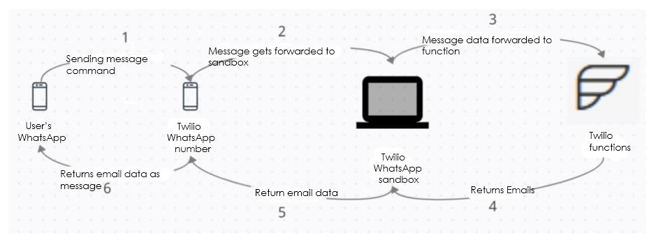

Fig 4.1

**5.RESULTS AND DISCUSSION**

**5.1 Set up sandbox in Twilio**

Setting up a sandbox in Twilio is a great way to test and prototype your messaging applications.

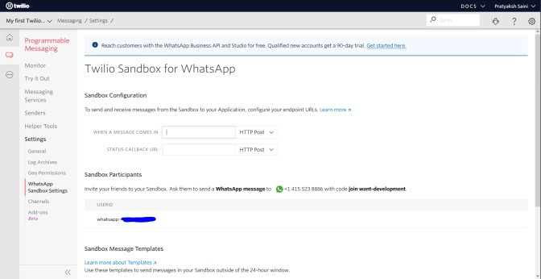

**Fig 5.1**

**5.2 Inside Twilio function creates New Service>-New Function**

To create a new service and function in Twilio, follow these steps:

**Log in to the Twilio Console:** Go to the Twilio Console and log in with your credentials.

**1.Create a New Service :**Navigate to the Services page or the Functions Overview page.Click on the Create Service button.Provide a name for your new service.

**2.Create a New Function:**After creating the service, you'll be redirected to the Functions Editor.Click on the Create Function button.Provide a name for your function and write your function code.Save and deploy your function.Your new function will be part of the service you created, and you can manage both from the Twilio Console.

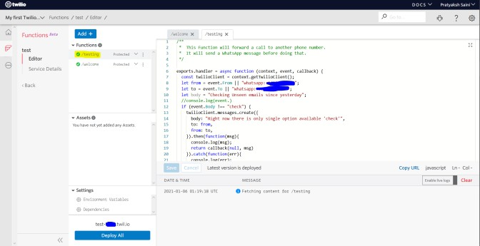

**Fig 5.2**

**5.3 Configure WhatsApp Sandbox with functions URL**

To configure your WhatsApp Sandbox with a Functions URL, here’s a step-by-step guide

Step 1: Deploy Your Function .Use the Twilio Serverless Toolkit to deploy your function.You’ll get a Functions URL upon deployment.

Step 2: Access Twilio Console.Navigate to the WhatsApp Sandbox Settings in your Twilio Console.

Step 3: Register Your WhatsApp Number.If not done already, register your WhatsApp number for testing purposes.

Step 4: Set the Function URL.In the Sandbox Configuration section, paste your Functions URL into the "WHEN A MESSAGE COMES IN" field.

Step 5: Save Configuration.Don’t forget to save your configuration to apply the changes.

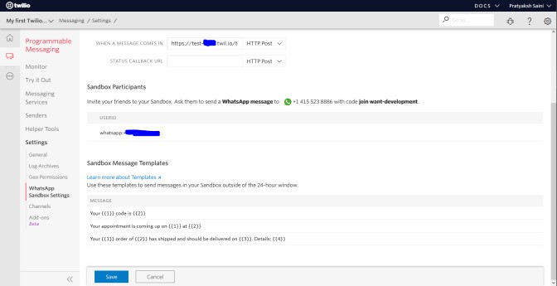

**Fig 5.3**

**5.4 Test it on WhatsApp**

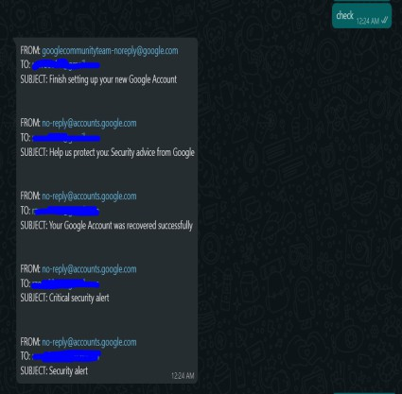

**Fig 5.4**

**6.CONCLUSION**

The Twilio Sandbox for WhatsApp is a pre-configured environment available through the Twilio Console in which you can prototype sending outbound messages, replying to incoming messages, and configuring things like message delivery callbacks. Twilio is not a free platform, it is a paid-service/platform. So, in order to use it more widelywe need topurchase the subscription.

**7.REFERENCES**

**Email Alerts on WhatsApp :**

https://www.crio.do/projects/javascript-whatsapp email-alerts/

**Twilio Docs for WhatsApp Automation** :https://www.twilio.com/docs/whatsapp/tutorial/send-whatsapp**-**notification-messages templates

**Parts of a Highly Converting Email – Analysis for Optimization by Nitin Deshdeep**

https://docs.python.org/3/library/imaplib.html

https://www.tutorialspoint.com/send-mail-from-your-gmail-account-using-python https://seaborn.pydata.org/generated/seaborn.countplot.html https://www.jetbrains.com/pycharm/download/ https://www.python.org/downloads/release/python-363/