**Machine Learning in Cybersecurity: Innovations in Threat**

**Detection and prevention**

Jalari Harshitha

3rd CSE

**ABSTRACT:**

In an increasingly digital world, cybersecurity is more critical than ever as cyber threats grow in complexity and frequency. Traditional methods of threat detection and prevention often fall short in addressing these sophisticated attacks. Machine Learning (ML) offers promising solutions by enabling more advanced threat detection through anomaly detection, predictive analytics, and automated identification of malware. ML models can analyze vast amounts of data, identifying patterns that might elude human analysts, thus providing real-time, adaptive security measures.Exploring the innovative applications of ML in cybersecurity, showcasing its potential to revolutionize the field. However, the integration of ML is not without challenges. Issues such as the quality and availability of data, vulnerability to adversarial attacks, and ethical concerns related to privacy present significant obstacles. Including case studies that demonstrate the practical application of ML in industrial settings, highlighting both successes and limitations.To fully harness the power of ML in cybersecurity, collaboration among stakeholders, including industry, academia, and government, is essential. By addressing current challenges and fostering continued innovation, ML can lead to more robust and adaptive cybersecurity systems, securing the digital future against evolving threats.

**Keywords*:*** *Cybersecurity,Machine Learning (ML),Data analysis,Real-time security,Data quality*

**Intoduction:**

As cyber threats grow in complexity and frequency, traditional cybersecurity methods are increasingly inadequate in addressing modern challenges. Machine Learning (ML) has emerged as a transformative solution, offering advanced capabilities in threat detection, anomaly identification, and malware prevention. ML algorithms can process vast amounts of data, uncovering patterns and behaviors that may elude human analysts, enabling real-time, adaptive security measures. However, the integration of ML into cybersecurity systems faces significant challenges, including data quality issues, vulnerability to adversarial attacks, and ethical concerns related to privacy. This paper explores the potential of ML in revolutionizing cybersecurity, highlighting its applications, advantages, limitations, and the need for collaboration across stakeholders to build more robust, resilient security systems against evolving threats.

**Literature Survey:**

This paper provides a comprehensive overview of the security challenges associated with the Internet of Things (IoT) and to explore machine learning (ML) solutions for enhancing IoT security intelligence. The study aims to review existing IoT security threats, vulnerabilities, and attack vectors, while examining how ML techniques can be applied to detect, prevent, and mitigate these risks in IoT networks. By focusing on the integration of ML with IoT security systems, the paper seeks to identify effective strategies for anomaly detection, intrusion detection, and threat prediction. Additionally, the paper aims to highlight current research gaps and future directions in the field of IoT security, including emerging trends in ML algorithms, edge computing, and the role of AI-driven solutions for proactive defense mechanisms.[1]

This paper provides review nature-inspired artificial intelligence (AI) and machine learning (ML) techniques and their applications in enhancing cybersecurity. The study aims to explore how algorithms inspired by biological systems—such as genetic algorithms, swarm intelligence, ant colony optimization, and neural networks—can be leveraged to solve complex cybersecurity problems. By examining their potential in areas such as threat detection, intrusion prevention, and system resilience, the paper seeks to demonstrate how these innovative, bio-inspired approaches offer unique advantages in tackling the dynamic and evolving nature of cyber threats. Additionally, the paper aims to identify challenges, limitations, and future research directions in the integration of nature-inspired AI and ML methods into cybersecurity frameworks.[2]

This paper propose a deep learning-based detection framework for identifying and mitigating cyber-attacks in Internet of Things (IoT) networks. The study aims to explore how advanced deep learning models, including convolutional neural networks (CNNs) and recurrent neural networks (RNNs), can be employed to detect malicious activities in IoT environments characterized by diverse devices and complex network topologies. By developing a distributed attack detection system, the paper seeks to enhance the scalability, accuracy, and real-time response of IoT security. Additionally, the paper aims to address the challenges of deploying deep learning in IoT security, such as data heterogeneity, computational constraints, and the need for effective threat classification in large-scale, dynamic IoT ecosystems.[3]

This paper provides survey the application of machine learning (ML) and deep learning (DL) techniques in intrusion detection and prevention for Internet of Things (IoT) networks. The study aims to explore various ML and DL models—such as decision trees, support vector machines, convolutional neural networks, and recurrent neural networks—highlighting their effectiveness in identifying and mitigating security threats in IoT environments. By examining current approaches and methodologies, the paper seeks to provide a comprehensive understanding of how these technologies can improve the accuracy, scalability, and adaptability of intrusion detection systems (IDS) in dynamic and resource-constrained IoT networks. Additionally, the paper addresses challenges related to data diversity, model training, and real-time detection, while outlining future research directions in IoT security through advanced machine and deep learning solutions.[4]

This paper explore the application of machine learning (ML) techniques in enhancing threat detection systems within cybersecurity frameworks. By examining current challenges and innovations, the study aims to demonstrate how ML can improve the identification and mitigation of advanced threats, such as zero-day attacks, malware, and sophisticated intrusions. The paper seeks to highlight the potential of machine learning to process large-scale data, recognize patterns, and adapt to emerging cyber threats in real-time, thereby contributing to the development of more proactive and efficient security measures in the digital landscape.[5]

This paper provides an in-depth analysis of the role of machine learning (ML) in enhancing cybersecurity practices. The study aims to review various ML techniques—such as supervised learning, unsupervised learning, and deep learning—and their applications in identifying, preventing, and mitigating cybersecurity threats. Additionally, the paper seeks to address the key challenges associated with integrating machine learning into cybersecurity systems, including issues related to data quality, model interpretability, adversarial attacks, and scalability. Ultimately, the goal is to provide a comprehensive understanding of both the potential and the limitations of ML in securing digital infrastructures.[6]

This paper explore the application of Deep Reinforcement Learning (DRL) in enhancing cybersecurity threat detection and protection mechanisms. The study aims to investigate how DRL, a subset of machine learning, can be leveraged to dynamically adapt to evolving cyber threats and provide real-time, autonomous decision-making capabilities for detecting and mitigating advanced security risks. By focusing on its potential for proactive threat defense, the paper seeks to evaluate the effectiveness of DRL in dealing with complex, adaptive, and often unseen attacks, while addressing challenges such as model convergence, computational overhead, and integration with existing cybersecurity infrastructure. The goal is to showcase the promise of DRL in shaping the future of adaptive, self-learning cybersecurity systems.[7]

This paper provides a comprehensive review of Artificial Intelligence (AI)-driven detection techniques and their impact on advancing cybersecurity. The study aims to critically examine various AI methodologies—such as machine learning, deep learning, and natural language processing—and their application in detecting and mitigating cyber threats. By reviewing the state-of-the-art in AI-powered security systems, the paper seeks to highlight the strengths and limitations of these technologies in real-world cybersecurity scenarios. Additionally, the paper aims to explore emerging trends, challenges, and future directions for AI in enhancing threat detection, response time, and overall system resilience against evolving cyber threats.[8]

This paper explores the role of neural network architectures in optimizing anomaly detection and prevention mechanisms within cybersecurity systems. The study aims to examine various neural network models—such as feedforward networks, convolutional neural networks (CNNs), and recurrent neural networks (RNNs)—and their effectiveness in identifying unusual patterns and potential threats in real-time. By investigating the design and application of these architectures, the paper seeks to highlight their potential in enhancing the accuracy, scalability, and adaptability of cybersecurity systems. Additionally, the paper aims to address the challenges of implementing neural networks for anomaly detection, including issues related to training data quality, model generalization, and computational efficiency.[9]

This paper is explains the impact of Artificial Intelligence (AI) and Machine Learning (ML) on enhancing organizational cybersecurity frameworks. The study aims to explore how AI and ML technologies are transforming the way organizations detect, prevent, and respond to cyber threats. By investigating both the benefits and challenges associated with integrating AI and ML into cybersecurity practices, the paper seeks to demonstrate their potential in improving threat intelligence, automating security tasks, and predicting emerging vulnerabilities. Additionally, the paper aims to address the implications for organizational cybersecurity strategy, including considerations of risk management, resource allocation, and the evolving landscape of cyber threats.[10]

This paper explores the application of evolutionary algorithms (EAs) in enhancing AI-driven cybersecurity solutions for adaptive threat mitigation. The authors aim to investigate how EAs, which are inspired by natural selection and evolutionary processes, can be used to develop more dynamic and adaptive security systems that continuously evolve in response to changing cyber threats. The paper focuses on integrating EAs with artificial intelligence (AI) to improve threat detection, prediction, and response mechanisms in cybersecurity, ensuring that security solutions can adapt to new and emerging attack strategies. The overall goal is to provide an innovative approach for improving the effectiveness and resilience of cybersecurity systems through the use of adaptive, self-optimizing algorithms.[11]

This paper explains the design and develop a deep learning-based model specifically for detecting anomalies in Internet of Things (IoT) networks. The authors aim to address the challenges of securing IoT networks, which are often vulnerable to a wide range of cyber threats due to their large-scale and heterogeneous nature. By utilizing deep learning techniques, the paper proposes a model that can automatically identify abnormal behaviors in IoT devices and communication patterns, which may indicate potential security breaches or malicious activities. The objective is to enhance the detection of both known and unknown threats in IoT environments, thereby improving the overall security and resilience of these networks.[12]

This paper proposes and evaluate a robust approach for detecting cyber attacks using Support Vector Machines (SVMs). The author aims to address the challenge of detecting both well-known (established) and previously unseen (novel) cyber threats by leveraging the ability of SVMs to classify complex data patterns. The paper focuses on developing a method that can effectively distinguish between normal and malicious behaviors, even in the face of new or evolving attack strategies. The goal is to enhance the reliability and accuracy of cyber attack detection systems, making them more resilient to a wide range of cyber threats, including those that may not have been encountered during the system's training phase.[13]

This paper explores how machine learning (ML) techniques can be applied to enhance both cybersecurity and cyber forensics. The authors aim to demonstrate how ML algorithms can be used to improve the detection and prevention of cyber threats (such as intrusions, malware, and phishing) as well as to support cyber forensics tasks, like investigating cybercrimes and tracing malicious activities. By leveraging ML's ability to identify patterns and anomalies in large datasets, the paper investigates the potential of machine learning to automate and improve decision-making in these critical areas, thereby making cybersecurity systems more effective, adaptive, and efficient in responding to emerging threats.[14]

This paper explores and demonstrate the application of deep reinforcement learning (DRL) techniques in addressing various challenges in the field of cybersecurity. Specifically, the authors aim to investigate how DRL can be used to improve defense strategies against cyber threats, optimize response systems, and enhance overall security performance by automating decision-making processes for security interventions. They also explore the potential benefits and limitations of applying DRL in cybersecurity domains, such as intrusion detection, malware defense, and automated response mechanisms, with the goal of making systems more adaptive and resilient to evolving threats.[15]

**Methodologies:**

**1)Identifing IOT Security Challenges:**

**1)Data Collection:** Gather data from IoT devices to identify various types of cybersecurity threats.Feature Engineering: Extract relevant features from the collected IoT data for threat detection and classification.**2)Supervised Learning:** For labeled threat data, using classifiers like Decision Trees or Support Vector Machines (SVM).Unsupervised Learning: For anomaly detection, using techniques like clustering (e.g., K-means).Deep Learning: Apply Convolutional Neural Networks (CNN) or Recurrent Neural Networks (RNN) for complex pattern recognition, especially useful for time-series IoT data.**3)Training and Validation:** Train the selected models on historical threat data and validate using cross-validation techniques.Deployment and Real-time Monitoring: Implement the models within the IoT environment for real-time threat detection and monitoring.**4)Continuous Learning:** Update models with new data for improved adaptability to emerging threats.

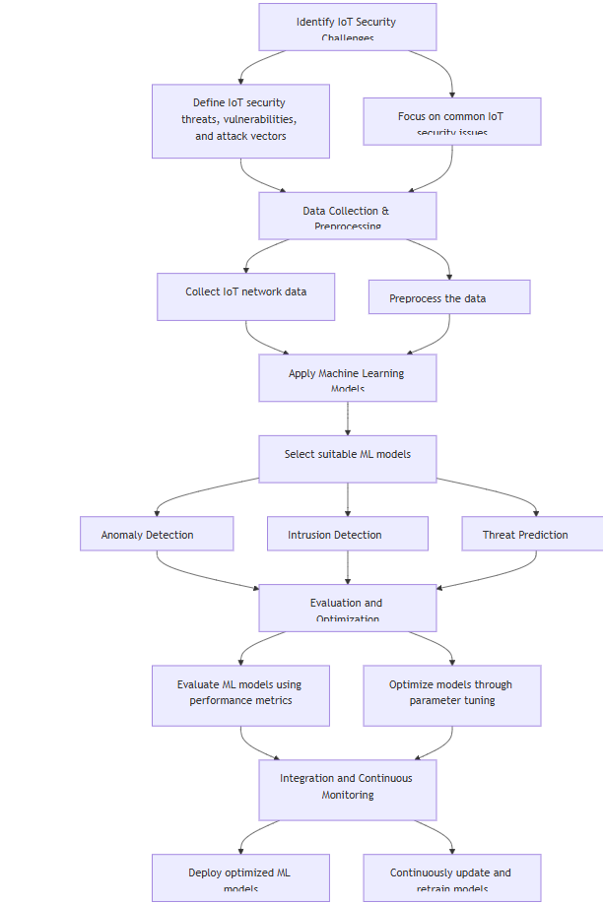

1. **Problem Identification**Define specific cybersecurity challenges (e.g., threat detection, intrusion prevention, system resilience).**Algorithm Selection:** Select appropriate nature-inspired algorithms based on the cybersecurity task and desired outcomes.**Data Collection & Preprocessing:** Collect cybersecurity data, such as logs, network activity, and known attack patterns. Preprocess the data (e.g., normalization, feature extraction) to make it suitable for algorithm processing.**Application of Nature-Inspired Algorithms**Implement chosen algorithms to model and analyze cybersecurity threats.

Tune parameters based on the data and specific requirements of the problem.

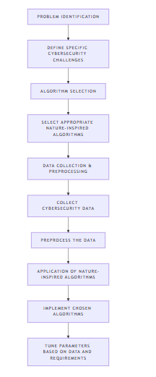

**3)Data Preprocessing with SVM:**

**1)Data Collection and Preparation:** Collect a diverse dataset of network traffic, including both normal and attack-related data. This data may come from open-source cybersecurity repositories or from in-house network monitoring logs.**2)Feature Extraction and Selection:** Extract relevant features from the network traffic data, such as packet size, frequency, source/destination IP, and protocol type.Use feature selection techniques to identify the most discriminative features, reducing dimensionality and improving model efficiency.**3)Data Preprocessing:** Normalize or standardize feature values to ensure that all features contribute equally to the model’s decision boundary.Use techniques like Principal Component Analysis (PCA) to reduce noise, especially for high-dimensional datasets with potentially redundant features.

**4)Model Training with SVM:** Train an SVM model on the labeled data using a kernel (typically, linear or Radial Basis Function (RBF)) suited to the dataset's distribution.Fine-tune SVM hyperparameters such as regularization (C) and kernel-specific parameters (e.g., gamma for RBF kernels) to optimize model performance.**5)Evaluation and Testing:** Evaluate the model using metrics like accuracy, precision, recall, and F1-score on a test set. Emphasis is often placed on recall to ensure the model identifies as many attacks as possible.**6)Deployment and Continuous Monitoring:** Deploy the trained SVM model within the network infrastructure to provide real-time or near-real-time monitoring of network traffic.Implement continuous learning to adapt the SVM model as new types of threats emerge, potentially using a combination of supervised and unsupervised learning techniques.

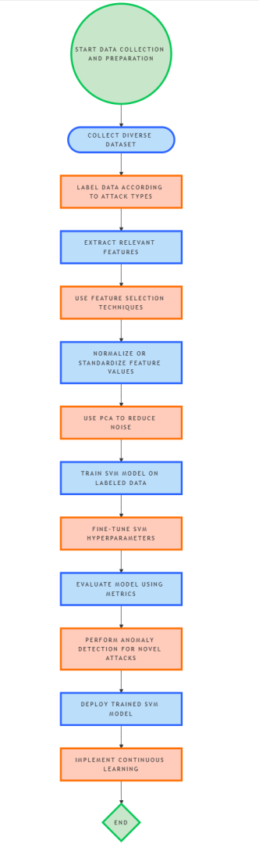

**Result and Discussions:**

The term paper discusses the application of Machine Learning (ML) in cybersecurity, emphasizing innovations in threat detection and prevention. Key results include:**Improved Threat Detection:** ML models can detect anomalies and predict cyber threats more effectively than traditional methods. They analyze large datasets, identifying complex patterns that may elude human analysts.**Real-Time Security:** ML systems can adapt to new threats in real-time, improving the speed and accuracy of threat response.**Effectiveness Across Domains:** Studies reviewed indicate that ML techniques, including deep learning and reinforcement learning, improve security in various domains like IoT networks and organizational cybersecurity.**Challenges Identified:** Challenges include data quality, vulnerability to adversarial attacks, and ethical concerns regarding data privacy.

|  |  |  |  |
| --- | --- | --- | --- |
| **Study** | **Method** | **Accuracy** | **F1Score** |
| [13] | Support Vector Machines (SVMs) | 85  85-95% | 0  0.85-0.93 |
| [3] | Convolutional Neural Networks (CNNs) | 90-  90-97% | 0.90 - 0.96 |
| [4] | Recurrent Neural Networks (RNNs) | 80-93% | 0.80 - 0.92 |
| [6] | Decision Trees | 75-85% | 00.0  0.75-0.83 |
| [3] | Deep Reinforcement Learning (DRL) | 90% | 0.85 - 0.90 |
| [9] | Genetic Algorithms | 75  75-90% | 0.78-0.88 |
| [12] | Autoencoders | 80-95% | 0.82 - 0.93 |

**Conclusion**Machine Learning has transformative potential in cybersecurity, particularly in automating threat detection and enabling real-time responses. Although the technology faces challenges, such as data limitations and privacy concerns, ongoing collaboration across sectors is crucial to addressing these issues. With further innovation and refinement, ML could provide robust, adaptive defenses against evolving cyber threats, securing digital environments more comprehensively.

**References:**

1. Giovani Apruzzese,pavel Laskov, Edgardo Montes de Oca, Wissam Mallouli,Luis Brdalo Rapa, Athanasios Vasileios Garmmatopoulos,Fabio Di Franco,Authors Info & Claims The role of mechine learing in cybersecurity(2023). Digit. Threat.: Res. Pract. 4, 1, Article 8 ,38 pages.
2. Sewak, M., Sahay, S.K. & Rathore, H. Deep Reinforcement Learning in the Advanced Cybersecurity Threat Detection and Protection.(2023). *Inf Syst Front* **25**, 589–611 .
3. Sarker, I.H., Khan, A.I., Abushark, Y.B. *et al.* Internet of Things (IoT) Security Intelligence: A Comprehensive Overview, Machine Learning Solutions and Research Directions. (2023). *Mobile Netw Appl* **28**, 296–312 .
4. Nijim, M., Goyal, A., Mishra, A., Hicks, D. A Review of Nature-Inspired Artificial Intelligence and Machine Learning Methods for Cybersecurity Applications. In: Shandilya, S.K., Wagner, N., Gupta, V., Nagar, A.K. (eds) Advances in Nature-Inspired Cyber Security and Resilience. EAI/Springer Innovations in Communication and Computing. Springer, Cham.
5. Jullian, O., Otero, B., Rodriguez, E. *et al.* Deep-Learning Based Detection for Cyber-Attacks in IoT Networks(2023): A Distributed Attack Detection Framework. *J Netw Syst Manage* **31**, 33.
6. P. L. S. Jayalaxmi, R. Saha, G. Kumar, M. Conti and T. -H. Kim, "Machine and Deep Learning Solutions for Intrusion Detection and Prevention in IoTs: A Survey," in *IEEE Access*,(2022).vol. 10, pp. 121173-121192.
7. Sewak, M., Sahay, S.K. & Rathore, H. Deep Reinforcement Learning in the Advanced Cybersecurity Threat Detection and Protection. Inf Syst Front 25, 589–611 (2023). https://doi.org/10.1007/s10796-022-10333-x
8. Salem, A. H., Azzam, S. M., Emam, O. E., & Abohany, A. A. (2024). Advancing cybersecurity: a comprehensive review of AI-driven detection techniques. Journal of Big Data, 11(1), 105.
9. Maddireddy, B. R., & Maddireddy, B. R. (2024). Neural Network Architectures in Cybersecurity: Optimizing Anomaly Detection and Prevention. International Journal of Advanced Engineering Technologies and Innovations, 1(2), 238-266.

[10]Abdulhussein, M. (2024). The Impact of Artificial Intelligence and Machine Learning on

Organizations Cybersecurity. Liberty University.[11]Maddireddy, B. R., & Maddireddy, B. R. (2021). Evolutionary Algorithms in AI-Driven

Cybersecurity Solutions for Adaptive Threat Mitigation. International Journal of Advanced

Engineering Technologies and Innovations, 1(2), 17-43.

[12]Ullah and Q. H. Mahmoud, "Design and Development of a Deep Learning-Based Model for

Anomaly Detection in IoT Networks," in IEEE Access, vol. 9, pp. 103906-103926, 2021, doi:

10.1109/ACCESS.2021[13]Selvan, M. A. (2021). Robust Cyber Attack Detection with Support Vector Machines: Tackling

Both Established and Novel Threats.[14]Goni, I., Gumpy, J. M., Maigari, T. U., Muhammad, M., & Saidu, A. (2020). Cybersecurity and

cyber forensics: machine learning approach. Machine Learning Research, 5(4), 46-50.[15]Nguyen, T. T., & Reddi, V. J. (2021). Deep reinforcement learning for cyber security. IEEE

Transactions on Neural Networks and Learning Systems, 34(8), 3779-3795.