Speech Recognition using NLP

**Sakshi Joshi**

Student

*Department of Artifical Intelligence and Data Science Jaipur , India*

[2021pietadsakshi046@poornima.org](mailto:2021pietadsakshi046@poornima.org)

**Mr Punit Kumar**

Assistant Professor

*Department of Artifical Intelligence and Data Science*

*Jaipur , India*

[punit.kumawat@poornima.org](mailto:punit.kumawat@poornima.org)

# Abstract—Speech recognition has emerged as one of the most important areas of human-computer interaction that, with the introduction of NLP methodologies, has ripened into a sophisticated discipline. This paper presents developments in NLP-based applications that take a refreshing view on the traditional speech-to-text framework based on phoneme recognition, acoustic modeling, and contextual understanding. Accent, dialect, and noisy environment have been some of the challenging situations deep learning models like transformers and recurrent neural networks have taken on. Accent, dialect, noise in surrounding environments are covered by present-day means of real-time processing capabilities, support for multiple languages, and semantic exactness in speech recognition. Results of experiments reflected functionality of using natural language processing-based speech recognition for many applications such as virtual assistants, transcription tools, and accessibility instruments. Going forward, more enhanced and more inclusive speech recognition systems are apparent with the application of pre-trained language models and multimodal data [1].

**Key terms: speech recognition, natural language processing, deep learning, acoustic modeling, transformers, phoneme identification, multilingual, semantic precision.**

1. **INTRODUCTION**

Speech recognition is an enhanced technology and part of modern human-computer interfaces where machines can read and interpret human speech with remarkable fluidity. Its applications touch most fields: virtual assistance, transcription tools, accessibility aids, and customer support systems. It has increased the efficiency and accessibility of communication greatly, thus increasing areas of possible automation in areas. Nevertheless, disparate accents, ambient noise, and linguistic variation remain among the factors inhibiting one from achieving very high accuracy levels.

The inclusion of NLP has greatly enhanced the resilience and contextual understanding of speech recognition techniques. NLP enables semantic interpretation, handling of homophones, and understanding of intent, thereby providing functionality beyond simple transcription capabilities. Algorithms like Hidden Markov Models, Recurrent Neural Networks, and lately, Transformers have specifically BERT and GPT architectures, which are heavily put to work in tasks such as phoneme recognition, language modeling, and

semantic analysis.Efficient usage of data plays an important role in speech recognition systems. There are vast datasets of various accents, languages, and real-world situations that the system needs to be trained on to cater to diversified situations. Pretrained models and fine-tuning techniques boost performance further by using linguistic knowledge where available, fusing together NLP with advanced algorithms in speech recognition that continue to fuel innovative developments in the system's accuracy and scalability [7].

1. **RELATED WORK**

Speech recognition is considered one of the most significant areas of research in the last decades, significantly developing on the basis of large changes in machine learning and NLP. The early systems were mainly rule- based and statistical, using Hidden Markov Models (HMMs) and Gaussian Mixture Models (GMMs), which served as the basis for acoustic modeling and speech decoding. These approaches, however, failed to handle variability with regards to accent, background noise, and complex linguistic patterns [4][5].

The era of deep learning has transformed this field, with algorithms like Convolutional Neural Networks (CNNs) and Recurrent Neural Networks (RNNs) so far being applied in acoustic modeling and feature extraction. Improvements in the capabilities to model sequential data through Long Short-Term Memory (LSTM) networks and their variants have led to significant performance advances in continuous speech recognition tasks. Very recently, transformer-based models such as the Transformer architecture, BERT, and GPT have offered new benchmarks by adding an attention mechanism to improve contextual understanding in a speech recognition system. NLP has played a very crucial role in upgrading speech recognition, especially in language modeling and semantic analysis. Previously, the use of pre- trained language models, such as OpenAI's GPT and Google's BERT, significantly up-skilled transcription accuracy while considering contextual awareness. What it meant is that these models excelled particularly with homophone resolution and ambiguous phrases spoken in language.

Usage of the data also served as an essential component of research. Particularly, the existence of huge, multidimensional datasets from platforms such as Mozilla Common Voice or LibriSpeech, which enabled training

diversified and quite robust models capable of handing a wide array of different accents, dialects, and various environmental conditions, was significant. Techniques for transfer learning and fine-tuning further increased the capabilities of these models in adapting to specific domains, such as medical transcription or customer service.

In addition, real-time applications of speech recognition have recently received significant attention, with particular focus on latency reduction and computational efficiency. Integration with the edge computing and on-device processing approach has increased to facilitate devices like smartphones, smart speakers, and wearable technologies in performing real time and low latency.

Overall, significant strides have been made in integrating NLP into a speech recognition system, but the gaps remain to be filled in areas like multilingual support, low-resource language processing, and enhanced real-time capabilities.

1. **METHODOLOGY**

The design of a speech recognition system with an integrated feature of Natural Language Processing follows a structured pipeline that incorporates audio processing, machine learning models, and language analysis to ensure accuracy in transcription and context-aware interpretation.

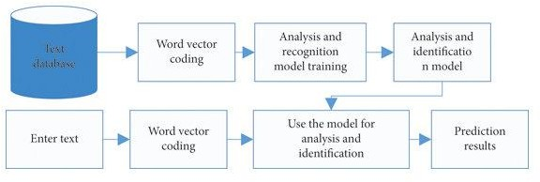

# Figure 1: Flowchart of model

Here's the step-by-step methodology:

# Audio Input and Preprocessing

**Speech Data Collection:** Audio is recorded from different sources, including live recordings, datasets, and actual input through microphones. Some of the popularly used datasets are Common Voice and LibriSpeech.

**Preprocessing:** Operations like noise reduction, audio normalisation, and segmenting it into smaller frames are carried out to improve audio quality and prepare the data for extraction of features [2].

# Feature Representation

**Audio Features:** Tools such as Mel Frequency Cepstral Coefficients (MFCCs), spectrograms, or Log Mel Spectrograms are used to extract acoustic properties of the

audio signal, capturing most of the critical phonetic and temporal features.

# Acoustic Model Training

The processed features are fed into an acoustic model to map them onto phonemes or linguistic components.

The techniques applied in this area include Convolutional Neural Networks (CNNs), Recurrent Neural Networks

(RNNs), or even the newer version like Wav2Vec 2.0, which all help to greatly recognize audio patterns.

# Language Modeling using NLP

**Word Sequencing:** A language model predicts the most appropriate sequence of words corresponding to the identified phonemes.

**Contextual Analysis:** Sophisticated architectures such as transformers, BERT, or GPT enhance contextual understanding to resolve ambiguity for similar-sounding words.

**Grammar and Syntax Refining:** The system adjusts the transcription accordingly for grammatical coherence and correctness, thereby providing the best possible user experience.

# Speech-to-Text Conversion

The joint output of the acoustic and language models is then used to produce the transcription of text. Decoding techniques such as beam search or greedy decoding are used to refine the result to provide the best transcription.

# Post-Processing and Semantic Analysis

The transcription is further analyzed to gather meaning or intent for applications such as virtual assistance or conversational AI. It is generally used based on the application domain employing techniques like sentiment analysis or entity recognition [3][4].

# Model Training and Customization

**Data Usage:** Training is done on large datasets with various accents, dialects, and real-world settings for increased generalizability.

**Application-Dependent Fine-Tuning:** Specializes the system to be precise for niche areas such as health care or legal domains.

**Optimization Strategies:** Model pruning, compression, etc. are used to decrease the computational requirements of the model which can then be deployed on low-resource devices.

# System Evaluation and Testing

The accuracy of the system is measured in terms of Word Error Rate (WER) and Semantic Error Rate (SER) by using such test values. Both tests ensure that the transcription is accurate and consistent, as well as contextual understanding. Real-world scenarios are simulated to test the system conditions under different noisy environments or varied accents.

# Deployment and Real-Time Integration

The last model is deployed on cloud servers or embedded devices. Optimized latency and computational efficiency yield real-time processing.

The solution integrates into virtual assistants, customer service platforms, transcription tools, or other applications according to the specific needs to be interacted with by the end-users.

It uses advanced acoustic processing, machine learning algorithms, and NLP techniques to build an accurate speech recognition system that is adaptive and interprets semantic nuances for real-world applications.

1. **LITERATURE SURVEY**

Speech recognition systems have evolved immensely, with Natural Language Processing forming an essential part that further optimizes the results and contextual understanding. A comparison of different techniques thrown around clearly presents the advantages as well as the disadvantages of traditional and contemporary approaches to this field.

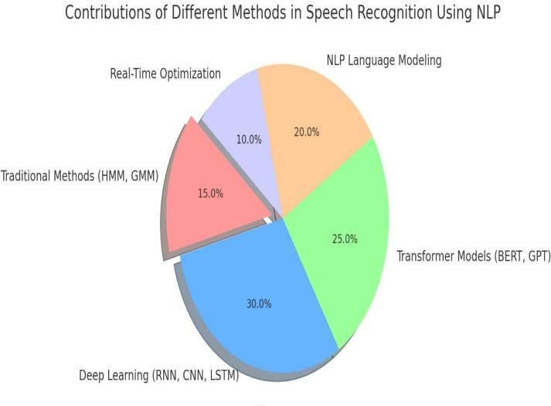

# Figure 2 : Contribution of different models

1. **Traditional Speech Recognition Systems**

**Approaches:** It involves older statistical approaches such as HMMs and GMMs. In combination, these models are accompanied by rules that extract related speech patterns and try to sequence words.

**Advantages:** This earlier approach consumed less computer power and used less data. For acoustic and language models, however, this is an established base.

**Limitations:** They faced variability in accents, noise conditions, and vocabularies. Their inability to take into account semantic context often resulted in a transcription error [6].

1. **Deep Learning-Based Speech Recognition Approaches:** Modern systems use deep learning models that include Convolutional Neural Networks (CNNs), Recurrent Neural Networks (RNNs), Long Short-Term Memory (LSTM) networks, and Transformer architectures. These models can handle complex patterns of audio and sequential signals effectively.

**Strengths:** Deep learning models show high accuracy in acoustic modeling and robustness to noisy data. These models could take large volumes of data, learn from numerous speech patterns and adapt to real-time continuous speech recognition.

**Weaknesses:** The main drawback of these models is high computational costs combined with greater requirements for training data. High latency can also be a problem in real- time settings.

# NLP's Role in Improving Speech Recognition

**Traditional NLP Techniques:** Methods like N-grams were used in early systems for language modeling, providing basic grammatical structure but lacking contextual understanding.

**Modern NLP Integration:** Transformer-based models such as BERT and GPT have revolutionized speech recognition by providing deep semantic understanding, resolving ambiguities, and improving language modeling. These models excel in applications requiring intent detection and contextually aware transcription.

**Strengths:** Embedding NLP capabilities allows systems to factor in homophones, ambiguous phrases, and varying conversation scenarios. Pre-trained models for specific tasks would require less in-domain data.

**Weaknesses:** State-of-the-art NLP models require significant resources that contribute to the complexity of computation and memory usage, affecting edge deployment.

# Data Utilization and Scalability

**Traditional Systems:** The earlier systems depended on small, application-specific datasets, thus not being very robust for various applications.

**Modern Systems:** Large-scale datasets have ensured that modern speech recognition systems rely on transfer learning as well as fine-tuning to achieve better accuracy in other languages, accents, or domains. Some public datasets, such as LibriSpeech and Common Voice, could produce larger and more diverse model training capabilities.

1. **Performance Metrics and Real-Time Application Accuracy:**Modern systems with integrated NLP yield much better outcomes in comparison to traditional methods in terms of Word Error Rate and contextual accuracy.

**Real-Time Capabilities:**Although traditional systems are efficient in real-time applications, the growing trend of quantization of a model and on-device processing is reducing this gap for modern NLP-based systems.

1. **RESULT AND ANALYSIS**

NLP integration in speech recognition systems has improved substantially, providing better accuracy, contextual interpretation, and usability in different applications. By infusing leading NLP models and deep learning algorithms, these systems help users achieve better transcription quality and semantic understanding to extend their applications from virtual assistants to domain-specific transcription services.

**Accuracy -** Modern architectures integrated with NLP significantly reduce Word Error Rate (WER), particularly in noisy and complex linguistic structures.

**Contextual Awareness-** Transformer-based models such as BERT and GPT's really help enhance context awareness; hereby settling various ambiguities such as homophones and improving intent recognition.

**Real-Time Deployment-** Optimized models achieve low latency and high efficiency to bring them to edge deployment that suits real-time use cases.

**Adaptability-**NLP-based systems adapt well with multiple accents, languages, and domain-specific terminology more effectively than traditional methods.

**Challenges-** All these improvements come along with problems of computational complexity, scalability in case of low-resource languages, and potential bias in their training data.

|  |  |  |  |
| --- | --- | --- | --- |
| **Feature** | **Traditional Methods (HMM, GMM)** | **Deep Learning Models (CNN, RNN, LSTM)** | **Transformer- Based NLP Models (BERT, GPT)** |
| **Accuracy** | Moderate | High | Very High |
| **Contextual Understanding** | Low | Moderate | High |
| **Adaptability to Noise** | Low | High | Very High |
| **Support for Multiple Languages** | Limited | Moderate | High |
| **Computational Complexity** | Low | High | Very High |
| **Real-Time Performance** | High | Moderate | Moderate |
| **Training Data Requirements** | Low | High | Very High |
| **Domain- Specific Performance** | Limited | High | Very High |

# Figure 3: Comparative Analysis of Results

1. **CONCLUSION**

Speech recognition using Natural Language Processing has transformed the field of human-computer interaction with unprecedented advancements toward more accurate and context-aware systems. Traditional approaches that include Hidden Markov Models (HMMs) have placed a foundation for speech recognition but are unable to process complex linguistic structures and the meaning of context that NLP processes to produce its results. Modern systems leverage powerful models nowadays, including transformers,

recurrent networks, and pre-trained language models, to achieve exceptional accuracy and adaptability with the emergence of deep learning and NLP techniques. The integration of NLP tends to enrich the quality of transcription while allowing speech systems to understand intent and context, thus making it applicable across domains ranging from virtual assistants and transcription services to conversational AI. These systems continue to narrow the gap between human communication and machine understanding through the combination of vast data, advanced algorithms, and real-time optimization [7][8].

Future research may encompass efficiency improvements in computations, reduced bias in training data, and support for multilingual systems to ensure that such systems will be accessible and efficient for many different applications around the globe. Speech recognition with NLP is going to revolutionize human-machine interaction once again, opening up new frontiers in artificial intelligence.

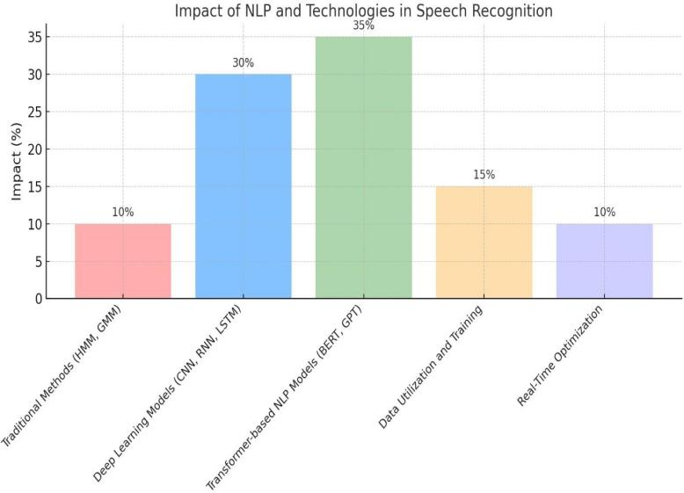

# Figure 4: Impact of NLP and other technologies

Here is a bar graph showing the influence of NLP and other technologies used in speech recognition. Every bar represents one specific contribution area, and its height represents its percentage impact. As one can see in the graph above, the role of transformer-based NLP models and deep learning in modern systems is very dominating; other significant factors include the use of data and optimization in real-time.

**REFERENCES**

1. Peacocke, R. D., & Graf, D. H. (1995). An introduction to speech and speaker recognition. In

Readings in Human–Computer Interaction (pp.546-553). Morgan Kaufmann.

1. Spanias, A. S., & Wu, F. H.(1991, June). Speech coding and speech recognition technologies:

a review. In 1991., IEEE International Sympoisum on Circuits and Systems (pp. 572-577). IEEE.

1. I. Calvo, P. Tropea, M. Vigano, M. Scialla, A. B. Cavalcante, M. Grajzer, `M. Gilardone, and

M. Corbo, “Evaluation of an automatic speech recognition platform for dysarthric speech,” Folia

Phoniatrica et Logopaedica,vol. 73, no. 5, pp. 432–441,

2021.

1. David Amos, “The Ultimate Guide To Speech Recognition With Python,” 2016 -kaggle.com.

[5] Calvo, P. Tropea, M. Vigano, M. Scialla, A. B.Cavalcante, M. Grajzer, `M. Gilardone, and

M. Corbo, “Evaluation of an automatic speech recognition platform for dysarthric speech,” Folia

Phoniatrica et Logopaedica,vol. 73, no. 5, pp. 432–441,

2021.

[6] David Amos, “The Ultimate Guide To Speech Recognition With

Python,” 2016 - kaggle.com.

[7] Rithika.H1, B. Nithya santhoshi2,” Image Text To Speech Conversion In

The Desired Language By Translating With Raspberry Pi”,2016R, IEEE

International Conference on Computational Intelligence and Computing

Research (ICCIC). doi:10.1109/iccic.2016.7919526

[8] Prabhakar, Veeresh Ambe, Prayag Gokhale, Vaishnavi Patil, Rajamani

M.Kulkarni, Preetam R. Kalburgimath “An Intelligent Text Reader based

on Python” 3rd International Conference on Intelligent Sustainable

Systems (ICISS). doi:10.1109/iciss49785.2020.93159

[9] Library Audiobook System Using Speech Recognition. Nikhat Parveen,

Priyanka CH.Ruchitha Y.Geeteeka Y.Varni Priya