**Should we refer to language as a mere system of symbols?**

**Anhad Srivastava**

School of Computer Science and Engineering

Vellore Institute of Technology, Vellore-632014, Tamil Nadu, S. India

**Prof. G. Anburaj**

Assistant Professor of English

VIT, Vellore-632014, Tamil Nadu, S. India anburaj.g@vit.ac.in

**Abstract:**

This paper explores whether language should be understood as a mere system of symbols or if it has a broader role in human communication, encompassing social, cultural, emotional, and cognitive dimensions. The research is based on the problem statement "Limited View of Language" and it delves into how language is not just symbolic representation. The study is based on a survey of university participants and the perceptions of language and its uses, asking whether language is simply a symbolic tool or a complex form of communication and expression. It turns out that all of us believe that language is not simply a vehicle for carrying information but a living, evolving "thing" used to forge friendships, to express emotions, for cultural contact. The paper does call for more research in the future on the cognitive and cultural aspects of language, but then again, everything does nowadays since language is realizing how complex it is. This contradicts the old belief that language is a "sign system", and instead lends itself to a more holistic theory of language as a force that molds and is molded by the human experience.

**Keywords:**

Language, Symbols, Communication, Cultural Identity, Cognitive Linguistics, Non-verbal Communication, Social Interaction.

**Problem Statements:**

Problem Statement 1: Limited View of Language

To say language is a symbolic system is an understatement that takes away the complexity of language and its social, cultural, and emotional uses. This short-sighted view often fails to acknowledge the concept that language is not just a tool used for communication, but is the foundation by which humans build relationships, find their identity and express their feelings. How does this narrow focus impact linguistic research and our knowledge of the human language.

Problem Statement 2: Context and Interpretation

Language is so reliant on context and tone and all the things around it for meaning. However, to merely focus on symbols neglects the way in which these aspects play a role in communication, particularly in the area of interpersonal communication, because meaning comes from so much more than the words themselves.

Problem Statement 3: Non-verbal Communication

Body language, facial expressions, and gestures, the three most important aspects of nonverbal communication. The symbolic view is to narrow minded because it misses these points and cannot explain how humans are able to express meanings so far beyond the literal meaning of the words.

Problem Statement 4: Emotional and Cultural Expression

Language is a medium of expression of emotion, and of a culture. To reduce it to nothing more than a system of symbols is to deny its function as a vehicle for the communication of emotion, as a means of passing on cultural traditions, as a means of expressing individual and societal identity.

Problem Statement 5: Cognitive Limitations

Language is not only a medium of communication but also effects thought processes and cognition. To study language only symbolically, is to deny the cognitive and neural complexity of the human ability to process, understand, and create language.

Problem statement chosen for our study is problem statement 1 that is limited view of language.

**Introduction:**

Language is usually defined as a system of symbols (letters and sounds) that humans use to transmit information. But that definition barely touches the nature of language. Of course, language is a tool used to transmit information through symbols, but to define it in that way alone is to deny its broader function in the construction of human interaction, emotion, identity, and thought. Should we refer to language as merely a system of symbols? This question forms the foundation of this paper, as we argue that language extends far beyond the confines of a symbolic system. It is a living, breathing entity, which of course is directly connected to the human experience.

Background Study:

According to Saussure, language consists of signs made up of two parts: the **signifier** (the form of the word or phrase) and the **signified** (the concept it represents). This approach provided the groundwork for much of modern linguistics, which focused on the symbolic nature of language.

But as linguistics has grown so has the notion that this symbolic view is the whole story. Cognitive linguists and sociolinguists have been arguing for years that language is not merely a symbolic system, but is in fact, an integral part of the way we think and interact and relate to one another. As these more holistic theories of language have come to the forefront, language's part in human communication has been up for reevaluation, and the spotlight has shifted to language's cultural, emotional, cognitive dimensions.

Explanation of Research Problems:

Limited View of language," where it discusses how if one regards language as nothing more than a system of symbols, one cannot possibly hope to understand all what a language can do. While the other problem statements—contextual interpretation, non-verbal communication, emotional and cultural expression, and cognitive limitations—are certainly relevant, they all stem from this fundamental issue. By pushing the symbolic approach to its limits, we set the stage for a much broader theory of language and its function within the human communication process.

Reasons and Goals:

This research is mainly intended to show how the treatment of language as a symbolic system leaves out many other aspects of language. Through these constraints we wish to expand the field of linguistics and hopefully promote further research which is more wholistic in its approach to language. In particular, this study aims to highlight the importance of social, cultural, and emotional factors in shaping how we use and understand language.

Justification for Problem Statement Selection:

The first Problem Statement is being used because it seems as though much of linguistic research has focused on the symbolic aspect of language, sometimes at the cost of its other uses. Of course, many of these issues have been explored in depth in sociolinguistics and discourse analysis, like problem statement 2-contextual interpretation- or problem statement 3-non-verbal communication- but the overall issue of language being more than symbolic has not been as much of a topic. This study is intended to fill this gap, and it takes a look at language from the limited vantage point of language as a symbolic system, and it sets the stage for future research on how language functions in different social, cultural, and cognitive settings.

**Literature Review:**

Now that we've asked the question of language being just a system of symbols so many classical and contemporary theories illuminate the complexities of language. Structuralist theories, as first defined by Ferdinand de Saussure in his work, Course in General Linguistics (1916), provided the foundation for the belief that language is a system of arbitrary signs, where the signifier (sound or word) is connected to the signified (concept) only by convention. Saussure's work, however, presented language as a closed, structured system, and focused very much on the symbolic nature of language and not at all on social, cultural, and contextual influences. This view, although groundbreaking in early 20th century linguistics, has been heavily criticized for its inability to account for the many aspects of language used in human communication.

Noam Chomsky's Universal Grammar (1957) expanded structuralism in that it concentrated on the syntactical rules that are common to all languages. Chomsky theorized that humans are endowed with a linguistic faculty, which enables them to learn language from a finite number of grammatical constructs. While Chomsky’s work highlighted the cognitive dimensions of language, it remained largely focused on formal structures and syntax, reinforcing the idea of language as a symbolic system. However, Chomsky's theory has been criticized for neglecting the social and cultural environments in which language operates, and for disregarding the role of nonverbal communication, emotional expression, and cultural identity in language use.

George Lakoff and Mark Johnson's (1980) groundbreaking work, Metaphors We Live By, challenged the dominant symbolic view of language as they proposed the theory of conceptual metaphors. They claim that metaphors are not simply a part of language but are a fundamental part of the way humans perceive and make sense of the world. Lakoff and Johnson say that language is not just a symbolic system, but that language actually shows the metaphorical structures of human thought, and so language is a device that makes reality what it is for us. This cognitive-linguistic standpoint enables the study of language to transcend formal structures and to demonstrate language as being grounded in the physical experiences and cultural realities of the users of that language.

Repetition, Dialogue, and Imagery in Conversational Discourse, looks at the way in which language is used in everyday conversations, especially those that are more casual. Tannen talks about repetition and intonation and imagery, and how these things are used in every-day language, and how communication is not always based on symbolic meaning. Her work definitely shows how language is not simply symbolic, because it creates relationships, and it expresses feelings, and it expresses cultural identity.

Benjamin Whorf, in his linguistic relativity hypothesis from his book Language, Thought, and Reality (1956), also talks about how culture affects language. I'm referring to Whorf's theory of linguistic determinism, which is basically saying that the structure of a language will determine how its speakers see the world. This theory suggests that language shapes not only how people communicate but also how they think and perceive the world. Whorf's work contests the symbolic view because it asserts that language and cognition and culture are all so intricately related that without considering these broader influences, language can never be understood.

Joshua Fishman's work on language maintenance and language shift (1991) too, emphasizes the cultural aspects of language. Fishman is interested in the process of minority languages being maintained or extinguished through time, illustrating the fact that language is an integral aspect of one’s culture and background. And work, his work shows that language is not just a symbolic system used for communication, but a tool used to express cultural values, traditions, and to build a sense of community.

Steven Pinker, in his book The Stuff of Thought (2007), offers another cognitive perspective by arguing that language is not just a vehicle for conveying thoughts but also a window into the nature of human cognition. Pinker says that the way language is formed gives us hints about people’s perception of time and space, causality, and relationships. His work expands the discussion on language by connecting linguistic structures to cognitive processes, illustrating that language functions as both a cognitive tool and a cultural artifact.

An Ethnographic Approach (1974). Hymes contended that language cannot be examined merely from the standpoint of its formal structures, but that one must also examine the social rules that govern the use of this language. He argued that language is used to negotiate social roles and identities and relationships, and he stressed that the meaning of language is defined by the social and cultural contexts in which it occurs.

Forms of Talk (1981) by Erving Goffman is another sociological perspective on language. In language, Goffman examines how people use language in forms of communication, whether it is conversation, oration, or written word. His work is on the performativity of language, how speakers change their language according to the social norms, the roles they are playing and the scene of the interaction. Goffman's analysis shows that language is not just symbolic but is grounded in social interaction, and meaning is created between speaker and listener.

Lastly, Albert Mehrabian's research on nonverbal communication in Silent Messages (1981) proves that body language, facial expressions, and tone of voice are 35%, 55%, and 7% of communication respectively, compared to actual words. Because, according to Mehrabian, as much as 93% of the effectiveness of communication is nonverbal, and a strict symbolic theory of language does not account for that. His research disputes the notion that language is limited to words and symbols and proves that communication is a multimodal process, involving both verbal and nonverbal channels.

The writings that are studied in here vary from everything under the sun, and none of them is that language is simply a symbolic system. From the structural and cognitive approaches of Saussure and Chomsky to Lakoff, Tannen, and Whorf and their examinations of metaphor, culture, and cognition, it seems that language functions on many levels. It is not simply symbolic words but a living media to convey social relationships, cultural values, and cognitive processes. The research in nonverbal communication and especially sociolinguistics both emphasize even more that language cannot just be viewed as symbols, but must be analyzed in the entire social, cultural, and emotional context in which it is used.

**Methodology:**

This study uses a survey as its research method with university students as the subjects. The survey consisted of 10 structured questions, designed to assess participants’ perceptions of language and its functions. All the questions were in a multiple-choice format and the responses were graphed into pie charts to show any patterns in the reception of language. The survey results were visualized in the attached PDF, providing a clear representation of how participants view language in relation to its symbolic and broader social, cultural, and emotional roles【31†source】. This quantitative approach allowed for a structured analysis of how language is perceived among a specific population, offering insights into the broader debate surrounding the symbolic interpretation of language.

**Result Analysis:**

The survey results revealed several key findings. Notably, 40% of respondents viewed language as a tool for forming connections, while 48% emphasized its role in emotional expression. These answers all suggest that an overwhelming percentage of respondents do not consider language to be merely a symbolic system, but rather a vehicle for social interaction and emotional expression.

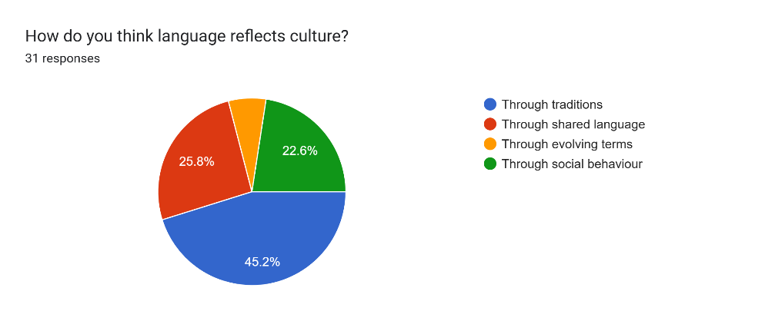

In contrast, 25% of respondents still adhered to a more traditional view of language as a means of sharing thoughts. This agrees with the symbolic theory of language in that although the symbolic view is still there, it is not the overall consensus among the participants tested.

This survey also delved into the opinions of the test subject on nonverbal communication and context. 41% of respondents indicated that context significantly influences the meaning of language, and 33% highlighted the importance of non-verbal cues. This would imply that the participants understand intuitively that language is not just a matter of symbols, but that meaning is very much derived from the situation and non-verbal cues.

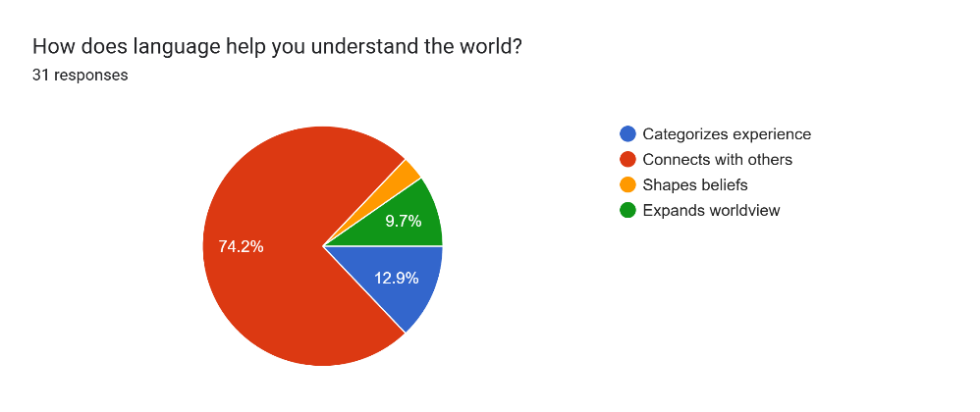

**Unexpected Findings:**

One unexpected finding was the relatively high percentage of participants who still viewed language primarily as a system for sharing thoughts (25%. This implies that although there is an increasing awareness of language's multiple purposes, the symbolic conception is still rooted in some educational or cultural structures. Additionally, the survey revealed that only 18% of participants viewed language as a means of preserving cultural traditions, indicating that the role of language in cultural identity may not be as widely recognized as its social and emotional functions.

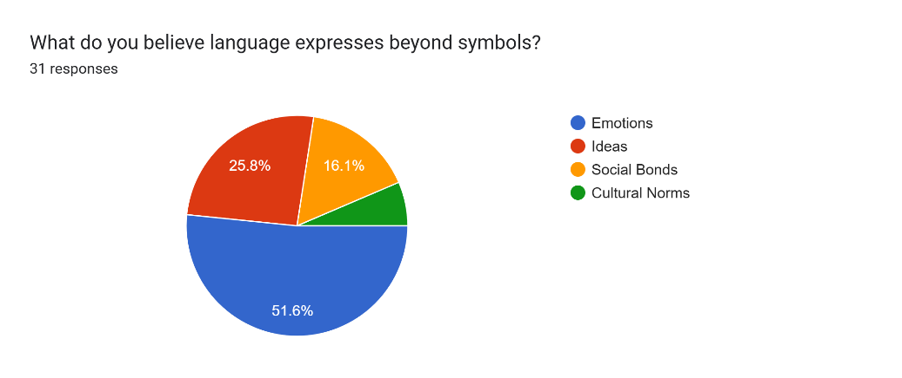

**Scope for Further Research:**

There are several areas for future research based on the findings of this study. The first would be more research on the cognitive aspects of language, specifically how language relates to neuro processes. The second is cross-cultural studies to examine how various linguistic communities conceive of language especially with respect to its symbolic and non-symbolic use. Lastly, more studies need to be done on how language changes as a result of technological and social change, especially in digital communication.

**Conclusion:**

This research shows that although the symbolic view of language continues to exist, it cannot account for the entire spectrum of purposes that language fulfills in human communication. The information from the survey definitely backs up this theory that language is not a stagnant, unchanging tool used merely for social interaction and emotional expression, but also a tool for cultural exchange. But future research should definitely further the investigations into the non-symbolic aspects of language, especially with respect to cognition and culture in order to give a more complete picture of how language functions in the human experience.

**References:**

* Saussure, F. de. (1916). **Course in General Linguistics**. Open Court Publishing.
* Chomsky, N. (1957). **Syntactic Structures**. Mouton.
* Lakoff, G., & Johnson, M. (1980). **Metaphors We Live By**. University of Chicago Press.
* Pinker, S. (2007). **The Stuff of Thought**. Penguin Books.
* Tannen, D. (1989). **Talking Voices: Repetition, Dialogue, and Imagery in Conversational Discourse**. Cambridge University Press.
* Hymes, D. (1974). **Foundations in Sociolinguistics: An Ethnographic Approach**. University of Pennsylvania Press.
* Fishman, J. (1991). **Reversing Language Shift**. Multilingual Matters.
* Whorf, B. L. (1956). **Language, Thought, and Reality**. MIT Press.
* Mehrabian, A. (1981). **Silent Messages: Implicit Communication of Emotions and Attitudes**. Wadsworth Publishing.
* Sapir, E. (1921). **Language: An Introduction to the Study of Speech**. Harcourt, Brace & Company.
* Jakobson, R. (1960). **Linguistics and Poetics**. Harvard University Press.
* Geertz, C. (1973). **The Interpretation of Cultures**. Basic Books.
* Gumperz, J. J. (1982). **Discourse Strategies**. Cambridge University Press.
* Labov, W. (1966). **The Social Stratification of English in New York City**. Cambridge University Press.
* Lakoff, G. (1987). **Women, Fire, and Dangerous Things**. University of Chicago Press.
* Halliday, M. A. K. (1978). **Language as Social Semiotic**. Edward Arnold.
* Austin, J. L. (1962). **How to Do Things with Words**. Oxford University Press.
* Searle, J. R. (1969). **Speech Acts: An Essay in the Philosophy of Language**. Cambridge University Press.
* Goffman, E. (1981). **Forms of Talk**. University of Pennsylvania Press.
* Fairclough, N. (1992). **Discourse and Social Change**. Polity Press.
* Grice, H. P. (1975). **Logic and Conversation**. In P. Cole & J. Morgan (Eds.), *Syntax and Semantics: Speech Acts* (pp. 41-58). Academic Press.
* Bernstein, B. (1971). **Class, Codes and Control**. Routledge & Kegan Paul.
* Van Dijk, T. A. (1988). **News as Discourse**. Lawrence Erlbaum Associates.
* Lenneberg, E. H. (1967). **Biological Foundations of Language**. Wiley.
* Tomasello, M. (2003). **Constructing a Language**. Harvard University Press.
* Levinson, S. C. (1983). **Pragmatics**. Cambridge University Press.
* Foucault, M. (1972). **The Archaeology of Knowledge**. Pantheon Books.
* Derrida, J. (1976). **Of Grammatology**. Johns Hopkins University Press.
* Barthes, R. (1967). **Elements of Semiology**. Hill and Wang.
* Silverstein, M. (1981). **The Limits of Awareness**. Sociolinguistic Working Paper, No. 84.
* Bakhtin, M. M. (1981). **The Dialogic Imagination**. University of Texas Press.
* Vygotsky, L. (1986). **Thought and Language**. MIT Press.
* Luria, A. R. (1976). **Cognitive Development: Its Cultural and Social Foundations**. Harvard University Press.
* Gee, J. P. (1999). **An Introduction to Discourse Analysis: Theory and Method**. Routledge.
* Harris, R. (1981). **The Language Myth**. Duckworth.
* Tomasello, M. (2008). **Origins of Human Communication**. MIT Press.
* Crystal, D. (2001). **Language and the Internet**. Cambridge University Press.
* Romaine, S. (2000). **Language in Society**. Oxford University Press.
* Scollon, R., & Scollon, S. W. (2004). **Nexus Analysis: Discourse and the Emerging Internet**. Routledge.
* Duranti, A. (1997). **Linguistic Anthropology**. Cambridge University Press.
* Ong, W. J. (1982). **Orality and Literacy**. Routledge.
* Auer, P. (1998). **Code-Switching in Conversation: Language, Interaction, and Identity**. Routledge.
* Labov, W. (1972). **Sociolinguistic Patterns**. University of Pennsylvania Press.
* Ferguson, C. A. (1959). **Diglossia**. Word, 15(2), 325-340.
* Horn, L. R. (1989). **A Natural History of Negation**. University of Chicago Press.
* Rorty, R. (1989). **Contingency, Irony, and Solidarity**. Cambridge University Press.
* Bourdieu, P. (1991). **Language and Symbolic Power**. Harvard University Press.
* Blommaert, J. (2005). **Discourse: A Critical Introduction**. Cambridge University Press.
* Cameron, D. (2001). **Working with Spoken Discourse**. SAGE Publications.
* Kramsch, C. (1998). **Language and Culture**. Oxford University Press.
* Eckert, P., & McConnell-Ginet, S. (2003). **Language and Gender**. Cambridge University Press.
* Luhmann, N. (1995). **Social Systems**. Stanford University Press.
* Giddens, A. (1984). **The Constitution of Society: Outline of the Theory of Structuration**. University of California Press.
* Habermas, J. (1984). **The Theory of Communicative Action, Vol. 1: Reason and the Rationalization of Society**. Beacon Press.
* Benveniste, É. (1971). **Problems in General Linguistics**. University of Miami Press.
* Ricoeur, P. (1981). **Hermeneutics and the Human Sciences**. Cambridge University Press.
* Hall, E. T. (1959). **The Silent Language**. Anchor Books.
* Pierce, C. S. (1931-1958). **Collected Papers of Charles Sanders Peirce**. Harvard University Press.
* Fillmore, C. J. (1968). **The Case for Case**. In E. Bach & R. Harms (Eds.), *Universals in Linguistic Theory*. Holt, Rinehart, and Winston.
* Harris, Z. S. (1951). **Methods in Structural Linguistics**. University of Chicago Press.
* Newmeyer, F. J. (1986). **The Politics of Linguistics**. University of Chicago Press.
* Trudgill, P. (2000). **Sociolinguistics: An Introduction to Language and Society**. Penguin Books.
* Wierzbicka, A. (1996). **Semantics: Primes and Universals**. Oxford University Press.
* Collins, J. (1999). **The Economics of Language**. Addison-Wesley.
* Ochs, E. (1988). **Culture and Language Development: Language Acquisition and Language Socialization in a Samoan Village**. Cambridge University Press.
* Bernstein, B. (2000). **Pedagogy, Symbolic Control, and Identity: Theory, Research, Critique**. Rowman & Littlefield.