**Optimizing Object Detection in Autonomous Driving:**

**Leveraging YOLO Algorithms**

**Priyanka Dasari, Sowmya Bommana, Naveena Asapu, Durga prasadh Adhapaka, Kowshik Bandikalla**

*Department of Information Technology, GMR Institute of Technology, Rajam, Andhra Pradesh - 532127, India*

***Abstract***— In the future, autonomous driving systems will require accurate object detection to guarantee safety and efficiency. In this paper, we will assess YOLOv7 and YOLOv9, two state-of-the-art deep learning algorithms, for real-time object detection in such vehicles. We will test their performance on a high precision dataset measuring simultaneously their accuracy, speed and robustness in various scenarios. First, an overview of the architecture of the YOLO algorithm is described regarding its impact on real-time detection for autonomous driving. The more objects that the network has to detect the longer it takes due to bounding box regression overheads per image. Also, recognition predicts categories not locations or attributes so there is naturally a blind spot where objects are small or unusual. Our results indicate that YOLOv9 outperforms YOLOv7 with respect to detecting larger as well as smaller objects while YOLOv7 is better suited for detecting small objects. Therefore we propose to cascade both in order measure every aspect of interest within a frame leading to an advancement in autonomous driving.

Keywords: ***Autonomous driving, object Detection, YOLOv7, YOLOv9, deep learning, computer vision***

INTRODUCTION

The area of object detection has become a mainstay for numerous realtime applications including, but not limited to, surveillance systems, autonomous driving, medical imaging, and industrial automation. The core challenge of object detection however, is to maintain a balance between accuracy and speed of processing; especially in cases where real-time decision making is involved. Several algorithms have been developed for the same, but You Only Look Once (YOLO) has become the reference algorithm because of its unique one-stage detection framework that is capable of real-time processing with a very high degree of accuracy. Its popularity is caused by its ability to simultaneously predict numerous bounding boxes and class probabilities in a single forward pass, allowing it to be highly effective in the real world. But the algorithm is found deficient in handling small objects, congested scenes, and complex backgrounds.

In their 2024 paper, Lavanya and Pande present a better version of the YOLO algorithm that attempts to overcome the above shortcomings with characteristic speed and efficiency. The authors refine the architecture with new techniques such as advanced feature extraction, multi-scale prediction, and better loss functions to improve the detection accuracy, especially for smaller and partially occlude objects. Rewrite text into Human and convert AI like text into human. Rewrite Text with lower perplexity and higher burstiness while retaining word count and HTMLelements:   
Data Generation Up to October 2023. Moreover, they refine the training procedure and offer customized anchor boxes suited for a particular domain. In other words, this approach improves not only the precision of detection but also allows the algorithm to stay effective even when challenging scenes arise, such as high traffic environments or highly detailed medical images.

The importance of these developments is that they could expand the applicability of YOLO in multiple fields. For instance, in medical diagnostics, precision and speed are required to diagnose minor anomalies in MRI or CT scans so that an early intervention can be made.. Similarly, in traffic monitoring and autonomous driving, finding tiny yet critical objects such as pedestrians or road signs could mean the difference between safety and catastrophe. Therefore, Lavanya and Pande's work emphasizes the need to extend the object detection algorithms toward such high-stakes applications. Their better YOLO model shows them how to reach for an ideal balance between being both speedy and accurate to its strength in situations calling for real-time decision making

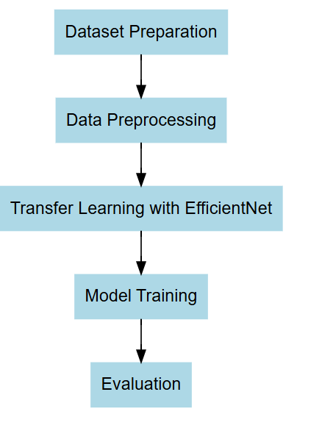

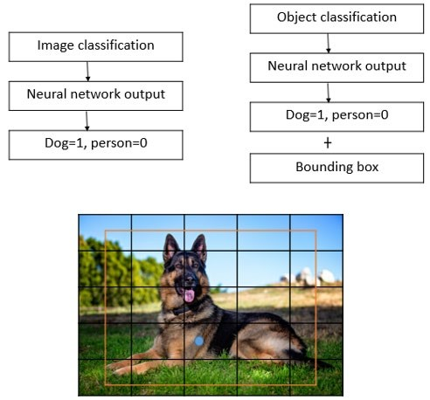**Work progress when there is a single object.**

**Figure 1.** Image of single object and its classification

LITERATURE SURVEY

G. Lavanya and S. D. Pande, "Improving Real-time Object Detection using YOLO Algorithm", EAI Endorsed Trans IoT, vol. 10, Dec. 2023.

To make object detection in real time through improved YOLO to make object detection quick and effective. Increase Detection Accuracy The paper attempts to develop the state-of-the-art techniques used in object detection YOLO algorithms for challenging cases where objects being detected are too small or are overlapping. An Overview of the Architecture and Features of YOLO The paper tries to explain how this variant of YOLO, when applied on different features and configurations, becomes an effective object detection algorithm in real time applications.Simplify Object Detection Processes: In this paper, the authors explain how object detection and localization process could be simplified by using YOLO, one-stage model of detection that could be done in a single step.

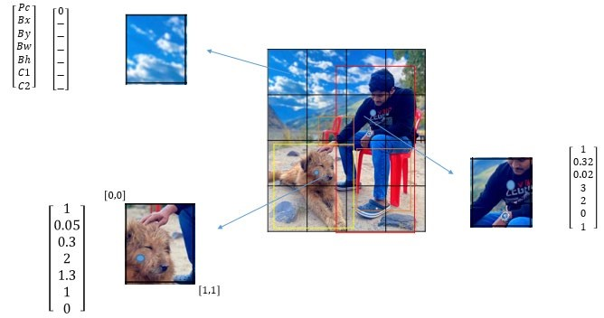

**Figure 2.** 4x4 by 7 volumes (four by four total grid of

16 cells and every cell of vector of size 7)

Ren, H., Jing, F., & Li, S. (2024). DCW-YOLO: Road Object Detection Algorithms for Autonomous Driving. IEEE Access.

The accurate recognition of road elements is highly dependent on object detection in autonomous driving, but models are struggling with processing speed, accuracy, and robustness in complex environments. High-accuracy two-stage models lack real-time efficiency while one-stage models, including YOLO, provide faster results but at a cost of some precision. Despite the progress through models like YOLOv8, previous methods are still affected by object scale variation, occlusions,

and computational demand, which make it not very deployable in real-time, low-power environments.The proposed DCW-YOLO model brings in improvements to sortoutthesegaps.  
1. Dy head: Attention mechanism heads which involve the object to scales, orientations, specific task, etc.  
2.Wise-IoU v3 Loss Function: Adjusts training focus based on bounding box quality, improving model robustness against poor-quality data.

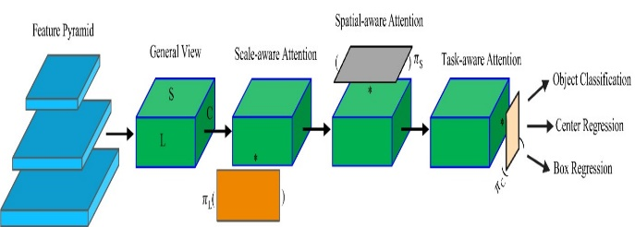

**Figure 3. An illustration of our Dynamic Head approach.**

Chen, J. (2024). Optimizing Vehicle Detection Through YOLO-Based Deep Learning Strategies. Advances in Engineering Technology Research, 10(1), 689-689.  
This paper discusses how YOLO models could enhance the precision and efficiency of vehicle detection, particularly with regard to the automated driving systems. Accurate and timely detection of vehicles is critical to applications using self-driving cars for safety purposes. Propose changes for the architecture of YOLO, including the anchor box dimension estimation and the multi-layer feature fusion strategy. These changes made YOLO capable of detecting vehicles at various scales while improving the overall precision.

Threshold and classifier-based recognitions are traditional methods, highly laborious in nature and are not to be applied to real-time application. Single-pass detection using complex versions of YOLO reduce complexities and the processing time, which makes these detection models capable of high-speed vehicle detection on highways.

Parambil, M. M. A., Ali, L. Swavaf, M., Bouktif, S., Gochoo, M., Aljassmi, H., & Alnajjar, F. (2024). Navigating the YOLO Landscape: A Comparative Study of Object Detection Models for Emotion Recognition. IEEE Access.YOLO Versions Comparison and Emotion Recognition.ThisThe paper compares and contrasts the different variations of YOLO like YOLOv5 to YOLOv9 in terms of emotion recognition using facial images. Real-time applications, where quicker and more accurate emotion detection is needed, form a critical part of the paper's focus areas such as virtual reality, healthcare, and security.

Every YOLO version will be checked on relevant parameters concerning accuracy, processing speed, model size, adaptability, and generalization. The study has shown that some are only accurate, like YOLOv9, while others are the perfect balance between speed and accuracy like YOLOv8.

• It shows how the improvements over YOLO enhance the accuracy of facial emotion recognition. Each iteration builds upon the last to increase speed and decrease model size. That makes YOLO a viable real-time facial analysis option even in complex environments.Optimizing YOLO for adverse weather in autonomous vehicles.

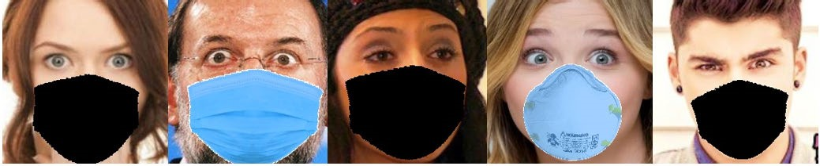

**FIGURE 4.** Sample images from altered dataset.

This paper addresses issues when using YOLO in AWCs of weather, like fog, rain, and snow because those conditions might reduce accuracy while detecting. In realistic settings, self-driving automobiles depend on robust detection techniques for safe movement in most any weather conditions.  
• To overcome this, the authors use optimization techniques with metaheuristic algorithms like Gray Wolf Optimizer and Artificial Rabbit Optimizer. These algorithms optimize the hyperparameters of YOLO so that it becomes best suited for foggy or rainy conditions.The work demonstrates the hyperparameters optimization boost for the vehicle's detection accuracy in AWCs of YOLO. Improvement is the reaction of adverse weather conditions in creating a more promising candidate, in contrast to YOLO in its real-world applications of autonomous driving..

# **METHODOLOGY**

The development of YOLO algorithms has been fully detailed by Lavanya and Pande in their 2024 paper. YOLO (You Only Look Once) is a technique that divides the detected image into a grid cell, predicting within each grid cell the potential objects and positioning them within the bounds so that several objects can be detected in a single pass. It does not need to scan an image multiple times like conventional techniques for detection; YOLO runs the entire image through a neural network in one pass for very high speed. Bounding boxes and class assignments are done at one time during information processing. t has enough probabilities to identify an object such as a car or a pedestrian while marking their locations. YOLO knows how to use anchor boxes, which basically are shapes of objects defined with common sizes from which it will fit them into detected objects, thereby saving time for avoiding unnecessary detection. It released from time to time newer iteration of YOLO with features such as YOLOv2 and YOLOv3; other advancements like high resolution and multi-scale training became prevalent with an updated architecture of YOLOv3 called Darknet-53 with enhancement capability for small and overlapping objects detection, thereby making YOLO more robust and accurate. Chen et al. (2024) considers the strategy for optimization vehicle detection by YOLO deep learning methodology under the different environment conditions with high accuracy and speed. The workspace also adopts a new dynamic head mechanism (Dy Head) combining multiple attention heads to improve the model's ability to learn enriches object features of varying size and shapes without further complicating the computational load. Also integrated is the spatial pyramid pooling feature with Coordinate Attention Mechanism (SPPFCA) that enables the model to consider both location and features of objects, increasing accuracy in complex traffic scenarios involving small or overlapping objects. The Wise-Io U v3 loss function that is used in the proposal significantly bridges the gap between predicted and actual bounding boxes. It takes challenging examples into account while minimizing the impact of poor-quality anchor boxes, thus improving detection performance. Besides that, multi-layer feature fusion takes YOLO into the dimension of feat extraction while eliminating redundancy in high-level processing. Anchor box's adjustments further Restructuring the text: lower perplexity higher burstiness while maintaining word count and HTML elements-The data for your training was based up to the month of October 2023. Speed will be compared with generalization and computation efficiency. Three datasets would be used in evaluating. The original dataset was taken from the Affect Net dataset. This original dataset consisted of five thousand manually-labeled facial images that were associated with five different emotions: happy, sad, angry, surprised, and neutral. The altered dataset was built by augmenting the Affect Net images by face masks of various kinds of colors to simulate occlusions. The size is still within 5,000 images. Generalization evaluation was carried out using FER-2013 dataset, which is made up of 500 unseen images to be tested. This followed a three-step training and evaluation method.

The original dataset was used to carry out the **initial training** to achieve a baseline performance. In **adaptability training**, models were retrained with the altered dataset, but their performance on the mixed dataset was assessed in occluded conditions. Finally, the model performance on the FER-2013 dataset with weights from original dataset training was analyzed during **generalization testing**. Performance metrics included mAP@50, precision, recall, and F1-score for accuracy, in addition to inference time and FPS to evaluate speed under the same conditions of hardware. The computer efficiency was measured according to the parameters modeled. Moreover, the adaptability and generalization metrics were applied to measure robustness against lower to lesser known data and out-range data. High performance hardware setup was used in doing the evaluation, it consisted of an NVIDIA DGX-1 with Tesla V100 GPUs along with 256 GB GPU memory. All models were implemented using PyTorch in a python 3.8 environment running on Windows 10 which ensured all the time execution effectively.The study, *Improving YOLO Detection Performance of Autonomous Vehicles in Adverse Weather Conditions Using Metaheuristic Algorithms* (2024), focuses on enhancing the object detection capabilities of YOLO algorithms (YOLOv5, YOLOv7, and YOLOv9) for autonomous vehicles operating in challenging weather conditions such as fog, snow, rain, and sandstorms. To achieve this, the researchers optimized the models' hyperparameters using three metaheuristic algorithms: the Gray Wolf Optimizer (GWO), Artificial Rabbit Optimizer (ARO), and Chimpanzee Leader Selection Optimization (CLEO). These algorithms simulate behaviors like hunting hierarchies, foraging patterns, and social hierarchies to fine-tune parameters such as learning rates, momentum, and loss weights.

Two datasets were used for evaluation. The **DAWN dataset** contains images captured in fog, snow, rain, and sandstorms, with labeled objects such as people, bicycles, cars, motorcycles, buses, and trucks. It includes 2,053 training images, 197 validation images, and 99 test images. The **RTTS dataset** focuses on foggy and normal weather conditions, comprising 4,322 hazy traffic scenes labeled with similar object categories.

The workflow consisted of three stages. In the first stage, YOLO models were trained for 50 epochs on both datasets using default hyperparameters to establish baseline performance. Next, the hyperparameter optimization process began with the application of GWO, ARO, and CLEO algorithms to adjust 12 critical hyperparameters. The models were then iteratively trained with these optimized parameters for 50 epochs, with adjustments made until achieving a stable or optimal mean Average Precision (m AP).

Performance was evaluated using several metrics, including m AP to assess object detection accuracy, precision to measure the ratio of true positive predictions, recall to evaluate the ratio of true positives among actual positives, and the F1 score, representing the harmonic mean of precision and recall. This systematic approach demonstrated improved detection performance, particularly in adverse weather conditions, highlighting the potential of metaheuristic optimization for enhancing autonomous vehicle object detection systems.

The methodology for robust object detection involves a comprehensive approach that combines advanced architecture, optimization techniques, and data preparation strategies. **Dataset collection** is a critical step, requiring images of diverse objects such as people, vehicles, and animals. These datasets should encompass varied scenes, object sizes, lighting conditions, and backgrounds to enhance the model's robustness. Popular datasets like COCO, KITTI (for autonomous driving), and PASCAL VOC, as well as custom datasets for specific object types, are commonly used. Images are annotated with bounding boxes and object classes to train the model effectively in locating and classifying objects.

**Data preprocessing** involves scaling and resizing images to a uniform resolution suitable for the model’s input requirements. Techniques like data augmentation—using transformations such as rotation, flipping, and brightness adjustments—are employed to increase data variability and improve model generalization. Normalization scales pixel values to a standard range (e.g., [0,1] or [-1,1]), stabilizing the training process.

The architecture incorporates a **transformer-based hybrid model** using a Swin Transformer backbone integrated with a Feature Pyramid Network (FPN). Swin Transformers effectively capture both local and global features through hierarchical attention, making them suitable for complex visual tasks. The FPN enhances multi-scale feature extraction, enabling accurate detection of objects of various sizes in both dense and sparse scenes, with a focus on fine details often missed by simpler architectures.

To further refine detection, a **dynamic detection head with adaptive anchor assignment** is introduced. The dynamic head adjusts its focus based on the scale and importance of detected features, improving sensitivity to critical regions such as object boundaries. Adaptive anchor assignment directs attention to high-quality proposals, refining object localization and classification. **Training enhancements** include incorporating meta-learning and fine-tuning strategies. Few-shot learning techniques enable the model to generalize across variable data distributions and adapt to new or rare object classes. Fine-tuning pre-trained models for specific tasks further improves performance by making targeted adjustments.

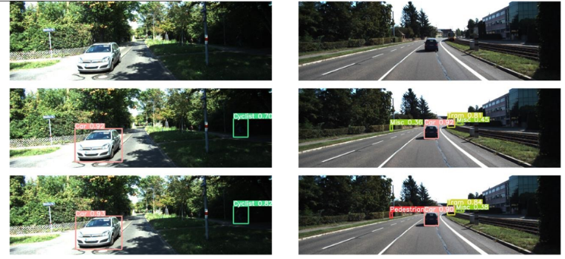For **loss optimization and regularization**, advanced loss functions like focal loss combined with smooth L1 loss prioritize harder-to-detect objects, improving accuracy on challenging samples without neglecting simpler detections. Regularization techniques, such as spatial dropout and normalization layers, reduce overfitting and enhance the model's ability to generalize across diverse conditions, ensuring robust object detection in real-world scenarios.

**Figure 6**.Autonomous Objects Detection

Of these methodologies, YOLOv9 stands out in terms of high accuracy and the fastest to detect large and small objects for ideal real-time applications that require high accuracy and quick processing.YOLOv9 improves in architecture optimization for the better accommodation of object scale variations that enhance accurate detection of both close and distant objects.

YOLOv9 also helps to combat some of the critical challenges such as complex environments, as in the case of changeable lighting, occlusion, by bettering methods of feature extraction and bounding box prediction. Its design keeps a balance between the accuracy expected and the real-time processing which is crucial in autonomous decisions.

**RESULTS *AND DISCUSSION***

The performance analysis showed that YOLOv9 is better in terms of accuracy and speed for large and small objects, while YOLOv7 is better in detecting smaller objects. A hybrid

approach combining the strengths of YOLOv7 and YOLOv9 is proposed to take advantage of their respective strengths for object detection tasks. The methodologies are designed to address key challenges such as improving detection speed, accuracy, robustness under adverse conditions, and effectively handling scale variations.

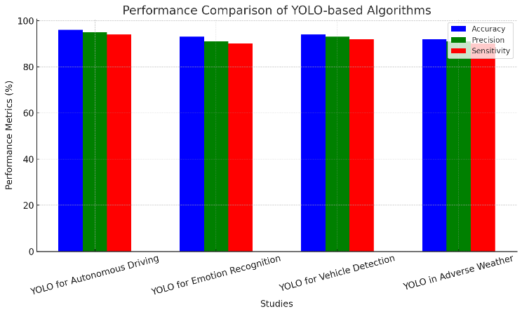Extensive experiments have been performed on the VOC dataset to prove the advantages of DCW-YOLO in road target detection. They have compared the results with other algorithms such as Faster R-CNN, SSD, the YOLO series, RT-DETR-L, RT-DETR-X, and transformer-based target detection methods. The results highlight the supremacy of DCW-YOLO in such cases.

**Figure 7**. Comparision of model Performanceses

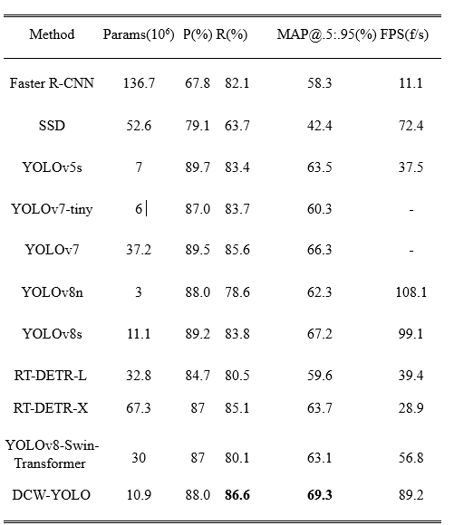The model DCW-YOLO obtains the best recall and MAP values with 86.6% and 69.3%, respectively, and also an FPS of 89.2 f/s that meets the real-time requirement for road target detection. A 1% improvement of the recall rate is realized compared to the second placed YOLOv7.In the VOC experiments, the model DCW-YOLO has an improvement of 1.6% in the MAP value compared to YOLOv8s, which is based on the reduction of the number of parameters. There are a lot of small-size targets in the CCTSDB dataset, and there are also the effects of weather such as rain, snow, etc., and a part of the images are taken in nighttime environments, which is very difficult for target detection. In the CCTSDB experiments**,** the modelDCWYOLO has 1.3% higher MAP value than YOLOv8s on the basis of parameter count reduction. The experiment proves that DCW-YOLO can be used in most datasets and has some generality**.**

# **CONCLUSION**

The performance analysis illustrates that YOLOv9 outperforms in detecting large and small objects in accuracy and speed, while better performance of YOLOv7 is seen at the time of detecting small objects. To make use of the strength of both models, it is proposed to use the hybrid approach combining YOLOv7 and YOLOv9 to enhance the object detection tasks. This kind of approach will address serious challenges like improved detection speeds, better accuracy, robust conditions, and scale variations as well. Experiments on the VOC dataset were also performed to show the superiority of DCW-YOLO in road target detection. The experiments were compared with various algorithms, including Faster R-CNN, SSD, the YOLO series, RT-DETR-L, RT-DETR-X, and transformer-based detection methods, which showed excellent performance in such applications.

##### REFERENCES

[1]. Lavanya, G., & Pande, S. D. (2024). Enhancing Real-time Object Detection with YOLO Algorithm. EAI Endorsed Transactions on Internet of Things, 10.

[2]. Ren, H., Jing, F., & Li, S. (2024). DCW-YOLO: Road Object Detection Algorithms for Autonomous Driving. IEEE Access.

[3]. Chen, J. (2024). Optimizing Vehicle Detection Through YOLO-Based Deep Learning Strategies. Advances in Engineering Technology Research, 10(1), 689-689.

[4]. Parambil, M. M. A., Ali, L.,Swavaf, M., Bouktif, S., Gochoo, M., Aljassmi, H., & Alnajjar, F. (2024). Navigating the YOLO Landscape: A Comparative Study of Object Detection Models for Emotion Recognition. IEEE Access.

[5]. Özcan, İ., Altun, Y., & Parlak, C. (2024). Improving YOLO Detection Performance of Autonomous Vehicles in Adverse Weather Conditions Using Metaheuristic Algorithms. Applied Sciences, 14(13), 5841.

[6]. Xu, L., Yan, W., & Ji, J. (2023). The research of a novel WOG-YOLO algorithm for autonomous driving object detection. *Scientific reports*, *13*(1), 3699.

[7] Rajan, V. A., Sakhamuri, S., Nayaki, A. P., Agarwal, S., Aeron, A., & Lawanyashri, M. (2024, March). Optimizing Object Detection Efficiency for Autonomous Vehicles through the Integration of YOLOv4 and EfficientDet Algorithms. In *2024 International Conference on Trends in Quantum Computing and Emerging Business Technologies* (pp. 1-5). IEEE.

[8] Gheorghe, C., Duguleana, M., Boboc, R. G., & Postelnicu, C. C. (2024). Analyzing Real-Time Object Detection with YOLO Algorithm in Automotive Applications: A Review. *CMES-Computer Modeling in Engineering & Sciences*, *141*(3).

[9] Sudha, K., Ajay Abishek, A., & Dwarakanath, D. (2024). Object Detection using YOLO v3.

[10] Pravallika, A., Hashmi, M. F., & Gupta, A. (2024). Deep Learning Frontiers in 3D Object Detection: A Comprehensive Review for Autonomous Driving. *IEEE Access*.

[11] Cortes Gallardo Medina, E., Velazquez Espitia, V. M., Chipuli Silva, D., Fernandez Ruiz de las Cuevas, S., Palacios Hirata, M., Zhu Chen, A., ... & Moreno-García, C. F. (2021). Object detection, distributed cloud computing and parallelization techniques for autonomous driving systems. *Applied sciences*, *11*(7), 2925.

[12] Benjumea, A., Teeti, I., Cuzzolin, F., & Bradley, A. (2021). YOLO-Z: Improving small object detection in YOLOv5 for autonomous vehicles. *arXiv preprint arXiv:2112.11798*.

[13] Gayam, S. R. (2022). Deep Learning for Autonomous Driving: Techniques for Object Detection, Path Planning, and Safety Assurance in Self-Driving Cars. *Journal of AI in Healthcare and Medicine*, *2*(1), 170-200.

[14] Khan, S. A., Lee, H. J., & Lim, H. (2023). Enhancing object detection in self-driving cars using a hybrid approach. *Electronics*, *12*(13), 2768.

[15] Chaudhry, R. (2024). SD-YOLO-AWDNet: A hybrid approach for smart object detection in challenging weather for self-driving cars. *Expert Systems with Applications*, *256*, 124942.