**A REVIEW ON DC-DC CONVERTER TOPOLOGIES FOR SOLAR PV POWER GENERATION**

**Javier Sanz1, Kumar Mahtani1, Amit K. Sharma2**

1Department of Automation, Electrical and Electronic Engineering and Industrial Informatics, ETSI Industriales, Universidad Politécnica de Madrid, Madrid, Spain

2Department of Electrical Engineering, Indian Institute of Technology Bombay, Mumbai, India

Corresponding author: kumar.mahtani@upm.es

**ABSTRACT**

The efficient conversion of solar energy into electrical energy is a fundamental aspect of photovoltaic (PV) systems, and the choice of DC-DC converter plays a crucial role in optimizing performance, efficiency, and reliability. This paper provides an in-depth examination of various DC-DC converter topologies used in solar PV applications, including buck, boost, buck-boost, Cuk, Zeta, SEPIC, and flyback converters. Each converter is analyzed in terms of its operational principles, advantages, limitations, and suitability for different PV system configurations. The paper also explores the impact of these converters on power conversion efficiency, voltage regulation, current ripple minimization, and system stability, addressing the challenges posed by fluctuating environmental conditions. By comparing and contrasting these converter topologies, this review offers valuable insights for researchers, engineers, and industry professionals seeking to optimize solar PV systems for higher efficiency and better integration with the grid. The findings highlight the importance of selecting the appropriate DC-DC converter to enhance the overall performance and reliability of renewable energy systems, contributing to the continued advancement of sustainable power generation.

**Keywords:** Boost converter, Buck converter, Buck-boost converter, Cuk converter, DC-DC converters, Energy conversion, Flyback converter, MPPT, Photovoltaic systems, Power efficiency, Renewable energy, SEPIC, Solar power generation, Zeta Converter.

1. **INTRODUCTION**

The increasing need for sustainability and the reduction of environmental impact have driven a substantial global transition toward renewable energy systems. Each renewable technology possesses unique attributes in terms of efficiency, cost, maintenance, lifespan, and reliability. Solar photovoltaic (PV) systems [1] have emerged as a critical technology in this renewable energy shift, thanks to their ability to directly convert solar radiation into electrical energy using semiconductor materials. PV systems are scalable, ranging from small residential installations to large utility-scale power plants, and are now increasingly integrated into modern power grids [2][3]. However, the inherent intermittency and variability of solar energy pose challenges in achieving stable and efficient power output. Furthermore, the voltage generated by PV panels is often insufficient for practical applications, necessitating power electronics solutions to step up, regulate, or condition the output for subsequent use [4].

A general overview of solar PV systems is shown in Figure 1. In these systems, DC/DC converters [5] play a pivotal role in addressing these challenges by enabling the optimization of power extraction and ensuring compatibility with downstream components like inverters, batteries, or grid connections. The well-known boost converters, for instance, are integral to PV systems as they elevate the low output voltage of solar panels to levels suitable for storage or grid integration [6]. The design and operation of boost converters must account for multiple factors, including efficiency, voltage gain, cost, and reliability, while also addressing practical constraints like thermal management, electromagnetic compatibility (EMC), and durability under fluctuating environmental conditions.

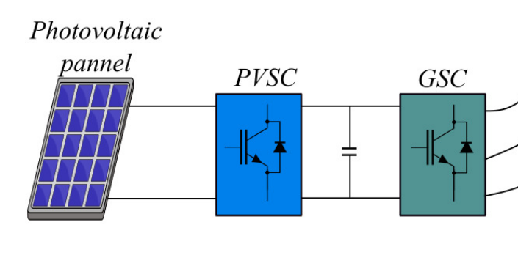

**Figure 1:** General overview of the solar PV system

Modern DC/DC converters [7] incorporate advanced control techniques such as maximum power point tracking (MPPT) to ensure that the PV panels operate at their optimal power point regardless of changes in sunlight intensity or temperature. These converters often utilize high-frequency switching and soft-switching methods to improve efficiency and reduce losses. Additionally, innovations in wide-bandgap semiconductor materials, such as silicon carbide (SiC) and gallium nitride (GaN), have significantly enhanced the performance of DC/DC converters by enabling higher power densities, faster switching speeds, and better thermal efficiency.

The rapid evolution of PV technology has also led to the development of diverse DC/DC converter topologies, including buck, boost, Cuk, Zeta, SEPIC, and flyback configurations. Each topology offers unique advantages, such as bidirectional operation, enhanced voltage regulation, or isolation between input and output, making them suitable for specific PV applications. For instance, Cuk and Zeta converters are valued for their ability to provide inverted or non-inverted output voltages, while flyback converters are commonly used in low-power applications where isolation is required.

This paper explores these DC/DC converter topologies and their role in PV power generation systems. It provides an overview of their operating principles, performance metrics, and application scenarios. Furthermore, it examines how advancements in semiconductor technology, control algorithms, and thermal design are pushing the boundaries of efficiency and reliability in solar PV systems. By shedding light on these critical aspects, this work aims to contribute to the ongoing innovation in power electronics, which is essential for realizing the full potential of solar energy in meeting global energy needs sustainably.

1. **BUCK CONVERTER**

The buck converter, depicted in Figure 2, is widely recognized for its simplicity, robustness, and high efficiency, making it a vital component in PV systems. Its primary role is to step down the voltage from the PV array to a level suitable for charging batteries or powering loads, ensuring efficient energy management. Particularly in PV applications, where power output is often variable and dependent on environmental factors such as sunlight intensity, the buck converter plays a crucial role in regulating voltage, current, and power flow to maintain system stability and performance.

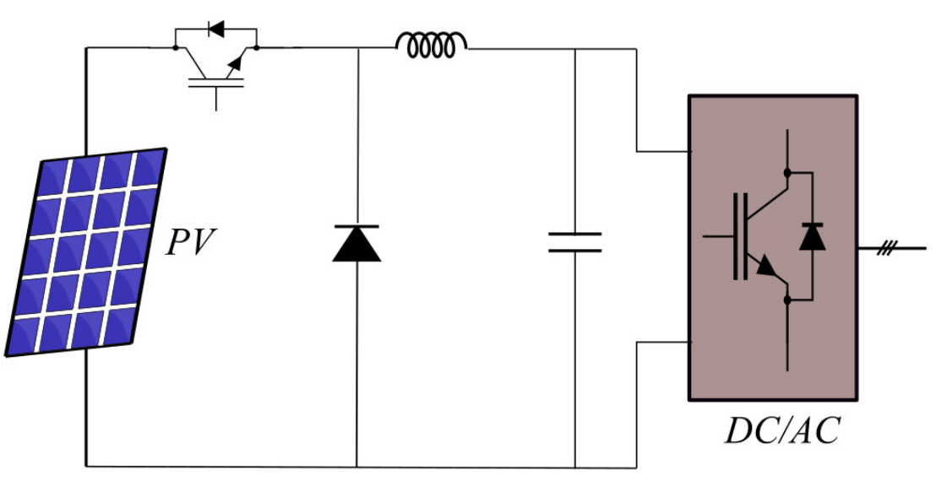

**Figure 2:** Buck converter

One of the challenges in using buck converters arises from their operation across continuous conduction mode (CCM) and discontinuous conduction mode (DCM). These modes are influenced by factors such as load conditions and irradiance levels, which can fluctuate dynamically. Transitions between these modes may affect the performance and efficiency of the connected loads. Addressing these operational complexities has led to a range of innovations in buck converter design to enhance their adaptability and efficiency under varying conditions [8][9].

Advanced configurations, such as reconfigurable switched capacitor circuits [10], have been introduced to improve performance. These circuits adapt to varying input and output voltages, thereby reducing energy loss. However, incorporating additional components can increase switching losses, necessitating the development of advanced modulation strategies. For instance, hybrid pulse width modulation (PWM) techniques have been employed to mitigate these losses, balancing efficiency with operational complexity.

Another significant innovation is the multiphase interleaved buck converter [11][12], which divides the output current among multiple parallel phases. This design reduces stress on individual switches, minimizes conduction losses, and enhances thermal performance. The interleaved approach is particularly beneficial in high-power PV systems, as it facilitates better current sharing and improves overall reliability.

Despite the increasing complexity of PV systems, these advancements in buck converter technology have proven effective in ensuring continuous operation, improving conversion efficiency, and optimizing power utilization. By integrating innovative control algorithms and leveraging advancements in semiconductor technology, modern buck converters are well-suited to meet the demands of evolving PV applications. These developments underscore the buck converter's critical role in managing energy flows efficiently and reliably within solar power systems.

1. **BOOST CONVERTER**

Solar PV systems face inherent challenges due to external factors such as weather variability and shading, which can significantly affect energy output. These fluctuations often result in inconsistent voltage levels from PV panels. To address these challenges and ensure stable, reliable energy conversion, the DC-DC boost converter, illustrated in Figure 3, plays a pivotal role [13]. By stepping up the low voltage produced by PV arrays—typically ranging from 12 V to 60 V—to higher levels exceeding 380 V, the boost converter ensures compatibility with downstream systems, including inverters and grid-connected applications.

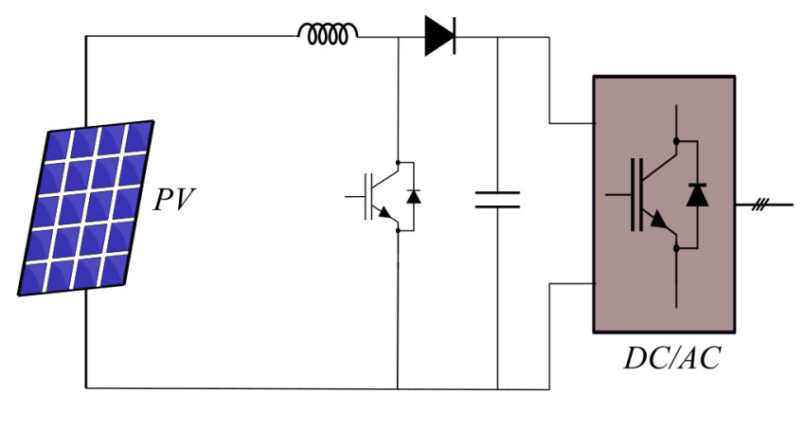

**Figure 3:** Boost converter

The boost converter achieves its function through high-frequency switching techniques, such PWM, which enables precise voltage control. As PV systems must adapt to dynamically changing environmental conditions, ongoing research focuses on enhancing the efficiency and reliability of boost converter designs, ensuring consistent and optimal performance across diverse scenario [14].

A wide range of boost converter topologies has been developed to meet the diverse requirements of PV systems. Conventional boost converters, while effective at achieving high voltage gains, encounter significant efficiency losses at elevated duty cycles due to increased conduction and switching losses. To address these limitations, innovative topologies incorporating soft-switching techniques have been introduced. For example, zero current transition (ZCT) converters eliminate reverse recovery issues in the diode, reducing power losses during switching. Similarly, zero voltage transition-PWM (ZVT-PWM) converters combine coupled inductors and advanced control methods to improve voltage regulation and efficiency.

Further advancements include zero voltage switching (ZVS) and zero current switching (ZCS) techniques, which aim to minimize energy dissipation during switching events [15]. These designs enhance system efficiency by ensuring smooth transitions and reducing electromagnetic interference. For applications requiring high voltage ratios, non-inductive converters and switched-capacitor converters offer viable solutions. Switched-capacitor configurations, in particular, excel in light-load scenarios, maintaining high efficiency while reducing reliance on bulky magnetic components.

In high-density applications, multiplier/divider topologies and modular capacitor-coupled designs provide improved voltage control and scalability [16]. These architectures enhance the power density of PV systems and allow for better integration with modern power management frameworks.

As PV technology advances, boost converters continue to evolve, incorporating state-of-the-art semiconductor devices such as wide-bandgap materials (e.g., silicon carbide and gallium nitride) to achieve higher switching speeds and thermal efficiency. By integrating these technological innovations, modern boost converters are capable of meeting the stringent demands of solar PV applications, ensuring high performance and long-term reliability in renewable energy systems.

1. **BUCK-BOOST CONVERTER**

The buck-boost converter, depicted in Figure 4, offers a versatile solution for PV systems by addressing the limitations of standard boost converters. Its ability to operate across the entire current-voltage (I-V) characteristic curve of PV panels ensures improved adaptability to varying environmental conditions [17]. Furthermore, in CCM, it effectively minimizes input current ripple, enhancing overall system performance and reducing the stress on upstream components.

Compared to single-switch designs, two-switch buck-boost configurations provide a significant reduction in component stress, contributing to improved reliability and efficiency. An innovative variant of this topology is the two-switch non-inverting buck-boost converter, which introduces additional current storage capability and optimizes energy transfer by leveraging MPPT algorithms. This design excels in scenarios with heavy load conditions, ensuring higher operational efficiency [18].

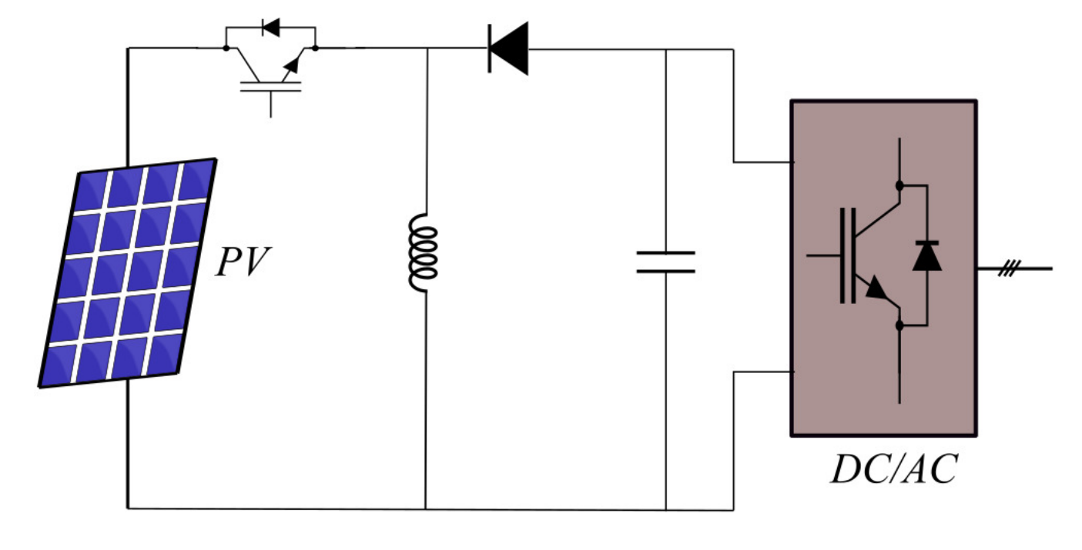

**Figure 4:** Buck-boost converter

However, implementing these advanced configurations is not without challenges [19][20]. For instance, the introduction of buffer regions to facilitate energy storage can result in increased inductor currents and higher switching losses. These factors may restrict the effective operational regions and necessitate advanced control strategies to balance trade-offs between efficiency and complexity.

To overcome these challenges and further enhance performance, researchers have explored advanced configurations such as cascade, interleaved, and super-imposed topologies, using AC-DC equivalent circuit synthesis methods. These designs demonstrate improved conversion efficiency and enhanced thermal management, although they often require detailed and precise parameter optimization to maximize their potential.

In addition to these advancements, incorporating high-frequency transformers and hybrid integration of converter types has emerged as a promising approach [21]. These innovations improve dynamics, efficiency, and power density, making the buck-boost converter a valuable component in modern PV systems. By enabling both step-up and step-down operations, the buck-boost converter is particularly effective in maintaining stable output voltages in scenarios with fluctuating input power, a common challenge in solar energy applications.

Ongoing developments in wide-bandgap semiconductor technology, such as SiC and GaN, further enhance the performance of buck-boost converters. These materials support higher switching frequencies, reduced losses, and improved thermal efficiency, making them increasingly viable for next-generation PV systems. With its adaptability and potential for innovation, the buck-boost converter remains a critical component in optimizing energy harvesting and management in renewable energy applications.

1. **CUK CONVERTER**

The Cuk converter, shown in Figure 5, is a distinctive DC-DC converter topology known for its ability to provide continuous input and output currents [22]. This characteristic minimizes current ripple, reduces electromagnetic interference (EMI), and enhances the overall performance of PV systems and other renewable energy applications. Its unique topology allows for voltage inversion with just a single active switch, making it particularly suitable for applications requiring bidirectional power flow.

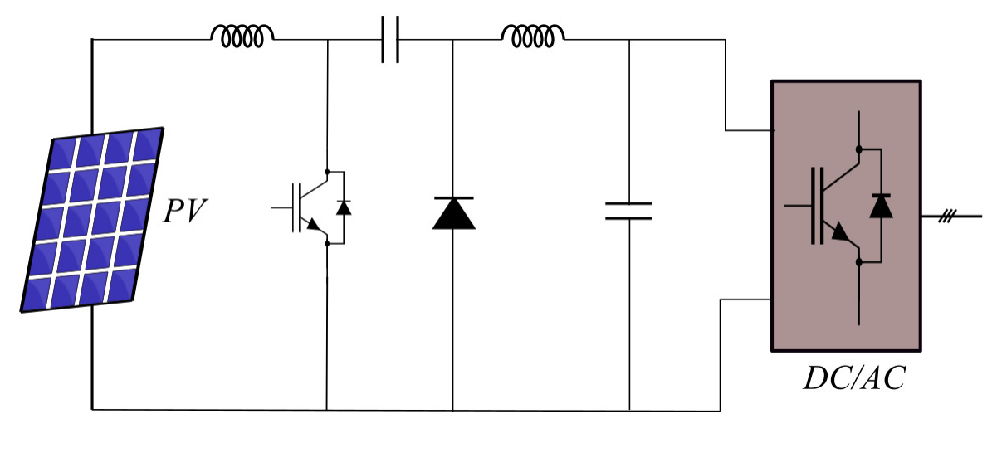

**Figure 5:** Cuk converter

One of the key advantages of the Cuk converter is its inherent capacity to perform both step-up (boost) and step-down (buck) voltage conversion [23][24]. This dual capability enables its use in a variety of scenarios, from interfacing PV panels with batteries in energy storage systems to managing power flow in hybrid renewable systems. The converter’s continuous current operation also reduces stress on components and enhances compatibility with devices sensitive to input or output current fluctuations.

Despite these benefits, the Cuk converter presents certain challenges, primarily due to its increased complexity. The topology incorporates additional passive components, such as inductors and capacitors, which can result in higher voltage and current stresses on the components. These stresses necessitate careful selection of components and precise design of the control system to ensure reliability and efficiency. Moreover, achieving optimal performance requires addressing potential issues like increased losses and heat generation under high-power operation.

Recent research has focused on mitigating these challenges through advanced techniques and materials. For instance, the integration of wide-bandgap semiconductors like SiC and GaN has improved the converter’s efficiency and reduced its physical size by enabling higher switching frequencies. Advanced control algorithms, including MPPT and dynamic mode control, are also being employed to optimize its operation in PV systems under varying environmental conditions.

The versatility of the Cuk converter, combined with its ability to regulate power effectively in renewable energy systems, continues to make it a subject of active research. By addressing its design complexities and component stresses, the Cuk converter holds significant potential for enhancing energy conversion efficiency and reliability in modern power systems, particularly those reliant on intermittent renewable energy sources like solar PV.

1. **ZETA CONVERTER**

The Zeta converter, depicted in Figure 6, is a versatile DC-DC converter topology with significant applications in renewable energy systems, particularly stand-alone PV and wind energy conversion systems. Its primary advantage lies in its ability to provide uninterrupted output current, reduced input and output current ripple, and a wide operating region for MPPT. These features make it an effective choice for stabilizing power flow in systems characterized by variable and intermittent energy sources [25].

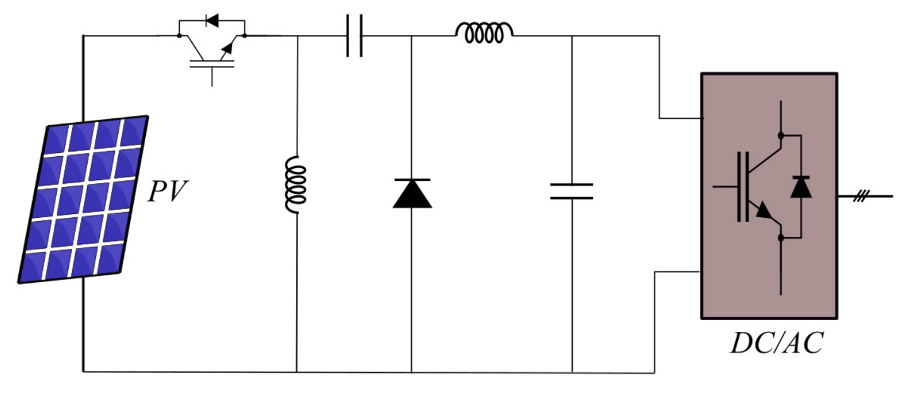

**Figure 6:** Zeta converter

In renewable energy conversion systems, the Zeta converter often serves as a controlled interface. The topology commonly incorporates an uncontrolled rectifier upstream to simplify the overall control system while maintaining efficiency. The Zeta converter then regulates power delivery, ensuring stable operation and optimal energy utilization. It supports both CCM and DCM, with CCM being the preferred operational mode for its superior performance in reducing ripple and ensuring consistent power delivery.

The design of the Zeta converter relies on precise mathematical modeling to define critical parameters such as inductor and capacitor sizing, switching frequency, and control system dynamics. These parameters are crucial for maintaining efficiency and stability, especially when the converter operates under varying load and environmental conditions. Innovations such as the modified Zeta inverter (MZI) topology extend the converter's functionality by enabling step-up voltage conversion in DCM while injecting active current into the grid. This configuration is particularly valuable in grid-tied PV systems, as it achieves reduced total harmonic distortion (THD) and enhances power quality.

Advanced control strategies have been developed to optimize the Zeta converter's performance [26][27]. Nonlinear control techniques using multiple regulators enable fine-tuned operation, improving efficiency across a wide MPPT range. These strategies are essential in managing the trade-offs between operational modes, minimizing switching losses, and ensuring robust performance during dynamic changes in input power.

The Zeta converter’s ability to provide stable output and efficient energy conversion, coupled with its adaptability to various renewable energy applications, underscores its importance in modern power electronics. By further refining its design and integrating advanced materials and control methods, the Zeta converter continues to play a pivotal role in improving the reliability and efficiency of renewable energy systems, including those based on PV and wind energy technologies.

1. **SEPIC CONVERTER**

The Single-Ended Primary-Inductor Converter (SEPIC), illustrated in Figure 7, is a versatile DC-DC converter topology well-suited for PV systems and other renewable energy applications. SEPIC converters are particularly valued for their ability to provide a regulated output voltage, stepping it up or down as needed, while minimizing voltage and current ripple. These features contribute to improved performance and reliability in PV systems, where consistent power delivery is crucial despite varying environmental conditions.

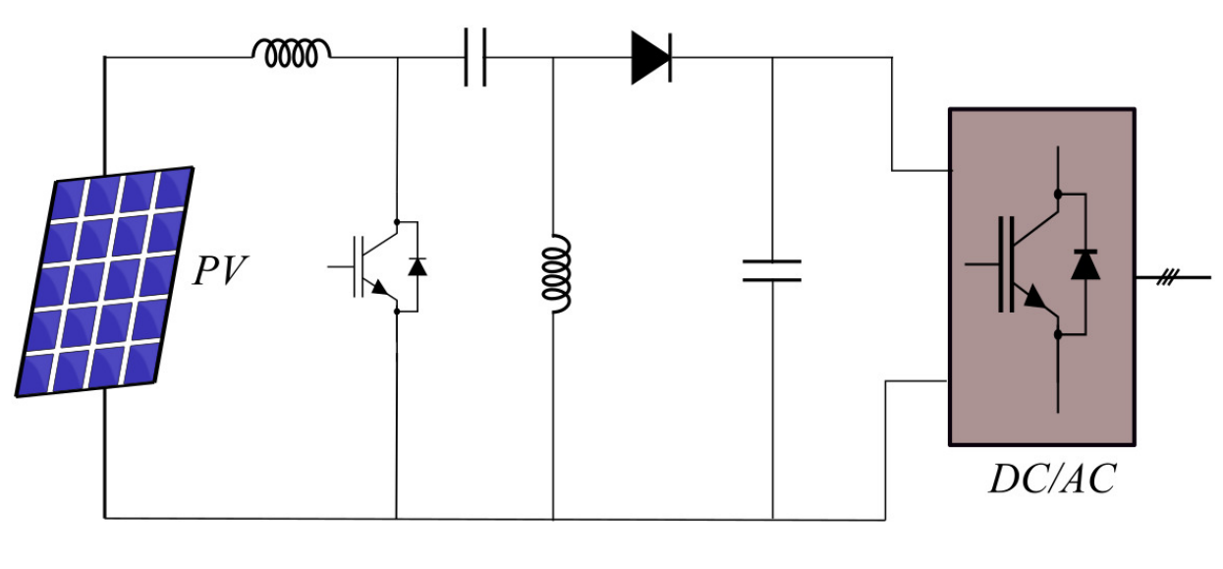

**Figure 7:** SEPIC converter

One of the SEPIC converter's key attributes is its capacity to reduce input voltage ripple. This is achieved through careful optimization of equivalent inductance and capacitance, which are crucial design parameters [28]. Research has shown that the ripple characteristics depend significantly on input voltage variations and load resistance, making precise component selection essential for optimal performance. Enhanced designs [29], such as the modified SEPIC converter, introduce additional diodes and capacitors to further reduce input current ripple and function as effective preregulators, improving energy conversion efficiency.

In CCM, the SEPIC converter operates in either complete-inductor-supply mode or incomplete-inductor-supply mode, each offering unique ripple and efficiency characteristics [30]. Detailed analyses of output voltage ripple waveforms in relation to equivalent inductance provide insights into how the topology can be tuned to achieve high efficiency under various operating conditions.

To address challenges such as input current distortion and switching losses, advanced techniques like harmonic balance analysis and soft-switching methods are employed [31]. Soft-switching strategies, including zero voltage switching (ZVS) and zero current switching (ZCS), minimize energy losses during the switching process and reduce stress on the power electronic components. These methods enhance resilience against switching-induced stresses and extend the converter's operational lifespan.

Further innovations include the integration of quasi-resonant circuits, which maintain zero voltage switching over a wide input-output range. These circuits incorporate resonant components to synchronize inductor voltage with the PV array's output current, ensuring efficient energy transfer and minimal switching losses. Additionally, incorporating complementary gate driver circuits for MOSFET inverters enhances the dynamic response and operational efficiency of the converter.

The SEPIC converter’s adaptability, coupled with these advanced design modifications, makes it a critical component in modern PV systems. By minimizing voltage and current ripple, reducing switching losses, and improving power quality, SEPIC converters enable efficient energy harvesting and reliable power delivery, even under fluctuating input conditions. These attributes ensure their continued relevance in optimizing renewable energy applications and advancing sustainable power systems.

1. **FLYBACK CONVERTER**

The flyback converter, shown in Figure 8, is a widely used DC-DC converter topology in renewable energy systems, including PV applications [32]. Its design centers on achieving high efficiency and stable performance while addressing challenges such as input and output voltage ripple. The flyback converter's compact architecture and versatility make it particularly suitable for low- to medium-power applications, where isolation between input and output is required.

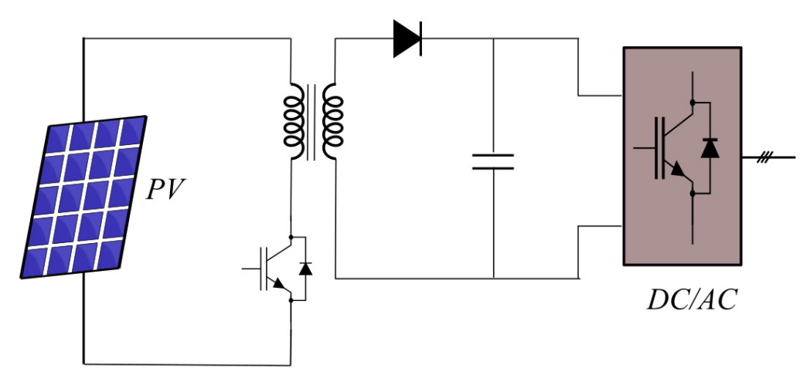

**Figure 8:** Flyback converter

Key design parameters, including duty cycle, switching frequency, and the transformer turns ratio, play a critical role in determining the converter's output voltage and minimizing voltage ripple [33]. The transformer, a central component of the flyback converter, provides electrical isolation and facilitates voltage step-up or step-down, depending on the system requirements. By carefully optimizing the turns ratio and transformer inductance, the converter can deliver stable output across a range of operating conditions.

Flyback converters operate in two primary modes: CCM and DCM. In CCM, the transformer’s magnetic flux does not return to zero during a switching cycle, which generally results in lower voltage ripple and improved efficiency for higher power levels. Conversely, DCM, where the flux resets to zero, is preferred for lower power applications and is characterized by simpler control and faster transient response. The trade-offs between these modes, such as efficiency versus switching loss and stability versus control complexity, are carefully considered during the design phase.

Recent research has focused on the interplay of parameters such as transformer inductance, load resistance, and advanced control techniques to improve system efficiency and stability [34]. Enhanced control mechanisms, including feedback and feedforward loops, help maintain output voltage regulation under varying load and input conditions. Techniques like active clamp circuits are also employed to recover energy from leakage inductance, further boosting efficiency.

The compact and isolated nature of flyback converters makes them ideal for integration into PV systems, especially in microinverter designs where space constraints and isolation are critical. By continuously advancing the understanding of operational modes, ripple management, and parameter optimization, researchers are enabling flyback converters to meet the evolving demands of modern power electronics applications. These efforts ensure the flyback converter remains a reliable and efficient choice for renewable energy systems, contributing to the broader adoption of sustainable technologies.

1. **CONCLUSION**

The efficient conversion of solar energy into electricity through PV systems relies heavily on the careful selection and optimization of DC/DC converter topologies. Each converter type—whether buck, boost, buck-boost, Cuk, Zeta, SEPIC, or flyback—offers distinct advantages and challenges, making it critical to choose the most suitable topology based on specific application requirements and environmental conditions. The performance characteristics of these converters, including voltage regulation, current ripple, efficiency, and operational stability, are essential to ensure reliable power conversion in solar PV systems.

Advancements in converter technologies, such as the use of soft-switching techniques, innovative control strategies, and high-frequency components, continue to improve the overall efficiency and sustainability of PV systems. The integration of these converters into renewable energy applications plays a vital role in enhancing the dependability and scalability of solar power generation, contributing to the broader shift toward renewable energy sources. By selecting the most appropriate DC/DC converter topology, PV systems can achieve optimal performance, ensuring that solar energy is harnessed efficiently and effectively.

In the context of the global transition to cleaner and more sustainable energy, the continuous research and development in DC/DC converter technologies are pivotal. These advancements not only improve the economic viability of PV systems but also support the integration of solar power with other renewable energy sources, such as wind and hydroelectric power, to create more resilient and efficient energy systems. Ultimately, the refinement of DC/DC converter technologies is a crucial step in advancing our efforts toward a cleaner, greener, and more sustainable energy future.

1. **REFERENCES**
2. H. H. Pourasl, R. V. Barenji, and V. M. Khojastehnezhad, "Solar energy status in the world: A comprehensive review," Energy Reports, vol. 10, pp. 3474–3493, 2023.
3. T. E. K. Zidane et al., "Grid-Connected Solar PV Power Plants Optimization: A Review," in IEEE Access, vol. 11, pp. 79588-79608, 2023.
4. M. Morey, N. Gupta, M. M. Garg, and A. Kumar, "A comprehensive review of grid-connected solar photovoltaic system: Architecture, control, and ancillary services," Renewable Energy Focus, vol. 45, pp. 307–330, 2023.
5. F. Blaabjerg, Y. Yang, K. A. Kim and J. Rodriguez, "Power Electronics Technology for Large-Scale Renewable Energy Generation," in Proceedings of the IEEE, vol. 111, no. 4, pp. 335-355, 2023.
6. J. -P. Gaubert and G. Chanedeau, "Evaluation of DC-to-DC converters topologies with quadratic conversion ratios for photovoltaic power systems," 2009 13th European Conference on Power Electronics and Applications, Barcelona, Spain, 2009, pp. 1-10.
7. G. Dileep and S. N. Singh, "Selection of non-isolated DC-DC converters for solar photovoltaic system," Renewable and Sustainable Energy Reviews, vol. 76, pp. 1230–1247, 2017.
8. K. V. G. Raghavendra, K. Zeb, A. Muthusamy, T. N. V. Krishna, S. V. S. V. P. Kumar, D.-H. Kim, M.-S. Kim, H.-G. Cho, and H.-J. Kim, "A Comprehensive Review of DC–DC Converter Topologies and Modulation Strategies with Recent Advances in Solar Photovoltaic Systems," Electronics, vol. 9, no. 31, pp. 1–31, 2020.
9. P. Azer and A. Emadi, “Generalized State Space Average Model for Multi-Phase Interleaved Buck, Boost and Buck-Boost DC-DC Converters: Transient, Steady-State and Switching Dynamics,” IEEE Access, vol. 8, pp. 77735–77745, 2020.
10. S. Kapat, "Sampling-Induced Border Collision Bifurcation in a Voltage-Mode DPWM Synchronous Buck Converter," in IEEE Transactions on Circuits and Systems II: Express Briefs, vol. 66, no. 6, pp. 1048-1052, 2019.
11. Y. Li, B. L. Dobbins, and J. T. Stauth, “An Optically Powered, High-Voltage, Switched- Capacitor Drive Circuit for Microrobotics,” IEEE Journal of Solid-State Circuits, vol. 56, no. 3, pp. 866–875, 2021.
12. T. Jiang, S. Zhang, J. Xie, J. Fan, C. Yang and X. Han, "A Coupled L-LC Filter for Interleaved Buck Converter Ripple Cancellation," in IEEE Transactions on Power Electronics, vol. 39, no. 5, pp. 6028-6039, 2024.
13. E. Ibarra, A. Arias, I. M. de Alegría, A. Otero, and L. de Mallac, “Digital Control of Multiphase Series Capacitor Buck Converter Prototype for the Powering of HL-LHC Inner Triplet Magnets,” IEEE Transactions on Industrial Electronics, vol. 69, no. 10, pp. 10014–10024, 2022.
14. F. H. Aghdam and M. Abapour, “Reliability and Cost Analysis of Multistage Boost Converters Connected to PV Panels,” IEEE Journal of Photovoltaics, vol. 6, no. 4, pp. 981–989, 2016.
15. Q. Huang, A. Q. Huang, R. Yu, P. Liu, and W. Yu, “High-Efficiency and High-Density Single-Phase Dual-Mode Cascaded Buck–Boost Multilevel Transformerless PV Inverter With GaN AC Switches,” IEEE Transactions on Power Electronics, vol. 34, no. 8, pp. 7474–7488, Aug. 2019.
16. T.-J. Liang, M.-H. Cheng, W.-Y. Huang, and W.-J. Tseng, “Interleaved Half-Bridge Flyback Converter With Zero-Current Switching,” IEEE Transactions on Power Electronics, vol. 34, no. 4, pp. 3370–3383, 2019.
17. C. Lu, N. Shanthi, P. Nivethitha, S. Sindhuja, M. Hilasini, and K. Divyabharathi, “High efficient interleaved boost converter for photovoltaic applications,” Proc. Int. Conf. Comput. Power, Energy, Inf. Commun., Chennai, 2018, pp. 305–309.
18. M. R. Banaei and H. A. F. Bonab, “A Novel Structure for Single-Switch Nonisolated Transformerless Buck–Boost DC–DC Converter,” IEEE Transactions on Industrial Electronics, vol. 64, no. 1, pp. 198–205, 2017.
19. H. Wu, T. Mu, H. Ge and Y. Xing, "Full-Range Soft-Switching-Isolated Buck-Boost Converters With Integrated Interleaved Boost Converter and Phase-Shifted Control," in IEEE Transactions on Power Electronics, vol. 31, no. 2, pp. 987-999, 2016.
20. P. Saha, T. Rahman and K. M. Abrar Yeaser, "Design and Comparative Analysis of Robust Non-Inverting DC-DC Buck-Boost Converters: Exploring Three Distinct Configurations for Optimal Performance," 2023 5th International Conference on Sustainable Technologies for Industry 5.0 (STI), Dhaka, Bangladesh, 2023, pp. 1-6.
21. J. Monteiro, V. Fernão Pires, D. Foito, A. Cordeiro, J. Fernando Silva, S. Pinto, "A Buck-Boost Converter with Extended Duty-Cycle Range in the Buck Voltage Region for Renewable Energy Sources", Electronics, vol.12, no.3, pp.584, 2023.
22. H. -S. Son, J. -K. Kim, J. -B. Lee, S. -S. Moon, J. -H. Park and S. -H. Lee, "A New Buck–Boost Converter With Low-Voltage Stress and Reduced Conducting Components," in IEEE Transactions on Industrial Electronics, vol. 64, no. 9, pp. 7030-7038, 2017.
23. W. Ma et al., "Hopf Bifurcation and Its Control in the One-Cycle Controlled Cuk Converter," in IEEE Transactions on Circuits and Systems II: Express Briefs, vol. 66, no. 8, pp. 1411-1415, 2019.
24. D. Chen, X. Hu, "A Multiobjective Feedback Linearization Control of a Cuk Converter", IEEE Journal of Emerging and Selected Topics in Power Electronics, vol.11, no.3, pp.2990-2999, 2023.
25. C. A. Ramos-Paja, D. Gonzalez-Motoya, J. P. Villegas-Seballos, S. I. Serna-Garces, and R. Giral, “Sliding-mode controller for a photovoltaic system based on a Cuk converter,” International Journal of Electrical and Computer Engineering (IJECE), vol. 11, no. 3, pp. 2027–2044, 2021.
26. M. R. Banaei and H. A. F. Bonab, “A High Efficiency Nonisolated Buck–Boost Converter Based on ZETA Converter,” IEEE Transactions on Industrial Electronics, vol. 67, no. 3, pp. 1991–1998, 2020.
27. K. Umapathi, G. Kathiravan and P. Usha, "Design and Development of INC-MPPT Switched ZETA Converter for Solar PV Arrays," 2023 9th International Conference on Advanced Computing and Communication Systems (ICACCS), Coimbatore, India, 2023, pp. 1434-1438.
28. B. Kanouni, A. E. Badoud and S. Mekhilef, "Design of Super twisting MPPT Controller Using DC-DC ZETA converter," 2023 20th International Multi-Conference on Systems, Signals & Devices (SSD), Mahdia, Tunisia, 2023, pp. 951-956.
29. S.-W. Lee and H.-L. Do, “Zero-Ripple Input-Current High-Step-Up Boost–SEPIC DC–DC Converter With Reduced Switch-Voltage Stress,” IEEE Transactions on Power Electronics, vol. 32, no. 8, pp. 6170–6177, 2017.
30. H. Ardi and A. Ajami, “Study on a high voltage gain SEPIC-based DC–DC converter with continuous input current for sustainable energy applications,” IEEE Transactions on Power Electronics, vol. 33, no. 12, pp. 10403–10409, 2018.
31. M. Heydari, H. Khoramikia, A. Fatemi, "High-voltage gain SEPIC-based DC–DC converter without coupled inductor for PV systems", IET Power Electronics, vol.12, no.8, pp.2118-2127, 2019.
32. M. Rezvanyvardom, A. Mirzaei, "High gain configuration of modified ZVT SEPIC-Boost DC-DC converter with coupled inductors for photovoltaic applications", Solar Energy, vol.208, pp.357, 2020.
33. C. Pesce, J. Riedemann, R. Peña, M. Degano, J. Pereda, R. Villalobos, C. Maury, H. Young, and I. Andrade, "A Modified Multi-Winding DC–DC Flyback Converter for Photovoltaic Applications," Applied Sciences, vol. 11, no. 24, pp. 11999, 2021.
34. G. Spiazzi and S. Buso, “Extended Analysis of the Asymmetrical Half-Bridge Flyback Converter,” IEEE Transactions on Power Electronics, vol. 36, no. 7, pp. 7956–7964, 2021.
35. Y. Cao, K. Li, and M. Lu, “Balancing Method Based on Flyback Converter for Series-Connected Cells,” IEEE Access, vol. 9, pp. 52393–52403, 2021.