**Characterization of Pig Bone Ash and Hamburger Seed Shell Wastes from Umuahia, Abia State, Nigeria.**

**N. B. Nnaji1, K. C. Owuama2, V. C. Ezechukwu3**

1Ph.D student Department of Mechanical Engineering Chukwuemeka Odumegwu Ojukwu University, Uli, Anambara State, Nigeria.

2,3Department of Mechanical Engineering Chukwuemeka Odumegwu Ojukwu University Uli, Anambara State, Nigeria.

Corresponding author’s email [ndubuisinnaji028@gmail.com](mailto:ndubuisinnaji028@gmail.com)

***Abstract***

***Pig bone ash and hamburger seed shell are agricultural wastes which are not properly disposed. This study characterized pig bone ash and hamburger seed shell sourced from Umuahia to find out its micro structural, chemical and physical composition. Methods employed in the study were Ultraviolet Radiation Analysis (UVR), Fourier Transform Infrared Spectroscopy (FTIR), X-Ray Diffraction (XRD), Scanning Electron Microscopy – Energy Dispersive X-Ray Spectroscopy Analysis (SEM-EDX). UVR analysis showed that the agricultural wastes have good absorbance values. FTIR results presented strong Carboxylic acids and alkynes in the agricultural wastes. XRD analysis results indicated the presence of Quartz, Sylvite, Orthoclase and illite in the agricultural wastes. The SEM analysis revealed a hollow and porous structures for the pig bone ash and hamburger seed shell.These elements O, C, K, mg, P and Si were contained in the agricultural wastes from the EDX analysis. The presence of valuable elements and functional groups in these agricultural wastes makes them suitable for Industrial application especially as fillers/reinforcements in plastics, ceramics and composites.***

**Keywords:** Pig bone ash, Hamburger seed shell, characterization, agricultural waste.

1. **Introduction**

The increasing generation of agricultural waste has great environmental concerns in Nigeria. Pig bone ash and hamburger seed shell waste are many in Umuahia, Abia State, Nigeria and needs sustainable management. There has been limited research on the characterization of these wastes which affects their potential reuse. Pig bones are classified as long bones, short bones, flat bones and irregular bones (Chyrle, 2023). Pig bone ash is produced by the calcination of pig bones at high temperature. It has potential uses in agriculture, construction and environment remediation (Osondu, 2019). Eze (2020) stated that the chemical composition of pig bone ash is calcium oxide, silicon dioxide and Aluminum oxide. Hamburger seed shell or hamburger seed coat is the hard black covering of hamburger bean seed; it is a natural polymer and fiber. Many researchers like *Ajala et al* (2021) have applied hamburger seed shell in water purification. According to Fern (2024) hamburger seed shell can be used for these purposes: Textile, resin and polish production, making of buttons. Other uses are bio fertilizer soil conditioner and absorbent for heavy metals (Bamidele, 2019). Bone ashes equally are applied in these areas ceramics (Bone china), fertilizer, metallurgy, casting (Sahithi et al, 2024). Research has shown that hamburger seed shell has rich carbon, nitrogen and phosphorous content. The physical properties are high porosity and surface area (Oyedepo, 2020). These agricultural wastes constitute serious environmental/health hazards like corrosion damage, respiratory problems and headaches in areas where they dumped. Characterization of these waste materials is important in understanding their functional and structural properties. This study will elucidate the waste materials elemental composition, functional groups, microstructural features. According to Clemens et al (2017) microstructures constitute of vacancies, dislocations, sub grains, phase boundaries and precipitates characterization methods done in this study are Ultraviolet Radiation Analysis (URA), Fourier Transform Infrared Spectroscopy (FTIR), Scanning Electron Microscopy – Energy. Dispersive X-Ray Spectroscopy (SEM-EDX), X-Ray Diffractometer Analysis (XRD). According to Ejikeme et al (2022) ultraviolet radiation affects pig bone ash crystallinity and hamburger seed shells lignin structure improving absorption capacities. Characterization aids in providing information for predicting the engineering industrial and agricultural application of these waste materials characterization methods employed in this study are: FTIR is used in characterizing a materials composition in order to obtain the functional group (Thermofisher scientific), SEM reveals the materials microstructure showing volume fraction, inclusions, voids, defects and crystal orientations (Postek et al 2017). EDX analysis was used to determine the various elements present in the pig bone ash and hamburger seed shell. XRD analysis provided information on the crystallite sizes, lattice strain and mineralogical composition of the materials. The aim of this study was to characterize pig bone ash and hamburger seed shell wastes obtained in Umuahia, Abia State Nigeria. The objectives of the study are:

1. To examine effect of ultraviolet radiation on pig bone ash and hamburger seed shell.
2. To observe the microstructure of pig bone ash and hamburger seed shell.
3. To find out the mineralogical composition, functional groups and elements present in these agricultural waste.

**2.0 Materials and Methods:**

**2.1 Materials**

**2.1.1 Pig Bone Ash**

The pig bone ash was produced from pig bone waste collected from the pig butchers dumpsite in railway station Umuahia, Abia state, Nigeria.

**2.1.2 Hamburger Seed Shell**

The hamburger seed shell used was obtained from, Orie Ugba market in Umuahia North LGA, Abia State, Nigeria. It is the husk of hamburger seed popularly known as “UKPO” in igbo land. Hamburger seed shells were collected in large quantity from where it is dumped by food dealers in the market.

**2.2 Methods**

**2.2.1 Processing of Pig Bone Ash**

Adequate number of pig bone was picked from the dumpsite and washed with water to remove impurities such as dust, blood stains and fat. After washing, the pig bone was dried in the sun for five days to remove moisture. The dried pig bones were taken to D line Ariaria market Aba for crushing using a bone crushing machine. The crushed pig bone particles were taken to TESAC, Aba, (Abia State Ministry of Science and Technology), Nigeria where it was burnt in an oven for six hours; it was cooled and ground to fine particles. The particle size of the pig bone ash used was 10μm.

**2.2.2 Processing of Hamburger Seed Shell**

**T**he hamburger seed shells were washed in water, after washing they were dried in the sun for a day. The dried shell was ground using a grinder. The ground hamburger seed shell had a particle size of 10μm.

**2.2.3 Ultraviolet Radiation (UVR) Analysis**

The UVR analysis was performed in the department of Chemical Engineering Ahmadu Bello University Zaria, Kaduna State, Nigeria using an UV – VIS spectrophotometer. The UV – VIS spectrophotometer measured the amount of wavelengths of UV or Visible light that are absorbed through the samples (pig bone ash and Hamburger seed shell).

**2.2.4 Fourier Transform Infrared Spectroscopy Analysis (FTIR)**

The FTIR analysis was done in the department of Chemical Engineering Ahmadu Bello University Zaria using a Fourier Transform Infrared Spectrometer. An **AGLIENT** Technology **CARY** 630 FTIR was used applying standard procedure for operating it.

**2.2.5 X-Ray Diffraction Analysis (XRD)**

The XRD analysis was done in the Chemical Engineering Laboratory of Ahmadu Bello University, Zaria using an X-ray diffractometer.

**2.2.6 Scanning Electron Microscope and Energy Dispersive X-Ray Spectroscopy Analysis (SEM-EDX)**

The **SEM–EDX** analysis was done in the chemical engineering laboratory of Ahamadu Bello University Laboratory (**ABU**) Zaria. The equipment used for the analysis was a hitachi model (Carl Zees) of Scanning Electron Microscope with an. The samples were labeled as follows: Sample A pig bone Ash, and Sample B hamburger seed shell.

* 1. **RESULTS AND DISCUSSION**
  2. **Ultra Violet Radiation**

Ultra violet radiation test was carried out to check the rate of absorption of light by the samples which are sample A (pig bone ash) and Sample B (Hamburger seed shell).

Absorbance is defined as a measure of the quantity of light that enters a material at a specific wavelength (Hassan, 2022)

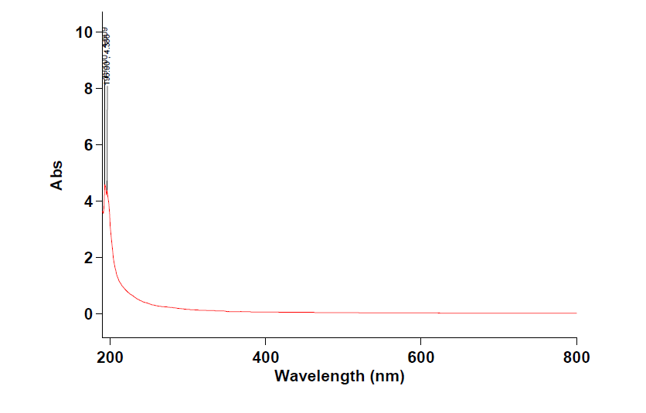Figure 1 shows the Absorbance (ABS) Spectrum versus wavelength (nm) of Sample A (pig bone ash). The range of Absorbance was 190nm to 800nm from the Absorbance versus wavelength spectrum.

**Figure 1 Absorbance spectrum versus wavelength of pig bone ash**

Range 800.00nm to 190.00nm

Wavelength (nm) 193.00, Abs 4.609

The absorbance spectrum of the pig bone Ash showed a peak at 193nm. The absorbance at this wavelength was 4.609. This absorbance value means that the material can absorb 53.91% of light in it. The reasons that can be attributed to this absorbance level are; opaque nature of the material and the grey/black color. Since pig bone ash had an average absorbance value it can be used in solar energy applications (the content authority.com)

According to Wang *et al* (2020) materials with good absorbance level can be applied in these areas: solar absorbing paints, suspended particles devices and pigmented polymer foils for radioactive cooling.

Figure 2 shows the Absorbance Spectrum (ABS) versus wavelength (nm) of hamburger seed shell. The range of wavelength was the same with the Pig bone ash. It can be seen from the Absorbance Spectrum that the wavelength showed a peak at 196nm having an absorbance value of 4.166.

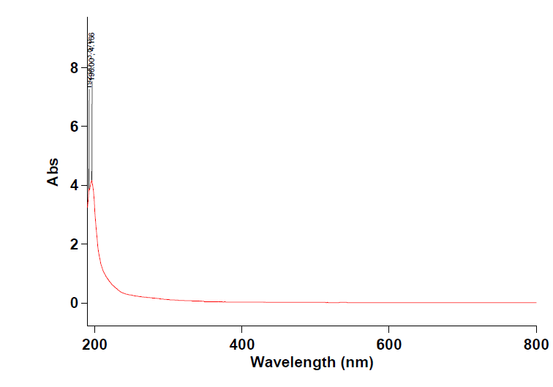

**Figure 2 Absorbance Spectrum versus wavelength hamburger seed shell**

Peak Threshold 0.0100

Range 800.00nm to 190.00nm

Wavelength (nm) 196.00, Abs 4.166

The absorbance value of 4.166 means that 58.34% of light at the wavelength of 196nm can be absorbed by the material. The black color of the hamburger seed shell and the thick texture contributed to its good absorbance value. Absorbance gives information on the quantity of light absorbed by the material.

* 1. **Fourier Transform Infrared Spectroscopy**

(FTIR) Spectroscopy Analysis: The FTIR analysis was done to identify the functional groups present in the pig bone ash (Sample A) and hamburger seed shell (Sample B)

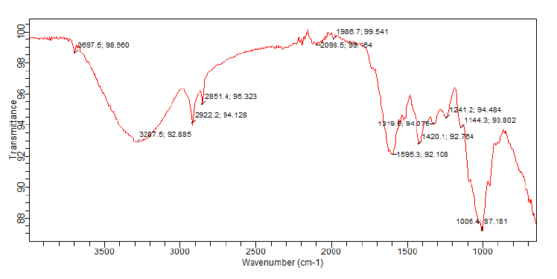Figure 3 and table 1 shows the FTIR spectrum and functional groups identified in the pig bone Ash. (Sample A)

**Fig 3: FTIR spectrum of pig bone ash (sample A).**

**Table 1: Functional group of pig bone ash (sample A).**

|  |  |  |  |
| --- | --- | --- | --- |
| **wave number (cm-1)** | **class of compound (functional group)** | **Intensity** | **assignment** |
| 3574.5 | Carboxylic acid  CH3 – C (o) – OH  R – C O O H | Strong | O – H stretch |
| 2098.550 – 2109.7 | Alkynes | Medium | C ≡ C stretch |
| 1559.0 | Amides  CH3 – C(0) – NH3  (R – (CO) – O – R1 | Medium – strong | N – H bend |
| 1453.7 | Aromatic compounds | Medium – strong | Ring C = C stretch |
| 1021.3 | Ethers  CH3 O CH3 (R – O – R1) | Medium – strong | = C – O – C symmetric |
| 872.2 | Peroxides | Medium | C – O – O Stretch |
| 738.0 | Monosubsituted Aromatic compound | Strong | C – H bend |
| 670.9 | Cis Alkenes | Medium – strong | = C – H bend |

From the table above it can be seen that the pig bone ash contains Carboxylic acid, Alkynes, Amides, Aromatic compounds, Ethers, peroxides and C is alkenes. These functional groups contributes to its structure and behavior as a filler in engineering products.

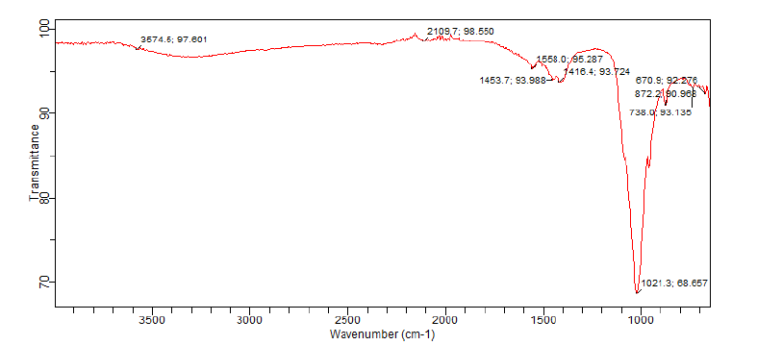Fourier transform infrared spectrum and functional groups identified in sample B (Hamburger seed shell).

**Fig. 4: FTIR spectrum of hamburger seed shell (sample B).**

**Table 2: Functional groups of hamburger seed shell (sample B).**

|  |  |  |  |
| --- | --- | --- | --- |
| **Absorption wave**  **number (cm-1)** | **Class of compound** | **Intensity** | **Assignment** |
| 3697.5 | Alcohol | Medium | O – H stretch non bonded hydroxyl group |
| 3287.5 | Amine Aliphatic secondary Amine | Strong | N – H stretch |
| 2922.5 | Carboxylic acid | Strong | O – H stretch |
| 2851.4 | Alkanes and Alkyls | Strong | C – H stretch |
| 2098.5 | Alkynes | Medium – strong | C ≡ C Stretch |
| 1986.7 | Isothiocyanate (Nitrogen O XY compounds) | Medium | - NCS  (R – N = C = S) |
| 1596.3 | Alkyl halides | Very strong | C – F stretch |
| 1219.9 | Amides | Weak – medium | N – H bend |
| 1420.1 | Carbonate ion | Medium | Co $\frac{2}{3}$ Stretch |
| 1241.2 | Esters | Strong | O = C – O – C stretch |
| 1144.3 | Nitro compounds | Strong | N – O symmetric & asymmetric stretch |
| 1006.4 | Alkylhalides | Very strong | C – F stretch |

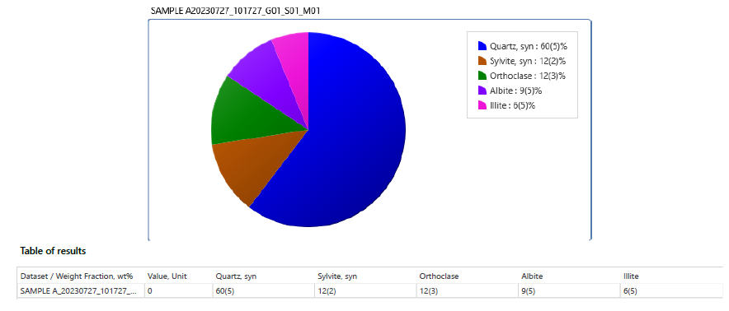

From table 2 above it can be seen that the Hamburger seed shell contained these functional groups: Alcohol, Amine, Carboxylic acid, Alkyls and Alkanes, Alkyne, Isothiocyanate, Alkyl halides, Amides, Carbonate ion, Esters and Nitro compounds.

* 1. **X-Ray Diffraction Analysis**

The XRD analysis was performed to analyze the structure of the Pig bone ash (sample), Hamburger seed shell (sample B) and polypropylene – Pig bone ash – hamburger seed shell composite.

The XRD results showed different minerals present in the samples, their crystallite sizes and strains, the peaks, orientation and phases present in these materials.

**Table 3: Peak list observed in pig bone ash (sample A)**

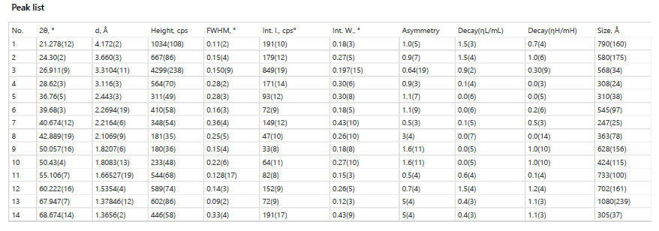

Table 3 shows the phases identified in the Pig bone ash analysis and their formular. It can be seen that quartz, sylvite or thoclase, albite and illite were contained in the pig bone ash used for these analysis.

The phase data view and the phases identified is shown in Fig 5 and table 4 From the figure shown below quartz had the greatest composition while illite had the least.

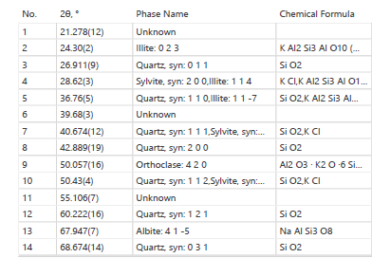**Table 4: Phases identified in pig bone ash (sample A)**

The plot of the results are illustrated in figure 5 and table 6 From the diagrams illustrated above the values of the identified minerals are quartz 60%, Sylvite 12% orthoclase 12%, Albite 9%, illite 6% by weight. Similar work on fly ash cement by Haruna etal (2019) equally revealed that high value of quartz was contained in fly ash geopolymer cement.

**Figure 5 and table 6** plot and table of results for XRD minerals in pig bone ash.

Table 7 shows the peak list observed in the XRD analysis of hamburger seed shell (sample B). It was equally observed that as the two theta values increases the interplanar distance (spacing) decreases. FWHM values increased as the interplanar distances increased. Large FWHM values indicated small particles while small FWHM indicated big particles.

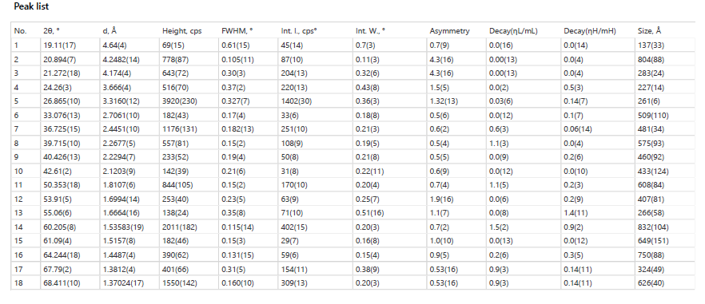**Table 7 Peak list observed in hamburger seed shell**.

Table 8 below shows the phases identified from the XRD analysis of hamburger seed shell and their chemical formula. From the table it can be seen that the minerals contained in the hamburger seed shell are Quartz, Orthoclase, Albite and illite.

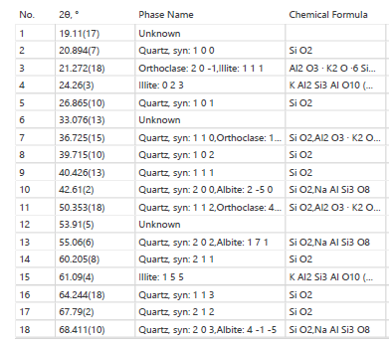**Table 8: Phases identified in hamburger seed shell.**

The plot of results is shown in Fig 6 while the table of results is shown in table 9

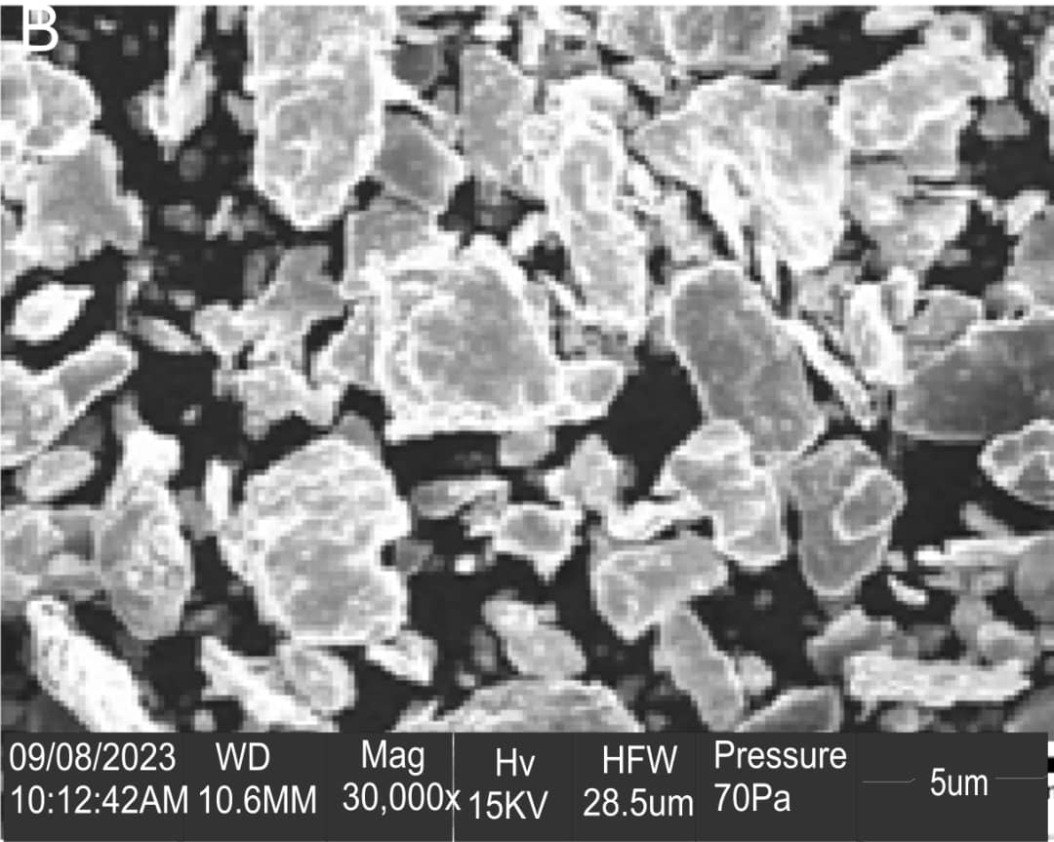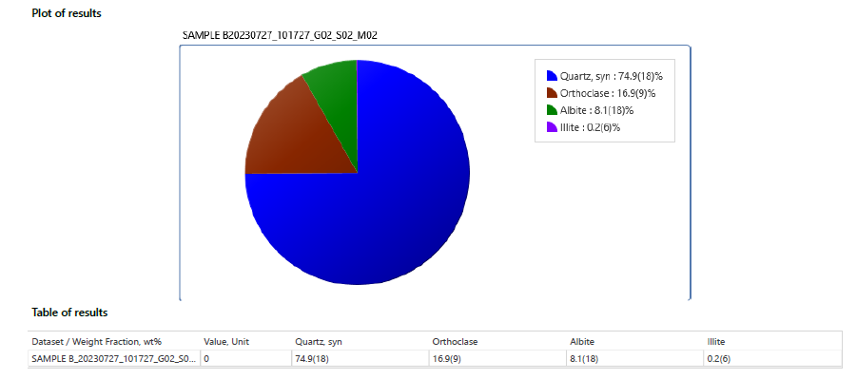

**Fig 6 and table 9 Plot and table of results of XRD results for hamburger seed shell**

From all the analysis quartz had the highest composition of 74.9wt% while illite had the least composition of 0.2%.

**3.4 Scanning Electron Microscopy and Energy Dispersive X-Ray Spectro Scopy (SEM-EDX) Analysis.**

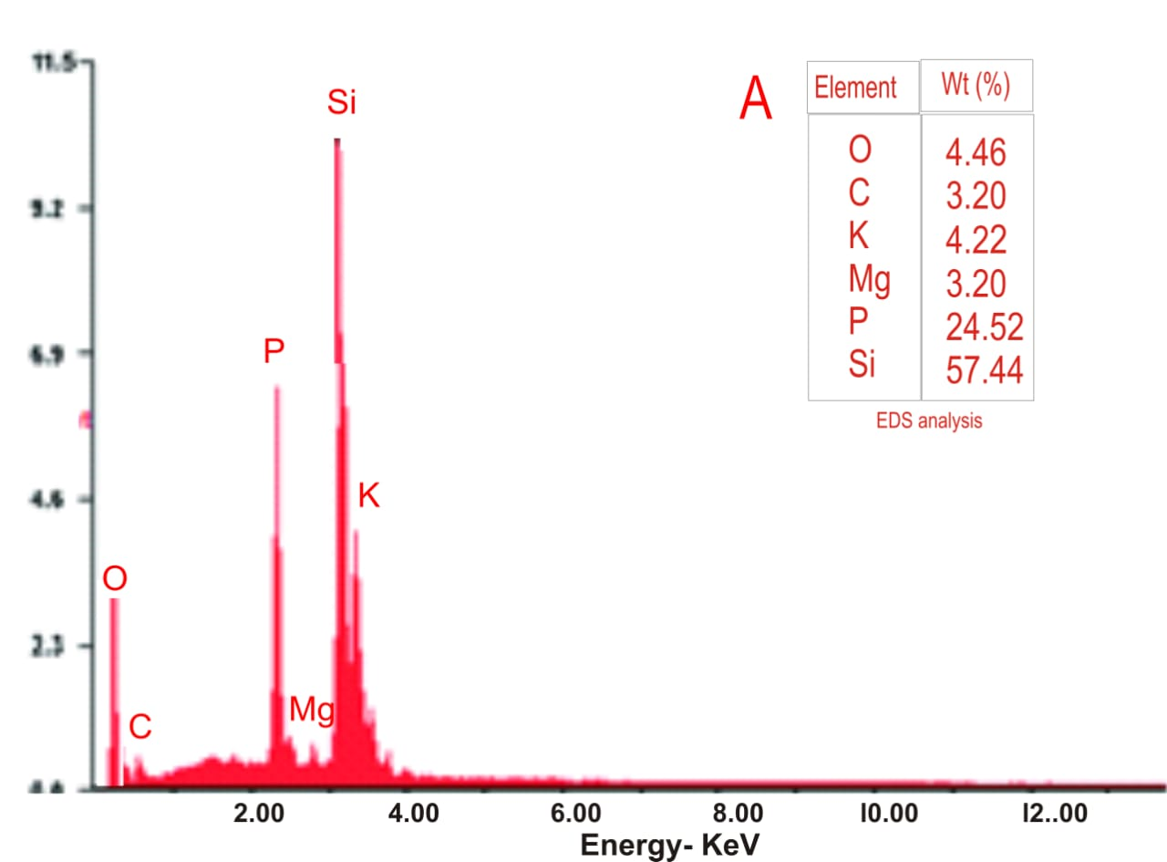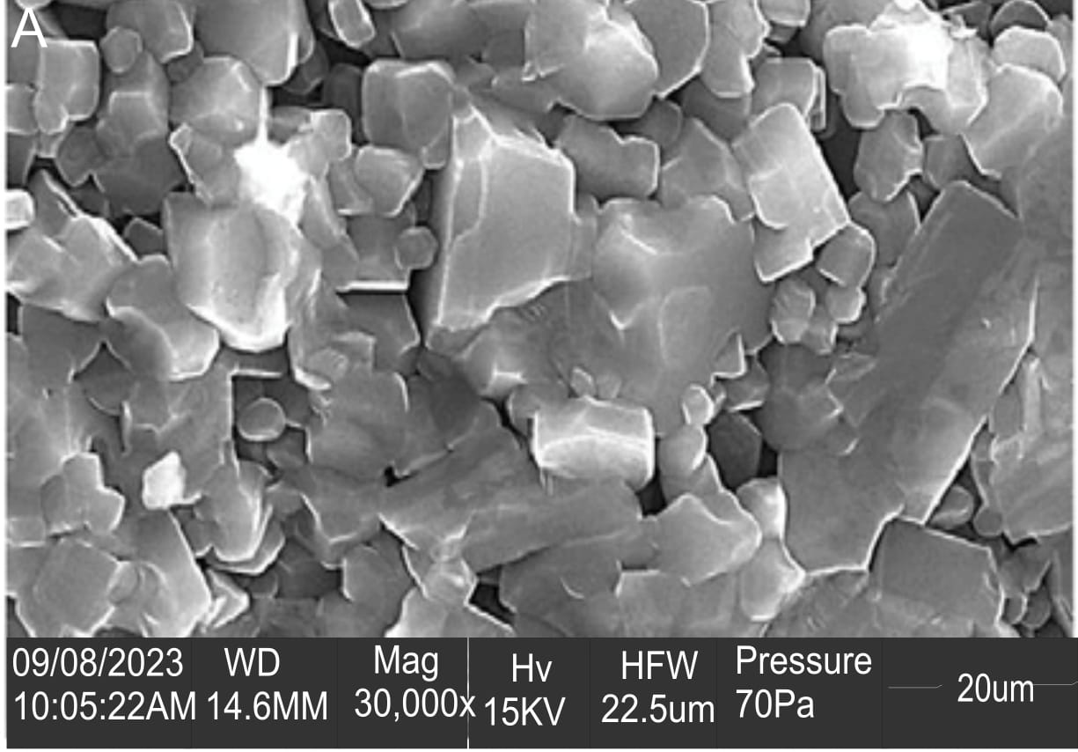Scanning electron microscopy analysis was performed to study the structure, morphology and interactions of the samples. The samples were pig bone ash (sample a), hamburger seed shell (sample b). EDX analysis was done to obtain the chemical elements that occurred due to electron and sample interaction.

**Fig 7** Photomicrograph of pig bone ash

**Fig 8** EDX spectrum pig bone ash

The particles of the pig bone Ash were dispersed. The dispersed particles were seen to pile up. This pilling up of dispersed particles can help to stop vertical dislocation in the material. Fig 7 further proves the hollow ,porous, cellular and semi spherical structure of pig bone ash. EDX spectrum of pig bone ash is presented in 7. From the spectrum the elements present are o, c, k, mg, p si. The composition of the elements in wt% are shown in the table at the spectrum. Silicon had the highest composition of 57.44wt% while carbon (3.20wt %) and magnesium (3.20 wt%) had the least composition.

The higher percentage of silicon is attributed to the nutrition of the pigs. Most pigs consume sand and mud which is indigestible.

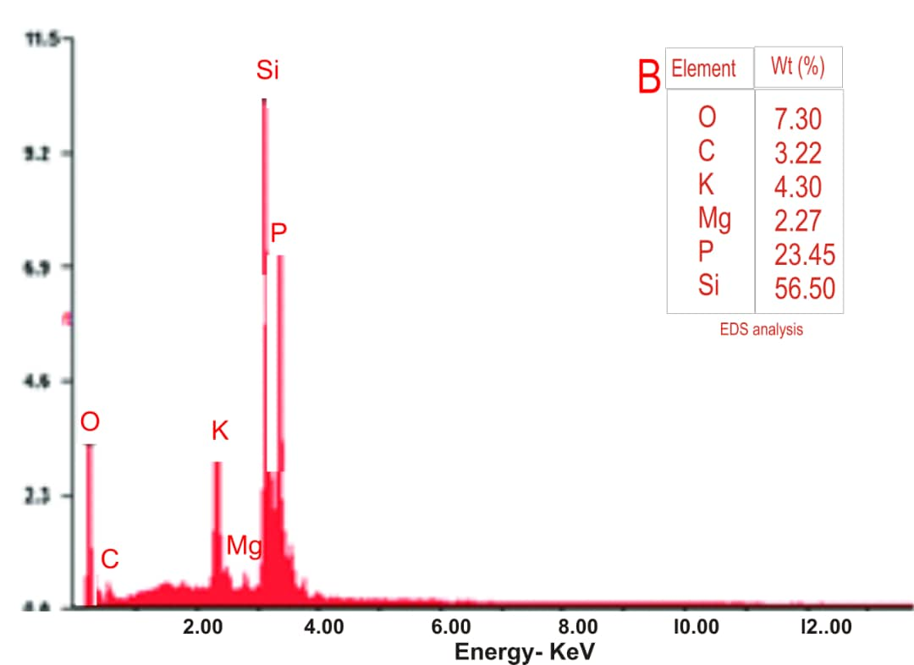Figure 9 present the scanning electron microscopy photomicrographs of hamburger seed shell. The hamburger seed shell has thick topography with porosity The particles are not aligned together. There are large inter particle distances among the particles.

**Fig 9** Photomicrograph of h hamburger seed shell at the magnification of 30,000X

**Fig 10** EDX spectrum of hamburger seed shell

It presented a fibrous structure showing non uniform grain size distribution.

Hamburger seed shell had different shapes of particles in its microstructure. The shapes of particles observed were circular, spherical, rectangular and oval. Very wide gaps existed between the particles.

Figure 10 shows the EDX spectrum of the hamburger seed shell. The elements contained in hamburger seed shell are o, c, k, mg, p, si.

Si had the highest composition of 56.50wt% while Mg had the least composition of 2.27. The higher percentage of silicon is attributed to environmental factors and the absorption of silicon dioxide by the root of plants which is translocated into the cell wall.

**4.0 Conclusion**

Characterization of pig bone ash and hamburger seed shell was conducted in this study. The results revealed essential minerals, elements and functional groups highlighting their compositional value. This discovery underscores the potential of these agricultural waste products as sustainable engineering materials.

Scanning Electron Microscopy (SEM) analysis exposed a porous structure in both materials, suggesting their effectiveness in various applications including: Thermal Insulation, Sound absorption, filtration, high surface areas for enhanced adsorption capabilities and engineering products requiring improved toughness and compressive strength.

**5.0 REFERENCES**

Absorbance Vs Absorbance: When to use each one in writing the content authourity.com/absorbance –vs- absorbance. Accessed 16th July, 2023

Ajala, L. O., Ali, E. E., Singh J (2022) insights into purification of contaminated water activated charcoal derived from hamburger seed coat International Journal of Environment Science and Technology Vol. 19 pp6541-6554.

Bamidele O. S (2019) “Hamburger seed shell as Biofertilitzer for improved crop yield” Journal of Environmental Science and Health Part B 54, 137 -144.

Clemens H, Mayer S, Christian S (2017) Microstructure and properties of engineering materials wiley online library <https://onlinelibrary>. Wiley.com > pdf

Chyle B (2023) which bones make up the skeleton of a pig. Zoonery for all pet loves. Zoonery.com/ which bones make up the anatomy of a pig.

Ejikeme C. et al (2022) U. V. radiation effects on pig bone ash and hamburger seed shell for adsorption applications. Journal of Environmental Science and Technology 16 (2), pp12-20

Eze U. C. (2020) “Physicochemical characterization of pig bone ash for environmental remediation” Journal of Environmental Management 262, 110-118.

Fern K (2024) Tropical Plants Data Base < tropical the ferns/info/view.php?id=muluna+sloanei

FTIR Spectroscopy principles & Applications/Thermofisher scientific US https://www.thermofisher.com>ftir? Information accessed 30th October, 2022.

Hassan M. (2022) What is the unit of absorbance study.com/learn/lesson.absorbance-units-overview-measurement- html. Accessed 13th March, 2023.

Osondu A. (2019) “Pig Production in Abia State challenges and prospects” Report submitted to Abia State Government, Nigeria

Oyedepo G. A. (2020) Physical properties of Hamburger seed shell for adsorption studies [www.researchgate.net](http://www.researchgate.net)

Postek M. T. et al (2017) “Scanning Electron Microscopy” A Student’s Handbook Springer Science and Business Media Doi: 10.1007/978-3-319-49241-1

Sahithi S, Manasa L, Anusha G, Krishna S. V. (2024) Review on Different Parameters and Uses of Bone Ash Journal of Emerging Technologies and Innovative Research (JETPR) April 2024 Vol. II, Issue 4

Wang J, Nilsson A. M, Barrios D, Vorgas W. E. (2020) Light Scattering Materials for energy related applications Determination of absorption and scattering coefficients. Materials today proceedings volume 33 part 6 pp2474-2480.