**An overview on a Computer-Aided Drug Design by Pharmacophore modelling and Virtual screening approach.**

Krushna Bapusaheb Jare1, Miss. Aaditee Gore2 and Dr. Megha T. Salve3.

Department of B. Pharmacy.

Shivajirao Pawar College Of B. Pharmacy, Pachegaon,

Ahilyanagar-413725.

ABSTRACT: The drug discovery process is a rocky path that is full of challenges, with the result that very few candidates progress from hit compound to a commercially available product, often due to factors, such as poor binding affinity, off-target effects, or physicochemical properties, such as solubility or stability. This process is further complicated by high research and development costs and time requirements. It is thus important to optimize every step of the process in order to maximize the chances of success. As a result of the recent advancements in computer power and technology, computer-aided drug design (CADD) has become an integral part of modern drug discovery to guide and accelerate the process.

Computer-aided drug discovery techniques reduce the time and the costs needed to develop novel drugs. Their relevance becomes more and more evident with the needs due to health emergencies as well as to the diffusion of personalized medicine. Pharmacophore approaches represent one of the most interesting tools developed, by defining the molecular functional features needed for the binding of a molecule to a given receptor, and then directing the virtual screening of large collections of compounds for the selection of optimal candidates. Computational tools to create the pharmacophore model and to perform virtual screening are available and generated successful studies. This article describes the procedure of pharmacophore modelling followed by virtual screening, the most used software, possible limitations of the approach, and some applications reported in the literature.

KEYWORDS:: structure-based pharmacophore modeling; ligand-based pharmacophore modeling; virtual screening; drug discovery; bioinformatics; computational biology.

**INTRODUCTION:** The concept of pharmacophore was first introduced in 1909 by Ehrlich[1], who defined the pharmacophore as ‘a molecular framework that carries (*phoros*) the essential features responsible for a drug's (*pharmacon*) biological activity’. After a century's development, the basic pharmacophore concept still remains unchanged, but its intentional meaning and application range have been expanded considerably. According to the very recent definition by IUPAC [2] Computer-Aided Drug Discovery (CADD) investigates molecular properties to develop novel therapeutic solutions by way of computational tools and data resources. In its broadest meaning, it includes computational approaches for designing or selecting compounds as potential candidates before they are synthesized and tested for their biological activity[3]. Bioinformatics and computational tools offer an in silico approach to reducing costs and times, i.e., the factors that influence the progress of the research and, in the specific field of drug development, limit the possibilities of fighting more pathologies. To date, in vitro screening is expensive and time-consuming, and alternatives are highly desirable. Virtual Screening (VS) is a CADD method that involves in silico screening of a library of chemical compounds, to identify those that are most likely to bind to a specific target [4].

Pharmacophoric modelling is based on the theory that having common chemical functionalities, and maintaining a similar spatial arrangement, leads to biological activity on the same target. The chemical characteristics of a molecule capable of creating interactions with its ligand are represented in the pharmacophoric model as geometric entities such as spheres, planes and vectors.

**Table 1: Programs and servers used in pharmacophore modeling**.

|  |  |
| --- | --- |
| **Program/Server** | **Brief Description** |
| CATALYST-HipHop (5) | CATALYST is now part of the BIOVIA Discovery Studio. It consists of algorithms used in pharmacophore generation: HipHop and HypoGen. HipHop gives the alignment of active ligands against a specific target and finds the three dimensional arrangements of common features by overlapping various structures. |
| PharmaGist (6) | It is a freely accessible server used in ligand-based pharmacophore generation. This web server detects pharmacophores via multiple flexible alignments of the input molecules. |
| Pharmer (7) | It is a pharmacophore method that makes searching based on the width and complexity of the query instead of the molecular library screened. It is a very fast method and its source code is available under an open-source license. |
| LigandScout (8) | Though it is possible to perform both structure-based and ligandbased phamacophore modeling with LigandScout, it is among the first programs specialized in structure-based pharmacophore modeling. Especially, if the structure of the target protein is present in its ligand bound state, LigandScout is widely used. |
| GALAHAD (9) | The program uses modified genetic algorithm and fixes certain shortcomings of the GASP program and thus increases its performance. It increases the computational speed by using prebuilt structures as a starting point. |

**PRINCIPLES OF PHARMACOPHORE MODELING:**

Pharmacophore is a pattern of features responsible for the biological activity of a compound. This shows that the concept of pharmacophore is more of about features than chemical groups. Each atom or group of a compound that shows features associated with molecular recognition can be converted into a pharmacophore pattern[10,11].

The most important pharmacophoric feature types are: hydrogen bond acceptors (HBAs); hydrogen bond donors (HBDs); hydrophobic areas (H); positively and negatively ionizable groups (PI/NI); aromatic groups (AR); and metal coordinating areas (Figure 1). Additional size restrictions in the form of a shape or exclusion volumes (XVOL)—forbidden areas—can be added to represent the size and the shape of the binding pocket. Since the models themselves do not focus on actual atoms, but on chemical functionalities, they are good tools in recognizing similarities between molecules. Pharmacophore activity is independent of the scaffold, and this explains why similar biological events can be triggered by chemically divergent molecules. The use of these models as a query allows performing searches in the large libraries of compounds made available on the computational platform in order to select molecules of interest for the next vs. or in the chemo-informatics field [12].

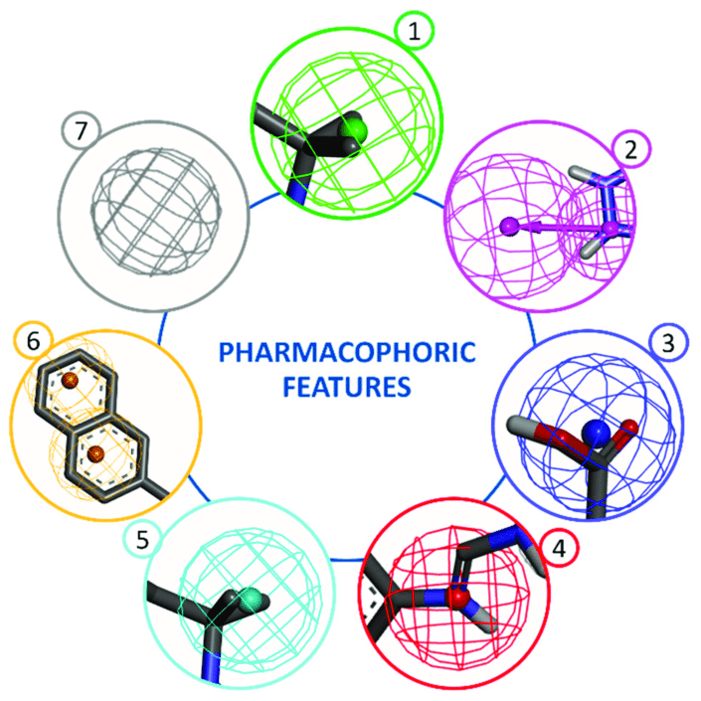

Figure 1. Pharmacophoric features. Main pharmacophoric feature types are represented by geometric entities and include: 1—hydrogen bond acceptor (HBA), 2—hydrogen bond donor (HBD), 3—negative ionizable (NI), 4—positive ionizable (PI), 5—hydrophobic (H), 6—aromatic (AR), 7—exclusion volume (XVOL).[13]

Pharmacophore models can be generated using two different approaches depending on the input data employed for model construction, which are, namely, “structure-based” and “ligand-based” pharmacophore modelling. The structure-based approach uses the structural information of the target proteins like enzymes or receptors, to identify compounds that can potentially be used as a drug. On the other hand, the ligand-based approach consists of the development of 3D pharmacophore models and modelling quantitative structure-activity relationship (QSAR) or quantitative structure-property relationship (QSPR), using only the physicochemical properties of known ligand molecules for drug development. The choice of the best approach to use depends on several factors such as data availability, data quality, computational resources and also the intended use of the generated pharmacophore models.

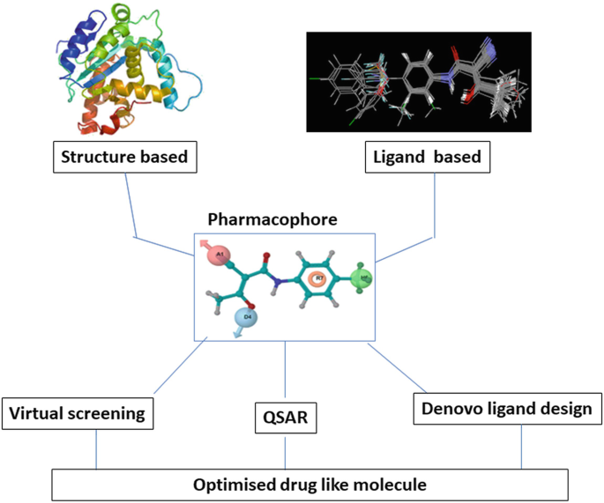

**Structure-Based Modeling of Pharmacophores**

The three-dimensional structure of a macromolecule target is a necessary precondition for creating a structure-based pharmacophore, which is how the structure-based method got its name. A protein's three-dimensional structure offers important details at the atomic level, which can be highly helpful in the development or discovery of novel medications. As explained above, a pharmacophore is an abstract image that displays the stereo-electronic characteristics that, when combined with the protein target's 3D structure in either its holo or apo form, render a ligand bioactive toward a particular target. Generally, the structure-based approach includes the following steps: ligand binding prediction, identification, or protein production.[14]

The 3D structure of the target or the ligand–target complex is the required starting point of this methodology. The RCSB Protein Data Bank (PDB) [www.rcsb.org] (accessed on 20 May 2022) includes thousands of protein structures at high resolution alone or in the presence of a bound ligand, mainly solved by X-ray crystallography or NMR spectroscopy. In case experimental structural data are lacking, computational techniques such as homology modelling may be an alternative strategy to retrieve a 3D model and machine learning-based methods are successfully applied to retrieve protein structures, a powerful example is ALPHAFOLD2. [15,16] Molecular docking is another method to study in silico the interaction of a known active compound towards a specific receptor and derive protein-ligand complexes from the most favorable binding poses [17].

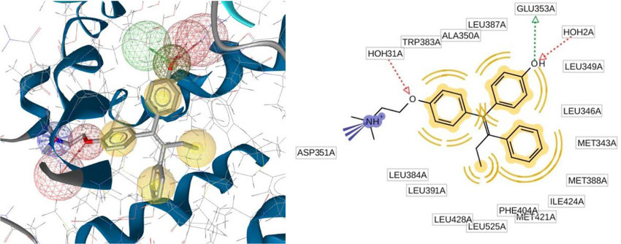

Figure 2: 3D Structure based pharmacophore modeling.[18]

Since the goal of the structure-based method is to generate a pharmacophore model from the interactions between an active molecule (the ligand) and its protein target (enzyme or receptor), the characterization of the ligand-binding site can be used to derive a map of interaction and to build accordingly one or more pharmacophore hypotheses describing the type and the spatial arrangement of the chemical features required for a ligand to interact with the residues of the binding region. Initially, many features are detected with this approach and therefore only those that are essential for ligand bioactivity should be selected and incorporated into the final model to have a more reliable and selective pharmacophore hypothesis. This operation can be accomplished in different ways, such as removing features that do not strongly contribute to the energy binding, identifying the most conserved interaction if multiple protein–ligands structures exist, preserving residue with key functions from sequence alignments or variation analysis, and incorporating spatial constraints from the receptor information[19,20].

**Ligand-based pharmacophore modeling:**

Ligand-based pharmacophore modeling has become a key computational strategy for facilitating drug discovery in the absence of a macromolecular target structure. It is usually carried out by extracting common chemical features from 3D structures of a set of known ligands representative of essential interactions between the ligands and a specific macromolecular target. In general, pharmacophore generation from multiple ligands (usually called training set compounds) involves two main steps: creating the conformational space for each ligand in the training set to represent conformational flexibility of ligands, and aligning the multiple ligands in the training set and determining the essential common chemical features to construct pharmacophore models. Handling conformational flexibility of ligands and conducting molecular alignment represent the key techniques and also the main difficulties in ligand-based pharmacophore modeling[21].

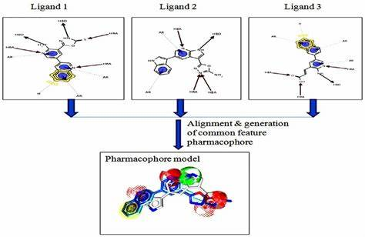

Fig. Ligand-based pharmacophore modeling.

Despite the great advances, several key challenges in ligandbased pharmacophore modeling still exist. The first challenging problem is the modeling of ligand flexibility. Currently, two strategies have been used to deal with this problem: the first is the pre-enumerating method, in which multiple conformations for each molecule are precomputed and saved in a database. The second is the on-the-fly method, in which the conformation analysis is carried out in the pharmacophore modeling process [22].

The first approach has the advantage of lower computing cost for conducting molecular alignment at the expense of a possible need for a mass storage capacity. The second approach does not need mass storage but might need higher CPU time for conducting rigorous optimization. It has been demonstrated that the preenumerating method outperforms the on-the-fly calculation approach [23].

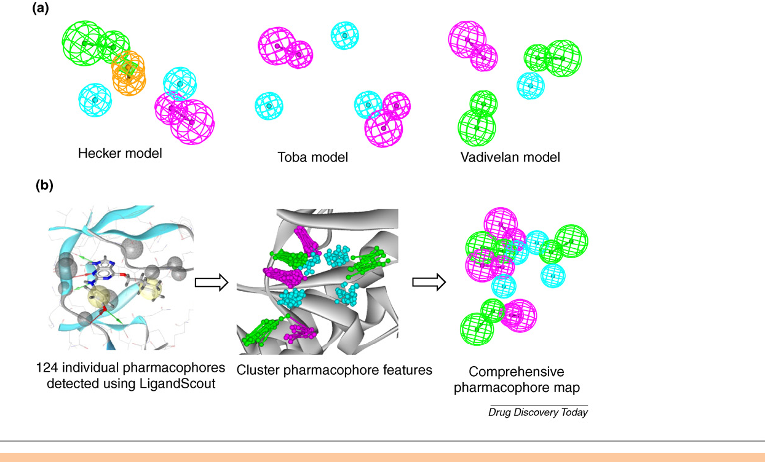

Fig:Pharmacophore models of cyclin-dependent kinase 2 (CDK2) inhibitors. (a) Pharmacophore models of CDK2 inhibitors developed using Catalyst by Hecker et al. [24], Toba et al. [25] and Vadivelan et al. [26]. (b) The basic process for the generation of multicomplex-based comprehensive pharmacophore map of CDK2 inhibitors. The chemical features are color coded: green, hydrogen-bond acceptor; magenta, hydrogen-bond donor; light blue, hydrophobic feature; orange, aromatic ring.

**Virtual screening based pharmacophore modelling:**

Once a pharmacophore model is generated by either the ligandbased or the structure-based approach, it can be used for querying the 3D chemical database to search for potential ligands, which is so-called ‘pharmacophore-based virtual screening’ (VS). Pharmacophore-based VS and docking-based VS represent the mainstream of VS tools at the present time. In contrast to its counterpart, the docking-based VS method, pharmacophore-based VS reduces the problems arising from inadequate consideration of protein flexibility or the use of insufficiently designed or optimized scoring functions by introducing a tolerance radius for each pharmacophoric feature. In the pharmacophore-based VS approach, a pharmacophore hypothesis is taken as a template. The purpose of screening is actually to find such molecules (hits) that have chemical features similar to those of the template. Some of these hits might be similar to known active compounds, but some others might be entirely novel in scaffold. The searching for compounds with different scaffolds, while sharing a biological activity is usually called ‘scaffold hopping’ [27]. The screening process involves two key techniques and difficulties: handling the conformational flexibility of small molecules and pharmacophore pattern identification. The strategies for handling the flexibility of small molecules in pharmacophore-based VS are very similar to those used in pharmacophore modeling. Again, the flexibility of small molecules is handled by either pre-enumerating multiple conformations for each molecule in the database or conformational sampling at search time. Pharmacophore pattern identification, usually called ‘substructure searching’, is actually to check whether a query pharmacophore is present in a given conformer of a molecule. The frequently used approaches for substructure searching are based on graph theory, which include Ullmann [28], the backtracking algorithm [29], and the GMA algorithm [30]. Pharmacophore-based VS can be very time-consuming, especially in cases of screening large chemical databases with flexible molecules, which is currently a key challenge in pharmacophore based VS. A commonly used method to speed up the screening process is the multilevel searching approach [31]. In this approach, a series of screening filters are applied to the molecules in an increasing order of complexity so that the first filters are fast and simple, whereas successive ones are more time-consuming but are applied only to a small subset of the entire database.

**De-novo based Pharmacophore modelling:**

Besides the pharmacophore-based VS described above, another application of pharmacophore is de novo design of ligands. The compounds obtained from pharmacophore-based VS are usually existing chemicals, which might be patent protected. In contrast to pharmacophore-based VS, the de novo design approach can be used to create completely novel candidate structures that conform to the requirements of a given pharmacophore. The first pharmacophore-based de novo design program is NEWLEAD [32], which uses as input a set of disconnected molecular fragments that are consistent with a pharmacophore model, and the selected sets of disconnected pharmacophore fragments are subsequently connected by using linkers (such as atoms, chains or ring moieties). Actually, NEWLEAD can only handle the cases in which the pharmacophore features are concrete functional groups (not abstract chemical features). Other shortcomings of the NEWLEAD program include that the sterically forbidden region of the binding site is not considered and that, as in traditional de novo design programs, the compounds created by the NEWLEAD program might be difficult to chemically synthesize. Other programs such as LUDI4 and BUILDER [33] can also be used to combine identification of structure-based pharmacophore with de novo design. They, however, need the knowledge of 3D structures of the macromolecular targets. To overcome drawbacks of the current pharmacophore-based de novo design software, we have developed a new program, PhDD (a pharmacophore-based de novo design method of drug-like molecules) [34]. PhDD can automatically generate drug-like molecules that satisfy the requirements of an input pharmacophore hypothesis. The pharmacophore used in PhDD can be composed of a set of abstract chemical features and excluded volumes that are the sterically forbidden region of the binding site. PhDD first generates a set of new molecules that completely conform to the requirements of the given pharmacophore model[35].

**CONCLUSION:**Pharmacophore is a pattern of features responsible for the biological activity of a molecule. There are various programs used in the generation of pharmacophore models. The pharmacophore models developed are used to identify new molecules that satisfy the pharmacophore requirements and thus expected to be biologically active. Pharmacophore approaches have evolved to be one of the most successful concepts in medicinal chemistry through the collective efforts of many researchers in the past century. In particular, considerable progress of pharmacophore technology in the past two decades has made pharmacophore approaches one of the main tools in drug discovery. Despite the advances in key techniques of pharmacophore modeling, there is still room for further improvement to derive more accurate and optimal pharmacophore models, which include better handling of ligand flexibility, more efficient molecular alignment algorithms and more accurate model optimization. Lower efficiency (computational time cost) and poor effect (lower hit rate) of pharmacophore-based VS seriously obstructs the applications of pharmacophore in drug discovery. The former, however, will be further reduced and diminished by the increasing capacity and reducing cost of computer hardware. ‘Synergistic’ combination of pharmacophore method and other molecular modeling approaches such as docking is a good strategy to further improve the effect.

**AKNOWLEDGEMENT:**

The corresponding author would like to express sincere gratitude to Miss.Aaditee Gore Mam for their aspiring guidance, valuable contributions and support throughout the preparation of this review article. Her dynamic vision, genuine sincerity, and unwavering motivation have been a profound source of inspiration for me. It was a tremendous privilege and a source of great honor to have the opportunity to learn and collaborate under their exceptional guidance.

**REFERENCES:**

1. C.G. Wermuth,[Glossary of terms used in medicinal chemistry (IUPAC Recommendations 1997)](https://www.sciencedirect.com/science/article/pii/S006577430861101X)Annu. Rep. Med. Chem.(1998)
2. G. Wolber,[Molecule-pharmacophore superpositioning and pattern matching in computational drug design](https://www.sciencedirect.com/science/article/pii/S1359644607003996) Drug Discov. Today (2008)
3. Giordano, D.; Biancaniello, C.; Argenio, M.A.; Facchiano, A. Drug Design by Pharmacophore and Virtual Screening Approach. Pharmaceuticals 2022, 15, 646. <https://doi.org/10.3390/ph15050646>.
4. Voet, A.; Banwell, E.F.; Sahu, K.K.; Heddle, J.G.; Zhang, K.Y.J. Protein Interface Pharmacophore Mapping Tools for Small Molecule Protein: Protein Interaction Inhibitor Discovery. Curr. Top. Med. Chem. 2013, 3, 989–1001.
5. Barnum D, Greeene J, Smellie A, Sprague P. Identification of common functional configurations among molecules. J Chem Inf Comput Sci. 1996;36:563–71. DOI: <https://doi.org/10.1021/ci950273r>.
6. Schneidman-Duhovny D, Dror O, Inbar Y, Nussinov R, Wolfson HJ. PharmaGist: a webserver for ligand-based pharmacophore detection. Nucleic Acids Res. 2008;36 (Web Server issue):223–8. DOI: <https://doi.org/10.1093/nar/gkn187>.
7. Koes, DR, Camacho CJ. Pharmer: Efficient and exact pharmacophore search. J Chem Inf Model. 2011;51(6):1307–14. DOI: <https://doi.org/10.1021/ci200097m>.
8. Wolber G, Langer T. LigandScout: 3-D pharmacophores derived from protein-bound ligands and their use as virtual screening filters. J Chem Inf Model. 2005;45(1):160–9. DOI: <https://doi.org/10.1021/ci049885e>.
9. Richmond NJ, Abrams CA, Wolohan PRN, Abrahamian E, Willett P, Clark RD. GALAHAD: 1. Pharmacophore identification by hypermolecular alignment of ligands in 3D. J Comput Aided Mol Des.
10. Kaserer T, Beck KR, Akram M, Odermatt A, Schuster D, Willett P. Pharmacophore models and pharmacophore-based virtual screening: Concepts and applications exemplified on hydroxysteroid dehydrogenases. Molecules. 2015;20(12):22799– 832. DOI: <https://doi.org/10.3390/molecules201219880>.
11. Bajorath J. Pharmacophore. In: Schwab M, editor. Encyclopedia of Cancer. Berlin Heidelberg: Springer; 2015. p. 2–5. ISBN: 978-3-540-47648-1.
12. Vuorinen, A.; Schuster, D. Methods for generating and applying pharmacophore models as virtual screening filters and for bioactivity profiling. Methods 2015, 71, 113–134.
13. <https://www.google.com/imgres?imgurl=https%3A%2F%2Fwww.researchgate.net%2Fpublication%2F360843647%2Ffigure%2Ffig1%2FAS%3A1160718195929090%401653748191808%2FPharmacophoric-features-Main-pharmacophoric-feature-types-are-represented-by-geometric.png&tbnid=vvQL9UJQBxjxSM&vet=1&imgrefurl=https%3A%2F%2Fwww.researchgate.net%2Ffigure%2FPharmacophoric-features-Main-pharmacophoric-feature-types-are-represented-by-geometric_fig1_360843647&docid=nxrJd56dkrVbRM&w=705&h=705&itg=1&hl=en-GB&source=sh%2Fx%2Fim%2Fm1%2F4&kgs=79cdde0b19086184&shem=abme%2Ctrie>
14. Sanders, M.P.A.; McGuire, R.; Roumen, L.; de Esch, I.J.P.; de Vlieg, J.; Klomp, J.P.G.; de Graaf, C. From the Protein’s Perspective: The Benefits and Challenges of Protein Structure-Based Pharmacophore Modeling. MedChemComm 2012, 3, 28–38.
15. Muhammed, M.T.; Aki-Yalcin, E. Homology modeling in drug discovery: Overview, current applications, and future perspectives. Chem. Biol. Drug Des. 2019, 93, 12–20.
16. Jumper, J.; Evans, R.; Pritzel, A.; Green, T.; Figurnov, M.; Ronneberger, O.; Tunyasuvunakool, K.; Bates, R.; Žídek, A.; Potapenko, A.; et al. Highly accurate protein structure prediction with AlphaFold. Nature 2021, 596, 583–589.
17. Sousa, S.F.; Fernandes, P.A.; Ramos, M.J. Protein-ligand docking: Current status and future challenges. Proteins 2006, 65, 15–26
18. <https://images.app.goo.gl/BYR1ebUnSQiw2kw46>.
19. Chandrasekaran, B.; Agrawal, N.; Kaushik, S. Pharmacophore Development. In Encyclopedia of Bioinformatics and Computational Biology: ABC of Bioinformatics; Elsevier: Amsterdam, The Netherlands, 2018; Volume 1–3, pp. 677–687.
20. Choudhury, C.; Narahari Sastry, G. Pharmacophore Modelling and Screening: Concepts, Recent Developments and Applications in Rational Drug Design. Chall. Adv. Comput. Chem. Phys. 2019, 27, 25–53.
21. Drug Discovery Today Volume 15, Numbers 11/12 June 2010.
22. Poptodorov, K. et al. (2006) Pharmacophore model generation software tools. In Pharmacophores and Pharmacophore Searches (Langer, T. and Hoffmann, R.D., eds),pp. 17–47, Wiley–VCH.
23. Wolber, G. et al. (2008) Molecule-pharmacophore superpositioning and pattern matching in computational drug design. Drug Discov. Today 13, 23–29 16 Smellie, A. et al. (1994) Poling: promoting conformational variation. J. Comput. Chem. 16, 171–187.
24. Hecker, E.A. et al. (2002) Use of Catalyst pharmacophore models for screening of large combinatorial libraries. J. Chem. Inf. Comput. Sci. 42, 1204–1211.
25. Toba, S. et al. (2006) Using pharmacophore models to gain insight into structural binding and virtual screening: an application study with CDK2 and human DHFR. J. Chem. Inf. Model. 46, 728–735.
26. Vadivelan, S. et al. (2007) Virtual screening studies to design potent CDK2-Cyclin A inhibitors. J. Chem. Inf. Model. 47, 1526–1535.
27. Zhao, H. (2007) Scaffold selection and scaffold hopping in lead generation: a medicinal chemistry perspective. Drug Discov. Today 12, 149–155.
28. Ullmann, J.R. (1976) An algorithm for subgraph isomorphism. J. ACM 23, 31–42.
29. Barnard, J.M. (1993) Substructure searching methods: old and new. J. Chem. Inf. Comput. Sci. 33, 532–538.
30. Xu, J. (1996) GMA: a generic match algorithm for structural homorphism, isomorphism, maximal common substructure match and its applications. J. Chem. Inf. Comput. Sci. 36, 25–34.
31. Dror, O. et al. (2006) Predicting molecular interactions in silico. I. An updated guide to pharmacophore identification and its applications to drug design. Front. Med. Chem. 3, 551–584.
32. Tschinke, V. and Cohen, N. (1993) The NEWLEAD program: a new method for the design of candidate structures from pharmacophoric hypotheses. J. Med. Chem. 36, 3863–3870.
33. Roe, D.C. and Kuntz, I. (1995) BUILDER v.2: improving the chemistry of a de novo design strategy. J. Comput. Aid. Mol. Des. 9, 269–282.
34. Huang, Q. et al. (2010) PhDD: a new pharmacophore-based de novo design method of drug-like molecules combined with assessment of synthetic accessibility. J. Mol. Graph. Model. 10.1016/j.jmgm.2010.02.002.
35. Brenk, R. and Klebe, G. (2006) ‘Hot spot’ analysis of protein-binding sites as a prerequisite for structure-based virtual screening and lead optimization. In Pharmacophores and Pharmacophore Searches (Langer, T. and Hoffmann, R.D., eds),pp. 171–192, Wiley–VCH.