**A STUDY ON RECRUITMENT AND SELECTION AT HINDUSTAN UNILEVER LIMITED, ANDHRA PRADESH, AP.**

**SANGADI SURESH RAM KUMAR**

Email ID: sureshramkumarsangadi@gmail.com

And

**Dr.** **PRK.RAJU**

PROFESSOR(DMS)DIRECTOR (SKILL DEVELOPMENT)

Department Of Management Studies

Godavari Institute of Engineering & Technology (A)

Rajahmahendravaram, Andhra Pradesh, India

Email ID:prkraju008@gmail.com

**ABSTRACT**

This study focuses on the recruitment and selection processes within Hindustan Unilever Limited

(HUL), examining how these essential HR functions contribute to organizational efficiency and

employee effectiveness. The research provides an in-depth analysis of the recruitment process,

exploring various sourcing strategies, including both internal and external methods such as employee

referrals, campus recruitment, online job portals, and third-party recruitment agencies. The selection

process is also analysed, covering procedures from initial screening to final selection stages, such as

aptitude tests, interviews, and background checks. The study emphasizes the importance of aligning recruitment policies with HUL's organizational objectives and legal frameworks. Through structured methods and innovative approaches like recruitment and job fairs, HUL aims to attract a broad talent pool while ensuring cost-effective and fair recruitment practices. By enhancing the selection process, HUL seeks to improve employee retention and job satisfaction, ultimately fostering a productive and motivated workforce. This research provides insights and recommendations for refining the recruitment and selection practices to better meet organizational needs and support strategic growth.

**KEY WORDS:** recruitment , selection, Organization, effectiveness.

**INTRODUCTION:**

Today, in every organization personnel planning as an activity is necessary. It is an

important part of an organization. Human Resource Planning is a vital ingredient for the success

of the organization in the long run. There are certain ways that are to be followed by every

organization, which ensures that it has right number and kind of people, at the right place and

right time, so that organization can achieve its planned objective.

Recruitment and Selection plays a vital role in this situation. Shortage of skills and the

use of new technology is putting considerable pressure on how employers go about Recruiting

and selecting staff. It is recommended to carry out a strategic analysis of Recruitment and

Selection procedure. With reference to this context, this project has been prepared to put a light

on Recruitment and Selection process.

**INDUSTRY PROFILE:**

Fast-moving consumer goods (FMCG):

FMCG sector is India’s fourth-largest sector and has been expanding at a healthy rate over the years because of rising disposable income, a rising youth population, and rising brand awareness among consumers. With household and personal care accounting for 50% of FMCG sales in India, the industry is an important contributor to India’s GDP. The FMCG sector in India expanded due to consumer-driven growth and higher product prices, especially for essential goods. FMCG sector provides employment to around 3 million people accounting for approximately 5% of the total factory employment in India. The key growth drivers for the sector include favorable Government initiatives & policies, a growing rural market and youth population, new branded products, and growth of e-commerce Resilience needs to be the key factor in the manufacturing process, daily operations, retail and logistic channels, consumer insights and communication that will help FMCG companies to withstand the test of time and create more value for consumers in the long run. India’s fast-moving consumer goods (FMCG) sector grew 7.5% by volumes in the April-June 2023 quarter, the highest in the last eight quarters, led by a revival in rural India and higher growth in modern trade.

**COMPANY PROFILE :**

Hindustan Unilever Limited (HUL) is a FMCG company in India. With nearly 90 years of heritage in India. HUL is a subsidiary of Unilever. Unilever holds 61.90% stake in HUL. Hindustan Unilever Limited (HUL) is India's largest fast moving consumer goods company is popularly known for its production, marketing, distribution and selling of various products. The Company has about 21,000 employees and has turnover of INR 58,154+ crores (financial year 2022-23). With sales in over 190+ countries. The company mainly involved in five types of commodities, that are • Food products • Home care products • Personal care products • Home water purifiers The company is having around 50+ brands. Its portfolio includes • Food Annapurna salt and Atta, Bru coffee, Brooke Bond tea, Kissan squashes, ketchups, juices and jams, Lipton ice tea, Knorr soups & meal makers and soupy noodles, Quality Wall’s frozen dessert, Hellmann’s mayonnaise, Magnum (ice cream), Cornetto Ice cream cone, Horlicks • Homecare Active Wheel detergent, CIF Cream Cleaner, Comfort fabric softeners, Domex disinfectant/toilet cleaner, Nature Protect disinfectant surface cleaner, Rin detergents and bleach, Sunlight detergent and colour care, Surf Excel detergent and gentle wash, Vim dishwash, Magic – Water Saver. • Personal care Aviance Beauty Solutions, Axe deodorant, aftershave lotion and soap, LEVER Ayush Therapy ayurvedic health care and personal care products, International breeze, Brylcreem hair cream and hair gel, Clear 20 anti-dandruff hair products, Clinic Plus shampoo and oil, Close Up toothpaste, Dove skin cleansing & hair care range: bar, lotions, creams and anti-perspirant deodorants, Denim shaving products, Glow and Lovely, skin lightening cream, Hamam, Indulekha, Lakmé beauty products and salon, Lifebuoy soaps and handwash range ,Liril 2000 soap, Lux soap, body wash & deodorant, Pears soap, body wash, Pepsodent toothpaste, Pond’s creams &talc’s, Rexona, Sun silk shampoo, Sure anti-perspirant, Vaseline petroleum jelly, skincare lotionTRESemmé, TIGI.

**LITERATURE AND REVIEW:**

Recruitment refers to the process of identifying, attracting, and engaging potential candidates for job vacancies within an organization. It involves creating job descriptions, posting job advertisements, and seeking out suitable candidates through various channels.

**The Push and Pull Model**: This model suggests that recruitment occurs in two directions. The "push" factor involves candidates being pushed toward a specific job due to dissatisfaction with their current role. The "pull" factor represents the organization’s ability to attract candidates through compelling employer branding, culture, and other benefits (Barber, 1998).

**Realistic Job Preview (RJP)**: The RJP theory posits that providing potential candidates with a realistic view of the job helps manage expectations, leading to higher job satisfaction and reduced turnover (Wanous, 1973). By being transparent about both positive and negative aspects of the job, organizations can prevent the mismatch between the candidate’s expectations and reality.

Internal recruitment involves filling vacancies with existing employees, which can improve morale and retention. However, external recruitment allows access to a larger pool of candidates and new skills (Breaugh, 2008).

With the rise of technology, recruitment has increasingly moved online through job boards (e.g., LinkedIn, Indeed) and social media platforms. Digital recruitment offers broader outreach and the ability to target passive candidates (Stone et al., 2015).

**Need For the Study :**

• The purpose of study is to learn the practical applicability of the theoretical knowledge gained about Recruitment & Selection process.

• To gain knowledge about, the process of Recruitment & Selection as well as to know the effectiveness or ineffectiveness of the process of Recruitment &Selection in Hindustan Unilever Limited.

• To provide suggestions if any for having an effective recruitment &selection process at Hindustan Unilever Limited.

**Scope Of the Study:**

* The study was conducted to have an insight in to the Recruitment and Selection process.
* The scope of the study was to identify various techniques used in the Recruitment and Selection process and how effective it is done
* The study can be used to recruit the right peo
* Recruitment help store duce the costs.
* Overall efficiency of organization can be improved, if Recruitment process is done properly.

**Objectives Of the Study :**

• To study Recruitment and Selection process in Hindustan Unilever Limited.

•To analyze the effectiveness of Recruitment and Selection process at Hindustan Unilever Limited.

• Attracting and obtaining as many applications as possible from eligible job seekers.

• Increases pool of job candidates at minimum cost.

• Help increase the success rate of the selection process by reducing the number of visibly under qualified or over qualified job applicants.

• Help and reduce the probability that job applicants, once recruited and selected, will leave the organization with in a short span of time.

**Methodology Of the Study:**

This study on recruitment and selection practices at Hindustan Unilever Limited (HUL) utilizes both primary and secondary data to ensure a comprehensive analysis. Data collection methods were chosen to accurately reflect the recruitment and selection processes and to provide a robust foundation for analysis and insights.

**Primary Data :**

Primary data consists of first-hand information collected directly from relevant sources to provide an original perspective on the recruitment and selection practices at HUL.

**Secondary data :**

Data Secondary data includes information and analyses previously collected by other sources, providing a broader context and supporting the primary data.

**DATA ANALYSIS AND INTERPRETATION**

1. **Recruitment is done on the basis of skills and knowledge.**

|  |  |  |
| --- | --- | --- |
| **DIMENSIONS** | **RESPONDENTS** | |
| **No of employees** | **%** |
| **Strongly agree** | **29** | **29%** |
| **Agree** | **53** | **5%** |
| **Disagree** | **9** | **9%** |
| **Strongly disagree** | **6** | **6%** |
| **Neither agrees nor disagree** | **3** | **3%** |

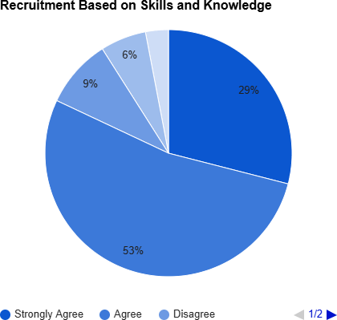

**INTERPRETATION:**

As per the survey, it is found the majority of the employees strongly agree that recruitment is done on the basis of skills and knowledge. The employees are looking out for more area of career growth in the employment, rather than just work. The employees want those specific position skills to improve the work.

1. **Internal recruitment is also given importance**

|  |  |  |
| --- | --- | --- |
| **DIMENSIONS** | **RESPONDENTS** | |
| **No.of employees** | **%** |
| **Strongly agree** | **60** | **60%** |
| **Agree** | **24** | **24%** |
| **Disagree** | **8** | **8%** |
| **Strongly disagree** | **4** | **4%** |
| **Neither agrees or disagree** | **4** | **4%** |

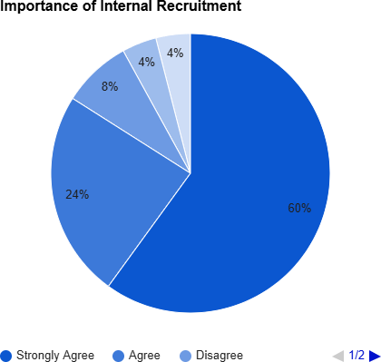

**INTERPRETATION:**

As per the survey, it is found that majority of the employees strongly agree and want internal recruitment be given importance. The employees are preferring more of interdepartmental test and other basic skills for getting internally posted.

### Is Internal recruitment is also given importance

|  |  |  |
| --- | --- | --- |
| **DIMENSIONS** | **RESPONDENTS** | |
| **No.of employees** | **%** |
| **Strongly agree** | **74** | **74%** |
| **Agree** | **16** | **16%** |
| **Disagree** | **6** | **6%** |
| **Strongly disagree** | **4** | **4%** |
| **Neither agrees nor disagree** | **0** | **0%** |

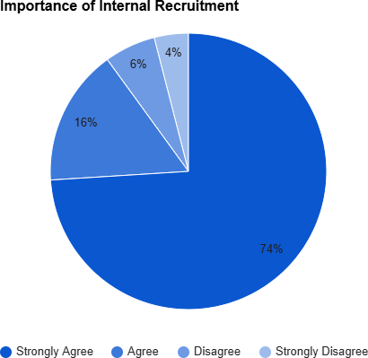

**INTERPRETATION:**

As per the survey, it is found the majority of the employees strongly agree that recruitment is done systematically on a regular basis as soon as there are vacancies. The above statistics show that the recruitment is periodic as soon as there are vacancies.

1. **Recruitment takes place as soon as there are vacancies.**

|  |  |  |
| --- | --- | --- |
| **DIMENSIONS** | **RESPONDENTS** | |
| **No.of employees** | **%** |
| **Strongly agree** | **28** | **28%** |
| **Agree** | **53** | **53%** |
| **Disagree** | **9** | **9%** |
| **Strongly disagree** | **4** | **4%** |
| **Neither agrees nor disagree** | **6** | **6%** |

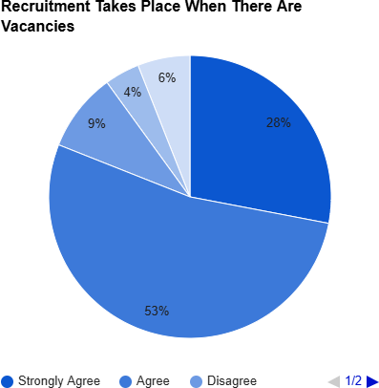

**INTERPRETATION:**

As per the survey, it is found that the majority of employees that agreed and they believe that recruitment takes place as soon as there are vacancies. The above statistics show that at they don’t possibly look for outside recruitment, they definitely take time but do fill in the vacancies as soon as possible.

### chances are given to both fresher’ sand experience aspirants.

|  |  |  |
| --- | --- | --- |
| **DIMENSIONS** | **RESPONDENTS** | |
| **No.of employees** | **%** |
| **Strongly agree** | **66** | **66%** |
| **Agree** | **16** | **16%** |
| **Disagree** | **14** | **14%** |
| **Strongly disagree** | **4** | **4%** |
| **Neither agrees nor disagree** | **0** | **0%** |

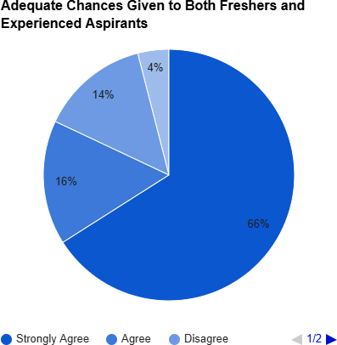

**INTERPRETATION:**

As per the survey, it is found that majority of the employees strongly agree that adequate chances are given for both fresher’s and experienced persons. They believe that a good and equal preference is given for both in the process of recruitment. Freshers are very much eligible for vacancies in the organization.

### FINDINGS:

* + Majority of the employees feel that the job security is good in their organization.
  + Most of the employees feel that work place environment is very good.
  + Many employees are satisfied with the canteen facilities during the shifts.
  + Most of the employees are satisfied with housing facilities provided by the organization.
  + Many employees are satisfied with educational facilities and scholarship facilities provided by the organization.
  + The drinking water facilities provided by the company are sufficient to all the employees.
  + Medical facilities also good in this organization.

### SUGGESTIONS:

* The organization should increase the loan facilities provided to the employees.
* The organization should increase the motivational schemes to the employees.
* The organization should concentrate towards retirement benefits.
* The organization should increase the insurance policies to the employees.
* Majority of the employee that retirement benefits provided are not at is factory.
* It’s better to improve inking water facilities in the organization.

### CONCLUSION:

The process starts with recruitment which continues with selection and ceases with placement of the candidate. Recruiting makes it possible to acquire the number and types of people necessary to ensure the continued operation of the organization. In the letter part of the study, it was discussed about the selection process and its steps that help in selecting an efficient candidate effectively. The sketch of selection procedure at Hindustan Unilever limited involves Job Analyze recruitment, application bank and different kinds of interviews, evaluation references and then placement.

**REFERENCE:**

1. Lievens, F., & Chapman, D. (2019). Recruitment and selection. *The SAGE handbook of human resource management*, 123-150.
2. Newell, S. (2005). Recruitment and selection. *Managing human resources: Personnel management in transition*, 115-147.
3. Abdalla Hamza, P., Jabbar Othman, B., Gardi, B., Sorguli, S., Mahmood Aziz, H., Ali Ahmed, S., ... & Anwar, G. (2021). Recruitment and selection: The relationship between recruitment and selection with organizational performance. *Hamza, PA, Othman, BJ, Gardi, B., Sorguli, S., Aziz, HM, Ahmed, SA, Sabir, BY, Ismael, NB, Ali, BJ, Anwar, G.(2021). Recruitment and Selection: The Relationship between Recruitment and Selection with Organizational Performance*.
4. Anderson, N., Born, M., & Cunningham-Snell, N. (2002). Recruitment and selection: Applicant perspectives and outcomes.
5. Roberts, G. (1997). *Recruitment and selection*. CIPD publishing.