**A STUDY ON WORKING CAPITAL PRACTICES OF NACL INDUSTRIES LIMITED, EETHAKOTA, ANDHRA PRADESH, INDIA Tekumudi Srinu, MBA 2nd year**

Email ID : srinucherry024@gmail.com

And

**Dr. Bandaru Venkata Reddi Naidu**, *M.Com, MBA, Ph.D.,*

**Professor & Head**

Department of Management Studies

Godavari Institute of Engineering and Technology (Autonomous)

Rajamahendravaram, Andhra Pradesh, India.

Email ID: drnaidubandaru@gmail.com

**ABSTRACT**

This report analyses NACL Industries Limited, a major company in India’s agrochemical industry. It focuses on understanding the company’s market position, products, and contribution to sustainable agriculture. NACL Industries manufactures and distributes various agrochemicals such as insecticides, herbicides, fungicides, and plant growth regulators. The company operates three manufacturing plants to ensure a steady supply of products.

The report examines NACL’s market strategies, which include a strong distribution network, investment in research and development, and the aim to provide affordable and safe crop protection solutions. It also highlights the company’s commitment to environmental sustainability and how it tackles challenges in the agrochemical sector. Additionally, the financial performance and growth potential of NACL Industries are analyzed to assess its position in the market.

The findings show that NACL has a strong advantage in delivering quality products while maintaining a balance between profit and sustainability. The report concludes with recommendations for the company to explore new opportunities and improve its market presence.

#### **INTRODUCTION TO WORKING CAPITAL**

###### **Introduction:**

Working capital refers to the short-term financial resources required for the day-to-day operations of a business. It is the difference between a company’s current assets (like cash, inventory, and accounts receivable) and current liabilities (like accounts payable and short-term debt). Essentially, working capital measures a company's liquidity and its ability to meet short-term obligations. A company needs working capital to pay for raw materials, wages, rent, and other operational expenses.

###### **Purpose and Importance of Working Capital:**

The main purpose of working capital is to ensure smooth and efficient operations. It provides the necessary funds to meet immediate financial needs, manage unforeseen expenses, and keep the business running without interruption. Proper management of working capital also helps maintain a balance between profitability and liquidity, reducing financial risk.

Working capital management involves decisions about inventory, accounts receivable, and accounts payable. Good working capital management helps a company improve its cash flow, minimize costs, and maintain financial stability. Too much working capital can lead to unnecessary holding costs, while too little can cause disruptions and liquidity problems. Thus, the goal is to strike a balance, ensuring that there is enough working capital to run the business smoothly without holding excessive funds.

**Working capital** is the amount of money a business needs to cover its day-to-day operations. It is the difference between a company’s current assets (such as cash, inventory, and accounts receivable) and current liabilities (such as accounts payable and short-term debt).

In simple terms, working capital represents the funds available to a business for handling routine expenses like paying suppliers, salaries, rent, and managing inventory. It acts as a financial cushion to ensure that the business can operate smoothly and meet its short-term obligations.

#### **Formula:**

Working Capital=Current Assets−Current Liabilities

**Example:** If a company has current assets worth ₹1,00,000 and current liabilities of ₹60,000, its working capital is:

1,00,000−60,000= ₹40,000

This ₹40,000 is the amount available for the company to run its daily operations smoothly.

###### **Concepts of Working Capital:**

1. **Gross Working Capital**
   * **Definition:** Gross working capital refers to the total value of a company’s current assets. Current assets include cash, inventory, accounts receivable, and marketable securities. It represents the total investment a company has made in its short-term assets.
   * **Objective:** The focus of gross working capital is to effectively manage these current assets to ensure smooth operations and prevent liquidity shortages.

**Example:** If a company’s current assets consist of ₹50,000 in cash, ₹30,000 in accounts receivable, and ₹20,000 in inventory, its gross working capital is ₹1,00,000.

###### **Net Working Capital**

* + **Definition:** Net working capital is the difference between a company’s current assets and its current liabilities. It measures the company’s short-term financial health and ability to cover its current obligations with its current assets.

###### **Formula:**

Net Working Capital=Current Assets−Current Liabilities

* + **Objective:** The focus of net working capital is to determine whether the company has enough resources to meet its short-term debts and manage daily expenses.

**Example:** If a company has current assets of ₹1,00,000 and current liabilities of ₹40,000, its net working capital is:

1,00,000−40,000= ₹60,000

###### **Types of Working Capital Based on Time Period**

1. **Permanent Working Capital:** This refers to the minimum amount of working capital required to keep the business running throughout the year. It remains in the business permanently.
2. **Temporary Working Capital:** This refers to the additional working capital required to meet seasonal demands or temporary fluctuations in sales.

###### **Key Points to Remember:**

* + **Positive Working Capital** indicates that the company has sufficient current assets to cover its short-term liabilities, which is a sign of good financial health.
  + **Negative Working Capital** means the company’s current liabilities exceed its current assets, indicating a potential liquidity problem.
  + Efficient working capital management helps maintain a balance between liquidity and profitability.

**PROFILE of NACL LIMITED**

**1. Overview**

Company Name NACL diligence Limited

innovated 1994

Headquarters Hyderabad, Telangana, India

Type Public Limited Company

Stock Listing Listed on the Bombay Stock Exchange(BSE) and the National Stock Exchange of India(NSE )

**2. Industry Sector**

NACL operates within the agrochemical sector, specializing in manufacturing and marketing a wide range of crop protection products. The company is a significant player in the Indian agrarian request and is concentrated on enhancing agrarian productivity through innovative results.

**3. Product Portfolio**

NACL diligence has a different product portfolio that includes

Fungicides

Germicides Products aimed at controlling colourful nonentity pests. Dressings Used to manage unwanted weeds that contend with crops. Pesticides Designed to cover crops from fungal infections.

Factory Growth Controllers Enhance crop yield and quality by modifying factory growth processes.

Adjuvants Ameliorate the effectiveness of fungicides and dressings.

**4. Manufacturing installations**

NACL operates multiple manufacturing installations to insure a steady force of products

expression shops

position Srikakulam District, Andhra Pradesh.

Focus on producing a variety of agrochemical phrasings in different forms( liquid, greasepaint, grains, etc.).

Specialized Plant

Location Eethakota, East Godavari District, Andhra Pradesh.

Specialized in manufacturing active constituents that form the base of agrochemical phrasings.

**5. Research and Development( R&D)**

NACL places significant emphasis on R&D to introduce and develop new products that meet the evolving requirements of the agrarian sector. The company invests in

Developing Eco-friendly and sustainable agrochemical results. Formulating bio fungicides andbio-stimulants.

uniting with exploration institutions for advanced agrarian practices.

**6. Distribution Network**

NACL has established a robust distribution network across India, icing that its products reach growers efficiently. The company also exports its products to colorful countries, expanding its global footmark.

**7. Sustainability enterprise**

NACL is committed to sustainable husbandry and is concentrated on developing products that are environmentally friendly. The company aims to promote responsible use of agrochemicals to minimize environmental impact and support sustainable husbandry practices.

**8. Fiscal Performance**

NACL has shown harmonious growth over the times, with a strong focus on profitability and functional effectiveness. crucial fiscal highlights include

profit Growth The company has reported steady profit growth, driven by increased demand for its agrochemical products.

request Capitalization Listed on stock exchanges, NACL’s request capitalization reflects its position as a leading agrochemical manufacturer in India.

**The Board of Directors for NACL diligence Limited includes:**

1. Mrs. K Lakshmi Raju- Chairperson &Non-Executive Director

2. Mr. M Pavan Kumar- Managing Director & CEO

3. Mr. Sudhakar Kudva- Independent Director

4. Mr. N Vijayaraghavan-Non-Executive Director

### ****Literature Review****

**Working capital** is essential for any business to handle daily operations, like buying raw materials, paying salaries, and managing other expenses. It is the difference between a company's **current assets** (like cash and inventory) and **current liabilities** (like loans and bills to pay). Proper management of working capital ensures the company has enough money to run smoothly without financial problems.

### ****Why is Working Capital Important?****

1. **Liquidity**: Ensures the company can pay bills on time.
2. **Profitability**: Helps in balancing money used for daily needs and profits.
3. **Stability**: Keeps the company financially healthy even in challenging times.

### ****Types of Working Capital****

1. **Permanent Working Capital**: The minimum money needed to keep the business running all year.
2. **Temporary Working Capital**: Extra money needed during busy seasons (like agricultural seasons).

### ****Challenges in Managing Working Capital****

* Raw material prices may go up, creating unexpected costs.
* Delays in collecting money from customers can cause cash shortages.
* Over or understocking inventory affects business operations.

### ****Why Study NACL Industries?****

NACL Industries is a leading agrochemical company. Since their products depend on seasonal demand, managing working capital is especially challenging. This study focuses on how NACL:

* Handles money for day-to-day operations.
* Manages cash, inventory, and debts effectively.
* Maintains a balance between short-term needs and long-term goals.

### ****What Was Found?****

1. NACL uses strategies like maintaining good inventory levels and quickly collecting money from customers.
2. Their financial performance shows they are stable but need improvements in some areas, like reducing costs and improving cash flow.

**Need and Scope for the Study**

The need for the study working capital to run the day-to-day business activities cannot be emphasized. Earning a steady amount of profit requires successful sales activity. The firm has to invest enough funds in current assets for the success of sales activity. Current assets are needed because sales are not converted in to cash immediately to find out deficiencies in Working Capital Management. To analyse the solvency or liquidity position and to suggest optimum working capital to suit the needs of the company. The scope of this study is to explore the business operations, strategies, and market positioning of NACL Industries Limited within the agrochemical industry. It focuses on examining the company’s product portfolio, which includes insecticides, herbicides, fungicides, and plant growth regulators, and its manufacturing capabilities across its three plants. The study also analyses NACL’s market strategies, emphasizing its distribution network, investment in research and development, and commitment to providing cost-effective and sustainable solutions. Additionally, the study assesses the company’s financial performance to understand its growth trends and profitability. The research also delves into NACL’s efforts towards sustainability and innovation in its product development processes. Finally, the study aims to identify the challenges faced by NACL in a competitive market and explore potential opportunities for growth. This comprehensive approach provides a holistic understand of NACL Industries Limited’s business practices and strategic direction within the agrochemical sector.

**Objectives of the Study**

* To Study the Working Capital and its Components of the Company.
* To know the overall Operational Efficiency and Performance of the Company.
* To Study the Financial Position of Company.
* To Study Financial Information about Financial Resources and obligations of Company.
* To know the Working Capital Efficiency of the Company.
* To Evaluate Efficiency Working Capital Management of NAGARJUNA AGRICHEMS LIMITED, Eethakota.
* To analyse the patterns of financial working capital needs.

**Methodology of the Study**

The data required for this study is collected from two major sources.

They are

**Primary data:**

The **Primary** data is collected from employees through a structured questionnaire.

**Secondary data:**

The secondary source of data was collected from various journals, company records and websites.

**RESULTS DISCUSSION**

**Table -5.1**

##### **CURRENT RATIO:**

**Graph-5.1**

###### **Current Ratio**:

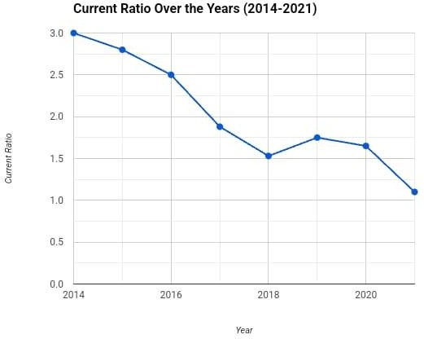

**Source:**

The firm analysis of total of all current ratios are shows fluctuations. In the year 2014&2015 the current ratio is 3&2.8. In the year 2016 the current ratio is 2.5. In the year 2017 current ratio is 1.8. In the year 2018 the current ratio is 1.5. In the year 2019 the current ratio is 1.7. In the year 2020 the current ratio is 1.6. In the year 2021 the current ratio is 1.1.

##### **Table-5.2**

##### **COMPUTATION OF ABSOLUTE LIQUID RATIO:**

Absolute liquid ratio= cash\current liabilities

##### 

**Graph-5.2**

Absolute Liquid Ratio = Cash/Current Liabilities

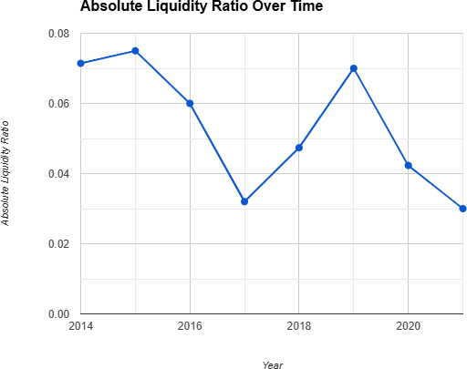

###### **Source:**

The ratio establishes the relationship between cash and current liabilities. Cash is the most or absolute liquid asset for any firm. The accepted standard ratio is 0.75: 1. The absolute liquidity ratio of NAGARJUNA AGRICHEM LIMITED was not up to the mark during all the five years.

**Table-5.3**

##### **COMPUTATION OF INVENTORY TURNOVER RATIO:**

Inventory Turnover Ratio: Sales / Average Stock

|  |  |  |  |
| --- | --- | --- | --- |
| **Year** | **Sales** | **Average Inventory** | **Ratio** |
| 2014-2015 | 41209.51 | 7678.67 | 5.37 |
| 2015-2016 | 60535.77 | 9503.79 | 6.37 |
| 2016-2017 | 65031.39 | 15944.52 | 4.08 |
| 2017-2018 | 57008.39 | 14575.03 | 3.91 |
| 2018-2019 | 64306.50 | 16420.02 | 3.92 |

**Table-5.3**

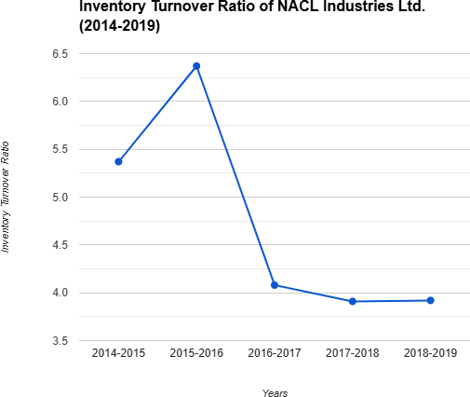**Graph-5.3**

###### **Source:**

The ratio indicates the efficiency of the firm in selling its product. It is calculated by dividing the cost of goods sold with average inventory. For NAGARJUNA AGRICHEM LIMITED, in this the Inventory Turnover Ratio is moves in a decreasing way.i.e.in the year 2014-2015 it stands at 5.37 and then in the next year 2015-2016 it increased and in the next years 2016-2017 ,2017-2018 &2018- 2019 decreased.

##### **Table-5.4**

##### **SALES TO NET WORKING CAPITAL RATIO:**

Sales to Net Working Capital= Sales**/** Net Working Capital

|  |  |  |  |
| --- | --- | --- | --- |
| **Year** | **Sales** | **Networking capital** | **Ratio** |
| 2014-2015 | 41209.51 | 7250.56 | 5.68 |
| 2015-2016 | 60535.77 | 9357.4 | 6.47 |
| 2016-2017 | 65031.39 | 22611.44 | 2.88 |
| 2017-2018 | 57008.39 | 8196.77 | 6.95 |
| 2018-2019 | 64306.50 | 6567.92 | 9.79 |

**Graph-5.4**

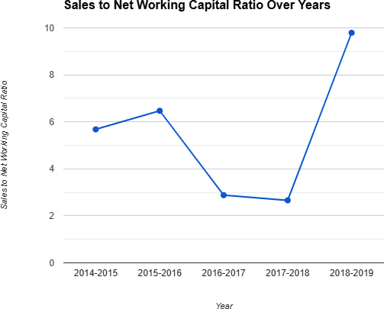

Source:

The ratio indicates the relationship between the Sales and the Net Working Capital of NAGARJUNA AGRICHEM LIMITED., as increased over the years, it has increased to 5.68 & 6.47 in the years 2014-2015 & 2015-2016 and decreased to2.88 in the year 2016-2017and it has increased to 6.95 in the year 2017-2018 and finally in the year 2018-2019 it has increased to 9.79.

##### **Table-5.5**

##### **TOTAL ASSETS TO NET WORKING CAPITAL RATIO:**

Total Assets to Net Working Capital Ratio = Total Assets **/**Net Working Capital

|  |  |  |  |
| --- | --- | --- | --- |
| **Year** | **Total Assets** | **Networking capital** | **Ratio** |
| 2014-2015 | 22858.14 | 7250.56 | 3.15 |
| 2015-2016 | 25520.89 | 9357.4 | 2.73 |
| 2016-2017 | 41020.42 | 22611.44 | 1.18 |
| 2017-2018 | 55164.93 | 8196.77 | 6.73 |
| 2018-2019 | 63081.44 | 6567.92 | 9.60 |

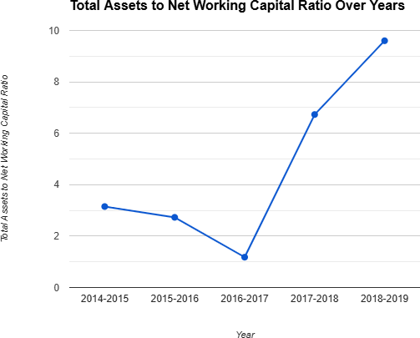 **Graph-5.5**

###### **Source:**

The ratio indicates the relationship between the total Assets and the Net Working Capital of the firm; the ratio stands to 3.15 in the year 2014-2015 and it is decreased to 2.73 & 1.81 in the years 2015- 2016 &2016-2017 In the year 2017-2018 is increased to 6.73 and finally in the year 2018-2019 it has increased to9.60.

* + **FINDINGS**
* During the period of study, it was observed that the current ratio position is not met standard except 2014.
* In the year 2017 the quick ratio is 1.2 it gives good sign and all the remaining years it is up to the standard ratio that is 11.
* During the period of study, it is observed that in the year 2011-2012 Inventory Turnover Ratio is very high.
* As far as financial data concern the Net Working Capital position of the company is increase year by year except 2012-2013.
* A part from the study it has been found that Debtors Turnover Ratio has been decreased year by year.
* As far as the study concern the Net Profit position of the company is very good in the year 2010-2013buy company could not maintain sufficient Net Profit in the year 2014&2015 it indicates dangerous sign. with high salary and pay rise on good performance.
* **SUGGESTIONS**
* I suggest that shortage of sales is reduced then the networking capital will be increased.
* Cash and bank balances should be saved to avoid future problems.
* The company has to maintain good working capital with systematic planning and techniques.
* It is better for future contingencies.
* The company should liberalize the credit policy to encourage credit sales.
* The company current ratio is below the standard ratio. So that, I suggested that the company should be increased in the current ratio.

### Summary of the Project

**Objective**:

To study and evaluate the working capital components of NACL Industries.

To understand the company’s financial efficiency, operational performance, and solvency.

**Scope**:

The study explores NACL’s product portfolio, financial strategies, and sustainability initiatives.

It highlights the challenges and opportunities within the agrochemical industry.

**Key Findings**:

The analysis of working capital trends over multiple years reveals effective management of current assets and liabilities.

Tools like current ratio and liquidity analysis indicate NACL's capacity to meet short-term obligations while ensuring operational efficiency.

Inventory management and debtor-creditor relationships contribute significantly to the company's financial health.

**Recommendations**:

Improve cash flow cycles by optimizing receivables and payables.

Leverage sustainable practices and technology for cost efficiency.

**Methodology**:

Data was collected through primary means (interviews) and secondary sources (company reports).

**BIBLIOGRAPHY**

* Sharma, R., & Jain, K. (2019). Working Capital Management in Agrochemical Industry. Journal of Financial Studies, 12(2), 135-149.
* Brigham, E. F., & Houston, J. F. (2019). Fundamentals of Financial Management. Cengage Learning.
* Pandey, I. M. (2010). Financial Management. Vikas Publishing House.
* Gupta, S., & Agarwal, A. (2020). Financial Performance and Working Capital Efficiency of Fertilizer Companies in India. Journal of Agricultural Economics, 56(3), 219-234.
* Bhattacharya, H. (2007). Working Capital Management Strategies and Techniques. PHI Learning.
* Deloof, M. (2003). Does Working Capital Management Affect Profitability of Belgian Firms? Journal of Business Finance & Accounting, 30(3-4), 573-588.
* Singh, P., & Reddy, K. (2022). Managing Cash Flow in Agrochemical Companies. International Journal of Finance and Accounting, 47(2), 301-315.
* Weston, J. F., & Brigham, E. F. (2010). Managerial Finance. Harcourt College Publishers.
* Lee, S. (2023). Optimizing Working Capital in Fertilizer Companies: A Case Study. Financial Management Review, 21(4), 190-202.