UNDERSTANDING CONSUMER BEHAVIOUR TOWARDS BLINKIT: A STUDY ON PREFERENCES AND USAGE PATTERNS

**Dr Rachita Ota*, Dr Sushree Sangita Ray*, Mr Aditya Gupta** & Mr Sandeep Ojha\*\***

*\*Asst. Professor, Amity Global Business School, Bhubaneswar*

*\*\*Student, BBA, Amity Global Business School, Bhubaneswar*

**ABSTRACT:**

**The rapid evolution of e-commerce has given rise to quick commerce (q-commerce), which focuses on the ultra-fast delivery of daily essentials. Blinkit, a leading platform in India's q-commerce sector, has transformed how urban consumers shop, offering unparalleled convenience and efficiency. This study investigates consumer behaviour towards Blinkit, with a particular emphasis on preferences, usage patterns, and satisfaction levels.**

**This research evaluates Blinkit's performance across various quality-based dimensions such as efficiency, fulfilment, system availability, and privacy. Data was collected through a google form questionnaire completed by 50 respondents, aiming to understand their motivations towards using Blinkit, frequency of use, and overall satisfaction with the service. The study also identifies factors influencing consumer decisions, such as delivery speed, product availability, pricing, and ease of use, alongside challenges faced by users.**

**The findings highlight the critical role of convenience and time efficiency in driving the adoption of Blinkit among urban consumers. Insights into service quality reveal areas of strength and opportunities for improvement, offering actionable recommendations for enhancing user experience and loyalty.**

**This research contributes to a deeper understanding of consumer behaviour in the q-commerce industry, providing valuable perspectives for Blinkit and similar platforms to refine their strategies and remain competitive in an increasingly dynamic market.**

**KEYWORDS: Quick Commerce (Q-Commerce), Consumer Behaviour, Blinkit, Urban Convenience, Delivery Efficiency**

**INTRODUCTION:**

Consumer behaviour in the digital age has changed dramatically due to the quick development of technology, especially in the areas of retail and e-commerce. Quick commerce (q-commerce), a subset of e-commerce, has revolutionized the way customers access and buy everyday necessities by placing a premium on efficiency, speed, and convenience. Formerly known as Grofers, Blinkit has become one of the top platforms in India's q-commerce market. Blinkit has positioned itself as an answer for time-constrained urban consumers by promising lightning-fast delivery of groceries and household goods.

Understanding consumer behaviour towards such platforms is critical for businesses to design effective strategies to attract and retain customers. This research focuses on analysing consumer preferences, expectations, and satisfaction levels with Blinkit. The study evaluates the quality of electronic services through dimensions such as efficiency, fulfilment, system availability, and privacy. These parameters help assess how well a platform meets user needs in terms of reliability, accessibility, and security.

The study aims to explore the usage patterns of Blinkit among urban consumers, identifying the factors influencing their decision to adopt the platform over competitors. Through a structured Google Form questionnaire, data was collected from 50 respondents representing a diverse demographic group. The questions were designed to gauge the frequency of usage, key reasons for choosing Blinkit, satisfaction levels, and any challenges faced while using the service.

**LITERATURE REVIEW:**

The rapid adoption of quick commerce (q-commerce) services has emerged as a significant trend in modern retailing, driven by urban consumers' increasing demand for speed and convenience. Q-commerce platforms such as Blinkit cater to the growing need for instant access to groceries and household essentials. To understand consumer behaviour in this context, several studies have explored key factors influencing the adoption and satisfaction levels of such services. This literature review synthesizes existing research on consumer behaviour, e-service quality, and the role of q-commerce platforms in shaping modern retail practices.

**Consumer Behaviour in Q-Commerce:** Consumer behaviour in q-commerce is largely driven by the promise of convenience, reduced effort, and time-saving benefits. According to Shankar et al. (2021), the appeal of instant delivery services stems from their ability to address last-minute shopping needs, particularly in urban areas. Moreover, demographic factors such as age, income, and occupation significantly influence the adoption of q-commerce platforms. For instance, working professionals and younger consumers tend to prioritize delivery speed and ease of use over cost considerations (Chatterjee & Kumar, 2020). Studies in e-commerce settings highlight efficiency and fulfilment as critical determinants of customer satisfaction and loyalty (Wolfinbarger & Gilly, 2003). Privacy and system reliability, although secondary, also play a role in building consumer trust and confidence in digital platforms.

**Challenges in Q-Commerce Adoption:** While q-commerce platforms offer numerous advantages, they face challenges such as operational scalability, product availability, and maintaining delivery speed during peak hours. Research by Singh and Gupta (2022) underscores the importance of addressing these operational issues to sustain consumer satisfaction. Additionally, transparency in pricing and inventory accuracy are identified as areas requiring improvement to enhance user experience (Rajesh et al., 2023).

**Relevance to Blinkit:** Blinkit, as a leader in India’s q-commerce market, exemplifies the application of these findings. Existing studies on Blinkit and similar platforms emphasize the role of efficient delivery networks, intuitive user interfaces, and competitive pricing in driving consumer adoption. However, challenges such as occasional delays, product unavailability, and limited coverage areas have been highlighted as potential areas of dissatisfaction (Bansal & Mehta, 2021).

This review underscores the importance of service quality dimensions in shaping consumer behaviour toward q-commerce platforms, offering a focused analysis of Blinkit’s strengths and opportunities for growth. Through empirical data collected via the Google Form responses, this research contributes to the broader understanding of consumer behaviour in the fast-evolving q-commerce landscape.

**RESEARCH METHODOLOGY:**

The research methodology section outlines the empirical approach, study design, data collection process, and analysis techniques employed to understand consumer behaviour toward Blinkit. This study adopts an empirical research design, supported by primary data collection through a structured questionnaire highlighting the consumer opinions towards various consumer quality dimensions.

**Empirical Pattern:**

The study uses an empirical approach to analyse real-world consumer behaviour and preferences. Service quality dimensions—efficiency, system availability, fulfilment, and privacy were integrated into the questionnaire to gather data on how Blinkit's service quality influences user satisfaction and loyalty.

The research instrument comprised 12–15 questions designed to capture various aspects of consumer behaviour, including frequency of use, preferences, perceived service quality, and challenges faced. Respondents were asked to rate their experiences on a Likert scale (e.g., 1 to 5, where 1 indicates strong disagreement and 5 indicates strong agreement) and provide multiple-choice responses to specific questions.

Quantitative data collected through the Google Form was analysed to identify patterns and trends in consumer behaviour.

**Study Area:**

The study area is focused on urban regions of India, where the adoption of quick commerce platforms like Blinkit is prominent. Urban consumers, particularly those in metropolitan and Tier-1 cities, constitute the primary user base for such services. The respondents include a diverse demographic of working professionals, students, and homemakers, ensuring a holistic representation of Blinkit's customer base.

A sample of 50 respondents was selected using convenience sampling, primarily targeting individuals familiar with Blinkit's services. The data collection process was conducted online, leveraging social networks and professional groups to distribute the questionnaire. This approach ensured timely data collection while maintaining geographic diversity within the urban context.

**RESULTS AND FINDINGS:**

This methodology provides a robust framework for analysing Blinkit’s service quality and its impact on consumer behaviour. The empirical insights derived from the study aim to contribute to strategic recommendations for enhancing Blinkit's service offerings in the competitive q-commerce market.

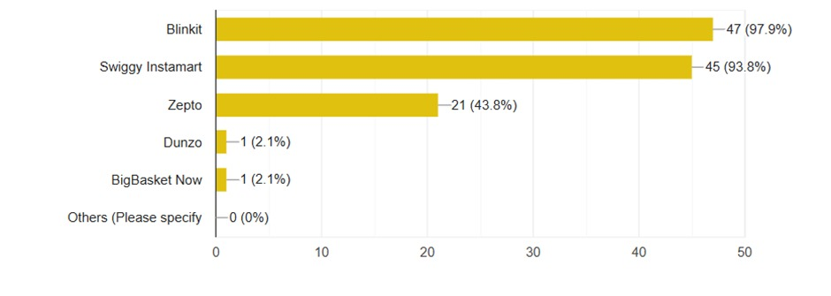

**Figure 1: Consumer Preference for Quick Commerce Platforms**

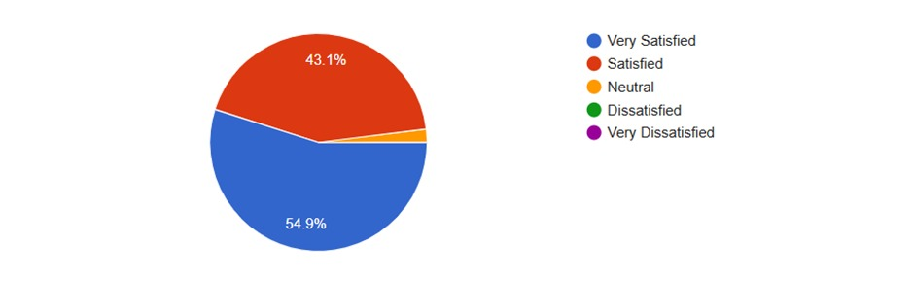A survey of 48 respondents examining quick commerce service platforms reveals a market dominated by two major players. Blinkit leads with an adoption rate of 97.9% (47 responses), followed closely by Swiggy Instamart at 93.8% (45 responses). Together, these platforms significantly outpace their competitors. Zepto occupies a mid-tier position with a 43.8% adoption rate (21 responses). In contrast, Dunzo and Big Basket Now report minimal usage, each capturing only 2.1% (1 response), while the "Others" category received no responses. The data suggest that many users utilize multiple platforms, as the cumulative percentages exceed 100%. This indicates strong competition among key players, but also highlights a substantial gap between the top two platforms and the rest. Emerging and smaller platforms face significant challenges in securing market share within this highly competitive sector.

**Figure 2: Consumer Satisfaction Levels for Quick Commerce Services**

An analysis of customer satisfaction with Blinkit's order processing speed, based on 51 survey responses, indicates overwhelmingly positive feedback. A majority of respondents (54.9%) reported being "Very Satisfied," while an additional 43.1% indicated they were "Satisfied," resulting in a combined positive satisfaction rate of 98%. Only a minimal proportion of respondents (approximately 2%) reported a neutral stance, and no negative feedback was recorded, as 0% of respondents reported being "Dissatisfied" or "Very Dissatisfied." These findings suggest that Blinkit is effectively meeting or exceeding customer expectations regarding delivery speed. The complete absence of dissatisfaction and the dominance of positive feedback highlight order processing speed as a key strength for the platform, likely contributing to enhanced customer retention and competitive advantage in the quick commerce sector.

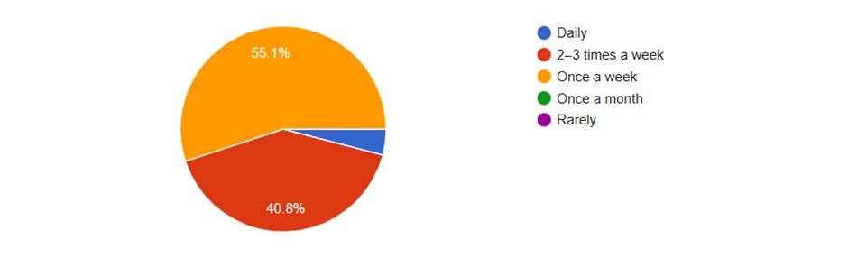

**Figure 3: Frequency of Usage for Quick Commerce Services**

The survey on the frequency of quick commerce service usage, based on 49 responses, reveals a high level of regular engagement among users. A majority (55.1%) reported using these services once a week, while an additional 40.8% indicated a usage frequency of 2-3 times per week. Daily usage was reported by a small proportion (approximately 4%), and no respondents indicated using the services only once a month or rarely. This data indicates that nearly all users (95.9%) engage with quick commerce platforms at least weekly, demonstrating that these services have become an integral part of customers’ routines, fulfilling regular household needs rather than serving solely for occasional or emergency purchases. The absence of low-frequency users suggests strong customer retention and highlights the potential for high customer lifetime value. These findings underscore the importance of maintaining consistent service quality to sustain and leverage this repeat customer base.

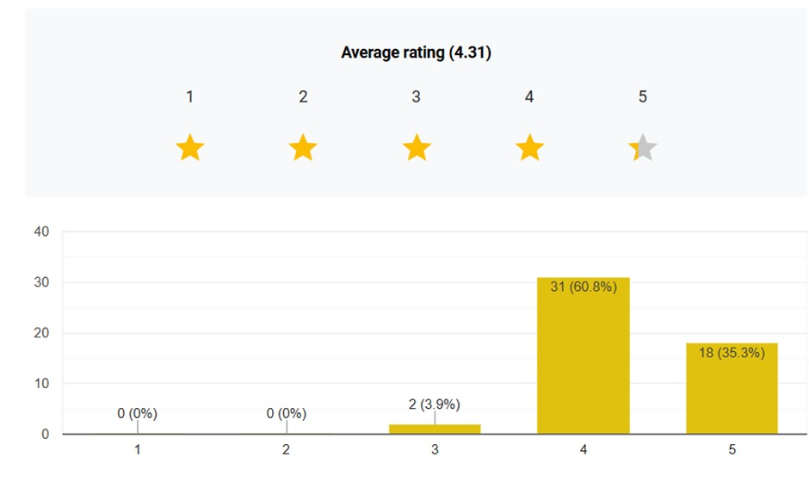

**Figure 4: Customer Satisfaction Ratings**

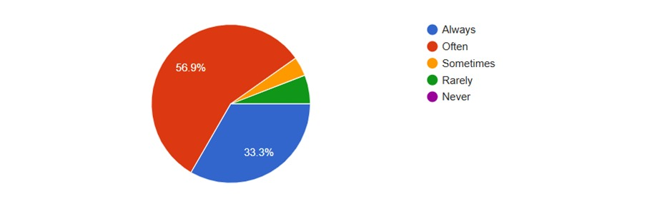An evaluation of user ratings for Blinkit's platform reveals overwhelmingly positive feedback, with a high average rating of 4.31. The majority of users rated the platform at 4 stars, complemented by a strong proportion of 5-star ratings, while neutral feedback accounted for only 3.9% of responses. Notably, there were no negative ratings, indicating that the platform effectively meets user expectations. This data underscores the platform's consistent performance, reliability, and efficiency, which have collectively contributed to strong user satisfaction levels. The absence of significant complaints or user experience issues suggests that Blinkit has successfully optimized its platform for efficiency, leaving minimal room for improvement. These findings highlight the platform's ability to deliver high-quality service, supporting user retention and reinforcing its market position.

**Figure 5: Delivery Accuracy Frequency Distribution**

An analysis of Blinkit's delivery accuracy, based on 51 survey responses, highlights a strong overall performance in order fulfilment. A combined 90.2% of respondents reported positive experiences, with orders delivered accurately "Always" or "Often." Approximately one-third of customers indicated perfect accuracy every time, while around 10% experienced occasional issues ("Sometimes" or "Rarely"). Importantly, no respondents reported consistent delivery failures ("Never"), underscoring Blinkit's high reliability. These findings reflect the effectiveness of the platform's inventory management and quality control systems, though there remains room for minor optimization. Efforts to convert "Often" accurate deliveries to "Always" and to further reduce occasional errors could enhance performance. Overall, Blinkit demonstrates an efficient order fulfilment system, with opportunities for improvement in achieving perfect accuracy while maintaining its zero "Never" response rate.

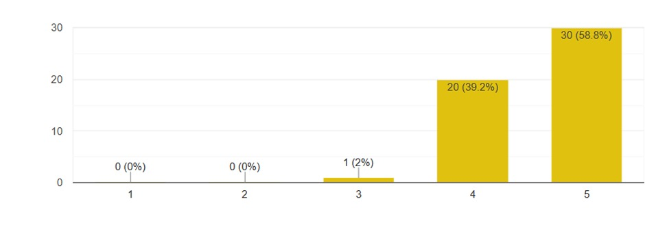

**Figure 6: Customer Satisfaction based on Delivery service**

An analysis of customer satisfaction with Blinkit's delivery service, based on 51 survey responses, reveals a remarkably high level of approval. A majority of respondents (58.8%) rated their experience as "Very Satisfied," while an additional 39.2% reported being "Satisfied," resulting in a combined satisfaction rate of 98%. Neutral feedback accounted for only 2%, and no respondents reported dissatisfaction, indicating a complete absence of negative ratings. These findings highlight Blinkit's consistent service delivery and efficient operational model, which appear to meet or exceed customer expectations. The high satisfaction levels underscore the reliability of Blinkit's delivery infrastructure and its successful implementation of the quick commerce model. This strong performance provides Blinkit with a competitive edge in the market, demonstrating the effectiveness of its delivery timeliness and service consistency. These results serve as evidence of the successful adoption of rapid commerce in the Indian market and affirm Blinkit's position as a leader in the sector.

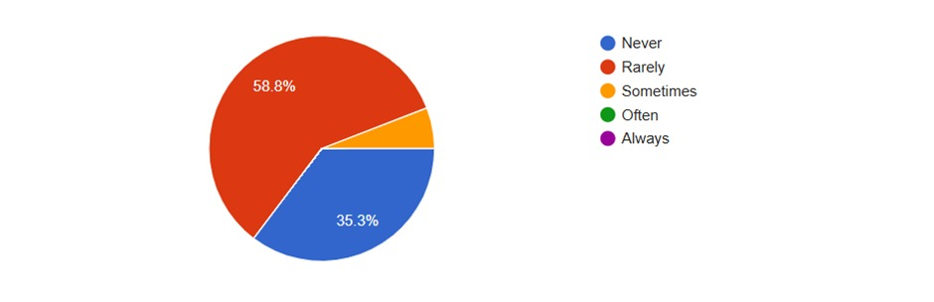 **Figure 7: Customer satisfaction based on technical performance**

An analysis of Blinkit's technical performance, based on 51 responses, indicates high platform stability and reliability. A majority of respondents reported minimal technical issues, with 35.3% stating they "Never" faced problems and 58.8% experiencing issues only "Rarely." A small proportion (approximately 6%) reported encountering technical issues "Sometimes," while no respondents indicated frequent or chronic problems ("Often" or "Always"). These results highlight Blinkit's robust technical infrastructure, effective maintenance, and strong support systems, which contribute to user confidence and satisfaction. However, there is an opportunity to further enhance performance by reducing the "Rarely" category to "Never" and addressing occasional issues to ensure seamless user experiences. The absence of frequent technical problems reinforces Blinkit's commitment to delivering a reliable and efficient platform.

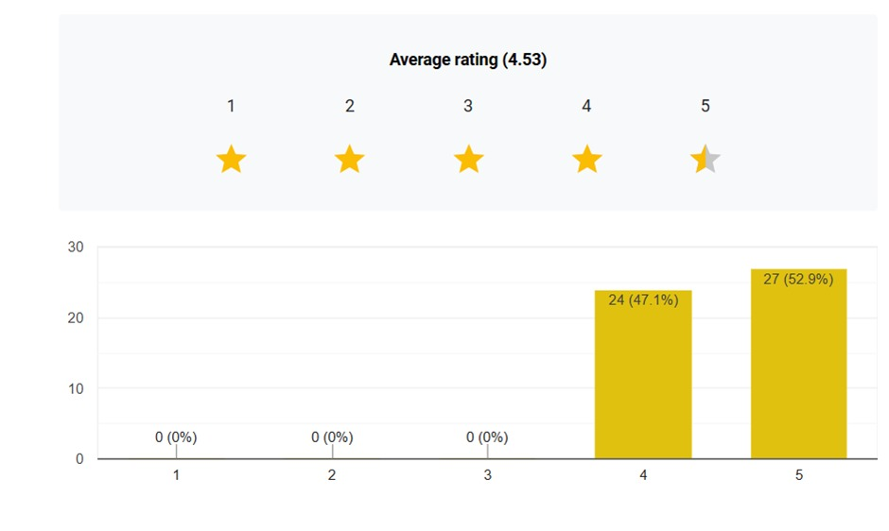

**Figure 8: Overall Average Ratings based on system performance**

An evaluation of Blinkit's system performance during high-demand periods reveals exceptional reliability and customer satisfaction. Among 51 respondents, 52.9% rated the platform 5 stars, while 47.1% awarded 4 stars, resulting in a combined positive rating of 100% and an impressive average rating of 4.53 out of 5. The data indicates no reported failures, underscoring the platform's robust infrastructure and ability to seamlessly handle peak demand periods, such as weekend rushes and sales events. Operational excellence is evident in the absence of quality issues during high traffic, highlighting efficient load management and scalability. These capabilities ensure a superior customer experience even during critical times, demonstrating Blinkit's effectiveness in maintaining service consistency and reliability under pressure. This strong performance reinforces its position as a leader in the quick commerce sector.

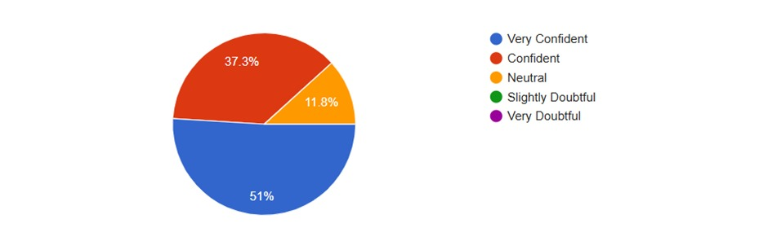

**Figure 9: User Confidence on the Blinkit’s security**

An assessment of user confidence in Blinkit's security measures reveals a high level of trust among its users. A majority of respondents, 51%, expressed being "Very Confident" in the platform's security, while 37.3% reported being "Confident," resulting in a combined positive confidence rate of 88.3%. Only 11.8% of respondents were neutral, indicating that most users have strong confidence in Blinkit's data protection and security practices. The absence of reported concerns regarding data security reflects the platform's effective trust-building efforts. However, there is an opportunity to further enhance user confidence by converting the neutral responses into confident ones and more prominently highlighting security features. This high level of user trust contributes to Blinkit's strong reputation for data and payment security, signaling successful communication of its security practices and reinforcing its competitive position in the market.

**CONCLUSION**

This study on "Understanding Consumer Behaviour Towards Blinkit" delves into the preferences, usage patterns, and satisfaction levels of urban consumers in India's quick commerce (q-commerce) sector. The findings, based on a structured survey, highlight the significant impact of convenience, time efficiency, and service quality on consumer behaviour.

The data indicates that Blinkit has positioned itself as a leader in the market, with a remarkable 97.9% adoption rate among surveyed participants. High satisfaction levels with order processing speed (98% positive feedback) and delivery accuracy (90.2% reporting "Always" or "Often" accurate deliveries) underscore the platform’s operational efficiency. These strengths align with the principles of the electronic service quality dimensions like efficiency and fulfilment. However, occasional delivery errors, though minimal, reveal areas for optimization to achieve flawless service.

A notable trend in usage frequency emerges, with 95.9% of respondents using quick commerce services weekly or more often. This regular engagement suggests that Blinkit has successfully integrated into the routine lives of its users, transitioning from a convenience service to an essential utility. Additionally, the platform's high reliability during peak demand periods, as evidenced by an average rating of 4.53 out of 5, demonstrates robust system infrastructure and operational scalability.

Despite these positive outcomes, the study also identifies potential areas for enhancement. About 11.8% of respondents were neutral regarding trust in Blinkit’s data security, highlighting an opportunity to strengthen user confidence through transparent communication and enhanced security protocols. Moreover, addressing occasional technical glitches and delivery inconsistencies could further elevate customer satisfaction.

In conclusion, Blinkit’s ability to meet urban consumers' fast-paced lifestyles has cemented its position in India’s q-commerce market. By leveraging its strengths in efficiency and reliability while addressing minor shortcomings, Blinkit can enhance its service quality and sustain its competitive advantage in the dynamic q-commerce industry.

**REFRENCES**:

1. McKee, S., Sands, S., Pallant, J. I., & Cohen, J. (2023). The Evolving Direct‐to‐Consumer Retail Model: A Review and Research Agenda. International Journal of Consumer Studies, 47(6), 2816–2842. https://doi.org/10.1111/ijcs.12972
2. Rangaswamy, E., Nawaz, N., & Changzhuang, Z. (2022). The impact of digital technology on changing consumer behaviours with special reference to the Home Furnishing Sector in Singapore. Humanities and Social Sciences Communications, 9(1). <https://doi.org/10.1057/s41599-022-01102-x>
3. Schorung, M. (2024). Quick Commerce and the evolving business models of the food retail industry - investigating the quick commerce supply chain and the urban impacts of Dark Stores. Transportation Research Procedia, 79, 305–312. <https://doi.org/10.1016/j.trpro.2024.03.041>
4. Mukhopadhyay, M. (2024). From click to quick - examining the drivers of quick commerce on online consumer behavior using fuzzy cognitive mapping. *SSRN Electronic Journal*. <https://doi.org/10.2139/ssrn.4720199>
5. Chakraborty, U., & Biswal, S. (2024). *Re-Strategizing in a Crisis: The Space of Quick Commerce in Swiggy’s Business*. <https://doi.org/10.4135/9781071935095>
6. SHIVOM GUPTA. (2024). A study on emergence of Quick Commerce. *International Journal For Multidisciplinary Research*, *6*(2). <https://doi.org/10.36948/ijfmr.2024.v06i02.19226>