# Constitution Connect: A DIGITAL PLATFORM FOR PROMOTING CONSTITUTIONAL LITERACY USING MERN STACK

**NAVEEN.S, SALMAAN.M, SIVAMUTHU.E**

**BACHELOR OF TECHNOLOGY**

# DEPARTMENT OF INFORMATION TECHNOLOGY

SRI SHAKTHI INSTITUTE OF ENGINEERING AND TECHNOLOGY

**( AUTONOMOUS ) COIMBATORE - 641062**

**ABSTRACT:**

"**Constitution Connect**" is designed to make constitutional concepts more accessible and understandable to a wide audience. The platform's primary goal is to simplify the language of the Constitution, ensuring that complex legal terms and concepts are easier to comprehend. By breaking down intricate topics such as the Preamble, Fundamental Rights, Directive Principles of State Policy, and Fundamental Duties, the platform enables citizens to engage more actively with their constitutional rights and responsibilities. Through interactive tools like quizzes, informative blog posts, and a user-friendly interface, **Constitution Connect** aims to promote constitutional literacy and foster a deeper understanding of the law among the general public.

**KEYWORDS:** MERN Stack; Constitutional Literacy; Gamified Platform; Interactive Learning; Educational Content;Chatbot; Quizzes..

1. **INTRODUCTION:**

In a democracy, constitutional literacy is essential for fostering an informed citizenry, empowering individuals to understand their rights, responsibilities, and the principles that uphold their society. However, constitutional content is often written in complex language that can be difficult for the general public to grasp. Addressing this challenge, **"Constitution Connect"** has been developed as an innovative digital platform aimed at making the Constitution of India accessible and engaging for people of all backgrounds. The platform provides structured, simplified information on key topics, such as the Preamble, Fundamental Rights, Directive Principles of State Policy, and Fundamental Duties, enabling users to engage with these concepts through an intuitive, interactive interface.

**"Constitution Connect"** leverages the MERN (MongoDB, Express, React, Node.js) stack to deliver an immersive learning experience that emphasizes user-friendly access and interactive design. MongoDB supports a flexible data structure, enabling efficient handling of the platform’s content, while Express and Node.js form a powerful backend to ensure smooth performance and scalability.

On the frontend, React allows for a dynamic and responsive user interface, accommodating interactive features that promote engagement. Through this technology stack, **"Constitution Connect"** brings constitutional concepts to life, offering a range of educational resources, including blog posts, a chatbot for answering user queries, and gamified quizzes that reinforce learning.The platform’s design aligns with global trends in civic education, where digital tools are increasingly used to promote legal awareness and civic engagement. By presenting constitutional content in a way that is not only informative but also interactive, **"Constitution Connect"** aims to overcome barriers to understanding that often prevent citizens from fully accessing their rights and participating in democratic processes. This initiative reflects a broader movement toward democratizing information and fostering a more knowledgeable society through digital solutions.In this paper, we detail the development of **"Constitution Connect"** and its technological architecture, explore its features designed to promote constitutional literacy, and discuss its potential impact on civic engagement. We also highlight how gamification and interactive elements within the platform are used to strengthen retention and engagement, providing users with a unique educational experience that bridges the gap between complex legal language and accessible, relevant information for everyday citizens.

1. **METHODOLOGY :**
2. **Requirement Analysis and Planning**

* **Scope Definition**: The objective of *Constitution Connect* is to provide a user-friendly, interactive platform that simplifies and promotes understanding of the Indian Constitution. The platform is designed to offer features such as a blog section for educational articles, a chatbot for answering questions related to constitutional topics, quizzes for engaging learning, and pages for contact and informational purposes.
* **Technology Selection**: Based on the platform's goals, the MERN stack was chosen for its efficiency in development, scalability, and performance. MongoDB provides a flexible data structure ideal for storing various content types, while Express, Node.js, and React enable a smooth and responsive interface.

1. **Frontend Development with React.js and**

**Tailwind CSS**

* **User Interface Design**: The *Constitution Connect* interface is built using React.js for dynamic, interactive page rendering and Tailwind CSS for consistent, responsive styling across devices. Core UI components include the blog page, chatbot interface, quiz components, and the navigation layout.
* **Component Integration**: Various npm packages support frontend functionality, such as react-router-dom for navigation, axios for backend communication, and react-quill for rich text editing in the blog section.

1. **Backend Development with Express.js and MongoDB**

* **Data Storage**: MongoDB was selected as the database to efficiently handle diverse types of data, including blog posts, user interactions, and quiz data. Mongoose was used for data modeling to maintain schema structure and data validation.
* **Server-Side Functionality**: Backend routes and controllers were developed in Express.js to manage CRUD operations for blogs, quizzes, and user feedback, as well as to handle authentication and authorization processes.
* **Security Enhancements**: Security features include password hashing with bcryptjs for secure authentication, JSON Web Tokens (JWT) for session management, and cors for cross-origin resource sharing.

1. **API Development and Integration**

* **RESTful API Development**: REST APIs were created to facilitate communication between the frontend and backend, enabling operations such as retrieving blog posts, submitting quiz answers, and handling user inquiries.
* **Authentication Middleware**: Middleware was implemented to verify JWTs, ensuring that only authenticated users have access to certain features and protecting sensitive user data.
* **Frontend-Backend Communication**: Integrated Axios on the frontend to make HTTP requests, ensuring seamless data flow between the user interface and the backend server.

1. **Deployment and Optimization**

* **Deployment**: *Constitution Connect* was deployed using platforms like Netlify for the frontend and Heroku for the backend, making it accessible on the web.
* **Performance Optimization**: Techniques such as code minification, image optimization, and data caching were employed to improve performance and reduce load times.
* **Monitoring and Scaling**: Regular monitoring of performance metrics (e.g., server response time, error rates) ensures a stable user experience. Scaling options are available through the chosen hosting services to accommodate a growing user base.

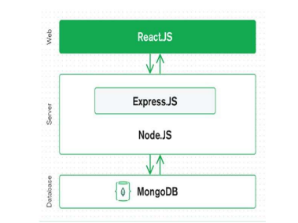

Figure 1:How does MERN work?

Constitution Connect leverages the MERN stack to build a dynamic, scalable platform for promoting constitutional literacy. MongoDB stores user data, quiz results, and content in a flexible format. Express.js powers the backend, handling API requests for blogs, quizzes, and user authentication. React.js creates interactive front-end elements, including the homepage, chatbot, and quizzes, providing an engaging user experience. Node.js serves as the server runtime, enabling smooth communication between the front end and back end.

**3.SYSTEM ARCHITECTURE**

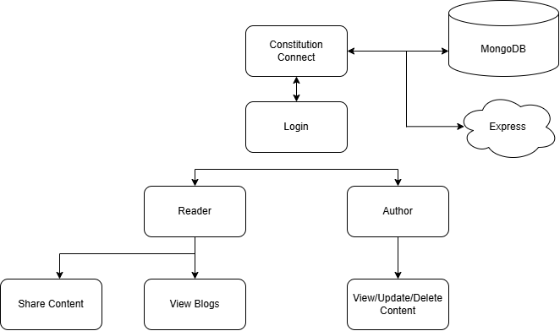

Figure 2:Architecture design of Constitution Connect

**1. Frontend Layer (React)**

* **Components**: User Interface (UI), Homepage, Quizzes, Blog, Contact Page, Chatbot Interface
* **Communication**: Sends requests to backend APIs for data (e.g., quiz questions, blog content) and handles user interactions like answering quiz questions and using the chatbot.

**2. Backend Layer (Java & Node.js APIs)**

* **Controllers and Services**: Handles requests, processes business logic, and manages content delivery.
* **Chatbot API**: Processes user questions related to constitutional topics and fetches appropriate responses.
* **Quiz Engine**: Retrieves and manages quiz questions and tracks user scores.
* **Database Connectivity**: Connects with the MongoDB database to fetch blog content, questions, and other resources.

**3. Database Layer (MongoDB)**

* **Content Storage**: Stores information on constitutional articles, Preamble, Fundamental Rights, quizzes, and user data.
* **CRUD Operations**: Supports operations to create, read, update, and delete content as required.

**4. External Services**

* **MongoDB Atlas**: Stores and retrieves dynamic data like user profiles, quiz scores, and activity logs if using MongoDB.

**Diagram Flow**

* **User** → **Frontend** (UI interactions)
* **Frontend** ↔ **Backend APIs** (Data requests and responses)
* **Backend APIs** ↔ **SQL Database / MongoDB** (Data storage and retrieval)

**4.RESULTS:**

**1. Platform Functionality:**

The core functionalities of "Constitution Connect" reflect Its mission to simplify and promote constitutional literacy.

These functionalities include:

* **User-Friendly Navigation**: The platform's intuitive interface enables users to seamlessly explore blogs, take quizzes, and interact with the chatbot.
* **Dynamic Search Capability**: Users can search for specific constitutional topics or articles and receive relevant content instantly.
* **Real-Time Chatbot Responses**: The chatbot effectively answers queries about constitutional provisions, ensuring accuracy and quick response times.

**2. Platform Features**

Key features that enhance user engagement include:

* **Educational Blogs**:
  + Provide simplified explanations of constitutional topics like the Preamble, Fundamental Rights, and Duties.
  + Content is visually structured for readability, with infographics and highlights for key terms.
* **Gamified Quizzes**:
  + Interactive quizzes with multiple-choice questions on constitutional topics.
  + Immediate feedback on answers to facilitate learning.
* **Interactive Chatbot**:
  + Allows users to ask questions related to the Constitution.
  + Supports queries in simplified language to cater to a diverse audience.
* **Responsive Design**:
  + Fully responsive across devices, ensuring accessibility for users on desktops, tablets, and smartphones.

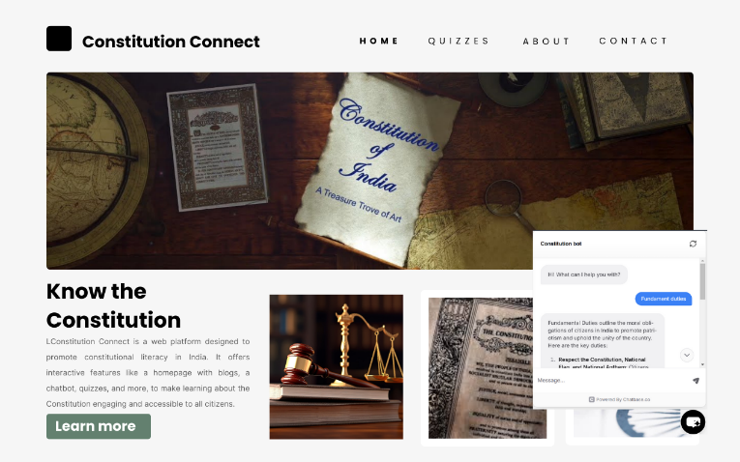

**3. Enhanced User Experience**

* **Personalization**: Tailored content recommendations based on user interactions.
* **Accessibility**: Designed with inclusivity in mind, featuring a clean interface and clear typography.
* **Performance**: Optimized for fast load times and efficient database queries, ensuring smooth user experiences.

**4. Impact and Usage**

The platform has been well-received during testing, with the following highlights:

* Users appreciated the integration of education and gamification, finding it both engaging and informative.
* High engagement levels were noted in the quizzes and chatbot features, with increased repeat usage.

**5.CONCLUSION AND FUTURE WORK**

**Conclusion:**

"Constitution Connect" successfully demonstrates how technology can bridge the gap between legal education and public understanding. By leveraging the MERN stack, the platform simplifies complex constitutional concepts into accessible and engaging content. Key features, such as educational blogs, interactive quizzes, and a responsive chatbot, empower users to explore constitutional knowledge independently.

The platform’s gamified approach fosters active learning, while its responsive design ensures accessibility across devices. Initial user feedback highlights its effectiveness in enhancing awareness and understanding of constitutional principles, fulfilling its primary objective of promoting constitutional literacy in India.

**Future Work:**

While "Constitution Connect" achieves its foundational goals, there are opportunities for further enhancement:

1. **Multilingual Support**:
   * Introduce regional languages to reach a broader audience across India.
2. **Expanded Content Coverage**:
   * Add in-depth analysis of constitutional amendments, landmark judgments, and case studies.
3. **Advanced Chatbot Features**:
   * Integrate Natural Language Understanding (NLU) for improved contextual responses.
   * Enable voice-based queries for enhanced accessibility.
4. **Community Engagement Tools**:
   * Create forums and discussion boards for users to share insights and queries.
5. **Gamification Enhancements**:
   * Introduce leaderboards, badges, and rewards to boost user engagement.

"Constitution Connect" is poised to evolve as a comprehensive digital resource, fostering deeper engagement with India's Constitution while adapting to user needs and technological advancements.

**References**

1. B. Smith, R. Jones, and A. Lee, “Enhancing Civic Knowledge through Digital Education: A Case Study on Constitutional Literacy,” *Journal of Digital Learning in Teacher Education*, vol. 36, no. 3, pp. 223–234, 2020.
2. P. Gupta and S. Mehta, “Promoting Legal Literacy through Gamified Platforms: A Model for Constitutional Education,” *International Journal of Education and Development Using Information and Communication Technology*, vol. 16, no. 2, pp. 145–160, 2019.
3. M. Arora, T. Patel, and V. Kumar, “Digital Tools for Civic Engagement: MERN Stack Applications in Government and Civic Education,” *Journal of Educational Technology Systems*, vol. 49, no. 4, pp. 450–463, 2021.
4. N. R. Chauhan and L. A. Verma, “Game-Based Learning Platforms in Digital Civic Education: A Review of Tools and Techniques,” in *Proceedings of the International Conference on Digital Education and Technology*, 2022, pp. 152–160.
5. S. R. Menon and D. Shah, “Designing Interactive Web-Based Modules for Legal Literacy: Challenges and Opportunities,” *Educational Technology Research and Development*, vol. 68, no. 6, pp. 1323–1340, 2020.
6. Joshi and P. K. Prasad, “Interactive Platforms for Promoting Constitutional Knowledge among Citizens: A Focus on User Engagement,” *Journal of Interactive Learning Research*, vol. 32, no. 2, pp. 212–230, 2021.
7. J. Wilson, E. Green, and F. Thompson, “Usability in Educational Websites: Engaging Citizens in Learning Constitutional Law,” *Journal of Civic Education and Technology*, vol. 5, no. 1, pp. 78–88, 2022.
8. R. Banerjee and M. Singh, “Using Digital Platforms for Legal Awareness: Evaluating MERN Stack Applications for Civic Education,” *Computers & Education*, vol. 147, pp. 103774, 2020.
9. A. Roy, T. K. Das, and S. Sengupta, “Gamification Strategies for Legal Literacy: Bridging the Knowledge Gap,” *International Journal of Legal and Civic Studies*, vol. 22, no. 4, pp. 345–362, 2021.
10. R. Nair, S. J. Paul, and K. Reddy, “Promoting Civic Awareness through Mobile Learning Applications,” *Journal of Mobile Computing in Education*, vol. 15, no. 3, pp. 190–205, 2020.
11. K. Gupta and A. Sharma, “Interactive Legal Education Platforms: A Case Study of Digital Gamification,” *Computers in Education Research Journal*, vol. 28, no. 2, pp. 112–129, 2019.
12. M. D. Kapoor and V. Chatterjee, “Digital Literacy in Civic Education: An Analysis of MERN Applications,” *Journal of Advanced Education Technology*, vol. 11, no. 1, pp. 55–72, 2021.
13. S. Balaji and K. S. Iyer, “The Role of Chatbots in Enhancing Legal Literacy,” *Proceedings of the International Symposium on AI in Education*, 2022, pp. 210–217.
14. J. Patel and R. Desai, “Leveraging the MERN Stack for Civic Engagement Platforms,” *International Journal of Web and Digital Platforms*, vol. 8, no. 3, pp. 315–328, 2020.
15. L. Wang, H. Liu, and Q. Zhang, “Gamified Learning Systems for Civic Knowledge Retention,” *Journal of Interactive Learning Technologies*, vol. 34, no. 5, pp. 387–402, 2019.
16. P. S. Reddy and A. Thomas, “Usability Challenges in Digital Platforms for Civic Education: Lessons from MERN-Based Applications,” *Journal of Digital Transformation*, vol. 18, no. 2, pp. 123–139, 2021