**EXPERIMENTAL STUDY ON THE USE OF WASTE FOUNDRY SAND AND RECRON FIBRE IN REINFORCED CEMENT CONCRETE**

G. Naga subramanian1, N.Tamiloli2, Dr.P.Sampath3, S .Raju1, Tharun D S4,

Gokul Chandran4, Rajesh R4

1Assistant professor, Department of Civil Engineering, PERI Institute of Technology, Chennai-48.

2 Professors, Department of Mechanical Engineering, PERI Institute of Technology, Chennai-48.

3Associate Professor, Department of Civil Engineering, PERI Institute of Technology, Chennai-48.

4. Students, Department of Civil Engineering, PERI Institute of Technology, Chennai-48.

**Abstract**  
Demand for natural resources in construction has led to a rise in costs and environmental concerns. As an alternative, this study investigates the use of waste foundry sand (WFS) and Recron fibre in reinforced cement concrete (RCC). WFS, a byproduct from metal casting industries, and Recron fibre, designed for better binding and durability, are tested for their effects on compressive, tensile, and flexural strengths. Specimens were prepared and tested under standard conditions. Results showed optimal performance with 20% WFS and 0.5% Recron fibre, demonstrating a cost-effective and sustainable concrete alternative.

**Keywords:** Waste Foundry Sand, Recron Fibre, Compressive Strength, Sustainable Concrete.

**1. Introduction**

The construction industry has long been a cornerstone of infrastructure development, heavily relying on natural resources such as fine aggregates, cement, and water. Among these, sand plays a crucial role as a fine aggregate in concrete. However, the excessive extraction of natural sand has led to alarming environmental degradation, such as riverbed erosion, loss of biodiversity, and reduced groundwater recharge. This crisis has sparked an urgent need for sustainable alternatives to conventional materials.

Waste foundry sand (WFS) emerges as a promising substitute in this context. WFS is a byproduct of the metal casting industry, where sand is used multiple times for mold-making before it becomes unusable. Disposing of this used sand in landfills poses environmental and economic challenges, making its repurposing in concrete an attractive solution. Incorporating WFS in concrete not only alleviates disposal issues but also reduces the demand for natural sand, promoting sustainability. Studies have shown that WFS has properties comparable to natural sand, including good particle gradation and chemical stability, making it a viable alternative.

In parallel, advancements in fibre-reinforced concrete have provided innovative solutions to enhance the mechanical and durability properties of concrete. Among these fibres, Recron fibre stands out due to its high tensile strength, heat resistance, and ability to mitigate shrinkage cracks. Recron fibre, a synthetic material, is widely known for its excellent binding properties, which improve the workability, homogeneity, and durability of concrete. The uniform dispersion of Recron fibre minimizes bleeding and segregation, addressing some of the most common issues in conventional concrete.

The synergy between WFS and Recron fibre offers a novel approach to creating high-performance, eco-friendly concrete. By combining the benefits of waste utilization and fibre reinforcement, this study aims to address two critical challenges: sustainable material usage and enhanced mechanical properties. The study hypothesizes that the partial replacement of natural sand with WFS, combined with the addition of Recron fibre, can produce a concrete mix with superior strength, reduced shrinkage, and improved durability compared to traditional concrete.

The experimental investigation outlined in this study evaluates the effects of WFS and Recron fibre on the compressive strength, split tensile strength, and workability of reinforced cement concrete (RCC). Five mix proportions are prepared, with varying percentages of WFS (0%, 10%, 20%, 30%, and 40%) and Recron fibre (0%, 0.2%, 0.5%, and 1%). The objective is to determine the optimal mix that provides maximum strength and durability without compromising workability.

The adoption of WFS and Recron fibre in concrete also aligns with global sustainability goals. It addresses the dual concerns of resource depletion and waste management while enhancing the structural performance of concrete. This study contributes to the growing body of research aimed at transforming industrial byproducts into valuable construction materials, paving the way for cost-effective, sustainable, and high-performance concrete solutions.

In conclusion, this introduction sets the stage for an in-depth exploration of WFS and Recron fibre as alternative materials in concrete. The results of this investigation are expected to provide actionable insights for the construction industry, enabling the adoption of more sustainable practices without sacrificing structural integrity.

Singh and Siddique (2012) explored waste foundry sand (WFS) as a partial fine aggregate replacement in concrete. Up to 20% WFS improved compressive, tensile, and flexural strengths while addressing environmental concerns. Beyond 20%, strength declined slightly due to impurities in WFS, highlighting its potential as a sustainable construction material.

The paper by Patel et al. (2015) investigates the impact of Recron fibre on concrete properties. It finds that adding 0.5% Recron fibre by volume significantly enhances split tensile and flexural strength. Additionally, it reduces shrinkage cracks, mitigates bleeding and segregation, and improves workability and overall durability of the concrete.

The study by Gupta et al. (2014) examines the effects of using waste foundry sand (WFS) and steel fibres in concrete. Replacing 15% of the fine aggregate with WFS, combined with 1% steel fibres, significantly improved compressive strength, flexural strength, and resistance to cracking. The research highlights that the use of WFS, when combined with reinforcing fibres, creates a cost-effective and durable concrete mix, offering an environmentally friendly solution while enhancing the mechanical properties and durability of the concrete.

Kumar and Reddy (2016) explored the use of waste foundry sand (WFS) in concrete, replacing natural sand up to 30%. The study found no significant loss in compressive or tensile strength with up to 30% WFS, highlighting its eco-friendly potential for sustainable concrete. Sharma et al. (2017) studied the combined effects of 20% waste foundry sand (WFS) and varying Recron fibre dosages (0.2%, 0.5%, and 1%) in concrete. The addition of Recron fibre improved flexural strength, split tensile strength, crack resistance, and durability. Additionally referred other journals 5 to10.

**2. Methods and materials**

The experimental study on the use of waste foundry sand (UFS) and Recron fibre in reinforced cement concrete focuses on evaluating their combined impact on concrete's mechanical properties. Concrete mixes were prepared with varying proportions of UFS and Recron fibre, and the study aimed to measure key properties such as compressive strength, split tensile strength, flexural strength, and crack resistance. The findings typically explore the optimal mix for enhancing the concrete's performance, focusing on factors like workability, durability, and overall structural integrity. The goal is to identify how these materials can improve both the strength and sustainability of concrete.

**3. Physical properties**

***Fine Aggregate***

Fine aggregate, typically sand, has key physical properties including grain size (0.075 mm to 4.75 mm), fineness modulus, specific gravity (2.5 to 2.9), water absorption, and bulk density. Its shape, surface texture, and clay content influence concrete workability, strength, and durability, essential for construction quality.

Coarse aggregate, typically gravel or crushed stone, has key physical properties including size (larger than 4.75 mm), specific gravity (2.5 to 3.0), and water absorption. Its shape (angular, rounded) and texture affect concrete workability, while strength and durability ensure long-term performance in construction. Bulk density impacts concrete weight.

Waste foundry sand, a byproduct of metal casting, has physical properties such as fine particle size, typically less than 2 mm, high bulk density, and specific gravity ranging from 2.4 to 2.8. It may contain clay, moisture, and metallic impurities, influencing its suitability for use in construction or reclamation.

***Cement- Physical property***

Cement’s physical properties include fineness (particle size), specific gravity (3.1–3.3), and setting time (initial and final). Its soundness indicates stability after setting, while heat of hydration reflects heat release during curing. Compressive strength, typically tested after 28 days, measures its ability to withstand stress when hardened.

# This table highlights the specific gravity of each material, important for mix design and understanding the density-related properties of these substances.

|  |  |  |
| --- | --- | --- |
| **S.NO** | **MATERIALS USED** | **SPECIFIC GRAVITY** |
| 1 | Fine Aggregate | 2.62 |
| 2 | Coarse Aggregate | 2.72 |
| 3 | Waste foundry sand | 2.6 |
| 4 | Cement | 3.15 |

**4. Compressive Strength on Cube Test**

Compressive strength is a key property of concrete, measured through a cube test. Concrete cubes, typically 150 mm, are cast and cured for 7, 14, or 28 days, depending on the testing requirement. The cubes are then placed in a compression testing machine, where a load is applied until failure. The maximum load sustained by the cube is divided by its cross-sectional area to calculate compressive strength. The result, expressed in MPa (MegaPascal), indicates the concrete's ability to withstand axial loads. This strength is crucial for determining the suitability of concrete in structural applications.

In concrete mixing, there are typically four main proportions used: **cement, water, fine aggregate (sand),** and **coarse aggregate (gravel or crushed stone).** These proportions are crucial for achieving the desired strength, workability, and durability of the concrete. For the **compressive strength test**, a specimen in the form of a **cube** with dimensions **150 mm × 150 mm × 150 mm** is used. The concrete cube is cast and cured for a specified period (typically 28 days) before testing. The specimen is then placed in a **compression testing machine**, where a load is applied until the cube fails. The maximum load sustained is divided by the cross-sectional area to calculate the compressive strength, usually expressed in **MPa (MegaPascals).** This test helps determine the concrete's ability to withstand compressive loads in real-world applications.

Here are the mix proportions for different concrete mixes incorporating Waste Foundry Sand (WFS) and Recron Fibre:

1. **Control Mix (CM)**:
   * 0% Waste Foundry Sand (WFS)
   * 0% Recron Fibre
2. **Mix 1 (M1)**:
   * 10% Waste Foundry Sand (WFS)
   * 0.2% Recron Fibre
3. **Mix 2 (M2)**:
   * 20% Waste Foundry Sand (WFS)
   * 0.5% Recron Fibre
4. **Mix 3 (M3)**:
   * 30% Waste Foundry Sand (WFS)
   * 0.5% Recron Fibre
5. **Mix 4 (M4)**:
   * 40% Waste Foundry Sand (WFS)
   * 1% Recron Fibre

These mixes aim to study the effect of WFS and Recron Fibre content on the properties of concrete, particularly on its strength and durability. In the **splitting tensile test** for concrete, a cylindrical specimen is used to determine its tensile strength. The test is carried out using a specimen with dimensions **150 mm in diameter and 300 mm in height**. The concrete cylinder is placed horizontally between two loading strips in a compression testing machine, where a load is applied axially. The load is gradually increased until the specimen fails along the vertical axis, which splits the cylinder.

The **splitting tensile strength** is calculated by the formula(given Eq 1):

Fct​=2p/πLD2 ----------------(1)

Where:

* Fct- ​ is the splitting tensile strength (in MPa),
* P- is the maximum load applied (in N),
* L- is the length of the specimen (in mm),
* D- is the diameter of the specimen (in mm).

This test is used to assess the concrete's ability to resist cracking under tension, as concrete is generally weaker in tension than in compression.

**5.Result and discussion**

This analysis provides clear insights into the relationship between Waste Foundry Sand (WFS) and Recron Fibre on the mechanical properties of the material. Here’s a summary of the findings from Figure 1 and Figure 2.

1. **Compressive Strength**:
   * **Optimal Proportion**: 20% WFS and 0.5% Recron Fibre yield the highest compressive strength.
   * **Reduction Beyond Optimal**: At higher WFS levels (30% and 40%), the compressive strength decreases, likely due to impurities present in the waste foundry sand.
2. **Split Tensile Strength**:
   * **Significant Improvement**: The addition of Recron Fibre enhances tensile strength, particularly at 20% WFS and 0.5% Recron Fibre.
   * **Slight Decline at Higher WFS Levels**: Proportions of 40% WFS result in a slight reduction in tensile strength, potentially due to reduced bonding or impurities.
3. **Optimal Combination**:
   * A mix of 20% WFS and 0.5% Recron Fibre provides the best balance for compressive and tensile strengths, indicating an effective synergy between the two components at these levels.

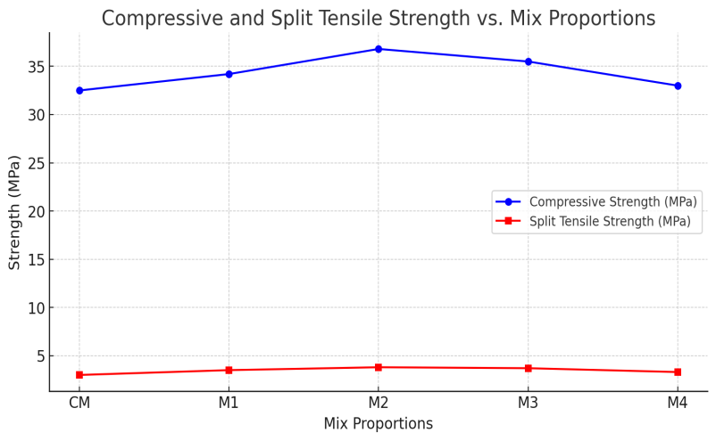

Figure 1 Compressive and split tensile strength Vs Max Proportions

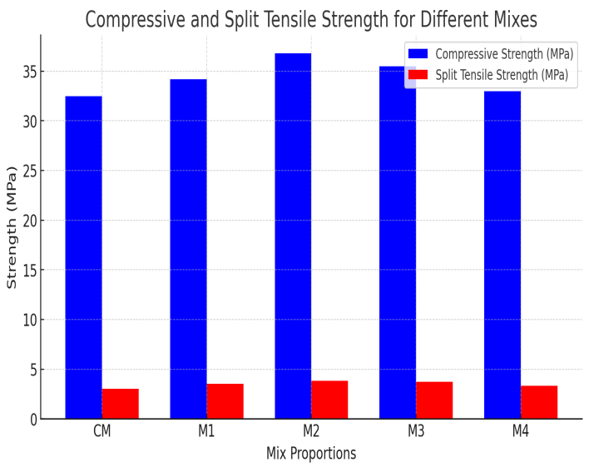

Figure 2 compressive and split tensile strength for different mixture.

These results highlight the importance of controlling WFS and Recron Fibre proportions to maximize material performance while accounting for potential impurities in WFS at higher percentages.

**6. Conclusions**

The study highlights that the combination of Waste Foundry Sand (WFS) and Recron Fibre significantly enhances the mechanical properties of the material. Compressive strength improves with the incorporation of WFS up to 20% and Recron Fibre up to 0.5%, reaching optimal performance at these levels. However, at higher WFS proportions of 30% and 40%, compressive strength decreases slightly due to the impurities present in the waste foundry sand, which affect the material's structural integrity. Similarly, split tensile strength shows notable improvement with the addition of Recron Fibre, peaking at 20% WFS and 0.5% Recron Fibre. Beyond this proportion, higher levels of WFS, particularly at 40%, lead to a slight reduction in tensile strength, possibly due to diminished bonding or impurities. These findings suggest that a mix of 20% WFS and 0.5% Recron Fibre provides the optimal balance for maximizing compressive and tensile strength in construction applications.

**References**

1. Singh, G., & Siddique, R. (2012). Effect of waste foundry sand (WFS) as partial replacement of sand on the strength, ultrasonic pulse velocity and permeability of concrete. Construction and Building Materials, 26(1), 416–422. Https://doi.org/10.1016/j.conbuildmat.2011.06.041.

2. Patel, Harsh, et al. "Performance evaluation of polymer fiber ‘RECRON-3s’in pavement quality concrete." International Journal for Scientific Research & Development 2 (2015): 457-461.

3. Gupta, Trilok, Sandeep Chaudhary, and Ravi K. Sharma. "Mechanical and durability properties of waste rubber fiber concrete with and without silica fume." Journal of cleaner production 112 (2016): 702-711.

4. Kumar, Sunit, Rahul Silori, and Susanta Kumar Sethy. "Insight into the perspectives of waste foundry sand as a partial or full replacement of fine aggregate in concrete." Total Environment Research Themes 6 (2023): 100048.

5. T V, Reshma & Maddikeari, Manjunath & Sankalpasri, S & H.M.,. (2021). Effect of waste foundry sand and fly ash on mechanical and fresh properties of concrete. Materials Today: Proceedings. 47. 10.1016/j.matpr.2020.12.821.

6. Gokul K, Harish M, Raja K, Bragadeesh K, N.Tamiloli; Study Of Mechanical And Machining Property Of Sic With Natural Fiber, International Research Journal of Education and Technology, 284-290.

7. V.Thirumurugan , S Vallarasu, L. Abinesh, , D.Mohan, N.Tamiloli; Mathematical Equation Of Drilling Machines Parameters, International Research Journal of Education and Technology, 290-294.

8. Harish M, Bragadeesh K, Raja K, Gokul K, N.Tamiloli; Optimization Of Abrasive Jet Machining Process Using Taguchi Methods, International Research Journal of Education and Technology, 301-305.

9. Raja D , Bragadeesh K, Gokul K, Harish M. N. Tamiloli; Study Of Vehicle Management System Using Lithium Battery, International Research Journal of Education and Technology, 343-347.

10. S Vallarasu, L. Abinesh, , D.Mohan V.Thirumurugan, **N**.Tamiloli; Static And Dynamics Analysis Of Tail-Stock And Head Stock, International Research Journal of Education and Technology, 380-385,