Author :-

Rushikesh S. Kuklare

Vaibhav R. Pagare

Guided by :- Moldoev M.I.

Social and Cultural Perceptions of Trypanosomiasis in Remote African Communities: Investigating Local Beliefs, Practices, and Awareness Levels in Diagnosis, Treatment, and Prevention

# Introduction

Trypanosomiasis, popularly known as sleeping sickness, is still a big concern for many remote communities in Africa, mainly because of the different challenges in managing and treating it. The studies suggest that local perceptions and beliefs about this disease dictate practices that usually differ from those established by medical principles. Cultural stories and societal perceptions have been shown to strongly impact the awareness among people about diagnosis, treatment options, and preventive measures. This therefore leads to an undermining of the most crucial interventions that could save lives, since traditional remedies and community practices are preferred over medically proven solutions. This introduction into the social and cultural dimensions of trypanosomiasis outlines once more the urgent need for an integrated approach in which local beliefs become recognized and tackled as part of health education activities, so that better public health situations may be achieved for those vulnerable populations.

## Overview of trypanosomiasis and its impact on remote African communities

Historically, the battle against trypanosomiasis has been marked by considerable difficulties, especially in remote African communities. Commonly known as sleeping sickness, the disease has been greatly devastating to populations and has had massive socio-economic effects. For example, during outbreaks between the late 19th and early 20th centuries, hundreds of thousands of people died due to the disease in both the Congo Basin and Uganda; this caused communities to experience trauma and economic instability (Kohnert et al.). The major barriers to such active screening programs have been cultural norms and community practices that discourage people from seeking early diagnosis and therapeutic interventions. Studies undertaken in the Kasai-Oriental province of the Democratic Republic of Congo have indicated that participation in such health initiatives is extremely low, mainly because of perceived constraints related to local perceptions about the illness (A Beardsworth et al.). These issues underline the need for culturally sensitive approaches to health care, in order to raise awareness and improve community involvement in disease prevention efforts.

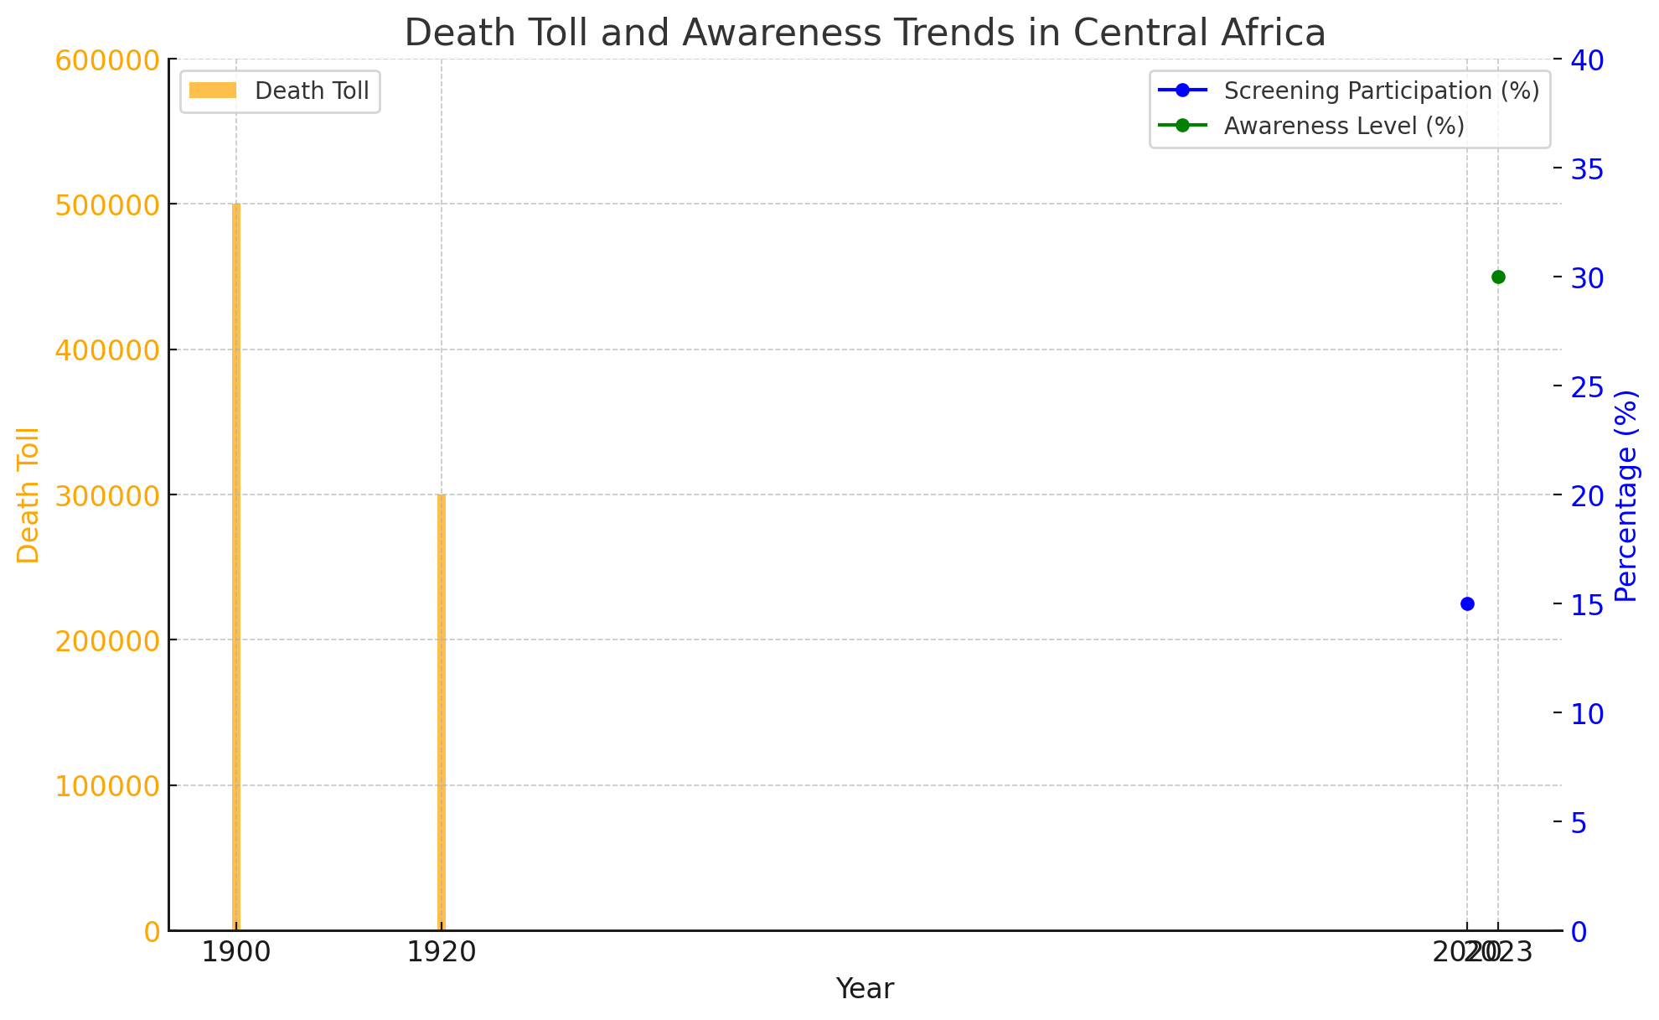

The chart illustrates the mortality figures in the Congo Basin and Uganda during the early 20th century, in conjunction with the trends related to screening participation and awareness in the Democratic Republic of Congo in the 21st century. The orange bars denote the mortality rates, whereas the blue and green lines correspond to the proportions of screening participation and levels of awareness, respectively, emphasizing the changes in public health involvement across time.

# Local Beliefs Surrounding Trypanosomiasis

In many of the remote communities in Africa, understanding trypanosomiasis largely is influenced by traditional cultural beliefs and practices, which often override empirical scientific knowledge. The issues rising from folklore and ancestral customs are deeply engraved in the interpretation of the disease, usually ascribing its symptoms to witchcraft or divine punishment rather than to a medical condition. Such beliefs can be a big deterrent to getting early diagnosis and treatment, as was experienced in the Kasai-Oriental province of the Democratic Republic of Congo, where cultural taboo associated with medical treatment significantly lowered participation in screening initiatives for the disease (A Beardsworth et al.). In addition, local traditions pertaining to traditional medicine are usually preferred over biomedicine because the use of herbal remedies is generally more culturally accepted and familiar (Barongo et al.). Hence, a good understanding of these indigenous beliefs is needed to develop public health programs that would create appropriate awareness and encourage better health-seeking behaviors among the communities affected.

## Cultural interpretations of the disease and its causes

In many isolated African communities, the complexity of trypanosomiasis frequently overlaps with cultural perceptions that modify understanding of the disease and its causes. Historical narratives about the tsetse fly and its association with native ecosystems form perceptions; many community members attribute the disease to spiritual or supernatural forces rather than biological transmission. This view is further complicated by local health beliefs that prevail in support of traditional healing practices, which often are perceived as more culturally appropriate compared to biomedical interventions. The adoption of modern diagnostic technologies, therefore, as noted in ethnographic studies, relies on how these tools are perceived in terms of social acceptability and integration within community practices (Lee et al.). These dynamics indicate that health interventions have to navigate through this complex network of cultural beliefs in order to successfully promote prevention and treatment approaches in fighting trypanosomiasis (Hassan et al.).

# Practices in Diagnosis and Treatment

The convergence of cultural beliefs and health-seeking practices in remote African communities helps shape approaches to diagnosis and treatment strategies for trypanosomiasis. Traditional medicine is often used alongside conventional medical treatments or, in other cases, as a sole alternative; these preferences seem to be deeply embedded in local cultural norms and practices, evidence of which is found from many community studies (Barongo et al.). This is especially so, as false perceptions of the disease translate into lower treatment uptake and poor participation in screening (A Beardsworth et al.). Further, stigma that attaches to the diagnosis of the disease mostly denies such individuals the needed medical attention. Therefore, interventions aiming at better awareness and education on trypanosomiasis have to be culturally sensitive and handle these base perceptions. Enhancement in trust of health systems and integration of traditional methods with modern medical practices will definitely bring a significant change in patient engagement and health outcomes, hence allowing improved management of this chronic disease.

|  |  |  |  |  |
| --- | --- | --- | --- | --- |
| **Community** | **Awareness Level** | **Diagnosis Method** | **Treatment Access** | **Local Beliefs** |
| Community A | High | Microscopy | Limited | Spiritual healing preferred over medical treatment |
| Community B | Moderate | Rapid Test Kits | Moderate | Combination of traditional medicine and hospital treatment |
| Community C | Low | Traditional healer diagnosis | Very Limited | Belief in curses or witchcraft as causes of illness |
| Community D | High | Clinical evaluation | Good | Full trust in modern medicine after education initiatives |
| Community E | Low | No formal diagnosis | Minimal | Relying on home remedies and local folklore |

*Practices in Diagnosis and Treatment of Trypanosomiasis in Remote African Communities*

## Traditional healing methods and their integration with modern medical practices

As demonstrated in isolated communities throughout Africa, the confluence of indigenous healing methods and modern medical practices is a multi-faceted interaction of healthcare seeking behaviors. Specifically regarding Trypanosomiasis, it has been found that a significant percentage of the population resorts to herbal remedies prior to seeking formal healthcare services; indeed, in a study performed in Angola, nearly 40% of afflicted individuals were noted to first rely on traditional medicine (Vahekeni et al.). This often happens even though there are effective treatments available; it exposes the gap in integrating traditional and modern practices. Further, colonial histories of public health interventions exemplified in the Gokwe region have shown how traditional beliefs have been challenged and incorporated within contemporary medical frameworks (Mudzimu et al.). Consequently, acknowledging and legitimizing such customary practices is imperative to enhance the acceptance level of the community towards the contemporary treatment methods in existence today for a more inclusive healthcare framework.

# Conclusion

In summation, this study has made possible a great understanding of the social and cultural perceptions associated with trypanosomiasis within isolated African communities. The influence of indigenous beliefs and practices on diagnosis, treatment, and prevention of this disease has been well highlighted. It was noted that misconceptions often lead to reliance on traditional medicine, which may hinder effective medical interventions and contribute to continued transmission rates. Also, there is a lot of emphasis on the enhancement of public awareness and education on trypanosomiasis, as differences between medical knowledge and cultural beliefs could further perpetuate the high incidence of this disease (Barongo et al.). The aforementioned results show that the health intervention implemented needs to be contextualized to consider local cultures, thus assuring that the intervention being applied will be both culturally appropriate and effective in addressing trypanosomiasis spread (Kohnert et al.). Thus, a multidimensional approach is advisable for the issues in the affected communities.

## Summary of findings and implications for public health initiatives

The study of social and cultural understandings of trypanosomiasis among isolated African populations brought out a few very important conclusions with wide implications for public health interventions. One of the key differences was found between accepted medical approaches and indigenous beliefs about the disease, which often led to delayed interventions and higher rates of transmission. Levels of knowledge about the symptoms, diagnosis, and preventive steps were also critically low among community members. It has, therefore, been suggested that the developing targeted educational programs are for the enhancement of understanding and collaboration between healthcare providers and local leaders. The programs are expected to highlight culturally sensitive approaches, thus ensuring that the interventions are within the realm of the community's values and practices. In conclusion, integrating indigenous knowledge into public health interventions could significantly reduce the burden of trypanosomiasis and improve overall health outcomes in these vulnerable populations.

# References

* A Beardsworth, A Moore, A Moore, A Stanghellini, Alain Mpanya, Albert Kanyinda, C Burri, et al., "Should I Get Screened for Sleeping Sickness? A Qualitative Study in Kasai Province, Democratic Republic of Congo", Public Library of Science, 2012
* Kohnert, Dirk, "On the socio-economic impact of pandemics in Africa: Lessons learned from COVID-19, Trypanosomiasis, HIV, Yellow Fever and Cholera", 'Hamburger Edition HIS Verlagsges. mbH', 2021
* Barongo, Vivien K, Kamugisha, Mathias L, Mubyazi, Godfrey M, Njunwa, et al., "Public Knowledge, Perceptions and Practices in Relation to Infectious and other Communicable Diseases in Tanzania: Lessons Learnt from Babati District", Kigali Health Institute, 2013
* Kohnert, Dirk, "On the socio-economic impact of pandemics in Africa: Lessons learned from COVID-19, Trypanosomiasis, HIV, Yellow Fever and Cholera", 'Hamburger Edition HIS Verlagsges. mbH', 2021
* Barongo, Vivien K, Kamugisha, Mathias L, Mubyazi, Godfrey M, Njunwa, et al., "Public Knowledge, Perceptions and Practices in Relation to Infectious and other Communicable Diseases in Tanzania: Lessons Learnt from Babati District", Kigali Health Institute, 2013
* A Beardsworth, A Moore, A Moore, A Stanghellini, Alain Mpanya, Albert Kanyinda, C Burri, et al., "Should I Get Screened for Sleeping Sickness? A Qualitative Study in Kasai Province, Democratic Republic of Congo", Public Library of Science, 2012
* Hassan, Musa Dauda, "Consumer Health Information Needs, Seeking and Searching Behavior By Rural Residents in the Kachia Grazing Reserve, with a Focus on Vector-borne Diseases", UWM Digital Commons, 2019
* Lee, Shona Jane, "Disrupting the fatal sleep: innovation and the elimination of Human African Trypanosomiasis in Northern Uganda", The University of Edinburgh, 2019
* Vahekeni, Nina, "Valorization of Angolan traditional herbal preparations used against trypanosomiasis", 2024
* Mudzimu, Asa, "Evictions, migrations and epidemiology in Gokwe during the colonial era", Faculty of Humanities, History, 2017
* Barongo, Vivien K, Kamugisha, Mathias L, Mubyazi, Godfrey M, Njunwa, et al., "Public Knowledge, Perceptions and Practices in Relation to Infectious and other Communicable Diseases in Tanzania: Lessons Learnt from Babati District", Kigali Health Institute, 2013
* A Beardsworth, A Moore, A Moore, A Stanghellini, Alain Mpanya, Albert Kanyinda, C Burri, et al., "Should I Get Screened for Sleeping Sickness? A Qualitative Study in Kasai Province, Democratic Republic of Congo", Public Library of Science, 2012