**Cinnamomum Camphora oil (Camphor) is Anti-oxidant activity by several uses**

**Ms. Roshanee D. Agrawal**

**Assistant Professor**

**Department of Pharmacognosy**

**Aditya Institute of Pharmacy, Chalisgaon**

**Abstract-**

This work used a compound coacervation process to create microcapsules of gelatin, arabic gum, camphor oil, and polystyrene. The parameters of oil/wall volume ratio, emulsification stirring speed, cross-linking agent concentration, treatment time, and oil release qualities were studied. To optimize the continuous release effect of camphor oil, oil-soluble polystyrene (PS) was used as Agent that provides a sustained release. The camphor oil release curves were expressed using the exponential equation where represents the camphor oil concentration in the operation environment,

**Key Words -** camphor oil, antirheumatic, antispasmodic, cardiotonic, carminative, diaphoretic, sedative

**Introduction-**

When camphor is extracted, oil known as camphor oil is released and is utilized in medicine. Analgesic is one of camphor oil's medicinal qualities, laxative, insecticide, stimulant, rubefacient, antidepressant, antiseptic, cardiac, carminative, diuretic, febrifuge, hypertensive, and vulnerary Nevertheless, the application environment has an impact on the short life of camphor oil due to its volatility. Therefore, numerous studies looked into encapsulating volatile oil with a type of micro-porous wall membrane to optimize the sustained release effect. This study looked at the connection between the gelatin-gum arabic complex wall membrane that was created under different circumstances and the sustained release behavior of camphor oil. Additionally, different amounts of oil-soluble polystyrene (PS) were utilized as a sustaining agent to enhance the release characteristics.

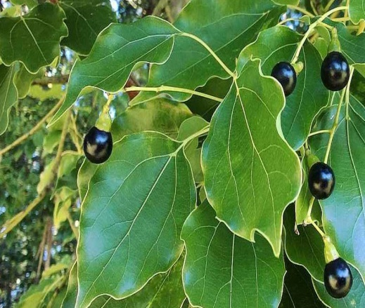

**Collection and Cultivation of camphor-**

Steam is used to extract camphor oil from chipped wood, root stumps, and branches, which is then vacuum-pressed and filtered. After vacuum distillation and rectification, the oil is filtered and separated into three fractions: white, yellow, and brown camphor. Only white camphor oil is used, and it smells clear and fresh. Brown and yellow camphor, which contains safrole, is poisonous and carcinogenic and should not be used in aromatherapy.

Camphor Oil's long-lasting scent, which is similar to menthol and can be described as chilly, clean, clear, thin, brilliant, and piercing, has been shown in aromatherapy to stimulate fuller and deeper breathing. As a result, it is often used in vapor rubs to relieve a clogged respiratory system by cleaning the lungs and alleviating bronchitis and pneumonia symptoms.

Camphor Essential Oil's cooling properties, when applied cosmetically or topically, can relieve inflammation, redness, sores, insect bites, itching, irritation, rashes, acne, sprains, and muscular aches and pains, including those associated with arthritis and rheumatism. Camphor Oil is used medicinally to stimulate and improve circulation as well as the function of the body's other systems, such as digestion, excretion, metabolism, and secretion. Precautions Camphor oil is a strong oil that should be handled with caution. It is not commonly used in aromatherapy because it is classified as a convulsant and neurotoxic. Overdosing can cause convulsions and vomiting, thus pregnant women, epileptics, and asthmatics should avoid using it.

**Description of Cinnamomum Camphora-**

Kingdom Plantae Order – Laurales

Family – Lauraceae

Genus – Cinnamomum

Species – C.camphora

Common name – Kapur

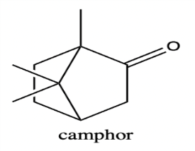

**Cinnamomum Camphora:**

**Medical Applications**

Camphor has a long history of use as an herb. Historically, it was used to cure hysteria internally, but in current herbal medicine, it is primarily utilized as an essential oil.   
It is not recommended for use. The wood and leaves have several medicinal properties, including analgesic, antispasmodic, odontalgic, rubefacient, and stimulating effects.

An infusion can be inhaled to treat colds and lung disorders. Distilling essential oil from the tree's chipped branches, trunk, and wood, as well as its leaves and twigs, is the most ideal method of use. Typically, wood between 24-40 years old is used. The essential oil has several medicinal properties, including anthelmintic, antirheumatic, antispasmodic, cardiotonic, carminative, diaphoretic, sedative, and tonic. External uses include liniments for joint and muscular pain, balms for chilblains, chapped lips, cold sores, skin illnesses, and an inhalant for bronchial congestion. The oil may be absorbed through the skin, potentially causing systemic toxicity. Aromatherapy uses essential oils

**Camphor is used as semisolid preparation in pharmaceuticals.**

**Camphor As a Drug**

**T**

**Camphor as a Tablet**

**Camphor as a Oil**

**Camphor Powder**

**Uses of Camphor Oil** 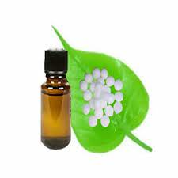

1. Camphor has long been used in natural medicine. Historically, it was used internally to cure hysteria, but in modern herbal medicine, it is primarily utilized as an essential oil and internally. .The usage of this product is not recommended. The wood and leaves have analgesic, antispasmodic, odontalgic, rubefacient, and stimulating properties.
2. The essential oil has multiple benefits, including anthelmintic, antirheumatic, antispasmodic, cardiotonic, carminative, diaphoretic, sedative, and tonic properties. It isusedexternally.   
   liniments for alleviating joint and muscle discom fort Balms for chilblains, chapped lips, cold sores, skin illnesses, and inhalation for bronchial congestion. Camphor oil is now being researched for its headaches.
3. Essential oils may be effective in treating headaches, including migraine headaches.  
   If a person has persistent headaches or migraine headaches, they should seek medical treatment.

**Conclusion-**

In summary, camphor has been used traditionally for many years, either alone or in combination.  
Combined with other treatments, it can effectively relieve pain, inflammation, and irritation in the body and skin. Additionally, it can prevent and treat serious, life-threatening diseases and act as an antioxidant.

**Reference-**

1. Ghanta Vithal K., Hiramoto Nancy S., Solvason Brent H., Soong Seng­Jaw, Hiramoto Raymond N. Conditioning: A New Approach to Immunotherapy. American Association for Cancer Research 1990;50:4295­299.
2. Kaegi Elizabeth. Unconventional Therapies for Cancer: 714­X. Canadian Medical Association Journal 1998;158(12):1621­624.
3. Weiss Lola, Barak Vivian, Raz Itamar, Or Reuven, Slavin Shimon, Ginsburg Isaac.Herbal Flavonoids Inhibit the Development of Autoimmune Diabetes in NOD Mice: Proposed Mechanisms of Action in the Example of PADMA 28. Alternative Medicine Studies 2011;1(e1):1­6.
4. J. Ling, WY Liu. Cytotoxicity of Two New RibosomeInactivating Proteins, Cinnamomin and Camphorin, to Carcinoma Cells. Cell Biochem Funct 1996;14(3):157­61.
5. LIU Ren­shui, WEI Guo­qing, HE Wen­jun, LIU Wang­YI. Cinnamomin, A Type II RibosomeInactivating Protein, Is A Storage Protein in the Seed of the Camphor Tree (Cinnamomum Camphora). Biochemical Society Journal 2002;362:659­63.
6. Kumar M., Ando Youshinori. Single­wall and Multiwall Carbon Nanotubes from Camphor­A Botanical Hydrocarbon. Diamond and Related Materials 2003;12:1845­85
7. C.P. Chang, T. Dobashi, Colloids Surf. B 32 (2003) 257.
8. R. Cortesi, E. Esposito, M. Osti, G. Squarzoni, E. Menegatti, S.S. Davis, C. Nastruzzi, Eur. J. Pharm. Biopharm. 47 (1999) 153.
9. D. Lemoine, F. Wauters, S. Bouchend’homme, V. Preat, Int. J. Pharm. 176 (1998) 9.
10. A.B. Pepperman, J.C.W. Kuan, J. Control. Release 34 (1995) 17.
11. 11 G. Coppi, V. Iannuccelli, E. Leo, M.T. Bernabei, R. Cameroni, J. Microencapsulation 19 (2002) 37. [12] T. Sato, T. Yamamoto, S. Shibako, K. Ichikawa, T. Dobashi, J. Membr. Sci. 213 (2003) 25.
12. Sabah, A. L., Effect of Camphor on Uterus Histology of Pregnant Rats, 2009. JKAU: Med. Sci. 16, 77-90.
13. Grbic, G. et al., Effect Of Camphor Essential Oil On Rat Cerebral Cortex Activity As Manifested By Fractal Dimension Changes, 2008. Arch. Biol. Sci. 60, 547-553.
14. Jamshidzadeh, A. et al., Effects of Camphor on Sexual Behaviors in Male Rats, 2006. Iranian Journal of Pharmaceutical Sciences 2, 209-214.
15. Hye, Ja. L. et al., In vitro anti-inflammatory and anti-oxidative effects of Cinnamomum camphora extracts, 2006. Journal of Ethnopharmacology 103, 208-216.
16. Jharna, M. et al., Evaluation of the clinical efficacy and safety of the herbal cold balm in the treatment of the common cold associated with headache, 2009. The Antiseptic 106, 87-90.
17. Hiroki, T. et al., Identification of Dimethylmatairesinol as an Immunoglobulin E-suppressing component of the leaves of Cinnamomum camphora, 2011. Journal of Health Science 57, 184-187.