**A RESEARCH ARTICLE OF MOBILE COMMUNICATION IN 5G NETWORK**

1Swati Bhattacharjee, 2Rishav Gorai, 3Trisha Kumari

1Department of Electronics and Communication Engineering, Asansol Engineering College, Asansol, West Bengal, India. Email: swati.ece.aec@gmail.com

2Department of Electronics and Communication Engineering, Asansol Engineering College, Asansol, West Bengal, IndiaEmail:reesav111@gmail.com

3Department of Electronics and Communication Engineering, Asansol Engineering College, Asansol, West Bengal, India Email: trishakumari202@gmail.com

## ABSTRACT

*Over the past few decades, the landscape of mobile wireless communication systems has witnessed remarkable transformations, marked by the rapid advancement in wireless communication speeds, rendering wired telephony obsolete. The emergence of fifth-generation (5G) technologies has been pivotal in ushering in this new era of connectivity. However, defining the scope of 5G technologies and addressing the myriad challenges they pose requires a multifaceted approach. In this paper, we present a consolidated review of 5G technology alongside cutting-edge cellular network design strategies and key emerging advancements aimed at enhancing engineering solutions and catering to the evolving needs of technology users. Our study synthesizes insights from various scholarly works to delineate the multifaceted dimensions of 5G technology. The advent of fifth-generation technologies promises a plethora of benefits, including secure connections for encoding e-payment data and the widespread utilization of mobile wireless technical devices by 5G users. Furthermore, we delve into the latest developments and existing 5G wireless security systems, emphasizing the importance of robust safety protocols encompassing authentication, data availability, confidentiality, key management, and privacy protection.*

**Keywords:** Authentication, Confidentiality, Data Rate, Mobile Communication, Security Services.

# INTRODUCTION

The imminent advent of mobile communications of the 5th generation offers virtually unrestricted entry to the information and exchange of data at anytime and anywhere. For impending gadgets and radio access organizations (for example foundation), it will challenge the unwavering quality, insurance just as cost proficiency and energy proficient. The 5G organizations would cover an assortment of assignments, for example, low-inactivity high capacitive cells with expansive exhibit transmitters and low force PC style interchanges with moderate transmission rate requirements [1]. Exhibit receiving wire frameworks (AAS) for rapidcellcreatenovelprospects,yetadditionallypresentmostrecentplandifficultiesandafew

mechanical assembly based proving ground shows are being worked to investigate these viewpoints.Theprivacy andsecretivenessofdetailstransmittedfromasendertoarecipientis important in a mobile communication system [2].

A network that will process encrypted messages in mobile communications systems could be used to satisfy 5G legitimacy. The messages will be encoded and contain both the encoded contentandtheretrieving informationforencryption,sowhenacellphonegetsamessage,it can store the encryption that gets to data in its memory when required, encryption getting to datawillberecoveredfrommemorysoitverywellmaybedecodedandtheygotmessagescan beperusedafterthesemessageshasbeenencoded [3].Thiscouldbesupportiveiftherecipients are different; in this case, before the message is decrypted, the receiver would validate the signature,storingasafemessagekeyinahandsetcommunicationsystem.Thoughe-commerce is growing day by day at its peak payment methods have also been ultra-modern. While e- payment is made by using credit cards, a latest payment device that involves a mobile device connected or connection less audio response system has been introduced recently.

Inordertomakesurethesafetyofdepositdatainacomputerizedmoneyframework,asafe attachmentlayeri.e.SSLbasedframeworkisutilizedtoencodetheclient'sinstallmentdataand approval data, which is transmit to theheadset mobile communication workstation after encoding (i.e. shopping centers, petrol station). The standardization process is just at the very beginning for 5G connectionless systems [4]. Figure 1 illustrates a general fifth generation wireless network architecture. 5G wireless networks are capable of providing additionally conventional sound and data communication, furthermore many latest applications, modern manufacturing applications and a huge number of frameworks and applications to connect network on the loose.

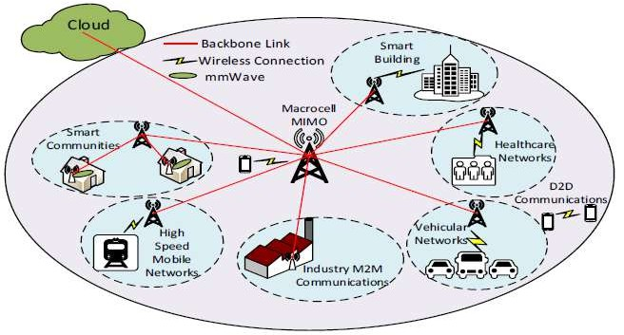

**Figure1**representsagenericarchitecturefor5thgenerationwirelesssystems [5].

1. **5THGENERATIONRESEARCHCHALLENGES**

The goals for the fifth era of portable correspondences are to give the long-term networked community with a range of interconnected radio access technologies. This leads to several research problems in the area of radio access include how to [6].

* + Expandtheadjustablespectrumtomaximumfrequency bands.
  + Increaseflexibilityinspectrumallocation.
  + Implement antennaarray techniques.
  + Utilizedmultistrategy.
  + Usepermission/terminalmixandmultijumpmethod,and
  + Allowgadgettogadgetcorrespondence.

Addingnewrangeatmm-wavefrequenciesgivenumerousnewoccasionstoradioplan.

Utilizationofhighgroupsofrecurrenceimplies.

There will be enormous amount of range accessibility, bringing about most extreme limit and information transmission rates.

* + Small frequencies requiring a wide scope of reception apparatus answers for keep association financial plans valuable.
  + Theclusterreceivingwireswillbelittleifthefrequenciesarriveatmm-waves,testing and building rehearses.
  + InDecember2015,theWorldRadioCommunicationsConferencechosetoadvancecell applications in groups under 6 GHz and reaches somewhere in the range of 24 and 84 GHz. The reasoning forthe 6 to 24 GHz gap is difficult to harmonize with available applications in this range [7].

# ARCHITECTUREOF5THGENERATIONTECHNOLOGY

This technology depends on the internet protocol. It is the stage through which radio telecommunication can boost adequate system communication. This technology will be optimized by using IP based radio associated. Each thing is under skillful and safe in mobile technology, so that any safe documentation can be utilized [8].

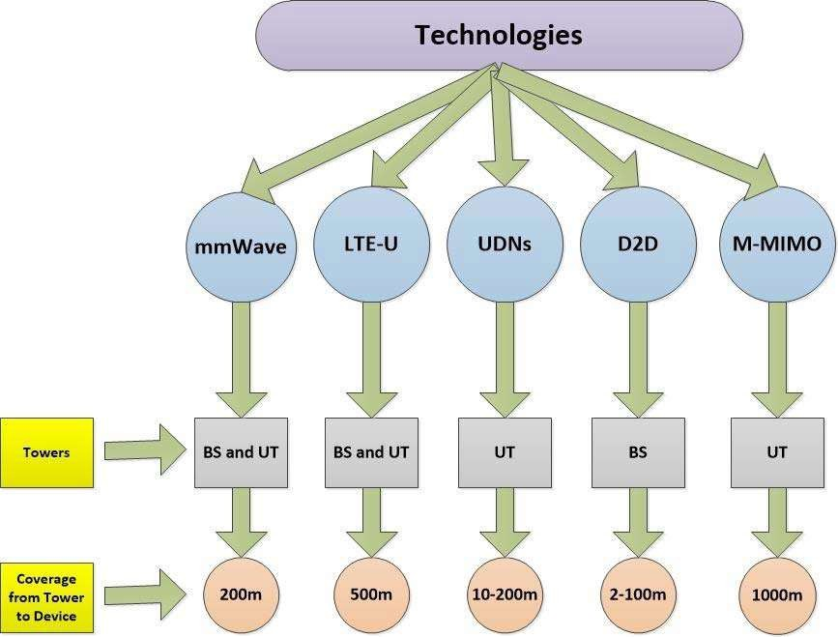

**Figure2**Taxonomyoffifthgenerationtechniques [8].

Above taxonomy of 5G techniques as shown in Figure.2 illustrate the association of advances to their individual methodology and imperatives that characterize the scope of pinnacle to gadget access [9].

# SECURITYSERVICESIN5GWIRELESSNETWORKS

The modern structure, new systems, and use cases in 5G connectionless organizations present newsecurityadministrationsascribesandrequest.Theyprincipallypresentfoursortsofdefend benefits in this progression: confirmation of the individual, verification of the message, classification of information, security, accessibility and respectability [5].

### Authentication:

Thetwo sorts of confirmations are thevalidation ofthe element and verification ofthe message. Inside 5G remote organizations, element validation and report confirmation areimportanttoaddresstheaboveassaults.Confirmationofthesubstanceisutilizedto guarantee that it keeps on being the imparting element. Shared confirmation between User Equipment (UE) and Mobility Management Entity (MME) is completed in the heritagecellnetworkpriortodiscussingthetwogatheringswithoneanother.Themajor significant security highlight in the customary cell security framework is the common approval between client hardware and versatility the executive’s element. Authentication and key agreement are dependent on symmetric key in 4G LTE cell organizations.Nonetheless,5GincorporatesvalidationamongEUandMMEjustasthe outsider which is a specialist organization.

### Confidentiality:

There are two parts of classification for example information security and protection. Information secrecy shields information transmission from uninvolved assaults by restrictingadmittancetoinformationjusttooproposedclientsanddenyingunapproved clientsfromgettingtooruncoveringit.Securityforestallsdataidentified withgenuine clients from being controlled and controlled, for instance, protection shields traffic streamsfromanassailant'sexamination.Trafficexamplescanbeutilizedtodistinguish touchydata,forexample,theareaofsendersorbeneficiaries,andsoonenormousclient related information are accessible for various 5G usage, for example vehicle steering information.

### Availability:

The level of assistance is open and usable to any genuine client at whatever point and any place it is mentioned is characterized as accessibility. Accessibility assesses how dependable the organization is when confronting various assaults and is a vital 5G executionmetric.Anassaultonaccessibilityisanordinarydynamicattack.DoSassault is oneofthesignificant assaults on accessibility, which can makegenuine clients deny assistanceaccess.Stickingorinterruptionbymeddlingwiththeradiosignswillintrude on the correspondence joins between real clients. 5G remote organizations are confronting a significant test with tremendous unstable IOT hubs to abstain from sticking and DoS assaults to guarantee the quality help.

### Integrity:

In spite of the fact that message validation offers affirmation of the message source, thereisnoprotectionagainstreplicationormessageadjustment.5Gplanstogiveaccess consistently, anyplace and at any rate, and to help applications firmly identified with human everyday life, for example, estimation of drinking water quality and transport booking. In certain applications, information respectability is one of the key security prerequisites.

# CONCLUSION

In order to enable many new applications, fifth generation of mobile communication network arerequiredtoprovideimprovedpresentation.Authorpresentedathoroughstudyonlatest5G wireless security network development in this paper. The existing security solutions were introduced primarily based on the intelligence agency provided, such as validation, obtainability, confidentiality of data, key management and privacy. Beam-forming is an importantcomponentfortheanticipated5Gnetworks,especiallyatmm-wavefrequencies,that would berequire acritical expansion in thequantity ofcorresponding radio chains. Dueto the most extreme recurrence and number of handsets needed to meet particulars on association financial plan, heat dissipation, power utilization, zone and volume and a compact building technique is required.

# REFERENCES

1. A.GuptaandR.K.Jha,“ASurveyof5GNetwork:ArchitectureandEmergingTechnologies,”

IEEEAccess.2015,doi:10.1109/ACCESS.2015.2461602.

1. J.Zhang,X.Ge,Q.Li,M.Guizani,andY.Zhang,“5GMillimeter-WaveAntennaArray:Design

andChallenges,”IEEEWirel.Commun.,2017,doi:10.1109/MWC.2016.1400374RP.

1. M. Agiwal, A. Roy, and N.Saxena,“Nextgeneration 5G wireless networks: A comprehensive survey,” IEEE Communications Surveys and Tutorials. 2016, doi: 10.1109/COMST.2016.2532458.
2. R.Hussain,A.T.Alreshaid,S.K.Podilchak,andM.S.Sharawi,“Compact4GMIMOantenna integratedwitha5Garrayforcurrentandfuturemobilehandsets,”IETMicrowaves,Antennas Propag., 2017, doi: 10.1049/iet-map.2016.0738.
3. D.Fang,Y.Qian,andR.Q.Hu,“Securityfor5GMobileWirelessNetworks,”IEEEAccess,

2017,doi: 10.1109/ACCESS.2017.2779146.

1. A.ImranandA.Zoha,“Challengesin5G:HowtoempowerSONwithbigdataforenabling

5G,”IEEENetw.,2014,doi:10.1109/MNET.2014.6963801.

1. S.Mattisson,“Overviewof5Grequirementsandfuturewirelessnetworks,”2017,doi:

10.1109/ESSCIRC.2017.8094511.

1. H.Beenish and M.Fahad, “5G a review on existing technologies,” 2019, Doi:

10.1109/ICOMET.2019.8673407.

1. S.Li,L.DaXu,andS.Zhao,“5GInternetofThings:Asurvey,”JournalofIndustrial

InformationIntegration.2018,doi:10.1016/j.jii.2018.01.005.

1. I.Ahmad,T.Kumar,M.Liyanage,J.Okwuibe,M.Ylianttila,andA.Gurtov,“Overviewof5G Security Challenges and Solutions,” IEEE Commun. Stand. Mag., 2018, doi: 10.1109/MCOMSTD.2018.1700063.