**Unveiling Trends: A Bibliometric Analysis of E-commerce and Consumer Awareness in the Digital Age**

**Mr. Bijayalal Naik**

Faculty in Commerce, Government College Sundargarh, Odisha

[Gmail-bjayanaik125@gmail.com](mailto:Gmail-bjayanaik125@gmail.com)

**Miss. Sonali Patel**

Faculty in Commerce, Government College, Sundargarh, Odisha

Gmail-sonali8895patel@gmail.com

**Abstract:** In the dynamic landscape with growing e-commerce, understanding consumer awareness has become very crucial for the businessmen and bureaucratic. This paper presents a bibliometric analysis of the scholarly literature in concern with e-commerce and consumer awareness. This study examines the evolutions, trends and key themes surrounding the intersection of e-commerce and consumer awareness. Other bibliometric indicators like top authors, top cited documents and thematic evolution have been studied. This paper will be helpful for researchers and academicians of the concerned field.

Keywords: E- commerce , consumer awareness, bibliometric study

**Introduction:**

Due to the ease with which consumers can now access a wealth of product information, reviews, and comparisons, e-commerce has had a substantial impact on consumer awareness. Thanks to increased product, price, and seller transparency, consumers are now better equipped to make educated purchases. Furthermore, e-commerce platforms frequently provide a range of tools, such as product recommendations, reviews, and ratings, which further raise consumer awareness and help them make educated decisions. But in the world of e-commerce, consumers need to be on the lookout for false information, fake goods, and privacy issues. Examining a range of factors, including consumer behavior, online purchasing patterns, digital marketing tactics, data privacy issues, and legal frameworks, is necessary to analyze the relationship between e-commerce and consumer awareness. Businesses that observe shifts in customer behavior can make the necessary adjustments to what they are providing to customers (Naik et al., 2023). A large variety of products and price comparison are two other reasons why customers purchase goods from any e-commerce website (Maharana & Acharya, 2023). To understand the concept of ecommerce and consumer awareness we will have to understand the various terms and concept, some of them are pointed here like -Consumer Behavior, it's critical to comprehend consumer behavior online, including preferences, surfing habits, and purchase decisions. Consumer decisions in e-commerce are influenced by elements such as price competition, product diversity, ease of use, and user experience. Online Shopping Trends: Analyzing the most recent developments in e-commerce, such as the emergence of mobile shopping, social media, subscription services, and the effects of sales occasions like Cyber Monday and Black Friday on consumer behavior. Digital Marketing Strategies: Examining the methods that e-commerce companies employ to contact and interact with customers while using digital marketing techniques including influencer marketing, email campaigns, social media advertising, and search engine optimization (SEO). Data Privacy Concerns: Addressing the worries that customers have about data security and privacy when they shop online, particularly in light of well-publicized data breaches and scandals. Gaining the trust of customers requires more and more transparency in data collecting, storage, and utilization procedures. Regulatory Frameworks: Being aware of the laws and regulations that control e-commerce, such as those pertaining to taxation, consumer protection, data protection (such as GDPR in Europe), and anti-trust companies to inform customers about their rights and obligations while making purchases online, include how to spot fraudulent sites, phony goods, and dishonest advertising tactics. Technological Innovations: Examining how cutting-edge technologies like block chain, augmented reality, virtual reality, and artificial intelligence (AI) are influencing e-commerce and improving the consumer purchasing experience.

**Prior review:**

Dharmaraj (2018), in his paper found that Online shopping is increasingly common, with varying customer perceptions. Many prefer it for selected products due to discounts, trust in reliable websites, and a perception of a broader range of choices. The convenience of avoiding travel, saving time and money, and the simplicity of online buying procedures are factors contributing to its popularity, particularly among educated consumers. Simil & Kavitha (2020) The study emphasizes the significance of customer awareness in e-commerce, with 'Electronic buying and selling' identified as the most influential factor. The rapid development of communication technology and the Internet presents both opportunities and challenges for online businesses, highlighting the need for e-business education. While there is positive progress in online transactions, ongoing technological advancements raise ethical concerns that must be addressed, especially regarding consumer protection in the realm of online shopping. Borkar & pethi (2022) in his study found that the retail environment is undergoing rapid changes as more consumers turn to online shopping, driven by factors such as time constraints, traffic issues, and increased internet accessibility. Survey participants, primarily from nuclear families with household computers, appreciate online shopping for its efficient, secure, and quality-driven processes. Their preferences lean towards options like cash on delivery and home delivery, with a positive inclination to recommend online shopping, highlighting overall satisfaction with products and services. Parimala & Ramachandran (2019) has found Male users with over 3 years of e-commerce experience are familiar with the E-Commerce Protection Act 2019, unlike newer users. To support online startup businesses, the government could enhance network bandwidth and telecommunication infrastructure. Implementing an e-commerce regulatory act, akin to the U.S. Federal Trade Commission guidelines, could build trust among users, encouraging increased e-transactions and a growth in the number of e-consumer users. Kumar & Sharma (2023) In his article, he discovered that a range of factors, such as price, convenience, product reviews and information, trust, and security, influence consumers' e-commerce purchasing decisions. In today's cutthroat online economy, e-commerce companies with a strong understanding of these elements and the ability to adjust to shifting consumer tastes and trends stand a better chance of prospering. Kousalya et al. (2013) it has been found that online shopping has profoundly impacted society, offering convenience, variety, quick service, and reduced prices. However, it also introduced concerns like fraud and privacy conflicts, prompting technological advancements to enhance security measures. With evolving privacy and security policies, the goal is to mitigate unethical practices, ensuring a continued successful future for online shopping. Ghaneshkumar (2019) in his article found that Online shopping has gained widespread popularity, particularly among the "Net-Generation," offering convenience across the nation. While this method has advantages, it presents unique challenges, leading to a study examining consumer awareness, preferences, and satisfaction. Findings reveal high awareness, with Flipkart and Amazon being top choices, and overall satisfaction with existing online shopping services among respondents. Fedushko & ustyianovych (2022) has concluded from his study that cohort analysis emerges as a valuable method for researching e-commerce customer behavior and experiences during the COVID-19 crisis. Employing features engineering and statistical analysis, the study validates the efficiency of cohort analysis in identifying critical factors influencing customer awareness and loyalty. The results demonstrate its effectiveness in answering business questions, addressing real-world e-commerce challenges, and providing insights into user satisfaction and relationships, enhancing the understanding of key e-business aspects. Yaseen et al. (2023) In his study, he discovered that a lack of understanding is a barrier to the adoption of e-commerce in developing nations like Jordan. This study highlights how important it is for customers to be aware of the benefits of e-commerce, implying that technological or legal obstacles are not the only reasons for the drop. The proposed framework offers a nuanced perspective to assist online businesses in improving the online acquisition journey for successful adoption. It does this by introducing a mapping technique that divides e-commerce awareness into four levels: awareness of products/services, payment, delivery, and brand. Saikrishnan (2023) the continuous expansion and profitability of online shopping platforms is contingent upon comprehending and addressing consumer perception and awareness of e-commerce, as per the findings of the research. Businesses can foster a positive atmosphere that promotes consumer trust, contentment, and involvement in the e-commerce ecosystem by giving priority to elements like trust, security, convenience, and customer service.

Top of Form

**Methodology**

The Dimension database provided the information used in this article for the years 1989-2024. Using quantitative analysis techniques, we examine a set of articles in bibliometric analysis. In order to find core research or authors and their relationships, bibliometric analysis is a scientific and computer-assisted review process that examines all the publications pertaining to a certain topic or field (Maharana & Pal, 2023; Maharana & Panda, 2023). This paper has employed bibliometric indicators such as the total number of publications on the research topic, the annual citation structure, the co-citation analysis, the co-citation network of cited sources, the co-citation network of authors, and the key word occurrence analysis. R software is utilized for the analysis because it provides clear and high-quality graphics to depict the bibliometric.

**Analysis And Results:**

The publications for the topics of e-commerce and consumer awareness broken down by nation are displayed in the following table and graph. The colors grey to dark blue on the graph below stand for low to high publication counts, respectively. The map's dark blue area has the most publications, whereas the grey area has none. China, which is represented by the deep blue color in the image, has the most publications worldwide for e-commerce and consumer awareness. The UK is in second place with six publications, followed by India and Indonesia in third place with five publications each. Poland, Italy, and Malaysia tie for fourth place with four publications each.

**Figure1:Country scientific production**

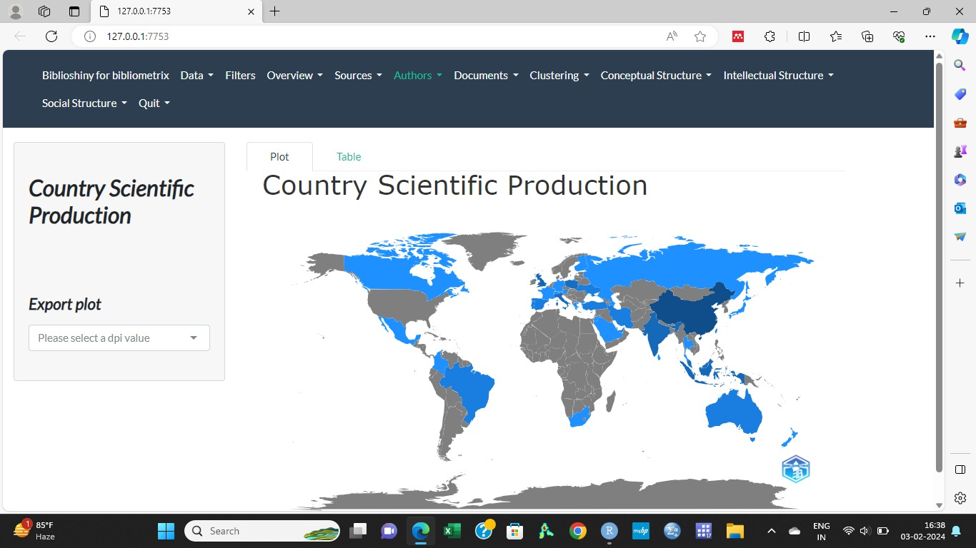

Source : Complied from biblioshiny

**Table 1: Country scientific productios**

|  |  |
| --- | --- |
| **Region** | **Freq** |
| CHINA | 15 |
| UK | 6 |
| INDIA | 5 |
| INDONESIA | 5 |

Source : Complied from biblioshiny

The table and graph below illustrate the annual number of papers published. In this piece, we've examined data from 1989 to February 2024. At first, there are only a few articles on this subject annually, but as time goes on, more people are becoming interested in it, and as a result, there are more publications overall. The year 2022 holds the record for the most publications globally, with 20. This is followed by the year 2018, which has 18 publications, and the year 2018 with 14 publications. The first three years with a single article every year were 1989, 1996, and 2001, In terms of this topic, 2016 has proven to be a turning point, and since then, trends have been rising. Data indicates that consumers are becoming less conscious of e-commerce and consumer awareness. It also shows that students and researchers are more interested in this topic, indicating the need for further research in this field.

**Table 2: Annual publications of articles**

|  |  |
| --- | --- |
| Year | **Articles** |
| 1989 | 1 |
| 1996 | 1 |
| 2001 | 1 |
| 2002 | 2 |
| 2003 | 1 |
| 2004 | 1 |
| 2005 | 1 |
| 2006 | 2 |
| 2008 | 1 |
| 2009 | 1 |
| 2011 | 2 |
| 2012 | 3 |
| 2013 | 2 |
| 2015 | 1 |
| 2016 | 4 |
| 2017 | 6 |
| 2018 | 2 |
| 2019 | 6 |
| 2020 | 8 |
| 2021 | 14 |
| 2022 | 20 |
| 2023 | 18 |
| 2024 | 1 |

Source : Complied from biblioshiny

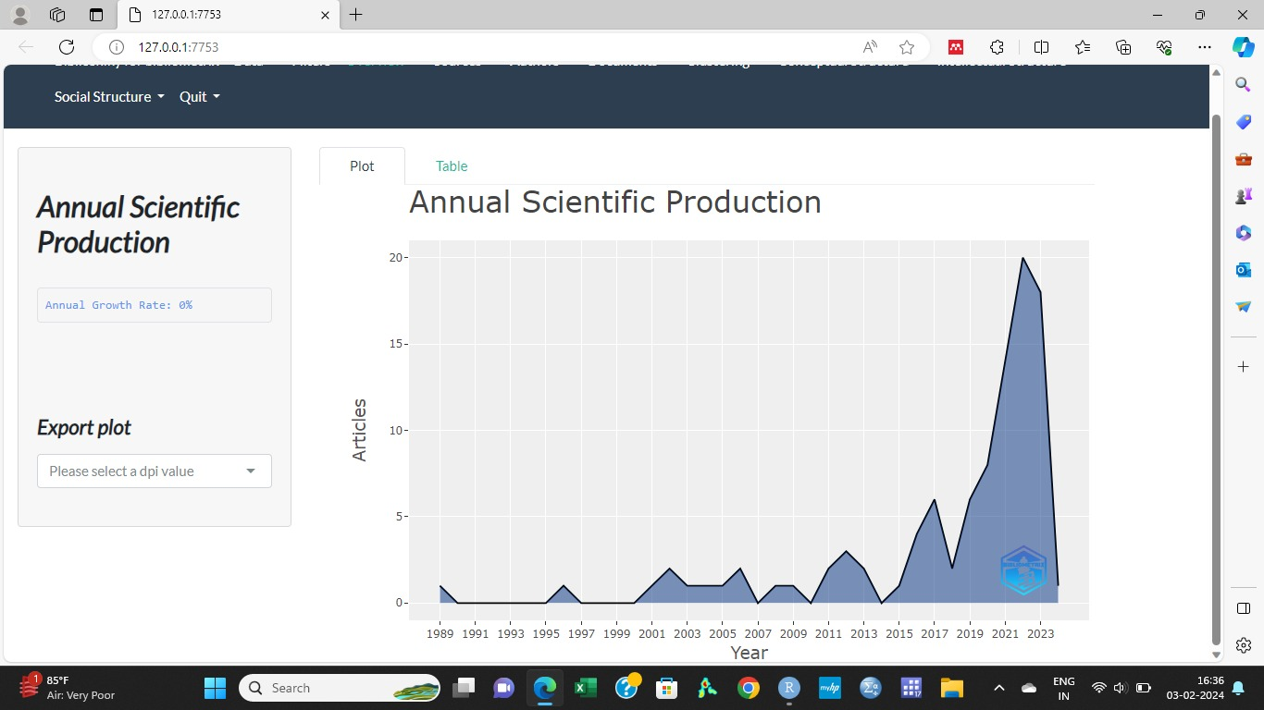

**Figure 2: Annual scientific production**

Source : Complied from biblioshiny

The image below, which spans the years 1989 to 2024 February, illustrates the area that writers are focusing on as time goes on. Customers, awareness, food, and business areas were given more weight in the beginning. Then, from 2015 to 2022, e-commerce, awareness, customer chains, and other areas received more weight. Currently, e-commerce, awareness, consumer, digital, and online areas are receiving more weight. Through an analysis of the following figure, it can be inferred that the subject matter under investigation for e-commerce and consumer awareness is expanding daily. While digital and online matters were not given much attention in the past, research on these topics has shown to be more significant currently.

**Figure 3: Thematic evolution map** 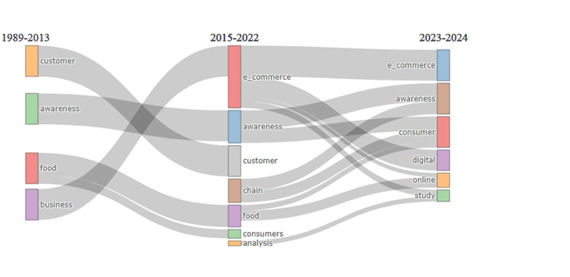 Source : Complied from biblioshiny

The number of articles about e-commerce and consumer awareness that are published in each journal is shown in the figure below. Five and four papers have already been published in the International Journal of Environmental Research and Sustainability respectively which is frequently utilized for paper publication. The next top most journal is international systems research, which has published three papers. With two publications to date, the British Food Journal, Journal of Financial Service Marketing, and Journal of Nutrition are ranked fourth.

**Figure 4: Most Relevant source**

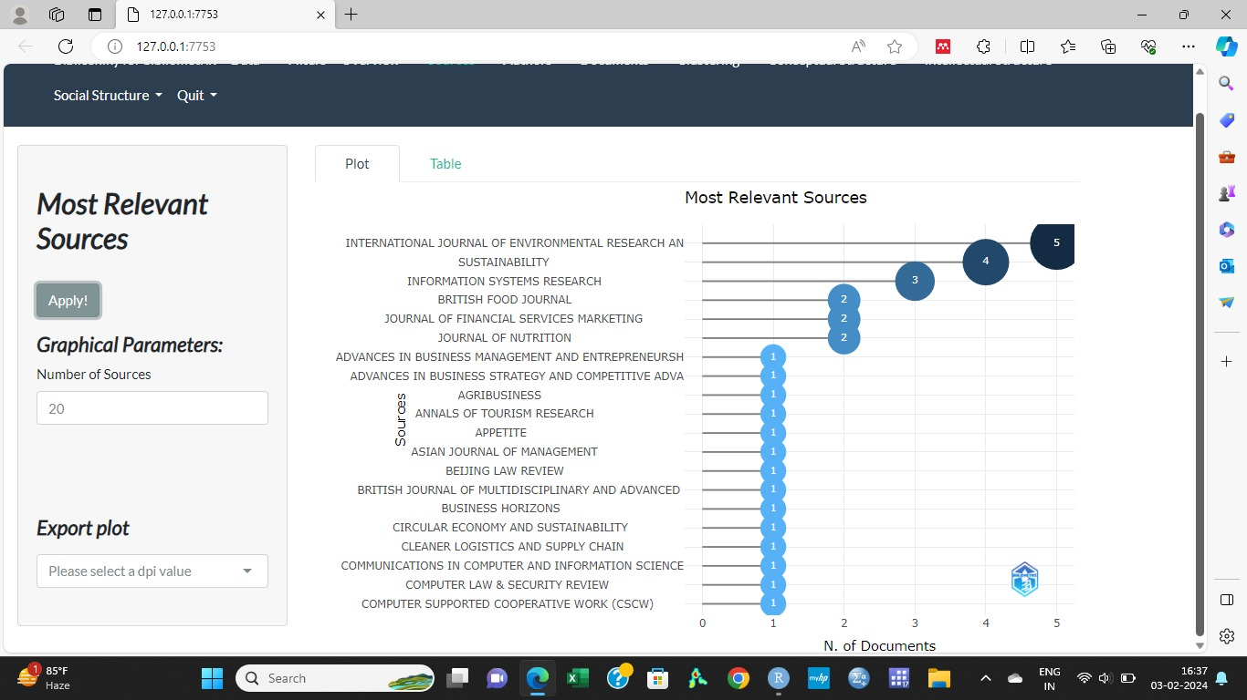 Source : Complied from biblioshiny

**Figure 5: Most global cited document**

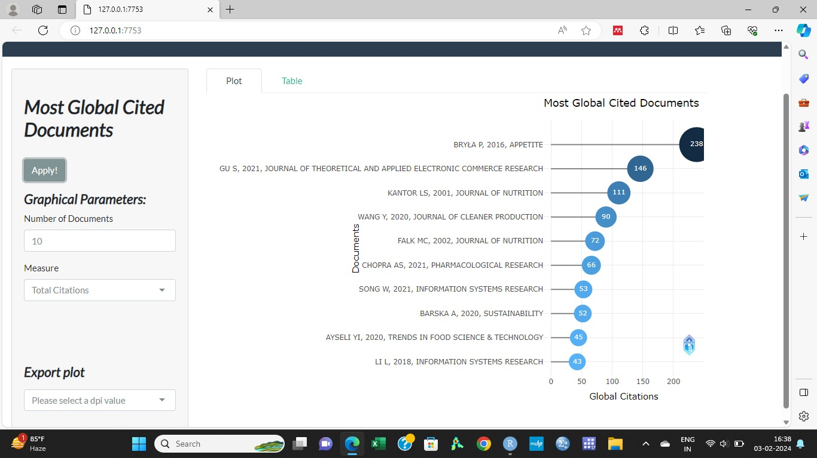 Source : Complied from biblioshiny

The aforementioned data illustrates which articles are most frequently cited while conducting research on the e-commerce and consumer awareness related articles and thesis .BRYLA p.(2016) has based on organic food consumption in poland ; motives and barriers , which found that High prices, limited consumer awareness, and low availability are key barriers to Poland's organic food market, while healthiness, ecological qualities, and food safety drive organic food selection, despite challenges like short expiry dates and low visibility in stores. The second most cited paper Is Gu S, 2021, Journal Of Theoretical And Applied Electronic Commerce Research which is concerned with impact of covid 19 pandemic on consumer purchasing behavior. From the study it is discovered that during the COVID-19 pandemic, certain alterations in online consumer purchasing behavior are usual. Customer experience and awareness have a greater influence now. The increasing level of experience among online shoppers has affected their purchasing patterns. This study demonstrated how, during the pandemic, elements influencing online consumer purchasing behavior changed. It was established that consumers' decision-making speed is becoming more and more crucial while making online purchases of goods and services. Then comes Kantor Ls,2001, Journal Of Nutrition in third position which is based on comprehensive narrative, umbrella review of the science and recommendations for enhanced public policy to improve intake.

**References:**

Dharmaraj, M. R., Com, M. B. A., Phil, M., & Sasirekha, K. B. (2018). A Study on Consumer Awareness towards Online Shopping in Vellore District, Tamil Nadu. *Shanlax International Journal s of Commerce*, *6*(1), 271–279. https://doi.org/10.5281/zenodo.1419456

Fedushko, S., & Ustyianovych, T. (2022). E-Commerce Customers Behavior Research Using Cohort Analysis: A Case Study of COVID-19. *Journal of Open Innovation: Technology, Market, and Complexity*, *8*(1). https://doi.org/10.3390/joitmc8010012

Ganeshkumar, K. (2019). A Study on Consumer Awareness and Satisfaction of Online Shopping Consumers with Special Reference to Coimbatore District. *Journal of Engineering Science*, *10*(12), 907–913. Retrieved from www.jespublication.com

Kousalya, P. R., Mohan, T., & Revathi, D. (2013). Consumer Awareness in Online Shopping System. *Indian Journal of Applied Research*, *3*(11), 281–283.

Kumar, K., & Kumar Sharma, S. (2023). *A Study on E-commerce-Consumer Buying Behaviour*. *International Journal of Research Publication and Reviews Journal homepage: www.ijrpr.com* (Vol. 4). Retrieved from www.ijrpr.com

Maharana, A. K., & Pal, S. (2023). Application of Bibliometric Analysis in the Study of Climate Change and Sustainable Development Practices. *International Journal of Environment and Climate Change*, *13*(6), 361–368. <https://doi.org/10.9734/ijecc/2023/v13i61835>

Maharana, A. K., & Panda, P. (2023). Exploring the Landscape of Corporate Tax Reforms: A Comprehensive Bibliometric Analysis. *VISION: Journal of Indian Taxation*, *10*(2), 71–86. https://doi.org/10.17492/jpi.vision.v10i2.1022305

Maharana, K. C., & Acharya, S. C. (2023). Customers’ Attitude Towards Online Shopping of Sambalpuri Handloom: a Study on Sambalpur District. *International Research Journal of Modernization in Engineering Technology and Science*, *05*(01), 822–828. <https://doi.org/10.56726/irjmets33001>

Naik, B., Meher, S., & Sethy, B. (2023). An empirical study of consumer buying behaviour towards eco-friendly FMCG products in Western Odisha. *International Journal of Research in Management*, *5*(2), 216–220. <https://doi.org/10.33545/26648792.2023.v5.i2c.111>

Parimala, S., & Ramachandran, M. (2022). A study on E-consumer awareness towards E-commerce Consumer Protection Act, 2019. In *AIP Conference Proceedings* (Vol. 2393). American Institute of Physics Inc. https://doi.org/10.1063/5.0074805

Ravindra Borkar, -Dr, & Pethe, A. (2022). A Study On Customers’ Awareness Towards Online Shopping. *Dogo Rangsang Research Journal*, *9*(1), 313–320.

Saikrishnan, S. (2023). Consumer Perception And Awareness On E-Commerce. *International Journal of Scientific Development and Research*, *8*(5), 1867–1869. Retrieved from https://www.researchgate.net/publication/373366720

Shimil, M. (2020). Article ID: IJM_11_11_406 Special Reference to Malappuram District, In Kerala. *International Journal of Management (IJM)*, *11*(11), 4060–4069. https://doi.org/10.17605/OSF.IO/K26JF

Yaseen, H., Alhosban, A., & Dingley, K. (2017). “Making Sense of E-Commerce Customers Awareness in a Developing Country Context: A Framework for Evaluation” Making Sense of E-Commerce Customers Awareness in a Developing Country Context: A Framework for Evaluation. *The Electronic Journal Information Systems Evaluation*, *20*.