**EFFECTS OF VARIATION OF AMBIENT TEMPERATURE IN ENERGY INTERACTIONS IN A CLOSED SYSTEM.**

**1Kingsley E. MADU and 1Chike M. ATAH**

Corresponding email atahchike44@gmail.com

1Department of Mechanical Engineering, Chukwuemeka Odumegwu Ojukwu University, Uli, Anambra State.

**Abstract**

The effects of variation of ambient temperature variation in energy interaction in a closed system have been analyzed in these ambient temperature changes study. It investigates how temperature variations impact energy transfer and overall system behavior. Through analysis, the study shed light on the intricate relationship between ambient temperature changes and energy exchanges in a closed system. From the study, it was observed that as temperature changes, it affects the thermal energy present in the system leading to alteration pressure, volume and overall system behavior. These changes are governed by the law of thermodynamics such as first law, second law and ideal gas interrelated. In a closed system, as temperature rises, the internal energy of the system increases, potentially causing expansion and higher pressure. These effects are crucial in various fields like engineering, chemistry and physics.

**Keywords**: Ambient Temperature, Energy Interactions, Closed System, Work, Temperature law

**INTRODUCTION**

In this research study, we delve into the effects of varying ambient temperatures on the intricate mechanisms that govern energy exchange and transformation. Through experimentation and analysis, we aim to uncover the profound implications of temperature fluctuations on closed systems, shedding light on the underlying principles that shape their behavior.

In thermodynamics, the interplay between temperature and energy interactions within closed systems has long been a subject of profound intrigue and scientific inquiry. The fundamental principles that govern these interactions hold pivotal importance, not only in the scientific understanding but also in various technological and industrial applications. The present research embarks on a journey to explore a crucial facet of this intricate relationship – the effects of varying ambient temperature on energy interactions within closed systems.

Closed systems, characterized by their defined boundaries and negligible exchange of matter with the surroundings, provide an ideal framework to investigate the effects of temperature variations on energy dynamics. The behavior of such systems is governed by the first and second laws of thermodynamics, which dictate the conservation of energy and the direction of energy flow, respectively. However, the impact of temperature fluctuations on these laws, and subsequently on the overall behavior of closed systems, remains a nuanced area warranting comprehensive investigation.

This research endeavors to address several key questions: How do changes in ambient temperature influence energy distribution and transformation within a closed system? What implications do such variations hold for the overall equilibrium and stability of the system? Can these findings be extrapolated to real-world scenarios, enhancing our ability to design and optimize energy-efficient processes?

By adopting a multidisciplinary approach, this study integrates concepts from thermodynamics, physics, engineering, and environmental science. Through meticulous analytical setups we aim to uncover the intricate mechanisms that underlie the observed effects. Furthermore, this research seeks to establish a theoretical framework that can guide future studies and practical applications in diverse fields ranging from energy production and storage to climate control and industrial processes.

As we delve into the heart of this investigation, it is imperative to recognize the potential ramifications of the findings. Understanding how variations in ambient temperature impact energy interactions within closed systems can pave the way for innovative solutions to challenges related to energy efficiency, environmental sustainability, and system optimization. Moreover, the insights garnered from this research may shed light on previously unexplored phenomena, leading to the expansion of our fundamental understanding of thermodynamics and its intricate connections to the natural world.

In the following sections, we will detail the experimental methodologies employed, present our observations, and discuss the implications of our findings in the context of existing literature. Through this comprehensive exploration, we hope to contribute to the ever-evolving body of knowledge in thermodynamics while offering valuable insights with potential implications across a spectrum of scientific and technological domains.

**2.0 ANALYSIS**

One common thermodynamic model for energy interaction in a closed system is based on the principles of the First Law of Thermodynamics, which states that the change in internal energy of a system is equal to the heat added to the system minus the work done by the system on its surroundings.

Mathematically, this can be expressed as:

ΔU = Q - W

Where:

ΔU is the change in internal energy of the system.

Q is the heat added to the system.

W is the work done by the system.

For a closed system, where no mass exchange occurs with the surroundings, the heat added to the system can be related to the temperature change using the specific heat capacity (C) of the substance:

Q = m * C * ΔT

Where:

m is the mass of the substance.

C is the specific heat capacity.

ΔT is the temperature change.

The work done by the system can be calculated depending on the type of work involved, such as pressure-volume work:

W = -P * ΔV

Where:

P is the pressure.

ΔV is the change in volume.

So, combining these equations, you can develop a thermodynamic model for energy interaction in a closed system at different temperatures by accounting for heat transfer, work done, and changes in internal energy.

**2.1 HEAT TRANSFER**

Heat is defined as the form of energy that is transferred across the boundary of one system to another system, at a lower temperature, by virtue of the temperature difference between the two systems. A substance does not contain heat. Heat is only identified as it crosses the system boundary. In actual fact the heat transfer takes place because the particles of the two systems collide with each other. The particles of the hotter substance has higher molecular energy than the particles of the colder substance. During a collision, some of the energy of the hot particle is transferred to the cold particle. This increases the kinetic energy of the cold particle and causes the temperature of the colder substance to rise. So heat transfer is actually kinetic energy transfer on the molecular level. The heat that enters the system ends up increasing the kinetic energies of the molecules and/or atoms of the system it entered. Temperature gives an indication of the average kinetic energy of the particles of a substance - the higher the kinetic energy, the higher the temperature.

In general heat transfer is calculated using the First Law.

**2.2 THE FIRST LAW OF THERMODYNAMICS:**

Closed Systems The first law of thermodynamics can be simply stated as follows: during an interaction between a system and its surroundings, the amount of energy gained by the system must be exactly equal to the amount of energy lost by the surroundings. A closed system can exchange energy with its surroundings through heat and work transfer. In other words, work and heat are the forms that energy can be transferred across the system boundary. Based on kinetic theory, heat is defined as the energy associated with the random motions of atoms and molecules. Heat Transfer Heat is defined as the form of energy that is transferred between two systems by virtue of a temperature difference.

   Note: there cannot be any heat transfer between two systems that are at the same temperature.

Note: It is the thermal (internal) energy that can be stored in a system. Heat is a form of energy in transition and as a result can only be identified at the system boundary. Heat has energy units kJ (or BTU). Rate of heat transfer is the amount of heat transferred per unit time. Heat is a directional (or vector) quantity; thus, it has magnitude, direction and point of action.

Notation:

– Q (kJ) amount of heat transfer

– Q° (kW) rate of heat transfer (power)

– q (kJ/kg) ‐ heat transfer per unit mass

– q° (kW/kg) ‐ power per unit mass

Sign convention: Heat Transfer to a system is positive, and heat transfer from a system is negative. It means any heat transfer that increases the energy of a system is positive, and heat transfer that decreases the energy of a system is negative.

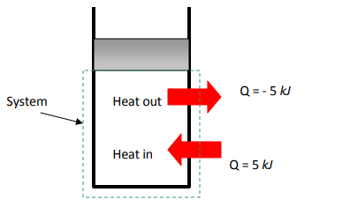

Fig. 2.1: Sign convention: positive if to the system, negative if from the system

**2.3 WORK:**

Work is the energy interaction between a system and its surroundings. More specifically, work is the energy transfer associated with force acting through a distance.

Notation:

– W (kJ) amount of work transfer

– W° (kW) power

– w (kJ/kg) ‐ work per unit mass

– w° (kW/kg) ‐ power per unit mass

Sign convention: work done by a system is positive, and the work done on a system is negative.

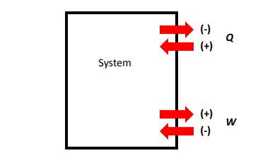

Fig. 2.2: Sign convention for heat and work.

Similarities between work and heat transfer:

¬ Both are recognized at the boundaries of the system as they cross them (boundary phenomena).

¬ Systems posses energy, but not heat or work (transfer phenomena).

¬ Both are associated with a process, not a state. Heat or work has no meaning at a state.

¬ Both are path functions, their magnitudes depend on the path followed during a process as well as the end states.

**Path functions:** have inexact differentials designated by symbol  δ. Properties, on the other hand, are point functions which depend on the state only (not on how a system reaches that state), and they have exact differentials.

$\int_{1}^{2}{dV=}V_{2}-V_{1}= ∆V$ (point function)

$\int_{1}^{2}{ δW=}W_{12}$ (path function, not nor W2 – W1)

Moving Boundary Work The expansion and compression work is often called moving boundary work, or simply boundary work. We analyze the moving boundary work for a quasi‐equilibrium process. Consider the gas enclosed in a piston‐cylinder at initial P and V. If the piston is allowed to move a distance ds in a quasi‐equilibrium manner, the differential work is:

δWb = F.ds = PAds = PdV

The quasi‐equilibrium expansion process is shown in Fig.2. 4. On this diagram, the differential area dA under the process curve in P‐V diagram is equal to PdV, which is the differential work. Note: a gas can follow several different paths from state 1 to 2, and each path will have a different area underneath it (work is path dependent). The net work or cycle work is shown in Fig. 2.5. In a cycle, the net change for any properties (point functions or exact differentials) is zero. However, the net work and heat transfer depend on the cycle path.

  ΔU = ΔP = ΔT = Δ(any property) = 0       for a cycle

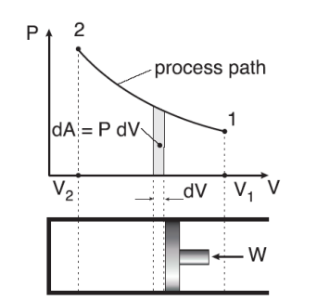

Fig.2.4 the area under P-V diagram represents the boundary work.

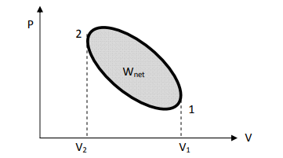

Fig.2.5 work done during a cycle.

Polytropic Process   During expansion and compression processes of real gases, pressure and volume are often related by PVn =C, where n and C are constants. The moving work for a polytropic process can be found:

Wpolytropic =

Since P1 = P2 = C. For an ideal gas (PV= mRT) it becomes:

Wpolytropic= , n ≠ 1 (kj)

(T2 – T1) is the temperature differential or variation.

Non‐mechanical forms of work Non‐mechanical forms of work can be treated in a similar manner to mechanical work. Specify a generalized force F acting in the direction of a generalized displacement x, the work transfer associated with the displacement dx is:

δW = F.dx

**2.4. ENERGY:**

First law, or the conservation of energy principle, states that energy can be neither created nor destroyed; it can only change forms. The first law cannot be proved mathematically, it is based on experimental observations, i.e., there are no process in the nature that violates the first law. The first law for a **closed system** or a **fixed mass** may be expressed as:

net energy transfer to (or from) the = net increase (or decrease) in the total energy of the system. system as work and heat

Q – W = ΔE (kJ)

where   Q = net heat transfer (=ΣQin – ΣQout)

W= net work done in all forms (=ΣWin – ΣWout)

ΔE= net change in total energy (= E2 – E1)

The change in total energy of a system during a process can be expressed as the sum of the changes in its internal, kinetic, and potential energies:

ΔE= ΔU + ΔKE + ΔPE (kJ)

Δ*U* = *m*(*u2-u1*)

Δ*KE* = *m*()

ΔPE = *mg(z1 – z2)*

For stationary systems as close system ΔPE=ΔKE=0, the first law reduces to

Q – W = ΔU

The first law can be written on a unit‐mass basis: q – w = Δe (kJ/kg)

or in differential form:

δQ – δW = Du (kJ)

δq – δW = du (kJ/kg)

or in the rate form:

Q° – W° = dE / dt (kW)

For a cyclic process, the initial and final states are identical, thus  ΔE=0. The first law becomes:

Q – W = 0 (kJ)

From the first law point of view, there is no difference between heat transfer and work, they are both energy interactions. But from the second law point of view, heat and work are very different.,

From the second law:

*Q = TΔS or SΔT* for variation in temperature.

Putting the of Qin the first law gives:

SΔT - W = ΔU

**2.5. SPECIFIC HEATS**

The specific heat is defined as the energy required to raise the temperature of a unit mass of a substance by one degree. There are two kinds of specific heats:

¬ specific heat at constant volume, Cv (the energy required when the volume is maintained constant)

¬ specific heat at constant pressure, Cp (the energy required when the pressure is maintained constant)

The specific heat at constant pressure Cp **is always higher than** Cv because at constant pressure the system is allowed to expand and energy for this expansion must also be supplied to the system.

Let’s consider a stationary closed system undergoing a constant‐volume process (wb = 0). Applying the first law in the differential form:

δq – δw = du

at constant volume (no work) and by using the definition of Cv, one can write:

*CV dT = du*

or

Cv =

Similarly, an expression for the specific heat at constant pressure Cp can be found. From the first law, for a constant pressure process (wb + Δu = Δh).

Cp =

--specific heats (both Cv and Cp) are properties and therefore independent of the type of processes.

  -- Cv is related to the changes in internal energy u, and Cp to the changes in enthalpy, h.

**Specific heats for ideal gases**

It has been shown mathematically and experimentally that the internal energy is a function of temperature only. u = u(T)

Using the definition of enthalpy (h = u + Pv) and the ideal gas equation of state (Pv = RT),

we have:

h = u + RT

Since R is a constant and u is a function of T only:

h = h(T)

Therefore, at a given temperature, u, h, Cv and Cp of an ideal gas will have fixed values regardless of the specific volume or pressure. For an ideal gas, we have:

*du = Cv (T) dT*

*dh = Cp (T) dT*

The changes in internal energy or enthalpy for an ideal gas during a process are determined by integrating:

*Δu = u2 – u1* = (Kj/kg)

*Δh = h2 – h1* = (Kj/kg)

As low pressures, all real gases approach ideal‐gas behavior, and therefore their specific heats depend on temperature only.

For an ideal gas, we can write:

*RT = h(T) – u(T)*

*R = $\frac{dh}{dT}- \frac{du}{dT}$*

*R = Cp - Cv*

The ratio of specific heats is called the specific heat ratio k = Cp/Cv:

k varies with temperature, but this variation is very mild.

Specific heats for solids and liquids A substance whose specific volume (or density) is constant is called incompressible substance. The specific volumes of solids and liquids (which can be assumed as incompressible substances) essentially remain constant during a process.

The constant volume assumption means that the volume work (boundary work) is negligible compared with other forms of energy. As a result, it can be shown that the constant‐volume and constant‐pressure specific heats are identical for incompressible substances:

Cp = Cv = C

Specific heats of incompressible substances are only a function of temperature,

C = C(T)

The change of internal energy between state 1 and 2 can be obtained by integration:

*Δu = u2 – u1* = (KJ/kg)

For small temperature intervals, a C at averaged temperature can be used and treated as a constant, yielding:

Δu≈ *Cave(T2 – T1)*

The enthalpy change of incompressible substance can be determined from the definition of enthalpy (h = u + Pv)

h2 – h1 = (u2 – u1) + v(P2 – P1)

Δh = Δu + vΔP     (kJ/kg)

The term vΔP is often small and can be neglected, so Δh = Δu.

**2.6. MECHANISMS OF ENERGY TRANSFER, EIN AND EOUT OF A CLOSE SYSTEM UNDERGOING AMBIENT TEMPERATURE VARIATION**

• Energy interactions (heat and work) are recognized at the system boundary as they cross it, and they represent the energy gained or lost by a system during a process.

• The only two forms of energy interactions associated with a fixed mass or closed system are heat transfer and work.

**1.** **Heat Transfer**, Q Heat transfer to a system (heat gain) increases the energy of the molecules and thus the internal energy of the system, and v. versa. The heat gain brought upon by an increase in the temperature of the surrounding (ambient temperature).

**2. Work Transfer**, W An energy interaction that is not caused by a temperature difference between a system and its surroundings is work. A rising piston, a rotating shaft, and an electrical wire crossing the system boundaries are all associated with work interactions. Work transfer to a system (i.e., work done on a system) increases the energy of the system and v. versa.

Ein –Eout = (Qin - Qout) + (Win - Wout) + = Esystem

• All four quantities on the right side of the equation represent “amounts,” ∆and thus they are positive quantities. The direction of any energy transfer is described by the subscripts “in” and “out.”

• The heat transfer Q is zero for adiabatic systems, the work transfer W is zero for systems that involve no work interactions.

Ein –Eout = ∆Esystem

• For a closed system undergoing a cycle, the initial and final states are identical, and thus

∆Esystem = E2 - E1 = 0.

• Then the energy balance for a cycle simplifies to Ein - Eout = 0 or Ein = Eout.

**3.0 RESULT AND DISCUSSION**

Considering 72g of ice in a well-sealed and well-insulated container

Table 3.i. variation of the ambient temperature of ice’

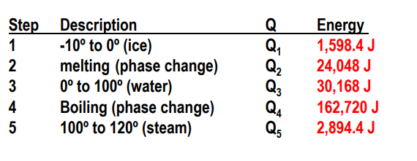

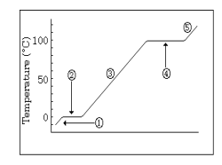

Fig. 3.1. stepwise reaction of the ice at various temperature variation.

The 72.0 grams of ice has changed from -10.0 ºC to 120.0 ºC. The energy calculation for this change required five steps .

The relation Q = mCΔT is used to obtain the energy transferred to the substance at variable temperature.

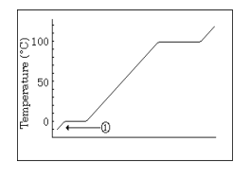

Fig.3.2. Step 1: solid ice rises in temperature

As we apply heat, the ice will rise in temperature until it arrives at its normal melting point of zero Celsius. Once it arrives at zero, the Δt equals 10 ºC. Δt = (TF-TI ). Here is an important point: THE ICE HAS NOT MELTED YET. • At the end of this step we have SOLID ice at zero degrees. It has not melted yet. That's an important point. • Since ice is different substance than water, a different specific heat value is needed.

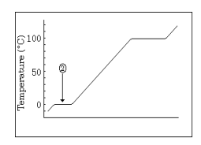

Fig.3.3. Step 2: solid ice melts (phase change)

Now, we continue to add energy and the ice begins to melt. However, the temperature DOES NOT CHANGE. It remains at zero during the time the ice melts. During this time, the energy is being used to overcome water molecules' attraction for each other, destroying the three dimensional structure of the ice. Energy calculation is the "heat of fusion"

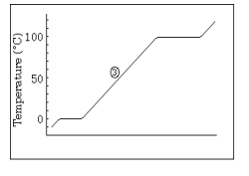

Fig.3.4. Step 3: liquid water rises in temperature

Once the ice is totally melted, the temperature can now begin to rise again. It continues to go up until it reaches its normal boiling point of 100 ºC. Since the temperature went from zero to 100, the Δt is 100. Δt = (TF-TI ). Here is an important point: THE LIQUID HAS NOT BOILED YET. At the end of this step we have liquid water at 100 º. It has not turned to steam yet.

**CONCLUSION**

The effects of varying the ambient temperature on energy interactions within a close system are significant and complex. As ambient temperature changes, the system responds by adjusting its energy distribution and transfer mechanism. This phenomenon has implications for various field including engineering, thermodynamics, and environmental science. Understanding these effects is crucial for optimizing energy utilization, predicting system behavior, and designing efficient technologies. Further research in this area will undoubtedly contribute to a more comprehensive grasp of energy dynamics and pave the way for innovative solutions to address the way for innovative solutions to address the challenges posed by temperature variation in a closed system.

**REFERENCES**

1. Kenneth Wark, thermodynamics, 4th ed. (New York:McGraw-Hill, 1983)
2. Thermo 1lec 3, 4, 5 feb 2020 print
3. Physics_13_4
4. . Dounis, A.; Caraiscos, C.; Caraiscos, C. Advanced control systems engineering for energy and comfort management in a building environment—A review. Renew. Sustain. Energy Rev. 2009, 13, 1246–1261. [CrossRef]
5. Mendoza-Serrano, D.I.; Chmielewski, D.J. HVAC control using infinite-horizon economic MPC. In Proceedings of the 2012 IEEE 51st IEEE Conference on Decision and Control (CDC), Maui, HI, USA, 10–13 December 2012; pp. 6963–6968.
6. Vázquez-Canteli, J.; Ulyaninc, S.; Kampf, J.; Nagya, Z. Fusing Tensor-Flow with building energy simulation for intelligent energy management in smart cities. Sustain. Cities Soc. 2019, 45, 243–257. [CrossRef]
7. Son, J.; Hyogon, K. Sensorless Air Flow Control in an HVAC System through Deep Learning. Appl. Sci. Spec. Issue Intell. Syst. Sens. 2018, 9, 3293. [CrossRef]
8. Chao, K.; Gates, R.S.; Sigrimis, N. Fuzzy logic controller design for staged heating and ventilating systems. Trans. ASAE 2000, 43, 1885–1894. [CrossRef]
9. Xu, F.; Chen, J.; Zhang, L.; Hongwu, Z. Self-tuning Fuzzy Logic Control of Greenhouse Temperature using Real-coded Genetic Algorithm. In Proceedings of the 9th International Conference on Control, Automation, Robotics and Vision, Singapore, 5–8 December 2006.
10. Mohamed, S.; Hameed, I.A. A GA-Based Adaptive Neuro-Fuzzy Controller for Greenhouse Climate Control System. Alex. Eng. J. 2018, 57, 773–779. [CrossRef]
11. Atia, D.; El-madany, H. Analysis and design of greenhouse temperature control using adaptive neuro-fuzzy inference system. J. Electr. Syst. Inf. Technol. 2017, 4, 34–48. [CrossRef]
12. Gruber, J.; Guzmán, J.; Rodríguez, F.; Bordons, C.; Berenguel, M.; Sánchez, J. Nonlinear MPC based on a Volterra series model for greenhouse temperature control using natural ventilation. Control Eng. Pract. 2011, 19, 354–366. [CrossRef]
13. Piñon, S.; Camacho, E.; Kuchen, B.; Pena, M. Constrained predictive control of a greenhouse. Comput. Electron. Agric. 2005, 49, 317–329. [CrossRef]
14. Coelho, J.P.; Oliveira, P.B.M.; Cunha, J.B. Greenhouse air temperature predictive control using the particle swarm optimisation algorithm. Comput. Electron. Agric. 2005, 49, 330–344. [CrossRef]