**Evaluation of Pathogenic Effect of Fungi on L*ycopersicum esculentum* (Tomato) and *Zingiber officinale* (Ginger) in Oluyole Local Government Area, Ibadan, Oyo State**

**Shofoluwe-IbikunleOlatomiwa1, Olajumoke Modupe Albert 3, Lanlokun Olabisi Adeola1, Oluwajimi Abidemi Lucy1, Aderoju Adeola2, Fasasi Kehinde Saheedat4**

1Department of Biological Sciences, Faculty of Computing & Applied Sciences, Dominion University, Km 24, Ibadan-Lagos Express Way, Ibadan, Nigeria.

2 Department of Computer Sciences, Faculty of Computing & Applied Sciences, Dominion University, Km 24, Ibadan-Lagos Express Way, Ibadan, Nigeria.

3Department of Science Laboratory Technology, School of Science and Technology , Moshood Abiola Polytechnic, Ojere, Abeokuta, Ogun State , Nigeria.

4Department of Biological Sciences, Faculty of Natural and Applied Sciences, Crescent University,

Abeokuta, Nigeria.

*Correspondence author: Shofoluwe-Ibikunle Olatomiwa; olashof2013@yahoo.com

**Abstract**

The study was conducted to evaluate, examine and analogize the pathogenic effect of fungi on healthy tomatoes and ginger with the perception of determining the detrimental changes and incidence of fungi on the ginger and tomato fruits. Nine (9) Fresh and physically damaged ginger and tomatoes were collected from three (3) locations, New garage (NGM), Odo ona (ODM) and Orita market (ORM), Oluyole Local Government Area, Ibadan, Oyo State. In total, twenty seven (27) fresh and physically damaged ginger and tomato fruit samples were collected, the fresh ginger and tomatoes were analyzed and assessed for severity rot for a period of five weeks. Pathogenicity test corroborate the proneness of fungal pathogens to cause spoilage and rotness of ginger and tomato. The morphological and microscopic characteristics of the fungal pathogens were identified using mycological atlas and literatures .Data obtained were estimated using the analysis of variance (ANOVA) 5% level of significance. The research disclose a total of six (6) fungi pathogens that causes spoilage of ginger and tomato species: *Aspergillus aculeatinus, Aspergillus flavus, Aspergillus niger, Aspergillus nidulans, Aspergillus japonicas* and *Fusarium moniliforme*. The study reveals that *Aspergillus flavus* had the highest percentage occurrence of (27.3%) followed by *Aspergillus niger* and *Fusarium moniliforme* (18.1%), while all of *Aspergillus aculeatinus,* *Aspergillus nidulans* had the least (9.0%) percentage occurrence. Result obtained indicate that Orita market had the highest spoilage of tomato, Odo ona market had the highest spoilage of ginger, new garage recorded the least for both tomatoes and ginger spoilage within the five (5) weeks of study. The result reveals that *Aspergillus spp* and *Fusarium moniliforme* are the major fungi pathogens that causes spoilage of ginger and tomato at storage. The study assert affirming data for prophylactic methods employ to restrain the post-harvest losses of ginger and tomato by the farmers, agriculturist and entomologist thus enhancing the effective yield of farm products.

**Key words:** Tomatoes, ginger, fruits, pathogenic effect, severity rot, assessment, occurrence, *Aspergillus spp*

**1.0 INTRODUCTION**

Tomatoes (*Lycopersicum esculentum*) are fruits that has a fleshy part surrounded with seeds. They are considered for nutritional and culinary purposes, tomatoes due to their taste, use in meals, and nutrient content (U.S Department of Agriculture, 2022). In different studies , tomatoes have been reported to be rich in antioxidants, the one called lycopene, responsible for tomatoes characteristic color, is linked to several benefits, such as a reduced risk of heart disease and certain cancers (U.S Department of Agriculture, 2022). However, according to USDA 100 grams red ripe tomatoes have 18 calories, Fat 1 gram, Cholesterol 0 milligrams, Sodium 5 milligrams, Carbohydrates 3.89 grams, Fiber1.20 grams, Protein1 gram (U.S Department of Agriculture, 2022). *Lycopersicum* *esculentum* helps to reduce the risk of metabolic syndrome depending on the lycopene status depending on the amount of lycopene in the blood or lycopene consumption may be related with favorable changes to the components of metabolic syndrome ( Senkus *et al* , 2019) and tomatoes are a major contributor of lycopene (Khan et al, 2021). A tomato-rich diet has been linked to a reduced risk of heart disease, the leading cause of death for adults in the US (Collins *et al*, 2022).  Moreover, tomato sauce plus olive oil has the maximum effect because the olive oil helps to boost the absorption of lycopene (Collins *et al*, 2022). Ginger root has been reported as a useful agent for culinary and medicinal purposes for thousands of years because of its warm, spicy flavor which makes it a popular ingredient in dishes like curries and soups, and teas (Modi *et al.*, 2022). Anti-inflammatory substances, including the phenolic compounds shogaols, gingerols, and zingerone are found in ginger which helps to inhibit certain pro-inflammatory pathways in the body, like the nuclear factor-κB (NF-κB) signaling pathway, and decreasing levels of inflammatory proteins such as tumor necrosis factor α (TNF-α) and interleukin-6 (IL-6) (Mao *et al*, 2019).

A review of 109 randomized controlled trials including eight that investigated the anti-inflammatory effects of ginger found that ginger supplements were effective for reducing pain and inflammatory markers in people with osteoarthritis and rheumatoid arthritis (Anh *et al*., 2020). Moreover, studies also concluded that ginger supplements were effective for reducing symptoms of some inflammatory diseases such as arthritis (Ballester *et al.*, 2022). Food spoilage is the process where a food product becomes unsuitable to ingest by the consumer. The cause of such a process is due to many outside factors as a side-effect of the type of product it is, as well as how the product is packaged and stored. Due to food spoilage, one-third of the world's food produced for the consumption of humans is lost every year (Garcha 2018). Fungi is one of the microorganisms responsible for microbial spoilage in food, causing only an undesirable appearance to food, however, there has been significant evidence of various fungi being a cause of death. Fungi are caused by acidifying, fermenting, discoloring and disintegrating processes and can create fuzz, powder and slimes of many different colors, including black, white, red, brown and green (Pitt *et al*, 2009).

**2.0 MATERIALS AND METHODS**

**2.1 Study Area**

This study was carried out in Oluyole Local Government Area, Ibadan, and Oyo State. Oluyole Local Government is located on latitude 7o 14’N and longitude 3o 52’E, with an elevation of 115 metres (377 feet). The climate of the area is humid with temperature range from 70o F to 93oF with an annual rainfall of 1467mm.

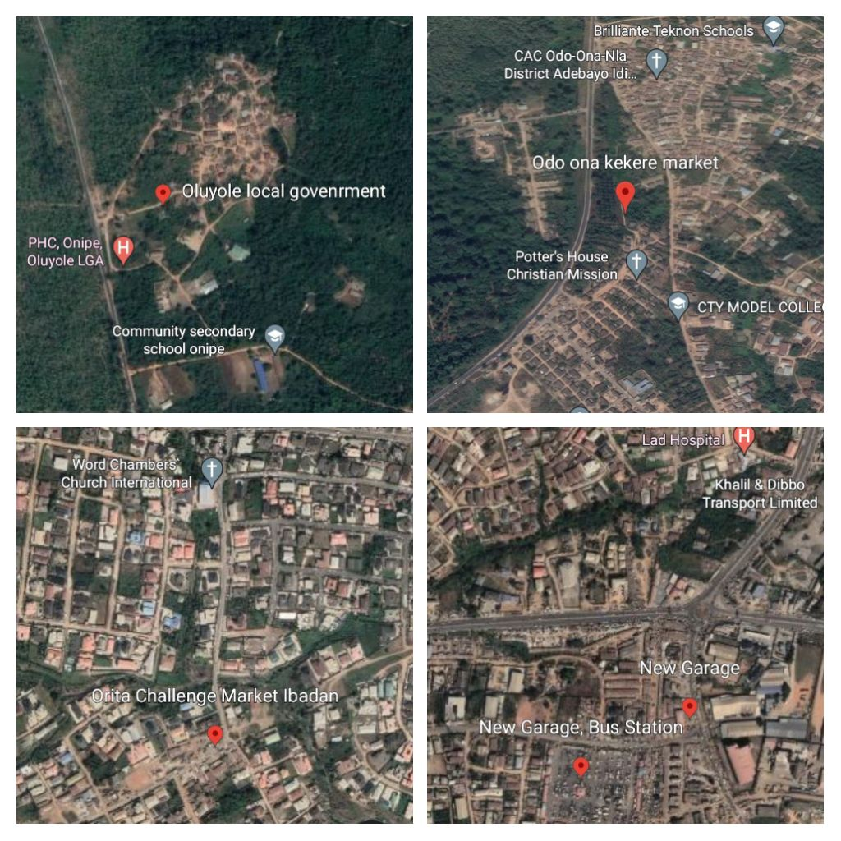

**Fig 1a, b, c and d: Location Odo Ona kekere market, Orita and New Garage, Oluyole Local Government, Ibadan, Oyo State, Nigeria showing the study areas**

**2.2 Samples Collection**

Three (3) samples of Ginger were collected randomly from three different sellers at three different market Odo Ona, Orita and New garage in Ibadan, Oluyole Local Government, a 10cm 2 plot was measured using 30- meter measuring tape. A total of 27 ginger fruits were selected using simple random sampling techniques (Kutama *et al*, 2007), placed in a sterile polythene bags and kept at room temperature to preserve its dry nature and avoid spoilage. Subsequently, after 4 weeks, when ginger began to show signs of infection by fungi, three (3) tomatoes samples were collected randomly from the same locations and a total 27 tomatoes were also collected using the same method. Infected tomato fruits and ginger with symptoms of softness were randomly procured locally from three different sellers (using simple random sampling techniques) at New Garage, Odo Ona kekere market, Orita market Oluyole Local Government, Ibadan. In total 27 infected tomatoes and ginger were placed in a separate sterile polythene bags, conveyed into the laboratory for subsequent dilution, isolation, identification and characterization.

**2.3 Assessment of Disease Incidence on the fresh tomatoes and ginger fruits**

Disease incidence was calculated by counting the number of infected plants out of each of the 27 tomato and Ginger fruits bought and observed at 7days interval for a period of five (5) weeks (Kutama *et al*, 2007). The percentage disease incidence was calculated using the following formula Percentage disease incidence (PDI) = Total number of infected plants X 100

Total number of plants assessed (Shuaibu *et al*, 2023).

**2.4 Isolation of Fungal Strains**

Fungal strains were isolated by serial dilution technique from the infected parts of each tomato and ginger fruits. Potato Dextrose Agar (PDA) was prepared according to the manufacturer’s instruction, heated in a water bath and autoclaved at 121oC for 15 minutes. The media were cooled to 45oc and ciprofloxacin (2%) was dispensed into the PDA to inhibit the growth of bacteria. Using the spread plate techniques, 1ml of the samples were innoculated into the plate and were labelled appropriately, plates were incubated at 250C for 2-3 days, plates were sub-cultured into fresh medium until a pure culture was obtained (Temesgen and Sefawdin, 2020).

**2.5 Identification and Characterization of Fungal Isolates**

The fungal colonial morphology was done microscopically by placing a fungi mycelia picked a sterile needle onto on a sterile glass slide, stained with Lacto-phenol in cotton blue, covered with a coverslip and examined under the microscope (X40) for their morphology and cultural characteristics (Sajad *et al*, 2017). Isolated fungi were identified based on their colonial colour, number of septate and nature of hyphae (Septate or Aseptate) (Temesgen and Sefawdin, 2020). The fungal isolates were subjected to comparative morphological studies by an image and analysis system using published descriptions in a mycological atlas. They were also identified by comparing the microscopic characteristics with journals that did related study. The characteristics observed were matched with those available in the aforementioned mycological atlas and journals, they were identified accordingly (Akintobi *et al*. 2011, Abubakar *et al*. 2023)

**2.6 Fungal Pathogenicity Test**

Healthy tomato and ginger fruits were surface sterilized with ethanol for 1 minute and washed in five changes of distilled water, weighed and readings recorded. Three seedlings were used for each of the pathogen while control remained untreated with any of the pathogens. Conidial Suspension was prepared using 14 days pure cultures in PDA. A sterile wire loop was used to scrape of the conidia and bring them to suspension. The suspension was filtered through a sieve to remove mycelia fragment and then collected filtrate diluted serially to 1×105 ml-1. A haemocytometer was used to adjust the spore concentration before inoculation (Wanjiku *et al.* 2020). Inoculation was carried out using injection method, the inoculums were introduced into the tomato and ginger with a clean hypodermic needle, 1ml of the inoculum was injected to each plant (Catroux *et al.,* 2001; Kutama *et al.,* 2013). Inoculated plants were covered with polythene to ensure equal environmental condition and avoid contamination. The inoculated tomato and ginger fruits were placed at room temperature (250C) under aseptic condition. After 72 hours, the healthy fruits with inoculum introduction showed rotten sign and the rotten part were scooped off, and then reweighed. The control experiment showed no sign of rot, pathogen obtained were re-Inoculated to confirm the Koch’s Postulate (Paletto *et al*, 2020), growth were recorded. The pathogens were later identified using the same procedures identified earlier.

**2.7 Analysis of Fungi Rot Severity**

The formula used to determine the severity of rots caused by the fungal pathogens of tomato and ginger fruits was achieved based on the weight values recorded from pathogenicity test procedure (Chukwu et al, 2010)

**%** Severity = W-w x 100%

W

Where W= Initial weight of healthy tomatoes and ginger

w = Final weight of rotted fruit

**2.8 Statistical Analysis**

The data difference in the pathogenic effect of fungi on ginger and tomato in relation to each market was compared using analysis of variance (ANOVA) at 5% level of significance.

**3.0 RESULTS**

**3.1 Assessment of fungal pathogens in Tomato and Ginger**

According to the study, Table 1 indicates that there was no difference in the disease incidence of fungal, however it was observed that as the week increases, the number of tomato and ginger that were affected increased. Also, 27 fruits of each tomatoes and ginger were assessed weekly, at week 1, three (3) ginger and 5 tomatoes fruits were affected by fungi pathogens, at week 2, Five (5) ginger and 8 tomatoes, week 3, six (6) ginger and 13 tomatoes, week 4, (ten) 10 ginger and 18 tomatoes while week 5, (thirteen) 13 ginger and 25 tomatoes respectively were affected by fungi pathogens. Apparently, out of 27 of each ginger and tomatoes assessed 13 ginger and 25 tomatoes were affected by the fungal pathogens within 5 weeks, this indicate that tomato is easily affected by fungal pathogens than ginger.

**Table 1: Percentage of disease incidence of ginger and tomato**

|  |  |
| --- | --- |
|  | **INCIDENCE OF FUNGAL DISEASES (%) IN WEEKS** |
| **CROP TYPES** | 1 2 3 4 5 |
| Ginger | 11.1 18.5 22.2 37.0 48.1 |
| Tomato | 18.5 29.7 48.2 66.7 92.3 |

**P < 0.05 which indicates there is difference according to LSD**

Figure 2 shows that as the weeks increase the number of tomato and ginger fruits affected by the fungal pathogens increases, the linear lines across the LSD indicates the differences between the number of ginger and tomatoes affected weekly.

**Fig 2: Bar chart on the percentage of fungal disease occurrence in tomato and ginger for 5 weeks**

**3.2: Correlation of Market locations in relation to fungal pathogen incidence in Tomato and Ginger**

Table 2 shows that out of 9 tomatoes bought at New garage market , the number of ginger and tomatoes affected by fungi pathogens from week 1 to week 5 are ( 1,1) ( 1,2) , ( 1, 3) (2,5),(2,8) respectively, at week 5 for both of the fruit bought at New garage only 2 tomatoes were infected while 8 out the 9 tomatoes were infected . Out 9 ginger and tomatoes bought at Odo Ona kekere market ,the number of tomatoes affected by fungi pathogens are as follows ( 1, 2), (2,3), ( 3,6), (5,7) ( 5,9), this indicates that at week 5 , all the tomatoes and 5 ginger bought at that location was infected. While at Orita market the number of tomatoes and Ginger affected by fungal pathogens from week 1to week 5 are as follows ( 1,2), (2,3) , ( 2,4) ,( 3, 6) , (6,8), this results shows that at week 5, six (6) out the 9 ginger collected was infected while 8 out of the 9 tomatoes collected were infected. Moreover, looking at the results critically 2 tomatoes were not affected from the collected ones, one (1) at New garage and one (1) Orita market while 7, 4 and 3 ginger bought from New garage, Odo ona and Orita market was not affected as at week 5, making a total of 14 ginger fruits that was not infected even after keeping it at room temperature for 4 weeks. However, in relation to the market locations Odo-ona market has the highest number (9) of tomatoes affected by the fungal pathogens while Orita market has the highest number (6) of ginger affected by affected by the fungal pathogens while new garage has the least number of both.

**Table 2: Comparison of the percentage incidence of fungal diseases in weeks on ginger and tomato fruits between each locations**

|  |  |
| --- | --- |
|  | **INCIDENCE OF FUNGAL DISEASES (%) IN WEEKS**  **GINGER TOMATO**  **1 2 3 4 5 1 2 3 4 5** |
| **LOCATIONS** |  |
| NGM | 11.I 11.1 11.1 22.2 22.2 11.1 22.2 33.4 55.5 88.9 |
| ODM | 11.1 22.2 33.3 55.5 55.5 22.2 33.3 66.7 77.8 99.9 |
| ORM | 11.1 22.2 22.2 33.3 66.6 22.2 33.3 44.4 66.7 88.8 |

**P > 0.05 which indicates there is no difference according to LSD**

Figure 3 shows that all the tomatoes bought at Odo ona market were infected by pathogens this can be related generally on the moisture content of tomato and basically on how busy and rowdy the market is especially at the evening times, the tomatoes infected may be due to different customers touch or microorganisms in the air, can also be based on the cleanliness of the seller spot. At New garage and Orita market 8 out of 9 tomatoes were spoilt, this can be based on the moisture content and other environmental factors. However 6 ginger out of 9 bought from Orita market were infected which might be due to environmental factors followed by Odo ona market 5 infected while New garage has the least infected ginger fruits.

**Fig 3: Fungal pathogens occurrence in tomato and ginger in correlation with each market locations.**

Table 3 show the fungal pathogens of ginger, from the study the fungi pathogens that causes the spoilage of ginger are Aspergillus species, they are of different species but same genus. For each locations of ginger the pathogenic fungi that causes spoilage of ginger are as follows NGM (*Aspergillus aculeatinus, Aspergillus flavus and Aspergillus nidulans*), ODM (*Aspergillus niger*) and ORM (*Aspergillus flavus*).

**Table 3: Fungal pathogens associated with Ginger** *(Zingiber officinale*)

|  |  |  |  |
| --- | --- | --- | --- |
| **Plate ID** | **Colony morphology** | **Microscopic morphology** | **Probable Identity** |
| NGM | Pale dull light green , radiate heads on basal mycelium and some columns in aerial mycelium (Robert et al. 2020) | The colonies were biserrate with philiades radiating in all sides from metulae that were borne on subglobose vesicles of variable size. The metulae obscured the entire surface of the vesicles. The conidia has a globose shape ranging between 250 and 450 micro meter in diameter with walls and rough texture. (Robert *et al*. 2020) | *Aspergillus flavus* |
| NGMT2 | Dark green with orange to yellow, reverse is purplish to olive (Perumal et al, 2012) | Hyphae are Septate and hyaline, conidiophores are brown, short 80cm micro meter and smooth –walled, vesicles are hemispherical, small 10 micro meter with metulae and phalides occurring on the upper portion. (Perumal et al, 2012, Samson , 1979, Raper and Fennell, 1965, ,) | *Aspergillus nidulans* |
| NGMT3 | 18mm wide and 11mm long, conidiophores are produced abundantly, conidial areas are light brown; sclerotia are present, small globose(0.4) , globose to subglobose , creamish to light yellow (Paramee et al , 2008) | Conidial heads radiate , splitting into poorly defined columns, stipes are short (380 micro meter), thin walls , smooth , hyaline vesicles is 55 micro meter wide , globose are uniserate ,halides has a flask like- shaped and cover the entire surface of the vesicle , conidia is subglobose to ellipsoidal, 2-4 x3.4 micro meter , ehinulate (Paramee et al, 2008) | *Aspergillus aculeatinus* |
| ODMT | Colonies with 20mm diameter and 10 mm width with a black pigmentation, the reverse colour on plate is yellow (Faith makobi 2021). | Smooth coloured conidiophores of 400 -3000 micrometre which becomes dark at the apex and terminating in a globose vesicle which is 30-75 micro meter in diameter and conidia , the conidiophores are protrusions from a Septate and hyaline hyphae.. (Faith makobi, 2021). | *Aspergillus niger* |
| ORMG | Colonies with diameter range of 50-70mm on PDA has a white mycelia colour with an olive-green conidia that dominated the colony’s appearance. (Rahim Khan 2021) | Conidiophores of *A. flavus* isolates were colourless, thick-walled, roughed, and bearing vesicles. The diameter of the conidiophores ranged from 800 to 1200 μm. The vesicle shape of *A. flavus* isolates was globose to sub-globose. The diameter of the vesicles ranged from 1800 to 2000 μm. ( Rahim Khan ,2021 ) | *Aspergillus flavus* |

Table 4 shows the fungal pathogens that causes rot and spoilage of the tomatoes. From the tomatoes bought at NGM, *Fusarium moniliforme* and *Aspergillus japonicus* were isolated, from ODM, *Aspergillus niger* and *Fusarium* *moniliforme* was isolated while from ORM *Aspergillus flavus and Aspergillus niger* were isolated.

**Table 4: Fungal pathogens associated with Tomato (*Lycopersicum esculentum*)**

|  |  |  |  |
| --- | --- | --- | --- |
| **PLATE ID** | **Colony morphology** | **Microscopic morphology** | **Probable Identity** |
| **NGMT** | Colonies are very low and quite sparse with white mycelium, leathery and difficult to dissect with needle. (Gwa and Nwankiti, 2017). | Septate hyphae breaking up into chains of hyaline , smooth, one celled , sub glubulose to cylindrical arthroconidia (Sandhul et al, 1995 Gwa and Nwankiti, 2017). | *Fusarium*  *moniliforme* |
| **NGMT2** | Colonies are 50mm , are have a black pigmentation , the reverse colour on plate is brown  (Vesth *et al*, 2018) | Conidiophores borne from surface hyphae , 1.0-3.0 mm long with heavy hyaline , smooth walls; vesicles are spherical , 50-75μm, bearing closely packed metuelae 10-15 μm long.(Vesth *et al*,2018) | *Aspergillus japonicus* |
| **ODMT** | Colonies are 1.5mm, with black pigmentation and reverse colour on plate is brown.  (Faith makobi,2021) | Conidiophores borne from surface hyphae, 1.0-3.0 mm long with heavy hyaline, smooth walls; vesicles are spherical, 50-75μm, bearing closely packed.  (Faith makobi , 2021) | *Aspergillus niger* |
| **ODMT2** | Colonies are 40mm, very low and quite sparse with white mycelium, leathery and difficult to dissect with needle. (Gwa and Nwankiti, 2017) | Septate hyphae breaking up into chains of hyaline. Smooth, one celled, sub glucose to cylindrical arthroconidia.(Gwa and Nwankiti, 2017) | *Fusarium moniliforme* |
| **ORM** | Colonies have a black pigmentation the reverse colour on plate is brown.  (Faith makobi , 2021) | Smooth coloured conidiophores of 400 -3000μm which becomes dark at the apex and terminating in a globose vesicle which is 30-75 μm in diameter and conidia.  (Faith makobi, 2021). | *Aspergillus*  *niger* |
| **ORMT2** | Colonies are 50mm, plane and sparse to moderately dense with a green pigmentation, the reverse colour is light yellow (Robert et al. 2020). | The colonies were biserrate with phialides radiating in all sides from metulae that were borne on subglobose vesicles of variable size. The conidia has a globose shape ranging between 250 and 450 μm in diameter with walls and rough texture. (Robert et al. 2020). | *Aspergillus flavus* |

**Fig 4: Fungal Pathogens occurrence in Tomato and Ginger**

**Table 5: Severity Rot Percentage of each of the Ginger fruits bought at different locations**

|  |  |  |  |
| --- | --- | --- | --- |
| **Sample ID** | **Initial weight**  **(g)** | **final weight**  **(g)** | **Severity-rot percentage**  **(%)** |
| NGMa | 6.98 | 4.58 | 34.4 |
| NGMb | 5.84 | 3.28 | 43.8 |
| NGMc | 6.46 | 4.54 | 29.7 |
| ODMa | 8.05 | 5.03 | 37.5 |
| ODMb | 7.09 | 4.98 | 29.7 |
| ODMc | 9.51 | 6.73 | 29.2 |
| ORMa | 9.63 | 5.34 | 44.5 |
| ORMb | 8.74 | 6.32 | 27.7 |
| ORMc | 9.33 | 5.21 | 44.2 |

**Scale: a, b and c indicate the three sellers at which each of the ginger were bought in each locations.**

**Fig 5: Severity rot Percentage of Ginger at different market locations**

**Table 6: Severity Rot Percentage of each of the tomatoes bought at different locations**

|  |  |  |  |
| --- | --- | --- | --- |
| **Sample ID** | **Initial weight**  **(g)** | **final weight**  **(g)** | **Severity-rot percentage**  **(%)** |
| NGMa | 7.85 | 4.25 | 45.9 |
| NGMb | 8.84 | 4.54 | 48.6 |
| NGMc | 15.3 | 7.74 | 49.4 |
| ODMa | 16.3 | 7.09 | 56.5 |
| ODMb | 11.4 | 4.25 | 62.7 |
| ODMc | 10.9 | 5.59 | 48.7 |
| ORMa | 15.3 | 5.96 | 61.0 |
| ORMb | 12.6 | 6.71 | 46.1 |
| ORMc | 11.6 | 5.98 | 48.4 |

**Scale: a, b and c indicate the three sellers at which each of the tomatoes were bought in each locations.**

**Fig 6: Percentage rot of tomatoes at different market locations**

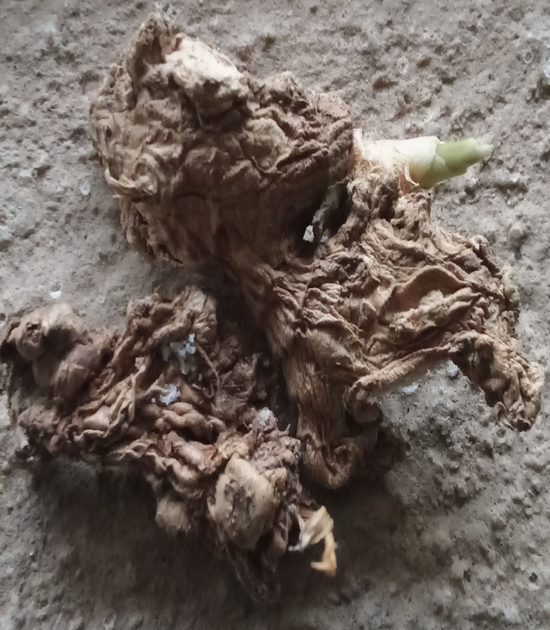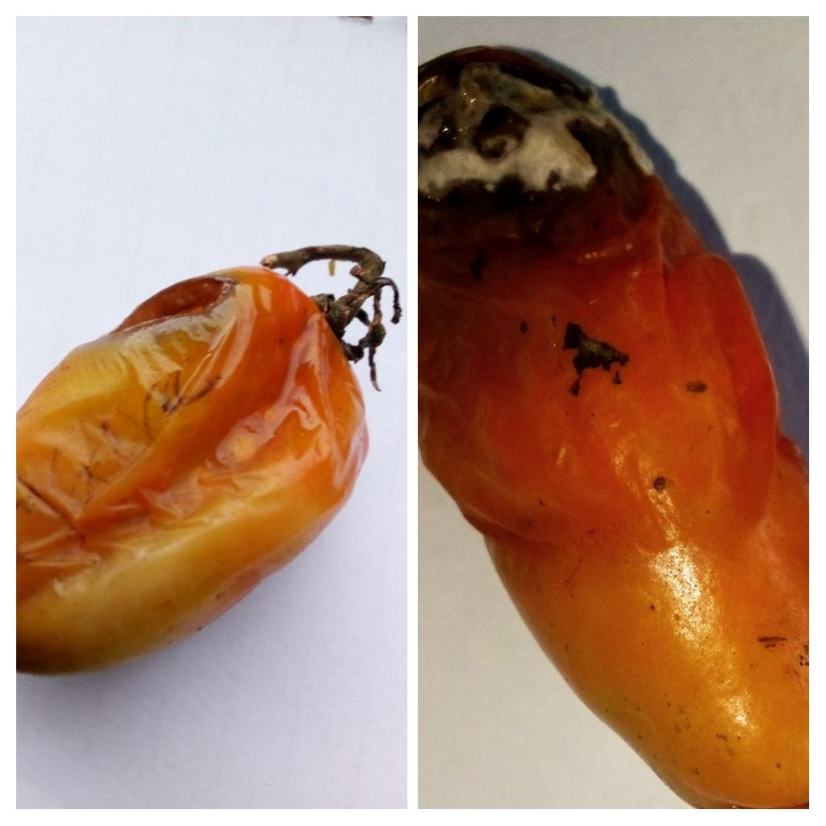

**Fig 7a and b: Fungi rot in ginger and tomatoes**

**Discussion**

The research reveals that the genus of *Aspergillus* are the dominant fungi pathogens that causes spoilage of ginger and tomatoes when stored. From the results in comparison to the locations, the ginger collected from Orita market and the tomatoes collected from Odo ona market has the highest fungal percentage incidence while new garage has the lowest fungal incidence for both tomato and ginger. A total of six isolates were isolated and identified of which *Aspergillus flavus* had the highest occurrence frequency (18.1%) of severity rot on ginger while in tomatoes *Aspergillus niger* and *Fusarium moniliforme* has percentage occurrence of (18.1) while *Aspergillus aculeatinus*, and *Aspergillus nidulans* had the percentage occurrence of (9.0%) which was the lowest. The prevalence of fungi as the spoilage organism of fruits and vegetables is due to a wide range of factors which are encountered at each stage of handling from pre-harvest to consumption and is related to the physiological and physical conditions of the produce as well as the extrinsic parameters to which they are subjected (Effiuwevwere, 2000). Moreover, the higher number of fungi species identified may be due to climatic conditions such as high temperature and air humidity which favor the growth of microorganism particularly fungal pathogens leading to deterioration of the fruits (Abubakar *et al*. 2019). The highest frequency of fungi occurrence recorded in tomato was *Aspergillus niger* (27.3%), this could be related to its high speculating capacity and production of toxins which inhibit the growth of other fungal pathogens (Rakesh *et al*., 2013). *Fusarium moniliforme* isolated in this study is one of the major fungi pathogens that is responsible for the spoilage of ginger and tomato which can be related to Ohr HD *et al,* 2013. *Aspergillus niger, Aspergillus flavus* and *Fusarium moniliforme* were isolated from both ginger and tomato samples, the genera *Aspergillus* dominated the spoilage of ginger and tomato. A large number of fungal species have been reported worldwide to cause spoilage of ginger which they belong to different species of *Aspergillus* and *Fusarium* (Pawar *et al*., 2008 Moreira *et al* 2013, Meenu and Kashul, 2017, Sefinew *et al*, 2022). Other fungal species isolated from ginger are *Aspergillus flavus, Aspergillus nidulans and Aspergillus aculeatinus while in tomato Aspergillus japonicus, and Aspergillus flavus* were isolated. The study revealed that ginger fruits collected from Orita market had the highest severity of (44.5%) while the tomato fruits collected from Odo- ona market also had the highest severity rot of (62.7%).

**Recommendation**

In accordance to the health benefit and high nutritive value of ginger and tomato fruits, new techniques should be espouse by the farmers, agriculturist and entomologist to reduce microbial spoilage of farm products which will increase the productivity yield. Farmers should consider the phenotypic and genotypic characteristics of the species of farm products to be cultivated and application of integrated pest control to reduce the infestation of fungi on ginger and tomato fruits. Moreover, ginger and tomatoes should be stored in a ventilated area and mishandling of ginger and tomatoes should avoided.

**Conclusion**

The study reiterates that seven fungal species with domination of genera *Aspergillus* are responsible for the spoilage and rotten of ginger and tomato fruits in Ibadan, Oluyole Local government. Proper handling and method should be adopted by consumers, farmers and retailers of tomatoes and ginger so as to reduce the fungal degeneration in the study area. Finally, care should be taken during selection of tomatoes and they should be washed thoroughly before human consumption.

**References**

Abubakar Sani, Mustapha Abubukar, Anas Hamsin. (2023). Fungal pathogens associated with post-harvest deterioration of tomato fruits in Jega Local Government area, Kebbi State, Nigeria, Vol4, no 7, pp. , 1303-1308

Abubakar M, Singh D, Hamisu A, Keta JN, Ahmad AJ. Identification and Assessment of the Effects of Pathogenic Fungi Associated With The Spoilage of Tomato Fruits in Jega Local Government Area, Kebbi State, Nigeria. *Journal of Innovative Research in Life Science* 1(2), (2019), 47– 54

Akintobi, A.O., Okonko, Agunbiade, S.O., Akano, O.r., Onianwi, O. (2011). Isolation and identification of fungi associated with the spoilage of some selected fruits in Ibadan south western Nigeria. Academia Arena, 3(11): 1-10.

Anh NH, Kim SJ, Long NP, et al. (2020). Ginger on human health: a comprehensive systematic review of 109 randomized controlled trials. *Nutrients*. 12(1):157 <https://doi.org/10.3390/nu12010157>.

Ballester P, Cerdá B, Arcusa R, Marhuenda J, Yamedjeu K, Zafrilla P,( 2022). Effect of ginger on inflammatory diseases. *Molecules*, 27(21):7223. <https://doi.org/10.3390/molecules27217223>

Collins EJ, Bowyer C, Tsouza A, Chopra M. Tomatoes, (2022): An extensive review of the associated [health impacts of tomatoes and factors that can affect their cultivation](https://www.ncbi.nlm.nih.gov/pmc/articles/PMC8869745/). *Biology (Basel)* 11(2):239. doi: 10.3390/biology11020239.

Chuku EC, Osakwe JA, Daddy-West C.Fungal spoilage of tomato (*Lycopersicon esculentum* mill), using garlic and ginger. Scientia Africana. (2010);9 (2):41.

Effiuvwevwere BFO. (2000). Microbial spoilage agents of topical and assorted fruits and vegetables (An Illustrated References Book). Port Harcourt: Paragraphics Publishing Company; 1-39.

Julian Kubala, RD, (2023). Health benefit of ginger. https//www.health .com /ginger –benefits

7372485.

Faith Makobi 2021, an overview on *Aspergillus niger*.

Gwa VI , Nwankiti AO (2017) In Vitro antagonistic Potential of Trichoderma hazianum for Biological Control of Fusarium moniliforme Isolated from Dioscorea rotundata Tubers. Virol-mycol 6: doi : 10.4172/2161-0517.1000166

Khan UM, Sevindik M, Zarrabi A, et al.( 2021). Lycopene: Food sources, biological activities, and human health benefit *Oxid Med Cell Longev*. 2713511. doi:10.1155/2021/2713511.

Kutama, A. S., Aliyu, B. S. and Emechebe, A. M. (2009). A Survey of sorghum Downy Mildew Sorghum sudano - sahelian savannah Zones of Nigeria. *Bayero journal of pure and applied sciences* 2 (2): 218-222

Mao QQ, Xu XY, Cao SY, et al., (2019). Bioactive compounds and bioactivities of ginger (*Zingiber officinale* Roscoe) *Foods*.8 (6):185. <https://doi.org/10.3390/foods8060185>.

Meenu, G., and Kaushal, M. ( 2017). Disease infecting ginger (Zingiber officinale Roscoe). A review .*Agri .Rev.* 38, 15-28. doi: 10.18805/ag.v0iOF.7305.

Modi M, Modi K. Ginger Root. [Updated 2022 Nov 28]. In: StatPearls [Internet]. Treasure Island (FL): StatPearls Publishing; (2023 ) Jan-.  <https://www.ncbi.nlm.nih.gov/books/NBK565886/>

Moreira, S.I., Dutra, D., Rodrigues, A.C., Oliverira, J.r, Dhingra, O.D., and Pereira , O.l .(2013).Fungi and bacteria associated with post- harvest rot of ginger rhizomes in Espirito Santo, Brazil. *Trop. Plant Pathol.* 38,218-226.doi:10.1590/S1982-56762013000300006.

Mozaffari-Khosravi H, Naderi Z, Dehghan A, Nadjarzadeh A, Fallah Huseini H. (2016) Supplementation on proinflammatory cytokines in older patients with osteoarthritis *J Nutr Gerontol Geriatric,* ; 35(3):209-218. <https://doi.org/10.1080/21551197.2016.1206762>

Ohr HD, Coffer MD, McMillan RT, 2013. Common names of plant diseases. American Phytopathological Society; .Available:http://web.archive.org/web(Assessed 2 July, 2015).

Paramee Noonim,Warapa Mahakarnchanakul, Janos Varga , Jens C, Frisvad , Robert A . Samson. (2008) Two novel species of Aspergillus section Nigri from Thai coffee beans.

Pawar, N., Patil ,V., Kamble, S, and Dixit , G (2008). First report of *Aspergillus niger* as a plant pathogen On Zingiber officinale from India. *Plant Dis*. 92:1968.doi : 10.1094?PDIS-92-9-1368C

Perumal, Nithiyaa & Mohd Zainudin, Nur Ain Izzati & Yusuf, Umi & Salleh, Baharuddin. (2012). Diversity and morphological characteristics of Aspergillus species and Fusarium species isolated from cornmeal in Malaysia. Pertanika *Journal of Tropical Agricultural Science.* 35. 103-116.

Poletto,T.,Marlove, F. M., Vinícius, S. F., Ricardo, H. and Jéssica, M. R. (2020). Characterization and Pathogenicity of *Fusariumoxysporum*Associated with *Carya illinoinensis*Seedlings. Floresta e Ambiente 27(2): doi.org/10.1590/2179-8087.108917

Pit. John: Hocking, Alisa D. (2009). Fungi and Food Spoilage Doi: 10.1007/978-0-387-92207. ISBN 978-0-387-92206-5.

Okayo RO, Andika DO, Dida MM, K'Otuto GO, Gichimu BM. Morphological and Molecular

Characterization of Toxigenic *Aspergillus flavus* from Groundnut Kernels in Kenya. Int J Microbiol. (2020). Sep 7;2020:8854718. doi: 10.1155/2020/8854718. PMID: 32963542; PMCID: PMC7492892.

Rahim Khan (2021). Morphology of *Aspergillus flavus,* DOI: 10. 13140/RG.2.2.27050.54724

Rakesh KN, Dileep N, Nawaz NA, Junaid S, Kekuda PT, (2013). Antifungal activity of cow urine against fungal pathogens causing rhizome rot of ginger. Environment and Ecology 1(3), 1241–1244

Sandhu, G.s., B.C.Kline.Stockman, and G. D. Roberts. (1995). Molecular probes for diagnosis of fungal infections. *J. Clin. Microbiol*. 332913-2919.

Sajad, A. M., Jamaluddin and Abid, H. Q. (2017).Fungi Associated with the Spoilage of Post-Harvest Tomato Fruits and Their Frequency of Occurrences in Different Markets of Jabalpur, Madhya-Pradesh, India. *International Journal of Current Research Review; 9*

Sefinew Tilahun, Marye Alemu , Mesfin Tsegaw, Nega Berhane ,( 2022). Morphological and molecular Diversity of ginger ( Zingiber officinal Roscoe) pathogenic fungi in Chilga District , North Gondar, Ethiopia.

Shuaibu, R.U., Dangora, I.I., Kutama, A.S., Bello, A., Zakari, M., Musa, N. and Dahiru, M. (2023). Pathological assessment of major fungal pathogens associated with tomato and pepper in Jama’are North –Eastern Nigeria. https://doi.org/10.33003/jaat.2023.0901.13.

Senkus KE, Tan L, Crowe-White KM, (2019). Lycopene and metabolic syndrome: A systematic review of the literature. *Adv. Nutr*. ; 10(1):19–29.doi:10. 1093/advances/nmy069.

Temesgen, O. and Sefawdin, B. (2020) Isolation and Characterization of Wilt-Causing Pathogens of Local Growing Pepper (*Capsicum annum* L.) in Gurages Zone, Ethiopia. *International Journal of Agronomy* Wolkite University*.*

Vesth TC, Nybo JL, Theobald S, Frisvad JC, Larsen TO,Nielsen KF, Hoof JB, Brandl J,Salamov A,Riley R,Gladden JM, Phatale P,Nielsen MT, Lyhne EK, Kolgle ME, Strasser K, MCdonnell E,Barry K, Clum A, Chen C , LaButti K, Haridas S, Nolan M, Sandor L , Kuo A, Lipzen A, Hainut M, Drula E, A, Magnuson JK, Tsang, Magnuson JK, Henrissat B, Wiebenga A, Simmons BA, Makela MR, de Vries RP, Grigoriev IV, Mortensen UH, Baker SE, Andersen MR. 2018 Dec; Investigation of inter – and intraspecies variation through genome sequencing of Aspergillus section Nigri. Nat Genet 2018 Dec; 50 (12): 1688-1695.doi: 10.1038/s41588-018-0246-1

Wanjiku, E. K., Waceke, J. W., Wanjala, B. W. and Mbaka, J. N. (2020). Identification and Pathogenicity of Fungal Pathogens Associated with Stem End Rots of Avocado Fruits in Kenya. Research *Article International Journal of Microbiology*, Article ID 4063697, 8 pages https://doi.org/10.1155/2020/4063697

U.S Department of Agriculture, Agricultural Research Service, (2022).USDA Food and Nutrient Database for Dietary Studies 2019-2020.Food Surveys Research Group Home page, <http://www.ars.usda>. gov/nea/bhnrc/fcrg.