**OPTIMIZATION OF MYCELIA GROWTH AND IMMOBILIZATION OF PLEUROTUS OSTREATUS CELLS FOR ENHANCED BIOTECHNOLOGICAL APPLICATIONS**

**Rohit Rawat1, Anjali Choudhary2, Amit Raj3, Himanshu Rathore4, Shivam Rajput5,**

**Akanksha Kashyap6**

1,6 HARI Lifesciences, Bhopal

2Department of Biotechnology, Career College, Bhopal

3, 4, 5Research Student, Department of Biotechnology, Career College, Bhopal

**ABSTRACT**

*Pleurotus ostreatus* is known for its culinary and medicinal characteristics, with potential use in biotechnology. This research attempts to optimise mycelia growth and find effective approaches for immobilising them. The jars containing the substrate were inoculated with solid and liquid inoculums. Incubation at 21°C for 10 days in dark conditions allowed for a comparison of the time required for each inoculum type to attain complete substrate covering. After 10 days of incubation, it was discovered that the jar inoculated with liquid inoculum had 100% mycelial coverage, while the jar inoculated with solid inoculum had only 85% mycelial coverage. *P. ostreatus* cells were successfully immobilised using sodium alginate and calcium chloride solutions. After drying, the beads generated by dropping sodium alginate and fungal broth into a calcium chloride solution were round, glossy, and off white in colour. The research has potential applications in bioremediation, medicines, food technology, and environmental sustainability. This project aims to use *Pleurotus ostreatus* biotechnological potential to offer new and environmentally friendly solutions to current challenges.

**Key words:** *Pleurotus ostreatus,* mycelial coverage, immobilisation, substrate

**1. INTRODUCTION**

*Pleurotus* species are classified as Agaricales and are members of the Pleurotaceae family (white spore oyster mushroom). They are recognised by their colour and habitat. The majority of them are saprophytic and rarely parasitic. A recent article by Bao et al. provides useful information on the number of Pleurotus species found in Asia (Bao D et al., 2004). Pleurotus species are commonly found growing on damp tree trunks and decomposing organic waste, both of which contain high levels of lignin and phenol-degrading enzymes. Pleurotus species have unstable morphological traits due to fluctuating agro-climatic conditions and cultivation substrates (Kong WS, 2004). *P. ostreatus* is one of the most extensively farmed edible mushrooms because of its economic (food source), environmental (waste remediation agents), and medicinal value (biocompounds supplying source) (Da Luz et al., 2012). Oyster mushrooms are a popular and well-loved food source because they are abundant in protein, fibre, vitamins, and minerals while being low in fat, sodium, calories, and cholesterol (Caglarirmak, 2007).

*P. ostreatus* fungal mycelium grows on a variety of substrates, including wheat straw, corn cob, saw dust, and sugarcane bagasse (Karmani et al., 2022). *Pleurotus* species can also consume wood waste or unusable wood residues to stimulate economic growth and protect the forest ecology. Globally, around 998 million tonnes of agricultural waste are produced each year, including paddy, wheat, and cereal straws. *Pleurotus* mushrooms use these agro-wastes as substrates for their growth, hence cultivating them assists in recycling agro-wastes and alleviates the nutritional gap, which is primarily prominent among the people of China, India and Africa. In addition, discarded substrates are used for fertiliser, animal feed, and biogas generation (Kakon AJ et al., 2012). During culture, a mushroom seed is utilised to propagate the mushroom mycelia on the desired solid substrate. The incubation room temperature ranges from 25 to 30 °C. Mycelium run periods and primordial initiation often last 24-30 days (Hoa HT et al., 2015; Girmay Z et al., 2016).

The temperature at which mycelium runs and basidiocarps are produced is also determined by the *Pleurotus* species being grown. Incubation rooms do not require light. Standardised mushroom growing preparation is required for various Pleurotus species. The mother culture can be cultured on potato dextrose agar, a solid media, or nutrient broth. The purpose of this study is to visualise the time it takes for solid and liquid mother cultures to fully cover a substrate in order to optimise mycelial growth of *Pleurotus* ostreatus for increased biotechnological applications. Fungal entire cells have been employed to digest a variety of environmental contaminants. The activity of non-ligninolytic and ligninolytic enzymes in fungi has been identified as crucial for remediating these harmful chemicals (R. K. Singh et al. 2019). However, live bacteria are susceptible to environmental factors such as nutrients, oxygen, soil moisture, and even toxins (Karigar and Rao, 2011; Vidali, 2001). This leads to substantial operational expenditures in maintaining their biological activity. In contrast, isolated enzymes are less susceptible to the aforementioned conditions that reduce cell viability (Sutherland et al., 2004). Several fungal enzymes can break down more resistant contaminants because of their higher redox potential (Mikolasch and Schauer, 2009; Rebrikov et al., 2006). Thus, instead of employing complete fungal cells, directly administering enzymes has increasingly gained popularity as a viable alternative (R. K. Singh et al., 2019). Apart from being used to clean up pollution, fungal enzymes have a significant commercial value due to their ability to breakdown chemicals (McKelvey and Murphy, 2017) in a number of industries, like baking products (Scarton et al., 2021) and detergents (Niyonzima, 2021).

Some other application for fungal enzymes is synthesis of economically valuable chemicals (McKelvey and Murphy, 2017). Metallic catalysts are effective, but they may be poisonous and produce additional byproducts (Lu et al., 2019). Enzymes, on the other hand, are non-toxic, biocompatible, and biodegradable, eliminating the possibility of downstream pollution (Jegannathan and Nielsen, 2013; Soetaer and Vandamme, 2010). Furthermore, enzymes normally operate under mild physiological settings, which helps safeguard sensitive raw substrates (Lu et al., 2019). Enzymes, as benign and environmentally friendly catalysts, have been proposed as widely applicable synthetic tools. Fungal enzymes, in particular, have a role in the synthesis of various monomers, oligomers, and polymers. These synthesised compounds can be used in a variety of industries, including renewable fuels, sophisticated materials, and many more (Amini et al., 2017; Vénica et al., 2020; Walde et al., 2019).

Fungal enzymes provide benefits, but they also have limitations. For example, if the conditions are harsh (e.g., high acidity and/or temperature), liberated enzymes might denature, reducing their activity and affinity for substrates (Franssen et al., 2013). To address these limitations, immobilisation technologies have been utilised to enhance enzyme catalytic characteristics and stability. Immobilisation optimises interactions between enzymes and substrates while minimising non-specific interactions (Homaei et al., 2013). Immobilised enzymes have the advantages of long-term operating stability, ease of recovery, and reusability in industrial applications, which improve performance while lowering total process costs (Datta et al., 2013; Hassan et al., 2019).

**2. MATERIALS AND METHODS**

**2.1. Multiplication of desired strain:**

The pure strain of *P. ostreatus* was catered from the ICAR-Directorate of Mushroom Research (DMR), Solan (HP). This strain was multiplied on potato dextrose agar slants to get an ample amount of culture. The slants were incubated for 7 days at 21 °C in dark conditions. After full mycelium coverage, these slants can be refrigerated at 4 °C for preservation and further use.

**2.2. Preparation of inoculum for substrate inoculation:**

To inoculate substrate, the desired fungal strain was grown on solid media as well as liquid broth. For solid inoculum preparation, a prior multiplied fungal strain was inoculated in potato dextrose agar media in petri plates. These plates were incubated for 15 days at 21 °C in dark conditions. For liquid inoculum preparation, a prior multiplied culture of *P. ostreatus* was inoculated in nutrient broth and kept for incubation for 15 days at 21 °C in dark conditions on a rotary shaker. After 15 days, both of these inoculums can be refrigerated at 4 °C for preservation and further use.

**2.3. Substrate Preparation:**

Wheat is used as a substrate for the growth of the mycelium of *P. ostreatus*. The wheat grains were cleaned and washed four times. This was followed by boiling in water for about 20 minutes until the grains were soft but intact and the starch was not released. The grains were weighed, and to them, 4% (w/w) of calcium carbonate and magnesium sulphate were added. 100 grammes of grains were transferred into jars and autoclaved at 121 °C and 15 psi pressure. These jars were left to cool in laminar air flow for 24 hours.

**2.4. Substrate inoculation:**

The jars were inoculated with solid and liquid inoculums separately and kept for incubation at 21 °C in dark conditions to check whether the time taken by the liquid inoculum to cover the full substrate is less or the time taken by the solid inoculum to cover the full substrate is less.

**2.5. Immobilisation of fungal cells:**

0.8 gm sodium alginate solution was made in 10 ml of distilled water. 1.8 gm calcium chloride solution was prepared in 20 ml of distilled water. Then 20 ml of broth culture was mixed with a sodium alginate solution. This solution was taken into a sterile syringe, and the calcium chloride solution was transferred to a clean petri plate. Then, sodium alginate with fungal broth was transferred drop by drop into a calcium chloride solution taken from a petri plate. The beads were left undisturbed in the calcium chloride solution for 30 minutes. The beads were filtered and left to dry for 24 hours.

**3.RESULT**

The jars containing the optimized substrate underwent inoculation with both solid and liquid inoculums. Incubation at 21°C for 10 days in dark conditions was allowed for the comparison of the time required for each inoculum type to achieve full substrate coverage. After 10 days of incubation of jars it was observed that the jar which was inoculated with liquid inoculum had 100% mycelial coverage whereas the jar which was inoculated with solid inoculum had only 80% mycelial coverage. The immobilization of *P. ostreatus* cells was successfully performed using a sodium alginate solution and calcium chloride solution. The resulting beads, formed by dropping the sodium alginate with fungal broth into the calcium chloride solution were spherical, shiny and off white in colour after drying.

**Table 1: Table showing Percentage of mycelium coverage inoculated with solid and liquid inoculum**

|  |  |  |
| --- | --- | --- |
| **S.NO.** | **TYPE OF INOCULUM USED** | **MYCELIUM COVERAGE (%)** |
| 1 | Solid | 85% |
| 2 | Liquid | 100% |

**Graph 1: Graph showing percentage of mycelium coverage vs type of inoculum used**

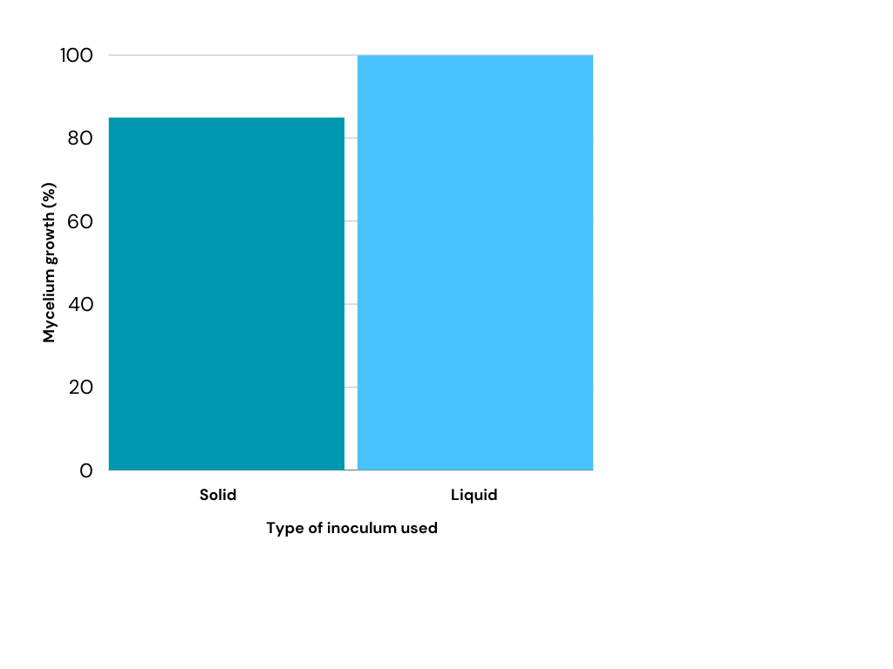

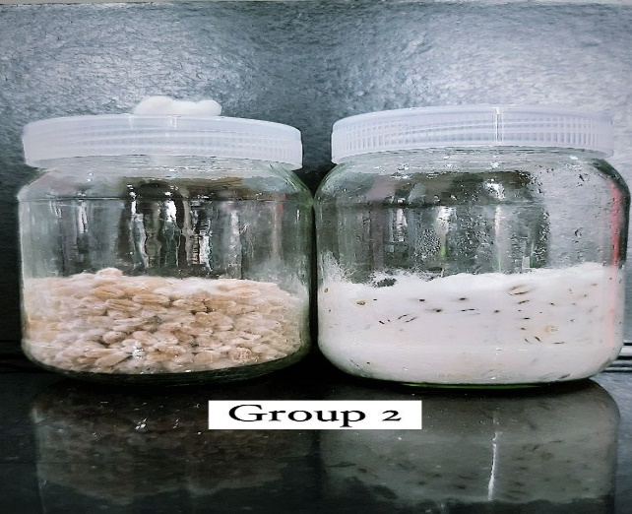

**Figure 1: Jar 1 showing mycelial coverage inoculated with solid inoculum and jar 2 showing mycelial coverage inoculated with liquid inoculum**

**4. DISCUSSION**

The jars containing the optimized wheat substrate were subjected to inoculation with both solid and liquid inoculums. Following a 10-day incubation period at 21°C in dark conditions, the mycelial coverage of each jar was assessed for a comparative analysis. After the 10-day incubation period, it was observed that the jar inoculated with the liquid inoculum exhibited complete mycelial coverage, reaching 100%. In contrast, the jar inoculated with the solid inoculum showed slightly less mycelial coverage, with only 80% of the substrate being colonized by the fungus.

This discrepancy in mycelial coverage suggests that the liquid inoculum was more effective in colonizing and spreading across the substrate within the given timeframe. The faster and more extensive coverage of the substrate by the liquid inoculum indicates its potential superiority for certain biotechnological applications or scale-up processes. Further investigations may be conducted to understand the underlying factors influencing the observed differences in mycelial growth between the two inoculum types, providing valuable insights for optimizing and refining future cultivation strategies. Liquid inoculants allow easy handling and low transportation costs as they can be designed to contain more propagules than solid products. The liquid inoculant is better suited for fertigation and irrigation than solid inoculants (Franssen et. al., 2011, Miguel D.A.R.J. et. al., 2007).

Immobilization of fungal cells was also performed in this study. After filtration and a 24-hour drying period, the immobilized cells exhibited stability and efficacy, showcasing their potential for enhanced biotechnological applications. This optimized immobilization process ensures the sustained functionality of *P. ostreatus* cells, opening avenues for innovative and efficient biotechnological endeavours. This optimization step is crucial for determining the most efficient method for subsequent biotechnological applications, providing insights into the kinetics of mycelial colonization on the chosen substrate.

**5. CONCLUSION**

*P. ostreatus*, being among the most widely cultivated edible mushrooms, holds immense potential for addressing food security, waste remediation, and medicinal applications. Its cultivation on diverse substrates, including agro-wastes, not only contributes to recycling agricultural by-products but also aids in mitigating nutritional gaps, particularly in regions such as China, India, and Africa.

The study focuses on Pleurotus cultivation, outlining the standardized procedures for incubation, mycelium run period, and primordial initiation. The choice of mother culture medium, whether solid Potato Dextrose Agar or liquid Nutrient Broth, becomes crucial for optimizing mycelial growth. The investigation focuses on visualizing the time taken by solid and liquid mother cultures to achieve full substrate coverage, offering insights for enhanced biotechnological applications.

Transitioning into the realm of fungal enzymes, the study highlights their pivotal role in environmental remediation and commercial applications. The discussion underscores the advantages of using isolated enzymes over whole fungal cells, addressing the challenges related to live microbial sensitivity to environmental conditions. Fungal enzymes, known for their diverse applications, demonstrate potential in synthesizing valuable compounds across various industries. Despite the advantages of fungal enzymes, their limitations, such as susceptibility to harsh conditions, are acknowledged. To overcome these challenges, the study explores immobilization technologies, emphasizing the improved stability and catalytic properties of immobilized enzymes. This opens avenues for long-term operational stability, ease of recovery, and reusability in industrial applications.

The experimental results reinforce the importance of choosing the right inoculum type for mycelial growth optimization. The observed higher mycelial coverage in jars inoculated with liquid culture suggests its potential superiority for certain biotechnological applications. Additionally, the successful immobilization of *P. ostreatus* cells using sodium alginate and calcium chloride presents a promising avenue for enhanced biotechnological endeavours. In essence, this study contributes multifaceted insights into Pleurotus cultivation, enzyme applications, and immobilization technologies. The findings provide a foundation for further research and innovations, fostering sustainable and efficient biotechnological practices with Pleurotus ostreatus at the forefront.

**6. REFERENCE**

1. Amini, Z., Ilham, Z., Ong, H.C., Mazaheri, H., Chen, W.H., 2017. State of the art and prospective of lipase-catalyzed transesterification reaction for biodiesel production. Energy Convers. Manag. 141, 339–353. <https://doi.org/10.1016/J.ENCONMAN.2016.09.049>
2. Bao D, Kinugasa S, Kitamoto Y. The biological species of oyster mushrooms (Pleurotus spp.) from Asia based on mating compatibility tests. *J Wood Sci*. 2004;50(2):162–168.
3. Caglarirmak N., 2007. The nutrients of exotic mushrooms (Lentinula edodes and Pleurotus species) and an estimated approach to the volatile compounds. Food Chem., 105: 1188-1194.
4. Da Luz J.M.R., Paes, S.A., Nunes, M.D., Torres, D.P., da Silva, M.C.S., 2012. Lignocellulolytic enzyme production of Pleurotus ostreatus growth in agroindustrial wastes. Braz. J. Microbiol., 43, 1508-1515.
5. Datta, S., Christena, L.R., Rajaram, Y.R.S., 2013. Enzyme immobilization: an overview on techniques and support materials. 3 Biotech 3, 1–9. <https://doi.org/10.1007/s13205-012-0071-7>
6. Fernández F., Dell’Amico J., Angoa M., de la Providencia I. Use of a liquid inoculum of the arbuscular mycorrhizal fungi Glomus hoi in rice plants cultivated in a saline Gleysol: A new alternative to inoculate. *J. Plant Breed. Crop Sci.*2011;3:24–33. [[Google Scholar](https://scholar.google.com/scholar_lookup?journal=J.+Plant+Breed.+Crop+Sci.&title=Use+of+a+liquid+inoculum+of+the+arbuscular+mycorrhizal+fungi+Glomus+hoi+in+rice+plants+cultivated+in+a+saline+Gleysol:+A+new+alternative+to+inoculate&author=F.+Fern%C3%A1ndez&author=J.+Dell%E2%80%99Amico&author=M.+Angoa&author=I.+de+la+Providencia&volume=3&publication_year=2011&pages=24-33&)]
7. Franssen, M.C.R., Steunenberg, P., Scott, E.L., Zuilhof, H., Sanders, J.P.M., 2013. Immobilised enzymes in biorenewables production. Chem. Soc. Rev. 42, 6491–6533. <https://doi.org/10.1039/c3cs00004d>
8. Girmay Z, Gorems W, Birhanu G, et al. Growth and yield performance of Pleurotus ostreatus (Jacq. Fr.) Kumm (oyster mushroom) on different substrates. *AMB Express*. 2016;6(1):87.
9. Hassan, M.E., Yang, Q., Xiao, Z., Liu, L., Wang, N., Cui, X., Yang, L., 2019. Impact of immobilization technology in industrial and pharmaceutical applications. 3 Biotech. https://doi.org/10.1007/s13205-019-1969-0
10. Hoa HT, Wang CL. The effects of temperature and nutritional conditions on mycelium growth of two oyster mushrooms (Pleurotus ostreatus and Pleurotus cystidiosus). *Mycobiology*. 2015;43(1):14–23.
11. Homaei, A.A., Sariri, R., Vianello, F., Stevanato, R., 2013. Enzyme immobilization: an update. J. Chem. Biol. 6, 185–205. <https://doi.org/10.1007/s12154-013-0102-9>
12. Kakon AJ, Md Choudhury BK, Shusmita S. Mushroom is an ideal food supplement. *J Dhaka Natl Med Coll Hosp*. 2012;18(1):58–62.
13. Karigar, C.S., Rao, S.S., 2011. Role of microbial enzymes in the bioremediation of pollutants: A review. Enzyme Res. 2011. <https://doi.org/10.4061/2011/805187>
14. Karmani, Muskan & Subramaniam, Geetha & Ambigai, Lalita & Cheng, W & Ling Shing, Wong. (2022). Effects of Different Substrates on the Growth and Nutritional Composition of Pleurotus ostreatus: A Review Lignocellulosic Substrates Nutrition Yield. Journal of Experimental Biology and Agricultural Sciences. 10(3). 481-486. 10.18006/2022.10(3).481.486.
15. Kong WS. Description of commercially important Pleurotus species In: Choi KW, editor. *Mushroom growers handbook*. Seoul (South Korea): Oyster Mushroom Cultivation, Mush World; 2004. p. 54–61.
16. Lu, Y., Lv, Q., Liu, B., Liu, J., 2019. Immobilized Candida antarctica lipase B catalyzed synthesis of biodegradable polymers for biomedical applications. Biomater. Sci. 7, 4963–4983. <https://doi.org/10.1039/C9BM00716D>
17. McKelvey, S.M., Murphy, R.A., 2017. Biotechnological use of fungal enzymes, in: Fungi. John Wiley & Sons, Ltd, pp. 201–225. <https://doi.org/10.1002/9781119374312.CH8>
18. Miguel D.A.R.J., Feliica F.M., Yuniesky P.C. In: *Liquid Mycorrhizal Inoculant.* Office E.P., editor. Instituto nacional de ciencias agricolas (INCA); San José de las Lajas, Cuba: 2007. pp. 1–8. [[Google Scholar](https://scholar.google.com/scholar_lookup?title=Liquid+Mycorrhizal+Inoculant&author=D.A.R.J.+Miguel&author=F.M.+Feliica&author=P.C.+Yuniesky&publication_year=2007&)]
19. Mikolasch, A., Schauer, F., 2009. Fungal laccases as tools for the synthesis of new hybrid molecules and biomaterials. Appl. Microbiol. Biotechnol. 82, 605–624. <https://doi.org/10.1007/s00253-009-1869-z>
20. Rebrikov, D.N., Stepanova, E. V., Koroleva, O. V., Budarina, Z.I., Zakharova, M. V., Yurkova, T.V., Solonin, A.S., Belova, O. V., Pozhidaeva, Z.A., Leont’evsky, A.A., 2006. Laccase of the lignolytic fungus Trametes hirsuta: purification and characterization of the enzyme, and cloning and primary structure of the gene. Appl. Biochem. Microbiol. 42, 564–572. <https://doi.org/10.1134/S0003683806060068>
21. Singh, R.K., Tripathi, R., Ranjan, A., Srivastava, A.K., 2019. Fungi as potential candidates for bioremediation, in: Singh, P., Kumar, A., Borthakur, A. (Eds.), Abatement of Environmental Pollutants: Trends and Strategies. Elsevier, pp. 177–191. <https://doi.org/10.1016/B978-0-12-818095-2.00009-6>
22. Sutherland, T.D., Horne, I., Weir, K.M., Coppin, C.W., Williams, M.R., Selleck, M., Russell, R.J., Oakeshott, J.G., 2004. Enzymatic bioremediation: From enzyme discovery to applications. Clin. Exp. Pharmacol. Physiol. 31, 817–821. <https://doi.org/10.1111/j.1440-1681.2004.04088.x>
23. Vénica, C.I., Wolf, V.I., Bergamini, C. V., Perotti, M.C., 2020. Effect of the incorporation of galactosidase in the GOS production during manufacture of soft cheese. Food Res. Int. 137, 109654. <https://doi.org/10.1016/j.foodres.2020.109654>
24. Vidali, M., 2001. Bioremediation. An overview. Pure Appl. Chem. 73, 1163–1172. https://doi.org/10.1351/PAC200173071163
25. Walde, P., Kashima, K., Ćirić-Marjanović, G., 2019. Synthesizing polyaniline with laccase/O2 as catalyst. Front. Bioeng. Biotechnol. 7, 1–10. <https://doi.org/10.3389/fbioe.2019.00165>