METROPOLITAN TRAFFIC STREAM FORECAST: A FAR REACHING EXAMINATION AND PRESCIENT MODEL

¹HARSH DAHIYA, ²PARDEEP
^{1.}M.Tech Scholar Civil Engineering Department SAT PRIYA GROUP OF INSTITUTIONS, Rohtak
^{2.} Assistant Professor, Civil Engineering Department SAT PRIYA GROUP OF INSTITUTIONS , Rohtak

ABSTRACT
Gridlocks happen regularly across the entire world, especially in a country with a huge populace like India. Subsequently, individuals bend over backward to address this issue to get where they need to go rapidly to save time. Nowadays, there is a ton of interest in rush hour gridlock related research since it will be useful to every individual who lives in packed urban communities. Savvy urban communities are one new imaginative arrangement achieved by the Web of Things (IoT) that permits people to live more proficiently, easily, and cleverly. The Clever Transportation Framework (ITS), which further develops worker and transportation processes, is a part of a few brilliant city applications. ITS looks to address traffic issues, especially blockage. To expect or anticipate the traffic esteem utilizing time series determining models, research on traffic networks was likewise directed. While arranging street offices, from the speculation possibility evaluation to making working administrative work, traffic estimating is a vital stage. The main subject managing both traffic gauge and traffic light is traffic time series investigation, which is huge. The review uncovers a tremendous distinction between the different models' capacity to foresee traffic dependably and unequivocally.
Keywords: Time Series Models, Traffic Estimating.

INTRODUCTION
India has the second-most elevated populace behind China, making it the most blocked country on the planet. India's vehicle populace is scattered unevenly. Everybody knows that traffic goes at the speed of its slowest component. Bikes, bikes, vehicles, transports, trucks, and trains are normal in many urban communities. In any case, organizations of auto-carts, bikes, bullock trucks, and hand-pulled carts have been startlingly dwarfing mechanized vehicles in India by an element of 100. These additional channels for metropolitan vehicle are a significant supporter of the clog. Be that as it may, the extension of the street network stayed aware of its development. Limited scope strategies for data and traffic light are expected to resolve the critical issue of proceeding and rising Indian urban communities that might encounter less gridlock subsequently. expanded interest for public vehicle and gridlocks
Trip delays, which are as of now terrible, are exacerbated by the trouble that cars have traveling through blocked city roads. Assembling new streets or expanding existing ones can quickly ease clog, yet over the long haul, these exercises will simply build the quantity of new cars out and about and hinder individuals from utilizing public travel.

Clog happens for various reasons, including lacking traffic authorization, tight roads, unlawful stopping, rising populace, expanded buyer spending power, and unfortunate city advancement arranging, among others. More slow velocities, lines, and longer travel times describe clog. This increments financial expenses and affects metropolitan locales and the inhabitants that live there.
Clog has roundabout results on individuals' personal satisfaction, levels of pressure, and security. It additionally affects individuals who use asphalts and other non-vehicular street spaces. To find the speediest courses and stay away from traffic, an ever increasing number of drivers are taking on navigational innovation and programming. The best route frameworks utilize state of the art traffic forecast administrations to furnish drivers with definite anticipated seasons of appearance (ETAs) and course improvements.
Machine learning is playing a significant role in traffic prediction. For two different types of organizations, traffic projections are essential.
- National/local authorities: In the past ten to twenty years, several cities have embraced ITS to help plan and manage urban transport networks. These systems employ real-time traffic data and forecasts to update road

infrastructure, notify users about current road conditions, and increase the efficiency and security of transportation. By employing this method, the general population can be better informed about TF and weather information on the roads, lowering the probability of accidents and raising overall road safety [1-2].
2. Logistics Organizations: Organizations in the coordinated operations area are another utilization. Among the enterprises that depend on careful booking and compelling course arranging are transportation, appropriation, and field administration.
While voyaging, taking into account both the present and the future is normal. These organizations rely upon exact traffic and street condition gauges for fruitful preparation.
Time-series examination was utilized to make traffic conjectures and select a model that will be useful for all city occupants as it provides them with an outline of the traffic hours or days before they expect to venture out to a particular area. To expect trip times, it is essential to break down traffic time series, which is commonly finished while simultaneously using a traffic light framework. This framework utilizes time-series information to work. The meaning of a period series is that information would deliver a series over a set period. The's venture will probably conjecture future traffic, which will empower us to appraise venture time. Nonetheless, it additionally influences the extension of the economy.

LITERATURE REVIEW
The comprehension of the internal vehicle system improvement rule is pivotal for control and expectation. In the paper [4]. To change over the traffic stream time plan into networks, a porousness outline calculation is utilized, because of the associations' new changes. From the main traffic stream, a couple of properties will be found to distinguish traffic states. Two expansive methodologies — multiracial detruded instability assessment (MFDFA) and porousness chart — have been proposed to completely research traffic stream time plan in various thicknesses. They gathered about 3000 examples from a road on the left half of the street that was assigned as their investigation area.
Through the creator of Compressive Detecting, the Mining Street Organization Relationship has fostered a technique for assessing transport traffic. This strategy has been attempted with traffic data of more than 4400 taxis from Shanghai town, China. The maker proposes a philosophy for surveying traffic that diminishes crafted by people and updates robotization. Accuracy measures are utilized to endorse this system [5].
In the Citywide Gathering Streams Significant Spatio-Transient Waiting Associations, swarms should move. They have a huge impact in busy time gridlock the chiefs. Many factors like events, environment, etc. impact it. They suggested a critical significant learning method, known as ST-Res Net, to figure packs in all regions of a town. The outcomes of the three remaining mind associations can be gathered in light of data and are consigned to various branches and districts by STRes Net. Two kinds of gathering streams are investigated in various roads in regards to Beijing and New York City.[6]
In the Consistent Mishap Assumption Dynamic Bayesian Organization Motor, the data paper has proposed the Bayesian organization dynamic (DBN) system. DBN structures in Shanghai, China were created with a period series for the persistent assessment of 551 setbacks and related speed data, gathered on freeways. An assessment of the model DBN and other computer based intelligence estimations was in like manner conveyed [7]. Artificial intelligence techniques that include making and expecting network planning structures or LSTM-based assumption models were used to make them. The accompanying goal is to use significant learning techniques to address potential assumption botches that could arise through the assumption interaction. Enormous data that has been gathered from the execution assessing structure is used subsequently. The LSTM model was effective as shown by the trials' results.
A traffic stream expectation model was advanced in this paper [8] for hindrances. This model's star include is that it relies upon the timing. This model will have the capacity of foreseeing future traffic conditions at a specific intersection site. The model is equipped for assessing the traffic stream with a precision of 88.74% and 81.96% for 15 minutes prior and 1 hour prior, separately.
This model was created, as per the journal [9], to take care of the truck bottleneck issue in a specific region in Bombay. The specialists led a fundamental examination and obtained information. They led an extra-earthbound assessment thusly. They then formed the data as indicated by standards. ARMA and ARIMA models were chosen for the issue in light of MMSE and MLR rules. These two were thought about while settling on the best model for every foyer. From that second on, they showed their endorsement.

In this work [10], two combinational speculation models in light of GM, ARIMA, and GRNN are created to further develop the expectation precision of the traffic stream. The Elman combinational gauge model, constructed utilizing GM, ARIMA, and GRNN, then, at that point, proposes utilizing brain organizations to pick variable weight coefficients and executes the joint effort of these three individuals.
In paper [11], it is found that ARIMA performs better compared to any remaining situations. By the by, this exactness comes to the detriment of the intricate idea of computation.

BACKGROUND
Time series investigation is a term used to portray a factual method used to look at and control measurable information. Information focuses that were obtained at standard spans were utilized to assemble it. An assortment of information obtained at customary stretches is known as a period series. Another strategy that gives the framework a slight lift in refinement is estimating. Things begin to become fascinating when it are blended to estimate and time series. It is an AI procedure. Time series information from the past are utilized as the contribution to this example. To have a superior handle of time series investigation and time series guaging, a few distributed articles were inspected.

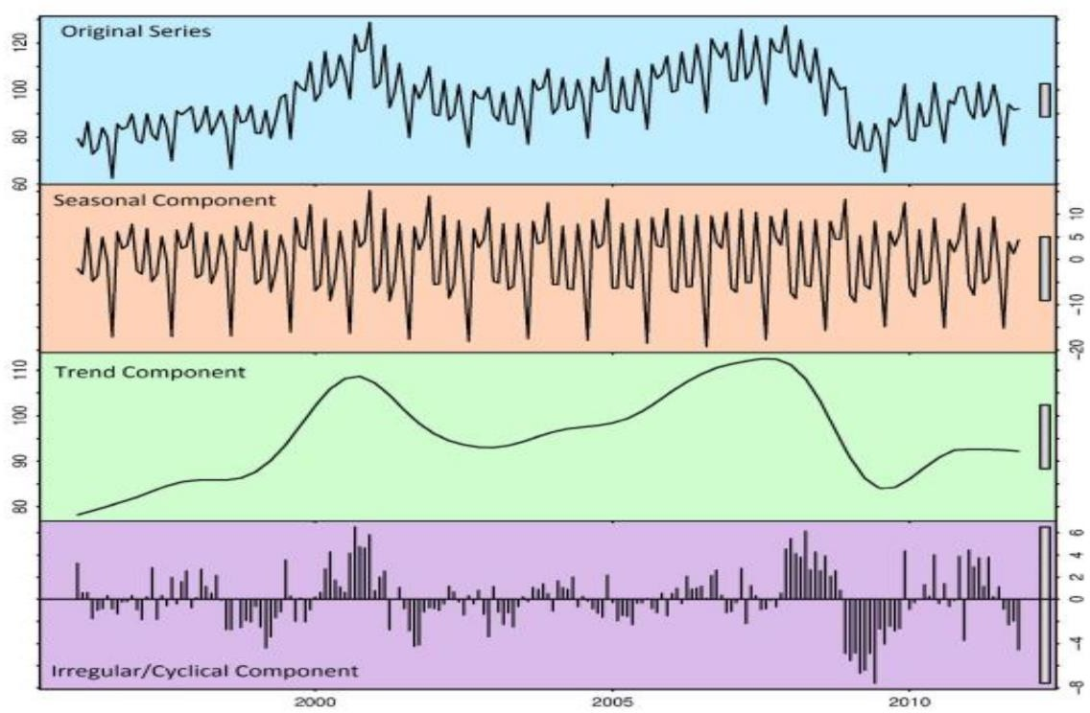
Algorithms/Models
Fig.1 Trend, Seasonal, Cyclical and Irregular graphical

Representation
- Time series can be design cycles, cyclic, infrequent or erratic. These four sections are inspected underneath:
- 1) Trend-It is the change of data all through some period. In fundamental thinking, a sporadic time series character is given by an example that can be deterministic.
- 2) Seasonal: It is continuous to know and fix repeat. A periodic model happens when infrequent components impact the time Series-incidental factors like a particular season day or year.
- 3) Cyclic-It is the difference in data. Cyclic doesn't have a legitimate repeat unlike periodic.
- 4) Information which are addressed in a sporadic manner as most would consider to be normal to be obscure, flighty periodic and transient factors for which the future can't be expected here.
In this work, a medium-scale assessment study for time series models is done which would show the most essential precision in measuring the traffic data of a periodic time series dataset. The models or estimations considered are the Autoregressive facilitated moving typical (ARIMA) model, Occasional naïve(SNAIVE), Outstanding Smoothing, and PROPHET which rely upon time series.

ARIMA: This plan which various types of time-series data for which it uses its smart system which is exceptionally fundamental nevertheless, refined in making guess for the data. It addresses autoregressive consolidated moving ordinary which is a hypothesis of auto-in reverse moving typical with the compromise part added. They are a class of statical estimations which is used for checking and analyzing data.
ETS: Surprising Smoothing method handles weighted midpoints of past insights to check future information. As discernments mature in time, these characteristics need to get more unobtrusive at an emotional rate since the continuous characteristics are given more importance in the series. They are a gathering of expecting models.
Seasonal naïve (SNAIVE): Some of the time the data available isn't adequate and data is of time-series type. In such conditions, the unsuspecting methodology is used which is used which uses past data from the last discernment to make the assumption for the net data. By and by incidental guileless works for data are particularly infrequent works for data which are very intermittent. SNAIVE makes assumptions like naïve month assumptions for it predicts the last seen data from a comparable season.
Prophet: The Prophet is an open-source library, made by Facebook, which is delivered for building gauges for univariate time series datasets. It is generally called Facebook Prophet which was appropriated by Facebook's Middle Data Science bunch. It is very easy to use. It is fundamental so that it can make definite figures for data having incidental and example direct. This model is an ideal partner for time series data containing rich periodic characteristics. Additionally, incidental undeniable data achieves the best outcome for this model. This concentrate shows us the immense qualification between all of the models.

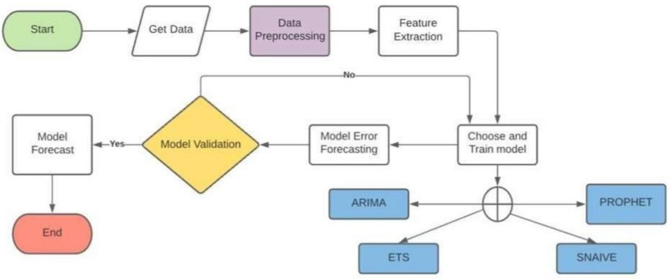
PROPOSED METHODOLOGY
Fig 2. Workflow Diagram
Seasonal patterns can be seen in the data, which is a time series data type. The analysis of the traffic data plotted for each street reveals a seasonal pattern-like increase in slope. For the dataset to get to the Implementation stage, data pre-processing and feature extraction must be completed.
1) Programming Devices: The estimating models are carried out involving Python language in jupyter scratch pad.
2) Target Factors for Time series: As is notable, time series models should be founded on a period variable, and they should likewise have an objective variable that might be anticipated from here on out. In the information pre-handling
segment, the information is changed to the hour information, which includes joining the date and time sections into a solitary segment and evolving. Besides, as to expect the quantity of vehicles, "Absolute Vehicles" is chosen as the objective variable. At last, the tidying up of the street names and the "street name" is utilized as an unmistakable identifier.
3) Plotting after information cleaning: Time is utilized as the free factor, with which "All out Vehicles" is plotted with time in the wake of cleaning the dataset to meet the prerequisites. The realistic shows the huge irregularity and appearing to be fixed nature of the series. The volume of traffic that goes through a road differs incredibly relying upon the season, and practically all roads show irregularity.

4) Forecast Models: North of 100 unique streets exist here. Despite the fact that a large portion of them contain occasional information, some of them likewise have whimsical information. To figure out which guaging model works best with which sort of information, four unmistakable models are utilized.
Four well known and complex anticipating models are — "ARIMA," "ETS," "SNAIVE," and "PROPHET. The prophet is utilized and story structures to incorporate these models. Numerous time series can be dealt with all the while by the tale bundle.

RESEARCH OBJECTIVES

Data Collection and Analysis: Gathering comprehensive data on historical traffic patterns, including peak hours, congestion hotspots, and seasonal variations. This involves utilizing various sources such as traffic cameras, sensors, GPS data, and traffic management systems.

Model Development: Developing robust predictive models that can accurately forecast future traffic conditions based on historical data. This could involve employing statistical methods, machine learning algorithms, or hybrid approaches to account for different factors influencing traffic flow, such as weather conditions, events, road construction, and population growth.

Scenario Analysis: Conducting scenario analysis to assess the impact of different variables on traffic flow, such as changes in infrastructure, introduction of public transportation initiatives, or alterations in urban planning policies. This helps in understanding potential future traffic scenarios and devising strategies to mitigate congestion.

Evaluation and Validation: Validating the accuracy and reliability of the forecast models through comparison with real-time data and feedback from transportation authorities and stakeholders. Continuous evaluation allows for refinement and improvement of the forecasting techniques to better adapt to changing urban dynamics and emerging trends.

FUTURE SCOPE
Future renditions of the framework are habitually improved with extra traffic the board related perspectives utilizing methods like profound learning, counterfeit brain organizations, and, surprisingly, enormous information. The clients can then utilize this procedure to search for the way that will make arriving at their area the least difficult. The calculation can help clients in making search ideas and in finding the most clear choice in a space with less traffic. Street gridlock determining has previously utilized an assortment of estimating methods. In spite of the fact that there is more space to work on the exactness of the clog forecast, there are more procedures that produce dependable expectations.
Furthermore, during this time, utilizing the later anticipating calculations with the better traffic information accessible aides improve the forecast. Today, traffic estimating is significant for essentially every area of the country as well as the whole world. Accordingly, this type of expectation may be valuable for anticipating traffic ahead of time. The grade and precision are significant variables in rush hour gridlock conjecture for better clog expectation. Later on, it is guessed that laid out request exactness expectation will be assessed utilizing easier, more congenial procedures so that individuals will find the forecast model valuable and won't burn through their time attempting to foresee the information.

REFERENCES

- Poonia, P., Jain, V. K., and Kumar, A. (2018). Momentary TFP systems: a survey. Mody College Worldwide Diary of Processing and Designing Exploration, 2(1), 2014.

- Tian, Y., Zhang, K., Li, J., Lin, X., and Yang, B. (2018). LSTM-based TFP with missing information. Neurocomputing, 318(1), 2014.

- Z. Liu et al., "Digging Street Organization Connection for Traffic Assessment through Compressive Detecting". IEEEE Trans Keen Transportation Framework vol 17, 2016.

- Z. Huang, Q. Li, F. Li and J. Xia. (2019). A Clever Transport Dispatching Model In light of Traveler Stream and Appearance Time Expectation, IEEE Access, 7(1), 2017.
- Juan Bao; Wei Chen; Yi Shui; Zheng-Tao Xiang, "Intricacy examination of traffic time series in view of multifractality and complex organization", 2018
- Y.LeCun, Y.Bengio and G.Hinton "Profound learning" Nature vol 223-233
- [[7] J.Zhang, Y.Zheng and D.Qi "Profound Lspatio-Terinal lingering networks for citywide group streams expectation", vol54, 2018.
- M. Karimpour, A. Karimpour, K. Kompany, and A. Karimpour, "Online Traffic Forecast Utilizing Time Series: A Contextual investigation," Basic Strategies in Science and Designing, Volume 2. pp. 147-156, 2020.
- S.L. Dhingra, P, P. Mujumdar, and R. H. Gajjar, "Use of time series strategies for estimating truck traffic pulled in by the Bombay metropolitan locale." Diary of Cutting edge Transportation, vol. 27, no.3, pp. 227-249, 2021.

