**CHARACTERIZATION OF SOLID WASTE IN COTABATO CITY:**

**BASIS FOR WASTE TO ENERGY GENERATION POTENTIAL**

Guialalluden M. Usop1, a

1 Professional Schools University of Mindanao, Davao City, Phillipines aguialalludenmusop@gmail.com,

**Keywords:** Solid Waste, Energy potential, calorific value, proximate analysis, moisture content, ash content, combustible volatile matter, Fixed carbon.

**Abstract.** This Waste is one of the most common problems in every community. Whether in the most advanced country or third-world country like the Philippines. People have difficulty disposing of their waste correctly; vis-à-vis the local government unit, which lacks a concrete plan for solid waste management. The energy sector is considered a perfect match for the waste management sector as it can help meet the growing energy demand. This paper primarily presents the waste to the energy potential of Cotabato city. First, the solid waste should be characterized, and then the calorific value should be determined to identify its energy potential. The study undergoes different methods, such as random sampling and proximate analysis. After analysis, the waste generation in Cotabato is equivalent to 136,400kg/day or 150.36 tons/day. It has been found that the most common waste in the city is kitchen garbage. Based on the proximate analysis, it can be concluded that the moisture content of the waste significantly affects the combustible content, resulting in low energy potential. When the waste is treated properly and has low moisture content, it can have energy potential.The study indicates that the waste samples have an average calorific value of 2,765.03 kcal/kg or 11,568.88 KJ/kg.

Introduction

This increase in population leads to a rise in waste, causing socio-economic and environmental issues worldwide. Furthermore, since most want to migrate from rural to urban areas, industrial wastes also contribute to accumulated waste [1]. Waste is an inevitable outcome of our modern society, and it presents a major challenge [2]. The words’ dominant concerns regarding solid waste are improper disposal, inefficient waste collection, and lack of disposal facilities [3]. Issues arise from producing, transporting and disposing of household waste. Even families have difficulty understanding proper waste management. The Local government fails to provide landfills that can dump this waste. Solid waste management plans are available, but implementation is lacking. People are not informed, and the government fails to provide facilities. This issue resulted in further problems, such as environmental problems, flooding, and health, which cause disease.  The current waste management system faces challenges due to inadequate collection and large uncollected waste fragments, leading to waste dumping and burning. These still linger due to insufficient technology to ensure proper management, poor implementation of regulation, and poor public awareness. As a result, waste generation has rapidly increased [4]. Meanwhile, the attitude and motivation of the people on waste management shall also be consider, and their participation should be strengthened [5]. Solid waste management affects everyone globally, with waste generation expected to increase by 70% to 3.4 billion tons annually by 2025 [6]. Decisions made by individuals and governments regarding consumption and waste management can have adverse effects on communities' health, productivity, and cleanliness. Poorly managed waste can lead to contamination of the world's oceans, blockages in drainage systems, floods, the spread of disease, and increased respiratory infections [7].

Energy waste is the process of recovering energy from waste materials and converting it into usable forms such as heat, electricity, or fuel [8]. The advancement of this technology, in conjunction with other renewable energy technologies such as wind, solar, hydropower, and thermal, plays a critical role in achieving two sustainable development goals: affordable and clean energy (SDG 7) and climate action (SDG 13). This technology helps to create inclusive, safe, resilient, and sustainable cities and human settlements [9]. The waste-to-energy concept is an excellent alternative to solid waste management. It is the combustion of commingled waste or some portion or kind of waste to produce energy like electricity. However, knowing the significant energy potential requires expertise and funding [10].

In Cotabato city, only one dumpsite caters to the 37 barangays of the city. The location is in a community center, and the houses are close. It can also be see that there is not enough space for solid waste. The area will get flooded during the rainy season, and the foul smell will bother the neighborhood. In addition, health concerns are rising, especially for children who frequently play outside their homes [11]. The city's physical limitations make it challenging to find a suitable site for a Sanitary Landfill (SLF).

The Biniruan RCA, located 13 kilometers from the Central Business District, is currently the only facility available for final disposal [12]. It should be noted that the amount of residual waste generated per person each day is 0.07 kg, which suggests that the design lifespan of the RCA (Residual Containment Area) is around three years. It is essential to mention that burning of waste is strictly prohibited in the vicinity of the dumpsite, as per the Clean Air Act of 1999 (RA 8749). Therefore, the City Government of Cotabato should consider constructing a sanitary landfill as an alternative solution for waste disposal.

Recycling, landfilling with energy recapturing, biological methods, and Thermal treatment are the choices considered in waste management. Treating waste does not only manage but also produces energy in different forms, so it is also called the waste-to-energy (WTE) approach.  [13].

The objective of this study is to examine the calorific value of Cotabato city's solid waste and determine its potential for energy generation. Specifically, this study aims to measure the waste generation rate of Cotabato City, determine the waste composition, get a proximate analysis of waste composition, and recommend waste-to-energy facilities that best suit Cotabato City based on the available data and results.

The study is limited only to characterizing and identifying the potential recoverable energy from the solid waste of Cotabato City through the calorific value.

Materials and Method

## A. Conceptual Framework

This study used a three-step framework. It involves solid waste profiling, proximate analysis, and solid waste characterization as a basis for potential energy [14].

INPUT PROCESS OUTPUT

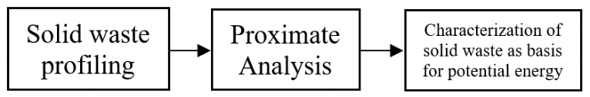

*Fig 1. Conceptual Framework*

Solid waste profiling includes the process of identifying the quantity as well as the composition of the wastes generated. In this case, the wastes were generated in the Biniruan dumpsite (the only dumpsite in Cotabato City), and they determined the waste generation rate, which was calculated, and concluded the approximate waste generated in the city and its potential as an energy source.

After conducting solid waste profiling, the waste is subjected to proximate analysis to determine its moisture content, volatile matter, ash content, and fixed carbon. These properties are significant if solid wastes become the fuel source [15].

Finally, the waste undergoes characterization to determine how much potential energy the city can recover from its generated waste. Recoverable energy is computed using the calorific value of each type of waste. After a thorough analysis of the sampling results, it is also incorporated in this study which type of WTE facility is feasible for the City following the waste-to-energy concept.

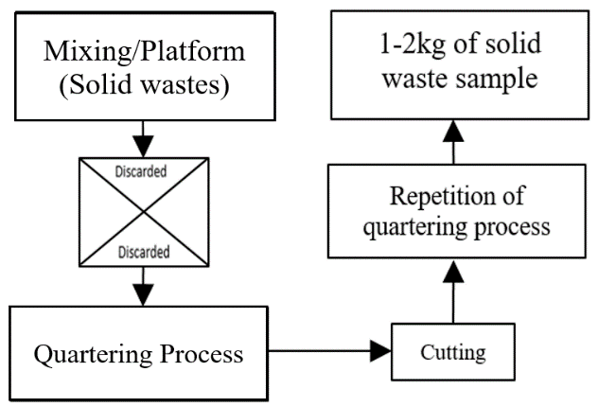

*Fig 2. Sampling Process Flow Diagram*

## B. Materials and Resources

During the collection of the sample, plastic bags were provided. Gloves were used during collection, and a wheelbarrow was utilized in transporting the waste. Additionally, garden tools were utilized, such as shovels for mixing and spreading the sample waste, scissors to reduce the size of samples in large sizes, as well as masks and rain boots was used during the collection process.

The samples were dried, weighed, stored, and later used for moisture and ash content tests. The standard process of Davao Analytics Laboratory, Inc. served as the basis for the weighted sampling test.

## C. Methods and Procedure

2.c.1. Sampling Method (Random sampling)

The American Standard Test Method (ASTM D-5231-92) was used for this study to analyze solid waste using a random sampling technique [14]. Using this method, it was able to identify the characterization of the new waste and be a potential energy source.

The solid waste will be collected at the Biniruan dumpsite in three batches during the morning. To ensure the credibility and accuracy of the collected sample, the collection was done in the presence of the City Environment and Natural Resources Office (CENRO), Local Government Unit representatives, and the designated workers at the dumpsite. In addition, actual photos will be taken to ensure complete documentation of the process.

The garbage truck's waste was dumped in the area within the dumpsite but separated from the old dumped waste. This ensures that the wastes used for this study are all freshly delivered. Nevertheless, it is not feasible to separate all of the waste loads based on the kind of composition in a single day because the quantity of waste that is collected is typically sufficient to fill a garbage truck.. Also, due to time constraints, the researcher only uses a certain amount of waste from a load of total collected waste. Only 200kg of solid waste was collected and evenly mixed thoroughly using the shovel to avoid inconsistencies in the mixture of solid wastes.

Following the mixing step, the quartering method—a methodical splitting procedure—was implemented [15]. It was done by quartering the waste into four portions. Two portions will be retained, while the two quarters will be discarded. Using scissors to eliminate bias, those samples in bigger sizes will be reduced into smaller pieces (approximately ten cm^2). The retained portion undergoes quartering again to achieve approximately 1–2 kg of waste remains. Since the collected waste is from a dumpsite, it likely attained random sampling.

After sampling, the waste sample was segregated according to composition and stored in plastic with a zip lock. The obtained waste sample is transported to the laboratory, where several processes are performed.

2.c.2. Waste Generation rate

Part of the study is to measure the waste generation rate to learn the speed of waste accumulated in Cotabato City. It is the estimated amount of waste generated in residences over time [14].

The waste generation rate was calculated using a method that multiplied the actual population of Cotabato City by the predicted waste generation per capita per day for 2022 based on WACS from the 10-year SWM Plan of Cotabato City Year 2018.

Hence, the daily waste generation is now computed using the following Eq. 1:

$Total domestic waste = Total average per capita x total population in the city$ (1)

Total domestic waste represents the fundamental components of solid waste discarded by the public in everyday life [16].

2.c.3. Composition of the Waste Determination

In determining the waste composition, solid wastes were segregated after sampling and brought to the Davao Analytics Laboratory, Inc. The standard method used in the waste composition is ASTM D5231-92 [17].

After the sampling, solid waste was placed on an even platform and segregated thoroughly according to its composition. Then, it weighs the segregated sample using analytical balance to measure its weight accurately and calculate its weight ratio (%) in the sample data sheet. After measuring the samples, each waste composition is stored in air-tight plastic bags with zip-lock.

In calculating the weight ratio (%) of the composition of the solid waste, Eq. 2 was used;

$Weight of Ratio \left(\%\right)= \frac{Mass of composition}{Total mass of waste} x (100\%)$ (2)

2.c.4. Moisture Content Determination

The moisture content is analyzed in Davao Analytics Laboratory, Inc. using the American Standards and Testing Material (ASTM 3173) [18].

The muffle furnace is heated up to 750 ºC, and previously ignited porcelain crucibles are covered for 10 minutes. The crucibles are then cooled in a desiccator for 1 hour.

Out of the sample provided, 1g is accurately weighed as a homogenized sample using a crucible. The sample was dried for 2 hours at 105ºC in an oven.

The drying process continues at 1-hour intervals until the loss is less than 0.0005g in an hour.

The moisture content of the waste is calculated using Eq. 3:

$\%Moisture = \frac{wt sample before-weight sample after}{wt ofsample} x 100$ (3)

2.c.5. Ash content determination

The Total Ash content is the proportion of the biomass that remains after the sample is incinerated. ASTM D-3174-02 [16] The procedure used to determine the ash is the American Standard Testing Material (ASTM 3174).

In this process, the sample from the determination of moisture and ash content will be utilized. Initially, the lids were placed in the uncovered crucibles in the muffle furnace at 750 ºC for 6 hours. The crucible is then cooled with lids placed in the desiccator for 1 hour and weighed. The burning process is repeated until the subsequent 1-hour period of heating results in a loss of less than 0.0005 g.

The ash content is calculated using Eq. 4; [16]

$\%Ash content = \frac{\left[weight of sample of sample+crucible\right]–[wt of empty crucible]}{wt ofsample} x 100$ (4)

2.c.6. Fixed carbon determination

The fixed carbon percentage was obtained by deducting the total moisture, volatile matter, and ash percentage from 100. (Eq. 5) [19].

$FC = 100- (\%MC + \%VM +\%Ash)$ (5)

Where:

$$MC = Moisture Content$$

$$VM=Volitile Matter$$

2.c.7. Calculating the Solid Waste's Calorific Value

The calorific value measures chemical energy in a material, which depends on its carbon, moisture, and hydrogen content [14]. The method used to calculate the calorific value of solid waste is based on ASTM 3173-3175 Standard Methods. Estimation of the calorific value of the solid waste is calculated using Eq. 6;

$CV=45V-6W$ (6)

Where:

$$CV-Calorific Value (\frac{Kcal}{kg})$$

$$V-Combustible Volitile Matter (\%)$$

$$W-Moisture Content (\%)$$

Result and Discussion

The purpose of this study was to explore the potential energy generated from the waste materials accumulated by CENRO in Cotabato City, which will be impactful economically, environmentally, and socially as the city will foresee a more urbanized and populated area. Accordingly, after a rigorous and detailed gathering of data, thorough analysis, and a series of sampling procedures and tests, the following is the tabulation of the results gathered during the study's duration.

3.1. Waste Generation in Cotabato City

According to the projected 2022 SWM plan of Cotabato City, the waste gen/cap/day is expected to be 0.40kg/day, and the actual population in this year 2022 is approximately 341,000. Based on this data, the estimated waste generation in Cotabato is equivalent to **136,400kg/day or 150.36 tons/day.** With this amount of waste, without proper waste management, it can lead to the accumulation and overloading of waste on temporary dumpsites and it may pose great danger to the community nearby and the city itself.

3.2. Percentile composition of the waste

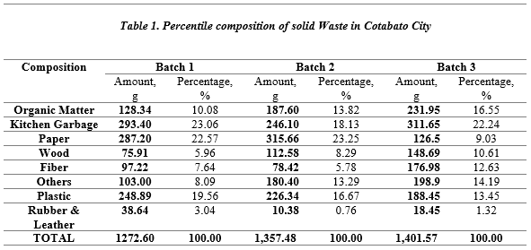

Table 1. According to the data, paper, plastic, and kitchen waste make up the majority of the sample that was gathered for batch 1. In the second batch, consistent with the kitchen garbage, it is dominant, but the amount of paper collected is immensely increased.

For the third batch, the kitchen garbage is consistently higher among all the compositions. At the same time, the amount of paper and plastic decreases.

It is concluded that the days of collection matter. For instance, if the collection is during weekdays, papers and other school materials are dominant, while if it falls on weekends, there is less paper or plastic. The way the waste was collected seemed comparable to those of other surrounding municipalities, such as Parang, Maguindanao. A total of five tons of waste were gathered during a clean-up effort along the Parang Beach shoreline by multiple non-governmental organizations (NGOs) in collaboration with the municipal office. The majority of the waste consisted of paper, plastics, empty bottles of water, and non-biodegradable objects [23]. Meanwhile, the kitchen garbage is consistent from weekdays to weekends.

***3.2.1 Average percentile of Biodegradable, Residual and Recyclable***

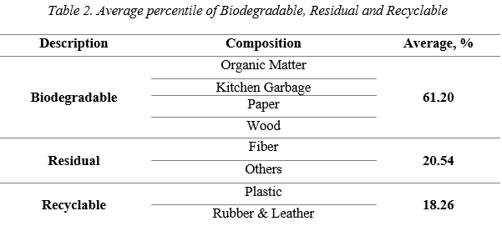

Table 2 shows the types of waste and where the compositions belong. For instance, Organic matter, Kitchen garbage, paper, and wood are biodegradable. In contrast, fiber and others (cellophane, fines, etc.) are residual. At the same time, recyclable are composed of plastic, rubber, and leather including the mean value of each waste categories.

Based on the data, the Biodegradable has the highest value with 61.20%, followed by residual with 20.54%, while Recyclable is the least with 18.26%. This is consistent with the data in Table 1, wherein most of the waste is paper, kitchen waste, and non-biodegradable materials such as plastic.

It can also be observed that metal, glass, ceramic, and stones are not included as samples due to the limitations of the laboratory to accommodate those types of waste compositions, as Cotabato City still has no sanitary landfill presently. Apparently, since Cotabato City has no sanitary landfill yet and no facility to process waste material, the accumulation of biodegradable waste, which has the highest percentage among the types of garbage, may incur problems in the community such as infectious disease, lousy odor, breeding grounds for mosquitoes, etc.

Additionally, biodegradable waste can be processed and converted to new energy naturally since biodegradable products decompose safely by biological means into the raw materials of nature, disappearing into the environment. They can be solids biodegrading into soil (compostable) or liquids biodegrading into water.

***3.3. Proximate Analysis***

The figures 3, 4, 5, and 6 represent the moisture content, ash content, combustible content, and fixed carbon. These are the important properties that determine the waste’s ability to become a fuel source.

3.3.1 Moisture Content

Moisture contents are an vital factor to consider, especially when treating waste materials. Accordingly [18], the moisture content of solid waste affects leachate formation, microbiological activity, pollutants leaching, and energy consumption. Therefore, assessing moisture content is crucial for solid waste management. As seen in table 3, the moisture content level is slightly decreasing from batch 1 to batch 3. Consistent with the percentile composition of solid waste in Cotabato City as shown in Table 1, the greater the waste, the lesser the moisture content it possessed.

*Fig. 3 Comparison of Moisture Content*

3.3.2 Ash Content

Ash content is also a part of waste management. An Ash test is a process that helps determine the percentage of filler material present in a given sample [16]. Additional test procedures are required to identify individual percentages in multi-filled materials, as an ash test cannot determine the percentage of carbon fiber or carbon black due to their combustion during the test [20]. As observed in figure 2, the ash content in batch 1 is seen slightly increased from batch 2 from 5.76% to 5.81%, while batch 3 attained the highest ash content with 7.11%. In compared with the moisture content shown in Figure 3, the higher the moisture content, the lower the ash content, and vice versa. This shows that the moisture contents affect the level of ash produced during the thermal processing of waste materials.

*Fig. 4 Comparison of Ash Content*

3.3.3 Combustible Content

Combustible content determines the capability of the waste for burning and incineration [21]. As shown in Figure 5, there was a vast increase that created gaps between batches 1 and 2 from 62.41 to 65.29, while batch 3 slightly increased from batch 2 with a total percentage of 65.35. The moisture content also posed a vital factor in the results of the ash contents; subsequently, the higher the moisture content, the lower the combustible contents, and vice versa. Hence, moisture content is also a significant factor in combustible content.

*Fig. 5 Comparison of Combustible Content*

3.3.4 Fixed Carbon

Fixed Carbon is the residue obtained to a waste burned from a certain degree [19]. In the figure 6, the batch 1 has slightly decreased from 9.29 to 7.02 in batch 2 and 6.66 in batch 3. As per observation in the other figures, the more moisture content the waste has, the more fixed carbon is likely to be obtained, while the more combustible and ash content in a waste, the lesser the fixed carbon percentage can be obtained.  It shows that moisture contents and combustible content contributed to the percentage of fixed carbon that can obtained in a processed waste material.

*Fig. 6 Comparison of Fixed Carbon*

* 1. The calorific value of the waste

Calorific value is the most essential characteristic of fuel to determine the energy content of fuel. The calorific value is based on the proximate analysis of moisture and volatile matter content [24]. Figure 7 represents the result of the calorific value based on the proximate analysis per batch. It showed that the third batch got the highest value of calorific value, followed by the second batch, while the first batch was considered few. This is consistent with the results of the moisture content and combustible content in figures 3 and 5. The calorific value significantly affects if the moisture content is too high the calorific value increases, the moisture content decreases.

*Fig. 7 Comparison of Calorific Value*

* 1. Statistical Treatment

Upon consultation with the statistician, the sample mean and standard deviation were used to treat all the collected data. First, the sample mean was used to determine the average percentile quantity of the solid waste in terms of moisture content, combustible content, ash content, and fixed carbon. In addition, the average calorific value of the solid waste was also determined using it. Furthermore, the standard deviation was used to know how tightly all the various examples are clustered around the mean in a data set.

*Table 3. Statistical treatment of the sample solid waste*

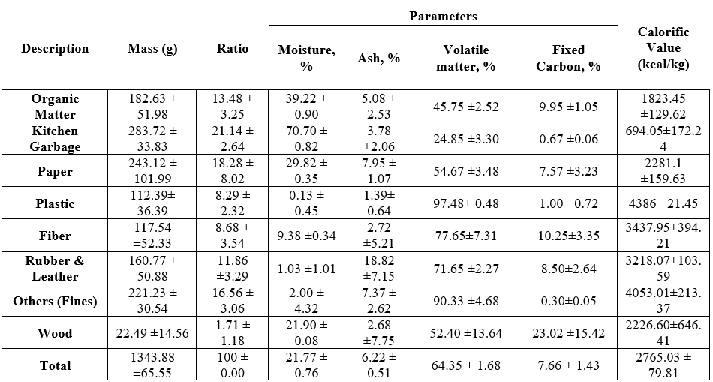

The mean and standard deviation of the solid waste sample are shown in Table 3.

Based on the table, the kitchen garbage garnered the highest mass, with a total number of 283.72. This is consistent with the percentile of waste materials as shown in Table 1. In contrast, wood waste has the lowest mass with a percentile of 22.49.

Regarding moisture content, the kitchen garbage also gained the highest percentile of 70.70. According to a study, kitchen and food waste usually contain high moisture among waste disposal. Still, it may be decomposed easily if adequately managed. Meanwhile, plastic has the most negligible moisture content of 0.13.

In terms of ash content, rubber and leather have the highest percentile with 18.82. Rubber contains a high ash content percentile because of its components. Meanwhile, plastics have the most minor ash content, 1.39. This is consistent with the other research, wherein the plastic bottles recorded the lowest ash content among all of the tested waste materials.

In terms of fixed carbon, fiber gained the highest percentile of 10.25. In contrast unidentified waste categorized as others gained the lowest fixed carbon percentile.

Lastly, among all waste materials, plastics garnered the highest calorific value with 4386, while kitchen garbage has the most negligible calorific value. This is consistent with the calorific value of waste shown in Figure 7, wherein waste with the least moisture content, such as plastics, can obtain a high calorific value. In contrast, waste with the highest moisture content tends to get the lowest calorific value, such as kitchen garbage. Hence, the average potential energy that can be recovered from waste in Cotabato City based on the calorific value is 2,765.03 kcal/day, equivalent to 11,568.88 KJ/kg.

* 1. Type of WTE facility for Cotabato city

Waste management in Cotabato City is a big problem since it adds to the city’s flooding during heavy rains.

Even though the sanitary landfill may pose a great innovation to solve the waste disposal of the city, based on the results of this study, since most of the waste in kitchen garbage is categorized as biodegradable, it may pose a risk to the community and nature. Biodegradable waste, due to its characteristics, has adverse effects in sanitary landfills such as foul odors, infectious diseases, the accumulation of methane gas, air pollution, and more. Additionally, geographical aspects pose a significant challenge since Cotabato is situated in a low and marshy area that is not suitable for a sanitary landfill.

With these factors, a waste-to-energy facility should be pursued. As shown by the results, kitchen garbage along with biodegradable waste has the highest number of waste disposals, indicating that the WTE facility to be pursued should be favorable to biodegradable waste while also catering to other waste materials. The most common WTEs include thermal combustion, mechanical biological treatment, thermochemicals, and biochemicals. The selection of WTE in Cotabato City should consider factors such as the guideline under RA 9153, the Renewable Energy (RE) Act of 2008, RA 8749, the Clean Air Act of 1999, and the Ecological Solid Waste Management Act and financial dependency. Among those, elaborated WTE, biochemical fermentation, and anaerobic digestion are highly recommended.

The biochemical waste-to-energy facility promotes a much more environmentally friendly and low-cost waste disposal facility than the WTE mentioned above, which is far more expensive and poses a threat to the community and environment.

Fermentation breaks down glucose in organic materials, converting sugar into alcohol or acid through chemical reactions. When added to the biomass, yeast or bacteria consume the sugar and release carbon dioxide and ethanol. Bioethanol needs to undergo a distillation process to attain the necessary purity level so that it is fit to be used as a transport fuel. The residue remaining from the fermentation process can be utilized as animal feed. At the same time, bagasse can be employed as fuel for boilers [22]. India, the People's Republic of China (PRC), and Thailand are among the countries that utilize this type of waste processing. Fermentation is the first process, which has two classifications: dry and wet fermentation, which leads to anaerobic digestion. Anaerobic digestion is the breaking down of organic waste in an environment without oxygen to produce biogas. In this stage, it will address the processing of biodegradable waste such as kitchen garbage, organic matter, paper, and wood, which, based on the results, dominates the mass of the waste collected at the dumpsite in Cotabato City.

The WTE (Waste-to-Energy) system is designed to collect and store ethanol, methanol, and bio-butanol, along with the resulting biogas. Heat from the biogas can be utilized to power appliances, lighting, small-scale cooking, and other things. It can also be transformed into electrical energy. This method is a cleaner, greener energy choice because it is not only effective but also contributes to the decrease in the usage of dangerous fossil fuels.

Additionally, the construction and maintenance costs of the other WTEs, especially the well-known combustion facility, are far more expensive than those of the anaerobic digestion facility. According to the article published by Eco-Business [23], the proposed WTE facility in Quezon would cost around P22 billion (US$423 million). The project aims to generate 36 megawatts of electricity by converting 3,000 metric tons of solid municipal waste daily. As we observed, a combustion facility requires a massive amount of electricity that the current distributor in Cotabato would not meet, even at a lower wattage. In comparison, the DOST announced the construction of an anaerobic digester in 2022, amounting to P444, 000.00 pesos. A biogas digester facility will be constructed in Aurora, Pampanga. It has a loading capacity of 20 cubic meters, or approximately 7 tons. The facility will use a process called anaerobic fermentation to convert waste into biogas. Biogas is a colorless and odorless gas composed mainly of methane and carbon dioxide. It can be utilized for heating purposes, like cooking. Also, utilize it in fuel cells or gas engines to produce electricity and heat.

Conclusion and Future works

The study evaluated the recovery energy potential of the waste generated in Cotabato City. The process begins by characterizing the composition of the waste collected. It shows that Cotabato City's primary source of waste is kitchen garbage, while rubber and leather are few. The waste samples are analyzed in the laboratory to determine their moisture content, ash content, volatile matter, and fixed carbon. The laboratory analysis's findings show that the waste's moisture content has a major impact on its combustible content. However, using biochemical waste for generate energy through fermentation and anaerobic digestion, there is a high tendency that the waste will have energy potential, such as biogas, ethanol, etc. It is a practical choice for the local government unit to select a cleaner and more cost-efficient facility to ensure the sustainability and efficacy of the facility and the degradation of accumulated waste in Cotabato City.

In this study, the following are recommended for waste profiling and future studies of the waste-to-energy potential: first, Cotabato City, through CENRO and in partnership with the Ministry of Environment, Natural Resources, and Energy, must make an understandable study on the waste management in Cotabato City, especially on the statistics of waste disposal. Second, CENRO must consider in their planning and budgeting pursuing the waste-to-energy facility in the city, as many major cities are now pursuing the building of their own WTE and also heeding the call of the COA. Additionally, since the recommended WTE focuses more on biodegradable waste, a supplemental study should focus on understanding the characteristics of non-biodegradable waste and possible results and include in the study the waste-to-energy facility’s structural, architectural, and mechanical design for easy reference by investors and the government.

References

[1] Vitorino de Souza Melaré, A., Montenegro González, S., Faceli, K., & Casadei, V. (2017). Technologies and decision support systems to aid solid-waste management: a systematic review. In *Waste Management*. https://doi.org/10.1016/j.wasman.2016.10.045

[2] Ciriminna, L., Signa, G., Vaccaro, A. M., Visconti, G., Mazzola, A., & Vizzini, S. (2021). Turning waste into gold: Sustainable feed made of discards from the food industries promotes gonad development and colouration in the commercial sea urchin Paracentrotus lividus (Lamarck, 1816). *Aquaculture Reports*. https://doi.org/10.1016/j.aqrep.2021.100881

[3] Prashant Jha, 2018. Uttarakhand among worst states in terms of waste management, *The Time of India.*

[4] David, V. E., Wenchao, J., John, Y., & Mmereki, D. (2019). Solid waste management in Monrovia, Liberia: Implications for sustainable development. *Journal of Solid Waste Technology and Management*. https://doi.org/10.5276/JSWTM.2019.102

[5] Intahphuak, S., Pamala, N., Yodkhong, B., & Buakhiao, A. (2017). Religion role on community movement for solid waste management. *Journal of Solid Waste Technology and Management*. https://doi.org/10.5276/JSWTM.2017.321

[6] Shekdar, A. V. (2009). Sustainable solid waste management: An integrated approach for Asian countries. *Waste Management*. https://doi.org/10.1016/j.wasman.2008.08.025

[7] Tan, S. T., Ho, W. S., Hashim, H., Lee, C. T., Taib, M. R., & Ho, C. S. (2015). Energy, economic and environmental (3E) analysis of waste-to-energy (WTE) strategies for municipal solid waste (MSW) management in Malaysia. *Energy Conversion and Management*. https://doi.org/10.1016/j.enconman.2015.02.010

[8] Yasin, H., Usman, M., Rashid, H., Nasir, D. A., & Randhawa, D. I. A. (2017). Alternative approaches for solid waste management a case study in faisalabad pakistan. *Earth Sciences Pakistan*. https://doi.org/10.26480/esp.02.2017.07.09

[9] Boumanchar, I., Chhiti, Y., M’hamdi Alaoui, F. E., Sahibed-dine, A., Bentiss, F., Jama, C., & Bensitel, M. (2019). Municipal solid waste higher heating value prediction from ultimate analysis using multiple regression and genetic programming techniques. *Waste Management and Research*. https://doi.org/10.1177/0734242X18816797

[10] Media. (2022). Descriptive Research: Definition, Characteristics, Methods, Examples and Advantages. *QuestionPro*.

[11] Dehghani, M. H., Omrani, G. A., & Karri, R. R. (2021). Solid Waste—Sources, Toxicity, and Their Consequences to Human Health. In *Soft Computing Techniques in Solid Waste and Wastewater Management*. https://doi.org/10.1016/B978-0-12-824463-0.00013-6

[12] JICA, 2022. Data Collection Survey on Urban Infrastructure Development in Greater Cotabato City, *Japan International Cooperation Agency.*

[13] AlQattan, N., Acheampong, M., Jaward, F. M., Ertem, F. C., Vijayakumar, N., & Bello, T. (2018). Reviewing the potential of Waste-to-Energy (WTE) technologies for Sustainable Development Goal (SDG) numbers seven and eleven. In *Renewable Energy Focus*. https://doi.org/10.1016/j.ref.2018.09.005

[14] ASTM D 5231-92. (2003). ASTM D 5231 – 92: Standard Test Method for Determination of the Composition of Unprocessed Municipal Solid Waste. *Current*.

[15]M. Campos M., R. Campos-C., 2017. Applications of quartering method in soils and foods. *Int. Journal of Engineering Researchand Application*. ISSN: 2248- 9622, Vol. 7, Issue 1, (Part - 2) January 2017, pp.35-39

[16] ASTM Internacional. (2002). Standard Test Method for Ash in the Analysis Sample of Coal and Coke from Coal D 3174-02. *Annual Book OfASTM Standards*.

[17] Sukarni, S. (2016). Exploring the potential of municipal solid waste (MSW) as solid fuel for energy generation: Case study in the Malang City, Indonesia. *AIP Conference Proceedings*. https://doi.org/10.1063/1.4965733

[18] ASTM. (2011). D3173/D3173M Standard Test Method for Moisture in the Analysis Sample of Coal and Coke. *ASTM International*.

[19] ASTM. (2020). Standard Test Method for Volatile Matter in the Analysis Sample of Coal and Coke. *ASTM International*.

[20] Wójcik, M., Stachowicz, F., & Masłoń, A. (2018). Sewage sludge conditioning with the application of ash from biomass-fired power plant. *E3S Web of Conferences*. https://doi.org/10.1051/e3sconf/20183003005

[21] ASTM Internacional. (2002). Standard Test Method for Ash in the Analysis Sample of Coal and Coke from Coal D 3174-02. *Annual Book OfASTM Standards*.

[22] Rahayu, A. S., Karsiwulan, D., Yuwono, H., Trisnawati, I., Mulyasari, S., Raharjo, S., Hokermin, S., & Paramita, V. (2015). Handbook POME-to-Biogas Project Development in Indonesia. *Winrock International*.

[23]PNA, 2021. NGOs collect tons of garbage in Maguindanao town shoreline.

[24] V I Variani 2021 J. Phys.: Conf. Ser. 1825 012006