EMERGING ISSUE OF E-COMMERCE IN INDIA

SOURAV BHUIYA ( FACULTY OF COMMERCE BUDGE BUDGE COLLEGE)

EMAIL – [bhuiyasourav@gmail.com](mailto:bhuiyasourav@gmail.com)

SUPRATIC BASU ( FACULTY OF AJC COLLEGE)

EMAIL – [evs.sbasu@gmail.com](mailto:evs.sbasu@gmail.com)

|  |  |  |
| --- | --- | --- |
| **Chapter No.** | **Topics** | **Page Number** |
| **1** | **Introduction**   * **1.1 abstract** * **1.2 What is Ecommerce?** * **1.3 History of E-Commerce** * **1.4 Concept** * **1.5 literature Review** * **1.6 Objectives** * **1.7 Methodology** * **1.8 Limitations** |  |
|  | **3** |
|  | **3** |
|  | **3** |
|  | **4** |
|  | **6** |
|  | **9** |
|  | **9** |
|  | **10** |
| **2** | **Conceptual Framework**   * **2.1 History and Success Story of Flipkart** * **2.2 Factor Lead to Grand Success of Flipkart** * **2.3 Regional Market** * **2.4 Flipkart Marketing Strategies** * **2.8 Future Road Map** |  |
|  | **10** |
|  | **12** |
|  | **13** |
|  | **14** |
|  | **14** |
|  |  |
|  |  |
|  |  |
| **3** | **Presentation of Data, Analysis and Findings**   * **Presentation of Data, Graphical Representation and Interpretation** * **Findings** |  |
|  | **15** |
|  | **32** |
| **4** | **Conclusion and Recommendation**   * **Conclusion** * **Recommendation** |  |
|  | **33** |
|  | **33** |
|  | **Bibliography** | **34** |
|  |  |  |

### 1.1 Abstracts –

E-commerce is a technology mediated exchange between parties as well as the electronically based intra or inter organizational activities that facilitate such exchanges. It has been defined broadly as the transacting of business over the web. Just as the 80’s and early 90’s were characterized by the business achieving greater efficiencies within their organization using information technology, the last half of this decade is seeing a new wave of increased efficiencies by extending the information technology to the web, both to the trading partner, as well as to end customers.

Keywords - Mediated ,Efficiencies ,Facilitate.

### 1.2 What is E-Commerce? –

E-commerce is the activity of buying or selling of products on online services or over the Internet. Electronic commerce draws on technologies such as mobile commerce, electronic funds transfer, supply chain management, Internet marketing, online transaction processing, electronic data interchange (EDI), inventory management systems, and automated data collection systems. Modern electronic commerce typically uses the World Wide Web for at least one part of the transaction's life cycle although it may also use other technologies such as e-mail. Typical e-commerce transactions include the purchase of online books (such as Amazon) and music purchases (music download in the form of digital distribution such as iTunes Store), and to a less extent, customized/personalized online liquor store inventory services. There are three areas of e-commerce: online retailing, electric markets, and online auctions. E-commerce is supported by electronic business.

### 1.3 History Of E –Commerce –

E-commerce was introduced [about 40 years ago in its earliest](https://www.historyofinformation.com/detail.php?entryid=4528) form. Since then, electronic commerce has helped countless businesses grow with the help of new technologies, improvements in internet connectivity, added security with [payment gateways,](https://www.bigcommerce.com/blog/payment-gateways/) and widespread consumer and business adoption.

More recently, with the global spread of [smartphones](https://www.britannica.com/technology/smartphone) and the accessibility of fast [broadband](https://www.britannica.com/science/broadband) connections to the Internet, much e-commerce moved to mobile devices, which also included [tablets](https://www.britannica.com/technology/tablet-computer), laptops, and wearable products such as [watches](https://www.britannica.com/technology/smartwatch). Ecommerce has come a long way since the CompuServe launch in 1969. Changes in technology have certainly driven ecommerce growth, along with global circumstances. Ecommerce has evolved in many ways since its start, and it’s changing the way we live, shop and do business. Let’s dive into the history and the future of ecommerce.

### 1.4 Concept -

Electronic Commerce, commonly known as E-Commerce, is the dealing in goods and services through the electronic media and internet. On the internet, it relates to a website of the vendor, who sells products or services directly to the customer from the portal using a digital shopping cart or digital shopping basket system and allows payment through credit card, debit card or EFT (Electronic fund transfer)payments. Electronic commerce draws on technologies such as mobile commerce, electronic funds transfer, supply chain management, Internet marketing, online transaction processing, electronic data interchange (EDI), inventory management systems, and automated data collection systems. Modern electronic commerce typically uses the World Wide Web for at least one part of the transaction's life cycle, although it may also use other technologies such as e-mail. For many Americans, e- commerce is something in which participation is done on a daily basis, like making an online bill payment or purchasing from an online seller. E-commerce can take many forms and involve different transactions. Ecommerce operates in four market segments including business-to-business (B2B), business-to-consumer (B2C), consumer-to-consumer (C2C)and consumer-to-business(C2B).

E-commerce businesses may employ some or all of the following:

* **Online shopping web sites for retail sales direct to consumers.**
* **Providing or participating in online marketplaces which process third-party business- to-consumer or consumer-to-consumer sales.**
* **Business-to-business buying and selling.**
* **Marketing to prospective and established customers by e-mail or fax (for example, with newsletters).**
* **Engaging in retail for launching new products and services.**

The Indian e-commerce market is expected to grow to US$ 200 billion by 2026 from US$ 38.5 billion as of 2017. Much growth of the industry has been triggered by increasing internet and smart phone penetration. The on-going digital transformation in the country is expected to increase India’s total internet user base to 829 million by 2021 from 560.01 million as of September 2018.

India has always been a land of great potential. The socioeconomic condition of the country has improved many folds after the independence and India is now emerging as one of the leading countries in the world. Moreover, with a population of over 100 crore and a growth rate of above 6%, it can be compared to a marketing giant. Hence it can be well judged why online shopping in India is rising at fast pace over the days. As technology is spreading to the remotest villages and many job opportunities are presenting themselves to the unemployed youth more and more people are gaining awareness and the money to purchase expensive and luxurious items over the internet.

### Online Shopping:

Which company flashes in your mind first? Flipkart, Amozon, eBay etc. Well, let us talk about the home-grown, Indian, e-commerce site ‘Flipkart', also considered as the amazon of India.

A company which started with just 4 lakhs is now worth over more than 2000 crore according to the data Flipkart has provided to Ministry of corporate affairs; the company's revenue in 2011-12 was $ 77 million (Rs. 500 crore). For the fiscal 2012-13, their revenue is estimated to be $350 million. With this huge success Flipkart is becoming the fate of online retail in India. This paper attempts to throw light on the growth of online retail business in India with special reference to Flipkart (analyzing the consumer feedback about the online business model of Flipkart).

The invention has opened a whole new world of possibilities for us. Not only we can communicate with the person we love within moments but nowadays many vital tasks like jobs, shopping, socializing and many others can be done easily at the convenience of our home. The concept of online shopping is a relatively new one and it enables us to buy all our

favourite goods and accessories over the internet. This not only saves time but also we can get the products at a much discounted price and that too at our homes. There are many online stores that have developed in recent time likes letshop.in, flipkart.com and many others. These stores host a wide range of products like bags, shoes, books, gadgets and many others to purchase any product you have to visit the site and click on the product that you would like to purchase and the product will be delivered to you within a week maximum. It's that simple.

### Growth of Online Retailing in India:

India e-commerce has grown at a compounded annual growth rate of 30% since FY09, and is expected to be $18 billion (around Rs 1,116,00 crore) opportunity by FY15. The findings part of report: Indian Ecommerce-Tip of the iceberg, by Macquire Equities Research back this high growth rate on rising internet population, over 300 million middle class populations, increasing mobile penetration and low levels of e-commerce activity.

"Compared to the west, India's commerce industry is still in its infancy. E- commerce contributes only 0.6% of the country's GDP vs. 1-3% for other countries, with only 12% of India's online population transacting online vs. 64% for the US and over 50% for China," said Atul soni and Nitin Mohta in the report. This growth will further be accentuated by companies going in for public listing. In the India context, only two internet-based companies are listed on the markets, including Info edge, which runs India's largest job portal (naukri.com), and just dial, which is India's largest local search site.

The nature of Indian e-commerce is also different. Travel has the lion's share of 71% of Indian e-commerce, but e-tailing has grown the fastest, at a 59% CAGR between FY09-13E, to reach 16% market share. Compared to the west, India's ecommerce industry is still in its infancy, but we believe that it may became a bigger part of the entire retail universe than in the west.

"We believe that for many young Indians, online shopping may become their primary way to shop throughout their lives. Whenever significant opportunities such as e-commerce present themselves, many market participants compete aggressively to try to emerge as undisputed leaders to gain brand recognition and customer loyalty, and oftentimes these players change their business model along the way to grow with the market," said the report.

### 1.5 Literature Review -

* + **Gupta (2019) in her paper “E-Commerce: Role of e- commerce in**

today’s business”, presents a comprehensive definition of e- commerce while isolating it from e- business. The paper enlists the different e-commerce models i.e. B2B, B2C, B2G and C2C, narratively analysing the nitty gritties of each.

* + **Rina(2016) also elaborates the different applications of e- commerce in “Challenges and Future Scope of E-commerce in India”, at the same time, defining the degree to which they are operational in the country.**
  + **Mishra & Kotkar(2015) trace the timeline and development of B2C e- commerce in “A Study on Current Status of E-Commerce in India: A Comparative Analysis of Flipkart and Amazon” with its inception in the mid 1990s through the advent of matrimonial and job portals. However, due to limited internet accessibility, weak online payment systems and lack of awareness, the progress was very slow. The Indian B2C ecommerce industry got a major boost in mid 2000s with the expansion of online services to travel and hotel bookings which continue to be major contributors even today.**
  + **Das & Ara(2015) observe in “Growth of E-Commerce in India” that though online travel and hotel bookings still control the lion’s share of e- commerce market, their share has comparitively fallen over the years due to the recent augmentation and consequent rise of e-tailing services. There has been a tremendous surge in the volume of investment in this sector. With the e-commerce markets in the west reaching their saturation, investors see tremendous potential in the Indian market, in thelight of which, many start ups have received funding from venture capitalists and private equity firms. China's Alibaba Group and affiliate Ant Financial became the largest shareholders of One97 Communications, the parent of Indian e-tailer Paytm, by investing $680 million, in 2015.**
  + **(Aulakh, 2015).To Tap and technology powerhouse Softbank invested**

$627 million into online retailing marketplace Snapdeal and$210 million in Ola cabs. (Mac, 2014).Similarly, New York firm Tiger Global Management has funded companies such Make MyTrip, Flipkart, Myntra and Quickr. The availablity of funds has presented a favourable ecosystem and growth opportunities for big as well as small companies. It has enabled local startups to survive in cut throat competition against foreign giants and has facilitated the penetration of e-commerce to every facetof human life; such that the differntiation between e- commerce and traditional business is getting blurred.

* + **(Aggarwal, 2014).Through “Probles and Prospects of E-Commerce”,**

Raghunath & Panga (2013) present a comprehensive analysis of various nuances of e-commerce while accentuating that, in present time every business activity, be it advertising, ordering, payment etc, can be performed in the digital ecosystem. The paper also enlists numerous points on the importance of e-commerce which are responsible for its development as the new convention. It has enabled the creation and exploitation of new business opportunities, at the same time increasing the say of customers in the development of new products and services. E-commerce has not only augmented the performance of internal business management, but, has also enabled better customer relationships by promoting a business model that is essentially based on information sharing. The accessibility of internet connectivity and other online tools herald a new revolution.

* + **SWOT analysis of e-commerce conducted by Awais & Samin (2012) highlights ubiquity, low operating cost, improved customer interaction and time saving as the unique strengths of e-commerce but, at the same time accentuates upon the necessity for the firms to adapt themselves to the changing environment and innovate constantly to come up with better offerings for customers. With an increase in the number of players in the B2C segment, competition for the first position is set to intensify, making it imperative for the firms to enhance service quality and to invest in logistics, so as to derive benefits from increase in the disposable income of houseolds, rise in internet subscriptions and in filteration of mobile commerce.**
  + **(Das & Ara, 2015) In the face of rising competition, the survival of the firms will depend upon how efficiently they are able to bridge the exsting gaps in e-commerce transactions. The ubiquitous nature of internet has enabled e-commerce to defy geographical boundaries and permeate different markets, so as to elicit demand from sub-urban and rural areas, after having succesfully tapped its potential in metropolitan cities. In anticipation of increasing demand from Tier 2 and 3 cities, many e-commerce firms are undertaking efforts to widen their reach by investing in better infrastructure. In the light of growing number of websites, offering similar goods and services, greater significance is being attributed to Internet Marketing, which shall play an unparalleled role in audience acquisition for e-commerce websites, by displaying the advertisements on search engine result pages and other portals.**

### 1.6 Objectives of the Study -

The study is intended to achieve the following objectives:

* **To study the growth of online retail business in India.**
* **To explore the online business of model of Flipkart.**
* **To analysis the customer feedback of Flipkart over other available online retail stores in India.**
* **To find out the mode by which the customer became aware of Flipkart.**
* **To reveal the satisfaction level of the consumer.**

### 1.7 Methodology -

Research methodology is a set of various methods used to collect information and data for the purpose of completion of a successful project.

* + 1. **Need of the Project**

Nowadays retail stores are facing more competition in retailing business good store design increase the visiting of more customers in to the store and increase the store goodwill, and price also plays major factor to use the customer giving reference and selection of the store. And as industry research as shown, there is much need to know the customer expectations, customer preference and their store choice's(features) and we will find out solutions for designing effective store which will getting more customers and getting more profits.

* + 1. **Data Type**

The data for this project has been collected through two main sources:

Primary data- Primery data collected by the researcher themselves through interviews, observations, action research, questionnaires etc. In this study the data was collected through the survey method (questionnaire observation) from the respondents of Kolkata. Observations regarding the rise of online shopping trends and the various products bought on this site. The questionnaire aimed at studying the customers’ preference and feedback of online shopping from Flipkart.

Secondary Data

Secondary data was collected through various websites and articles available on the internet.

* + 1. **Tools**

The tools used for analyzing data are rating method; graphs pie charts etc. questionnaire is distributed to the individual respondents and special care has been taken to make him/her feel comfortable so that, he/she could answer all the questions. This method is followed to get unbiased answer.

### 1.8 Limitations –

It is not possible for any market study to make it accurate due to many hurdles in the collection and computation of data. Some limitations of the study are listed below:

* **The sampling frame to conduct the study was restricted to only few places within the geographical area of Kolkata, West Bengal.**
* **The study is mainly concentrated on Flipkart.com**
* **Respondents showed reluctance towards providing correct information and co- operation was very less.**
* **Findings of the study are based on the assumption that respondents have disclosed in the questionnaire. The actual figures and data might differ.**

Time was a major constraint. Also due to the covid-19 situation survey was restricted to online survey (questionnaire observation) only.

### 2.1 HISTORY AND SUCCESS STORY OF FLIPKART -

When they were starting out, Sachin bansal and Binny bansal would get on a motorbike to make the rounds of book warehouses across Bangalore, ride back to their two-bedroom apartment and package orders for online customers.

It was a humble beginning for two former software developers for Amazon.com who set out in 2007 to beat their one-time employer at its own game long before Amazon entered India

The firm's success mantra: employing technology for speedy and accurate delivery to customers

Sachin and Binny co-founded the e-commerce site in 2007 after resigning from their jobs Amazon India. With Rs. 4 lakh in seed capital and just the two of them as employees, they were pouncing on a demand-supply gap in online book selling The duo initially did everything, from programming, forging supplier relationships and book procurement to logistics, packing and shipping. "it was a minimal start and a case of figuring out things as they came", sachin recalls. "we started earning customer goodwill and what followed was phenomenal word-of-mouth publicity. We became profitable in six months".

In 2007, Flipkart started by offering 50000 titles. Today, it offers four million. It has 500000 registered users, and has sold 750000 books so far Half the buyers have returned to buy a second book.

There are websites that offer better discounts, but flipkart plans to focus on expanding logistic and adding value." For now we are not joining the pricing game. The discounts and free shipping are possible because of our sales volumes, and low expenses on overheads like rent- all of which we are passing on to the customer". The cash-on-delivery (COD) scheme for those who hesitate to pay online owing to security fears now brings in 30 percent of the revenue.

Flipkart also continually tweaks its website, for that is where customer satisfaction first meets the technology. A preview of select pages from books will soon be up. Users have been demanding a loyalty scheme, and that too is being worked out.

When you browse the website, add items to the shopping cart, and confirm your order, you trigger Flipkart's automated communication system. It reads your postal address code and routes the purchase order to one of the company's four warehouse- in Mumbai, Delhi, Kolkata and Bangalore, if the book is not in stock, the nearest supplier is automatically queried. When the book is available, it is packed and picked up by a courier company within four to 24 hours. The book arrives at your address within one to three days. According to sachin, the company in "aiming at 24-hours delivery of most books because that's what the customer seeks. In the future, a customer can order a book in the morning and get it by evening.

### 2.2 Factors that lead to the grand success of Flipkart ;

1. **The always strove to provide great customer service. Flipkart customers are happier than with some of their competitors like Tradusin, indiaplaza.com have myself experienced this couple of times.**
2. **Their website is great, east to use, easy to browse through the products, add products to wish list or to a cart, get product reviews and opinions, pre-order products, make payments using different methods, in short hassle-free and convenient.**
3. **A very important point is that they introduced the option of cash on delivery. this way people demonstrated more confidence in buying products. An interesting is that fact, today Flipkart sells 20 products /min and has a massive customer base, s more than 60% of the Flipkart's customers une cash on delivery and card on delivery methods. This is because of two reasons, one is many people do not immense trust in e- commerce in India. Flipkart also provides a 30 day replacement guarantee on its products and EMI options to its customers for making payments.**
4. **Flipkarts reason of success is that it has a great customer retention rate, it has around 15 lack individual customers and more than 70% customers are repeat customers ie they shop various times each year. The company targets to have a customer base of 2 crore by 2015.**

### 2.3 Regional market -

The company is also busy switching to selling music, movies, mobile phones and game, besides books. Flipkart is also deepening its presence in book selling by targeting the regional language book market, which has largely been untapped. "More books are read in regional language. It is tough to get a book supplier on board, but once that is in place, this business will further explode. "says Sachin Things are easier said than done! To realize our dreams and that also in such a grand manner is really a tough task. The founders of Flipkart have probably conquered their dreams with the amazing success of Flipkart. Flipkart is something which has really opened up the Indian e-commerce market and that also in a big way.

Flipkart began with selling books, since books are easy to procure, target market which reads books is in abundance, books provide more margin, are easy to pack and deliver, do not damaged in transit and most importantly books are not very expensive, so the amount of money a customer has to spend to try out one's service for one time is very minimal. Flipkart sold only books for the first two years. Flipkart started with the consignment model (procurement based on demand) Le. they had ties with 2 distributors in Bangalore, whenever a customer ordered a book, they used to personally procure the book from the dealer, pack the book in their office and then courier the same. In the initial months of founder's personal cell numbers used to be the customer support members. So, in the start they tried their best to provide good service, focus on the website easy to browse and order and hassle-free, and strove hard to resolve any customer issues. Since there were not any established players in the market, this allowed them a lot of space to grow, and they did in fact grew very rapidly.

The company started from 2 employees and now has around 4500 employers Flipkart started with consignment model as decased above, since most of the cer issues like delivery delays etc. result from procurement model, the company started opening its own warehouse as it started getting more investments. The company opened its first warehouse in Bangalore and later on opened warehouse in Delhi Kolkata and Mumbai Today the company works with more than 500 suppliers Aco date more than 80% orders of Flipkart are handled via warehouses which help in quick and efficient service.

A humble beginning from books, Flipkart now has a gamut of products ranging from: cell phones, laptops, computer, games, music, audio players TV's, healthcare products, washing

machines etc. still, Flipkart derives around 50% of ts revenue from seling books online, it enjoys an online share of around 80%. The electronic tems have a large number of players like Naaptol, Letsbuy, Indiaplaca, Tradus, infibeam, Tebhi etc. the electronic market share is distributed among them in different unknown proportions.

India has around 13.5 crore internet users today where as the number of homes with cable and satellite (C85) television is 10.5 crore. The expected internet users will reach a figure of 30 crore by 2014 and C&S homes are expected to be 14 crore by 2014 Thus India has a tremendous internet growth and with the customers getting accustomed to e-commerce, the future of e-commerce sector is definitely rosy An approximated 25 lac people have transacted online this year, the number is all set to increase with time. Also to mention most of the Flipkart customers use internet from PCS/Laptops to order goods. The use of mobile internet is very less at the moment, but with the advent of smart phones the use of mobile intemet for e-commerce transactions will soar with time. India has 8 crore mobile internet users at the moment, the number is expected to swell to 22.5 crore by 2014.

### 2.4 Flipkart Marketing Strategy :

Flipkart has been mostly marketed by word of mouth advertising Customer satisfaction has been their best marketing medium. Flipkart very wisely used SEO (Search Engine Optimization) and Google AD-words as the marketing tools to have a far reach in the online world. Flipkart.com official Facebook page has close to 9 lack "yes" Flipkart recently launched a series of 3 ads with the tag fine-"No Kidding No Worries". Kids were used to create the adverts to send out the message-if a kid can do it, you can also do it. The message is very clear to make people more comfortable with Flipkart, to generate a great customer relationship and loyalty on the basis of great product prices and excellent customer service. All in all to create a great customer experience.

2.5 Future Roadmap :

Going forward electronics will be given more focus. Flipkart has recently added a string of electronic items like calculators, water purifier, microwave oven, washing machine, dish washers, vacuum cleaner etc.

Flipkart has opened a music store which sells CD's and DVD's of movies music releases and music albums Flipkart has also acquired Bollywood movie content from chakpak. Since digital media in going to rise in near future, Flipkart is geared up for the same. Soon it will start offering digital content like movies and songs online, as in the customers can pay and stream online digital content. Flipkart will also provide e-books very soon.

* **They aim at 10 times growth and eyes at $ 1Billion sales by 2015.**
* **They will look at bigger investments in their supply chain and technology.**
* **Investment will be made in large warehouses and increased automation of their process, so that the product is not delayed.**
* **They intend to enter in to various new categories and expand their current categories as well.**
* **Everything except for groceries and automobiles will be available on Flipkart in future.**
* **To go further in the value chain, Flipkart is looking at associations with a larger number of suppliers and partners, both nationally and internationally.**

Presentation of Data and Graphical Presentation

* 1. **Age**

Table – 1

|  |  |
| --- | --- |
| **Age Group (in years)** | **Percentage** |
| **18-30** | **77.3%** |
| **30-50** | **20.5%** |
| **Above 50 years** | **2.3%** |

***FIG 3.1.1***

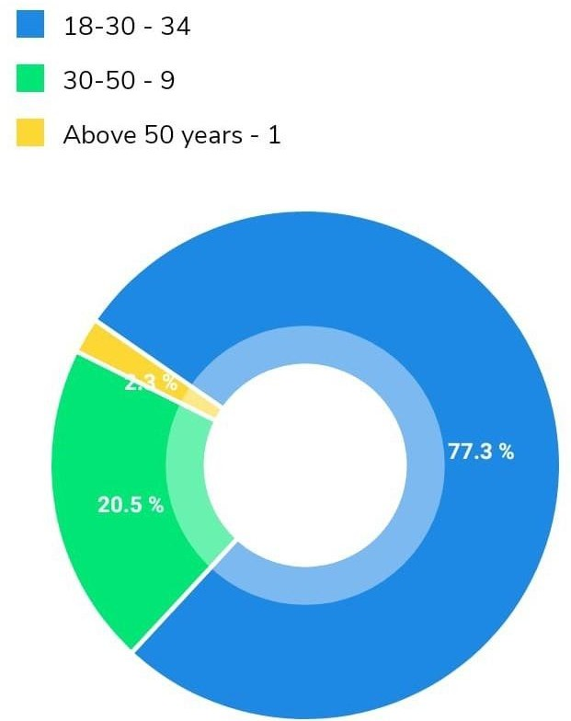

Graphical Representation

### Analysis and Interpretation

The above Figure 3.1.1, shows the age group of the number of customers who were taken as samples for the sample study. By analysing the same the following is concluded:

* + - **Above 77.3% of the samples belong to the age group of 18-30 i.e., products from this site are bought by the generation of adult teenagers. Whereas, only 20.5% of the samples belongs to the age group of 30-50 and a minimum of 2.3% belongs to the age of above 50 years.**

Q – 2 Gender

Table – 2

|  |  |
| --- | --- |
| **Gender** | **Percentage** |
| **Male** | **63.6%** |
| **Female** | **36.4%** |
| **Prefer not to say** | **-** |

### Graphical Representation

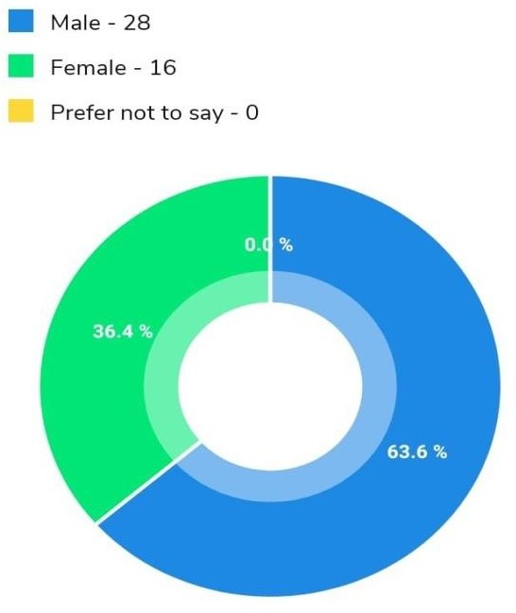

***FIG 3.1.2***

### Analysis and Interpretation

The above Figure 3.1.2, shows the gender division of the number of customers who were taken as samples for the sample study.

* + - * **63.6 % Males**
      * **36.4 % Females**

Q – 3 Occupation

Table – 3

|  |  |
| --- | --- |
| **Customers’ Occupation** | **Percentage** |
| **Student** | **70.45%** |
| **Working professionals** | **15.91%** |
| **Business person** | **9.09%** |
| **No occupation** | **4.55%** |

### Graphical Representation

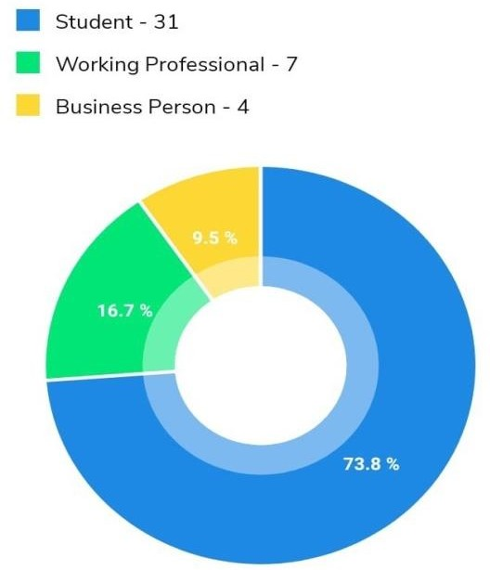

***FIG 3.1.3***

### Analysis and Interpretation

The above Figure 3.1.3, shows the occupation of the customers of the number of customers who were taken as samples for the sample study.

* + - * **By analysing that 73.8% were student**
      * **16.7% were Working Professionals**
      * **9.5% were business person Q- 4 How often do you buy on this site?**

Table – 4

|  |  |
| --- | --- |
| **Frequency of buying on this site** | **Percentage** |
| **Frequently** | **52.3%** |
| **Very frequently** | **4.5%** |
| **Seldom** | **43.2%** |

### Graphical Representation

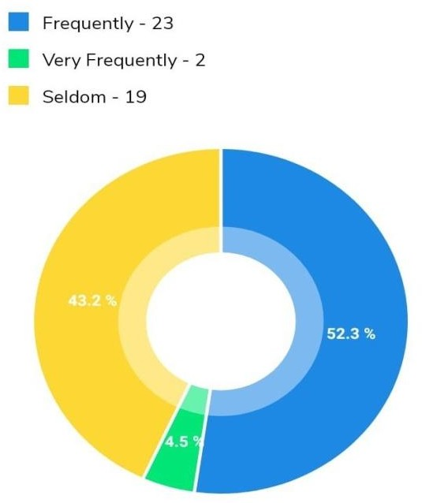

***FIG 3.1.4***

### Analysis and Interpretation

From the above Figure 3.1.4, it can be analysed that, 52.3% of the users are frequent buyers of this site whereas, 43.2% of the users seldomly buys from this site. On the other hand, only a handful of 4.5% of the total users very frequently buys from this site. The from the above data it can be concluded that there are both frequent buyers and seldom buyers of this site but, the percentage of seldom buyers are comparatively a little more as compared to very frequent buyers.

Q- 5 Choose any product you buy frequently on this site.

Table – 5

|  |  |
| --- | --- |
| **Products frequently bought by customers on this site** | **Percentage** |
| **Men’s Wear** | **50%** |
| **Women’s Wear** | **29.5%** |
| **Kid’s Wear** | **4.5%** |
| **Accessories** | **15.9%** |

### Graphical Representation

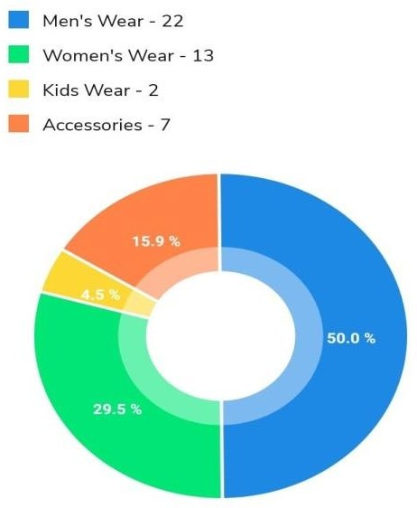

***FIG 3.1.5***

### Analysis and Interpretation

The above Figure 3.1.5, shows the products that are frequently bought by customers on this site. By analysing it is concluded that, 50% are buyers of men’s wear. 29.5% of the respondents are buyers of women’s wear, 4.5% buyers of kid’s wear and 15.9% of the respondents are buyers of accessories. Thus, from the above data it can be concluded that the percentage of buyers for men’s wear is higher than that of the buyers of other products.

Q- 6 Are you satisfied with the availability of the products?

Table – 6

|  |  |
| --- | --- |
| **Satisfaction of customers with the availability of the products** | **Percentage** |
| **Highly Satisfied** | **18.2%** |
| **Satisfied** | **54.5%** |
| **Neutral** | **27.3%** |
| **Highly dissatisfied** | **-** |

### Graphical Representation

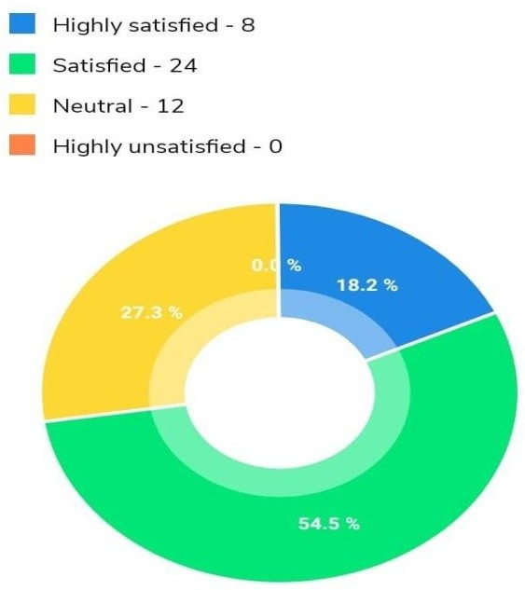

***FIG 3.1.6***

### Analysis and Interpretation

Customer Satisfaction is the key performance indicator within the business. The above Figure 3.1.6, shows customer satisfaction with the availability of products. By analysing it is concluded 18.2% of the respondents are highly satisfied with the availability of products on site. 54.5% of the respondents are satisfied with the availability of products on the site. 27.3% of the respondents are neutral with their opinion, i.e., neither they are satisfied nor they are unsatisfied.

Q- 7 How do you rate the quality of the products compared to the other e- commerce platforms?

Table – 7

|  |  |
| --- | --- |
| **Customer’s rating on the quality of the products compared to other e-**  **commerce platforms** | **Percentage** |
| **Very Good** | **22.7%** |
| **Good** | **59.1%** |
| **Neutral** | **18.2%** |
| **Bad** | **-** |
| **Very Bad** | **-** |

### Graphical Representation

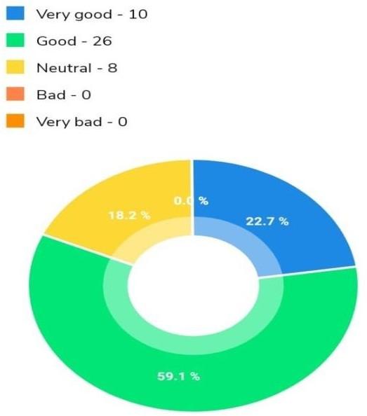

***FIG 3.1.7***

### Analysis and Interpretation

Customer Feedback plays an important role in retail business.

From the above Figure 3.1.7, it can be analysed that 22.7% of the people rated the product quality of the products very good, 59.1% said the quality is good. On the other hand, according to the rest 18.2% the product quality is neither good nor bad. They claimed it to be neutral.

Q- 8 Did the website include enough product details for you to feel well-informed about your purchase?

Table – 8

|  |  |
| --- | --- |
| **Customer’s reaction on the availability of the product details on the website** | **Percentage** |
| **Yes** | **45.5%** |
| **No** | **9.1%** |
| **Maybe** | **45.5%** |

### Graphical Representation

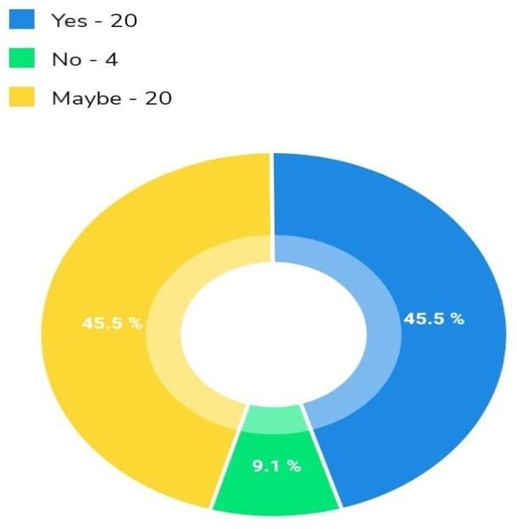

***FIG 3.1.8***

### Analysis and Interpretation

Customer service plays an important role in an organization’s ability to generate income and revenue.

From the above Figure 3.1.8, it can be clearly analysed that, 45.5% of the samples said yes, which means they feel that there were enough product details available on the website. Whereas, according to 9.1% of the samples there wasn’t enough product detailing on the website. Lastly, the rest 45.5% of the samples are not sure of the product detailing. Thus, it can be concluded that on an overall, the website had an average product detailing for the customers so that they feel well- informed regarding their purchase.

Q- 9 How would you rate the product prices on this website?

Table – 9

|  |  |
| --- | --- |
| **Customer rating on the product prices of**  **this website** | **Percentage** |
| **Beyond affordable range** | **25%** |
| **Affordable** | **66.9%** |
| **Very much affordable** | **9.1%** |

### Graphical Representation

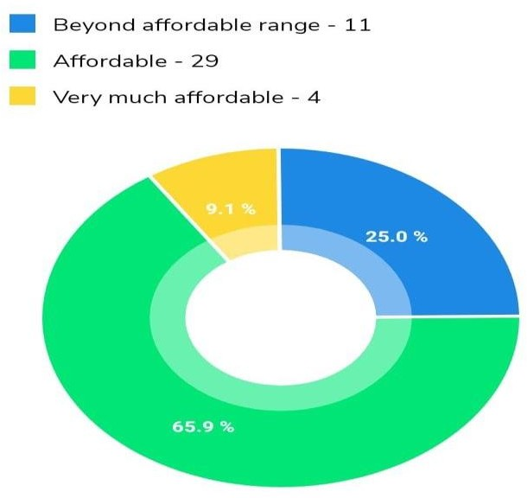

***FIG 3.1.9***

### Analysis and Interpretation

Customer rating plays an integral role in the betterment of the business.

The above Figure 3.1.9, shows customer rating on the product prices. By analysing it is concluded 65% of the respondents could afford the product prices listed on the website which indicates that the products are very much pocket-friendly and customers from any class from the society can afford them. On the other hand, according to 9% of the respondents, the price of the products was very much affordable. Whereas, for the rest 25% it was beyond affordable range.

Q – 10 What is the biggest challenge you face while shopping online?

Table – 10

|  |  |
| --- | --- |
| **Biggest challenge faced by customers while shopping online** | **Percentage** |
| **Slow checkout time** | **61.4%** |
| **Lack of choices** | **31.8%** |
| **Slow web page response time** | **8%** |

### Graphical Representation

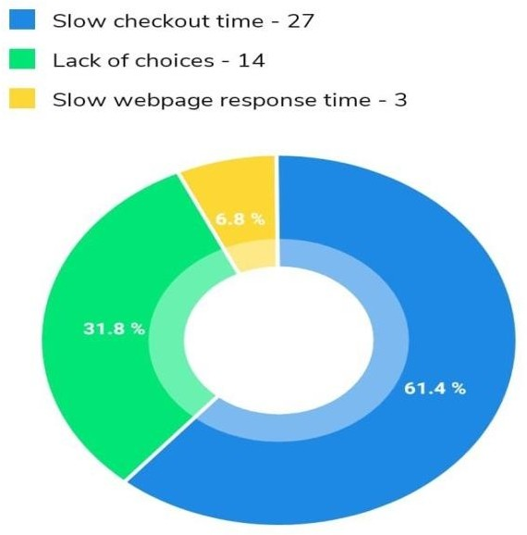

***FIG 3.1.10***

### Analysis and Interpretation

Facing different challenges while shopping online is a very common thing these days. The above Figure 3.1.10, shows the biggest changes faced but the customers while shopping. By analysing the same the following is concluded:

* **61.4% of the respondents faced the problem of slow checkout time.**
* **6.8% of the respondents faced the problem of slow webpage response time.**
* **Whereas, 31.8% of the respondents complained of having lack of choices.**

Thus, from the above data it can be concluded that majority of the customers of this website faced the problem of not having enough choices in the products of the website.

Q- 11 How likely are you to recommend this site to other online shoppers?

Table – 11

|  |  |
| --- | --- |
| **Customers’ recommendation of this site to other on-line shoppers** | **Percentage** |
| **Very likely** | **40.9%** |
| **Somewhat likely** | **56.8%** |
| **Very unlikely** | **2.3%** |

### Graphical Representation

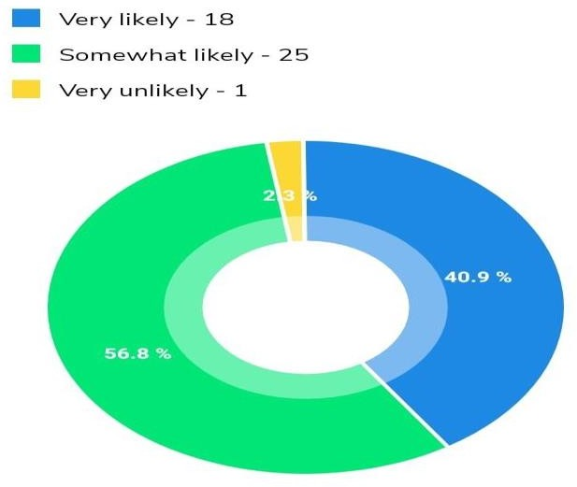

***FIG 3.1.11***

### Analysis and Interpretation

Good customer service is the lifeblood of any business. It is all about bringing customers back and about sending them away happy – happy enough to pass positive feedback about the business along to others. From the above Figure 3.1.11, it can be analysed that:

* + **40.9% of the respondents are very much likely of recommending this to other shoppers.**
  + **Whereas, 56.8% of them are somewhat likely. And 2.3% very unlikely. Thus, it can be concluded that this website has an average customer recommendation.**

Q- 12 How likely are you to return to this webpage for your online shopping?

Table – 12

|  |  |
| --- | --- |
| **Customers’ probability to return to this website for online shopping** | **Percentage** |
| **Very likely** | **36.4%** |
| **Somewhat likely** | **59.1%** |
| **Very unlikely** | **4.5%** |

### Graphical Representation

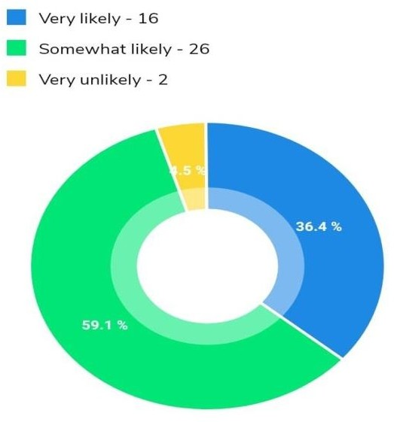

***FIG 3.1.12***

### Analysis and Interpretation

The above Figure 3.1.12, shows probability of customers to return to website for online shopping. By analysing the same the following is concluded:

36.4% of the respondents liked this website and is very much likely to get back for online shopping. On the other hand, 59.1% of the respondents are somewhat likely so they might shop from this website in future or might not. Rest, 4.5% did not like the products or services and thus are very unlikely to return to this website.

Q- 13 How would you rate your overall online shopping experience on this website?

Table – 13

|  |  |
| --- | --- |
| **Overall online shopping experience of customers on this website** | **Percentage** |
| **Excellent** | **20.5%** |
| **Good** | **54.5%** |
| **Average** | **22.7%** |
| **Poor** | **2.3%** |
| **Very poor** | **-** |

### Graphical Representation

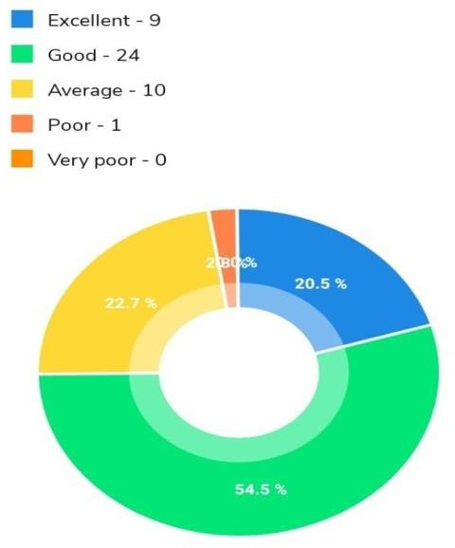

***FIG 3.1.13***

### Analysis and Interpretation

The above Figure 3.1.13, shows the overall shopping experience of the customers on this site. By analysing the above data received from the respondents, it can be concluded that:

* **20.5% of the customers surveyed had an excellent shopping experience.**
* **54.5% of them had a good sopping experience.**
* **22.7% of the customers claimed to have an average experience.**
* **Only 2% of them had poor experience of shopping.**

Thus, it can be concluded that overall, the website has good feedback from customers. Q- 14 How helpful was the customer support team?

Table – 14

|  |  |
| --- | --- |
| **Customer reviews on the customer support team** | **Percentage** |
| **Excellent** | **18.2%** |
| **Good** | **56.8%** |
| **Average** | **20.5%** |
| **Poor** | **4.5%** |
| **Very poor** | **-** |

### Graphical Representation

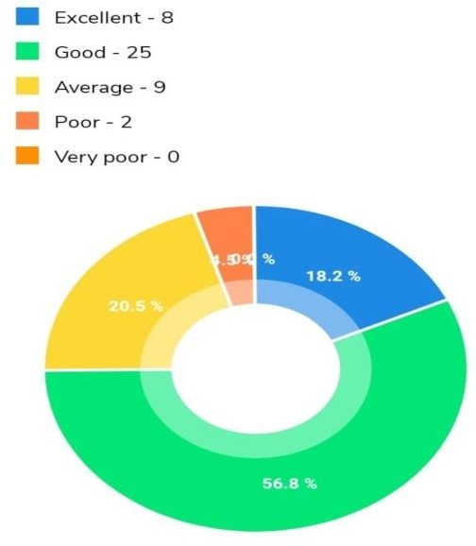

***FIG 3.1.14***

### Analysis and Interpretation

Customer service is the provision of services to customer before, during and after purchase. From the above Figure 3.1.14, it can be clearly interpreted that 56.8% of the respondents reviewed the customer support team as good, 18.2% said it is excellent. Whereas, 20.5% of them had an average customer experience and 4% had a poor experience.

Q- 15 How satisfied are you with the quality of the delivery services provided?

Table – 15

|  |  |
| --- | --- |
| **Customer satisfaction on the quality of the delivery services provided** | **Percentage** |
| **Highly satisfied** | **29.5%** |
| **Neutral** | **29.5%** |
| **Satisfied** | **40.9%** |
| **Highly dissatisfied** | **0%** |

### Graphical Representation

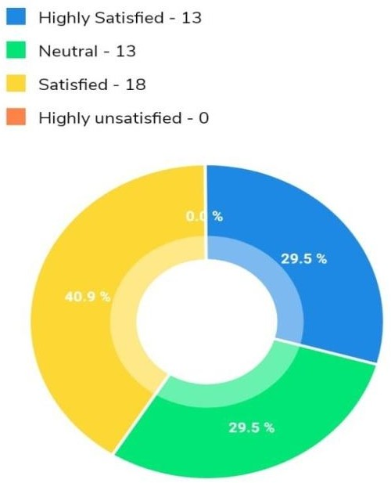

***FIG 3.1.15***

### Analysis and Interpretation

Delivery services plays a key role in online retailing businesses. From the above Figure 3.1.15, it can be concluded that 29.5% of the surveyed customers are highly satisfied with the delivery services provided whereas, 0% of them are highly unsatisfied. Again, 40.9% of the respondents are satisfied and 29.5% of them gives a neutral response. This proves that, most of the customers are happy and satisfied with the delivery services provided by the company.

### Findings

* **There is not much difference in gender for using online shopping.**
* **Students and salaried persons are most frequent users of Flipkart.**
* **Frequency of purchase for Men’s Wear, Women’s Wear and accessories are more in Flipkart.**
* **Word of mouth was more influential in promotion as many people were made aware by their friends and family when customers recommend this website to them.**
* **The services provided by Flipkart are good.**
* **Customers feeling more secured when purchasing through Flipkart.**
* **Digital marketing techniques like search engine marketing, links providing other website and advertisement also functioned well for promotion of this website.**
* **Fast delivery is one of best service Flipkart is providing.**
* **Page loading is the main issue faced by Flipkart.**
* **Most of customers have good experience with Flipkart while purchasing products.**
* **Convenience and time saving are two important factors that customer looking for while purchasing through online.**

### 4.1 Conclusion –

The thorough study is based on the consumer behaviour analysis which serves a great idea regarding consumer perception when they go for online shopping. In order to satisfy themselves consumer perceive many things before buying products and they will be satisfied if the company meet their expectation.

The Overall Brand Value of Flipkart is good, but it is facing some tough competition from its global competitors like Ebay and Amazon. Talking about domestic market i.e India, it is the most superior E-business portal which is aggressively expanding & planting its roots deep into the Indian market & at the same time shifting the mind-set of the people from going &shopping from physical store to online stores, which is magnificent!.Be very focused on consumers and build amazing experiences for the customers.

### Recommendation –

* + - **Flipkart has successfully placed itself into the prospects mind making it the India’s largest online store with huge range of products. But it still needs to work on their core competence that is books and stationery items.**
    - **Delivery services can be improved mainly in rural areas by selecting appropriate courier service which has services in customer area for dispatching an item.**
    - **Can make free delivery to all priced products.**
    - **Can include more coupon codes and gift vouchers for increasing the traffic of the customers.**
    - **Out of stock items can made available as soon as possible and intimate the needed customers.**
    - **Should look for International/ Overseas markets or Neighbouring Countries.**
    - **User Experience: Portal should continuously aim to work to improve the user experience by adding more & more innovative features in the website like virtually shopping basket, virtual trial rooms. In this competitive world**

to differentiate via user experience, the ultimate winner will be the Indian online consumer.

* + - **Should comprehensively invest into E-CRM & online reputation management.**
    - **Logistics & Supply Chain: can continuously aim to reduce the delivery time cycle.**

### BIBLIOGRAPHY –

Information and data related to the project has been taken from the sources below, special thanks to the editors for making the task easier:

* [**http://www.flipkart.com/**](http://www.flipkart.com/)
* [**http://www.commodityindia.com/**](http://www.commodityindia.com/)
* [**http://www.marketoperation.com/**](http://www.marketoperation.com/)
* [**http://www.ecommerce-land.com/**](http://www.ecommerce-land.com/)
* [**http://www.commodityindia.com/**](http://www.commodityindia.com/)
* [**http://www.marketoperation.com/**](http://www.marketoperation.com/)