**DESIGN AND FABRICATION OF A PLASTIC SHREDDER MACHINE FOR RECYCLING AND MANAGEMENT OF PLASTIC WASTES**

***Mr. Dushyal Kisanaji Dhote1, Mr. Gaurav Hemraj Sonwane2, Mr. Dhiraj Ganesh Shivankar3, Mr. Aditya Vilas Zode4,*** ***Asst. Prof. Dhanraj Raut5***

*1234Student,VIT, Nagpur, India*

*5Asst. Prof. Dhanraj Raut, VIT, Nagpur, India*.

**ABSTRACT**

Plastic pollution has become a global concern due to poor plastic waste disposal management. As an alternative, independent recycling efforts are necessary. A Plastic shredder machine is a preliminary machine used to cut plastic waste into small pieces before turning it into useful products. The concept design of the shredder machine that is currently available is fairly similar. The shaft and blades are the critical components in the shredder machine that determines its performance. The geometry and orientation of the blades that were fitted into the single or double-shafts were found to directly affect the shredding performance. Therefore, this article aims to review the various geometry and orientations of the blades that give direct effect on the shredding performance, as well as identifying the research gaps related to the shredder machine for plastic waste materials. . So, our intension behind this project is to reduce the cost of transportation of plastic. This machine is more beneficial in reducing labour work or labour cost.

**Keywords:** plastic shredder Machine, plastic waste, catia, waste management, shredding rate

1. **INTRODUCTION**

In today’s world, the major problem arising due to waste which are being produced in substantial amount in developing countries like India. So, there is a need of waste recycling. The waste can be classified as biodegradable and non-biodegradable waste. There are different sources of waste such as industrial, commercial, domestic and agriculture waste. Waste is collected, separated, processed and returned to use. Waste plastic shredder is a machine that reduces used plastic bottles to smaller particle sizes to enhance its portability, easiness and readiness for use into another new product. The design principle of this machine was got from the ancient tradition method of using scissors to cut materials into reduced form and scratching used by rabbits when digging or tearing. These two traditional methods were applied in the design of the machine by fabricating cutting blades to cut the waste plastic while some of the cutting blades have sharp curved edges to draw-in the plastic into the cutting blades teeth. The waste plastic shredder comprises of four major components, namely; the feeding unit, the shredding unit, the power unit and the machine frame. The machine can be powered by electric motor of 10 Hp. Many of the researchers have developed and designed shredder machine for waste recycling but it is limited to domestic purpose only for small use which are cost effective and efficient about 60-70%

1. **METHODOLOGY**

1. To understand the shredder machine, the main or most important part is blade. Blade design is very important part in shredder machine.

2. The design of the blade is done by using autocad and Solidworks 2018.

3. The designing is further classified as different components are designed separately according to load calculations.

4. After designing each component they assembled.

5. This is about CAD modelling.

6. Once Cad modelling is done the next step is material selection for the components.

7. Depending on the prototype we designed the actual manufacturing will start.

1. **MODELING AND ANALYSIS**

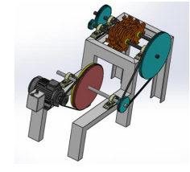

**Figure 1:** 3D view of Model.

1. **OBJECTIVES**
2. To reduced plastic waste place into landfills.
3. The scope of the project is to reduce the space consumed in truck so that more plastic waste can be transported without overloading the vehicle.
4. The crusher will help in managing and recycling plastic waste.
5. It would also help in reducing the volume of waste generated and will thus help in effective waste management.
6. It would help to improve the economy of country.
7. **DESIGN AND CALCULATION**

**DESIN OF MOTOR**

The rpm of the motor is 2800 rpm.but the machine was designed based on the load conditions 70rpm is inought to withstand the load From the above details we find the rpm of the motor 344593.4=P×60/(2πN) N=55.4~70rpm

1. GEAR

1. Number of gerar =2 Teeth of each gear = 35

2. Diameter of teeth =90 mm Material =M.S Steel

1. MOTOR

1.AC Single phase motor 1425 rmp

2.HP motor

1. BLADE

1. No. of blade= 8

2.Blade material =M.S steel( high tensile) Thickness = 10 mm

1. BEARING

1.Types of bearing = Universal bearing No. of bearing = four bearing (4)

1. CRUSHING CHAMBER
2. Material = M.S steel Size = 240 mm length
3. 130.1 width
4. 200 mm height
5. AXLE

1.Dia = 20 mm Length = 260 mm No of axle = 2 Material = M.S steel

1. FRAME

1. Material = M.S steel Size = 650 mm length

460 mm width

8) GEAR BOX

Speed revolution ratio = 1:15

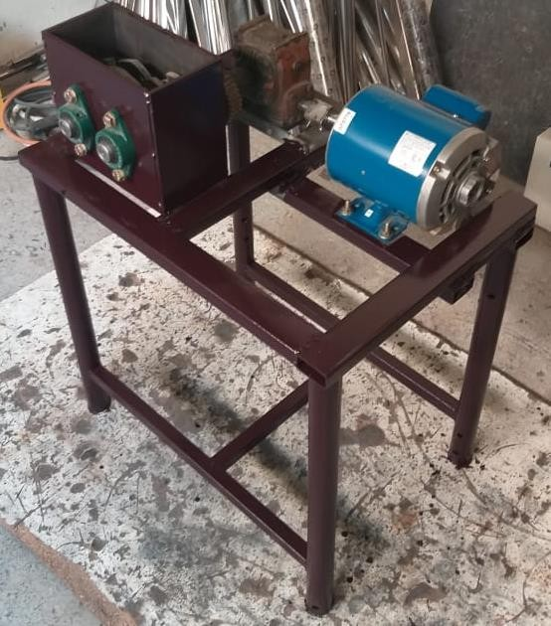

**Figure 2:** Fabricated Machine

1. **CONCLUSION**

Plastic plays a vital role in the current scenario. It has become the irreplaceable due to the its numerous advantages. But as plastic is non-biodegradable, it should be recycled and reused. The conclusion of this study is plastic waste can be effectively shredded using a shredding machine. The design procedure for this shredder is ease to understand and is also cost effective. Recycling is a complex method of environment protection, which aim is the limitation of the raw materials consumption and decrease of waste quantity. Shredder machine; - product/mass flow rate (HDPE) increases when speed of motor is rise.

1. **REFERENCES**
2. Hardesty, Britta Denise; Chris Wilcox ( 2015). "Eight million tonnes of plastic are going into the ocean each year". The Conversation. Retrieved 21 February 2015.
3. Jambeck, Jenna, Science 13 February 2015: Vol. 347 no. 6223; et al. (2015). "Plastic waste inputs from land into theocean".Science.347(6223):768771.doi:10.1126/science.1260352. PMID 25678662. Retrieved 21 February 2015.
4. Creton C (February 24, 2017). "Molecular stitches for enhanced recycling of packaging". Science. 355 (6327): 797–798. doi:10.1126/science.aam5803.
5. Eagan JM; et al. (February 24, 2017). "Combining polyethylene and polypropylene: Enhanced performance with PE/iPP multiblock polymers". Science. 355 (6327): 814–816. doi:10.1126/science.aah5744.
6. Fleischman T. "Polymer additive could revolutionize plastics recycling". cornell.edu. Cornell University. Retrieved 23 February 2017.
7. [http://www.plasticsrecycling.org/images/pdf/market_development/APR_Design_Guide_Exec_ Summary2014.pdf](http://www.plasticsrecycling.org/images/pdf/market_development/APR_Design_Guide_Exec_%20Summary2014.pdf)
8. Dr. M. MUTHUKUMARAN, P. MURASOLI MARAN etl,.., “DESIGN AND FARICATION OF PLASTIC WASTE SHREDDER MACHINE” INTERNATIONAL JOURNAL FOR RESEARCH & DEVELOPMENT IN TECHNOLOGY Volume-7,Issue-4, (April-17) ISSN (O) :- 2349-3585.
9. Sanket Yadav, Shubham Thite, etl,.., “Design and Development of Plastic Shredding Machine” JASC: Journal of Applied Science and Computations Volume VI, Issue IV, April/2019 ISSN NO: 1076-5131
10. Dutta J. and Choudhury M., (2018). Plastic Pollution: A Global Problem from a Local Perspective. J Waste Manage Xenobio,1(1): 000102