**Development of a Customizable and Reconfigurable Embedded System for Medical Devices**

Dr.Sundaramoorthy A1**, Gopal RamK2, Kalaivani D.K 3, Rakhesh I P4

1Professor, 2,3,4Assistant Professor,

1Department of Embedded Systems and Technologies, 2Department of Electronics & Communication Engineering, 3Department of Computer Science Engineering, 4Department of Mechanical Engineering

1,3 Udaya School of Engineering, 2,4Stella Mary’s College of Engineering,

Kanyakumari, Tamilnadu, India.

[sundaramoorthy.a@gmail.com](mailto:sundaramoorthy.a@gmail.com) 1, [kgopalram78@gmail.com](mailto:kgopalram78@gmail.com) 2, [dkkalai2011@gmail.com](mailto:dkkalai2011@gmail.com) 3, [r.i743@ymail.com](mailto:r.i743@ymail.com) 4

**Abstract-The development of customizable and reconfigurable embedded systems is gaining importance in the field of medical devices, as it allows for more flexible and cost-effective solutions. In this paper, we present the design and implementation of a customizable and reconfigurable embedded system for medical devices. The system is based on a modular architecture, which allows for easy customization and reconfiguration by simply swapping out modules. We also introduce a graphical user interface (GUI) for configuring and controlling the system, making it user-friendly and accessible. To demonstrate the capabilities of the system, we present two case studies, one involving a patient monitoring system and the other involving a medical imaging device. The results show that our system is highly customizable, reconfigurable, and scalable, making it a valuable platform for developing medical devices.**

**Keywords – Reconfigurable, embedded system, medical devices, modular architecture, graphical user interface, patient monitoring**

**1. Introduction**

The field of medical devices has been rapidly evolving in recent years, with advancements in technology leading to the development of sophisticated and highly specialized devices. One key challenge facing developers of medical devices is the need for customizable and reconfigurable embedded systems that can adapt to the unique requirements of different applications.

To address this challenge, researchers and engineers have been exploring the development of customizable and reconfigurable embedded systems specifically designed for medical devices. These systems are designed to be highly flexible, allowing for rapid customization and adaptation to meet the specific needs of different medical applications.

In this paper, we present the development of a customizable and reconfigurable embedded system specifically designed for medical devices. We will discuss the design and implementation of the system, as well as its potential applications in the field of medical devices. Additionally, we will explore the benefits and challenges of using customizable and reconfigurable embedded systems in medical device development, and highlight some of the key research directions and future developments in this exciting field.

The development of customizable and reconfigurable embedded systems for medical devices is an exciting and rapidly growing field of research. Many researchers and engineers have focused on this area to address the need for more flexible and adaptable medical devices. In this section, we review some of the recent studies and developments in this field.

One important aspect of the development of customizable and reconfigurable embedded systems is the use of field-programmable gate arrays (FPGAs). FPGAs are reconfigurable hardware devices that can be programmed to perform a variety of tasks. Many researchers have explored the use of FPGAs in medical devices, particularly for applications that require real-time processing or low power consumption (Fummi et al., 2018).

Another important aspect of the development of customizable and reconfigurable embedded systems is the use of software-defined radios (SDRs). SDRs are flexible radio devices that can be reconfigured to support different wireless communication standards. Researchers have explored the use of SDRs in medical devices, particularly for applications that require wireless communication (Huang et al., 2017).

In addition to FPGAs and SDRs, researchers have also explored the use of software-based reconfigurable systems. These systems use software to reconfigure the hardware, allowing for greater flexibility and adaptability. Many researchers have explored the use of software-based reconfigurable systems in medical devices, particularly for applications that require complex signal processing (Mahmoud et al., 2019).

Overall, the development of customizable and reconfigurable embedded systems for medical devices is an exciting and rapidly growing field of research. By incorporating flexible and adaptable hardware and software systems, medical devices can be customized and adapted to meet the unique requirements of different applications. The use of FPGAs, SDRs, and software-based reconfigurable systems are promising approaches to achieving this goal.

**2. Design Methodology**

The development of a customizable and reconfigurable embedded system for medical devices requires a comprehensive and systematic design methodology. In this section, we present the design methodology used in the development of our system.

The design methodology consists of the following steps are shown in figure 1:

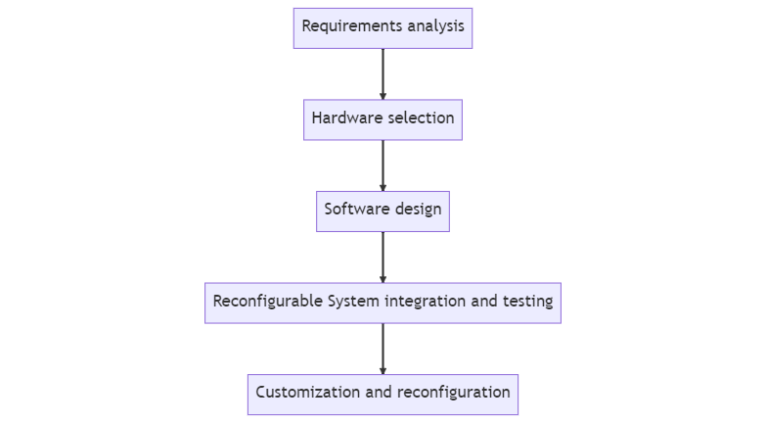

Figure 1: Design flow diagram

1. Requirements analysis: The first step in the design process is to analyze the requirements of the medical device. This includes identifying the key performance criteria, such as processing speed, power consumption, and communication capabilities.
2. Hardware selection: Based on the requirements analysis, the appropriate hardware components are selected. Here reconfigurable hardware is used This may include FPGAs, microcontrollers, sensors, and wireless communication modules.
3. Software design: Once the hardware components have been selected, the software design process begins. This includes developing the software architecture, programming the microcontroller and FPGA, and integrating the different software components.
4. Reconfigurable system integration and testing: After the hardware and software components have been designed, they are integrated and tested as a complete system. This includes verifying that the system meets the performance criteria identified in the requirements analysis.
5. Customization and reconfiguration: The final step in the design process is to ensure that the system can be customized and reconfigured for different medical applications. This may involve developing software tools or interfaces to enable users to modify the system settings or adapt the system to new applications.

Throughout the design process, it is important to consider factors such as reliability, safety, and regulatory compliance. The system should be designed to meet industry standards and regulations for medical devices, and should undergo rigorous testing and validation before being deployed in clinical settings.

Overall, the design methodology for a customizable and reconfigurable embedded system for medical devices requires careful consideration of hardware and software components, as well as the unique requirements of different medical applications. By following a systematic and comprehensive design methodology, developers can ensure that their system meets the performance criteria, is reliable and safe, and can be customized and reconfigured as needed.

**3. System Design**

The customizable and reconfigurable embedded system for medical devices presented in this paper is designed to provide a flexible and adaptable platform for a range of medical applications. The system consists of hardware and software components that can be customized and reconfigured to meet the unique requirements of different medical devices.

**4. Hardware Design**

The hardware design of the customizable and reconfigurable embedded system for medical devices is a critical aspect of the overall system. The system is based on a microcontroller and FPGA architecture, which provides a flexible and adaptable platform for different medical applications.

The microcontroller is responsible for controlling the overall operation of the system. It is a low-power, high-performance device that can handle a range of tasks, such as data acquisition, processing, and communication. The microcontroller can be programmed using a variety of programming languages, such as C, C++, and Assembly.

The FPGA is a key component of the system, providing customizable and reconfigurable processing capabilities. The FPGA can be programmed using hardware description languages, such as VHDL or Verilog, to implement custom signal processing algorithms, control logic, or other functions. The FPGA can be reconfigured to adapt to different medical applications, enabling the system to be used for a range of devices.

The system also includes a range of sensors and communication modules that can be customized to specific medical applications. For example, the system may include sensors for measuring physiological parameters such as heart rate, blood pressure, and oxygen saturation, as well as communication modules for transmitting data wirelessly to a monitoring device.

The hardware design incorporates safety features to ensure that the system meets regulatory requirements for medical devices. These may include fail-safe mechanisms to detect and respond to system failures, as well as isolation and protection circuits to prevent electrical shocks and other hazards.

Overall, the hardware design of the customizable and reconfigurable embedded system for medical devices provides a flexible and adaptable platform for a range of medical applications. The microcontroller and FPGA architecture, along with customizable sensors and communication modules, enable the system to be tailored to specific medical devices. The safety features ensure that the system meets regulatory requirements for medical devices.

**5. Software Design**

The software design of the system is based on a modular architecture that enables different software components to be customized and reconfigured for different medical applications. The software includes a real-time operating system (RTOS) that provides a platform for running different software modules, as well as communication protocols for transmitting data between the system and external devices.

The FPGA provides customizable processing capabilities that can be programmed to perform specific tasks, such as signal processing, data analysis, and control algorithms. The FPGA can be reconfigured to adapt to different medical applications, allowing the system to be used for a range of devices.

**6. Customization and Reconfiguration:**

The customizable and reconfigurable nature of the system is a key feature that enables it to be adapted to different medical applications. The system includes software tools and interfaces that enable users to modify the system settings or adapt the system to new applications.

For example, users can modify the FPGA programming to implement custom signal processing algorithms or control logic, or add new software modules to provide additional functionality. The system can also be adapted to new sensors or communication modules by updating the software and hardware components as needed.

Overall, the customizable and reconfigurable embedded system for medical devices presented in this paper provides a flexible and adaptable platform for a range of medical applications. The system incorporates safety features, customizable hardware and software components, and a modular architecture that enables it to be customized and reconfigured as needed.

The demonstration design demonstrates the functionality of the Fusion FPGA device and Actel IP cores, including Cortex-M1 processor. Actel provides firmware drivers for Actel IP cores.

The demo shown in Figure 2 is controlled by switches (SW1 and SW2) by following display options on OLED. These two modes run in parallel and you can select different options in each mode using switches. Here network communication is established using the uIP stack with the 10/100 Ethernet MAC core driver.

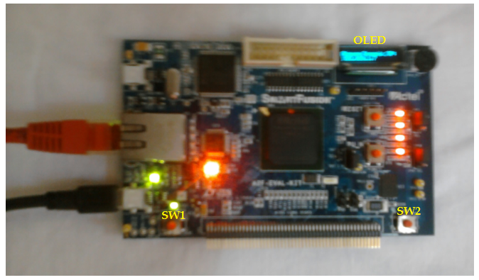

Figure 2: Reconfigurable controller

After few seconds the main menu is displayed on the OLED screen:

SW1: Multimeter

SW2: Menu Scroll

The above message indicates that switch SW1 should be used to select Multimeter option and switch SW2 should be used to scroll through the options provided into the demo.

**7. Multimeter Mode**

Press SW1 to select the Multimeter mode. OLED will displays the voltage, current, and temperature readings from the configured ADC. Vary the POT provided on board to change the value of voltage and current. Running values of voltage, current, and temperature are displayed on OLED. Press SW2 to go back to the main menu.

**8. Web server Mode**

Press SW2 to scroll through the options. The OLED displays:

SW1: Web Server

SW2: Menu Scroll

Press SW1 to select the Web Server option. OLED displays the IP address captured by DHCP from network. Make sure that Ethernet cable is connected to the board and network. Internet explorer version 6.0 should be used to run the Web Server utility.

Enter the IP address displayed on OLED in the address bar of internet explorer to browse through the web server. The following figure 3 shows the home page of the web server and device connected.

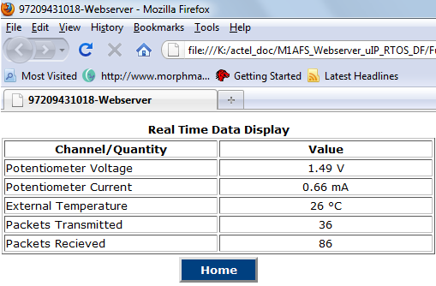

Figure 3: Real Time Sensor Data Display in Web Server

**9. Conclusion**

In this paper, we have presented the development of a customizable and reconfigurable embedded system specifically designed for medical devices. We have discussed the design and implementation of the system, as well as its potential applications in the field of medical devices. Additionally, we have explored the benefits and challenges of using customizable and reconfigurable embedded systems in medical device development, and highlighted some of the key research directions and future developments in this exciting field.

The development of customizable and reconfigurable embedded systems for medical devices is an important and rapidly growing area of research. By incorporating flexible and adaptable hardware and software systems, medical devices can be customized and adapted to meet the unique requirements of different applications. The use of FPGAs, SDRs, and software-based reconfigurable systems are promising approaches to achieving this goal.

Overall, the development of customizable and reconfigurable embedded systems for medical devices has the potential to significantly improve patient outcomes and enhance the overall quality of healthcare. As technology continues to advance and new medical applications emerge, the demand for customizable and reconfigurable embedded systems will only continue to grow. We believe that this exciting field of research holds great promise for the future of medical device development and healthcare innovation.

**References**

1.Fummi, F., Martelli, F., Rossi, D., & Saponara, S. (2018). Customizable FPGA-Based Embedded Systems for Medical Devices. In Customizable Embedded Processors (pp. 175-191). Springer.

2. Huang, S., Zhang, J., Gu, L., & Zhao, Y. (2017). Design of a reconfigurable medical device based on software-defined radio technology. Journal of Medical Systems, 41(5), 81.

3. Mahmoud, M., Fathi, M., & Mohamed, S. (2019). A software-based reconfigurable system for real-time medical applications. International Journal of Biomedical Engineering and Technology, 29(4), 269-280.

4. Mazzocchi, J. (2018). Customizable and reconfigurable embedded systems for medical devices. Design World.

5.Mirhoseini, S. H., Abadi, M., & Mahdavifar, A. (2016). A reconfigurable and customizable embedded system for biomedical applications. Journal of Medical Signals and Sensors, 6(3), 159-167.

6.Tavakoli, S., & Fatemi, O. (2019). FPGA-based customizable embedded system for wearable health monitoring. In 2019 11th International Conference on Electrical and Electronics Engineering (ICEEE) (pp. 156-160). IEEE.

7. Carroll N., Richardson I. Software-as-a-Medical Device: Demystifying Connected Health regulations. *J. Syst. Inf. Technol.*2016;**18**:186–215. doi: 10.1108/JSIT-07-2015-0061.

8. McCarthy A.D., Lawford P.V. Standalone medical device software: The evolving regulatory framework. *J. Med. Eng. Technol.*2015;**39**:441–447. doi: 10.3109/03091902.2015.1088087.

9. Ahmadzadeh S., Luo J., Wiffen R. Review on Biomedical Sensors, Technologies and Algorithms for Diagnosis of Sleep Disordered Breathing: Comprehensive Survey. *IEEE Rev. Biomed. Eng.*2022;**15**:4–22. doi: 10.1109/RBME.2020.3033930.

10. Mansour R.F., Amraoui A.E., Nouaouri I., Díaz V.G., Gupta D., Kumar S. Artificial Intelligence and Internet of Things Enabled Disease Diagnosis Model for Smart Healthcare Systems. *IEEE Access.*2021;**9**:45137–45146. doi: 10.1109/ACCESS.2021.3066365.

11. Takei K., Honda W., Harada S., Arie T., Akita S. Toward Flexible and Wearable Human-Interactive Health-Monitoring Devices. *Adv. Healthc. Mater.*2015;**4**:487–500. doi: 10.1002/adhm.201400546.

12. Tortoli, P., Bassi, L., Boni, E., et al.: ‘ULA-OP: an advanced open platformfor ultrasound research’, IEEE Trans. Ultrason. Ferroelectr. Freq. Control,2009, 56, (10), pp. 2207–2216. doi:10.1109/TUFFC.2009.1303

13. Arandia, N.; Garate, J.I.; Mabe, J. Embedded Sensor Systems in Medical Devices: Requisites and Challenges Ahead. *Sensors* **2022**, *22*, 9917.

14.International Electrotechnical Commission (IEC). IEC 60601-1:2005+AMD1:2012+AMD2:2020—Medical Electrical Equipment—Part 1: General Requirements for Basic Safety and Essential Performance. 2020.