**PREPARATION OF C-TEA (*Cordyceps* Tea) USING POLYHERBS TO EVALUATE THE TOXICOLOGICAL EFFECTS IN ZEBRAFISH**

Mathumitha Nadesan1, Keerthiga K1, Aniskumar mani*

1Department of Biotechnology, V.S.B Engineering College, Karur

**ABSTRACT**

Tea is well-known throughout the world for its distinct flavour and beneficial effects on human health. Recent research on tea has demonstrated that many of its constituents offer notable health benefits. Herbal teas include a variety of organic anti-inflammatory substances that may be beneficial to human health, including antioxidants that help the body resist stress, and tea is a fantastic technique to alleviate pain and inflammation. The prepared C-Tea, which is used to resist stress and menstrual cramps, was fed to the zebrafish for 30 days in three different concentrations (1mg, 4mg, and 8mg). Zebrafish are an emerging animal model to study metabolic, oxidative, and inflammatory vascular processes relevant to the pathogenesis of humans. The second-most often employed animal in medical research is the zebrafish. Zebrafish usage has grown significantly over the past ten years, frequently displacing the use of rats. Toxicological studies were conducted on the 15th and 30th days of the treatment to analyze the toxic effects of the C-Tea. This study shows that the C- tea does not have any harmful effects on zebra fish and can be used as a beverage for stress and menstrual cramps.

**KEY WORDS**: Herbal tea, C-Tea, Stress, Menstrual Cramps, Toxicological studies

**INTRODUCTION**

The world's second most popular beverage after water is tea. Tea, a dry herb infusion produced from plant material such as leaves, flowers, seeds, fruits, and roots, is the most common way that herbs are ingested (Oh*et al*., 2013). Herbal teas are more properly referred to as "tisanes," which are combinations of multiple herbs. Herbal teas don't contain caffeine like the majority of other types of tea do(Ravikumar*et al*., 2014). They are also simple to drink and have a nice flavor. For more than 5000 years, people have utilized tea as a beverage and for its therapeutic properties. Most carbonated drinks are being replaced by tea nowadays, and tea is growing in popularity worldwide, even among the younger, health-conscious population (Ravikumar*et al*., 2014). The global tea market is expanding, particularly for herbal teas, in tandem with the expanding health and wellness trend. The primary producers of herbal tea are in Asia, specifically Bangladesh, China, India, Indonesia, Sri Lanka, and Vietnam; in Africa, specifically Burundi, Kenya, Malawi, Rwanda, Tanzania, Uganda, and Zimbabwe; and in South America, including Argentina, Brazil, and other countries. According to observational studies, drinking 2-3 cups of tea each day lowers the risk of premature death, heart disease, stroke, and type 2 diabetes. It is crucial that people develop the habit of drinking herbal tea because nowadays people continuously consume, drink, and breathe poisons into their bodies. In addition, as herbs aid in the detoxification of our bodies, there is a need to incorporate them into our regular diets. Due to their health-promoting qualities, which include anticancer, antibacterial, antidiabetic, anti-inflammatory, and antioxidant ones, herbal teas are widely used in traditional medicine across a wide range of cultures.

**COMPONENTS OF TEA**

It is now widely accepted that natural resources that provide our bodies with nourishment and the spiritual significance tied to those natural resources are the two components that humans need to exist on earth. The beneficial effects of tea on people are mostly dependent on the chemical components of tea as well as the mental and cultural components (such as those associated with tea ceremonies) offered in tea. Natural bioactive substances such as carotenoids, phenolic acids, flavonoids, coumarins, alkaloids, polyacetylenes, saponins, and terpenoids, among others, are abundant in herbal teas and beverages. Several diverse biological effects, including antioxidant, antibacterial, antiviral, anti-inflammatory, antiallergic, antithrombotic, and vasodilatory actions, as well as antimutagenic, anticarcinogenic, and antiaging effects, are produced by natural bioactive compounds, according to a wealth of available scientific evidence. There are several herbal beverages enjoyed worldwide, and depending on where they are from, some beverages have become more popular than others

**ANIMAL MODEL: ZEBRAFISH**

The zebrafish (*Danio rerio*), a freshwater fish, is indigenous to South Asia. It has a reputation for being able to regenerate. It is a member of the Cyprinidae suborder of the *Cypriniformes phylum*. Zebrafish is not economically significant as a food source; their use in research studies as model systems is becoming more and more significant as scientists attempt to understand the neural and genetic underpinnings of behavior. As model organisms, they are crucial for developmental biology, biomedicine, and neurophysiology.

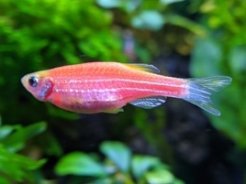

**Figure 1: Zebrafish**

Zebrafish was first introduced by Streisinger and colleagues as an animal model for use in genetic studies. In addition, Zebra fish shows a high degree of genome structure similarity between zebrafish and humans (70% of human genes have at least one evident zebrafish ortholog, as opposed to 80% of human genes having mouse orthologs) has made it easier to employ zebrafish for studying human genetic illnesses (Choi *et al*., 2021).

Zebra fish are an effective tool for drug discovery due to a several factors.

1. Zebrafish have similar digestive, neurological, and cardiovascular systems to mammals.
2. Automation of fluorescent zebrafish experiments will enable high-throughput, and medium-throughput compound screening (a large number of compounds like 1,000 compounds a day). The human and zebra fish genomes share a high degree of conservation (about 75% similarity).
3. The high fecundity of zebrafish results in the production of vast numbers of embryos. 200–250 eggs can be laid by each mature female during mating. Mating occurs year-round. Also, maintenance expenses are far cheaper than those for mammals.
4. Zebrafish larvae are translucent, allowing for in vivo visualization and real-time investigation of organs, cells, and tissues.

Zebrafish are currently the most significant research instrument due to the benefits listed above.

**MATERIALS AND METHODS**

**ANIMALS**

Zebrafish (Danio rerio, 0.3–0.6 g body weight; BW) were bought. The fish was separated into 4 tanks (control, 1 mg, 4 mg, 8mg) with 10 liters of tap water for a week before the experiment. Each tank contains 10 fish. The procedures for the animal studies were followed.

**MATERIAL REQUIREDS:**

Giemsa stain, Methanol, EDTA (Ethylene Diamine Tetra Aceticacid), Tryphan Blue, PBS Buffer, KCl, Thiobarbituric acid and HCl are the chemicals required for this study.

**ACCLIMATIZATION:**

The Zebrafish was bought from the local market in Tiruchirappalli. Zebrafish were transported or shipped in oxygenated, water-filled, sealed plastic bags. These fishes were examined for any indications of stress, injury, or possible transit-related mortality. Fishes were segregated into four different tanks three treatment tanks along with a control. Each tank contains 20 fish. Before treatment, fishes are maintained acclimatized in laboratory conditions for 7 days.

**Composition of Feed preparation**

|  |  |
| --- | --- |
| **INGREDIENTS** | **QUANTITY** |
| Soybean meal | 13g |
| Milk powder | 10g |
| Turmeric powder | 0.8g |
| Coconut oil | 0.6ml |
| Vitamin B and E Complex | 1 |
| Corn flour powder | 4g |
| Garlic | 0.2g |

**Table 1: Composition of fish feed**

The Feed was prepared by mixing these ingredients.

**C-TEA FORMULATION**

The following herbal ingredients are mixed to prepare C-TEA

|  |  |
| --- | --- |
| **HERBS** | **QUANTITY (mg)** |
| *Cordyceps militaris* | 150 mg |
| Ashwagandha | 130 mg |
| Ashoka | 100 mg |
| Shatavari | 150 mg |
| Ginger | 100 mg |
| Licorice | 75 mg |
| Tea leaves | 100 mg |
| Clove | 20 mg |
| Rose petals | 25 mg |
| Pepper | 25 mg |
| Thulasi | 25 mg |
| Hibiscus | 25 mg |
| Avaram poo | 25 mg |
| Cardamon | 25 mg |
| Turmeric | 25 mg |

.

**Table 2: Ingredients of C-Tea**

After acclimatization, 1mg, 4mg, and 8 mg concentrations of C-Tea extract were prepared. These three concentrations are mixed with feed and fed to Zebrafish for 30 days. Control is maintained in a separate tank. Toxicological assays were observed on the 15th and 30th days

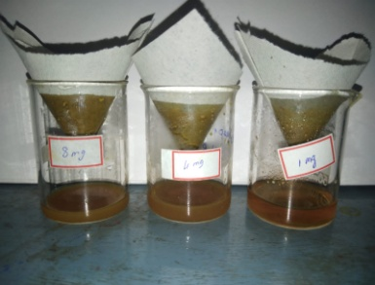

**Figure 2: C-Tea extract**

**MICRONUCLEUS ASSAY**

Cut the tail of the fish and place the fish carefully into the tube with the wounded end facing the tube downwards. Add EDTA/Heparin solution in Eppendorf tube. Centrifuge the tube at 6000 pm for 10 minutes. Discard the fish and collect the remaining turbid sample in the Eppendorf tube. Place a small drop of sample over the slide and smear it over the slide using another slide. Air Dry for 24 hours. Place the slide in a coupling jar containing Methanol for 10 minutes. Place the slide in a Coupling jar filled with Giemsa stain for 5 mins and air dry. View under a microscope.

**CELL VIABILITY ASSAY**

Take 1g sample with 9ml DPBS is added in a Pestel and Mortar and homogenized. The extract is filtered using Muslin cloth. Collect the filtered liquid in ¾” of Eppendorf tube and Centrifuge at 10000 pm for 2 – 3 minutes. Leave the supernatant and take the pellet completely. Add DPBS:Pellet (1:1) ratio in the Eppendorf tube. Centrifuge at 5000pm for 2 minutes. Take 1 drop of solution in an Eppendorf tube and add an equal volume of Tryphan blue solution. Add the mixture to a slide and place a cover slip. View under microscope and observe viable cells.

**LIPID PEROXIDASE ASSAY**

Take 1g of fish and homogenize with 10 ml ice-cold KCL solutions. Take 1ml of the homogenized solution and add 1ml of TBA solution. Place the solution in a boiling tube and boil at 60°C for 20 minutes. After cooling observe at 540nm using UV-Vis Spectrophotometer. Take the graph.

Malondialdehyde (MDA), a byproduct of the breakdown of lipid peroxides, and thiobarbituric acid (TBA) produce a colored complex, which is the cause of the color changes in the lipid peroxide test. When TBA and MDA interact, they produce a spectrophotometrically measurable pink or red chromophore.The amount of MDA in the sample, which is an indicator of the degree of lipid peroxidation, directly relates to the color's intensity

**HISTOPATHOLOGY**

Zebrafish liver is dissected to study the structural- Architecture of its liver. The fish have been given hibiscus at the following concentrations for 30 days Inl2m1, 2.5ml. The fish tissues, such as the gills, liver, muscle, and intestine, have been eliminated and preserved for histological investigation as soon as the therapy was once completed.

**Principle:**

Microtome (or micro method) is a specialized self-discipline of biology that research animal tissues. The Micro method is one of the techniques for getting ready slides containing animal tissues for microscopic examination. Because animal tissues are sectioned and investigated for shape after staining with the use of a microscope, micro techniques are additionally recognized as histological procedures. Microtechnological know-how employs the following methods:

**Preparation of the fixative**: 75 ml saturated (aqueous) picric acid and 25 ml glucaric acid had been diluted in distilled water to make the Bouins fluid. After then, used to be fined. Fixing the animal tissues (fixation is the maintenance of elements to continue the tissue lifestyles like condition). In physiological saline solution, the managed and therapy fishes had been dissected. The gills, liver, muscle, and gut have been cleaned in distilled water and positioned in a tiny specimen tube (or) glass vial with 10 ml of Bouins fixative. For 24 hours, the tissue was once immersed in the fixative.

**Washing:** After the tissue has been fixed, the tube containing the tissue has to be crammed with 70% alcohol. Pour the fixative into a specific specimen tube. By setting the tissues in the tube, they have to be cleaned with 70% alcohol Dehydration. Tissues are dehydrated in a sequence with a number of concentrations of alcohol and absolute alcohol, and then transferred to a glass vial containing 10 to 15 ml of methyl benzoate with the usage of clarifying agents.

**Cleaning:** The tissues are illuminated by way of light, permitting us to see the tissue's transparency. It is crucial to preserve the tissue on the cleaning agent till it sinks. The dehydrated tissue embedding phenomenon of embedding is the technique of normalizing tissue for microscopic leam about the usage of a microtome. I gather the quality paraffin bits and location them in my bedding tub cup.

**Sectioning:** For paper size, the paraffin wax blocks containing the tissues have been sectioned with the usage of a microtome blade. After that, the surplus wax is removed.

**Cutting**: The microtome is used to reduce the blocks.

**Staining:** The first stage in staining is to de-paraffinize the slides with xylene for 30 to 60 minutes. The de-paraffinized slides are cleaned with a lower-grade ethyl alcohol series. The slides are no longer dried throughout this process. The slides have been then stained for two to 5 minutes with a hematoxylin-eosin staining solution, which grew to become reddish brown earlier than being destined with a drop of distilled water and a drop of HCL. The slides are dehydrated with a sequence of alcohol as soon as they have been destined. Finally**,** the aspects had been washed with solute alcohol for 5 to 10 minutes.

**RESULT AND DISCUSSION**

**MICRONUCLEUS ASSAY**

The micronucleus was observed under the microscope. There is no blabbing had been observed with C-Tea.

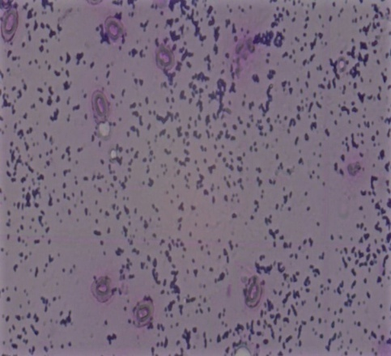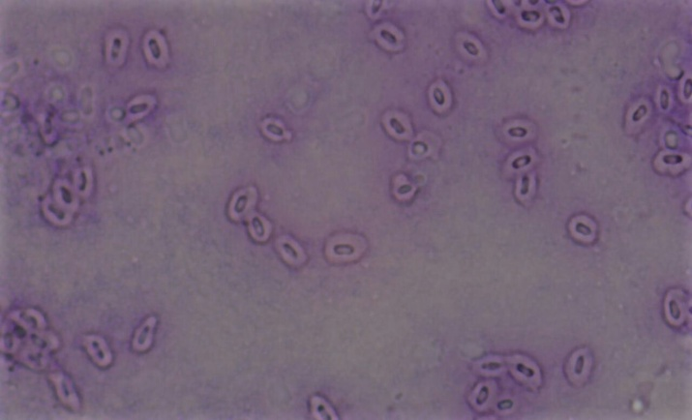

**(a) Control (b) 1mg**

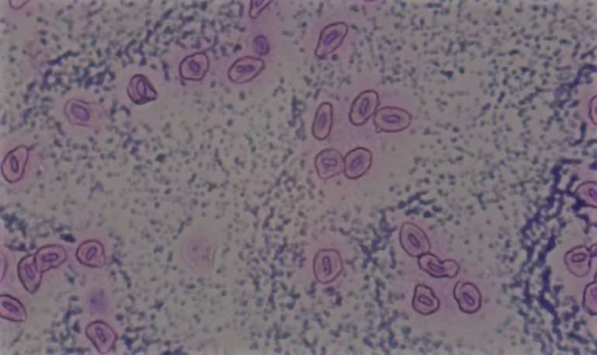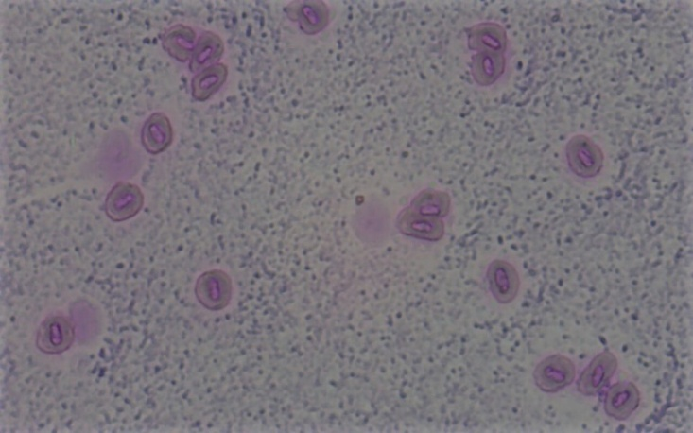

**(c) 4mg (d) 8mg**

**Figure 3: Micronucleus test on the 15th day**

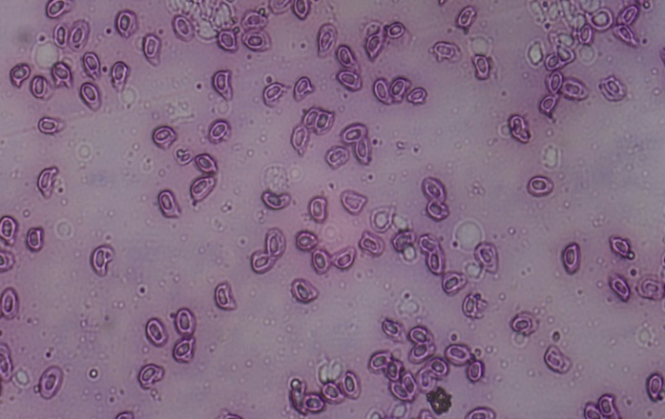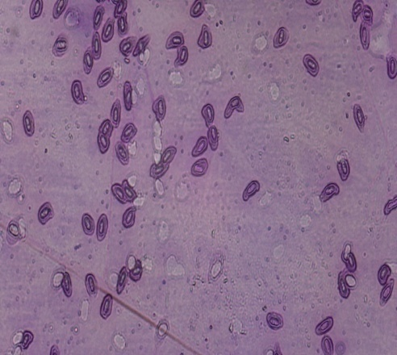

(a) control (b) 1mg conc.

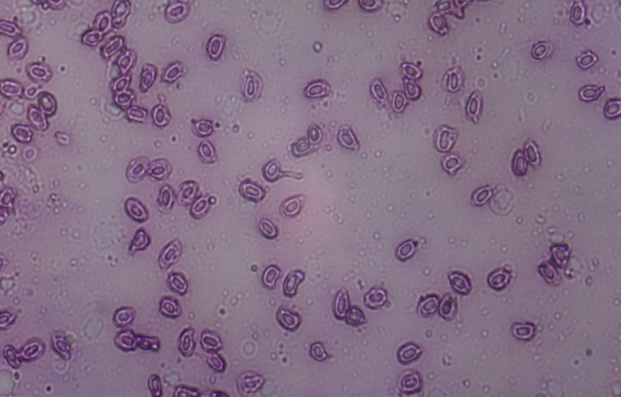

(c) 4mg conc.(d) 8mg conc.

**Figure 4: Micronucleus test on the 30th day**

At the end of the 30th day there is no blabbing has been observed in the micronucleus. This test shows that C-Tea does not have any harmful effect on the micronucleus of zebrafish

**CELL VIABILITY TEST**

The cell viability test was conducted to determine the potential activity of c-tea. Zebrafish has exposed to C-tea concentrations 1mg, 4mg, and 8mg for 30 days. The cell viability test using PBS and trypan blue was used to determine thepercentage of viable cells in each treatment group.

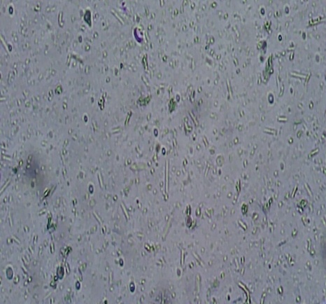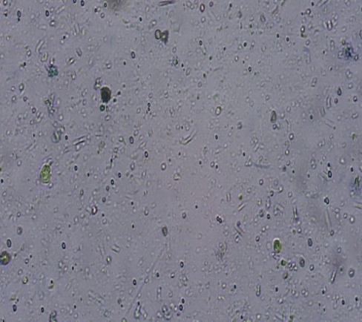

(a) control (b) 1 mg conc.

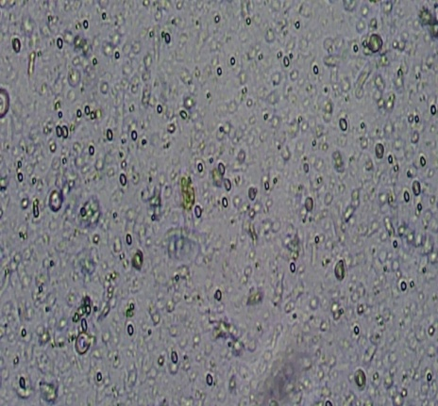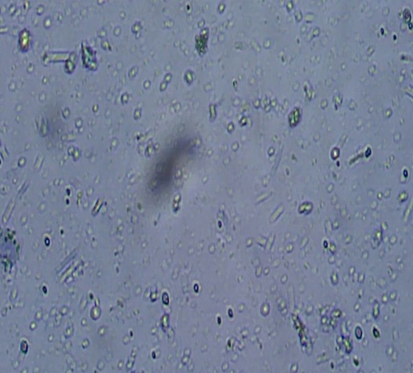

(c) 4mg conc.(d) 8mg conc.

**Figure 5: Cell viability test on the 15th day**

The slide was viewed the under microscope. The average cell viability had calculated using the formula

Dead cells in fish

× Total number of cells

Viable cells in fish

Exposure of zebrafish cells to C-tea after the 15th day resulted in a significant decrease of a small amount incell viability compared to the control group. The percentage of dead cells was 14% in 1mg, 16% in 4mg, and 9% in 8mg concentration

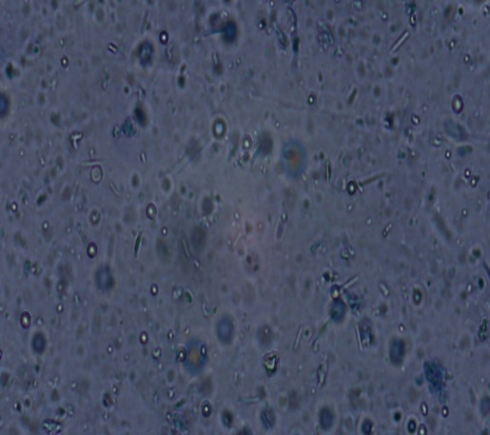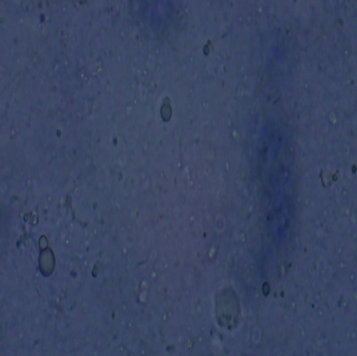

(a) Control conc.(b) 1mg conc.

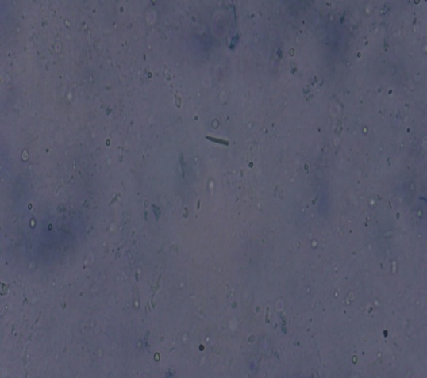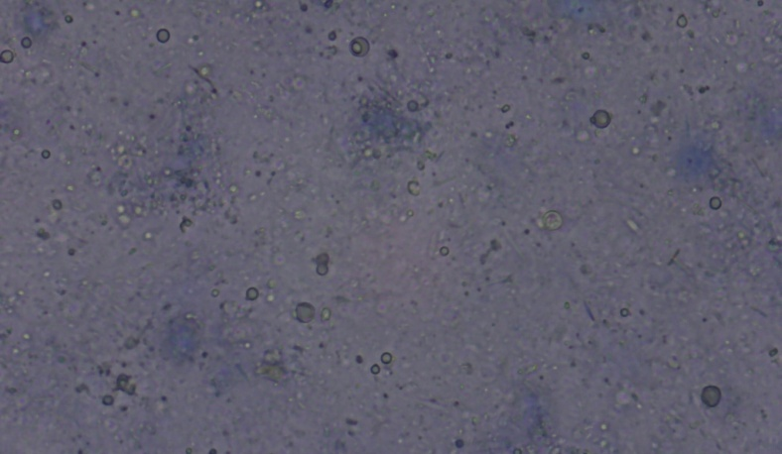

(c) 4mg conc. (d) 8mg conc.

**Figure 6: Cell viability test on the 30th day**

Exposure of zebrafish cells to C-tea after the 30th day resulted in a significant decrease of a small amount in cell viability compared to the control group. The percentage of dead cells was 19% in 1mg, 36% in 4 mg, and 15% in 8mg concentration.

**LIPID PEROXIDASE TEST**

The fluid in the boiling tube changes color to light pink. The presence of the molecule melan-di-aldehyde is indicated by this alteration. This demonstrates that the C-tea is not harmful.

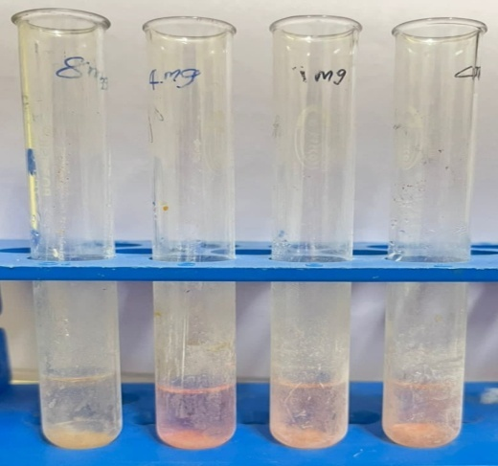

**Figure 6: Homogenized solution**

**Figure 8: Graphical representation of lipid peroxidase test**

Compared to 1mg, 4mg, and 8 mg concentrations, a high concentration 8 mg shows the high OD value in the test on the 15th and 30th days.

**HISTOPATHOLOGY**

**Test on the 15th day**

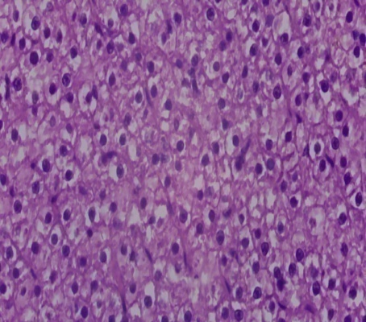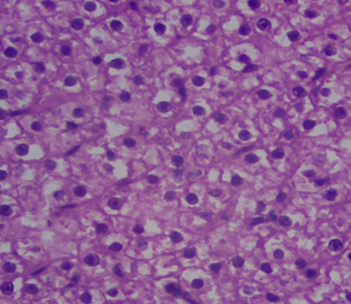

(a) Control (b) 1mg conc.

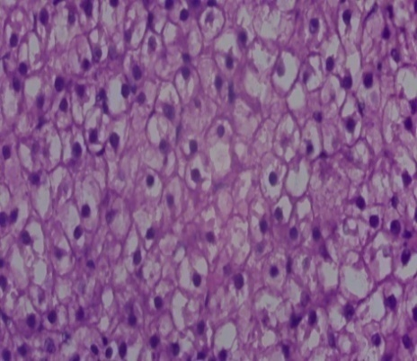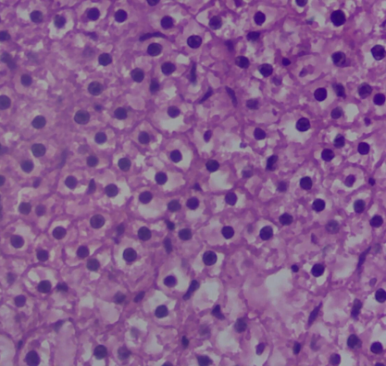

(c) 4 mg conc. (d) 8mg conc.

**Figure 9: Histopathology on the 15thday**

**Test on the 30th day**

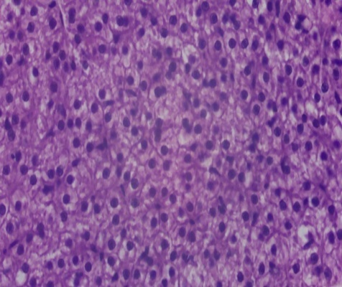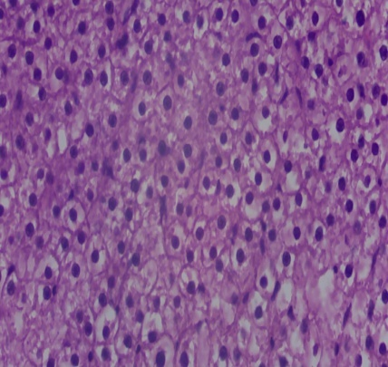

(a) Control (b) 1mg conc.

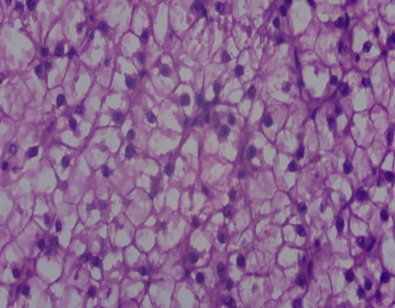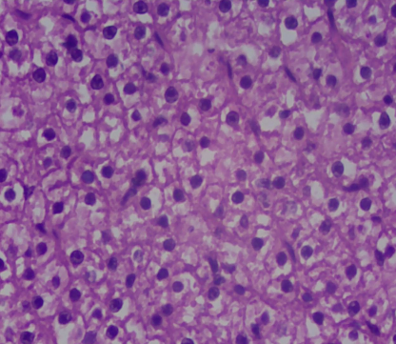

(c) 4mg conc. (d) 8 mg conc.

**Figure 10: Histopathology on the 30th day**

The slides were observed under the microscope. The Histological tissue stain was found to have less damage or changes.

**SUMMARY AND CONCLUSION**

This study focuses on the preparation of C-Tea and analyses the toxicological effects of the prepared herbal tea. The C-Tea was prepared using 15 different types of herbs for each of their medicinal benefits. The study aims to evaluate the ability of the C-Tea extract to reduce stress and menstrual cramps and to find the toxicological effects of the product using zebrafish as an animal model. This study involved the extraction of C-Tea in different concentrations (1mg, 4mg, and 8 mg). The extract was then mixed with fish food and fed to the zebrafish for 30 days to analyze the toxicological effects of the product. The toxicological studies were conducted on the 15th and 30th days. The study showed that the Product C-Tea does not have any harmful effect on the zebrafish in each concentration (1 mg, 4 mg, and 8 mg) in the 30days of treatment. The study highlights the potential of C-Tea and it can be used as a natural remedy to reduce stress and pain during menstruation. From this work, I conclude high concentration 8mg shows the best result. Less cell death in cell viability was observed along with no liver damage. In the future further studies had to done to be develop the C-tea as a herbal remedy to treat stress and menstrual cramps.

**REFERENCE**

1. Alammar, N., Wang, L., Saberi, B., Nanavati, J., Holtmann, G., Shinohara, R. T., & Mullin, G. E. (2019). The impact of peppermint oil on the irritable bowel syndrome: a meta-analysis of the pooled clinical data. BMC complementary and alternative medicine, 19, 1-10.
2. Bahmani, M., Eftekhari, Z., Jelodari, M., Saki, K., Abdollahi, R., Majlesi, M., ... & Rasouli, S. (2015). Effect of Iranian herbal medicines in dysmenorrhea phytotherapy. J Chem Pharm Res, 7(2), 519-26
3. Bazrafshan, M. R., Jokar, M., Shokrpour, N., & Delam, H. (2020). The effect of lavender herbal tea on the anxiety and depression of the elderly: A randomized clinical trial. Complementary therapies in medicine, 50, 102393.
4. Chakraborty, C., Hsu, C. H., Wen, Z. H., Lin, C. S., & Agoramoorthy, G. (2009). Zebrafish: a complete animal model for in vivo drug discovery and development. Current drug metabolism, 10(2), 116-124.
5. Choi, T. Y., Choi, T. I., Lee, Y. R., Choe, S. K., & Kim, C. H. (2021). Zebrafish as an animal model for biomedical research. Experimental & Molecular Medicine, 53(3), 310-317.
6. Dhanik, J., Arya, N., & Nand, V. (2017). A review on Zingiber officinale. Journal of Pharmacognosy and phytochemistry, 6(3), 174-184.
7. Hwang, P. P., & Chou, M. Y. (2013). Zebrafish as an animal model to study ion homeostasis. Pflügers Archiv-European Journal of Physiology, 465, 1233-1247.
8. Jin, L., Li, X. B., Tian, D. Q., Fang, X. P., Yu, Y. M., Zhu, H. Q., ... & Li, M. (2016). Antioxidant properties and color parameters of herbal teas in China. Industrial Crops and Products, 87, 198-209.
9. Kara, D. (2009). Evaluation of trace metal concentrations in some herbs and herbal teas by principal component analysis. Food Chemistry, 114(1), 347-354.
10. Kinki, A. B. (2021). A review on the production and uses of herbal teas. Journal of Nutrition and Food Processing, 4(2), 1-3.
11. Luczaj, W., & Skrzydlewska, E. (2005). Antioxidative properties of black tea. Preventive medicine, 40(6), 910-918.
12. Mandiwana, K. L., Panichev, N., & Panicheva, S. (2011). Determination of chromium (VI) in black, green and herbal teas. Food Chemistry, 129(4), 1839-1843.
13. Mollabashi, E. N., Ziaie, T., Bekhradi, R., & Khalesi, Z. B. (2020). Do Chamomile effect on duration, amount of bleeding, and interval of menstrual cycles?. Journal of Pharmacopuncture, 23(1), 25.
14. Naveed, S., Ghayas, S., & Hameed, A. (2015). Hormonal imbalance and its causes in young females. Journal of Innovations in Pharmaceuticals and Biological Sciences, 2(1), 12-13.
15. Oh, J., Jo, H., Cho, A. R., Kim, S. J., & Han, J. (2013). Antioxidant and antimicrobial activities of various leafy herbal teas. Food control, 31(2), 403-409.
16. Oh, J., Jo, H., Cho, A. R., Kim, S. J., & Han, J. (2013). Antioxidant and antimicrobial activities of various leafy herbal teas. Food control, 31(2), 403-409.
17. Ohishi, T., Goto, S., Monira, P., Isemura, M., & Nakamura, Y. (2016). Anti-inflammatory action of green tea. Anti-Inflammatory & Anti-Allergy Agents in Medicinal Chemistry (Formerly Current Medicinal Chemistry-Anti-Inflammatory and Anti-Allergy Agents), 15(2), 74-90.
18. Pan, S. Y., Nie, Q., Tai, H. C., Song, X. L., Tong, Y. F., Zhang, L. J. F., ... & Liang, C. (2022). Tea and tea drinking: China’s outstanding contributions to the mankind. Chinese Medicine, 17(1), 1-40.
19. Prasanth, M. I., Sivamaruthi, B. S., Chaiyasut, C., & Tencomnao, T. (2019). A review of the role of green tea (Camellia sinensis) in antiphotoaging, stress resistance, neuroprotection, and autophagy. Nutrients, 11(2), 474.
20. Rad, H. A., Basirat, Z., Bakouei, F., Moghadamnia, A. A., Khafri, S., Kotenaei, Z. F., ... & Kazemi, S. (2018). Effect of Ginger and Novafen on menstrual pain: A cross-over trial. Taiwanese Journal of Obstetrics and Gynecology, 57(6), 806-809.
21. Ravikumar, C. (2014). Review on herbal teas. Journal of Pharmaceutical Sciences and Research, 6(5), 236.
22. Speisky Cosoy, H., Rocco, C., Carrasco, C., Lissi Gervaso, E. A., & López Alarcón, C. (2006). Antioxidant screening of medicinal herbal teas.
23. Speisky, H., Rocco, C., Carrasco, C., Lissi, E. A., & López‐Alarcón, C. (2006). Antioxidant screening of medicinal herbal teas. Phytotherapy Research: An International Journal Devoted to Pharmacological and Toxicological Evaluation of Natural Product Derivatives, 20(6), 462-467.
24. Stewart, A., Wong, K., Cachat, J., Gaikwad, S., Kyzar, E., Wu, N., ... & Kalueff, A. V. (2011). Zebrafish models to study drug abuse-related phenotypes
25. Yassin, S. A. (2012). Herbal remedy used by rural adolescent girls with menstrual disorders. Journal of American Science, 8(1), 467-473.
26. Zhang, X., Zhang, R., Chen, D., Huang, R., Tian, Y., Zhang, P., & Zhang, J. (2019). Association of tea drinking and dysmenorrhoea among reproductive-age women in Shanghai, China (2013–2015): a cross-sectional study. BMJ open, 9(4), e026643.
27. Zhao, X., Zhou, M., Deng, Y., Guo, C., Liao, L., He, L., ... & Li, Y. (2022). Functional Teas from Penthorum chinense Pursh Alleviates Ethanol-Induced Hepatic Oxidative Stress and Autophagy Impairment in Zebrafish via Modulating the AMPK/p62/Nrf2/mTOR Signaling Axis. Plant Foods for Human Nutrition, 77(4), 514-520.