**OPTIMIZATION OF MYCELIA GROWTH AND IMMOBILIZATION OF GANODERMA LUCIDUM CELLS FOR ENHANCED** **BIOTECHNOLOGICAL APPLICATIONS**

**Rohit Rawat1, Nidhi Tripathi2, Rajeshwari Saha3, Monisha Budhani4, Tanu Rajput5,**

**Thirani Budhathoki6, Priyanshi Chauhan7**

1HARI Lifesciences, Bhopal

2Department of Biotechnology, Career College, Bhopal

3, 4, 5, 6, 7Research Student, Department of Biotechnology, Career College, Bhopal

**ABSTRACT**

*Ganoderma lucidum* is a medicinal species that is classified as a white rot fungus that may produce extracellular ligninolytic enzymes. Ganoderma lucidum is a pharmacologically diverse basidiomycete that degrades wood. Due to the mushroom's extreme rarity in the wild, fruiting bodies have been artificially cultivated on wood logs and sawdust in plastic bags or bottles. It has also been studied that *G. lucidum* mycelia can be biotechnologically cultivated in bioreactors on solid substrates and in liquid media through the submerged cultivation of fungal biomass. The aim of this study was to optimize the mycelial growth of Ganoderma lucidum inoculated on a substrate (wheat) with liquid and solid media. The liquid media inoculated substrate showed enhanced growth and covered 95% of the substrate. While solid culture showed only 50% of the mycelium cover. An interesting finding is the fact that mycelium grown on liquid medium and used as inoculum for substrate provided a 3-fold increase in mycelium coverage in the substrate, and cells from liquid broth were immobilized by the entrapment method to increase its application in various fields.

**Keywords:** *G. lucidum*, mushroom, mycelium, substrate, fungus

**1. INTRODUCTION**

Asian herbal medicine, or *G. lucidum*, is well-known and possesses a wide variety of uses. G. lucidum is consumed widely across the world, and there are many dietary supplements that contain this plant as an active ingredient that are patented and sold commercially. Capsules, lotions, hair tonics, syrups, and capsules containing isolated ingredients and extracts in various formulations are sold globally. In China, Japan, and other Asian nations, Ganoderma lucidum, an oriental fungus, has long been used to extend life and improve health. The Ganodermataceae family is known as reishi or mannentake in Japan, while *G. lucidum* is known as lingzhi in China. (Donk M. A. ,1964). An oriental fungus called *G. lucidum* has long been utilized to prolong life and enhance health in China, Japan, and other Asian countries. China refers to *G. lucidum* as lingzhi, and Japan refers to the Ganodermataceae family as reishi or mannentake. The most physiological and health-promoting properties of *G. lucidum*, including anti-tumor activities, have been shown by *G. lucidum* polysaccharide (GLPS), one of the main bioactive components of the plant. (Zjawiony JK.,2004, Zhu X, et.al.,2007) immune-regulating (Zhu X et al.,2007, Lin ZB et al.,2004) antioxidant (Zhong W et al.,2013, Yang Q et al.,2010, Zhang TX et al.,2011, Yan Y et al.,2009) hypoglycaemic,and other activities.

There are many mushroom nutraceutical components in *G. lucidum* that may provide medicinal benefits. (Chang et al.,1996). Interestingly, over the past thirty years, more than 150 triterpenes have been discovered. (Kim HW et al., 2002; Fang et al., 2002) and more than 50 polysaccharides that inhibit cancer have been identified; these are thought to be special substances found in this mushroom. As a result, distinct pharmacological actions are anticipated to be produced by *G. lucidum* products containing distinct triterpenes and polysaccharides, or combinations of these two categories. (Leung et al, 2002). Anticancer medications, hormone derivatives, antiviral agent preparation, and antioxidant preparations are the main uses in medicine (Rocasalbas, G. et al., 2013). The fungus laccase also catalyses the oxidative binding processes. The growth of ganoderma involves a number of stages, including mycelium, primordium, young and mature fruiting bodies, and so forth. Each stage has its own requirements in terms of growth parameters and nutritional elements, such as temperature, light, relative humidity, and oxygen supply at different stages of development. To inoculate the substrate, two different forms of inoculums are available: liquid and solid. The liquid inoculum is made in potato dextrose broth, sometimes referred to as nutritional broth, and the solid inoculum is made in potato dextrose agar. In this study, *G. lucidum* was monitored for its mycelium coverage when the substrate (wheat) was inoculated with liquid and solid media, and then the cells were entrapped with the best results by the immobilization technique. Enzymes or whole cells can function as immobilized biocatalysts (Kawaguti et al. 2006). Animals, plants, and a variety of microbes all include enzymes, which are protein catalysts. The employment of enzymes expands back thousands of years, when they were mostly employed in the production of numerous foods, including yogurt, cheese, wine, beer, sourdough, and vinegar, in addition to being utilized in the production of everyday goods like linen, leather, textiles, etc. (Homaei,A. 2015) Enzyme immobilization refers to the process of limiting an enzyme to a phase (support or matrix) that is distinct from that of substrates and products. Typically, carrier matrices consist of inorganic minerals and inert polymers. An optimal matrix should have the following qualities in addition to being reasonably priced: inertness, physical strength, stability, regenerability, capacity to boost enzyme specificity/activity and decrease product inhibition, nonspecific adsorption, and microbial contamination (Singh [2009](https://link.springer.com/article/10.1007/s13205-012-0071-7#ref-CR99)). Continuous economic activities, automation, a high investment/capacity ratio, and the recovery of purer product are the results of immobilization (D'Souza 1998). There are numerous techniques for immobilization, and a number of variables affect how well immobilized enzyme’s function. Various immobilization strategies are employed, including adsorption, covalent binding, affinity immobilization, entrapment, and encapsulation. Materials used to fabricate immobilization supports include synthetic polymers, inorganic materials, and natural polymers such as alginate, chitosan and chitin, collagen, carrageenan, gelatin, cellulose, starch, pectin, and sephrose. Nevertheless, the short shelf life, low stability, and high susceptibility to various process settings and conditions of cells limit their expected useful features and the numerous uses of these cells. (Razzaghi, M.et al.,2018) Immobilizing strategies could be used to reduce or eliminate a lot of the drawbacks (Liu, D. M. et al., 2020). Immobilization techniques for preserving cells and/or enzymes have several applications in biomedical research, agriculture, and other domains.

**2.MATERIALS AND METHODS**

**2.1 Strain used**

*Ganoderma lucidum* strain was purchased from DMR Solan and cultured in potato dextrose agar (PDA) (Hi Media, Mumbai, India) plates and slants. The plates and slants were kept at 4 °C for the purpose of research.

**2.2** **Mass culture**

**2.2.1. Culture in Potato dextrose agar (PDA)**

PDA plates were inoculated with mycelial culture purchased from DMR Solan and incubated at 21°C for 14 days to obtain fresh inoculums, as well as for one month for extraction. PDA plates were maintained at 4°C for long-term storage. The growth optimization of the culture was carried out for optimal growth and further experiments.

**2.2.2. Culture in potato dextrose broth/Nutrient broth (PDB)**

PDB was prepared in the laboratory by adding 0.97 g to 100 ml of distillation water and autoclaving it at 121 °C to 15 psi pressure for 30 minutes. The sterile media were then inoculated with 2-3 pieces of fresh mycelia taken from a potato dextrose agar (PDA) plate prepared before from the purchased culture and cultured in a shaking incubator (120 rpm) at 21°C for 14 days.

**2.3 substrate preparation for quantitative analysis**

**2.3.1. Substrate preparation**

The substrate used for the analysis was wheat; it was washed and boiled till the wheat was 75% cooked. After that, the excess water was removed, and chemicals like CaCO3 and MgSO4 were mixed to maintain the pH and kept for autoclaving.

**2.3.2. Substrate inoculation with solid culture (PDA) and liquid culture (PDB)**

As the substrate was autoclaved and cooled properly, it was inoculated with the solid culture, i.e., 1 cm cube in each jar, and 5 ml of liquid culture in each jar. After inoculation, jars were kept in incubation for 10 days at 21 °C.

**2.4. Immobilization of fungal cells (*G. lucidum*)**

As a result, the liquid culture cells were immobilized by the entrapment technique. For that, sodium alginate was prepared by mixing 0.8 grams in 10 ml of distilled water and calcium chloride was prepared by mixing 1.8 grams in 20 ml of distilled water. 20 ml of liquid culture was mixed with a preprepared sodium alginate solution, and in autoclaved petri, the cacl3 solution was poured. By sterile syringe, the premixed liquid culture and sodium alginate solution were poured drop-wise in cacl3, and the entrapped beads were formed.

**3. RESULT AND DISCUSSION**

*Ganoderma lucidum* cells have yielded promising results for enhanced biotechnological applications. Through systematic experimentation and careful manipulation of culture conditions, the study has achieved notable improvements in mycelial growth. The comparison between solid and liquid cultures indicates that the liquid culture exhibits superior outcomes in terms of promoting enhanced mycelia growth. Liquid culture has given 95% mycelial coverage within 10 days, whereas solid culture has only covered 50% of the substrate. This finding suggests that liquid culture conditions are more conducive to the proliferation of *Ganoderma lucidum* mycelia. This result interpreted that liquid culture spread evenly in the substrate, hence showing faster mycelial growth as compared to solid culture and also minimizing the chances of substrate contamination as the solid culture sticks to a place and the mycelium takes time to cover the substrate.

**Figure 1: Jar 1 showing mycelial coverage inoculated with solid inoculum and jar 2 showing mycelial coverage inoculated with liquid inoculum**

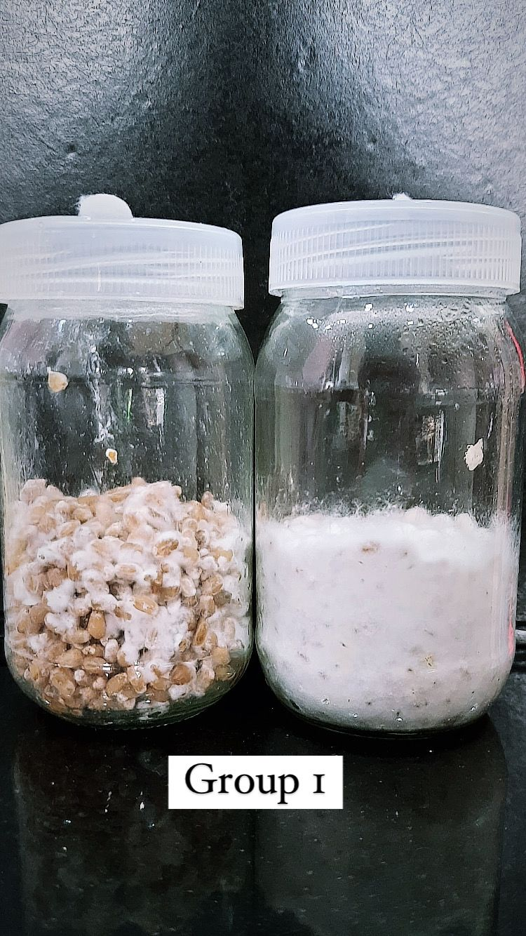

**Table 1. percentage of mycelial covered in 10 days by solid and liquid culture**

|  |  |  |  |
| --- | --- | --- | --- |
| S.no. | Type of culture | Days | Percentage |
| 1. | Solid culture (PDA) | 10 days | 50% |
| 2. | Liquid culture (PDB) | 10 days | 95% |

**Figure 1: Graph percentage of mycelial covered in 10 days by solid and liquid culture**

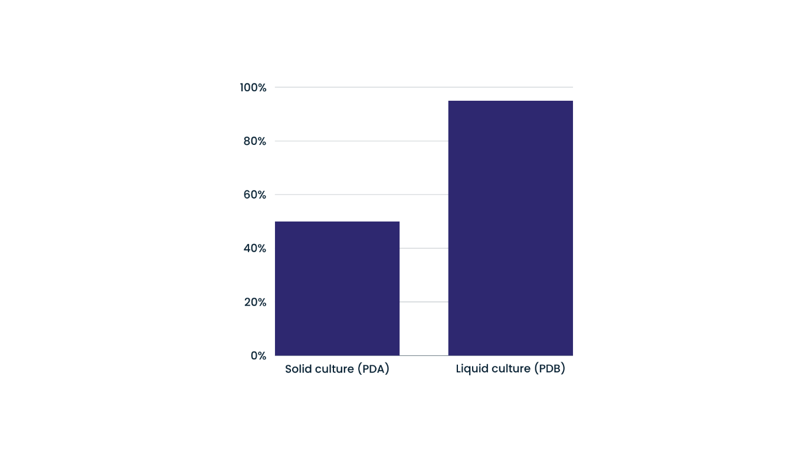Furthermore, the immobilization of *Ganoderma lucidum* cells has been successfully implemented, showcasing advancements in cell stability and potential applications for biotechnological purposes. The immobilization process has demonstrated its effectiveness in enhancing the overall performance and viability of *Ganoderma lucidum* cells. These results contribute valuable insights into optimizing the cultivation of *Ganoderma lucidum* for biotechnological applications, offering a foundation for further research and development in harnessing the biotechnological potential of this fungus. The findings hold significance for industries exploring the production of bioactive compounds, pharmaceuticals, or other valuable metabolites derived from *Ganoderma lucidum* in a more efficient and controlled manner.

**4.CONCLUSION**

The value of *Ganoderma lucidum* stems from its many health advantages, which include immune system support and possible anticancer effects. The fungus continues to show potential for enhancing health outcomes and advancing biotechnology and medicine as scientific understanding grows. In addition to its therapeutic qualities, *Ganoderma lucidum* is useful for its biotechnological uses. Its production for a range of industrial uses, such as medicines and nutraceuticals, can be improved by optimizing its mycelia development and immobilization. This research has suggested that the mycelial coverage is rapid in liquid culture which means that enhanced growth of the mycelium can be achieved by liquid culture which will indirectly help in rapid growth of *Ganoderma lucidum*. The immobilization of fungal cells is a crucial technique in biotechnology that involves confining these microorganisms within a supportive matrix or carrier. This process enhances the stability and longevity of fungal cells while maintaining their metabolic activity, offering numerous advantages for various biotechnological applications. Immobilized fungal cells find extensive use in bioremediation, where they play a pivotal role in degrading pollutants and contaminants in soil and water. Moreover, the immobilization technique is employed in the production of bioactive compounds, enzymes, and pharmaceuticals. This method allows for continuous and controlled production processes, improving efficiency and reducing the overall cost of production. The versatility of immobilized fungal cells extends to applications in food and beverage industries, contributing to the fermentation processes crucial for the production of diverse products. Overall, the immobilization of fungal cells stands as a cornerstone in biotechnology, offering sustainable and efficient solutions for a range of industrial processes with potential benefits for environmental and economic sustainability.

**5. REFERENCE**

1. Chang ST, Buswell JA: Mushroom nutriceuticals. World Journal of Microbiology & Biotechnology, 1996;12(5):473-476.
2. D’Souza SF (1998) Immobilized enzymes in bioprocess. Curr Sci 77:69–79
3. Donk M. A. A conspectus of the families of Aphyllophorales. Persoonia. 1964;3:19–24.
4. Fang QH, Zhong JJ: Submerged fermentation of higher fungus Ganoderma lucidum for production of valuable bioactive metabolites-ganoderic acid and polysaccharides. Biochemical Engineering Journal, 2002; 10: 61-65.
5. Homaei, A. Enzyme immobilization and its application in the food industry. *Adv. Food. Biotechnol.* **2015**, *90*, 145– 164,  DOI: 10.1002/9781118864463.ch09
6. Kawaguti HY, Manrich E, Sato HH (2006) Production of isomaltulose using *Erwinia* sp. D12 cells: culture medium optimization and cell immobilization in alginate. Biochem Eng J 29:270–277
7. Kim HW, Kim BK: Recent advances on the biologically active triterpenoids of Ganoderma lucidum. In: Ganoderma: Genetics, Chemistry, Pharmacology and Therapeutics. ZB Lin (Ed), Beijing Medical University Press, Beijing, 2002, pp: 10-19
8. Leung SWS, Yeung KY, Ricky YLS, Man YK: Lingzhi (Ganoderma) research the past, present and future perspectives. In: Ganoderma: Genetics, Chemistry, Pharmacology and Therapeutics. ZB Lin (Ed), Beijing medical University Press, Beijing 2002; pp:1-9.
9. Lin ZB, Zhang HN. Anti-tumor and immunoregulatory activities ofGanoderma lucidumand its possible mechanisms.Acta Pharmacol Sin.2004;25:1387-1395.
10. Liu, D. M.; Dong, C. Recent advances in nano-carrier immobilized enzymes and their applications. *Process. Biochem.* **2020**, *92*, 464– 475,  DOI: 10.1016/j.procbio.2020.02.005
11. Razzaghi, M.; Homaei, A.; Mosaddegh, E. *Protease* stabilizing process of ZnS nanoparticles. *Int. J. Biol. Macromol.* **2018**, *112*, 509– 515,  DOI: 10.1016/j.ijbiomac.2018.01.173
12. Rocasalbas, G. *et al.* Laccase-assisted formation of bioactive chitosan/gelatin hydrogel stabilized with plant polyphenols. *Carbohydr. Polym.* **92**(2), 989–996 (2013).
13. Singh BD (2009) Biotechnology expanding horizons. Kalyani, India
14. Yan Y, Zhang H, Nie SP, et al. Physico-chemical characteristics andantioxidant activity of polysaccharide fromGanoderma atrumfruit-body.Food Sci. 2009;30:55-60
15. Yang Q, Wang S, Xie Y, et al. HPLC analysis ofGanoderma lucidumpolysaccharides and its effect on antioxidant enzymes activity andBax, Bcl-2 expression.Int J Biol Macromol. 2010;46:167-172.
16. Zhang TX, Liu HB, Zhang WZ, et al. Study on enzymatic extractionprocess of polysaccharide fromGanoderma lucidumand its oxidationresistance.J Anhui Agri. 2011;39:4496-4498.
17. Zhong W, Liu N, Xie Y, et al. Antioxidant and anti-aging activities ofmycelial polysaccharides fromLepista sordida.Int J Biol Macromol.2013;60:355-359.
18. Zhu X, Chen A, Lin Z.Ganoderma lucidumpolysaccharides enhancethe function of immunological effector cells in immunosuppressedmice.J Ethnopharmaco. 2007;111:219-226.
19. Zjawiony JK. Biologically active compounds from Aphyllophorales(Polypore) fungi.J Nat Prod. 2004;67:300-310.