**Smart Traffic Management System Using AIML**

MRS.R.Prabha Monika R

Department of ECE Department of ECE

SNS College of Technology,Coimbatore,India. SNS College of Technology,Coimbatore,India

[Prabha.r.ece@snsct.org](mailto:Prabha.r.ece@snsct.org) [monika.r.ece.2020@snsct.org](mailto:monika.r.ece.2020@snsct.org)

Manoj kumar N Joseph Immanuel B

Department of ECE Department of ECE

SNS College of Technology,Coimbatore,India. SNS College Technology,Coimbatore,India

[manoj.n.ece.2020@snsct.org](mailto:manoj.n.ece.2020@snsct.org) [Joseph.b.ece.2020@snsct.org](mailto:Joseph.b.ece.2020@snsct.org)

Kevin A

Department of ECE

SNS College of Technology,Coimbatore,India

[kevin.a.ece.2020@snsct.org](mailto:kevin.a.ece.2020@snsct.org)

***Abstract*-** ***To solve the growing problems of urban traffic congestion and inefficiency, the Smart Traffic Management System (STMS) is a creative solution that makes use of artificial intelligence (AI) and machine learning (ML), specifically employing AIML. The number of vehicles on the road and urbanization are growing at an exponential rate, making traditional traffic management systems ineffective in improving transportation efficiency, easing congestion, and managing traffic flow. This AIML -based system's intelligent decision-making features are intended to revolutionize traffic management. In this paper, traffic control system which can easily keep traffic in control using image processing techniques is presented. Count of vehicles in these images is calculated using image processing tools in Matlab and different timings are allocated according to the count along with a green signal for vehicles to pass. In the proposed prototype, the green and red signals are represented using LEDs and the decrementing timer for the green signal is represented by a seven segment display.***

# *Keywords-Urban, exponential, efficiency, revolutionize, patterns, sensor, authority, detect.*

# I. Introduction:

# In an increasingly urbanized world, the management of traffic and transportation systems has emerged as a critical challenge. The relentless growth of urban populations, coupled with the proliferation of vehicles has resulted in ever-worsening traffic congestion. Traditional traffic management systems, which rely on fixed timing of traffic signals and lack adaptability, are often ill-equipped to address the complexities of modern urban traffic. The aim of this introduction is to provide an overview of the significance of Smart Traffic Management Systems using AIML, highlighting their potential to reshape urban mobility and improve the quality of life in cities. It can dynamically routes to drivers, and provide valuable insights to traffic control insights to traffic control.

**II. Litreature Review**

CHENG-JIAN LIN et al [1] to solve traffic problems, road data collection is important. Therefore, in this paper, we develop an intelligent traffic-monitoring system based on you only look once (YOLO) and a convolutional fuzzy neural network (CFNN), which record traffic volume, and vehicle type information from the road.

Guy M. Lingani et al [2] as urban communities’ populace size raises, and streets getting clogged, government offices like Department of Transportation (DOT) through the National Highway Traffic Safety Administration (NHTSA) are in squeezing need to consummate their administration frameworks with new productive advances. The test is to expect on previously unheard of issues, in their work to save lives and execute practical financially smart the board frameworks.

Volodymyr Miz et al [3] This work is intended to portray a mental traffic the executives’ framework (CTMS) in view of the IOT approach. Media transmission innovations, which can be utilized for the framework improvement and organization, are broke down. Brilliant traffic signal incorporation is proposed as a substitution of the current traffic signals

Md. Rokebul Islam et al [4] Since the quantity of vehicles is expanding [4] step by step, gridlocks are turning into a typical situation in huge urban communities like Dhaka. In this way it makes a requirement for a productive traffic the board framework. This paper proposes to carry out a shrewd traffic signal framework which depends on the estimation of traffic thickness utilizing constant video handling strategy.

Sabeen Javaid,et al [5] Traffic board framework is considered as one of the significant elements of a shrewd city To handle different issues for overseeing traffic on streets and to help experts in legitimate preparation, a smart traffic the board framework utilizing the IOT is proposed in this paper.

Amaresh A M, et al [6] Traffic light is a significant issue in metropolitan regions; cutting edge innovation is needed to keep up with productive traffic.. This paper proposes a framework which will gauge the traffic in light of the thickness of the vehicles inside the specific longitude and scope.

**III. Previous Works of the Paper:**

Traffic congestion and accidents have become two major issues , these issues cause to create many social, economic and environmental problems. Lack of effective Traffic Light Control System is one of the reasons for it happen. This paper [1] provides an improved intelligent traffic-monitoring system is introduced. The proposed system has three functions, namely [(1)](https://ieeexplore.ieee.org/document/#deqn1) vehicle detection, [(2)](https://ieeexplore.ieee.org/document/#deqn2) vehicle counting,and [(3)](https://ieeexplore.ieee.org/document/#deqn3-deqn7) vehicle classification. First, real-time road images are obtained from traffic cameras. Then, the proposed mYOLOv4-tiny model is used to detect the position of a vehicle. To solve the problem of the repeated recording of the same car as different vehicles in different frames, a counting Finally, the vehicles passing through the virtual detection area are counted and classified, and the resulting information is collected and stored for subsequent analysis. dimensionality between the features, by principal component analysis (PCA) to train a Neural Network model. Using cameras, lanes are monitored and capture image of its.

Heunget et al. [15] give a dynamic programming based algorithm for traffic control.Their approach is decentralized and based on installing local controllers at the junctions of traffic lights. These controllers are physically and functionallyindependent employing fuzzy logic and genetic algorithms to handle the local controland the learning process, respectively. Coordination is introduced among the localcontrollers to derive optimal green time decisions using a global dynamicprogramming algorithm. The algorithm is a conventional serial CPU basedimplementation.

**IV. Proposed System**

The proposed system is implemented in Matlab with an objective to reduce the traffic based on density. Four main steps are considered for the system: a) image acquisition b) RGB to gray scale transformation c) image enhancement and d) morphological operations.. The total number of cars present in the image is found out using image processing algorithms. If the total number of cars exceeds a predefined threshold, heavy traffic status is displayed as a message. It Improves System accuracy by using foreground subtraction with improved morphological segmentation.

***A. Image acquisition****:*

Image acquisition is the process of employing cameras or other imaging devices to record and gather visual data from the traffic environment. The integration of Artificial Intelligence and Machine Learning (AI/ML) into the system enables the analysis and decision-making of obtained images. Integrate the traffic control systems as a whole with the AI/ML models. Assure smooth communication between the decision-making elements and the picture acquisition module.

***B. RGB to grayscale transformation***

A common pre processing step is to convert an RGB (Red, Green, Blue) image to gray scale. Gray scale photographs can simplify processing and lower computational needs because they only contain intensity information (brightness), not colour. This conversion is frequently carried out in the context of traffic management prior to the use of AI/ML algorithms for tasks like object detection, segmentation, or traffic flow analysis. Images in grayscale frequently demand less computing power and are simpler to handle.Finding objects in traffic scenes, such as cars, pedestrians, and other pertinent entities, can be made easier with the use of gray scale.

***C. Image enhancement***

In a traffic management system, image enhancement techniques are essential for enhancing the quality of images taken by cameras, which facilitates analysis and decision-making by AI/ML algorithms. Use adaptive picture enhancing techniques that allow for real-time parameter adjustments in response to shifting lighting or other circumstances. Through the improvement of the quality of input data for AI/ML models, image enhancement techniques can considerably increase the overall effectiveness of a traffic management system.

***D. Morphological operations***.

Image processing methods called morphological operations are used to change an object's form or composition. Morphological operations can be used to improve object detection, improve image quality, and increase the overall accuracy and efficiency of AI/ML-based studies in traffic management systems. By preparing images for further processing steps, these procedures significantly contribute to the system's ability to make more intelligent decisions. Morphological procedures for real-time processing, guaranteeing the system's ability to effectively manage the constant stream of images from traffic cameras.

**Figure 1: Block diagram of Smart traffic management system using aiml**

***E. Machine Learning Algorithms:***

**Decision making**: In traffic system, a decision tree could be used to represent the logic and criteria for making decisions related to traffic control, signal timings, and other aspects of traffic management. Decision nodes represent points in the process where a decision needs to be made. These decisions could be based on various factors such as Traffic Density, Time of Delay, Emergency Situations. Creating a decision-making algorithm for a traffic system using AIML involves implementing a rule-based system that can interpret and respond to various traffic scenarios.

***F.******Preprocessing with MATLAB***

Captures real-time images of traffic and Converts RGB images to grayscale for simplified processing Converts RGB images to grayscale for simplified processing.

Image enhancement techniques are applied to improve the quality of the grayscale images. These techniques may include contrast adjustment, brightness normalization, or other methods to enhance the visibility of objects in the image, improves image quality.

Morphological operations analyzes the structure and shape of objects in the image using morphological operations.Uses image processing algorithms to identify and count the number of vechicles in each lane. A predefined threshold is set based on the total number of vechicles. If the total number of vechicles exceeds the predefined threshold, a decision is made to display a message indicating heavy traffic status.

The entire system is implemented using MATLAB, widely used for image processing and computer vision applications.MATLAB provides a rich set of functions and toolboxes for image processing, making it suitable for tasks such as image enhancement, morphological operations, and algorithm development.

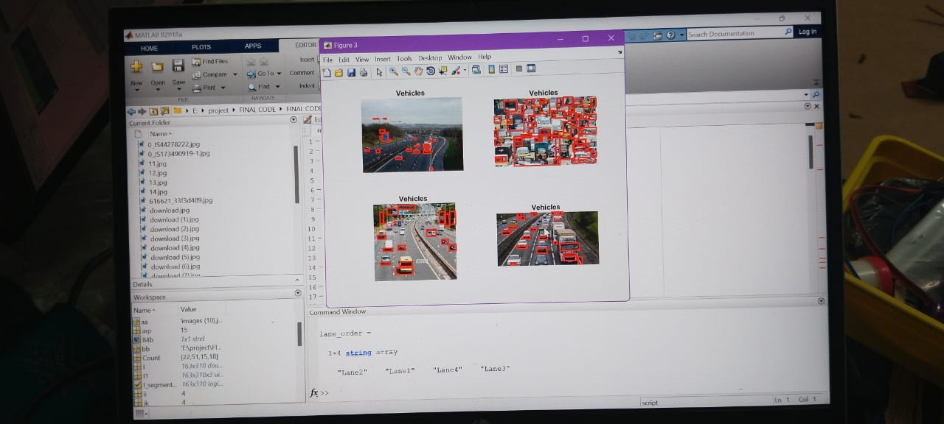

**Figure 2 : Detected count of vechicles**

**V. Conclusion and Future Works**

An efficient density based traffic control system is simulated and implemented which provides a good traffic control mechanism without time wastage In conclusion, an AI-based smart traffic management system represents a significant advancement in transportation management. To implement specific methods for emergency response To improve data privacy measures, ensuring the anonymity and security of data collected from various sources.

**VI. References**

# CHENG-JIAN LIN,JYUN-YU-JHANG, Intelligent traffic monitoring system based on yolo and convolutional fuzzy neural networks,IEEE,2022.

1. Guy M. Lingani, Danda B Rawat, Moses Garuba, Smart Traffic Management System using Deep Learning for Smart City Applications, IEEE, 978-1-7281-0554-3/19,2019.
2. Volodymyr Miz, Vladimir Hahanov, Smart traffic light in terms of the Cognitive road traffic management system (CTMS) based on the Internet of Things, IEEE,2017.
3. Md. Rokebul Islam, Nafis Ibn Shahid, Dewan Tanzim ul Karim, Abdullah Al Mamun, Dr. Md. Khalilur Rhaman, An Efficient Algorithm for Detecting Traffic Congestion and a Framework for Smart Traffic Control System, ISBN 978-89-968650-6-3, ICACT, 2018.
4. Sabeen Javaid, Ali Sufian, Saima Pervaiz, Mehak Tanveer, Smart Traffic Management System Using Internet of Things, International Conference on Advanced Communications Technology (ICACT), February 2018.
5. Amaresh A M, Kavya Shivanand Bhat, Ashwini G, Bhagyashree J, Aishwarya P, Density Based Smart Traffic Control System for Congregating Traffic Information, IEEE Xplore, ISBN: 978-1-5386-8113-8,2019.
6. Shubham N. Mahalank, Keertikumar B. Malagund, R.M.Banakar, Non Functional requirement analysis in IoT based Smart Traffic Management System, ICCUBEA, 2016.
7. Patan Rizwan, K Suresh, Dr. M. Rajasekhara Babu, Real-Time Smart Traffic Management System for Smart Cities by Using Internet of Things and Big Data, International Conference on Emerging Technological Trends, IEEE, 2016.
8. Mahima Jaiswal, Neetu Gupta, Ajay Rana, Real-time Traffic Management in Emergency using Artificial Intelligence, International Conference on Reliability, Infocom Technologies and Optimization, June 2020.
9. U. Ihsan, R. Malaney, and S. Yan, “ Machine learning and location verification in vehicular networks,” in Proceedings of the 2019 IEEE/CIC International Conference on Communications in China (ICCC), pp. 91–95, Changchun, China, August 2019.
10. A. Elkhalil, J. Zhang, R. Elhabob, and N. Eltayieb, “An efficient signcryption of heterogeneous systems for internet of vehicles,” Journal of Systems Architecture, vol. 113, Article ID 101885, 2020.
11. S. Suresh Kumar, M. Rajesh Babu, R. Vineeth, S. Varun, A. N. Sahil, and S. Sharanraj, “Autonomous traffic light control system for smart cities,” in Computing and Network Sustainability, vol. 75, pp. 352–335, Springer, Singapore, Asia, 2019.
12. H. Joo, S. H. Ahmed, and Y. Lim, “Traffic signal control for smart cities using reinforcement learning” vol. 154, no. 3, pp. 324–330, 2020.
13. M. Radivojević, M. Tanasković, and Z. Stević, “The adaptive algorithm of a four way intersection regulated by traffic lights with four phases within a cycle,” Expert Systems With Applications, vol. 166, p.2019.
14. Heung, T.H., Ho, T.K., Fung, Y.F.: Coordinated Road-Junction Traffic Control byDynamic Programming. IEEE Transactions on Intelligent Transportation Systems 6(3),341–350 (2019)