**BOOK MY HOARDING**

**Prof. J. N. Patil1, Manish Vijay Chavan2, Sanket Sanjay Gangurde3,**

**Prathamesh Bapusaheb Dumbare4, Vivik Vikas Tayde5**

1Professor Information Technology Sandip Foundation's Sandip Polytechnic Nashik, Maharashtra, India.

2,3,4,5Student, Information Technology Sandip Foundation's Sandip Polytechnic Nashik, Maharashtra, India.

**ABSTRACT**

M-learning is a rapidly expanding recently domain. Provoked by the fast advances of mobile technologies different applications and systems are developed continuously. Here we address the hoarding problem, which is weakly explored before but is particularly important issue in the mobile domain and solution should be included in every system with big quantity of data. Hoarding is the process of automatically selecting learning content which to be prepared and prefetched on the mobile device’s local memory for the following offline-session. We describe the hoarding problem and the strategy to solve it with the goal to provide an efficient hoarding solution.

**Keywords:** Mobile Learning, Hoarding, Offline Access to Learning Content, Disconnected Operation, Caching, Prefetching, Approach Techniques.

1. **INTRODUCTION**

Wireless and mobile technologies have been developing very fast over the last few years. New devices and technological solutions appear on the market with great speed and the research and development communities are trying to find the best possible ways to use them. Small, relatively inexpensive devices like PDA (Personal Digital Assistant) and smartphones enable computational and data access while on the move. As a consequence, mobile applications are appearing in different fields, like commerce, healthcare, tourism, etc. In the learning domain a whole new field is opening, that is called mobile learning, or in short m-learning. It is been considered as the next step in distance learning and as an integral part of any form of educational process of the future. Mobile learning can cover a wide range of applications, educational fields, pedagogical approaches and technological solutions. The common criterion for entering in the mobile learning domain is to use a mobile computational device in some teaching and/or studying activities or education supporting services. As the m-learning domain is explored only in the recent years, many new research topics are emerging in various areas, including technological issues, pedagogical and methodological ones, problems related to content and user interface adaptation, etc. The problem we focus on and that we describe in this paper is the one of supporting the access to web-based learning content from a PDA device during its periods of disconnection. Such offline periods may appear for different reasons – intentional (e.g. the available connection is too expensive for the user) or unintentional (e.g. lack of infrastructure at a given time and location). During offline periods the user can only access materials located on the device’s local memory. Mobile systems typically have a relatively small amount of memory, which is often not enough to store all the needed study material. In such a case a decision should be taken on which part of the material has to be cached. Often we can not count on the user’s own judgement of what he/she will need and prefetch it. Rather, in our opinion some sort of automatic prefetching would be desirable. The process of automatic selection and caching of material to be used during offline periods is called “hoarding”.

1. **METHODOLOGY**

* Login: module in this application user will able to login into application and searching hoarding to map
* Create a “candidate for caching” set. This set should contain related documents (objects) that the user might access from the started point we have selected.
* Prune the set - the objects that will probably not be needed by the user should be excluded from the candidate set, thus making it smaller. This should be done based on user behavior observations and domain knowledge.
* Find the priority to all objects still in the hoarding set after pruning. Using all the knowledge available about the user and the current learning domain, to every object left in the hoarding set should be assigned a priority value. The priority should mean how important the object is for the next user session and should be higher if we suppose that there is a higher probability that an object will be used sooner.

1. **MODELING AND ANALYSIS**

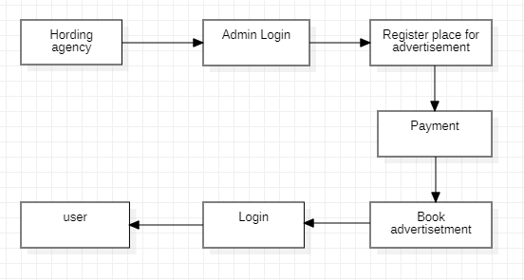

**Figure 1:** Level 0 Data Flow Diagram(DFD).

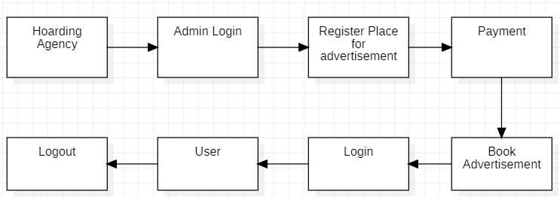

**Figure 2:** Level 1 Data Flow Diagram(DFD).

A data flow diagram (DFD) is used to show a graphical representation of the flow of data through an information system, modeling its process aspects. A DFD is also used as a preliminary step to create an overview of the system, which can later be elaborated.

1. **RESULTS AND DISCUSSION:**

User-friendly platform Help to needy people Accurate Price with up-to-date and accurate pricing information for a wide range of products from different retailers.

Mobile Accessibility: Developed a responsive an mobile-friendly platform to accommodate user on various devices, including smartphone and tablet.

Data security and privacy: prioritize the security and privacy of user data, ensuring that sensitive information is handled with care and following relevant data protection regulations.

| Phases | Cost/Hour | Hours | Cost Estimation |
| --- | --- | --- | --- |
| Requirement gathering | 30/- | 20H | 600 |
| Design | 50/- | 30H | 1500 |
| Code development | 50/- | 20H | 1250 |
| Implementation | 60/- | 40H | 2400 |
| Testing | 40/- | 10H | 400 |

table1:Cost Estimate Chart

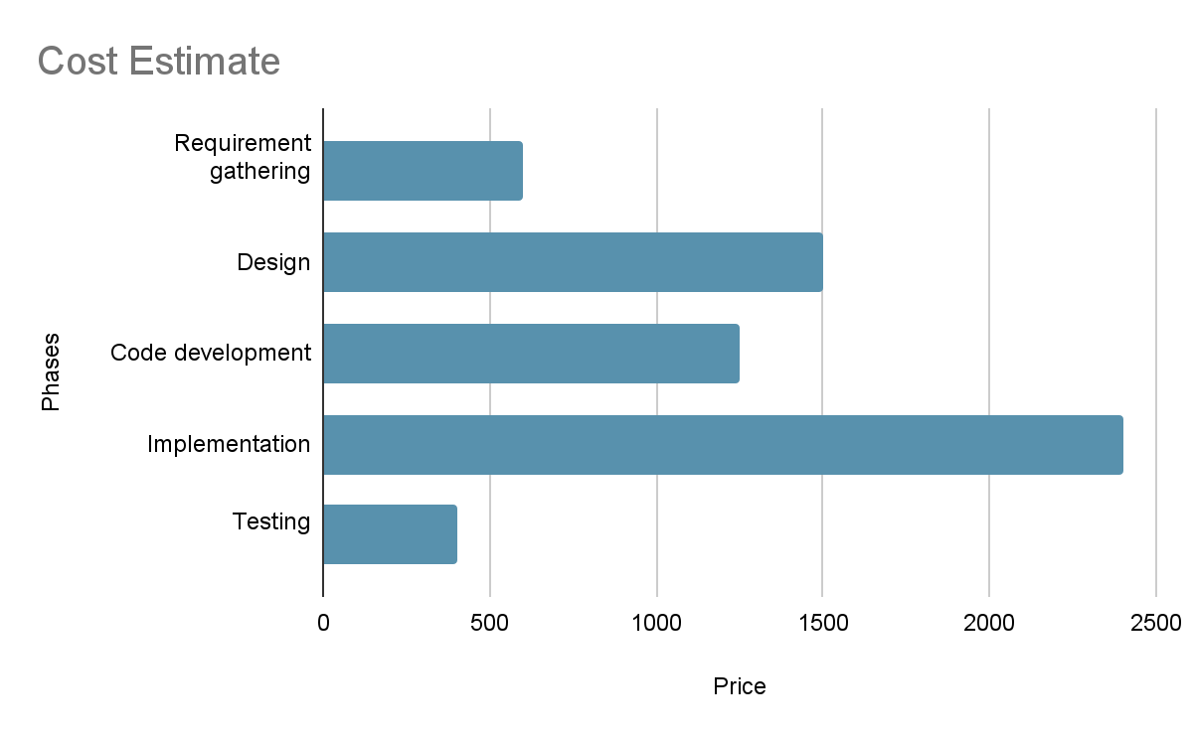

1. **CONCLUSION**

This paper describes the hoarding problem for a mobile learner without Internet connection. The problem is how to support work on a mobile device when it is impossible to load in its memory all the data that comprise the full knowledge base. We have outlined a general hoarding strategy and we gave details on possible approaches on every step of the described process. Though our work is still in progress we have shown that in a real-world mobile learning system hoarding might be a very important part. We have done some important deductions that can give also a starting point for other developers in the field. We have drawn attention to particularities of the mobile learning scenario that differ from scenarios considered previously: • Sessions – we have emphasized that there is a difference between a ‘session’ in the Internet word and what should be considered a session in this particular scenario – hoarding content for mobile learning. • Effective pruning and prioritizing – we have drawn the attention on the importance of these steps and also proposed pruning and prioritizing criteria that were not used for hoarding before, like considering what the user could but did not access in his/her previous sessions. While this technique can not be fully used in the general case of internet caching and prefetching it might be source of information for pruning in the m-learning case. The main contribution of this paper is the drawing of the attention of the researchers and developers in the mobile learning domain at the importance of the hoarding problem. People are going around this problem (in different domains) for years, saying that mobile device’s characteristics are continuously growing and soon there will be always available fast Internet connection. Though the problem exists! First, we can not assume that learners will equip themselves with the top technologies. Second, the always growing need of ‘more space’ can be seen also with desktop PCs. Once more space is available you start using it and you need more. As it is true for the compression technologies, that it will be always needed it will be the same with the mobile devices and hoarding. Once we can put on the devices memory all the text we will want to put video also; once we can put video we will want higher quality and etc. Thus hoarding should be considered whenever we want to develop an efficient real-world mobile learning system.

1. **REFERENCES**

## Adair, J. (1997), Sherborn Home Up in Flames, Boston Globe, Boston, MA, April 12.

## Ahuvia, A.C. (2005), “Beyond the extended self: loved objects and consumer’ identity narratives”,

## Journal of Consumer Research, Vol. 32, pp. 171-84.

## Beck, U. (1999), World Risk Society, Polity Press, Malden, MA.

## Belk, R.W. (1988), “Possession and the extended self”, Journal of Consumer Research, Vol. 15,

## pp. 139-68.

## Belk, R.W. (1992), “Moving possessions: an analysis based on personal documents from

## the 1847-1869 Mormon migration”, Journal of Consumer Research, Vol. 19, pp. 339-61

## Belk, R.W. (1995), Collecting in a Consumer Society, Routledge, London.

## Belk, R.W. and Joon Yong, S. (2007), “Dirty little secret: home chaos and professional organizers”,

## Consumption, Markets and Culture, Vol. 10 No. 2, pp. 133-40.

## Belk, R.W. and Kozinets, R.V. (2005), “Videography in marketing and consumer research”,

## Qualitative Market Research: An International Journal, Vol. 8 No. 2, pp. 128-41.

## Bianchi, M. (1997), “Collecting as a paradigm of consumption”, Journal of Cultural Economics,

## Vol. 21, pp. 275-89.

## Carter, P. (1992), Sound in Between: Voice, Space, Performance, New South Wales University

## Press, Sydney.