STUDY ON WOMEN DOCTORS WORK LIFE
BALANCE: WORK CONFLICTS PERSPECTIVE
*Madhavi Kandula
**Dr K.G. Chandrika
Abstract:
Family and work is an essential mainstay of human existence . Family sustains life and society while work and its derivatives such as income have strong implication for health and wellbeing. Individuals, specifically create something of value on the basis of work. Nevertheless, the family on the other hand provides reliance, safety, peace and comfort. Health is generally inviolable for the achievement of sustainable development . When it comes to the health of individuals in the workplace, the problems associated with work stress are often encountered as burnout. In the workplace, burnout is said to be a product of role conflict, less family time, amongst others . The rapid changes in technology with globalization, alongside social and economic sectors led the family structure and roles within the family to separate. Additionally, since the 20th century till date, social changes have led to the inclusion of women in world of work with women joining the positions where they can decide in the labour force. The role of both work and family cannot be understated. While home and workplace could be perceived as separate domains, studies have shown that the roles at the workplace and home are complementary. Working full time in an organization and keeping the household at the same time could require a lot of coordination, support and attention. The career paths of women in medicine are fraught with obstacles, including bias, a lack of support, discrimination, bullying, harassment, and conflict with coworkers, office politics, and more. Therefore, it is essential to provide a suitable working environment, a flexible work schedule, and strong family support to guarantee their needs are met, resulting in increased job satisfaction and consequently, superior medical care.
Keywords: Work Stress. Role Conflict, Duty Hours , Family Burdens
---------------------------------------------------------------------------------------------------------------------
*Research Scholar, Department of Business Management, Osmania University, Hyderabad.
**Sr. Professor (Retd.), Department of Business Management, Osmania University, Hyderabad.
Introduction:
Women majorly experience work-family conflict especially in cultures that expect married females to cook, attend to their children, husband and relatives and other home roles after a day’s work . The concept of work–family conflict consists of three distinctive conflicts: Time-based conflict can be defined as a situation whereby the time demanded for the performance of one role prevents an individual from executing other roles. Strain-based conflict; that is, negative emotions identical to anxiety that is formed in one domain but affect an individual in another domain such as the family duties causing strain and affecting the workplace and, Behaviour-based conflict; occurs when behaviours suitable to one sphere are unsuitable when acted out in another domain . Burnout is mostly confirmed in service and care-giving occupations such as among teachers, doctors, nurses, police, banking sector among others [10, 2, 21, 28]. Burnout is a growing and continuous challenge faced by physicians and is extremely ubiquitous in health-care settings. It is connected to strenuous working conditions and dissatisfaction with work [8]. A study among German physicians found that more than 33.3% of the health-care workers are undergoing burnout . Additionally, the study reported that burnout can affect up to 45% of medical and nursing staff .
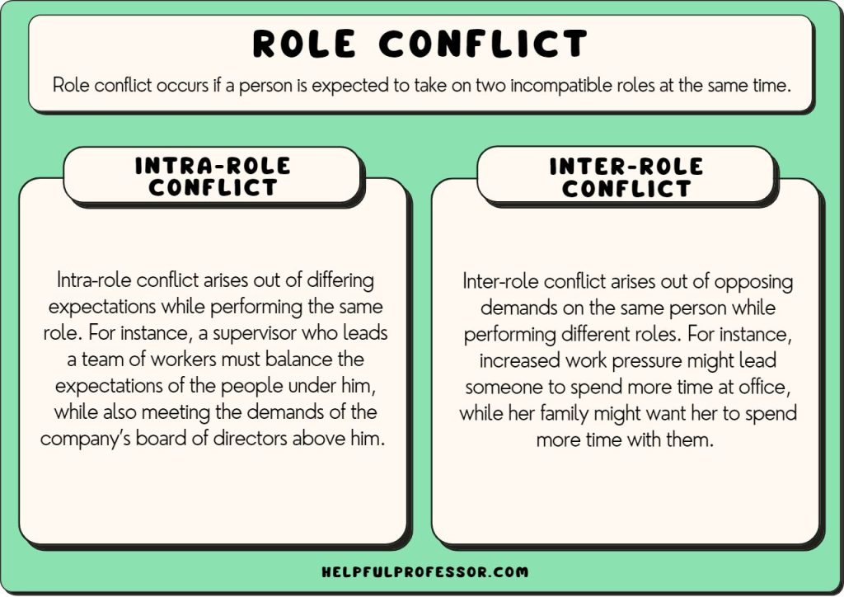
Source: Greenhaus (1985)
The effect of burnout is not only evident in the life’s of physicians but it also extends to their patients especially when the quality of care given is poor . In the hospital, health care providers such as the medical staffs at the emergency unit undergo burnout due to the poor working environments and emotional challenges they experience. They also experience burnout due to congested work place, serious cases treated and shifts that destabilize family and social relationships. Likewise, the development of burnout syndromes is also influenced by conflicts with patients’ companions, dangerous working environments, work complications and critical care decisions.
Role conflict is classified as being of two types:
- Intra-role Conflict – This kind of conflict arises out of differing expectations while performing the same role. For instance, a supervisor who leads a team of workers must balance the expectations of the people under him, while also meeting the demands of the company’s board of directors above him. If the employees want greater salaries and shorter working hours, the company’s directors might not view such a demand favorably, resulting in the supervisor finding himself or herself in the middle, experiencing an intra-role conflict. This is close to but different from the related concept of role strain.
- Inter-role Conflict – This kind of conflict arises out of opposing demands on the same person while performing different roles. For instance, increased work pressure might lead someone to spend more time at office, whereas his or her family might want them to spend more time with them. Thus, the conflicting demands arising out of their twin roles as a supervisor and a father/ husband/ mother/ wife lead to an inter-role conflict.
Literature:
Jadhav Tilekar, S., & Lele, V (2022) Explained that with a high quality of life at work, nurses, the largest group of healthcare providers, can better care for their patients. Nurses' working conditions should be respected as a result. Because of its negative impact on nurse and female doctor productivity, work-life balance has recently emerged as a pressing issue in private medical practises. Female medical professionals in the private sector were the primary research subjects.
Siva Prasad K.I. and Dr P. T. Raveendran (2019)used their study statistical methods such as frequency distributions, analysis of variances, and correlations were used for the analysis. This essay is an effort to shed light on the challenges that female nurses at the Academy of Medical Science, Pariyaram face when trying to strike a healthy work-life balance. The results showed that women nurses had a generally positive work-life balance, but that hospital administration rarely pays attention to formalizing work-life management policies.
Hossain, et al., (2019) The importance of housework cannot be overstated, as evidenced by the finding that 75% of female doctors reported spending less time with their children and 44% of doctors had given preference to housework. Female medical professionals confront unique difficulties, according to a study, including discrimination based on gender and a lack of workplace safety and security, particularly in rural areas.
Tripathi, (2017). The ability to maintain one's professional, personal, and social lives is also included. Personal contentment in one's roles at work and home is another phenomenon that can be explained by WLB. Women in the workforce regularly face trade-offs and sacrifices.
According to Arima (2016), WLB refers to the state in which an individual is equally invested in and satisfied by their work and family responsibilities. According to AlHazemi and Ali (2016), WLB "is a pattern of individuals combining their duties and dreams with peace and progress regardless of demographic factors like age, gender, race, etc."
Objectives:
1 ) To Study family issues stress impact work conflict during job hours.
2) To identify serious cases impact on family related conflicts due to stress
3) To study long working hours impact on conflict issues with family / colleagues.
.
Hypothesis:
H₀₁: There is no significant association between stress during job hours leads to family conflicts among public and private sector doctors.
H₀₂: There is no significant relation between serious medical case and its impact on family relations leads to conflicts among public and private sector doctors.

Sample & Sample Size:
Women doctors who are working in various public and private hospitals in Hyderabad city are considered as valid sample for this study. A Sample of 140 (77 Private doctors + 63 Public sector doctors) Women doctor’s opinion was captured by using a structured questionnaire to measure the results.

Data Analysis:
- Doctors Experience :

Work Experience | Responses | Percentage
> 3 Years | 24 | 17 %
3.1- 8 Years | 53 | 38 %
8.1 -15 Years | 41 | 29 %
Above 15 Years | 22 | 16 %
TOTAL | 140 | 100

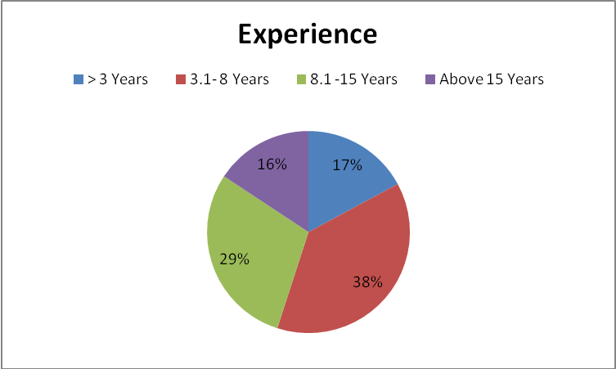

Inference: The above doctors experience chart indicating that, 39 % of doctors got 3-8 years experience followed by 29 % got good experience i.e up-to 15 years.

H₀₁: There is no significant association between stress during job hours leads to family conflicts among public and private sector doctors.

Crosstab
 |  |  | Stress |  |  |  |  | Total
 |  |  | Strongly Disagree | Disagree | Undecided | Agree | Strongly Agree | Total
 | Private | Count | 1 | 22 | 34 | 15 | 8 | 77
 | Private | % within TYPE OF SECTOR | 3.3% | 6.7% | 13.3% | 50.0% | 26.7% | 100.0%
 | Public | Count | 0 | 3 | 42 | 18 | 0 | 63
 | Public | % within TYPE OF SECTOR | 0.0% | 0.0% | 60.0% | 40.0% | 0.0% | 100.0%
Total |  | Count | 1 | 22 | 76 | 23 | 8 | 140
 |  | % within TYPE OF SECTOR | 2.0% | 4.0% | 32.0% | 46.0% | 16.0% | 100.0%

Chi-Square Tests
 | Value | df | Asymp. Sig. (2-sided)
Pearson Chi-Square | 15.761ª | 4 | .701
Likelihood Ratio | 19.586 | 4 | .001
Linear-by-Linear Association | 4.027 | 1 | .045
N of Valid Cases | 50
a. 6 cells (60.0%) have expected count less than 5. The minimum expected count is .40.

Inference: From the above table chi square is not significant (sig. value is greater than 0.05), no evidence to reject null hypothesis, i.e the job related stress in obviously indicating stress and family conflicts among both sector doctors.

H₀₂: There is no significant relation between serious medical case and its impact on family relations leads to conflicts among public and private sector doctors.

Crosstab
 |  |  | Case Seriousness |  |  |  | Total
 |  |  | Disagree | Undecided | Agree | Strongly Agree | Total
 | Public | Count | 3 | 3 | 47 | 7 | 58
 | Public | % within TYPE OF SECTOR | 10.0% | 10.0% | 56.7% | 23.3% | 100.0%
 | Private | Count | 1 | 5 | 38 | 0 | 82
 | Private | % within TYPE OF SECTOR | 5.0% | 25.0% | 70.0% | 0.0% | 100.0%
Total |  | Count | 4 | 48 | 84 | 7 | 140
 |  | % within TYPE OF SECTOR | 8.0% | 16.0% | 62.0% | 14.0% | 100.0%

The cross tab table result revealed that, online advertisement is having good impact with Maruthi but not that much progressive with Honda products.

Chi-Square Tests
 | Value | df | Asymp. Sig. (2-sided)
Pearson Chi-Square | 7.073ª | 3 | .010
Likelihood Ratio | 9.533 | 3 | .023
Linear-by-Linear Association | 1.607 | 1 | .205
N of Valid Cases | 50
a. 6 cells (75.0%) have expected count less than 5. The minimum expected count is 1.60.

Inference: From the above table chi square is significant (sig. value is less than 0.05), reject null hypothesis .i.e the case seriousness may not leads to such family conflicts issues..Moreover it depend on how efficiently particular doctor handling the case.

Discussion of Results:

The present study concluded that female doctors go through emotional exhaustion which is a major aspect in burnout. This could be due to the conflicting roles they play at home and at work which causes strain and fatigue. Also, the studies show that female doctors at the earliest stage of their career experienced burnout (emotional exhaustion) unlike those at the later stages of their career. Since most doctors at the early career were involved in the experience of burn out, the author considers it expedient that all employers of young female doctors should devolve manageable assignments to them to avoid burnout and the likely ill-health consequences. Also, repeated studies could be done on the effect of work-family conflict and burnout in other fields for possible comparison and in order states or through the country.
One of the few sectors that operates nonstop for the benefit of all inhabitants of any country is the health service sector. As a result, the health care industry requires its workers to be physically and mentally fit. Those women in the medical profession who experience emotional or physical strain as a result of their jobs are known as female doctors. Their job schedules prevent them from spending time with their loved ones and improving their own well-being, causing friction between their personal and professional lives. Many working women say they are overwhelmed by the demands of their careers and households. It's important to keep things in check on both the home and work fronts. Finding a good work-life balance is essential for achieving overall happiness, which includes job satisfaction. Medical professionals face rising challenges as they strive to improve patients' lives for the better via selfless, committed care. Workers in the healthcare industry must exercise extreme caution at all times. Therefore, healthcare workers are under significant stress. In the event of an emergency, doctors and nurses must attend to patients during non-standard working hours, regardless of whether or not they have children or other dependents at home. They may be required to work irregular hours or late into the night, among other tasks that could affect their work-life balance.

REFERENCE:
- Arim & Hosfair K., (2015). A Study on work life balance Employees in Selected Service Sectors. Pacific business Review International, 7(10),17-23.
- Coban H Irmis A (2016) Work-Family Conflict And Burnout in Turkish Banking Industry. European Scientific Journal 1857- 7431.
- Greenhaus J and Beutell N (1985) Sources of conflict between work and family roles. Academy of Management Review 10(1) 76-88.
- Hossein. T, Hasan, O., Dyrbye, L. N., Sinsky, C., Satele, D., Sloan, J., & West, C. P. (2019). Changes in Burnout and Satisfaction with Work-Life Balance in Physicians and the General US Working Population Between 2011 and 2014. Mayo Clinic proceedings, 90(12), 1600–1613.
- Jadhav. M., & Sarker, M. A. R. (2022). Work Life Balance of Female Doctors in Bangladesh: An Overview. Journal of Health and Medical Sciences, 2(3), 410-421. 18. Pandey, M. (2016). Impact of work-life balance on job satisfaction of women doctors. Problems and Perspectives in Management, 14(2), 319-324.
- Ogundipe O Olagunju A lasebikan V and Coker A (2014) Burnout among doctors in residency training in a tertiary hospital Asian Journal of Psychiatry 10 27–32.
- Siva Prasad., & Rhee, S. Y. (2019). Multi-level Sources of Work-Life Balance: Evidence from the Public Health Sector in Tanzania. Journal of International Trade & Commerce, 15(6), 79-103.
- Tripathi. (2017). Work-life balance in higher education for women: perspectives of athletic training faculty. Athletic Training Education Journal, 13(3), 248-258.

