Medical based Decision Support System for Diabetes and Reverse Diabetes using ML Algorithms

Dr. Ayesha Taranum1 ,Bhanupriya S* ,Bhoomika P *, Impana*,Impana M S*

1. Assoc Prof,* Student

Department of Computer Science andEngineering, Vidyavardhaka College of Engineering,Mysuru, INDIA

Abstract

Diabetes constitutes a persistent health condition or a cluster of metabolic disorders, Marked by using a chronic elevation in blood glucose stages due to both an insufficiency of insulin or the cells' incapacity to reply to it. In contemporary times, this ailment poses significant health challenges and enduring impediments. The healthcare sector grapples with substantial volumes of highly confidential information, demanding meticulous handling. Diabetes Mellitus (DM) is widely acknowledged as severe global diseases, necessitating a robust framework of objectives for comprehensive examination by clinical specialists. Numerous research initiatives have delved into this area, constructing models and presenting outcomes using programming languages such as R and Python, alongside data science tools. However, these efforts primarily remain theoretical models, lacking real-time applicability. Notably, absence of work on reverse diabetes prediction and personalized diet recommendations, critical elements for holistic patient care. Supervised ML algorithms as Random Forest, KNN (K-Nearest Neighbors), and Decision Tree have demonstrated promising results in predicting diabetes, their seamless integration into practical, real-world applications poses a persistent challenge. The translation of these algorithms from research settings to tangible, everyday use encounters obstacles that span from data collection and preprocessing to the interpretability and trustworthiness of the model outputs. Addressing these hurdles is crucial for the effective implementation of diabetes prediction models in clinical or public health contexts, requiring a concerted effort to enhance the algorithms' robustness, scalability, and user-friendliness to comprehend for improving healthcare outcomes.

Keywords: K-Nearest Neighbors, Diabetes Mellitus, Machine Learning

Introduction

Diabetes mellitus, characterised by using high ranges of blood sugar, manifests thru signs and symptoms like repeated urination, elevated thirst, heightened starvation, and weight loss. Powerful management of diabetes is crucial, as untreated cases can lead to extreme, lifestyles-threatening complications. The diagnosis generally involves assessing the 2-hour publish-load plasma glucose, with a degree of smallest 200mg/dL indicating diabetes.

The urgency of timely diabetes recognition is underscored by numerous studies focusing on recognizing the condition promptly. Early detection enables healthcare professionals to implement interventions and treatments to control levels of blood sugar, mitigate symptoms, and reduce the risk of complications. Ongoing research and advancements in diagnostic methods, including claim of ML algorithms, aim to enhance the efficiency and accuracy of diabetes recognition, ultimately improving patient outcomes and superiority of existence for those affected by this chronic condition.

There are several varieties of diabetes, every with distinct traits and causes. The main types include:

Kind 1 Diabetes: This outcomes from the immune machine mistakenly attacking and destroying insulin- producing beta cells. People through Kind 1 diabetes need insulin injections for survival.

Kind 2 Diabetes: This is greater common and often develops through the years. It takes area while the body does now not use insulin well, leading to insulin resistance. Life-style adjustments, oral medicines, and every so often insulin injections are used to control kind 2 diabetes.

Risk Factors:

Genetics, family history, and age are common risk factors.

Type 2 diabetes is associated with obesity and sedentary lifestyles.

pregnancy-related gestational diabetes Pregnant women should be routinely screened for gestational diabetes and, if found to have the illness, should collaborate closely with medical professionals to manage it. This can lower the dangers for the mother and the unborn child and make the pregnancy healthier.

Problems:

Extended high blood sugar might cause issues that effect numerous organs, which include the eyes (diabetic retinopathy), kidneys (diabetic nephropathy), nerves (diabetic neuropathy), and cardiovascular system(improved threat of stroke and coronary heart ailment).

Management and Treatment:

Lifestyle Changes: Dietary modifications, regular exercise, and weight management play a crucial role.

Medications: Insulin and various oral medications help regulate levels of blood sugar.

Continuous Glucose Monitoring (CGM): Technological advancements allow for real-time monitoring of glucose levels.

Prevention:

Wholesome way of life choices, which includes a balanced weight-reduction plan and ordinary bodily hobby, may additionally dramatically decrease the chance of getting kind-2 diabetes.

Regular screenings are important, especially for individuals with risk factors. Ongoing Research:

Researchers are exploring new treatment modalities, including advanced technologies, gene therapies, and medications to improve diabetes management.

Psychosocial Aspects:

Living with diabetes can impact mental health. Diabetes management often requires significant self-care, and support networks play a crucial role.

Global Impact:

Diabetes a medical condition that is becoming more commonplace globally, raising health concerns. Healthcare systems and organizations are developing preventative, early detection, and efficient management solutions.

Education and Awareness:

Public attention campaigns emphasize prominence of early detection, lifestyle modifications, and

everyday fitness check-ups.

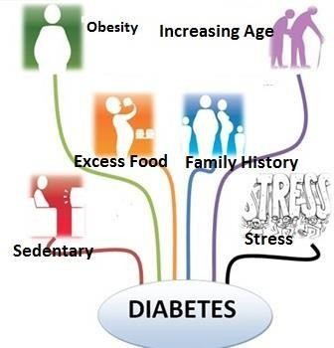

Fig1:Reason for diabetes

The usage of gadget mastering to discover diabetes has been the challenge of numerous prior studies. Research has been finished [2] at the prognosis of diabetes with aid Vector Machines (SVM) and Generalised Discriminant evaluation (GDA), and the effects are promising. Another study [3] used GRNNs (General Regression Neural Networks) to do the same job, and they too achieved very high accuracy. Unlike previous studies, we offer a more complete observe that contains numerous generally-used strategies for diabetes identification. Our objective is to evaluate each technique's overall performance and decide which is the most green. In this test, we compare numerous usually used information preprocessors to decide which is the satisfactory preprocessor for every of the classifiers we make use of. We evaluate the consequences after pleasant-tuning the parameters of every classifier to about attain its most accuracy, taking unique care to optimize the DNN (Deep Neural network) parameters. Finally, we also examine every characteristic's dating to the categorization result, for you to help us modify the information set for destiny studies.

Associated Works

[1] Device mastering techniques for class of Diabetes and Cardiovascular ailments yr of guides: 2020

Categorising diabetes and cardiovascular diseases (CVD) the usage of artificial neural networks (ANNs) and Bayesian networks (BNs). On a selection of papers that were released between

2008 and 2017, a comparison analysis was carried out. Multilayer feedforward neural networks with Levenberg-Marquardt learning algorithms are the most usually used sort of synthetic neural community (ANN) consistent with some of papers. On the other hand, the Naive Bayesian network—which is the most often used type of BN—has shown the highest accuracy rates—99.51% and 97.92%, respectively, In relation to the type of diabetes and cardiovascular disorder. Furthermore, When the usage of ANN, the imply accuracy calculation of discovered networks has shown better results, Indicating a more threat of manufacturing effects with a better degree of accuracy in the category of diabetes and/or CVD.

Drawbacks

Diabetes and cardiovascular illnesses are classified using this system. ANN techniques are used.

Less datasets used.

Less efficient

[2] Association Rule Extraction from clinical Transcripts Diabetic sufferers’ year of publications: 2020

Scientific databases can offer wealthy knowledge resources for effective medical diagnosis. Due to latest trends in scientific generation and the great use of electronic scientific record systems, hospitals and other healthcare institutions generate a lot of medical text data. These text files are packed with information, yet most of them are just filed and never used. If clinical statistics is used well, it has the capability to noticeably revolutionizes the clinical business. This take a look at offers a unique technique for finding trustworthy connection policies in transcripts of clinical activities. The extracted rules contain details on symptoms of a certain condition, medications used to treat diseases, age range of those most likely to contract a specific disease, and information on how one ailment may be related to another Information. To extract policies, NLP (herbal Language Processing) technologies have been coupled with information mining strategies (Apriori and FP- boom). The identification of fascinating policies emerge as completed using a correlation metric known as raise.

Cons: Designed to are expecting the relationship between several diabetes metrics. Less accurate result. No longer suitable for diabetes sickness prediction.

1. Diabetes Prediction Utilizing Resembling of Different Machine Learning Classifiers Year of Publications: 2021

Diabetes, often called continual contamination, is a set of metabolic sicknesses due to blood sugar stages which are always raised. Decreasing the chance element and severity of diabetes extensively can be completed by means of precise early prediction. Making a trustworthy and accurate diabetes prediction is quite challenging since the diabetes datasets contain outliers, or missing values, and there is a limited amount of labelled data .The use of a diffusion of machine reading (ML) classifiers, which include k-nearest Neighbor, choice timber, Random woodland, AdaBoost, Naive Bayes, and XGBoost, as well as Multilayer Perceptron (MLP)and talents like function preference, ok-fold go- validation, outlier rejection, and records standardization, we present a sturdy framework for diabetes prediction on this literature. Weighted assembling is also endorsed on this look at. To enhance diabetes prediction, weighted assembling of multiple machine learning models is also recommended in this have a look at. The applicable ML model's area underneath the ROC Curve (AUC) is wherein the weights come from. A favored overall performance metric is AUC, that is then optimized at some point of hyperparameter tuning by way of employing the grid seek approach.

Drawbacks

ML techniques to build the just model. Not suitable for real-time use.

Time prediction is not there.

1. A Novel Methodology to Predict Diabetes by Using Naive Bayes Classifiers Year of Publications: 2020

Most serious and persistent illnesses that diabetic sickness. This proposed experiment machine makes use of Naïve Bayes class to expect the lifestyles of diabetes. Facts mining is the process of taking records from a dataset and arranging it such that it makes sense for extra use. The clinic's archive, containing 1865 cases with a range of attributes, was used to create the informational collection for diabetes patients. This proposed system's online interface, which makes use of a Naïve Bayes classifier, would show the result of having diabetes or not depending on input data like age and insulin dosage. This gets better

Drawbacks

Just model is built using ML algorithms. Can’t be used in real time.

Time prediction is not there.

1. Multi-Agent System Based on MachineLearning for Early Diagnosis of Diabetes Year of Publications: 2020

Globally, there is an increase in diabetes cases. Over 2 million Moroccans who are 18 years of age or older suffer from diabetes. Early identification is essential for the diagnosis and treatment of diabetes. The goal of this qualitative study changed into to deal with this task by using granting extra independence and initiative to the diverse software modules which might be professionals in clinical diagnosis. Multi-Agent device can be used as a allotted diagnostic tool to facilitate strong, reliable clinical diagnostic support. On the way to verify the effectiveness of 3 famous system learning (ML) algorithms—logit model (LR), logistic regression, and assist vector machines (SVM)—this have a look at will try to increase a unique multi-agent system that accesses the diabetes database. Next, utilising a majority vote, the system combines these algorithms' classifications with a controller agent to improve classification accuracy. This essay also addresses the existing gap and the difficulties in implementing ML algorithms in multi-agent systems.

Drawbacks

SVM, regression ML algorithms usedwhich generates graphical results. Not suitable in real time.

Only model is developed, no real timeapplication useful for hospitals.

Survey Summation

The field of employing ML systems to forecast diabetic sickness has to be further investigated. Although the idea of diabetes prediction has been presented in a few studies, only few have gone on to actual implementation. These implementations have made use of various data science tools as well as programming languages like R and Python and tools like Weka. Interestingly, most of these approaches don't work in real time; instead, they use static datasets to build machine learning models.

Additionally, there is a dearth of study on the intriguing aspect of reverse diabetes prediction and the absence of real-time applications. In real-world situations, doctors usually get consultations from patients, after which manual diagnosis and testing are performed. The diagnosis process relies heavily on the doctor's expertise, consuming more time, requiring specialized medical equipment, and incurring higher costs.

This highlights the need for more research and development in the area to look at the possibility of reverse diabetes prediction and to bridge the knowledge gap between theoretical frameworks and

real-world applications. Such advancements could potentially streamline the diagnostic process, making it more efficient, accessible, and cost-effective for patients and healthcare providers alike.

Drawbacks

No reverse diabetes prediction done Existing works are models

No real time implementations done Used static datasets

More time required

Medical equipment required

More expensiveMethodology AppliedMachine Learning

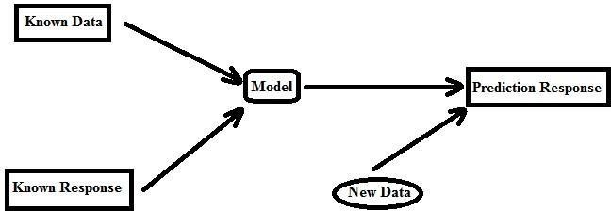

Fig:2 Proposed model

The technique of analysing a gadget the use of facts is called gadget getting to know. Records

technological know-how consists of gadget gaining knowledge of, where facts is processed the

usage of algorithms designed for device studying.Supervised Learning Technique.

This predictive model is applied to tasks that need the prediction of one value based on the prediction of other values in the dataset. Labels for supervised learning will be established. An object is classified using the parameters to one of the label sets that have been defined.

Various techniques, including KNN, Naive Bayes, selection timber, ID3, Random Forests, SVMs, and regression methodologies, may be used to construct models in supervised studying. Primarily based on the parameters, facts set, labels, and desires, we pick the most desirable prediction method. An set of rules is used to construct a model that, within the presence of uncertainty, makes predictions primarily based on information.

Rules for Classification

In essence, assigning each item in a piece of data to one of a predefined number of groups or classes is the process of categorization.

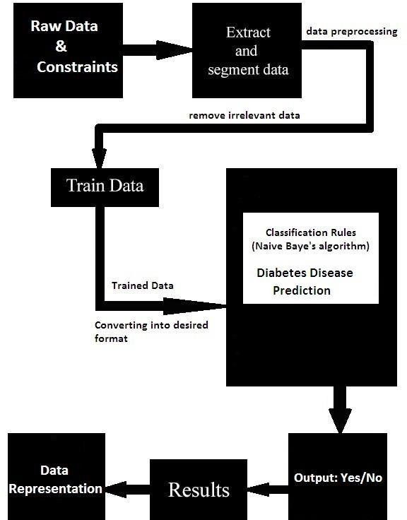

Figure 3: Methodology

Conclusion:

Diabetes, a main purpose of worldwide mortality, underscores the imperative for early detection. Leveraging the abilties of device learning, our gadget is meticulously crafted to concentrate on discerning diabetes through a comprehensive set of medical parameters. Through the judicious software of diverse system studying strategies, the machine endeavors to prognosticate the emergence of diabetes in its nascent ranges. This predictive capability holds the key to well timed intervention, allowing healthcare vendors to manage unique and personalized treatments. In the continuous combat in opposition to diabetes, the smooth incorporation of ML isn't always simply increases prediction accuracy however additionally creates a potential new area for preventive healthcare tactics on the way to in the long run cause better fitness effects.

# **REFERENCES**

1. World Health Organization, “Report of a study group: Diabetes Mellitus,” World Health Organization Technical Report Series, Geneva, 727, 1985.
2. Kemal Polat, Salih Gunes, and Ahmet Arslan, “A cascade learning system for classification of diabetes disease: Generalized Discriminant Analysis and Least Square Support Vector Machine,” Expert Systems with Applications, vol. 34. 1, January. 2008, pp. 482-487.
3. Kayaer K and Yildirim T, “Medical diagnosis on Pima Indian diabetes using general regression neural networks,” Proceedings of the International Conference on artificial neural networks and neural information processing, 2003, pp. 181-184.
4. Jack W. Smith, J. E. Everhart, W. C. Dickson, W. C. Knowler, and R. S. Johannes, “Using the ADAP learning algorithm to forecast the onset of diabetes mellitus,” Proc. Annu. Symp. Comput. Appl. Med. Care, November 9. 1988, pp. 261-265.
5. Karegowda A. G., Manjunath A. S. and Jayaram M. A., “Application of genetic algorithm optimized neural network connection weights for medical diagnosis of pima Indians diabetes,” International Journal on Soft Computing, vol. 2. 2, 2011, pp. 15-23.Carpenter G. A. and Markuzon N., “ARTMAP-IC and medical diagnosis: Instance counting and inconsistent cases,” Neural Networks, vol. 11. 2, 1998, pp. 323- 336.