**EMPOWERMENT EUPHORIA AND DARKSIDE OF SHAKTHI SCHEME IN KARNATAKA**

**AISHWARYA R, SAM ANAND PAUL & PAVITHRA G**

**VI B.COM Student of KRISTU JAYANTI COLLEGE AUTONOMOUS BENGALURU**

**Dr. C NAGADEEPA**

**ASSISTANT PROFESSOR, KRISTU JAYANTI COLLEGE AUTONOMOUS**

**Abstract :**

A comprehensive study that was carried out to get a better understanding of impact on free buses to the women's (residence of Karnataka), this scheme was introduced in order to uplift women's mobility and that it would be beneficial to all women’s in Karnataka by reducing the cost burden of public transport , it has even made woman in rural areas, come out of their remote place and move freely with an identity proof with zero fare ticket and adding to this study to be more precise we are going to analyze the schemes impact to over all society by examining how travelers of Karnataka feel about the experience of Shakthi scheme. The study examined the socioeconomic effects of free bus services, particularly focusing on accessibility, affordability, and mobility patterns. It investigates the extent to which the scheme has facilitated increased access to education, healthcare, and employment opportunities for different demographic groups, including low-income individuals and rural communities. The research delves into the environmental and traffic-related impacts of the free bus services, exploring changes in air quality, congestion level etc. It evaluates the sustainability of the scheme and its contribution to mitigating urban transportation challenges and promoting eco-friendly modes of travel.

Keywords: Shakthi Scheme, Euphoria, Perception.

**Introduction:**

The Karnataka government's initiative, the "Shakthi" scheme was introduced by the Congress government on June 11 2023, aimed to offer free bus rides within the state to women and transgender people, which stands as a testament to their commitment to empowering women across the state. Launched with the aim of promoting women's entrepreneurship and economic independence, this scheme encompasses comprehensive set of measures designed to uplift women from various socio-economic backgrounds. Through targeted interventions and support mechanisms, the Shakthi scheme strives to create an enabling environment where women can thrive as entrepreneurs, leaders, and contributors to the state's development. At its core, the Shakthi scheme recognizes the pivotal role women play in the socio-economic fabric of Karnataka. By providing them with opportunities and resources to start and scale their businesses, the government seeks to harness the untapped potential of women entrepreneurs. The scheme is not merely about financial assistance; it is about fostering a culture of entrepreneurship and innovation among women, thereby fostering economic growth and inclusivity.

These initiatives equip women with the necessary knowledge and expertise to excel in their chosen fields. Whether it's training in technical skills, management principles, or market dynamics, the scheme ensures that women have access to high-quality training opportunities tailored to their needs. In addition to financial and skill-based support, the Shakthi scheme also focuses on creating a conducive ecosystem for women entrepreneurs. This includes setting up dedicated business incubation centers, providing access to modern infrastructure and technology, and facilitating networking and mentorship opportunities. By nurturing a supportive ecosystem, the scheme empowers women to overcome barriers and realize their entrepreneurial aspirations.

Furthermore, the Shakthi scheme emphasizes the importance of gender mainstreaming and social inclusion in all aspects of economic development. By promoting women's participation in decision-making processes and advocating for gender-sensitive policies, the scheme seeks to address systemic inequalities and create a more equitable society. Through targeted awareness campaigns and advocacy efforts, it aims to challenge stereotypes and promote a culture of respect and equality. The impact of the Shakthi scheme extends far beyond individual beneficiaries; it contributes to the overall socio-economic development of Karnataka. By unleashing the entrepreneurial potential of women, the scheme drives job creation, fosters innovation, and stimulates economic growth across sectors. Moreover, empowered women serve as role models and agents of change within their communities, inspiring others to pursue their dreams and break free from the shackles of gender norms.

**Literature review:**

Dr. Ashish Verma, a prominent transportation researcher at the Indian Institute of Science (IISc) in Bangalore, has conducted extensive studies on the impact of free bus schemes in Karnataka, focusing on their effects on mobility patterns, congestion, and environmental sustainability. In his research paper titled "Assessing the Impact of Free Bus Services: Evidence from Karnataka, India. Dr. Verma explores the implications of increased bus ridership on traffic congestion and air quality. By modeling traffic flow and emissions scenarios, he assesses the potential reduction in congestion and pollution levels resulting from the modal shift towards buses. The findings suggest that free bus services have the potential to mitigate traffic congestion and improve air quality by reducing the number of private vehicles on the road. He examines how free bus services impact accessibility to transportation for various socio-economic groups, particularly low-income individuals who may rely heavily on public transit. Through surveys and interviews with stakeholders. Dr. Ashish Verma's research paper offers a comprehensive assessment of the impact of free bus services in Karnataka, drawing on empirical evidence, modeling techniques, and stakeholder perspectives. The paper highlights the potential benefits of promoting public transportation as a sustainable solution to urban mobility challenges while addressing the need for further research and policy interventions to enhance the effectiveness of free bus initiatives.

Dr. T V Ramanayya’s research delves into the socioeconomic benefits, ridership patterns and equity considerations associated with fare free transit, providing valuable insights. His research offers a comprehensive overview of the impact buses in Karnataka. He examines how the initiative has influenced various aspects such as accessibility, mobility patterns and socio-economic dynamics within the state. Through rigorous analysis, he highlights the positive effects of free bus services on enhancing transportation equity, reducing financial burdens on low income individuals. His work shows that its improving the quality of life for residents in Karnataka.

Dr. Ashish Chandra Khare, who is a faculty member at the Center for Public Policy, Indian institute of Management Bangalore, has investigated the effectiveness of free bus programs as a means of enhancing mobility and reducing congestion in Karnataka’s urban areas. He analyzes data in ridership, economic indicators and public opinion, the paper aims to provide insights into the efficacy and implications of such policies. He discussed the potential challenges and policy implications to have similar initiatives in other regions.

Dr. Ashish Vaidya is an economist specializing in public finance and policy evaluation and has examined the fiscal implications of implementing free bus services in Karnataka. His research has been cost effectiveness of such initiatives, offering valuable guidance for policymakers. Furthermore, the paper discusses the implications of these findings for policymakers and offers insights into the sustainability and scalability of similar initiatives elsewhere.

Dr. Sneha Divakar, who’s an expertise in urban governance and sustainable transportation. She has contributed to the discourse on free bus schemes of Karnataka through her research on governance structures, institutional arrangements and stakeholder partnerships. Her work emphasizes the importance of collaborative decision-making processes. She offers valuable insights for policymakers and stakeholders seeking to enhance public transportation systems in Karnataka and beyond.

**Research Methodology:**

The study is based on analysis of both primary and secondary data, questionnaire was developed to undertake the study to college students based on their experience or opinions regarding the Shakthi scheme, and interviews were taken to different age group of people, most of them were women and few men. We also went through the articles, newspapers, websites regarding the free buses for the study.

**Discussions and findings:**

The interview had taken place at Shivajinagar bus stop and shanthi nagar bus stop, we interviewed different age group of people, mostly women and few men According to the study what we found is that most of the women were happy about the Shakthi scheme as it has helped them to move from one place to another. Women who belong to low income sector, are being benefited as it had reduced their transportation cost, and that would not be a burden. Some of the women used to sit at home, after this implementation they are coming out of their home and are moving freely. They shared their experience of spending time with their family, friends and relatives and going to their favorite places. This has become an advantage for few tourist spots, A transgender said that she is satisfied with the scheme and wishes that it would last for a longer period of time. In a study, it says that it has benefitted 41.8 lakh women passengers on a daily basis. Passengers for about 70,15,937 out of total number of travelers 1,20,04,725 passengers at 58.43 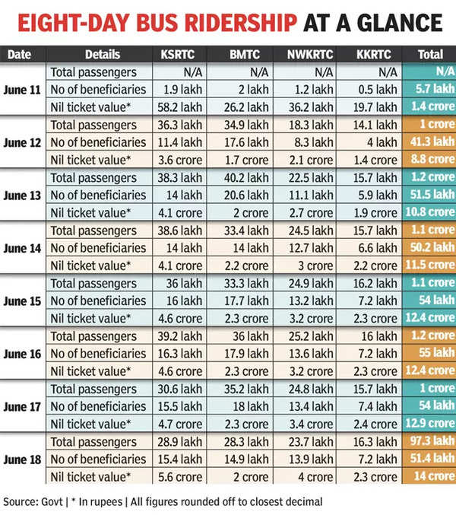

|  |  |  |  |
| --- | --- | --- | --- |
| DATES | TOTAL PASSENGERS | NO OF BENEFICIARIES | NIL TICKET VALUE |
| Jun-11 |  | 570000 | 14000000 |
| Jun-12 | 10000000 | 4130000 | 88000000 |
| Jun-13 | 12000000 | 5150000 | 1080000 |
| Jun-14 | 11000000 | 5020000 | 115000000 |
| Jun-15 | 11000000 | 5000000 | 124000000 |
| Jun-16 | 12000000 | 5500000 | 124000000 |
| Jun-17 | 10000000 | 5400000 | 129000000 |

**KSRTC**

|  |  |  |  |
| --- | --- | --- | --- |
| DATES | TOTAL PASSENGERS | NO OF BENEFICIARIES | NIL TICKET VALUE |
| Jun-11 |  | 190000 | 5820000 |
| Jun-12 | 3630000 | 1140000 | 36000000 |
| Jun-13 | 3830000 | 1400000 | 41000000 |
| Jun-14 | 3860000 | 1400000 | 41000000 |
| Jun-15 | 3600000 | 1600000 | 46000000 |
| Jun-16 | 3920000 | 1620000 | 46000000 |
| Jun-17 | 3060000 | 1550000 | 57000000 |

The above chart and graph shows the data collected of one week free bus ridership. This data is related to KSRTC buses availed from the day of shakti scheme launched. There is a rapid growth in passengers in KSRTC for free buses than paid passengers. It shows the good response from the women than male. The nil ticket value shows rise in the ridership in one week from the launch, and the same way there is down fall in the male ridership i.e beneficiaries decrease day by day.

**BMTC**

|  |  |  |  |
| --- | --- | --- | --- |
| DATES | TOTAL PASSENGERS | NO OF BENEFICIARIES | NIL TICKET VALUE |
| Jun-11 |  | 200000 | 2620000 |
| Jun-12 | 3490000 | 1760000 | 17000000 |
| Jun-13 | 4020000 | 2060000 | 20000000 |
| Jun-14 | 3340000 | 1400000 | 22000000 |
| Jun-15 | 3330000 | 1770000 | 23000000 |
| Jun-16 | 3600000 | 1790000 | 23000000 |
| Jun-17 | 3520000 | 1800000 | 23000000 |

In one week from the launch of shakti scheme have seen more than 50 lakh women utilising the free bus services daily with more than 2.3 crore having benefited as of June 17. According to the latest reports, daily passenger numbers have crossed the one crore mark i.e an increase of about 25% to 45%. The scheme was officially launched on Sunday afternoon, the response on day 1 stood at around 5.2 lakh, but there was an exponential rise in ridership from the second day-exceeding estimation by 21-33% .compared to the first days ridership there was a rapid increase in BMTC ridership in one week. The BMTC officers says that there is 35% increase in ridership in one week of launch of the scheme from government.

**Perception of the Respondents about the Scheme**

Forms response chart. Question title: How has the introduction of free buses in Karnataka impacted your daily commute?
. Number of responses: 51 responses.Based on the responses, it seems that the introduction of free buses in Karnataka has had a varied impact on people's daily commutes. A significant portion, 43.1%, reported improved convenience, likely due to easier access to transportation. However, a considerable percentage, 27.5%, expressed no significant change, indicating that while the buses are free, other factors may still influence their commuting experience. Additionally, 19.6% mentioned decreased travel costs, highlighting a financial benefit. Interestingly, a subset of respondents, 10.8%, expressed dissatisfaction, citing issues such as decreased transport availability and lack of respect for travelers. Overall, while many experienced positive effects, some challenges remain in ensuring a satisfactory commuting experience for all.

Forms response chart. Question title: What is your opinion on the effectiveness of free bus services in reducing traffic congestion?
. Number of responses: 51 responses.Based on the responses, it seems that there is a split opinion on the effectiveness of free bus services in reducing traffic congestion. Approximately 29.4% of respondents find them very effective, while 17.6% consider them somewhat effective. However, 39.2% of respondents are not convinced of their effectiveness, and 13.7% are unsure. This suggests that while there is some support for the idea, a significant portion of people either do not see it as a viable solution or are uncertain about its impact on alleviating traffic congestion.

Forms response chart. Question title: Have you noticed any improvements in air quality since the implementation of free buses?
. Number of responses: 51 responses.Based on the responses, it seems that there is some uncertainty about whether there have been improvements in air quality since the implementation of free buses, with 56.9% of respondents indicating they are not sure. This uncertainty could be due to a lack of clear information or awareness about the impact of free buses on air quality. Only 29.4% of respondents noted noticing improvements, suggesting that while some individuals have observed positive changes, it's not yet a widely recognized phenomenon. Further education and communication about the benefits of free buses for air quality may help clarify perceptions in the future.

Forms response chart. Question title: How frequently do you utilize the free bus services in Karnataka?
. Number of responses: 51 responses.Based on the survey responses from 51 individuals regarding their utilization of free bus services in Karnataka: 13.7% utilize the service daily, 31.4% use it occasionally, 13.7% use it rarely, 41.2% never use it. These results suggest that while a small percentage utilizes the service daily, a significant portion uses it occasionally or rarely, with a notable portion never utilizing it. Possible reasons for non-utilization could include alternative transportation methods, convenience factors, or lack of awareness about the service's availability or benefits.

Forms response chart. Question title: Do you think the provision of free buses has positively impacted the environment?
. Number of responses: 51 responses.It is found that 43.1% believe that the provision of free buses has positively impacted the environment, while 31.4% are unsure. Only 25.5% are inclined to think it hasn't had a positive impact. This suggests that a significant portion of respondents recognize the potential environmental benefits of free bus services, possibly including reduced traffic congestion and emissions. The uncertainty among some respondents could stem from a lack of comprehensive data or varying perceptions of the effectiveness of such initiatives. Overall, the majority view seems to lean towards the positive environmental impact of free bus provision.Forms response chart. Question title: Have you experienced any challenges or drawbacks with the free bus system?
. Number of responses: 51 responses.

Out of the 51 responses, 27.5% of participants reported experiencing challenges or drawbacks with the free bus system, while 33.3% did not encounter any issues. Interestingly, 39.2% indicated that the question was not applicable to them, suggesting a variety of experiences or contexts among respondents. This distribution suggests that while some individuals faced challenges, a significant portion did not, and a notable proportion may not have used the free bus system at all. Further investigation into the specific challenges faced by users could provide valuable insights for improving the system's effectiveness and accessibility.

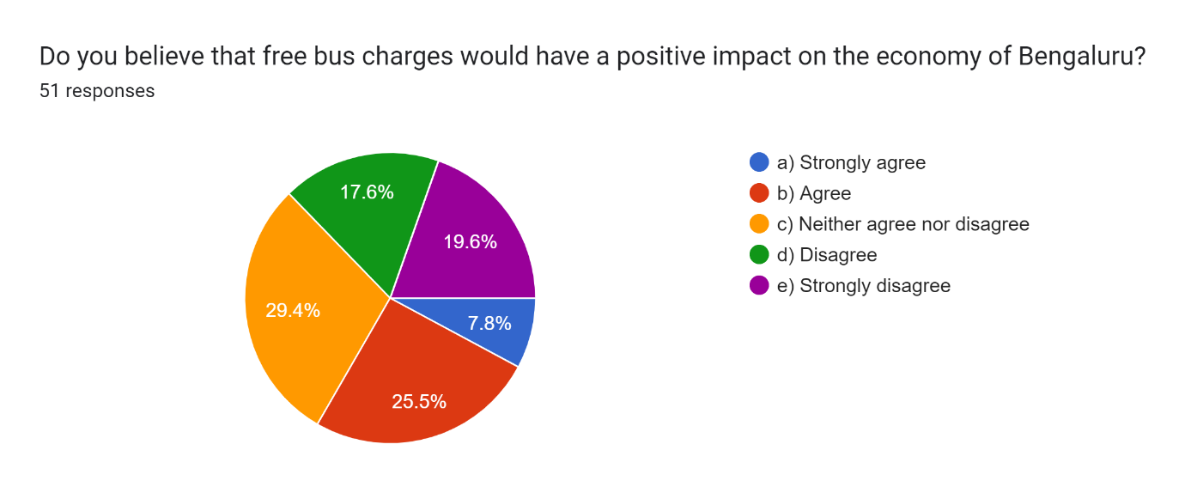The data suggests a mixed response to the proposition of free bus charges in Bengaluru. While 47.2% (a + b) of respondents agree or strongly agree, indicating potential positive economic impact through increased mobility and spending, a notable 37.3% (d + e) either disagree or strongly disagree. This could imply concerns about the feasibility or potential drawbacks of such a policy, such as cost burden or impact on other modes of transportation. Overall, further analysis on the potential economic benefits versus drawbacks, as well as stakeholder consultation, would be crucial for informed decision-making on implementing free bus charges in Bengaluru.

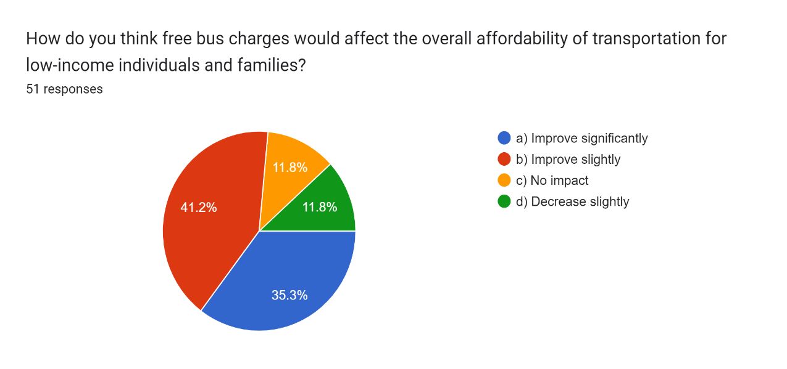Providing free bus charges would likely improve transportation affordability significantly for low-income individuals and families. With no cost for bus fares, they can allocate their limited resources to other essential needs, such as housing, food, and healthcare. This initiative could enhance mobility, enabling access to employment opportunities, education, and essential services, thus potentially lifting some financial burdens. However, the impact might vary depending on factors like the availability and reliability of public transportation infrastructure. Overall, implementing free bus charges could represent a meaningful step toward addressing transportation-related financial challenges faced by low-income communities.

Forms response chart. Question title: How has the availability of free buses impacted your attendance at educational institutions?
. Number of responses: 51 responses.The availability of free buses seems to have had a positive impact on attendance at educational institutions, with a majority of 69.1% indicating either a "Greatly improved" or "Somewhat improved" response. This suggests that removing transportation barriers through free bus services has contributed to increased attendance rates. Additionally, the 21.6% response of "No significant impact" could indicate that for some individuals, transportation costs were not a significant barrier to begin with. Overall, these findings underscore the importance of accessible transportation options in facilitating educational access and attendance.

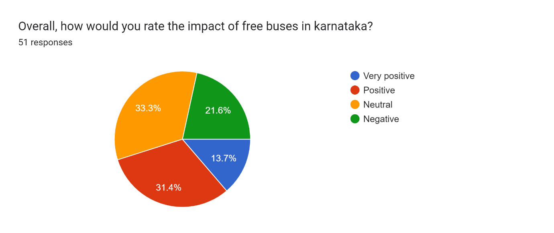The responses indicate a predominantly positive perception of the impact of free buses in Karnataka, with 54.9% of respondents rating it as either "Very positive" or "Positive." This suggests that the implementation of free bus services has been generally well-received and has had a beneficial effect on the population. The 21.6% response of "Neutral" may indicate that some individuals are undecided or unaffected by the presence of free buses. However, the relatively low percentage of 13.7% rating it as "Negative" indicates that there is overall satisfaction or at least no widespread dissatisfaction with this initiative in Karnataka.

To sum up, based upon these responses somehow students have had positive responses as it has helped them in attendance and also, and has slightly been a benefit to low income people, most of the students use bus on daily basis and some occasionally, besides, there is no positive change in traffic congestion. But there are other things that has negatively affected. There is no seats for women after this scheme was introduced, people find it difficult to go in a bus though it is for free. Some of the buses doesn’t give stops as the buses are crowded, this indirectly affects even the men, students of various colleges and schools. After the scheme started, there was an increase in the population and also there was a shortage of buses due to this. So, the transport minister of Karnataka, acknowledged this problem, and said that yearly 25000 buses were there, after the scheme was implemented, the population increased ,they needed 35000 buses more. Some of the house owners have reduced the salary of women who come for household chores because of free bus service. Auto drivers are not getting customers after this implementation, they say around 70% of their business is down. Even private bus operators are being affected especially in Malnad, coastal and old Mysuru region. There has been an increase in demand for housing to transportation hubs, potentially leading to higher rents and housing costs, making it difficult for low income individuals to afford housing in these areas. It would fall as an increased cost to the Government because they would need to find a additional funding to cover the cost of free bus passes. During the interview, a women said that it might affect GDP or what if Karnataka face debt in future.

**Conclusion :**

The implementation of free bus services in Karnataka has shown several positive impacts. Firstly, it has increased accessibility to transportation, particularly for low-income individuals, enhancing their mobility and access to essential services. It encourages more people to use public transport. Additionally, it has stimulated economic activity by facilitating easier travel for workers and consumers, free bus services in Karnataka have demonstrated tangible benefits in terms of social equity, environmental sustainability, and economic development. Therefore it has been successfully impacted on women. But, something which is for free, isn't really free, though women or transgender are being benefited, there are major negative impacts too, buses doesn't give stops at the time due to many reasons, especially during peak hours it will affect people who go to work, or students who go to their schools and colleges. Even though men pay the ticket, they won't be able to reach on time. It has affected businesses of auto drivers and private bus operators since the scheme was introduced, it has strained the state's budget, diverting funds from other essential services. Secondly, it has caused overcrowding and decreased the quality of service due to increased demand without proportional resources. Additionally, the absence of fare revenue has led to a decline in maintenance and expansion of the bus fleet, exacerbating existing transportation challenges. Suggestions what we got from interviews including our perceptions is that they could have done something better with this implementation which is by setting an age limit for example above 60, free ticket. And passes for others Or could have given zero fare ticket to only low income people, based on some criteria, or they could have done some better decisions in education sector. As a result, to see overall it has only been good to women for free' ticket but has more drawbacks as well, that would affect most of the people including the state government.

References:

* The Indian Express. (2021, November 2). Free bus travel for women: What Karnataka's 'Shakti' scheme means for finances. Indian Express. <https://indianexpress.com/article/explained/shakti-scheme-free-bus-travel-finances-karnataka-transport-8671672/>
* The Hindu. (2022, February 15). Shakti Scheme: No smart cards, Karnataka RTCs to opt for passes. The Hindu. <https://www.thehindu.com/news/national/karnataka/shakti-scheme-no-smart-cards-karnataka-rtcs-to-opt-for-passes/article67181024.ece>
* LiveMint. (2022, March 31). Netizens share photos of free bus tickets as Karnataka launches travel scheme; others slam 'freeloading'. LiveMint. <https://www.livemint.com/news/india/netizens-share-photos-of-free-bus-tickets-as-karnataka-launches-travel-scheme-others-slam-freeloading-11686474205202.html>
* Times of India. (2022, March 27). Architectural brilliance meets sustainable luxury: Explore life beyond the ordinary at Mantra Magnus. Times of India. <https://timesofindia.indiatimes.com/spotlight/architectural-brilliance-meets-sustainable-luxury-explore-life-beyond-the-ordinary-at-mantra-magnus/articleshow/108316383.cms>
* Dasgupta, A., & Datta, A. (2023). *Gendered Transport Subsidy and its Short Run Effect on Female Employment: Evidence from Delhi’s Pink Pass Scheme*. Ashoka University Discussion Paper.
* Lehe, L., & Pandey, A. An Equilibrium Model of a Bus Route with an Application to Fare-Free Transit. *Available at SSRN 4697945*.
* Padmavathy, R. D. (2017). Empowerment of Women through Gender Equality in Education. *South Asian Journal*, *17*(1), 79.