SMART PARKING SYSTEM

DR.N.Sambasivarao Professor and Head of the Deparment

Of Electrical and Electronics Engineering.NRI Institute of Techonology *(Automonous)* vijayawada,India

email [:-nsraohodeee@gmail.com](mailto:-nsraohodeee@gmail.com)

T.Hena Evangaline

UG Student Of Electrical and Electronics Engineering. NRI Institute of Techonology *(Automonous)* vijayawada,India

email:- [henaevangelinethodeti@gmail.com](mailto:henaevangelinethodeti@gmail.com)

R.Raghunath sastry Associate professor Of Electrical and Electronics Engineering .NRI Institute

of Techonology *(Automonous)*

vijayawada,India

email :- [raghunath.rrs@gmail.com](mailto:raghunath.rrs@gmail.com)

B.priyanka

UG Student Of Electrical and Electronics Engineering. NRI Institute of Techonology *(Automonous)* vijayawada,India

email :- [priyankabommali2@gmail.com](mailto:priyankabommali2@gmail.com)

L.Sai nagarjun

UG Student Of Electrical and Electronics Engineering .NRI Institute of Techonology*(Automonous)* vijayawada,India

email:- [sainagrjunlukka@gmail.com](mailto:sainagrjunlukka@gmail.com)

B.Praneeth kamal,S.Sobhana chalam UG Students Of Electrical and Electronics Engineering.

NRI Institute of Techonology *(Automonous)* vijayawada,India

praneethbudalar697@gmail.com,Sobha [nachalamsaggurthi77@gmail.com](mailto:nachalamsaggurthi77@gmail.com)

***ABSTRACT: Recently parking has become a serious issue and even worsen, because of the increasing number of automobiles everywhere. In this project we propose an IoT based guidance for user to monitor the parking space for the vehicle and for managing and monitoring free parking space, it provides an intelligent solution. It aims at implementing smarter and better parking guidance mechanism which significantly reduces difficulty in conventional parking system. The system can monitor the state of every parking slot by deploying a sensor node on the slot. Accordingly sensor senses the status of parking slot and send status to central node server controller. The MCU collect the data from all sensor node and upload to the server where user can check the parking status from anywhere using internet by using the thing view app..***

*keywords: smart parking, Microcontroller, ardunio uno, thing speak cloud, online parking*

Introduction:-

Now a days, main problem in malls, function halls and etc., is parking. It is due to the lack of sufficient parking space. Now a days the vehicles in a family are greater than the head count of the family members, and due to this the vehicles are also increased in the country, which leads to the parking scenario which is unhappily falling short to the current requirements in the country. Due to this parking is difficult and it also increases the time needed to park the vehicle with increase in the fuel consumption of the vehicle. And during the working days the companies and offices are facing the problem of the parking in urban areas. Now a days vehicles are most affordable to the low income group families also and the vehicles especially the cars are taking lot of space. Due to the increase in vehicles the parking space is also not sufficient in this congested cities. Whether at a shopping malls, stations and airport, problems with parking is a big issue. Most of the time people spend their time on searching parking, to park their vehicles. Thus, lot of congestion occurs in the traffic which leads to a tedious job to find the parking space to park their vehicle. The most traffic occurs only because of vehicle congestion in the urban

areas thus people are wasting time in searching the parking area abnormally to park their vehicles. And one more issue is also added to this is pollution, which effects the entire environment due to this increase in vehicles

# RECENT STUDIES:

Some of the recent studies shows about the parking management and the slot management. And also gives the information about reservation based parking management.

1. Chi-Hung Chuang, Luo-Wei Tsai developed a monitoring system for parking lot management system and the result of access management is reduced human resource, through the recognition car license. The constraint of this project is the recognition process takes more time to compare.
2. Mingkai Chen developed a parking guidance and information system based on wireless sensor system and the information is transmitted between the nodes and processing the data, and the information passes to the display drivers. In this the constraint is, if the main node of the sensor system fails means the total block is failed.
3. Huang Cai-mei Presented an idea for reserving the parking slots and reversed cars look for the intelligent terminals to achieve the parked position of vehicles and get the guide route, so that user can quickly find the parking area

# Benefits of Implementing Online Parking system:

1. No need to waste time on looking for parking.
2. Reduction in time and fuel spent by road user searching for parking.
3. Less queues as motorists will be guided to parking areas.
4. Proper selection of vehicle according to the availability of parking space.
5. Online parking results in higher

## BLOCK DIAGRAM OF SMART

**PARKING SYSTEM**

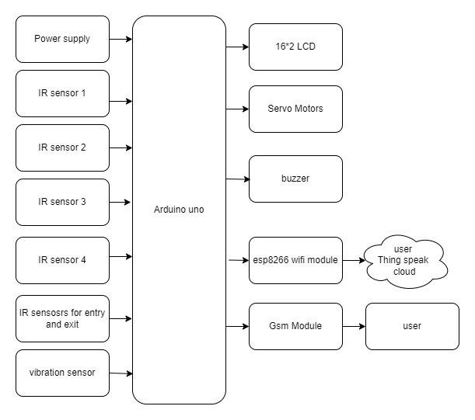

Fig 1: Block digram

***components:-***

### Arduino

* + Arduino is open source physical processing which is base on a microcontroller board and an incorporated

development environment for the board to be programmed. Arduino gains a few inputs, for example, switches or sensors and control a few multiple outputs, for example, lights, engine and others. Arduino program can run on Windows, Macintosh and Linux operating systems (OS) opposite to most microcontrollers’ frameworks which run only on Windows



## ARDUINO UNO:

The Arduino Uno is a microcontroller board based on the ATmega328 (datasheet). It has 14 digital input/output pins (of which 6 can be used as PWM outputs), 6 analog inputs, a 16 MHz crystal oscillator, a USB connection, a power jack, an ICSP header, and a reset button. It contains everything needed to support the microcontroller; simply connect it to a computer with a USB cable or power it with a AC-to-DC adapter or battery to get started. The Uno differs from all preceding boards in that it does not use the FTDI USB-to-serial driver chip. Instead, it features the Atmega8U2 programmed as a USB-to-serial converter.

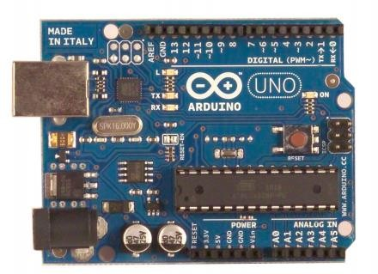

Fig 2:Arduino uno

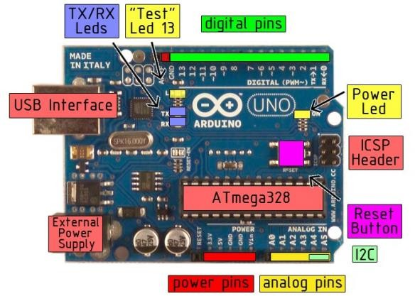

Fig3:Techincal specification of arduino

### ATMEGA Controller:-

* + [chip](https://en.wikipedia.org/wiki/Integrated_circuit) [microcontroller](https://en.wikipedia.org/wiki/Microcontroller) created by [Atmel](https://en.wikipedia.org/wiki/Atmel) in the [mega](https://en.wikipedia.org/wiki/MegaAVR) [AVR](https://en.wikipedia.org/wiki/MegaAVR) family (later [Microchip Technology](https://en.wikipedia.org/wiki/Microchip_Technology) acquired Atmel in 2016). It has a [modified Harvard](https://en.wikipedia.org/wiki/Modified_Harvard_architecture) [architecture](https://en.wikipedia.org/wiki/Modified_Harvard_architecture) [8-bit](https://en.wikipedia.org/wiki/8-bit) [RISC](https://en.wikipedia.org/wiki/Reduced_instruction_set_computer) processor core. [6]
  + **AT Mega Microcontrollers** belong to the **AVR family** of microcontrollers and is manufactured by **Atmel Corporation**. An AT Mega Microcontroller is an **8-bit microcontroller** with Reduced Instruction
  + Set (**RISC**) based Harvard Architecture.[6]As in fig

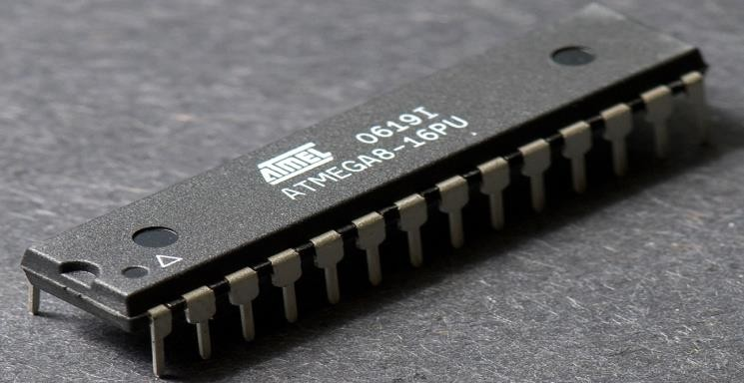

Fig 4:-At mega controller

overcurrent. Although most computers provide their own internal protection, the fuse provides an extra layer of protection. If more than 500 mA is applied to the USB port, the fuse will automatically break the connection until the short or overload is removed.

**Physical Characteristics:**

* A The maximum length and width of the Uno PCB are 2.7 and 2.1 inches respectively, with the USB connector and power jack extending beyond the former dimension. Four screw holes allow the board to be attached to a surface or case. Note that the distance between digital pins 7 and 8 is 160 mil (0.16"), not an even multiple of the 100 mil spacing of the other pins

### Power Supply

* In Power supply is a reference to a source of electrical power. A device or system that supplies electrical or other types of energy to an output load or group of loads is called a power supply unit or PSU. The term is most commonly applied to electrical energy supplies, less often to mechanical ones, and rarely to others

### programing :

The Arduino Uno can be programmed with the Arduino software. The ATmega328 on the Arduino Uno comes preburned with a bootloader that allows you to upload new code to it without the use of an external hardware programmer. It communicates using the original STK500 protocol (reference, C headerfiles). You can also bypass the bootloader and program the microcontroller through the ICSP (InCircuit Serial Programming) header; see these instructions for details. The ATmega16U2 (or 8U2 in the rev1 and rev2 boards) firmware source code is available . The ATmega16U2/8U2 is loaded with a DFU bootloader, which can be activated by: On Rev1 boards

### Automatic (Software) Reset:

Rather than requiring a physical press of the reset button before an upload, the Arduino Uno is designed in a way that allows it to be reset by software running on a connected computer. One of the hardware flow control lines (DTR) of theATmega8U2/16U2 is connected to the reset line of the ATmega328 via a 100 nanofarad capacitor. When this line is asserted (taken low), the reset line drops long enough to reset the chip. The Arduino software uses this capability to allow you to upload code by simply pressing the upload button in the Arduino environment. This means that the bootloader can have a shorter timeout, as the lowering of DTR can be well- coordinated with the start of the upload.

### USB Overcurrent Protection

The Arduino Uno has a resettable polyfuse that protects your computer's USB ports from shorts and

* ​
* This power supply section is required to convert AC signal to DC signal and also to reduce the amplitude of the signal. The available voltage signal from the mains is 230V/50Hz which is an AC voltage, but the required is DC voltage(no frequency) with the amplitude of +5V and +12V for various applications.

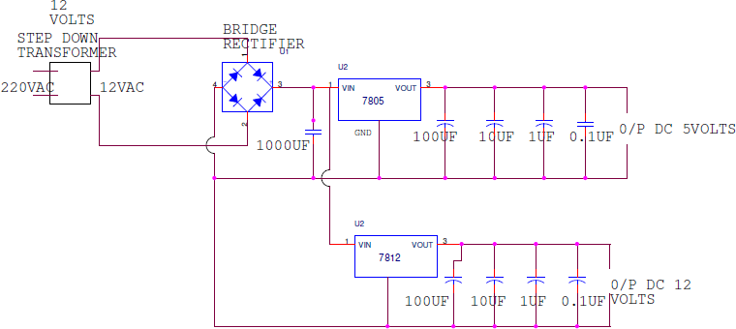

Fig 5: power supply

### Circuit Explanation

**1) Transformer**

A transformer is a device that transfers electrical energy from one circuit to another through inductively coupled electrical conductors. A changing current in the first circuit

(the primary) creates a changing magnetic field; in turn, this magnetic field induces a changing voltage in the second circuit (the secondary). By adding a load to the secondary circuit, one can make current flow in the transformer, thus transferring energy from one circuit to the other.

The secondary induced voltage VS, of an ideal transformer, is scaled from the primary VP by a factor equal to the ratio of the number of turns of wire in their respective windings:

 \frac{V_{S}}{V_{P}} = \frac{N_{S}}{N_{P}} 

### Basic principle

The transformer is based on two principles: firstly, that an electric current can produce a magnetic field (electromagnetism) and secondly that a changing magnetic field within a coil of wire induces a voltage across the ends of the coil (electromagnetic induction). By changing the current in the primary coil, it changes the strength of its magnetic field; since the changing magnetic field extends into the secondary coil, a voltage is induced across the secondary.

A simplified transformer design is shown below. A current passing through the primary coil creates a magnetic field. The primary and secondary coils are wrapped around a core of very high magnetic permeability, such as iron; this ensures that most of the magnetic field lines produced by the primary current are within the iron and pass through the secondary coil as well as the primary coil.

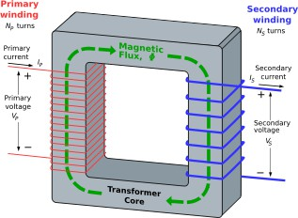

Fig6: Tranformer Induction law

The voltage induced across the secondary coil may be calculated from Faraday's law of induction, which states that:

 V_{S} = N_{S} \frac{\mathrm{d}\Phi}{\mathrm{d}t}  Where VS is the instantaneous voltage, NS is the number of turns in the secondary coil and Φ equals the magnetic flux through one turn of the coil. If the turns of the coil are oriented perpendicular to the magnetic field lines, the flux is the product of the magnetic field strength B and the area A through which it cuts. The area is constant, being equal to the cross-sectional area of the transformer core, whereas the magnetic field varies with time according to the excitation of the primary. Since the same magnetic flux passes through both the primary and secondary coils in an ideal transformer, the instantaneous voltage across the primary winding equals

 V_{P} = N_{P} \frac{\mathrm{d}\Phi}{\mathrm{d}t} 

Taking the ratio of the two equations for *VS* and *VP* gives the basic equationfor stepping up or stepping down the voltage

 \frac{V_{S}}{V_{P}} = \frac{N_{S}}{N_{P}} 

Servo motor:

## ESP32

* The ESP32 is programmed to control the servo motor, which is used to open and close a barrier arm. The IR sensor is used to detect the presence of a car. When a car approaches the parking space, the IR sensor sends a signal to the ESP32. The ESP32 then activates the servo motor to open the barrier arm. The car can then enter the parking space.



### Electricalblockdiagram

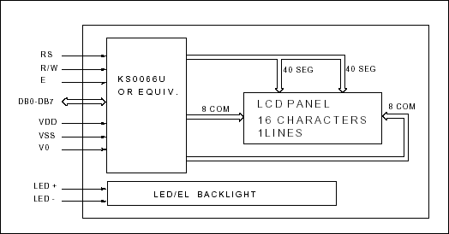

Fig 7 :electrical block diagram

### Power supply for lcd driving:

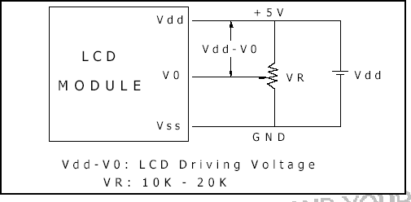

IMPLEMENTATION & WORKING

The Proposed System

Finding a place to park cars involves three-stage. First, the parking area which has Arduino devices along with the sensors to interact between the user and the parking area. The second stage contains the cloud services which act as an intermediary between the user and the parking area. The third stage is the user side. The user gets a notification of the availability via mobile applications. For each parking region, Arduino sensors are positioned, and the sensors detect the number of parking slots, the number of free, and booked slots. WIFI module is used for communication between the mobile app and sensors

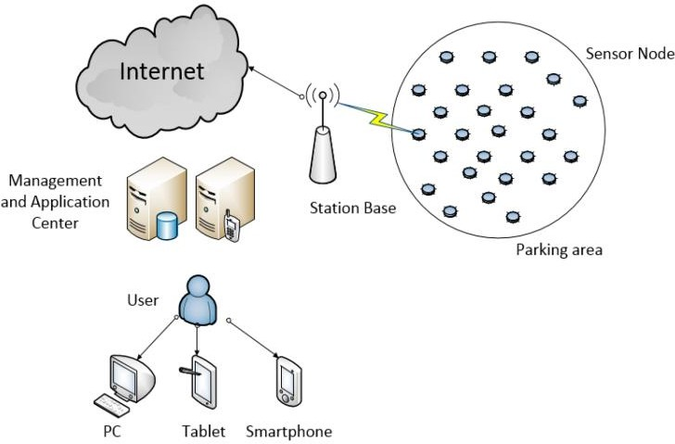

Fig 8:woring principle

# CONCLUSION:

* The growth of Internet of Things have given rise to New possibilities in terms of smart cities. Smart parking facilities and traffic management systems have always been at the core of constructing smart cities. In this paper, we address the issue of parking and present an IoT based web application smart parking system. The system that we propose provides real time information regarding availability of parking slots in a parking area. Users from any locations could monitor parking slot availability for them by the use of our web application. The efforts made in this project are indented to improve the parking facilities of a city and thereby aiming to enhance the quality of life of its people.
* FUTURE SCOPE:
* In the future scope a mobile/ web application can be developed for booking the slots from the mobile/web from any place through the internet of things(IOT)

APPLICATIONS:-

* Infrared Filters
* Night vision
* Thermography
* Other imaging
* Tracking
* Heating
* Communications
* Spectroscopy
* Meteorology
* Climatology
* Astronomy
* Art history
* Biological systems REFRENCES:-
  1. Abhirup Khanna, R. A. (2016). IoT based Smart Parking System. International Conference on

Internet of Things and Applications (IOTA) . Pune: IEEE

* 1. Deng, D. (2015). A Cloud-Based Smart-Parking System Based on Internet-of-Things

TechnologiesIEEE , 11.

* 1. Orrie, B. S. (2015). A Wireless Smart Parking System. IECON (p. 5).
  2. KhaoulaHassoune, W. D. (2016). Smart parking

Systems:A Survey .

* 1. Wael Alsafery, B. A. (2018). Smart Car Parking System Solution for the Internet of Things in Smart

Cities.

* 1. RachapolLookmuang, K. N. (2018). Smart Parking

Using IoT Technology .

* + 1. `