**A Futuristic Solar-Powered Wireless EV Charging Oasis**

**V.Ramanathan*1, S.Rajapriyan*2, T.Abdul Rahman*3. C.Valli *4**

*1,2,3 UG Student, Department of Electrical and Electronics Engineering, Sri Venkateswaraa College of Technology, Sriperumbudur, Kanchipuram, Tamil Nadu, India.

*4 Associate professor, Department of Electrical and Electronics Engineering, Sri Venkateswaraa College of Technology, Sriperumbudur, Kanchipuram, Tamil Nadu, India.

**ABSTRACT:**

This proposed work enlightens design of solar-powered charging station for charging of Electric vehicle which solves the problem of utilization of fuel and pollution. Electric vehicles are helpful in reducing travel cost as they are run by solar power which provides more environmental benefits other than fuel. The system will consist of solar panels to harness solar energy, a wireless charging pad for convenient EV charging, and IOT devices for monitoring and control. The system will also include a mobile app for users to monitor charging status and manage charging schedules. The goal is to provide an eco-friendly and efficient charging solution for electric vehicles, promoting sustainable transportation. The system demonstrates how electric vehicles can be charged at charging station under inductive power transfer (IPT) method. The system also implements a solar-powered wireless charging system for electric vehicles which can be integrated in the station.

**Index Terms:** Solar power, Wireless charging, Electric vehicle, IOT, IPT method.

**INTRODUCTION:**

The increasing adoption of electric vehicles (EVs) has highlighted the need for efficient and sustainable charging infrastructure. Traditional EV charging stations are often limited by their reliance on grid electricity, which can be costly and environmentally unsustainable. To address these challenges, this project proposes a solar-powered wireless EV charging station.

This charging station utilizes solar energy as its primary power source, making it cost-effective and environmentally friendly. By harnessing the sun's energy, the station can operate off-grid, providing a sustainable charging solution for EV owners. The station's wireless charging technology eliminates the need for physical connections, enhancing user convenience and reducing wear and tear on charging cables.

In addition to its solar and wireless capabilities, the charging station will be equipped with IOT devices for remote monitoring and control. Users will be able to check the station's availability, monitor their vehicle's charging status, and schedule charging sessions through a mobile app. This connectivity also enables the station to optimize its energy usage based on solar availability and grid demand, ensuring efficient operation.

Overall, this project aims to demonstrate the feasibility and benefits of a solar-powered wireless EV charging station. By combining renewable energy, wireless technology, and IOT connectivity, the station offers a sustainable and user-friendly solution for EV charging, contributing to a greener and more efficient transportation ecosystem.

**LITERATURE SURVEY:**

**Vijay Kumar[3], [May, 2022 ]** explain a wireless power transmission charging circuit for electric vehicles to increase the battery life of the vehicle and also to sort out the issue of battery overheating due to plugged in charging. In plugged in charging heat losses are more and it directly affects the life of the battery so that Battery thermal management is the main issue for electric vehicles. When we use wireless technology for the charging very less amount of heat is produced comparatively.

**Nishant Awdeshkumar Pandey[1],[July, 2022]** In this study, we apply the Internet of Things (IOT) model to managing electric vehicle (EV) charging in system. The mobile application manages the user authentication mechanism to initiate the electric vehicle charging process, where a sensor is used to measure the current and based on the microcontroller, the device establishes communication data with the mobile application. A user interface has been developed to visualize the process happening, show the various sensor data to the user and also send alerts.

**Rahul Singh[1],[January, 2020]** says that the Wireless power transfer (WPT or wireless charging) is a technology that allows transmission of energy through an air gap to a load without any interconnecting cables. The removal of ports and cables makes products less obtrusive and makes the recharging or powering of devices more convenient. WPT methods have been employed in a wide range of applications such as recharging smartphone and electric vehicles.

**N.UthayaBanu[2],[January, 2018]** This study representing the various technologies related to Wireless Power Transfer System, which is used to avoid the flux leakage during the transmission of power and to operate the cars with high efficiency and improve the quality parameters. It also shows the progress of generating power source through renewable energy.

**Akshya K. Swain [1] ,[February 2014]** explain bidirectional IPT system in which wireless power transfer is possible easily between the two sides which are separated by air gap, through weak magnetic coupling. Without an accurate mathematical model system is difficult to design and control.

**METHODOLOGY:**

Inductive power transfer (IPT) is a method of wirelessly transmitting electrical power from a charging station to an electric vehicle (EV) through electromagnetic induction. This technology uses a primary coil in the charging station to generate a magnetic field and a secondary coil in the EV to receive the power. When the two coils are in close proximity, the magnetic field induces an electric current in the secondary coil, which is then used to charge the EV's battery.

IPT offers several advantages over traditional wired charging methods, such as increased convenience, safety, and reliability. Since there are no physical connections between the charging station and the EV, IPT eliminates the need for plug-in cables, reducing wear and tear and making the charging process more user-friendly. IPT also reduces the risk of electric shock and fire hazards associated with exposed electrical connections.

However, IPT also has some limitations, such as lower efficiency compared to wired charging and the need for precise alignment between the coils to transfer power effectively. Despite these challenges, IPT is a promising technology for wireless EV charging and is being actively researched and developed to improve its efficiency and practicality.

**BLOCK DIAGRAM:**

This is the block diagram of our system This system consists two part of portions.

1. Transmitting part
2. Receiving part

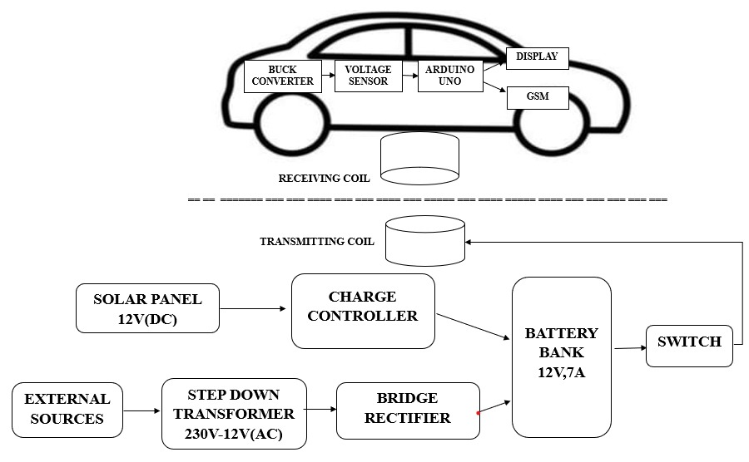

1. **Transmitting part:**

The solar panel gets charge from sunlight. Then the power is supplied to battery through the charge circuit, this charge circuit normally acts as AC to DC converter but, this case we are change the polarity of the circuit and this act as polarity corrector. Also The battery is charge from external power supply. Then the ES is fed to transformer is step down the voltage and bridge rectifier is used to converts AC to DC. This DC voltage is charge the battery. The battery is fed to the inverter to converts DC to AC and supply to transmitting coil. This coil is transfer the power to Receiving coil .

1. **Receiving part:**

The power is received in receiving coil from the transmitting coil. The received power is converted to AC to DC and fed to the battery is charged. The voltage sensor used to measure the voltage value. The GSM is used to send the massage to user. The user to monitor the charging status and parameters, etc.

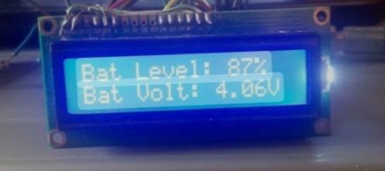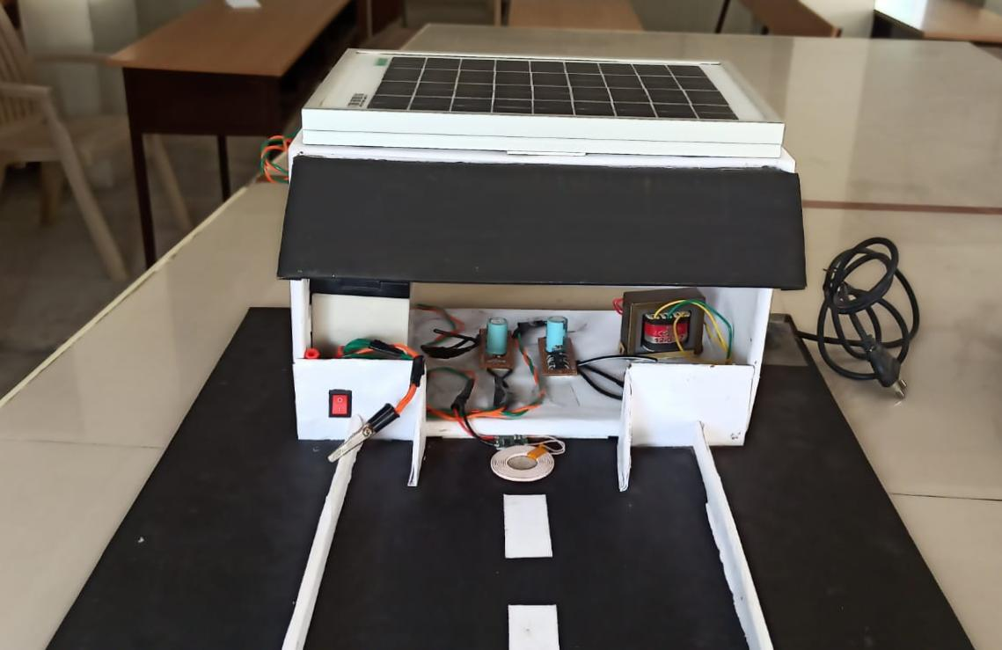**RESULTS:**

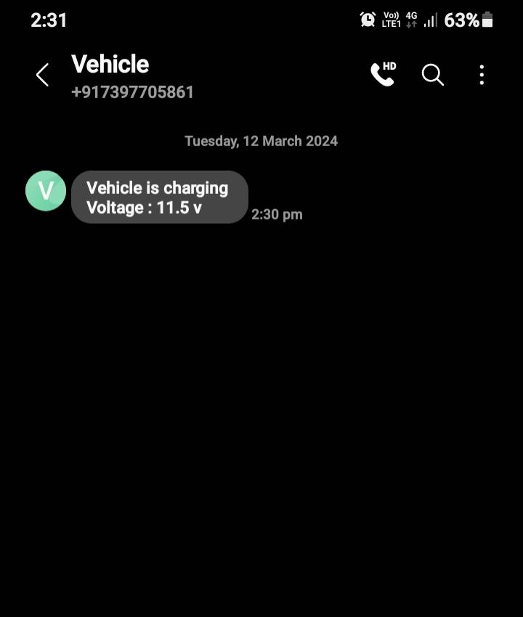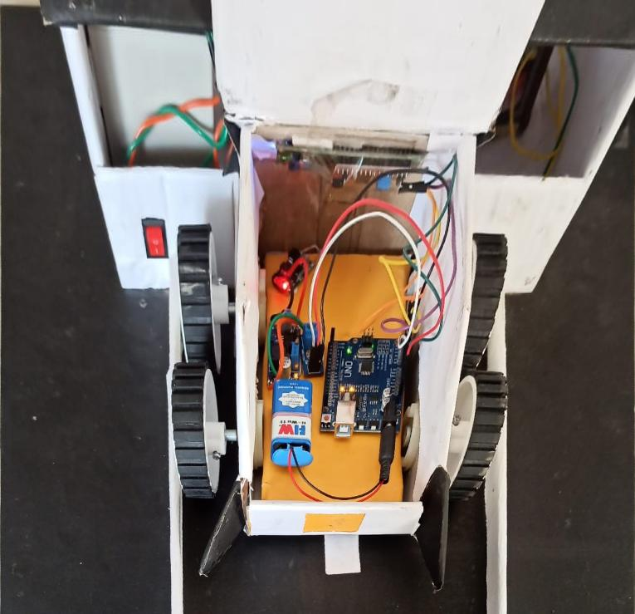

**CONCLUSION:**

In conclusion, the development of a solar-powered wireless electric vehicle (EV) charging station has been a significant endeavor in promoting sustainable transportation. The project successfully demonstrated the feasibility and benefits of utilizing solar energy for EV charging, reducing reliance on grid electricity and promoting environmental sustainability.

The wireless charging technology implemented in the station offers convenience and ease of use for EV owners, eliminating the need for physical connections and reducing wear and tear on charging cables. The integration of IOT devices has enabled remote monitoring and control of the station, enhancing its efficiency and user experience.

Overall, the project has showcased a practical and eco-friendly solution for EV charging, highlighting the potential of renewable energy sources and innovative technologies in shaping the future of transportation. The success of this project paves the way for further advancements in sustainable infrastructure and reinforces the importance of adopting green technologies in mitigating climate change

**FUTURE SCOPE:**

The future of solar-powered wireless electric vehicle (EV) charging stations holds significant promise, with several key areas for development and improvement. Efficiency enhancements in solar panels and wireless charging technology can lead to faster and more effective charging, enhancing the overall user experience. Advances in battery technology, such as higher energy density and faster charging capabilities, can make EV charging more convenient and efficient. Integrating charging stations with smart grid technology can optimize charging based on energy demand, availability of renewable energy, and electricity rates, reducing costs and environmental impact. Vehicle-to-Grid (V2G) integration allows EVs to store energy and return it to the grid when needed, increasing grid stability. Data analytics and IOT technology can improve the monitoring, management, and maintenance of charging stations, optimizing their performance and reliability. Additionally, government policies and regulations that support the adoption of solar-powered wireless EV charging stations can accelerate their deployment and growth. Overall, these advancements offer opportunities for innovation and improvement, benefiting both users and the environment.

**REFERENCE:**

1. Bugatha Ram Vara prasad, “Solar-Powered BLDC Motor with HCC Fed Water Pumping System for Irrigation,” Int. J. Res. Appl. Sci. Eng. Technol., vol. 7, no. 3, pp. 788–796, 2019, doi: 10.22214/ijraset.2019.3137.
2. N. Uthaya Banu, U. Arunkumar, A. Gokulakannan, M. K. Hari Prasad and A. B. Shathish. Sharma “Wireless Power Transfer in Electric Vehicle by Using Solar Energy” Asian Journal of Electrical Sciences ISSN:2249-6297,Vol.7,No.1,2018,pp.6-9
3. P Alanson Sample, Student Member, IEEE, David A. Meyer, Student Member, IEEE, and Joshua R. Smith, Member, “IEEE Analysis, Experimental Results, and Range Adaptation of Magnetically Coupled Resonators for Wireless Power Transfer”, IEEE Transactions on Industrial Electronics, Vol. 58, No. 2, Feb, 2011.
4. V. Etacheri, R. Marom, R. Elazari, G. Salitra, and D. Aurbach, “Challenges in the development f advanced Li-ion batteries: A review”, Energy Environ. Sci., Vol. 4, No. 9, pp. 3243–3262, 2011.
5. MDPI journal, Energies, Jose P. Martins , Joao C. Ferreira , Vitor Monteiro, Jose A. Afonso and Joao L. Afonso, Article, IOT and Paradigms for EV Charging System.
6. Al-Fuqaha, A.; Guizani, M.; Mohammadi, M.; Aledhari, M.; Ayyash, M. Internet of things: A survey on enabling technologies, protocols, and applications. IEEE Common. Surv. Tutor. 2015, 17, 2347–2376.
7. Gallardo-Lozano, Milanes-Monster, Guerrero-Martinez, Three-phase bidirectional battery charger for smart electric vehicles, International Conference-Workshop 2021.
8. Akshya K. Swain ,”Modeling, Sensitivity Analysis, and Controller Synthesis of Multipick up Bidirectional Inductive Power Transfer Systems”. IEEE TRANSACTIONS ON INDUSTRIAL INFORMATICS, VOL. 10, NO. 2, MAY 2014.