REVIEW ON FORMULATION OF HERBAL FACEPACK USING TERMERIC,RED SANDLE WOOD AND HIBISCUS ROSA SINESIS, ASHWAGANDHA,ALOVERA,ROSE WATER.

AUTHOR,S NAME:-

MISS. NIDHANE POOJA SANDIP(1).

MISS.LOHALE RENUKA FAKIRA(2),

MISS.DENGALE PRANALI SHANKAR(2) ,

MISS.KADNOR SONAL RAJENDRA(2) ,

Dr. NITIN BALKRISHNA AHER(2)

AFFLIATION:-

1) Principal M. Pharm, Ph.D, Department of Pharmacognosy, Ashwin College Of Pharmacy, Manchi Hills.

2) Final Year B.Pharmacy, Ashwin College Of Pharmacy, Manchi Hill.

Abstract:-

Everybody Wants To Get A Fair And Charming Skin. Now A Day, Acne, Black Heads, Pimples Are Common Among Persons Who Suffer From It. According To Ayurveda, Skin Problems Are Normally Due To Impurity In Blood. Herbal Face Packs Are Used To Simulate Blood Circulation, Rejuvenate The Muscles And Help To Maintain The Elasticity Of The Skin And Remove Dirt From Skin Pores.

The Aim Of This Work Is To Formulate And Evaluate An Herbal Face Pack For Glowing Skin By Using Natural Herbal Ingredients.

The Natural Herbal Ingredients Such As Termeric, RedSandalwood, Orange Peel, Aloevera, Ashwagandh Hibiscus Rosa-sinenrisAnd Rose Water for the application .

Thus, In The Present Work, We Formulated A Herbal Face Pack Which Can Be Easily Made With The Easily Available Ingredients.

After Evaluation, We Found Good Properties For The Face Packs, Free From Skin Irritation And Maintained Its Consistency Even After Stability Storage Conditions. Results Of The Study Scientifically Verified That Herbal Face

Pack Having Enough Potential To Give Efficient Glowing Effect On Skin. The Overall Study Is Useful To Substantiate Product Claims Due Its Useful Benefits On The Human Beings.

**Keywords –** Herbal Face Pack , Glowing , Natural ,Pimple , Irritancy , Anti Acne , Antibacterial

**Introduction:-**

Since From Ancient Period Of Time, People Are Aware Of The Use Of Plants For The Healthy, Glowing And Beautiful Skin Cosmetics Are Products Used Clean, Beautify And Promote Attractive To Appearance Cosmetics

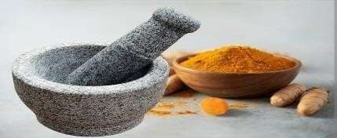Are Commercially Available Products That Are Used To Improve The Appearance Of The Skin By Action Of Cleansing. Beautifying, Promoting Attractiveness. From The Ancient Time, Different Herbs Are Used For Cleaning, Beautifying And To Manage Them Face Skin Is The Major Part Of The Body, Which Indicates The Health Of An Individual Skin Of The Face Is The Major Part Of The Body, Which Is A Mirror, Reflecting The Health Of An Individual A Balanced Nutrition Containing Amino Acids, Lipids And Carbohydrates Are Required For The Skin Keep It Clear Glossy And Healthy. Herbal face packs are helps to reduce wrinkles, pimples, acne and dark circles. Also increase the fairness and smoothness of skin. It also helps someone to boost their confidence. Ayurveda is the most useful and successful means for achieving this purpose

# Objectives :

* To formulate a face pack with flax seed it was used as Anti-inflammatory.
* To formulate and develop safe, effective, and stable face pack
* To formulate and evaluate having acceptable properties.
* To improve patient /Customer compliance.
* To help prevent acne, clear oiliness.
* To perform stability studies of the formulation as per ICH guidelines.

# Herbal face pack marketed prepartions:

1. Himalaya oil clear face pack :

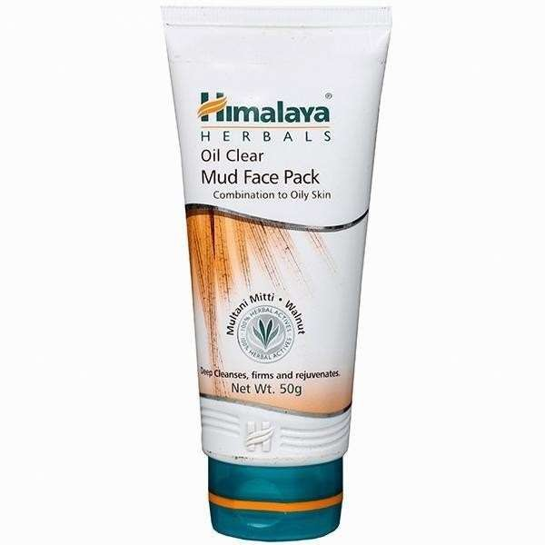

1. cucumber face pack :

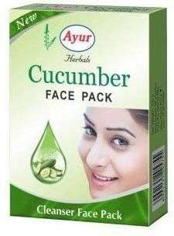

1. Mamaearth face pack :

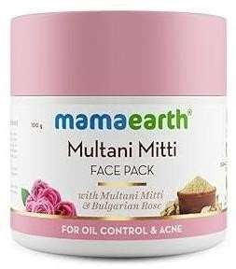

1. Ayur Face Pack :

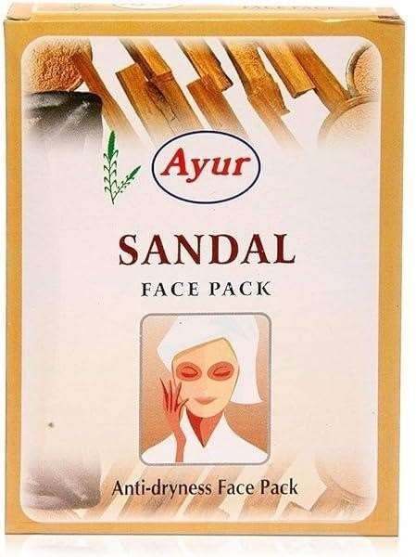

## MATERIALS AND METHODS

**Herbal Ingredients Profile**

### TURMERIC :

**Botanical Name :** Curcuma Longa

**Family :** Zingiberaceae

**Genus :** Curcuma

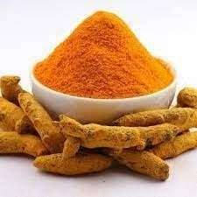

Turmeric Has Anti-Inflammatory And Anti-Allergic Activity. It Is Best Blood Purifier And Helps In Wound Healing. It Possesses Best Blood Purification Action So It Is Used In All Disease With Blood .

Impurities Origin.HaridraIs Rejuvenator Of Skin And Revitalizes Skin; Delays The Signs Of Aging Like Wrinkles. It Is A Very Good Antiinflammatory And Anti-Allergic Agent .

### RED SANDALWOOD :

**BotanicalName :** Pterocarpus Santalinus

**Family :** Fabaceae

**Genus**:Pterocarpus santalinus

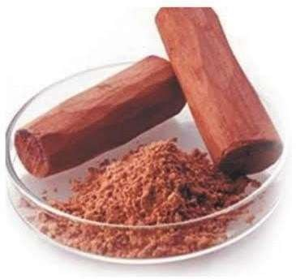

There are many advantages of using red sandalwood on the skin. It nourishes our skin and keeps it healthy, fair and glowing. Red sandalwood is also considered as a savior for dull, lifeless skin. It is one of the best natural ingredients for skin whitening and anti aging.

### HIBISCUS ROSA SINESIS

**Botanica lName :** Hibiscus Rosa - Sinensis

**Family:** Malvaceae

**Genus** : Hibiscus

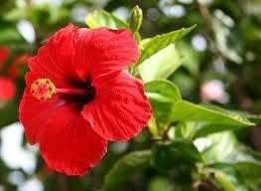

Lastly, Hibiscus has a naturally high mucilage content, a sticky substance produced by plants that help with the storage of water and food.

Mucilage makes a fantastic natural skin moisturiser that is gentle on sensitive skin. This high mucilage content of Hibiscus enhances the skin’s ability to retain moisture, which is a key factor in retaining a youthful complexion.

### 4 . ASHWAGANDHA

**BotanicalName**: Withaniasomnifera solanaceae withaania

**Family**: solanaceae

**Genus**: withaania

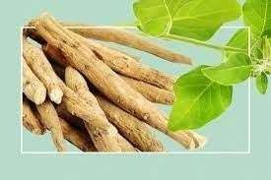

Ashwagandha encourages the production of natural oils that the skin needs. It helps in the reduction of acne, while keeping the skin soothed, clarified, and replenished. It is known to possess anti-ageing properties which keep the elasticity of the skin intact .

### .ALOE VERA :

**Botanical Name**:Aloe Barbadensis Miller

**Family**:Aloaceae **Genus**:Aloe

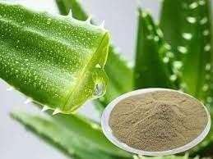

It’s A Great Skin Burn Treatment. It Also Helps To Speed Up Skin Cell

Reproduction As Much As Eight Times. Aloe Vera Is Also Known To Penetrate The Epidermis, I.E., The Outer Layer Of The Skin Faster Than water. Those Who Suffer From Acne Will Find Respite In Aloe Vera.Aloe vera may be prepared as a lotion, gel, soap or cosmetics product for use on skin as a topical

medication. For people with allergies to Aloe vera, skin reactions may include contact dermatitis with mild redness and itching, difficulty with breathing, or swelling of the face, lips, tongue, or throat.Aloe vera is used on facial tissues where it is promoted as a moisturizer and anti-irritant to reduce chafing of the nose.

**6. Rose Water**

**Botanical Name**: Rosa Damascena Mill L.

**Family**: Rosaceae

**Genus**: Rosa L.

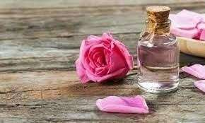

Rose Water Can Help Reduce Skin Redness, Prevent Additional Swelling, And Soothe The Discomfort Of Acne. In medieval Europe, rose water was used to wash

hands at a meal table during feasts. Rose water is a usual component perfume.Rose water ointment is occasionally used as an emollient, and rose water is sometimes used in cosmetics such as cold creams, toners and face wash.

## METHOD OF PREPARATION

#### Formulation Of Herbal Facepack:

###### Step – 1

* All The Required Herbal Powders For The Face Pack Preparation Were Accurately Weighed Individually By Using Digital Balance.
* The Quantity And Compositions Are Listed In Tabale.

#### Step – 2

* The accurate quantity ingredients were weighed and ground into fine powder by using sieve #120.

###### Step – 3

* Then the all ingredients were mixed geometrically by serial dilution method for uniform mixing.

###### Step – 4

* Then the prepared face pack was packed into a self-sealable polyethylene bag, labelled, and used for further studies.

# Formula :

|  |  |  |  |
| --- | --- | --- | --- |
| Sr.No | Ingredients (In Powder Form) | Role | Quantity (In Gm) |
| 1 | Turmeric | Antiinflamatory Activity Antiallergic Activity | 0.2gm |
| 2 | Red Sandalwood | Reduce Inflamatory Skin Condition | 3gm |
| 3 | Ashwaganda | Reduce Dead Skin Cells And Form New Ones | 2gm |
| 4 | Aloevera | Treats Skin Problems Antiinflamatorry Process | 1.8gm |
| 5 | Hibiscus | Inhances The Skin Ability To Retain Moisture | 3gm |
| 6 | Rose Water | Balance Out The PH Level Of Skin | Q.S |

C O

V E

R

**Procedure for Apply of Herbal Face Pack :**

Addition

Take Prepared Face Pack

Powder In A Bowl As Per The Requirement ,

Add Water Or Rose Water

To Mix It Well And Apply Over The Facial Skin.



Washing

And Then Wash The Face With Cold Water.

The Acne And Blemishes Spots. Kept As It Is For Complete Drying For 30

To 40 Min

Evaluation of Herbal Face pack:

#### Organoleptic Evaluation:

##### SR.NO PARAMETER OBSERVATION

|  |  |  |
| --- | --- | --- |
| **1** | Nature | Powder |
| **2** | Color | Reddish-brown |
| **3** | Odour | Pleasant |
| **4** | Appearance | Smooth |
| **5** | Texture | Fine |

The Result Of Evaluation Are Displayed In Table Form Of Organoleptic And Physico- Chemical And General FacepackEvaluation. The Study of Nature,

Color, Odor, Texture, Ph. Of Facepack Combined Form Under Investigation Provided

The Important Features Of Organoleptic And Physico-Chemical Evaluation, Irritancy Test And Speradability Test.

#### Physico-Chemical Evaluation:

**SR.NO PARAMETER OBSERVATION**

|  |  |  |
| --- | --- | --- |
| **1 )** | Tapped Density | 0.63g/Ml |
| **2 )** | Bulk Density | 0.42g/Ml |
| **3 )** | Angle Repose | 23.7 |
| **4 )** | Carr’sIndex | 33.33% |
| **5 )** | pH | 6.6 |

# Observation :

Physico-Chemical Evaluation Justified The Flow Properties Of The Facepack As It Was Found To Be Free Flowing And Non-Sticky In Nature. PH Was Found Neutral To Suit The Requirements Of All Skin Types. The Results Proved That The Formulation Was Stable In All Aspects.

**Irritancy Test :**

##### SR.NO. PARAMETERS OBSERVATION

|  |  |
| --- | --- |
| **1 )** | Irritant No Irritation |
| **2 )** | Erythema No Irritation |
| **3 )** | Edema No Irritation |

Table - Irritancy Test

###### Observation:

Irritancy Test Showed Negative Result For Irritancy, Redness, Swelling, And Photo Irritancy, As The Herbals In Their Natural Form Without Addition Oh Chemicals Were Found To Be Compatible With The Skin Protein.

# CONCLUSION

Natural Remedies Are More Acceptable In The Belief That They Are Safer With Fewer Side Effects Than The Synthetic Ones.

Herbal Formulations Have Growing Demand In The World Market.Herbal Face Packs Are Used To , Stimulate Blood Circulation, Rejuvenate The Muscles And

Help To Maintain The Elasticity Of The Skin And Emove Dirt From Skin Pores.

It Is An Our Good Attempt To Formulate The Herbal Face Pack Containing Natural Herbal Ingredients Such As Multani Mitti, Turmeric, Sandal Wood, Saffron, Milk Powder, Rice Flour, Orange Peel And Banana Peel.

# REFERANCE

1. Shoba rani R; Hiremanth. Text book of Industrial pharmacy, Drugdelivery systems & Cosmetics & Herbal drug technology:Universities press (India) Ltd; 2nd Edition.
2. Okereke JN, Udebuani AC, Ezeji EU, Obasi KO, Nnoli MC. Possible Health Implications Associated with Cosmetics: A Review, Sci J Public Health 2015; 3(5-1):58-63.
3. Mary P. Lupo. Antioxidants and Vitamins in Cosmetics. Clin Dermatol 2001; 19: 467–473.
4. Rieger MM. Harry's Cosmeticology. In: Chapter 23, Face, Body&Hair Masks & Scrubs. 8th

ed. vol I. New York: Chemical Publishing Co., Inc.; 2009. p. 471-483.

1. Rani, S. R. and Hiremanth, Text book of Industrial pharmacy, Drug delivery systems & Cosmetics & Herbal.
2. Baby, A. R., Zague, V., Maciel, C.P.M., Kaneko, T. M., Consiglieri, V. O., Velasco R , (2004).
3. Development of Cosmetic Mask Formulations. Rev Bras Cienc. Farm 40(10):159-161.
4. Banchhor, M., Ashawat, M.S., , Saraf, S. and Saraf, S. (2009). Herbal Cosmetics: Trends in Skin Care Formulation. Phcog Rev 3(5): 82-89.