# REVIEW ON FORMULATION OF HERBAL FACEPACK

#### AUTHORS NAME: MR. AHER N.B. (1),MISS.DENGALE PRANALI SHANKAR(2),MISS.NIDHANE POOJA SANDIP(2),MISS.LOHALE RENUKA FAKIRA(2)

**AFFLIATION: 1) Principal M.Pharm. PHD Department of Pharmacognosy, Ashwin College Of Pharmacy, Manchi Hill**

1. **Final Year B.Pharmacy, Ashwin College Of Pharmacy, Manchi Hill**

# ABSTRACT

The idea that natural medicines are safer and have fewer negative effects than synthetic ones make them more acceptable. The demand for herbal formulations is rising on the global market. This project's goal is to create and assess a polyherbal face pack that uses herbal substances as cosmetic ingredients. Flax seed, Tulsi, lemon peel, neem, Chandan, sandal wood, Multani Miti powder were purchased from the neighbourhood market in dried, powdered form, which was then put through sieve no. 80. The ingredients were thoroughly prepared and tested for their organoleptic, physicochemical, and microscopical characteristics. The combined dry powder exhibited satisfactory flow characteristics, making it appropriate for a face pack.

The usage of herbal face packs or masks helps to retain the flexibility of the skin, promote blood flow, and purge pores of impurities. The development of a herbal face mask with various plant powders is a very impressive effort. Herbal cosmetics have the advantage of being non-toxic, reducing allergic reactions, and using components that have been proven effective through time.

**Key Words:**

Cosmetic, Face Pack, Herbal, Ingredients, Natural, Product Rejuvenates.

**CHAPTER 1: INTRODUCTION**

Natural cosmetics are another name for herbal cosmetics. Herbal products are those that contain herbs in crude or extract form. Herbal cosmetics are defined as a beauty product that contains herbal elements and has beneficial physiological activities such as skin healing, smoothing, and appearance improving, and conditioning characteristics. The word cosmetic comes from the Greek word “kosm tikos.” Which means “having the power to arrange” or “having the skill to decorate.” Cosmeceuticals are cosmetics that contain biological active substances with medical or drug like properties. Only topically applied products, such as creams, lotions, and ointments qualify for the Cosmeceuticals classification. Nutraceutical are cosmetics that are similar in appearance but are consumed orally.

According to the D & C Act of 1940, any article intended to be rubbed, poured, sprinkled, or spread on or introduced to or applied to any part of the human body for the purpose of cleansing, beautifying, promoting, attractiveness, or altering the appearance, including any article intended for use as a cosmetic component. Skin moisturizers, perfumes, lipolytic, fingernail polishes, eye and facial makeup preparations, shampoos, permanent waves, hair color, toothpastes, and deodorants, as well as any material intended for use as a component of a cosmetic product, are all included in this definition. Customers have preferred herbal cosmetics because they are stronger, readily available, and thought to have less adverse effects. Herbal cosmetics is the quickest growing segment of the personal care industry.

Cosmeceuticals are cosmetic preparations that contain biologically active principles or substances of plant origin, and they are the fastest growing segment of personal care products. Herbs have been more popular in cosmetics in recent years due to their moderate action and lower toxicity, as well as the fact that they are more effective. Herbal cosmetics have a large market due to people’s desire to appear good and be beautiful. The desire to appear younger than one’s actual age, to be beautiful, fresh, charming, and fair has raised the demand for herbal cosmetics and cosmeceuticals in the market. As a result, the usage of herbal cosmetics and cosmeceuticals is overlooked in the evaluation. Herbs are also described as cosmetics, which may wish to be used for skin care as well as beautification. Ayurveda, Unani, siddha,

homoeopathy, and other natural herb-based health sciences have their origins in India. The manufacture of Saundarya prasadan (herbal cosmetics) in the Ayush pharmaceutical industry is highly probable and dependent in the future. Natural beauty aids blessing, while cosmetics enhance and improve many aspects of a person’s appearance and personality. The formulation of Saundarya Prasadan is a cosmetic base containing the known active component Ayurveda, siddha, and unani (Asu), which may be found in schedule 1 of the drug and cosmetic act 1940 and rule 1945. People were once utilized for Saundarya prasadan karma to several Lepas, such as alepa, Pralepa, udavartan, and prakshalan.

Herbs are plants or plant extracts having nourishing and healing properties, such as leaves, bark, berries, roots, gums, seeds, stems, and flowers. Cosmetics alone are insufficient to care for the skin and other body parts; a combination of active chemicals is required to prevent s kin damage and ageing. Herbal cosmetics have become increasingly popular among the general public. Herbal products’ effectiveness and intrinsic acceptability were demonstrated through frequent usage in ordinary life, and the negative effects associated with synthetic products were avoided. Herbal cosmetics are made up of plants like saffron (kesar), ashwagandha, sandal (Chandan), and a variety of others, all of which are increasingly supported by necessary elements and good minerals. Although only about 70 spices are officially recognized, it is estimated that approximately 500 tastes are used globally. Herbs can be used for a variety of purposes, including culinary flavouring, cosmetics, and medicinal in tea, tablets, capsules, and teas, liquids, creams, and syrups the major goal of this review article is to compile information on herbal cosmetics, which are preparations used to enhance and improve human appearance with no or little adverse effects when compared to conventional cosmetics. Cosmetics are substances that are applied to the body with the intention of boosting attractive traits and beautifying, cleaning, or improving appearance. The fairness and smoothness of the skin are improved by herbal face packs. In Ayurveda, "Mukha Lepa (facial pack)" refers to the herbal paste used to cure acne, pimples, scars, markings, and pigmentation.

Skincare products or cosmetics are usually synthetic or natural chemical compounds used to improve the appearance or smell of the body. Facial cosmetics are a necessary in the entertainment industry where hundreds of new recruits are daily added to the huge number of cosmetics users with little or no knowledge of their side effects. Some of the cosmetics used contain different compounds like zincite, cuprite goethite, amorphous carbon, elemental silicon or talc hematite, minimum organic compounds, and even heavy metals such as Lead, sometimes these synthetic cosmetics lead to allergic reaction so cosmetics made by plants are very helpful.

### ADVANTAGES OF FACE PACK:

#### NATURALLY AVAILABLE

1. Herbal cosmetics are made from natural herbs that are free of harmful synthetic Chemicals. Even though herbal cosmetics they use plant parts and extracts

That are readily available in nature. It is possible that natural products are just as good As synthetic ones. Aloe Vera gel is an example of this coconut oil, and so forth natural Nutrients are also found in them. Vitamins e and c, for example, are antioxidants

That nourish and beautify the skin.

1. They are simple to blend into the skin and hair.
2. Easily accessible and available in a wide variety and quantity.
3. Easy to make and the most affordable.
4. They cause no allergic reactions and have no harmful side effects.

5. When compared to synthetic cosmetics, they are incredibly effective with a modest amount.

### BENEFITS OF APPLYING FACE PACK:

1. It nourishes the skin. Fruit face masks provide the nutrition to skin requires.
2. Because of its herbal ingredients, it helps in minimizing scars produce by acne, blemishes, and acne itself.
3. Face packs generally remove the dead cell produce by skin.
4. The skin get soothing effect and feel relaxed by these face masks.
5. They aid in quickly restoring the skin's lost shine and glow.
6. Herbal face masks enhance skin texture and tone and give skin a glow when used frequently.
7. Face packs should be used carefully to prevent the damaging effects of pollutants and severe climate condition.
8. They help in preventing early skin ageing.
9. Natural face packs can successfully control the appearance of wrinkles, fine lines on skin.

10Natural face packs provide the skin a youthful, healthy appearance

* + 1. **SAFER TO USE:** Herbal cosmetics are safer to use than synthetic items. They are less allergic, nontoxic, and dermatologist have studied and verified that they are safe to use. They are because they are Natural substances have been used.

#### COMPATIBLE WITH ALL SKIN TYPES

Natural cosmetics are suitable for all skin types. No matter if you are dark or fair, you will find natural cosmetics like foundation, eye shadow, and lipstick which are appropriate irrespective of your skin tone.

# CHAPTER 3: OBJECTIVE OF STUDY

### NEED:

An herbal face pack is used to rejuvenate the muscles, maintain the elasticity of the skin, remove adhered dirt particles, and improve the blood circulation. The benefits of herbal based cosmetics are their nontoxic nature. It nourishes the facial skin. This face pack supplies vital nourishment to the skin.

### AIM OF THE STUDY:

* + - * To prepare and evaluate Face Pack.
      * To hydrate or glow face.
      * To prevent acne and oiliness.
      * Removal of tan or dust, dead skin.

### OBJECTIVES:

* + - * + To formulate a face pack with flax seed it was used as Anti- inflammatory.
        + To formulate and develop safe, effective, and stable face pack.
        + To formulate and evaluate having acceptable properties.
        + To improve patient /Customer compliance.
        + To help prevent acne, clear oiliness.
        + To perform stability studies of the formulation as per ICH guidelines.

### CHAPTER 4: PLAN OF WORK

#### PART 1

1. Literature survey.
2. Selection of drug, excipients, and other material.
3. Procurement of drug, excipients, and other material.

#### PART 2

1. Pre-formulation study.
2. Material, equipment and method selection for experimental work.

#### PART 3

1. Evaluation of face pack:
   * Physical assessment.
   * Angle of repose.
   * Bulk density.
   * Tapped density.
   * Ph.
   * Wash ability.

#### PART 4

1. Result and discussion.
2. Conclusion.

## DRUGS PROFILE

**HERBS USED IN HERBAL COSMECEUTICALS:**

**TABLE NO 01**

|  |  |  |
| --- | --- | --- |
| **SR.NO NAME OF INGREDIENT** | **SCIENTIFIC NAME** | **ROLES** |
| 1 Flax seed | *Linum usitatissium* | Reduction of wrinkles and fine lines on the face |
| 2. Multani mitti | *Calcium bentonite* | Reduce dark circles and give cooling effect to skin |
| 3. Sandal wood | *Santolum alba* | Reduce inflammatory skin conditions |
| 4. Lemon peel | *Citrus limon* | Helps to reduce age spot and brighten the skin |
| 5. Rose petals powder | *Rosa canina* | Helps to retain moisture in skin for long time |
| 6. Tulsi | *Osimum santumm* | Reduce skin inflammation |
| 7. Neem | *Azadirachta indica* | Reduce blemishes and promo clear skin |

**1. FLAX SEED:**

SYNONYM: linseed

Biological source: Linseed is the dried, ripe seed of *Linum usitatissimum Linn*. Linseed oil is obtained by expression of linseeds, belonging to family *Linaceae.*

FAMILY: *Linaceae*

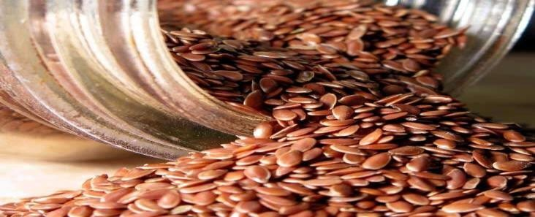

##### Fig 4.1 flax seed

ROLE: Lignans and antioxidants included in flax seeds aid in the reduction of wrinkles and fine lines on the face. Additionally, the fatty acids in flax seeds aid in maintaining the smoothness and moisture of the skin. Flax seeds' natural ability to maintain skin firm and reduce drooping with age is another benefit.

#### TULSI:

BIOLOGICAL SOURCE: Tulsi consists of fresh and dried leaves of *ocimum sanctum Linn.*

FAMILY: *Lamiaceae*

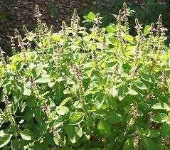

##### Fig 4.2: Plant of Tulsi

USE: the fresh leaves its juice and volatile oil are used for various purposes. The oil produce from tulsi leaves and seed is antibacterial and insecticidal. Leaves are used as stimulant and

they give aromatic fragrance. The extract of tulsi or drug produce from it has good immune- modulatory agent tulsi also has expectorant and anti -inflammatory properties.

#### NEEM

SYNONYMS: Neem, Nimtree or Indian lilac,

BIOLOGICAL SOURCE: It is a dried bark & leaves of plant *Azadirachita Indica*. FAMILY: *Meliaceae*.

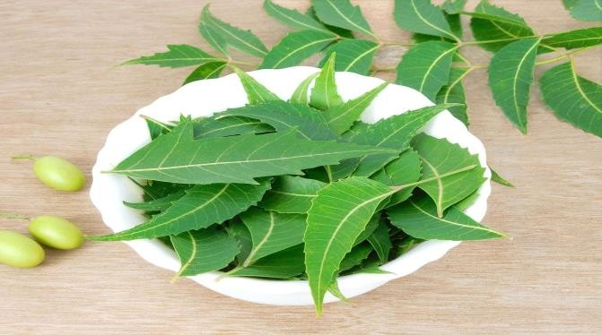

##### Fig 4.3: Leaves of Neem

***Azadirachita indica****,* commonly known as **Neem**, **Nimtree** or **Indian lilac**, is a tree in

the Mahogany family Meliaceae. It is one of two species in the genus Azadirachita, and is native to the Indian subcontinent and most of the countries in Africa. It is typically grown in tropical and semi-tropical regions. Neem trees also grow on islands in southern Iran. Its fruits and seeds are the source of neem oil.

#### MULTANI MITTI:

A common natural skincare item that is probably found in nearly every Indian home is Multani mitti. the name Multani Mitti is come from the place of origin Multan which currently in Pakistan. Although it looks like clay, it is significantly friendly to skin. It appears in a variety of color, including brown and green, and is rich in minerals and water. It has no taste or smell.

This clay is referred to in English as "Fuller's Earth."

CHEMICAL COMPOSITION OF MULTANI MITTI

Multani Mitti formed by hydrated aluminium silicates, magnesium chloride, and calcium bentonite and composition like bentonite clay.

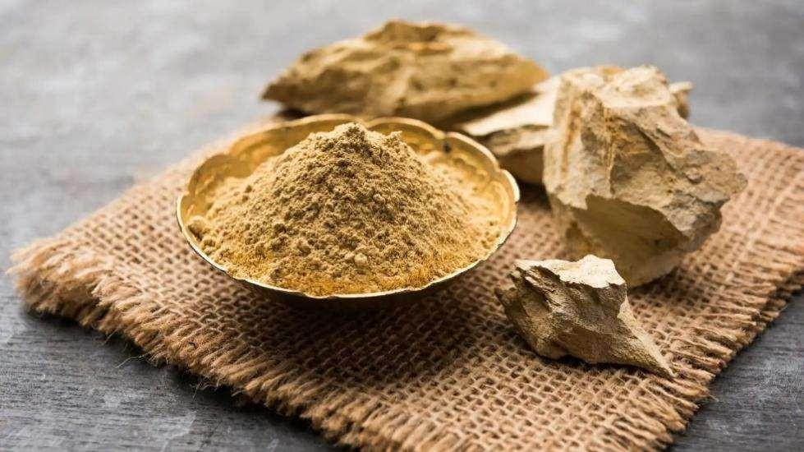

##### Fig 4.4: Multani Mitti

PROPERTIES OF MULTANI MITTI**:**

* It shows anti-acne property
* It has anti-inflammatory property
* It demonstrates astringent activity
* It has absorbent property
* It exhibits antimicrobial property
* It shows skin brightening property

### SANDAL WOOD:

BIOLOGICAL NAME: *Santalum album*

BIOLOGICAL SOURCE: Sandalwood consists of the heartwood of the stems and roots of Santalum album Linn, an evergreen small tree

FAMILY: Santalaceae

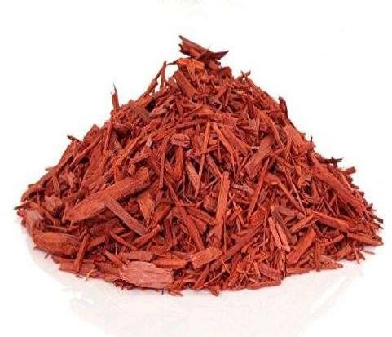

**Fig 4.6: Sandal Wood**

USES:

Sandalwood oil contains antioxidants that help maintain the buoyancy and structure of the skin cells. It also **reduces dryness and replenishes the moisture in skin, increasing elasticity**. “Due to the rich antioxidant component, sandalwood can help prevent wrinkles by fighting free radical formation.

#### LEMON PEEL:

SYNONYM: lemon rind

BIOLOGICAL SOURCE: Lemon peel is obtained from the fresh ripe fruit of *Citrus lemon (L.) Burn*

FAMILY: *Rutaceae*

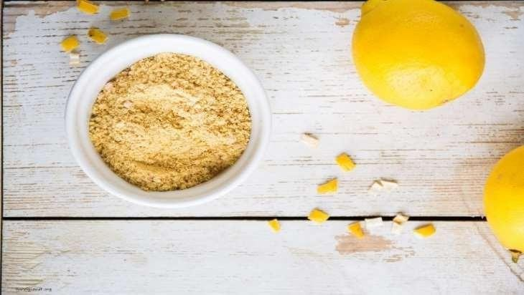

##### Fig 4.7: Lemon Peel Powder

USES:

Lemon peel powder are good for **treating the acne, and pimples**. It also help to fade away dark spots caused by sun tanning, acne and pimples. The Lemon peel powder provide mild exfoliation which help to keep the pores clean and reduce chances of skin problems like blackheads and White heads.

#### ROSE PETALS POWDER:

BIOLOGICAL NAME: *Rosa rubiginosa*

BIOLOGICAL SOURCE: petals of dried flower of ***Rosa rubiginosa.*** Belonging to family

*rubiginosa*

FAMILY: *Rubiginosa*

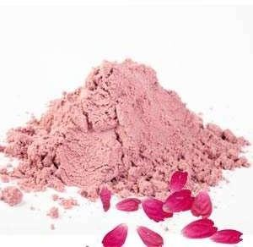

##### Fig 4.8: Rose Petal Powder

USES:

* Balances vatta and pitta, dosha Rose petal powder is like an elixir.
* Nerve healer.
* Maintains skin tone.
* Cleanses and nourishes skin.
* Subdues blemishes/dark spots.
* Works as an exfoliant.
* Anti-ageing properties.

## CHAPTER 5: EXPERIMENT WORK

**FORMULATION OF PREPARATION**:

|  |  |  |  |
| --- | --- | --- | --- |
| **SR.NO** | **NAME OF INGREDIENT** | **SCIENTIFIC NAME QUANTITY OF**  **SAMPLE** | |
| **1. MULTANI MITTI** | | *CALCIUM BENTONITE* | 25 gm. |
| **2. SANDAL WOOD** | | *SANTOLUM ALBA* | 10 gm. |
| **3. LEMON PEEL** | | *CITRUS LIMON* | 10 gm. |
| **4. ROSE PETAL POWDER** | | *ROSA CANINA* | 10 gm. |
| **5. TULSI POWDER** | | *OSIMUM SANTUMM* | 10 gm. |
| **6. NEEM POWDER** | | *AZADIRACHITA INDICA* | 15 gm. |
| **7. FLAX SEED** | | *LINUM USITATISSIUM* | 20 gm. |

### METHOD OF PREPARATION:

The accurate quantity ingredients were weighed and ground into fine powder by using sieve #120. Then the all ingredients were mixed geometrically by serial dilution method for uniform mixing. Then the prepared face pack was packed into a self-sealable polyethylene bag, labelled, and used for further studies.

### PROCEDURE OF FACE PACK APPLICATION:

Take prepared face pack powder in a bowl as per the requirement and add rose water to mix. Mix well and apply over the facial skin. Cover the acne and blemishes spots too. Kept as it is for complete drying for 20 to 25 min and then wash with cold water.

#### EVALUATIONS OF FORMULATION:

To guarantee the superiority of the prepared face pack, the following evaluation criteria were used.

#### PHYSICAL ASSESSMENT:

Physical characteristics like colour, smell, look, and texture were visually examined.

|  |  |
| --- | --- |
| **Sr No. parameter** | **Observation** |
| **1. Appearance** | Powder |
| **2. Colour** | Brown |
| **3. Odour** | Slight |
| **4. Texture** | Fine |
| **5. Smoothness** | Smooth |

**Table no. 3 Organoleptic Properties**

#### MEASURING MOISTURE CONTENT:

Place 1.5 g of the drug's powdered form in a porcelain dish that has been scaled and is flat and thin. Dry in the oven at 100°C or 105°C, checking that two subsequent weighing are within 0.5 mg of one another. Desiccate and weigh after cooling. The weight loss is typically noted as moisture **[27]**.

#### PARTICLE SIZE:

Particle size was assessed using the sieving method utilizing I.P. Standard sieves by mechanically shaking for 10 minutes. Particle size is a parameter that affects many qualities including spread ability, grittiness, etc.

#### ANGLE OF REPOSE:

Posing angle, it is described as the greatest angle that can be formed between the powder pile's surface and the horizontal flow.

#### METHOD WITH AN OPEN-ENDED CYLINDER:

A cylindrical tube with both ends open that contains the necessary amount of dried powder is put on a flat surface. The funnel should then be lifted in order to create a heap. It is noticed and recorded what the heap's height and radius are. The formula can be used to determine the angle of repose () for the method described above. θ = tan -1(h / r) where is the angle of repose, h is the height of the pile, and r is the base's radius.

#### VOLUME DENSITY:

The relationship between a powder's mass and bulk volume is known as bulk density. The necessary quantity of powder is dried and poured into a 50 ml measuring cylinder until it reaches the 50 ml mark. The cylinder is then dropped from a height of 1 inch at intervals of 2 seconds onto a hard wood surface. The powder's volume is calculated. The powder is then weighed. Repeating this will yield average results. The formula listed below is used to compute bulk density. Bulk Density = Mass/volume.

#### TAPPED DENSITY:

When a container containing a powder sample is mechanically tapped, a higher bulk density known as "tapped density" results. Following the initial measurement of the powder volume or mass, the measuring cylinder or vessel is mechanically tapped for one minute while readings are taken on the volume or mass until little more volume or mass change is seen. Grams per cubic centimeter (g/cm3) was used to express it **[29,30,31,32,33]**.

#### SPREADABILITY:

Equipment developed internally was used to measure spread-ability. The device is a wooden block with a fixed glass slide and a movable glass slide, one of which is attached to a weight pan rolling on a pulley that was in the horizontal level with the fixed slide and the other to a pulley. The prepared gel's spread-ability was evaluated based on its "Slip and Drag" properties. On this ground slide, an excess of the gel (approximately 2g) under

investigation was applied. After that, two slides were placed on top of the gel. For five minutes, a one kg weight was placed on top of the two slides to force air out and create a homogeneous gel film between them. Extra gel was scraped off of the surface **[34]**.

* 1. **pH:**

A calibrated digital pH meter was used to monitor the pH of the formulation's 1% aqueous solution at a constant **[35]**.

#### WASHABILITY:

This is the typical technique for determining whether the formulation is washable. One litre of water was used to manually verify the formulation that was applied to the skin as well as the ease and scope of water washing.

|  |  |  |
| --- | --- | --- |
| **Sr No. Parameter** | **observation** | **Flow character** |
| **1. Particle size** | 20-25 mm |  |
| **2. Angle of repose** | 40.69 | **Fair** |
| **3. Bulk density** | 0.31 g/cc |  |
| **4. Tapped density** | 0.41 g/cc |  |
| **5. PH** | 7.6 |  |
| **6. Grittiness** | No gritty particles were |
|  | found when mixed with |
|  | water |
| **7. Nature of face pack** | Soft and fresh, clean |
| **after wash** | from dust |

**Table no. 4 General powder characters**

### CHAPTER 6&7: RESULT AND DISCUSSION

Tables 3, 4, and 5 present the evaluation's findings. Preformulation studies included analysis of the formulation's organoleptic and physico-chemical properties, general powder characteristics, microscopical characteristics, and chemical evaluation. Organoleptic and physico-chemical evaluation were two crucial aspects of the research of the nature, colour, aroma, taste, texture, ash values, moisture content, and pH of dry powders in mixed form.

Total ash and acid insoluble ash readings were used to determine whether ash was present in the dry powder of mixed form. 4g of total ash and 2.7g of acid-insoluble ash were discovered to have been yielded. And 4% was discovered to be the moisture content value. The moisture content measurements clearly showed that the combined powder was of a very alkaline character due to the dried by creating a 1% dispersion of powder form in distilled water and monitoring the pH with a pH metre, the mixed powder form was identified. The pH of a 1% powder dispersion was 7.61, indicating that the mixed powder had a mildly alkaline PH.

Before being produced, dried powder in mixed form had its particle size, angle of repose, bulk density, and tapped density analysed. The values of particle size, angle of repose, bulk density, and tapped density obtained for powder of mixed form were determined to be 20- 25m, 40.69°1°05", 0.312g/cc, and 0.416g/cc, respectively, and had good flow qualities. The microscopic characteristics point to the presence of flavonoids as well as lignified fibres and sclerenchyma cells in dried powder form. The powder was able to flow easily, making it ideal for a face pack.

### CHAPTER 8: CONCLUSION

Cosmeceuticals are cosmetics that contain biological active substances with medical or drug like properties. Herbal cosmetics are defined as a beauty product that contains herbal elements and has beneficial physiological activities such as skin healing, smoothing, and appearance improving, and conditioning characteristics. Herbs have been more popular in cosmetics in recent years due to their moderate action and lower toxicity, as well as the fact that they are more effective. According to the D and C act of 1950, any article intended to be rubbed, poured, sprinkled, or spread on or introduced to or applied to any part of the human body for the purpose of cleansing, beautifying, promoting, attractiveness, or altering the appearance, including any article intended for use as a cosmetic component. Herbal cosmetics enhance and improve many aspects of a person's appearance and personality.

Herbs are plants or plant extracts having nourishing and healing properties, such as leaves, bark, berries, roots, gums, stems, and flowers. The formulation of Saundarya prasadan is a cosmetic base containing the known active component Ayurveda, siddha, and Unani (asu). Cosmetics alone are insufficient to care for the skin and other body parts; a combination of active chemicals is required to prevent s kin damage and ageing. Herbal cosmetics are preparations used to enhance and improve human appearance with no or little adverse effects when compared to conventional cosmetics. Cosmetics are substances that are applied to the body with the intention of boosting attractive traits and beautifying, cleaning, or improving appearance.

The fairness and smoothness of the skin are improved by herbal face packs. In Ayurveda, "Mukha Lepa" refers to the herbal paste used to cure acne, pimples, scars, markings, and pigmentation. Herbs can be used for a variety of purposes, including culinary flavouring, cosmetics, and medicinal in tea, tablets, capsules, and teas. Liquids, creams, and syrups the major goal of this review article is to compile information on herbal cosmetics, which are preparations used to enhance and improve human appearance with no or little adverse effects when compared to conventional cosmetics.

#### CHAPTER 9: REFERENCE

1: Chanchal D. and Saraf S. (2009). Herbal Photoprotective Formulations and their Evaluation. The Open Nat Prod Journal 2: pg. no. 71-76.

2: Gage, D. 1996. Aloe vera: Natures Soothing Healer. Healing Acts Press, Rochester, Vermont, USA, pg. no. 120.

3: Surjushe, A., Vasani, R. and Saple, D. G. 2008. Aloe vera: A short review. Indian Journal of Dermatology 53: pg. no. 163-166.

4: Eshun, K. and He, Q. 2004. Aloe vera: A valuable ingredient for the food, pharmaceutical and cosmetic industries, A review. Critical Reviews in Food Science and Nutrition 44: pg. no. 91- 96.

5: Klein, A. D. and Penneys, N. S. 1988. Aloe vera. J. of the American Academy of Dermatology 18: pg. no. 714-720.

6: Reynolds, T. and Dweck, A. C. 1999. Aloe vera leaf gel: A reviewupdate. J. of Ethnopharmacology 68: pg. no. 3-37.

7: Boudreau, M. D. and Beland, F. A. 2006. An evaluation of the biological and toxicological properties of Aloe barbadensis (Miller), Aloe vera. J. Environ. Sci. Health. C Environ. Carcinog. Ecotoxicol. Rev. 24(1): pg. no. 103-154.

8: Choi, S. and Chung, M. H. 2003. A review of the relationship between Aloe vera components and their biological effects. Semin. in Integrative Medicine 1: pg. no. 53-62.

9: Alemdar, S. and Agaogln, S. 2009. Investigation of in vitro antimicrobial activity of Aloe vera juice. Journal of Animal and Veterinary Advances 8: pg. no. 99-102.

10: Davis, R. H., Parker, W. I. and Samson, R. T. 1991. Isolation of a stimulatory system in an aloe extract. J. American Podiatric Medical Assoc. 81: pg. no. 473-478.

11: Ferro, V., Bradbury, B., Cameron, P., Shakir, E., Rahman, S. and Stimson, W. 2003. In vitro susceptibility of Shigella flexneri and Streptococcus pyogenes to inner gel of Aloe barbadensis Miller. Antimicrob Agents Chemother. 3: pg. no. 1137-1139.

12: Djeraba, A. and Quere, P. 2000. In vivo macrophage activation in chickens with Acemannan, a complex carbohydrate extracted from Aloe vera L. Int. J. Immunopharmacol. 22: pg. no. 365- 372.

13: Yu, Z. H., Jin, C., Xin, M. and JianMin, H. 2009. Effect of Aloe vera polysaccharides on immunity and antioxidant activities in oral ulcer animal models. Carbohydrate Polymers 75: pg. no. 307-311.

14: Tizard, I., Busbee, D., Maxweell, B. and Kemp, M. 1994. Effects of Acemannan, a complex carbohydrate, on wound healing in young and old rats. Wounds 6: pg. no. 201-209.

15: Talmadge, J., Chavez, J., Jacobs, L., Munger, C., Chinnah, T., Chow, J. T., Williamson, D. and Yates, K. 2004. Fractionation of Aloe vera L. inner gel, purification and molecular profiling of activity. Int. Immunopharmacol. 4(14): pg. no. 1757-1773.

16: Franz, Ch., Bauer, R., Carle, R., Tedesco, D., Tubaro, A. and ZitterlEglseer, K. 2005. Study of the assessment of plants/herbs, plant/herb extracts and their naturally or synthetically produced components as “additives” for use in animal production CFT/EFSA/FEEDAP/2005/ 01.

17: Serrano, M., Valverde, J. M., Guillén, F., Castillo, S., Martinez-Romero, D. and Valero, D. 2006. Use of Aloe vera gel coating preserves the functional properties of table grapes. J. Agric. Food Chem. 54: pg. no. 3882- 3886.

18: Feily, A. and Namazi, M. R. 2009. Aloe vera in dermatology: A brief review. G. Ital. Dermatol. Venereol. 144: pg. no. 85-91.

19: Zhang, L. and Tizard, I. R. 1996. Activation of a mouse macrophage cell line by acemannan: the major carbohydrate fraction from Aloe vera gel. Immunopharmacology 35: pg. no. 119-128.

20: Maenthaisong, R., Chaiyakunapruk, N. and Niruntraporn, S. 2007. The efficacy of Aloe vera for burnwound healing: A systematic review. Burns 33: pg. no. 713-718.

21: Rajendran, A., Narayanan, V. and Gnanavel, I. 2007. Study on the analysis of trace elements in Aloe vera and its biological importance J. of Applied Sciences Research 3: pg. no. 1467-1478.

22: Geremias, R., Pedrosa, R. C., Locatelli, C., de Fávere, V. T., CouryPedrosa, R. and Laranjeira, N. C. M. 2006. Lipid lowering activity of hydrosoluble chitosan and association with Aloe vera L. and Brassica oleracea L. Phytotherapy Research 20: pg. no. 288-293.

23: Lim, B. O., Seong, N. S., Choe, R. W., Kim, J. D., Lee, H. Y., Kim, S. Y., Yu, B. P., Jeon,

T. I. and Park, D. K. 2003. Efficacy of dietary Aloe vera supplementation on hepatic cholesterol and oxidative status in aged rats. J. Nutr. Sci. Vitaminol. 49: pg. no. 292-296.

24: Miladi, S. and Damak, M. 2008. In vitro antioxidant activities of Aloe vera leaf skin extracts. Journal de la Société Chimique de Tunisie 10: pg. no. 101-109.

25: Lee, K. Y., Weintraub, S. T. and Yu, B. P. 2000. Isolation and identification of a phenolic antioxidant from Aloe barbadensis. Free Radical Biology and Medicine 28(2):261-265.

26: Sumbul, S., Ahmed, S. W. and Azhar, I. 2004. Antifungal activity of Allium, Aloe and Solannum species. Pharmaceutical Biology 42:491- 498.

27: Dr K R Khandelwal, Dr Vrunda Sethi Dr. Practical pharmacognosy techniques and experiments practical, pharmacognosy, 2012edition, published by nirali prakashan, pg.no:23.8- 23.10, 25.5.

28: Quality control methods for medicinal plant materials World Health Organization Geneva.

29: P.K. Mukharjee, Quality Control of Herbal Drug, An Approach to Evaluation of Botanicals Horizones Publication, New Delhi, 3,2008, 184-291.

30: C.V.S. Subrahmanyam, Text Book of Physical Pharamcy Vallabh Prakashan 2, 2000, 221-

224.

31: Martin and Alfred, Physical Pharmacy London: Lea & Febigen Philadelphia, 4, 2007, 431- 432.

32: L. Lachman, H.A. Lieberman and J.L. Kanig, The Theory and Practice of Industrial Pharmacy Varghese Publishing House, Bombay, 3, 1991, 67.

33: Indian Pharmacopoeia the Indian Pharmacopoeial Commission. Ghaziabad, 1, 2007, 134,

191.

34: Choudhuri, RK. Emblica cascadingantioxidants: Novel natural skin careingredients. Skin Pharmacol. Applied Skin Physiol, (2002). Page no. 15: 374-380,

35: Joshan R.S, Nagarauk R, Anuradha P.Antibacterial properties of extracts of Indianmedicinal plants: Syzygium alternifolium,Phyllanthus niruri and Rubia cordifolia,Biomedical and Pharmacology Journal,3:1, 2011 pg. no. 123-128.