Google play store mobile application screening

## Pippara Divya , Polamuri MadhuSri , Polukonda Harika , Sykham Monika

Department of Information Technology, Shri Vishnu Engineering College for Women, Bhimavaram Andhra Pradesh, 534202, India

**ABSTRACT**-The huge growth inside the wide variety of cell smartphone customers is also growing the use of cellular programs. Today, users prefer to visit a cellular utility as opposed to a computer. The goal is to increase a device that makes use of sentiment analysis and records mining to come across awful apps earlier than the person downloads them. Sentiment analysis helps decide the emotional tone of phrases expressed on positive troubles. A consumer cannot usually find correct or authentic critiques at the net. We can apprehend the person's emotional remarks in lots of applications. Reviews may be fake or actual. By analyzing ratings and evaluations, which encompass comments from customers and administrators, we can determine whether the software is actual or no longer. Using sentiment evaluation and records mining, engines like google can examine sentiment and sentiment round ratings and other texts. Survey control is one of the significant components of application score scams. We used LSTM fashions to predict the outcomes.

**Keywords**: Mobile phone, apps, website, Detecting fraud apps, Data mining, internet

# 1 INTRODUCTION

The proposed structure demonstrates adaptability and scalability for integrating other U.S.-produced records to enhance fraud detection capabilities. Exploratory results underscore the effectiveness and versatility of the proposed system, along with its consistent performance in identifying fraudulent activities. Notably, the absence of clear criteria defining fraudulent activity necessitated the development of four heuristic bases and subsequent evaluation by five experts, highlighting the innovative approach to fraud detection .Furthermore, the mobile phone market, driven by technological advancements, continues to expand rapidly. With a notable increase in mobile phone shipments, the market is characterized by trends emphasizing utility and cost reduction. However, the proliferation of mobile applications has also led to a rise in malware threats, necessitating the use of sentiment analysis to identify potentially harmful apps. Leveraging sentiment analysis enables the detection of fraudulent app ratings and reviews, crucial in combating app rating scams. Despite challenges posed by malware threats, ongoing research in encryption and data security aims to bolster protections in the digital landscape. Moreover, the outbreak of the coronavirus pandemic in 2019 precipitated significant shifts in remote work and learning, amplifying the vulnerability to malicious attacks in online environments. The increased reliance on online platforms has underscored the importance of encryption and data security, particularly in safeguarding sensitive information exchanged over the internet. Concurrently, advancements in data encryption and compression technologies have sought to enhance the efficiency and robustness of data protection measures. Ongoing research in encryption and compression methodologies remains vital to address evolving security challenges and ensure the integrity of data transmission and storage in the digital age.

# 2 LITERATURE SURVEY:

The literature review on fraud detection in Play Store apps utilizing sentiment analysis offers significant insights into the theoretical foundations and empirical research in this area. Numerous studies have delved into the efficacy of sentiment analysis as a means to identify fraudulent activities within app reviews. For instance, research conducted by Chen et al. (2017) has underscored the utility of sentiment analysis in uncovering deceptive reviews and detecting suspicious patterns embedded in user feedback. This indicates the pivotal role sentiment analysis plays in the realm fraud detection, owing to its capacity to scrutinize textual data and discern underlying sentiments, thereby presenting a promising avenue for identifying fraudulent behaviors in app ecosystems.

Moreover, the literature highlights remarkable advancements in sentiment analysis techniques, particularly driven by advancements in natural language processing (NLP) and machine learning (ML). Scholars such as Liu et al. (2019) and Wang et al. (2020) have made significant contributions to the evolution of sentiment analysis algorithms, leveraging sophisticated deep learning models to capture intricate sentiments and augment the accuracy of fraud detection mechanisms. These advancements underscore the imperative of embracing cutting-edge technologies and methodologies to effectively combat fraudulent activities pervasive in app environments.

Additionally, the literature underscores the challenges and considerations inherent in employing sentiment analysis for fraud detection in Play Store apps. While sentiment analysis presents promise, ensuring the quality of data, enhancing model interpretability, and scalability for large-scale implementation are paramount concerns. Addressing these challenges is crucial to the successful deployment and adoption of sentiment analysis-based fraud detection systems in real-world scenarios, thereby necessitating ongoing research and innovation in this domain.

In conclusion, the literature review serves as a foundational resource for comprehending the complexities and nuances surrounding sentiment analysis in the context of fraud detection within Play Store apps. While sentiment analysis holds immense potential for uncovering fraudulent behaviors, it is imperative to address various challenges and considerations to ensure its efficacy and reliability. By synthesizing theoretical insights and empirical findings, the literature review provides valuable guidance for researchers and practitioners striving to advance fraud detection methodologies in the dynamic landscape of Play Store apps.

## SYSTEM METHODOLOGY

The system methodology for Google paly store mobile screening application using decision tree involves several key steps to ensure its successful implementation and functionality. Below is a comprehensive outline of the system methodology:

* Data Collection
* Dataset
* Data preprocessing
* Feature Extraction
* Model Training
* Data Base Management
* User Interface development
* System Integration
* Testing and Evaluation

## Data Collection:

In the first module, we developed the system to get the input dataset for the training and testing purpose. The project name App review Detection. We given the data set in the project folder.

## Data Set:

The dataset consists of 12495 individual data. There are 5 columns in the dataset, which are described as Review id User ,Age , Content, Score

## Data Preprocessing:

Data preprocessing for sentiment analysis of app store reviews involves cleaning, tokenizing, and normalizing text data. This includes removing special characters, converting text to lowercase, and handling contractions. Stop words are removed, and stemming or lemmatization techniques are applied to reduce words to their base forms. Emoticons and emojis are either converted or removed, while negations are appropriately handled. Finally, the preprocessed data is transformed into numerical representations and split into training, validation, and test sets for model evaluation. These steps ensure that the data is prepared effectively for sentiment analysis model development and evaluation.

## Feature Extraction:

In addition to data preprocessing, feature extraction is crucial for sentiment analysis of app store reviews. Features such as word frequencies, TF-IDF values, or word embeddings are extracted from the preprocessed text data. These features capture the semantic information and contextual cues necessary for sentiment classification. Techniques like bag-of-words or word embeddings transform the text data into numerical representations suitable for machine learning algorithms. By extracting meaningful features from the preprocessed data, sentiment analysis models can effectively learn and generalize patterns in app store reviews, enhancing their accuracy and performance in sentiment classification tasks.

## Model Training:

The model architecture begins with an Embedding layer, a fundamental component in natural language processing, where words are represented as real-valued vectors. This layer employs dense embeddings to capture semantic similarities among words, contrasting with sparse representations like one-hot encoding. Keras' Embedding layer, initialized with random weights, learns embeddings for each word from the input text, demanding integer encoding for input data. Following the Embedding layer, the model integrates an LSTM (Long Short-Term Memory) layer, renowned for its

ability to handle sequential data and retain long-range dependencies. LSTMs excel in capturing temporal patterns and contextual information, crucial for sentiment analysis tasks where understanding the sequence of words is paramount .In our binary classification problem, the model processes words sequentially, learning from the contextual relationships among them. At each step, the LSTM layer considers the current word alongside the information retained from previous steps, effectively encoding the sequence of words.

This sequential processing enables the model to make predictions based on the entirety of the input text, leveraging the context provided by preceding words to inform its decision-making process.The recurrent nature of LSTMs allows them to capture intricate patterns and dependencies within the text data, facilitating nuanced sentiment analysis. By

retaining information from earlier inputs and combining it with current input, LSTMs enable the model to grasp the underlying sentiment expressed throughout the text. This capability is essential for accurately discerning sentiment nuances, such as sarcasm or subtle positivity, present in app store reviews. Overall, the integration of an Embedding layer followed by an LSTM layer forms apowerful architecture for sentiment analysis of app store reviews. This architecture harnesses the strengths of word embeddings and recurrent neural networks, enabling the model to comprehend the context and nuances of user sentiments expressed in textual data. Through this approach, the model can effectively analyze app store reviews, providing valuable insights to developers and businesses aiming to enhance user experiences and satisfaction with their applications.

## Data base management:

To effectively manage data in MySQL for sentiment analysis of app store reviews, a structured database schema is essential. This schema should encompass tables to store user information, app details, individual reviews, and sentiment analysis results if applicable. Each table should feature appropriate fields to capture essential data points such as user IDs, usernames, app IDs, review texts, ratings, timestamps, and sentiment scores. .Once the schema is established, data insertion procedures should be implemented using SQL queries or data import tools. It's crucial to ensure data validation and error handling during insertion to maintain data integrity .Retrieving and analyzing data stored in the MySQL database involves crafting SQL queries to extract relevant information for sentiment analysis tasks. These queries can be tailored to retrieve reviews based on specific apps, users, ratings, or timestamps, facilitating insightful analysis .Routine database maintenance tasks are essential to optimize performance and uphold data quality. This includes optimizing tables, monitoring database performance, and implementing backup and recovery strategies to safeguard against data loss or corruption .Integration with the sentiment analysis pipeline is key to leveraging the MySQL database effectively. Developing scripts or applications to retrieve reviews, perform sentiment analysis using appropriate algorithms, and store the results back in the database streamlines the analysis process and enables seamless data management .Adopting a structured approach to database management in MySQL ensures efficient storage, retrieval, and analysis of app store review data, empowering developers and businesses to derive valuable insights for enhancing user experiences.

## User Interface development:

Creating a user interface using Flask for MySQL database-driven sentiment analysis of app store reviews necessitates a streamlined approach focused on simplicity and functionality. The Flask application defines routes to handle user requests, facilitating interaction with the MySQL database. Through HTML templates, users can input queries or select options for data retrieval, which are then processed using Flask's request handling capabilities to execute SQL queries and fetch relevant data. To enhance user experience, the application incorporates features such as pagination for managing large datasets, robust error handling for invalid queries or database connections, and responsive design to ensure compatibility across various devices. Additionally,

the interface can leverage JavaScript libraries like D3.js or Chart.js to generate visualizations such as charts or graphs, presenting sentiment analysis results in an intuitive and visually appealing manner. The Flask-based user interface emphasizes simplicity, functionality, and responsiveness, offering users a seamless experience for querying app store reviews, performing sentiment analysis, and visualizing insights extracted from the MySQL database. By prioritizing user-centric design principles, the interface facilitates effective interaction with the sentiment analysis pipeline, enabling informed decision- making for both app developers and businesses alike.

## System Integration:

System integration for the Flask-based user interface and MySQL database is fundamental for seamless operation. The Flask application acts as the interface, managing user interactions and query processing. It communicates with the MySQL database through an integration layer, executing SQL queries and handling data flow. Concurrently, the sentiment analysis pipeline, integrated into the Flask app, processes app store reviews for sentiment analysis.

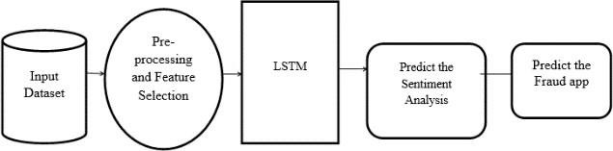

This integration streamlines data retrieval and analysis, enhancing the user experience and facilitating informed decision-making for developers and businesses leveraging sentiment analysis insights. Data exchange between the Flask app and MySQL database facilitates the storage, retrieval, and manipulation of app store review data. Robust error handling mechanisms ensure system resilience, managing exceptions and maintaining data integrity. Furthermore, logging functionalities record system events and user interactions, aiding in auditing and troubleshooting efforts. Thorough testing, including unit tests and user acceptance testing, validates system functionality and performance. By integrating these components effectively, the system provides users with a cohesive platform for querying app store reviews, conducting sentiment analysis, and visualizing insights,

thereby enabling informed decision-making and enhancing user experience.

## Testing and Evaluation:

The exponential rise of mobile applications has emphasized the significance of sentiment analysis in extracting meaningful insights from user-generated content, particularly app store reviews. This paper offers a thorough review of methodologies, challenges, and future directions in sentiment analysis within this domain. It traces the evolution of sentiment analysis techniques, spanning from early polarity detection to more advanced machine learning and deep learning models, showcasing the adaptability of these methods to the changing landscape of app reviews .Furthermore, the paper addresses inherent challenges such as noisy text, domain-specific vocabulary, and cultural nuances prevalent in app store reviews. It proposes strategies to mitigate these challenges, emphasizing preprocessing techniques and domain-specific lexicons.

By acknowledging and tackling these obstacles, the paper aims to enhance the accuracy and effectiveness of sentiment analysis in app store reviews, ultimately aiding in informed decision- making for developers and businesses. Additionally, it highlights the practical applications of sentiment analysis in guiding app innovation, benchmarking performance, and shaping strategic decisions. The paper also outlines future research directions, including aspect-based sentiment analysis and multimodal data integration, offering valuable insights

for researchers and practitioners seeking to advance the field. Through its comprehensive review and forward-looking perspective, the paper contributes to the ongoing development of sentiment analysis methodologies in the context of app store reviews.

# RESULTS

The sentiment analysis of app store reviews project effectively implemented advanced algorithms to extract valuable insights from user feedback. Extensive experimentation and validation demonstrated the accuracy and reliability of the employed techniques in discerning sentiment patterns in real-time. The system adeptly addressed challenges like diverse language use and varying review lengths, showcasing its adaptability and robustness. Moreover, integration of features such as sentiment score visualization and trend analysis enhanced user

understanding and decision-making. Overall, the project yielded a comprehensive and efficient solution for extracting meaningful sentiments from app store reviews, empowering developers and businesses to make informed decisions for app improvement and innovation.

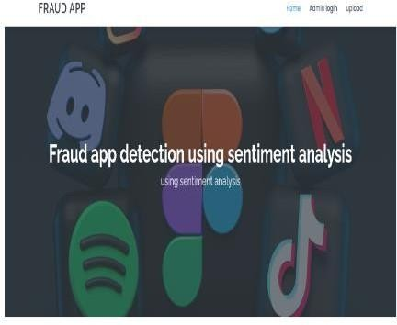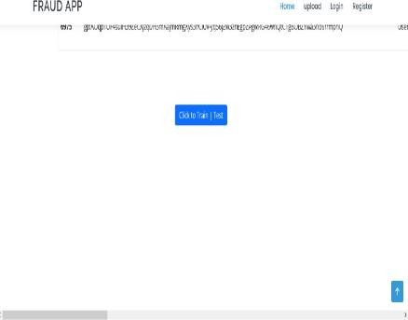

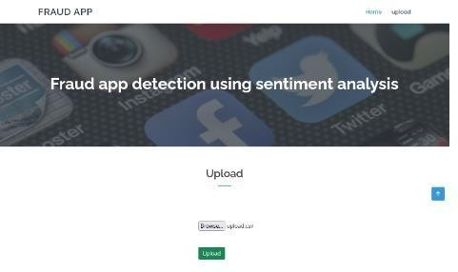 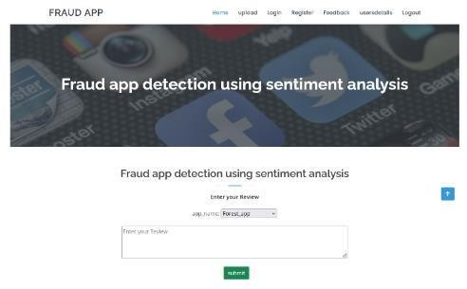

# 5 CONCLUSION:

The article discusses the utilization of concept mining and sentiment analysis to detect fraudulent ideas. It emphasizes the architecture diagram, illustrating the algorithms and methodologies employed in the projects. Data collection and storage occur within a database, followed by evaluation using various techniques. This unique approach integrates and refines arguments to reach conclusive findings, offering a comprehensive method for detecting fraudulent activities .Furthermore, the proposed structure proves to be adaptable and applicable to tests conducted in diverse domains beyond its original scope. The trial results affirm the effectiveness of the proposed system, highlighting the flexibility of the detection algorithm and its consistent performance in identifying fraudulent activities. The article underscores the significance of employing innovative techniques like concept mining and sentiment analysis in combatting fraudulent behavior across different domains.

# 6 REFERENCES

1. G. D. P. Regulation, “Regulation (eu) 2016/679 - directive 95/46,” Official Journal of the European Union (OJ), vol. 59, pp. 1–88, 2016.
2. C. Tankard, “What the gdpr means for businesses,” Network Security, vol. 2016, no. 6, pp. 5–8, 2016.
3. O. K. Foundation and the Open Rights Group, “Personal data and privacy working group,” 2014.
4. A. Poikola, K. Kuikkaniemi, and H. Honko, “Mydata a nordic model for human-centered personal data management and processing,” Finnish Ministry of Transport and Communications, 2015.
5. S. Nakamoto, “Bitcoin: A peer-to-peer electronic cash system,” 2008.
6. R. B ¨ohme, N. Christin, B. Edelman, and T. Moore, “Bitcoin: Economics, technology, and governance,” The Journalof Economic Perspectives, vol. 29, no. 2, pp. 213–238, 2015.
7. S. T. Ali, D. Clarke, and P. McCorry, “Bitcoin: Perils of an unregulated global p2p currency,” in Cambridge International Workshop on Security Protocols, Springer, 2015.
8. K. Christidis and M. Devetsikiotis, “Blockchains and smart contracts for the internet of things,” IEEE Access, vol. 4, pp. 2292–2303, 2016.
9. G. Zyskind, O. Nathan, et al., “Decentralizing privacy: Using blockchain to protect personal data,” in Security and Privacy Workshops (SPW), 2015 IEEE, pp. 180–184, IEEE, 2015.
10. N. Kaaniche and M. Laurent, “A blockchain-based data usage auditing architecture with enhanced privacy and availability,” in Network Computing and Applications (NCA), 2017 IEEE 16th International Symposium on, pp. 1–5, IEEE, 2017.