**POLICE STATION MANAGEMENT SYSTEM**

**ABISHEK S, HARIPRIYA A, GOKUL A.K**

**Guide:**  **Ms. K. Sugashini** AP/IT

Department Of Information Technology

Bachelor Of Technology

Sri Shakthi Institute of Engineering and Technology

An Autonomous Institution

Coimbatore 641062.

**ABSTRACT**

The Police Station Management System (PSMS) is a forward-thinking and technologically advanced solution designed to revolutionize the operational landscape of law enforcement agencies. In response to the dynamic challenges faced by traditional police station management systems, the PSMS project emerges as a comprehensive and innovative platform poised to enhance case handling, personnel coordination, and overall efficiency within police stations.

This transformative system leverages cutting-edge technologies to address the limitations of conventional approaches, providing a unified and digitally-driven framework for law enforcement agencies. The core objectives of the PSMS project include the digitization and centralization of case management processes, optimization of personnel coordination through sophisticated profiling and analytics, establishment of secure and efficient systems for evidence and property handling, promotion of seamless communication among officers and departments, and provision of advanced reporting and analytics tools for informed decision-making.

The PSMS project's scope encompasses the development and implementation of a user-friendly, scalable, and secure software system. Modules dedicated to case management, personnel coordination, evidence handling, communication, and reporting are intricately designed and integrated, ensuring a cohesive and streamlined user experience. The deployment of the PSMS within targeted police stations is aimed at ensuring compatibility with existing infrastructure while allowing for seamless integration and adaptability.

**CHAPTER 1**

**1. INTRODUCTION:**

This introduction provides an overview of the fundamental issues that the PSMS project seeks to address. From case inception to resolution, personnel coordination, evidence handling, and communication, the PSMS is envisioned as a holistic solution to streamline and enhance the operational efficiency of law enforcement agencies. By embracing digital transformation, the project aspires to provide a unified platform that fosters collaboration, transparency, and informed decision-making.

In the dynamic landscape of law enforcement, the challenges faced by police stations necessitate innovative and efficient solutions to enhance operational effectiveness and responsiveness. Traditional methods of police station management often grapple with inefficiencies in case handling, personnel coordination, and data management. Recognizing the need for a transformative approach, the Police Station Management System (PSMS) project emerges as a comprehensive solution designed to modernize and optimize key operational processes within police stations.

Law enforcement agencies play a crucial role in maintaining public safety and upholding justice. However, the evolving nature of crime and the complexity of investigations demand a sophisticated and technologically advanced system to support the day-to-day activities of police personnel. The PSMS project represents a pioneering initiative that leverages cutting-edge technologies to overcome the limitations of conventional systems, aiming to create a more responsive, transparent, and data-driven approach to law enforcement.

**CHAPTER 2**

**2. LITERATURE REVIEW**

**2.1 EXISTING SOLUTION**

However, there are various software solutions and platforms designed for law enforcement agencies that address case management, personnel coordination, evidence handling, and communication. Here are some categories of existing solutions, and you may want to explore the latest offerings within these categories:

**1. Integrated Law Enforcement Systems**

Comprehensive solutions that integrate multiple modules, including case management, records management, dispatch, and personnel tracking. Examples include CentralSquare, Hexagon's Intergraph, and Spillman Flex.

**2. Case Management Systems**

Software dedicated to managing the entire life cycle of a case, from initiation to resolution. Products like EnCase, Omnigo, and SceneDoc may include features for evidence management and personnel coordination.

**3. Records Management Systems (RMS)**

Systems that focus on maintaining records related to incidents, arrests, and other law enforcement activities. Popular RMS providers include TriTech Software Systems, Sun Ridge Systems, and New World Systems.

**4. Evidence Management Software**

Solutions dedicated to cataloging, tracking, and managing physical and digital evidence. Examples include Tracker Products, EvidenceOnQ, and FileOnQ.

**5. Communication and Dispatch Systems**

Platforms facilitating real-time communication among officers and dispatch centers. Motorola Solutions, Hexagon's OnCall suite, and Zuercher Suite are examples of solutions that provide communication and dispatch capabilities.

**2.2 PROPOSED SOLUTION**

The proposed solution for the Police Station Management System (PSMS) project aims to address the identified challenges in law enforcement and provide a comprehensive, technology-driven platform to enhance operational efficiency. The PSMS will leverage modern technologies and innovative features to streamline various aspects of police station management. Here's an outline of the proposed solution:

**1. Digital Case Management**

Implement a robust and user-friendly digital case management system that allows for the efficient creation, tracking, and resolution of cases. This includes features for case initiation, progress monitoring, and seamless collaboration among investigators.

**2. Personnel Coordination and Performance Analytics:** Develop a module for personnel coordination that includes detailed profiles, duty tracking, and performance analytics. This module will facilitate optimized staffing, resource allocation, and performance assessment to enhance overall personnel efficiency.

**3. Secure Evidence and Property Handling**

Establish a secure and automated system for evidence and property handling. This includes features for cataloging, tracking, and maintaining the chain of custody for physical and digital evidence. Security protocols will be implemented to ensure data integrity and confidentiality.

**4. Communication Hub**

Integrate a communication hub that fosters seamless information exchange among officers, investigators, and departments. This includes real-time messaging, notifications, and collaboration tools to enhance communication efficiency within the law enforcement ecosystem.

**5. Advanced Reporting and Analytics Tools**

Provide law enforcement agencies with advanced reporting and analytics tools. This includes customizable reports, data visualization, and analytics capabilities to support data-driven decision-making. The system will offer insights into crime trends, resource utilization, and operational effectiveness.

**CHAPTER 3**

**3. PROJECT SCOPE AND OBJECTIVES**

**3.1 PROJECT SCOPE**

The Police Station Management System (PSMS) aims to develop and implement a comprehensive software solution to modernize and optimize the operational processes within law enforcement agencies. The scope of the project includes the design, development, and deployment of a user-friendly, scalable, and secure system that addresses the challenges faced by traditional police station management systems.

**3.2** **PROJECT OBJECTIVES**

**1. Digitize Case Management:** Develop a module for digital case creation, tracking, and resolution to streamline and organize investigative processes.

**2. Optimize Personnel Coordination:** Implement a personnel coordination module with comprehensive profiles, duty tracking, and performance analytics to enhance staff management.

**3. Secure Evidence Handling:** Design a secure and efficient module for evidence and property handling, ensuring the integrity and traceability of physical and digital evidence.

**4. Enhance Communication:** Establish a communication module to facilitate real-time information exchange among officers, investigators, and departments, improving collaboration.

**5. Advanced Reporting and Analytics:** Provide law enforcement agencies with advanced reporting and analytics tools for data-driven decision-making and strategic planning.

**CHAPTER 4**

**4. SYSTEM REQUIREMENTS**

**4.1 HARDWARE SPECIFICATIONS**

* PIV 2.8 GHz Processor and Above
* RAM 512MB and Above
* HDD 20 GB Hard Disk Space and Above

**4.2 SOFTWARE TECHNOLOGIES**

* HTML
* CSS
* JavaScript
* PHP
* MySQL

**CHAPTER 5**

**5.SYSTEM DESIGN**

**5.1 PROCESS FLOW**

**Investigator**

He is the actor who can practically work upon the existing data inthe police station only for view purpose.

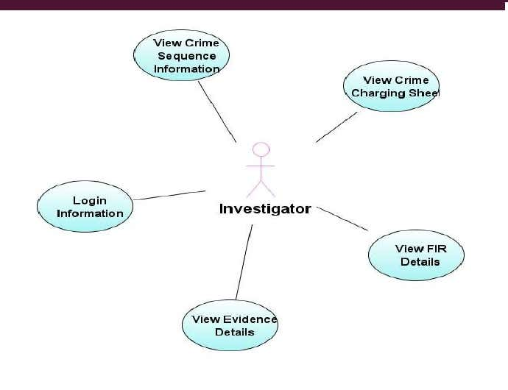

**Administrator**

 He is the actor who has the full-length potentiality and privilege to carryout transactions upon the system. He is authorized to maintain consistency within the information.

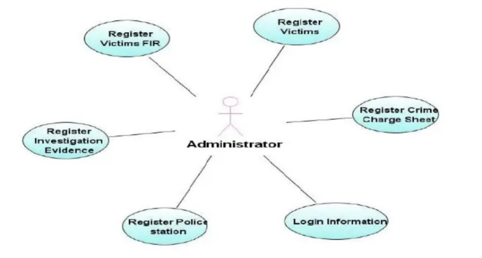

**Writer**

 He is the actor who can enter all the details of the crime or evidence. Once enter cannot be edited. On can edit or delete the record from the database.

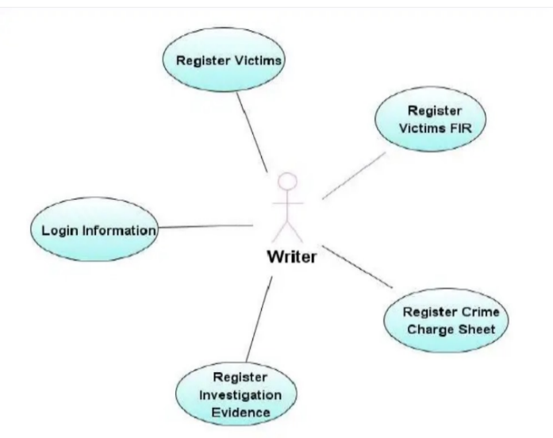

**5.2 LOGICAL SYSTEM DESIGN**

The logical system design reviews the present system and prepares input and output specifications, editing, security and control specification details of the implementation plans.

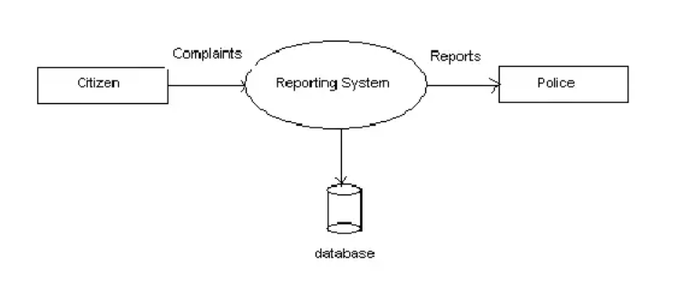

**CHAPTER 6**

**6. SCREENSHOTS**

**6.1 HOME PAGE**

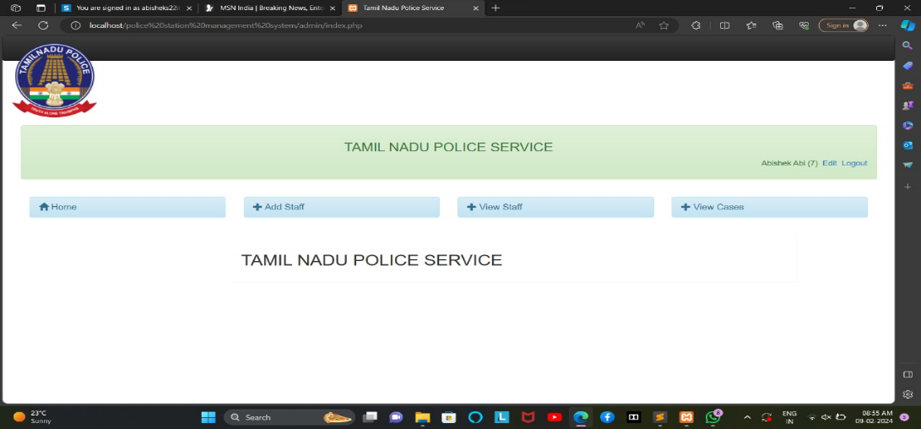

**6.2 ADD STAFF**

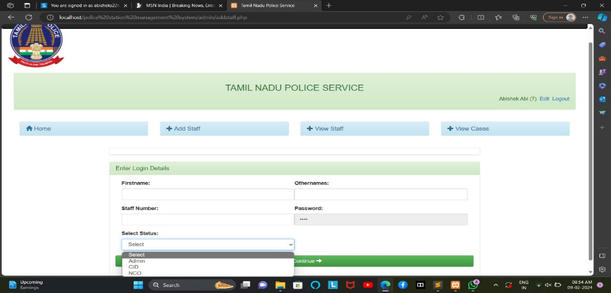

**6.3 COMPLAINT DETAILS**

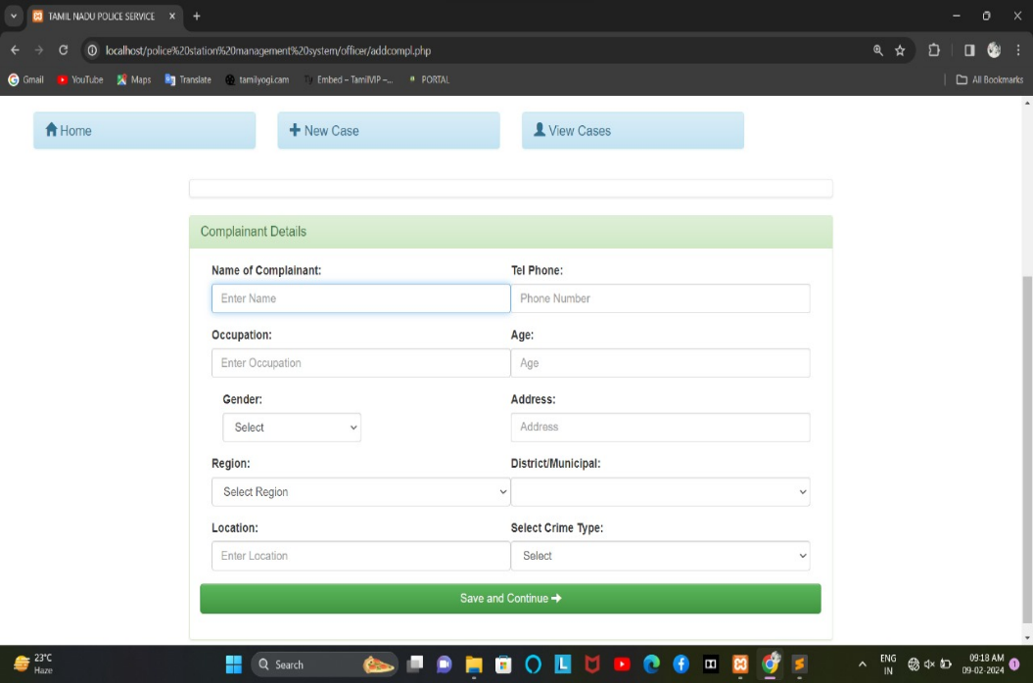

**6.4 VIEW CASES**

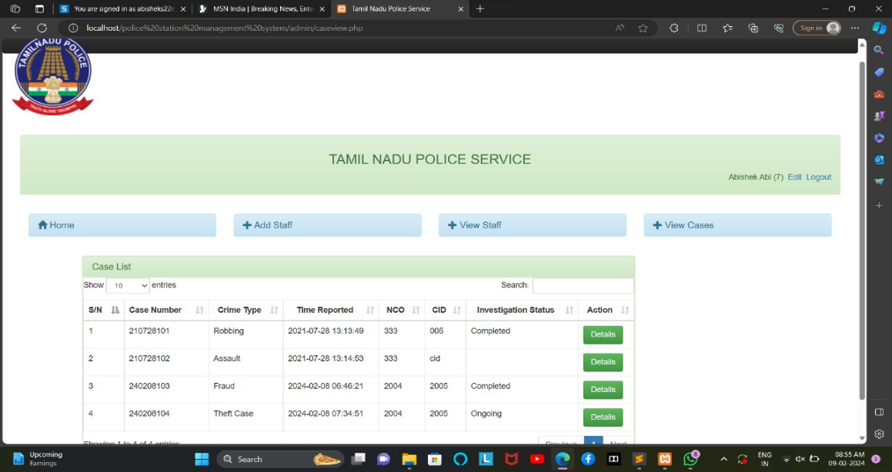

**6.5 CASE DETAILS HARDCOPY**

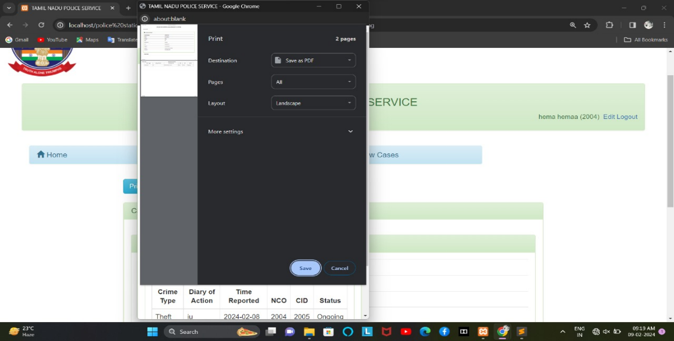

**CHAPTER 7**

**7. APPLICATIONS**

* The Police Station Management System (PSMS) application is a sophisticated and comprehensive platform designed to revolutionize the operational landscape of law enforcement agencies.
* With a focus on efficiency, transparency, and collaboration, the application integrates cutting-edge technologies to streamline critical aspects of police station management.
* From digital case creation and tracking to personnel coordination, evidence handling, and communication, the PSMS provides a centralized hub for law enforcement professionals to optimize their workflows.
* The application facilitates secure cataloging and tracking of physical and digital evidence, ensuring the integrity of investigations.
* Its personnel coordination module includes detailed profiles, duty tracking, and performance analytics, empowering law enforcement agencies with insights into staffing and resource utilization.
* Real-time communication tools enhance collaboration among officers and departments, fostering a cohesive and responsive environment.
* Advanced reporting and analytics tools offer data-driven decision-making capabilities, while the mobile accessibility feature ensures officers have critical information at their fingertips in the field.
* The PSMS application represents a paradigm shift in modern policing, offering a user-friendly, scalable, and secure solution that addresses the complexities of law enforcement operations in the digital age.

**CHAPTER 8**

**8. CONCLUSION AND FUTURE WORKS**

**8.1 FUTURE WORKS**

As the PSMS continues to serve as a cornerstone in modern policing, future developments aim to further refine and expand its capabilities. The following areas represent potential future works for the project:

**Enhanced Analytics and Predictive Policing:** Further development of advanced analytics tools for predictive policing, leveraging machine learning algorithms to anticipate and prevent criminal activities.

**Integration with Emerging Technologies:** Integration with emerging technologies such as artificial intelligence, facial recognition, and IoT devices to enhance investigative capabilities and improve overall security.

**Continued User Training and Support:** Ongoing training programs and support mechanisms to ensure that law enforcement personnel are continually equipped to maximize the benefits of the PSMS.

**Community Engagement Features:** Implementation of features that facilitate community engagement, promoting transparency and collaboration between law enforcement and the public.

**Cybersecurity Enhancements:** Continuous improvement of cybersecurity measures to safeguard sensitive data, staying ahead of evolving cyber threats and ensuring compliance with the latest security standards.

**8.2 CONCLUSION**

In conclusion, the development and implementation of the Police Station Management System (PSMS) mark a significant milestone in the evolution of law enforcement practices. The PSMS has successfully addressed the inherent challenges of traditional police station management, offering a robust and technologically advanced solution to enhance operational efficiency, transparency, and collaboration within law enforcement agencies. By digitizing case management, optimizing personnel coordination, and providing secure and efficient systems for evidence handling, the PSMS has proven to be an invaluable tool for streamlining daily operations and fostering a more responsive approach to modern policing.

The successful deployment and utilization of the PSMS have resulted in tangible benefits, including improved case resolution times, enhanced communication among officers, and a data-driven decision-making culture within law enforcement. The system's scalability and user-friendly interface have contributed to its widespread adoption, empowering agencies of various sizes to adapt to evolving challenges effectively.

**REFERENCES**

[1] A. S. Shah, M. Fayaz, A. Shah and S. Shah, “An Application Development for Record

Keeping of Police Stations in Pakistan”, Journal of Scientific Research and Advances, vol. 2,

no. 4, (2015), pp. 144-150.

[2] T. Remencius, A. Sillitti and G. Succi, “Assessment of Software Developed by a Third-Party: A Case

Study and Comparison”, Information Sciences, vol. 328, (2016), pp. 237-249.

[3] G. L. Kovács, S. Drozdik, P. Zuliani and G. Succi, “Open Source Software for the Public

Administration”, In: Proceedings of the Sixth International Workshop on Computer Science and

Information Technologies, Budapest, Hungary, (2004).

[4] K. Mordal, N. Anquetil, J. Laval, A. Serebrenik, B. Vasilescu and S. Ducasse, “Software Quality

Metrics Aggregation in Industry”, Journal of Software Evolution Process, vol. 25, no. 10, (2013), pp.

1117–1135.

[5] G. Garousi, V. Garousi, G. Ruhe, J. Zhi, M. Moussavi and B. Smith, “Usage and Usefulness of

Technical Software Documentation: An Industrial Case Study”, Information and Software Technology,

vol. 57, (2015), pp. 664-682.

[6] G. Garousi, V. Garousi, M. Moussavi, G. Ruhe and B. Smith, “Evaluating Usage and Quality of

Technical Software Documentation: An Empirical Study”, In: Proceedings of the 17th International

Conference on Evaluation and Assessment in Software Engineering, New York, (2013), pp. 24-35.

[7] J. M. Memon, A. Khan, A. Baig and A. Shah, “A Study of Software Protection Techniques”,

Innovations Advanced Techniques in Computer and Information Sciences and Engineering, Springer

Netherlands, (2007), pp. 249-253.

[8] A. Shah, A. Raza, B. Hassan and A. S. Shah, “A Review Of Slicing Techniques In Software

Engineering”, In: International Conference on Engineering and Technology, Srilanka, (2015)

March 17-18, pp. 1-15.

[9] Spring Framework, http://spring.io/. Retrieved 2016-06-09