**IoT Based Greenhouse Monitoring and Controlling System**

1. **I.Bandar, Tasalima Jamadar, Srushti Mali, Riya Kajave, Bibisaara Badwale**

Lecturer, Department of Computer, SIT Polytechnic, Yadrav, Maharashtra, India

Department of Computer,Third year, SIT Polytechnic, Yadrav, Maharashtra, India

**ABSTRACT**

This project is based on human less maintenance of agriculture . In this the moisture of the soil, temperature, humidity and light intensity of the place will maintained automatically. Although we can predict the upcoming weather, there can be changes like sudden rain or harsh sunlight. These unpredictable changes in weather can destroy the crops. To avoid this, this system will automatically maintain the conditions which are favorable for the crops. If there is sudden rain and if the temperature is too low for the crops, the system will turn on the heat lamp due to which the temperature will be maintained. If due to high temperature, the moisture of the soils gets reduced, the system will turn on the water pump to maintain the moisture. Some crops need specific amount of light. If there is a situation that the surrounding light is low for the crops, then the system will turn on the light bulb to maintain the light intensity. In all these situations the farmer need not to run behind things like turning on water pump, light bulb, fan, etc. This system will take care of the maintenance of agriculture. All this data will be transmitted to the mobile device of the farmer.

**Keywords:** agriculture, maintenance , temperature , light intensity, moisture, humidity.

1. **INTRODUCTION**

A Greenhouse, which is a exceptionally outlined homestead structure. As a part of this present-day period, for developing yields, following to more space of area which has vigorously utilized for commercial ventures and housing the area space is accessible. The cost-effective farming such as new blossoms, organic products and vegetables generation is the utilization of Greenhouse development in many tropical nations. The conformity of ideal atmosphere development conditions which is to attain to the high return at great quality, low natural burden and low cost is the effectiveness of plant creation inside Greenhouse which depends fundamentally. Parameters like light, humidity, temperature, soil moisture must be controlled ideally where the given certain criteria through water creation, warming, ventilation and lighting are used to attain certain objectives. By persistent checking and controlling of these ecological parameters which gives a significant data that is related to the individual impacts of the elements differently towards acquiring the most extreme creation of harvest. The present remarkable difficulties of Greenhouse is to control. Temperature changes quickly, In Greenhouse as a result, fluctuations relying upon sun powered radiation level, moisture levels and outside temperatures. Poor natural product set and quality frequently bought by the high stickiness and poor light intensity. Expanding the efficiency of labourer by empowering them for the more important assignments, electrical expenses and heating fuel, empowering producers and directors to settle on better administration choices and to invest more on the energy dealing with procedures can be decreased by practicing exact control over the system. In this thesis, we have proposed a system which can read the parameters data from the environment which is identified within the Greenhouse and will be controlled manually or by Android app which we have developed. In the cloud data will be stored for future use. If any climate values fluctuate the precautionary measures will be taken by the user. The relationship between reference estimations and sensor flags, breaking down the developments, the natural variables which are uncovered and advancement of yields are explored by strictly observing climate changing conditions.

1. **METHODOLOGY**

The main objective of this project is to control the system automatically. The temperature sensor, light sensor, humidity sensor will be controlled. By implementing advance technology in the industry will increase the demand for agriculture products which are concerned by the consumer's needs.

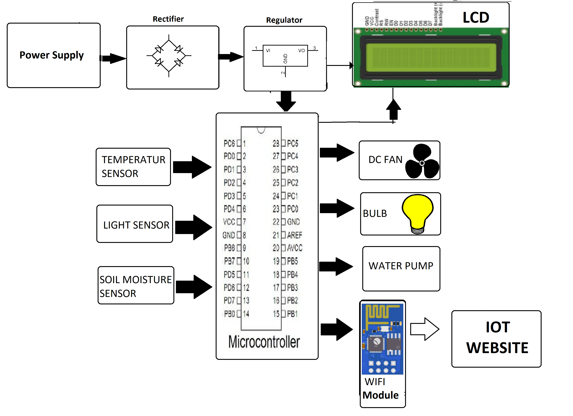

Block diagram of Greenhouse Monitoring and Control System Using IOT

1. **MODELING AND ANALYSIS**

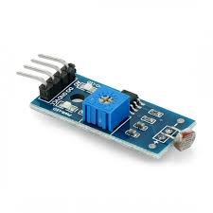

**Figure 1**: Light sensor

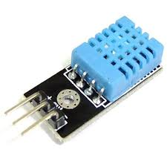

**Figure 2**: Temperature sensor

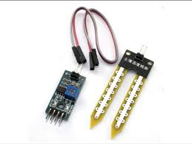

**Figure 3**: Moisture sensor

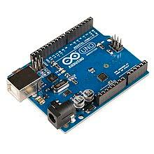

**Figure 4**: Arduino UNO Board

1. **RESULTS AND DISCUSSION**

This control unit collects all the details regarding the plant . Consisting of moisture, temperature, humidity and light sensor with a mini water pump attached for pumping sufficient amount of water to plants. The whole controlling system is having a power supply of 5v. LED is present in the controlling unit for providing enough light for the plants and a mini fan for controlling the temperature. Display console shows the measured values of moisture and temperature. We have created a cloud for storing all the details about the growth of plants. And have Developed an android application for monitoring the greenhouse and controlling the environment inside the greenhouse.

**5.CONCLUSION**

This Greenhouse project is designed intelligently for the betterment of the crop growth. The system gives the high efficiency plant growth, low cost and effective working. The user can control it manually and also using the Android app which we have developed. Greenhouse is more effective than the plants grown normally. The Android app is used to check the status inside the Greenhouse and can be handled it easily. The software and hardware working is so smoothly done and can be used easily. The system design give the user to understand the working and very ease to use it. The yield is so effective and the data can be stored in cloud for the future use.

.

1. **REFERENCES**
2. Yuthika Shekar, Ekta Dagur, Sourabh Mishra “Intelligent IoT Based Automated Irrigation System”, B. Tech Graduate, Department of Information Technology, SRM University, Kattankaluthur Campus, Chennai-601302, India,2017.
3. Shirsath, Punam Kamble, Rohini Mane, Ashwini Kolap, Prof.R.S. More “IoT Based Smart Greenhouse Automation Using Arduino, 2017Gyusoo Kim and Seulgi Lee, “2014 Payment Research”, Bank of Korea, Vol. 2015, No. 1, Jan. 2015.
4. Sridevi, Shreejith K, T.V.Ramachandra,”Comparative Analysis of Greenhouse”,2017.

[4] Quan Minh Vu, "Automated Wireless Greenhouse Management System", Master of Engineering in Electronics and Computer Systems, Massy University, Palmerston North, New Zealand, June 2011