**DESIGN AND IMPLEMENTATION OF AUTONOMOUS FIRE FIGHTING ROBOT**

Mr. Suraj Eknath Wasurke1, Mr. Nishant Yashwantrao Katre2, Mr. Laxmikant Gajananrao Wanjari3, Mr. Satishkumar Rajaram Turkar4, Asst. Prof. V. H. Bankar5

1234Student, Mechanical Dept, VIT, Nagpur.

5Asst. Professor, Mechanical Dept, VIT, Nagpur

**ABSTRACT**

Flames can cause critical harm and death toll, and it is pivotal to have powerful measures to control and douse them. The utilization of robots for firefighting activities has become progressively famous, provided their capacity to work in risky and testing conditions. In this paper, we present a point-by-point concentrate on the plan, improvement, and execution of a putting out fire robot. The putting out fires robot Is intended to explore through jumbled and temperamental conditions and furnished with sensors and cameras to identify and screen the fire. It is additionally equipped for conveying and sending firefighting gear, for example, quenchers and water hoses. The plan includes choosing the suitable sensors, actuators, and power sources to accomplish the ideal usefulness. The robot’s motion framework is intended to empower it to travel through lopsided territory and flotsam and jetsam, and it has a controller arm to get and work firefighting gear. The execution includes building the actual equipment and fostering the product that controls its activities. The equipment might be created utilizing a blend of off-the-rack parts and specially constructed parts. The product is intended to empower the robot to work independently in a putting out fires situation, utilizing Al calculations to identify and group various sorts of flames and select proper reactions in view of the seriousness of the circumstance. The robot is additionally intended to speak with human administrators, empowering them to screen the robot’s activities and settle on choices in view of the data given by the sensors

**Keywords:** Fighter, Robot, Extinguishment, Robot, Arduino Uno, Sensors.

1. **INTRODUCTION**

Robotics is one of the fastest growing engineering fields of today’s era. Robots are designed to remove the human’s factor for dangerous work and also for difficult environment. The use of robot is more widely used than ever before.The need of fire extinguisher Robot is that can detect and extinguish the fire at its own risk. Our aim as an engineer is to design such a device which can automatically Detect and extinguish the fire. Also aims to reduce the air pollution. It is a protocol which can move through a model structure, find a fire and extinguish with the help of the water Jet.Robots are very intelligent devices which can be use according to our use and our requirement. Keeping all the things in mind the robot is capable of being remotely controlled through the Arduino uno. In the realm of modern technological advancements, the development of automated systems has revolutionized various industries, ranging from manufacturing to healthcare. One such critical application lies in the field of emergency response and disaster management, where innovation has paved the way for the creation of Fire Fighting Robots – automated machines designed to combat fires in hazardous and challenging environments.

1. **PROBLEM FORMULATION**

Fire disaster is one of the dangerous problems that can lead to heavy loss both financially and by taking lives. Sometime it becomes difficult for fighters to access the site of a fire because of explosive materials, smoke, and high temperatures. Such situations risk the lives of fire fighters too. In such environments, fire-fighting robots can be useful.

This Fire Extinguishing Robot is based on IOT Technology. In Fire Extinguishing Robot, we intend to build a system that could extinguish a small flame by sensing and moving to the location itself. Sometime delay in the arrival of fire fighters leads to numerous consequences. The Fire Extinguishing robot continuously

1. **METHODOLOGY**

In this section, the prototype of robotic system is presented, in which it consists of IR flame sensors, servo motors, submersible water pump, motor driver, mini breadboard, BO motors, rubber wheels, processor, and communication module for exchanging data between the fire-fighting robot and Arduino software

**IV. BASIC OPERATION**

The flame sensor senses the fire and send the information to the Arduino which is the brain of this robot. The brain will take the action according to the condition and information getting from the sensor. Arduino will give the commands to the Motors to start and walk in the desired direction. if left sensor gives the information about the fire, then the Arduino will run the motor in left direction. Same for the front and right-side motor. The robot car will stop near to the fire and start watering to it till the fire will be under control. A firefighting robot car built using an Arduino Uno involves combining various components and programming to create a system that can detect and extinguish fires autonomously. Here's a general overview of the working principle.

Arduino Uno: The microcontroller that serves as the brain of the robot.

Flame Sensor: To detect the presence of a fire.

Motor Drivers: To control the movement of the robot's wheels.

DC Motors: To drive the wheels of the robot.

Water Pump and Tank: To carry and spray water for firefighting.

Chassis: The physical structure of the robot that holds all the components.

Batteries: To power the robot and its components

**V. EXPERIMENTATION**

Once you've designed your circuit in the schematic editor, you can run simulations to see how the circuit behaves under different conditions. Proteus supports various types of simulation, including DC analysis (steady-state analysis), AC analysis (frequency response analysis), transient analysis (time-domain analysis), and more. These simulations help you understand how the circuit's components interact and how signals propagate through the circuit.

Programming: The Arduino Uno needs to be programmed to handle the various tasks, including reading data from the flame sensor, controlling the motors, managing the water pump, and making decisions based on the sensor inputs. You would need to write code that integrates all these functionalities and ensures the robot operates safely and effectively. Please note that building such a robot involves a fair amount of electronics, mechanics, and programming knowledge. Safety measures are crucial to prevent accidents, especially when dealing with fire. Always take appropriate precautions and consider seeking guidance from experts if you're not familiar with all aspects of building and programming such a robot.

**VI. RESULTS AND DISCUSSION**

Fire Fighting Robot has developed to reduce human life lost and to develop such a device that automatically sense fire and extinguish it without human intervention. In this the fireplace is detected using the IR Flame sensors and are connected to Arduino UNO, which control the movement of Motor drive that helps the robot to reach the fireplace and extinguishes it with the pumping mechanisms. In the industry if any fire accident occurs, there is a need of person to monitor continuously and rectify it. In this process if any time delay takes place irreparable loss occurs in industry. The firefighting robot continuously monitors the surrounding and helps in extinguishing the fire. Fig 11 shows the overall prototype of Fire Fighting Robot. We have taken inspiration from the technique and tools used by human being fire fighters. Historical firefighting equipment like old water pump or early fire engines can spark ideas for designing the robot’s tools and mechanism. The Human body’s ability to sense and react to danger can inspire the design of sensors and algorithm for the robot. We have considered the needs and challenges faced by fire fighters and emergency responders

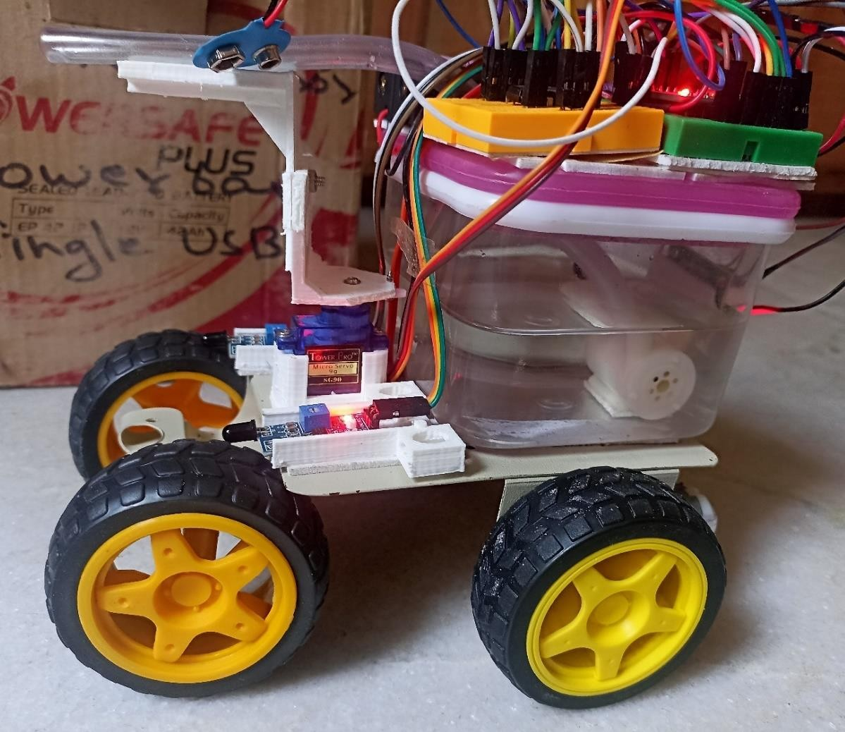

Figure. Hardware of firefighting robot.

Environmental Adaptation: Looking at how animals and plants adapt to different environments. We have designed a robot that can change its mode of operation based on the fire scenario could be a unique approach.

Designing a firefighting robot can be inspired by various sources and considerations. Aerial Drones: Drones used for aerial firefighting can inspire the design of robots that can access hard-to-reach areas or provide aerial views of the fire scene. These drones often carry firefighting agents like water or foam.

Underwater Robotics: If firefighting involves scenarios like shipboard fires or underwater environments, underwater robotics can provide inspiration. These robots are designed to navigate and perform tasks in challenging aquatic conditions.

1. **CONCLUSION**

In conclusion, the fire-fighting robot car demonstrated the potential of using an Arduino Uno microcontroller for autonomous fire detection and suppression. While the prototype showed promising results, further refinement is necessary to overcome the identified limitations and enhance its overall performance. This project serves as a foundation for future developments in fire-fighting automation and robotics using Arduino-based platforms. This model of Fire Extinguishing Robot aids to share out the burden of fire fighters in firefighting task. Our project aims to build a real time firefighting robot which moves in a constant speed, identify the fire and then extinguish it with the help of pumping mechanism. The detection and extinguishing was done with the help basic hardware components attached with the robot. Firstly, IR Flame sensors are used for the detection of fire. Secondly, BO Motors and Rubber wheels are used to navigate the robot to reach the fireplace. Finally, the robot extinguishes the fire with the help of submersible water pump and servo motors. Through this we can conclude that a robot can be used in place of humans without risk of human beings life as well as life of the fire fighters. We can use this robot in our homes, labs, offices etc. This robot will provide us greater efficiency to detect the flame and it can be extinguish before it become uncontrollable and threat to life. Hence, this robot will be very helpful and can play a important role. This project has been motivated by the desire to design a system that can detect fires. In the present condition it can extinguish fire only in the way and not in all the rooms. It can be extended to a real fire extinguisher by increasing robot size and configurations. This provides us the opportunity to pass on to robots tasks that traditionally humans had to do but were inherently life threatening.

.

1. **REFERENCES**
2. Tawfiqur Rakib, M. A. Rashid Sarkar, “Design and fabrication of an autonomous firefighting robot with multi sensor fire detection using PID controller”, ICIEV Vollum 23 issue-1 JUNE 2016.
3. Saravanan P. ,Soni Ishawarya, “Android controlled intergrated semi-autonomous firefighting robot”, Ineternational journal of innovative science Engg. and Technology 2015.
4. S. Jakthi Priyanka,R. Sangeetha, “Android controlled firefighting robot”,Ineternational journal of innovative science Engg. and Technology ,Volumn 3, 2017.
5. Nagesh MS, Deepika T V , Stafford Michahial, Dr M Shivakumar, “Fire Extinguishing Robot”, International Journal of Advanced Research in Computer and Communication Engineering, Vol. 5, Issue 12, December 2016.
6. Sushrut Khajuria, Rakesh Johar, Varenyam Sharma, Abhideep Bhatti, “ Arduino Based Fire Fighter Robot”,International Journal of Scientific Engineering and Research (IJSER),Volume 5 Issue 5, May 2017.
7. Khaled Sailan, Prof. Dr. Ing. Klaus- Dieter Kuhnert “Obstacle avoidance stratergy using fuzzy logic steering control of amphibious autonomous vehicle”, International journal of innovative science Engg. and Technology ,Volumn 2, 2015
8. J Jalani1 , D Misman1 , A S Sadun1 and L C Hong1,“Automatic fire fighting robot with notification”,IOP Conference Series: Materials Science and Engineering, Volume 637, The 3rd International Conference on Robotics and Mechantronics (ICRoM 2019) 9–11 August 2019, Sabah, Malaysia
9. Rashid Sarkar, “Design and fabrication of an autonomous firefighting robot with multi sensor fire detection using PID controller”, ICIEV Volumn 23 issue-1 JUNE 2016.

Saravanan P. “Android controlled intergrated semi-autonomous firefighting robot”, Ineternational journal of innovative science Engg. and Technology 2015. [3] S. Jakthi Priyanka,R. Sangeetha, “Android

1. controlled firefighting robot”,Ineternational journal of innovative science Engg. and Technology ,Volumn 3, 2017.
2. Nagesh MS, Deepika T V , Stafford Michahial, Dr M Shivakumar, “Fire Extinguishing Robot”, International Journal of Advanced Research in Computer and Communication Engineering,Vol. 5, Issue 12, December 2016.

this section. Table and Fluid should be in prescribed format.

**Figure 1:** Pycnometer Test Procedure.

1. **RESULTS AND DISCUSSION**

In this Section results and discussion of the study is written. They may also be broken into subsets with short, revealing captions. This section should be typed in character size 10pt Times New Roman.

**Table 1.** Sample Comparison

|  |  |  |
| --- | --- | --- |
| SN. | Sample | Quantity (Liter) |
| 1 | Fluid A | 22 |
| 2 | Fluid-B | 15 |
| 3 | Fluid-C | 12 |
| 4 | Fluid-D | 10 |
| 5 | Fluid-E | 27 |
| 6 | Fluid-F | 32 |

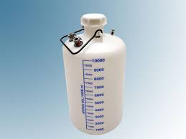

**Figure 2:** 10 liter capacity vessel (Font size-10)

Unless or otherwise specified specific gravity values reported shall be based on water at 270C. So the specific gravity at 270C = K Sp. gravity at Tx0C. The specific gravity of the soil particles lie with in the range of 2.65 to 2.85. Soils containing organic matter and porous particles may have specific gravity values below 2.0. Soils having heavy substances may have values above 3.0.

1. **CONCLUSION**

All the main points of the research work are written in this section. Ensure that abstract and conclusion should not same. Graph and tables should not use in conclusion.

**ACKNOWLEDGEMENTS (optional)**

The authors can acknowledge professor, friend or family member who help in research work in this section.

1. **REFERENCES**
2. T. Mohana Priya, Dr. M. Punithavalli & Dr. R. Rajesh Kanna, Machine Learning Algorithm for Development of Enhanced Support Vector Machine Technique to Predict Stress, Global Journal of Computer Science and Technology: C Software & Data Engineering, Volume 20, Issue 2, No. 2020, pp 12-20
3. Ganesh Kumar and P.Vasanth Sena, “Novel Artificial Neural Networks and Logistic Approach for Detecting Credit Card Deceit,” International Journal of Computer Science and Network Security, Vol. 15, issue 9, Sep. 2015, pp. 222-234
4. Gyusoo Kim and Seulgi Lee, “2014 Payment Research”, Bank of Korea, Vol. 2015, No. 1, Jan. 2015.
5. Chengwei Liu, Yixiang Chan, Syed Hasnain Alam Kazmi, Hao Fu, “Financial Fraud Detection Fluid: Based on Random Forest,” International Journal of Economics and Finance, Vol. 7, Issue. 7, pp. 178-188, 2015.
6. Hitesh D. Bambhava, Prof. Jayeshkumar Pitroda, Prof. Jaydev J. Bhavsar (2013), “A Comparative Study on Bamboo Scaffolding And Metal Scaffolding in Construction Industry Using Statistical Methods”, International Journal of Engineering Trends and Technology (IJETT) – Volume 4, Issue 6, June 2013, Pg.2330-2337.