IOT based battery monitoring system for

Electric vehicle

Dr. N.Sambasiva Rao  
Professor and Head of the Department of Electrical and Electronics Engineering(EEE).NRI Institute of Technology(Autonomous),Vijayawada,India,  
nsraohodeee@gmail.com

Poojitha Puvvadi  
Department of Electrical and Electronics Engineering(EEE).NRI Institute of Technology(Autonomous),Vijayawada,India,  
poojithapuvvadi26@gmail.com

Dinesh Ramisetti  
Department of Electrical and Electronics Engineering(EEE).NRI Institute of Technology(Autonomous),Vijayawada,India,  
dineshramisetti139@gmail.com

Siva Karthikeya Gogula  
Department of Electrical and Electronics Engineering(EEE).NRI Institute of Technology(Autonomous),Vijayawada,India,  
gsivakarthikeya@gmail.com

Rama Krishna Bathula   
Department of Electrical and Electronics Engineering(EEE).NRI Institute of Technology(Autonomous),Vijayawada,India,  
3300ramakrishna@gmail.com

Meghana Eturu  
Department of Electrical and Electronics Engineering(EEE).NRI Institute of Technology(Autonomous),Vijayawada,India,  
eturumeghana08@gmail.com

*Abstract*—Battery storage forms the most important part of any electric vehicle (EV) as it stores the necessary energy for the operation of EV.So, in order to extract the maximum o/p of a battery & to ensure its safe operations it is necessary that a efficient battery management system exist is the same .It monitors the Parameters, determine SOC and provide necessary services to ensure safe operation of battery. Hence BMS forms a integral part of any EV and safe guards both the user and the battery by ensuring that the cell operates within its safe operating parameters. The proposed system only monitor the battery and charge it safely but also protect it to avoid accidents from occurring. The proposed model has following functions current, voltage measurement, fire, protection, battery status detection, liquid crystal display (LCD) etc. Electric vehicles (EVs) are automobiles powered by one or more electric motors, which draw energy from rechargeable batteries instead of relying solely on internal combustion engines (ICEs) that consume fossil fuels. A Battery Management System (BMS) is a critical component in electric vehicles (EVs) and other battery powered systems. It monitors and controls the operation of the battery pack, ensuring its optimal performance, safety, and longevity.

Keywords—Electric vehicle , Battery Monitoring system , Aurdino , temperature sensor

# Introduction

An electric vehicle EVs is a type of vehicle that uses one or more electric motors for propulsion. Instead of using an internal combustion engine (ICE) that burns fuel, an EV use a battery pack to store electrical energy to power an electric motor, which turns the wheels. Compared to conventional ICE vehicles, EVs provide a number of benefits, such as decreased emissions, quieter operation, and a lessened reliance on fossil fuels. Since electricity is frequently less expensive than gasoline and electric motors are more efficient than ICEs, they also typically have reduced operational expenses. The popularity of EVs is fast rising as the globe moves towards a cleaner, more sustainable future. Governments all around the world are granting incentives to stimulate the use of EVs, and numerous automakers are already selling a variety of EV models. In addition to its benefits, common EV problems include internal cell shorts that may result in thermal runaway. An EV typically catches fire because of excessive heating. The electric vehicle's battery warms up, and when that heat interacts with petrol that has leaked, the battery simply catches fire. A battery management system (BMS) is an electrical device that controls and keeps track of the operation of rechargeable batteries, such as those found in renewable energy sources and electric cars. By regulating the charging and discharging process, keeping track of the battery's state of charge and overall health, and guarding the battery from harm brought on by overcharging or overheating, the BMS aids in ensuring the safe and effective operation of the battery. The BMS normally consists of a number of parts, such as sensors for measuring the temperature, voltage, and current of the battery as well as control circuits for controlling how the battery is charged and discharged in response to various conditions. Software algorithms that forecast the battery's remaining capacity and project its remaining life may also be present in the BMS. One of the key functions of a BMS is to prevent the battery from being overcharged or over discharged, which can cause permanent damage to the battery and reduce its lifespan. The BMS accomplishes this by controlling the charging and discharging process and shutting down the battery if any abnormal conditions are detected. Another important function of a BMS is to ensure that the battery is operating within a safe temperature range. If the battery gets too hot, the BMS may reduce the charging rate or shut down the battery to prevent damage. If the battery gets too cold, the BMS may increase the charging rate to help warm up the battery. Overall, a BMS is an essential part of any rechargeable battery system since it ensures the battery's safe and effective operation and increases its longevity. EV batteries that are frequently utilised are 2-cell lithium-ion (Li-ion) batteries. A 2-cell Li-ion battery should have a voltage of roughly 6.0V when it is fully depleted, and a maximum charge voltage of roughly 8.4V The balancing charger will keep track of each cell's voltage during the charging procedure and modify the charge rate as necessary to guarantee that all of the cells receive an equal charge. The balancing charger will automatically cease charging when the battery is fully charged. It is crucial to remember that overcharging a Li-ion battery might cause it to malfunction, which could cause a fire or explosion. As a result, it's crucial to pay close attention to the charging process and prevent leaving the battery alone while it's being charged. In our project, we keep an eye on battery voltage, temperature, and detect the presence of fire. If the battery temperature rises beyond a certain threshold, the power to the lithium-ion battery is automatically shut off using a relay.We create a little robot that can be operated by an android app and contains all the systems mentioned above.

# Block Diagram

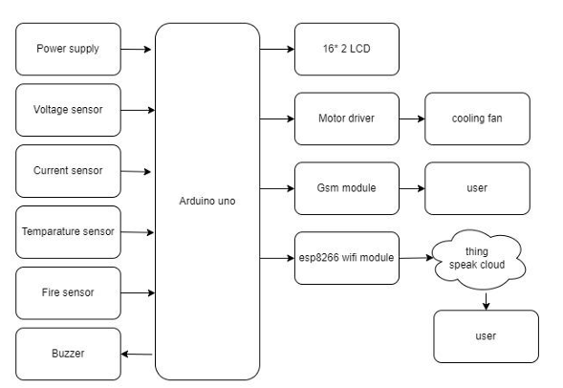

Fig.1.Basic Block diagram of Battery monitoring system for E.V.

One major problem in previous battery management systems was insufficient thermal management. As electric vehicle battery packs were charged and discharged, they generated heat that needed to be dissipated to prevent the batteries from overheating and potentially causing a fire. In some cases, battery management systems failed to detect and mitigate high temperatures, resulting in battery fires. The existing system block diagram is shown in the figure 1. To prevent battery fires, we should use advanced battery management systems with improved thermal management capabilities. These systems monitor each cell in the battery pack and adjust the charging and discharging rates to maintain safe temperatures. In the event of a fault, such as a short circuit, the system can also disconnect the battery pack to prevent further damage. In addition to thermal management, electric vehicles should also have other safety features to prevent battery fires, such as crash detection and prevention systems, as well as fire suppression systems. These safety features work together to ensure that electric vehicles are as safe as possible for drivers and passengers.

# List Of Components And Overview

The list of elements that are required to develop IOT based battery monitoring system for Electric vehicle as shown in the below table[I].

TABLE I. LIST OF ELEMENTS THAT ARE REQUIRED

|  |  |  |
| --- | --- | --- |
| **Component** | **Specification** | **Quantity** |
| Aurdino |  | 1 |
| Power supply | 6-20V | 1 |
| Memory | ATmega328 , 32KB | 1 |
| Input output | 14 Digit pin , 5v | 1 |
| Cooling Fan | 2000rpm | 1 |
| LCD | 16x2 pin | 1 |
| Buzzer | 6v | 1 |
| Temparature sensor | DHT11 , 3.5v – 5.5v | 1 |
| GSM module | GSM-900 | 1 |
| Voltage sensor | 5v | 1 |
| Motor | DC 5v | 1 |

Some of the main components required are Current sensor, Communication,Power supply adapter etc. We will discuss briefly about the each and every component that is listed in the above table[I].

A. Aurdino:

Arduino is open source physical processing which is base on a microcontroller board and an incorporated development environment for the board to be programmed. Arduino gains a few inputs, for example, switches or sensors and control a few multiple outputs, for example, lights, engine and others. Arduino program can run on Windows, Macintosh and Linux operating systems (OS) opposite to most microcontroller’s frameworks which run only on Windows. Arduino programming is easy to learn and apply to beginners and amateurs. Arduino is an instrument used to build better version of a computer which can control, interact and sense more than a normal desktop computer. It's an open source physical processing stage focused around a straightforward microcontroller board, and an environment for composing programs for the board. Arduino can be utilized to create interactive items, taking inputs from a diverse collection of switches or sensors, and controlling an assortment of lights, engines, and other physical outputs. Arduino activities can be remaining solitary, or they can be associated with programs running on your machine (e.g. Flash, Processing and Maxmsp.) The board can be amassed by hand or bought pre assembled; the open-source IDE can be downloaded free of charge. Focused around the Processing media programming environment, the Arduino programming language is an execution of Wiring, a comparative physical computing platform. Figure -2 Arduino’s

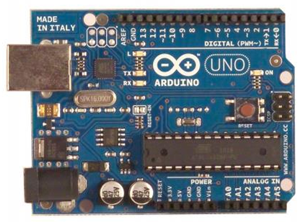 Fig.2 Aurdino UNO

B. Power supply:

The Arduino Uno can be powered via the USB connection or with an external power supply. The power source is selected automatically. External (non-USB) power can come either from an AC-to-DC adapter (wall wart) or battery. The adapter can be connected by plugging a 2.1mm center positive plug into the board's power jack. Leads from a battery can be inserted in the Gnd and Vin pin headers of the POWER connector. The board can operate on an external supply of 6 to 20 volts. If supplied with less than 7V, however, the 5V pin may supply less than five volts and the board may be unstable. If using more than 12V, the voltage regulator may overheat and damage the board. The recommended range is 7 to 12 volts.

C.Memory:

The Atmega328 has 32 KB of flash memory for storing code (of which 0,5 KB is used for the bootloader); It has also 2 KB of SRAM and 1 KB of EEPROM (which can be read and written with the EEPROM library).

D. INPUT/OUTPUT :

Each of the 14 digital pins on the Uno can be used as an input or output, using pinMode(), digitalWrite(), and digitalRead() functions. They operate at 5 volts. Each pin can provide or receive a maximum of 40 mA and has an internal pull up resistor (disconnected by default) of 20-50 kOhms. In addition, some pins have specialized functions:

• Serial: 0 (RX) and 1 (TX). Used to receive (RX) and transmit (TX) TTL serial data. TThese pins are connected to the corresponding pins of the ATmega8U2 USB to-TTL Serial chip .

• External Interrupts: 2 and 3. These pins can be configured to trigger an interrupt on a low value, a rising or falling edge, or a change in value. See the attachInterrupt() function for details.

• PWM: 3, 5, 6, 9, 10, and 11. Provide 8-bit PWM output with the analogWrite() function.

• SPI: 10 (SS), 11 (MOSI), 12 (MISO), 13 (SCK). These pins support SPI communication, which, although provided by the underlying hardware, is not currently included in the Arduino language.

• LED: 13. There is a built-in LED connected to digital pin 13. When the pin is HIGH value, the LED is on, when the pin is LOW, it's off. The UNO has 6 analog inputs, each of which provide 10 bits of resolution (i.e. 1024 different values). By default they measure from ground to 5 volts, though is it possible to change the upper end of their range using the AREF pin and the analog Reference() function. Additionally, some pins have specialized functionality:

• I 2C: 4 (SDA) and 5 (SCL). Support I2C (TWI) communication using the Wire library. There are a couple of other pins on the board:

• AREF. Reference voltage for the analog inputs. Used with analog Reference().

• Reset. Bring this line LOW to reset the micro-controller. Typically used to add a reset button to shields which block the one on the board.

E. Cooling Fan:

Cooling fans are essential for preventing overheating and maintaining optimal operating temperatures in electronic devices, industrial machinery, automotive systems, and more.

A cooling fan is an essential component of various electronic devices and systems, designed to regulate and dissipate heat to maintain optimal operating temperatures. It plays a crucial role in preventing overheating, which can damage internal components and impair performance.

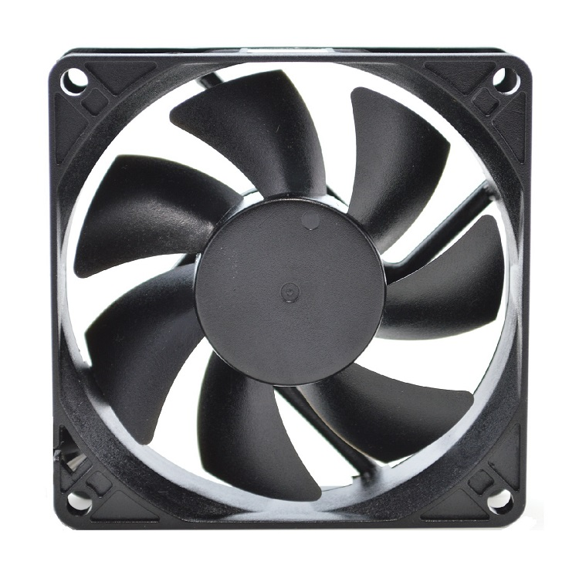

Fig.3. Cooling fan

F. LCD 16x2:

The term LCD stands for liquid crystal display. It is one kind of electronic display module used in an extensive range of applications like various circuits & devices like mobile phones, calculators, computers, TV sets, etc. These displays are mainly preferred for multi-segment light-emitting diodes and seven segments. The main benefits of using this module are inexpensive; simply programmable, animations, and there are no limitations for displaying custom characters, special and even animations, etc. .

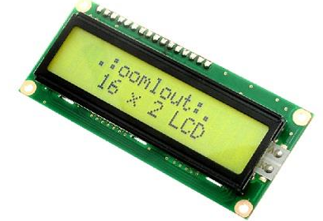

Fig.4. LCD 16x2

The features of this LCD mainly include the following.

The operating voltage of this LCD is 4.7V-5.3V

It includes two rows where each row can produce 16-characters. The utilization of current is 1mA with no back-light Every character can be built with a 5×8 pixel box

The alphanumeric LCDs alphabets & numbers Is display can work on two modes like 4-bit & 8-bit These are obtainable in Blue & Green Backlight . It displays a few custom generated characters

G. Buzzer:

A buzzer is a small yet efficient component to add sound features to our project/system. It is very small and compact 2-pin structure hence can be easily used on breadboard, Perf Board and even on PCBs which makes this a widely used component in most electronic applications. There are two types are buzzers that are commonly available. The one shown here is a simple buzzer which when powered will make a Continuous Beeeeeeppp.... sound, the other type is called a ready-made buzzer which will look bulkier than this and will produce a Beep. Beep. Beep. Sound due to the internal oscillating circuit present inside it. But, the one shown here is most widely used because it can be customized with help of other circuits to fit easily in our application. This buzzer can be used by simply powering it using a DC power supply ranging from 4V to 9V. A simple 9V battery can also be used, but it is recommended to use a regulated +5V or +6V DC supply. The buzzer is normally associated with a switching circuit to turn ON or turn OFF the buzzer at required time and require interval.

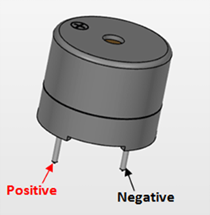

Fig.5. Buzzer

H. DHT11 Temperature and Humidity sensor :

The DHT11 is a commonly used Temperature and humidity sensor that comes with a dedicated NTC to measure temperature and an 8-bit microcontroller to output the values of temperature and humidity as serial data.

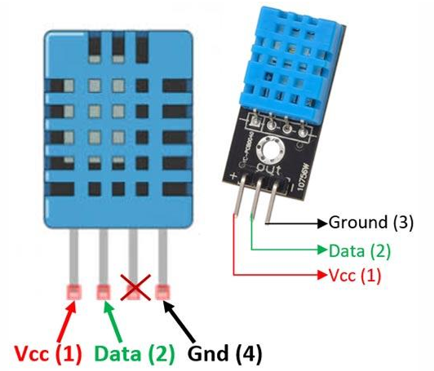

Fig.6. DHT11 Temperature and Humidity sensor

I. GSM (Global System for Mobile communications) :

GSM (Global System for Mobile communications) is a cellular network, which means that mobile phones connect to it by searching for cells in the immediate vicinity. GSM networks operate in four different frequency ranges. Most GSM networks operate in the 900 MHz or 1800 MHz bands. Some countries in the Americas use the 850 MHz and 1900 MHz bands because the 900 and 1800 MHz frequency bands were already allocated.

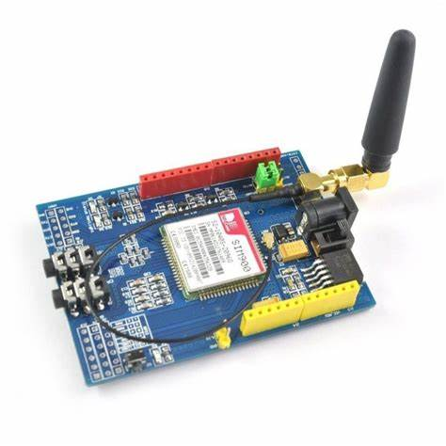

Fig.7.GSM 900 Module

J. Voltage sensor:

The voltage sensor module is a small size 0-25 DC voltage sensing device. The design of the module is based on a resistive voltage divider circuit. It is a voltage sensor module that reduces the input voltage signal by the factor of 5 and generates a corresponding analog output voltage with respect to step down voltage factor. This voltage measurement circuit is small and portable and can be used to detect under and over-voltage faults in electrical circuits.

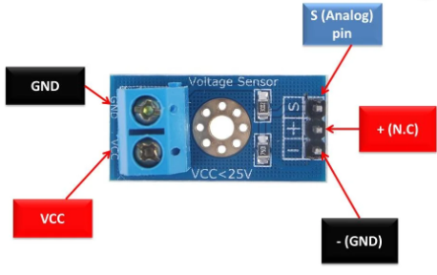

Fig.8. Voltage sensor

K. Motor :

The**motor**is such an electric device that transforms electric power into mechanical power. The working of these motors depends on the interaction of the field at the stator with the flux generated by the current armature windings at the rotor. Some motors are installed in different fans, pumping devices, drill machines, or some other devices like electric watches.

# SOFTWARE DESCRIPTION

The Arduino Integrated Development Environment - or Arduino Software (IDE) - contains a text editor for writing code, a message area, a text console, a toolbar with buttons for common functions and a series of menus. It connects to the Arduino and Genuino hardware to upload programs and communicate with them.

Programs written using Arduino Software (IDE) are called sketches. These sketches are written in the text editor and are saved with the file extension .ino. The editor has features for cutting/pasting and for searching/replacing text. The message area gives feedback while saving and exporting and also displays errors. The console displays text output by the Arduino Software (IDE), including complete error messages and other information. The bottom right-hand corner of the window displays the configured board and serial port. The toolbar buttons allow you to verify and upload programs, create, open, and save sketches, and open the serial monitor.

V. CONCLUSIONS

In conclusion, an essential part of electric vehicles that guarantees the security, dependability, and longevity of the battery pack is the EV BMS with charge monitor and fire prevention. By supplying crucial safety features like temperature control, fault detection, cell balancing, and fire prevention, the system lowers the possibility of battery fires and enhances the overall efficiency of electric vehicles.In order to improve the features and capabilities of EV BMS with charge monitor and fire prevention, more research and development is still possible. A few potential future work areas include eenhancing the precision and dependability of battery monitoring systems to deliver more accurate and timely data regarding the charge, health, and function of the battery pack..

##### VI. Acknowledgment

It is highly acknowledged that the Department of Electrical and Electronics Engineering(EEE) at NRI Institute of Technology,Agiripalli has provided assistance.

##### References

1. Ayman S. Elwer , Samy M. Ghania , Nagat M. K. A. Gawad ,” Battery Management Systems For Electric Vehicle Applications”
2. Aniket Rameshwar Gade,” The New Battery Management System in Electric Vehicle” International Journal of Engineering Research & Technology (IJERT) ISSN: 2278-0181 IJERTV10IS070210 www.ijert.org Vol. 10 Issue 07, July-202
3. Nitin Saxena , Anant Singh , Aniket Dharme , “Iot Based Battery Management System Inelectric Vehicle”.
4. Rui Hu University of Windsor.” Battery Management System For Electric Vehicle Applications”2011
5. A.Sowmiya , P.Aileen Sonia Dhas , L.Aquiline Lydia , M.Aravindan , K.Rajsaran,” Design of Battery Monitoring System for Electric Vehicle” IARJSET International Advanced Research Journal in Science, Engineering and Technology Vol. 8, Issue 11, November 2021
6. AswinthRaj,”Battery Management System(BMS)forElectricVehicles” December 5, 2018
7. Anjali Vekhande, Ashish Maske,” Iot-Based Battery Parameter Monitoring System For Electric Vehicle “© 2020 IJCRT | Volume 8, Issue 7 July 2020 | ISSN: 2320-2882
8. A. Hariprasad , I. Priyanka , R. Sandeep , V. Ravi, O. Shekar,” Battery Management System in Electric Vehicles” IJERTV9IS050458,Volume 09, Issue 05 (May 2020)
9. Mahadik Tejaswini J., Prof. Shivdas S.S,” Implementation of Charging Station for E-Vehicle using Solar Panel with IOT” Volume 7, Issue 8 (ISSN2349-5162) JETIR2008339 Journal of Emerging Technologies and Innovative Research (JETIR )
10. A. K. M. Ahasan Habib , Mohammad Kamrul Hasan , Ghassan F. Issa , Dalbir Singh ,* , Shahnewaz Islam and Taher M. Ghazal ,” Lithium-Ion Battery Management System for Electric Vehicles: Constraints, Challenges, and Recommendations “MDPI
11. JyotiKant , Hari Kr Singh,” Solar & Wind Energy System for Jodhpur Region, Case study” International Journal of Science and Research (IJSR) ISSN (Online): 2319-7064 Impact Factor (2012): 3.358 Volume 3 Issue 6, June 2014
12. Ms. Bhavana D B Mr. Darshan Naik Mr. Raviraj Ms. Roopa Gubbiyavar , Iot Based Wireless Ev Charging And Battery Monitoring System Project Reference No.: 45S_BE_0796
13. S. Gopiya Naik , Chaithra CB-Ayesha harmain , Bhojaraj-BhoomikaB-Shazia Sharif,” Battery Parameter Monitoring and Control System for Electric Vehicles” SSRG International Journal of Electrical and Electronics Engineering Volume 9 Issue 3, 1-6, March 2022 ISSN: 2348 – 8379
14. Pradyumna P. Jadhav , Ranveer R. Kumbhar , Sourabh P. Ligade,” Ev Surveillance System For Battery Monitoring”www.ijstm.com/images/short_pdf/1655550797_8086