Fashion recommendation system using machine learning

Vaishnavi Kantrao Potdar Suraj Santosh Hande

[vaishnavi897589@gmail.com](mailto:vaishnavi897589@gmail.com) [handesuraj04@gmail.com](mailto:handesuraj04@gmail.com)

Shraddha Rajesh Ambekar Dnyaneshwar Vitthal Ghadge

[shraddhaambekar28@gmail.com](mailto:shraddhaambekar28@gmail.com) [dnyaneshwarghadge2312@gmail.com](mailto:dnyaneshwarghadge2312@gmail.com)

**Guide- Dr. Mahantesh Kodabagi**

**Associate Professor ,Department of Information Technology,**

**Dr. D. Y. Patil School of Engineering, And Technology**

**Pune, Maharashtra, India.**

ABSTRACT

**Fashion stores are very popular and it is important for businesses to understand their customers and interact well with them. This has led to advances in customer relationship management (CRM) technology, improving customer experience and increasing retailers' profitability. Existing solutions often recommend popular products but do not have an individual approach. This study shows the agreement between fashion stores using different methods to distribute product and user information in physical and online stores. It solves the "cold start" problem in existing systems by using data mining technology to predict the purchasing behaviour of new customers.**

**Keywords**: recommendation system, multi-clustering, e-commerce, fashion e-commerce, item classification, Data augmentation

I . Introduction

Recommendations are often used by artificial intelligence and machine learning algorithms that can analyse big data (big data) and deliver personalized products or agreed-upon messages to customers. These recommendations are based on a variety of factors, including past purchasing history, search queries, and demographic data. These systems are widely used in e-commerce, streaming services, and many other online sites to improve user experience and increase engagement. The purpose of this research is to improve the quality of fashion data by developing data augmentation algorithms. The algorithm is based on transfer learning, which involves using knowledge in one domain (such as existing data) to improve performance in another (exempt data). The aim is to improve knowledge by using the features of the fashion dataset with deep learning. They want to improve the data using deep learning and a data augmentation algorithm that relies on transfer learning.

After enhancing the dataset, they plan to use a factorization machine model to make recommendations. They will then assess the success of their data augmentation approach by measuring the accuracy of their recommendations. In simpler terms, they try to make fashion recommendations better by using advanced techniques and checking whether they work. The "cold start problem" is a challenge that affects many recommendation models. To address this issue, the authors suggest a solution that uses a knowledge graph. They proposed building a user-item knowledge graph using the fashion dataset. This graph is intended to help uncover the hidden or implicit relationships between users and items, which can be valuable for making recommendations. Essentially, they use a knowledge graph to mitigate the cold start problem by gaining a deeper understanding of how users and items are connected in the fashion dataset.

II. Related work

1. FASHION RECOMMENDATION SYSTEM

Fashion endorsement is a specialized practice of endorsement in the fashion industry, particularly in e-commerce and retail. It uses various technologies such as artificial intelligence and machine learning to offer clothes and accessories to users based on their preferences, behaviour and other relevant information. Some of the main features and approval conditions are: User Profile Creation: The system creates user information by analysing user behaviour such as purchase history, search history and search patterns. It also takes into account demographics and style preferences.

1. User profile: The system creates user data by analysing user behaviour (such as historical purchase data, research data, and search patterns). It also takes into account demographics and style preferences.

2. Product analysis: Classify and list products such as clothing, shoes, and accessories by attributes such as colour, brand, type, and material. This information helps the system understand the characteristics of each activity.

3. Recommendation algorithms: Machine learning algorithms such as collaborative filtering, content-based filtering, and hybrid algorithms are used to recommend products that will appeal to these users. These algorithms take into account both user preferences and product features.

4. Personalized: Recommendations are highly personalized, including personal style, body type, and interaction history with the platform.

B. DATA AUGMENTATION

The quality of the data set is critical to the effectiveness of the proposed model. Clean data and quality standards are the basis for making good, reliable recommendations. But hand washing and processing can be time-consuming and expensive. Data augmentation techniques are increasingly used to solve this problem. Data enhancement is mainly used in two cases: Text-based data enhancement: This tool is mainly used in cases where data is written as an important part of the data set. Text-based data augmentation techniques involve generating new text data based on the existing dataset. Some methods, including Synonym Replacement, include replacing words or phrases with synonyms. Back Translation: Translating text from the original language to another and back to the original language. Text paraphrasing involves rewriting sentences while maintaining the same meaning. Text generation uses language models to generate text that is contextually relevant. Text-based data augmentation helps enrich the dataset with variations of existing data, reducing the need for manual data cleaning and improving the quality of the dataset for natural language processing tasks. Image-Based Data Augmentation: In cases where the dataset contains images, image-based data augmentation is valuable.

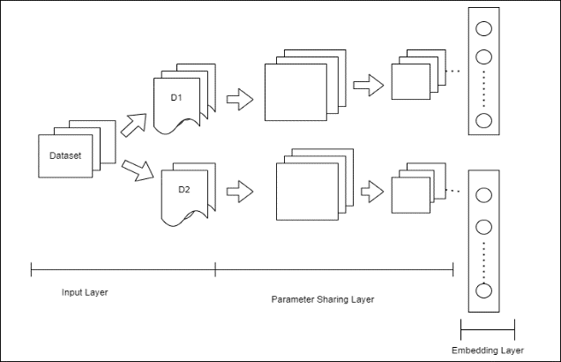

C. RECOMMENDATION BASED ON THE KNOWLEDGE GRAPH

The concept of knowledge graphs was first introduced by Google in 2012 to improve the quality and user experience of online research. However, over time, with the development and use of technology, information graphics has turned into an important technology and started to be widely used. Some of these applications include smart search, smart questions and answers, personalized recommendations, and content distribution platforms. Implementation of infographics in recommended language (RS) is common in many fields and is recommended in movies and music. For example, Obamas et al.

Demonstrates the integration of visual information into music and audio suggestions for music. In this context, they use graph information as follows: Hybrid Recommendation Engine: They often create a hybrid recommendation engine that combines multiple recommendation technologies to deliver better recommendations and to more people. In this case, the hybrid engine uses the knowledge graph as an additional data source to improve recommendations.

III. OVERVIEW OF THE FRAMEWORK

In order to recommend the most suitable products to users, there needs to be a framework that can detect customers' preferences and estimate their purchasing power based on historical data. It has four main components that work together to achieve this goal: data analysis and prioritization. This first product focuses on processing and organizing historical data. It includes tasks such as data cleansing, design, and feature removal. The purpose is to make the data available for further analysis.

1. Data Collection: The process begins by collecting data from various sources, which may include customer interactions, product descriptions, user data, reviews, and other relevant information.

2. Data Analysis: After the data is collected, it should be checked whether there are any problems. This involves examining data for missing values, errors, inconsistencies, or inaccuracies. Data analysis is the first step in defining a good data problem.

3. Data Cleansing: Data cleaning is the process of correcting or removing problematic data. This may include imputing missing values, correcting errors, and removing duplicates or outliers. The aim is to ensure that the data set is free of errors and inconsistencies that could affect analysis or modelling.

4. Noise reduction: Data filtering can also include noise reduction, which filters out irrelevant or negative data. This is especially important with recommendations where popular information can make the recommendations inaccurate or irrelevant.

IV. METHODOLOGIES

A. DATA AUGMENTATION

The quality of the data set directly affects the accuracy of recommendations. Ensuring data sets are accurate, complete, consistent and balanced is critical to creating an accurate RS. The development of good information and continuous information can increase the effectiveness of recommendations and become more useful to users through recommendations and personalization. Accuracy is important to evaluate the quality of the proposal.

1. Data integrity: The integrity of the data set is important. Without significant user interaction or relevant products, RS will not be able to successfully capture the user's interests, resulting in less positive recommendations.

2. Data sparsity: Data sparsity is a problem in RS, and most users only deal with a small amount of available work. A high level of information inequality will make it difficult to attract user attention.

3. Data Consistency: Consistency in collecting and recording data is important. False or inaccurate statements may lead to errors in the approval process, affecting the accuracy of the approval process.

4. Balanced data: Balanced data is especially important in distribution-based agreements. Unequal data (where some groups or classes are underrepresented) can lead to positive or negative results.

B. RECOMMENDATION WITH FM

Marshal (FM) is a term frequently used in the context of military ranks, but it is not clear what specific words you are looking for in relation to FM. Field Marshal (FM) is a term frequently used in the military context. Level, but it's unclear what specific FM advice you're looking for. Please state or state your background if you need advice or information on Marshal or any other subject; I would be happy to assist you. It looks like you want to use factorization technology (FM) for click-through rate (CTR) estimation and approval rating (RS). FM is indeed a powerful technique for high throughput and has been used in many machine learning methods, including CTR prediction and RS. Here are some tips and information on using FM in these situations: Understanding Factorization (FM): Before using FM for TO estimation and RS, an in-depth understanding of FM is required. FM is a supervised learning algorithm that can process heterogeneous data efficiently. They capture interactions between features by decomposing the feature matrix into a low-order matrix. Resources such as case studies and guides in FM can provide in-depth information. Data pre-processing: Good data pre-processing is crucial for any machine learning application. Before applying FM, make sure your product is clean, tidy and compatible.

C.  KNOWLEDGE GRAPH BUILDING ON THE DATASET

Creating information maps from datasets involves creating and representing data in a way that reflects relationships and collaboration between organizations. Here are step-by-step instructions for creating knowledge maps from data: Describe and label your data: Understand your data and the Name it covers. What are the places, relationships, and attitudes that influence your information image? Data extraction and pre-processing: Extract and save the data you want to include in image recognition. This information can be obtained from various sources such as databases, text files and web scraping. Pre-process data to clean, handle missing values, and validate. Good data is essential for a reliable map. Show locations and attributes: Show locations (nodes) in the file. These are the things or elements you want to represent in the infographic. Show attributes (objects) associated with each location. The device provides information about a location.

V. EXPERIMENTS AND EVALUATION

Experiments and evaluations are important parts of the research process and data. Whether you're conducting research, designing machine learning models, or evaluating the performance of your system, experiments and evaluations can help you draw conclusions and make informed decisions. Here are some important concepts and steps related to testing and evaluation: Testing and testing are important parts of the research process and data. Whether you're conducting research, designing machine learning models, or evaluating the performance of your system, experiments and evaluations can help you draw conclusions and make informed decisions. Some important points and steps regarding measurement and evaluation are:

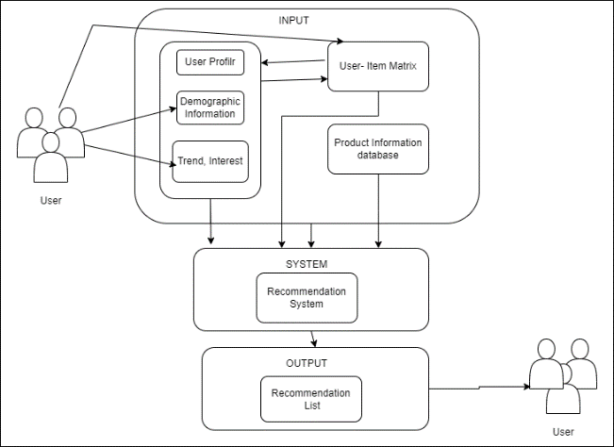

1.Define goals and objectives: Clearly state the goals and objectives of the experiment. What do you want to learn or achieve? Create a hypothesis that you want to test or verify.

2. Data collection: Collect the data needed for the experiment. Make sure your data collection process is rigorous, fair and well documented.

3. Experimental design: Plan the structure of your experiment, including treatment and control groups and the variables you intend to control or measure. Randomization and control group selection are important for valid studies.

4. Data pre-processing prepares data for analysis by cleaning, standardizing, and transforming the data as needed. This ensures that your data is in a format suitable for analysis.

VI.  CONCLUSION

In conclusion, a well-implemented fashion recommendation system can drive sales, improve user satisfaction, and create a win-win scenario for both consumers and e-commerce businesses. Continuous refinement and adaptation of such systems are essential to remain competitive in the ever-evolving fashion industry.

To successfully build a fashion recommendation system, it is essential to address challenges such as data quality, model performance, scalability, and ethical considerations. Moreover, staying current with evolving technology and the latest advancements in recommendation algorithms is crucial for delivering the best possible recommendations to users.

Building a fashion recommendation system is a complex and dynamic process that involves data collection, pre-processing, modelling, and evaluation. In conclusion, a well-designed fashion recommendation system can provide numerous benefits for both consumers and e-commerce businesses.

Enhanced User Experience: Fashion recommendation systems help users discover products that align with their style, preferences, and needs, leading to a more personalized and engaging shopping experience. Increased Customer Engagement: By offering relevant product recommendations, e-commerce platforms can keep users engaged for longer periods, increasing the likelihood of conversions and repeat visits.

VII. References

[1] Barnard, M. Fashion as Communication, 2nd ed.; Routledge: London, UK, 2008.

[2] Chakraborty, S.; Hoque, S.M.A.; Kabir, S.M.F. Predicting fashion trend using runway images: Application of logistic regression in trend forecasting. Int. J. Fash. Des. Technol. Educ. 2020, 13, 376–386. [CrossRef]

[3] Karmaker Santu, S.K.; Sondhi, P.; Zhai, C. On application of learning to rank for e-commerce search. In Proceedings of the 40th International ACM SIGIR Conference on Research and Development in Information Retrieval, Shinjuku, Tokyo, Japan, 7–11 August 2017; pp. 475–484. [CrossRef]

[4] Garude, D.; Khopkar, A.; Dhake, M.; Laghane, S.; Maktum, T. Skin-tone and occasion oriented outfit recommendation system. SSRN Electron. J. 2019. [CrossRef]

[5] Kang, W.-C.; Fang, C.; Wang, Z.; McAuley, J. Visually-aware fashion recommendation and design with generative image models. In Proceedings of the 2017 IEEE International Conference on Data Mining (ICDM), New Orleans, LA, USA, 18–21 November 2017; pp. 207–216. [CrossRef]