**COALMINE SAFETY MONITORING AND ALERT SYSTEM**

Dr.N.Sambasivarao  
Professor and Head of the Department Of Electrical and Electronics Engineering(EEE).NRI Institute of Technology *(Autonomous)  
Vijayawada*,India  
 email : [nsraohodeee@gmail.com](mailto:nsraohodeee@gmail.com)

S.Jareena  
student of Electrical and Electronics Engineering(EEE). Department*.NRI Institute of Technology( Autonomous)  
Vijayawada*,India  
email : [skjareena2002@gmail.com](mailto:skjareena2002@gmail.com)

Mrs. S.Ramayaka   
Assistant professor of the Department of Electrical and Electronics Engineering(EEE)*.NRI Institute of Technology (Autonomous)  
Vijayawada*,India  
email : [ramyaka.sammangi@gmail.com](mailto:ramyaka.sammangi@gmail.com)

M.Reshma  
student of Electrical and Electronics Engineering(EEE). Department*.NRI Institute of Technology( Autonomous)  
Vijayawada*,India  
email : [mesalaammu@gmail.com](mailto:mesalaammu@gmail.com)

A.Dhanista  
student of Electrical and Electronics Engineering(EEE). Department*.NRI Institute of Technology( Autonomous)  
Vijayawada*,India  
email : [angirekuladhanista@gmail.com](mailto:angirekuladhanista@gmail.com)

Ch.Siva Sai Reddy  
student of Electrical and Electronics Engineering(EEE). Department*.NRI Institute of Technology( Autonomous)  
Vijayawada*,India  
email: [sivasaireddyc@gmail.com](mailto:sivasaireddyc@gmail.com)

**ABSTRACT**:

**Coal mines are one of the most significant sectors in the country since they provide fuel for the steel and cement industries, which extract iron from stone and produce cement. Every characteristic, including methane gas, high temperatures, fire occurrences, and so on, should be evaluated on a regular basis in the underground mining industry. Because of the complexity of the mining environment and the wide range of tasks done in coal mines, it is critical to monitor the working conditions. To solve this issue, a system is in place to monitor fundamental safety measures and manage several coal mine limits, including gas leaks, temperature and humidity conditions, and fire sensors. All of the sensors are combined into a single device and then put in a coal mine**

**Keywords: atmega328microcontroller ,buzzer, led,MQ gas sensors ,DHT11 temperature sensor,wifi module**

1. **INTRODUCTION**

Underground mining operations are a high-risk endeavor in terms of worker safety and health.These dangers arise from the various processes used to extract different minerals.Thedeeperthemine,thegreateristherisk.These safety hazards are of great concern, particularly in coal industry. Thus, worker safety should always be a top priority in any sort of mining, whether it's coal or other minerals.Underground coal mining is riskier than open pit mining owing to ventilation issues and the possibility of collapse. However, the use of heavy gear and excavation techniques pose safety dangers in all forms of mining. Modern mines utilize a variety of safe methods, worker education and training, and health and safety requirements, resulting in significant modifications and advances in both opencast and underground mining.Coal has long been India's principal energy source, contributing greatly to the country's fast industrialization. Because coal accounts for almost 70% of total power output, its importance in the energy industry cannot be overstated. However, manufacturing brings with it byproducts that have the potential to harm the environment and the people who live in it. In place of that, the current study is an honest endeavor to analyze the gravity of the situation and create a real-time detection system employing IoT technology.

**2.BLOCK DIGRAM**

Fig 1The coal mine safety and monitoring system project combines many components to provide a complete monitoring system. This is a block schematic of the coal mine safety and monitoring system project.

The block diagram depicts the primary components and linkages of the coal mine safety monitoring and warning system. The ATMEGA328 Microcontroller acts as the system's core control unit. The ATmega collects and analyzes sensor data to take necessary actions.   
The system has three principal sensors: the MQ Gas Sensor for smoke detection and monitoring, the LM35 Temperature Sensor for temperature readings, and the Fire Sensor these sensor are conneted to the ATmega 328 microcontroler.Which collect data from them

The ATmega also communicates with additional components, such as an 16*2 LCD and a buzzer. The 16*2 LCD displays real-time information, including sensor readings, alarms, and status updates. The Buzzer sounds an audible alert during crises or anomalous sensor readings.

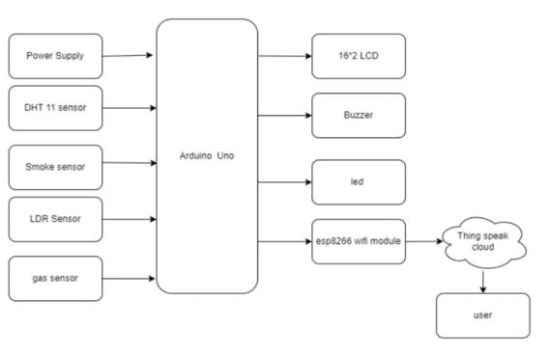

The ATmega transmits sensor data wirelessly to the central control unit , allowing real-time monitoring and analysis of the mine’s safety parameter.The central control unit may send orders or alarms to the atmega for remote control and emergency response. The power source for the system is not clearly depicted in the block diagram, but it is a critical component. It provides a consistent and dependable power source for all system components, despite the mine's difficult environment. The block diagram shows the integration of components, sensors, and wireless modules to build a comprehensive coal mine safety monitoring and warning system.

1. **ARDUINO UNO:**

The Arduino Uno is a microcontroller board built around the ATmega328 (datasheet). The device includes 14 digital input/output pins (6 of which may be used as PWM outputs), 6 analog inputs, a 16 MHz crystal oscillator, USB connection, power connector, ICSP header, and reset button. To use the microcontroller, connect it to a computer via USB or power it with an AC-to-DC converter or battery. All necessary components are included. Unlike previous boards, the Uno does not employ the FTDI USB-to-serial driver chip. Instead, the Atmega8U2 is coded as a USB-to-serial converter.

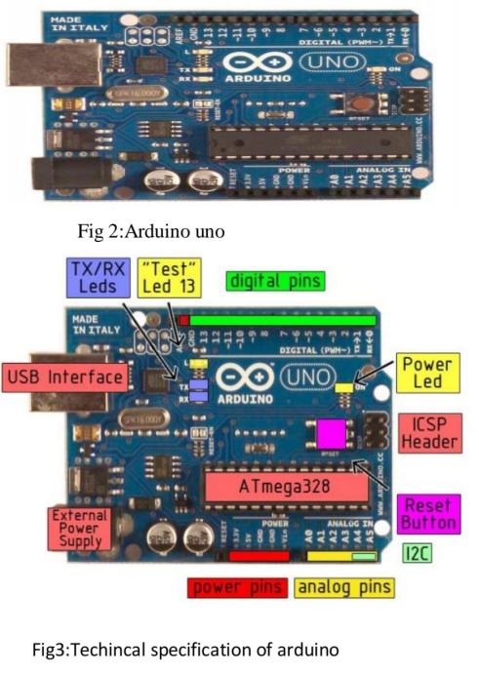

**4.ATmega328MICROCONTROLER**

The high-performance Microchip 8-bit AVR® RISC-based microcontroller combines 32 KB ISP Flash memory with read-while-write capabilities, 1 KB EEPROM, 2 KB SRAM, 23 general purpose I/O lines, 32 general purpose working registers, three flexible timer/counters with compare modes, internal and external interrupts, serial programmable USART, a byte-oriented Two-Wire serial interface, SPI serial port, 6-channel 10-bit A/D converter (8-channels in TQFP and QFN/MLF packages), The gadget runs between 1.8 and 5.5 volts.   
By executing strong instructions in a single clock cycle, the device achieves throughputs of around one MIPS per MHz, balancing power consumption and processing performance.

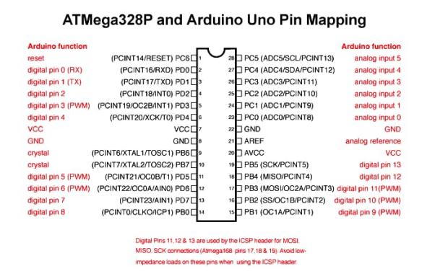

***Figure2:ATmega328 microcontroller***

**Programming:**

The Arduino Uno may be programmed using the Arduino software. The Arduino Uno's ATmega328 has a pre-burned bootloader that may be used to upload fresh code without the need for an external programmer. It interacts via the original STK500 protocol (reference and C headerfiles). To program the microcontroller without the bootloader, use the ICSP (InCircuit Serial Programming) header. Refer to the instructions for more information. The firmware source code for the ATmega16U2 (or 8U2 in revisions 1 and 2) is now available.   
The ATmega16U2/8U2 features a DFU bootloader that may be triggered on Rev1 boards.

**Automatic (Software) Reset:**

The Arduino Uno is designed to be reset via software on a linked computer, eliminating the need for a physical reset button before uploading. A 100 nanofarad capacitor connects one of the ATmega8U2/16U2's hardware flow control lines (DTR) to the ATmega328 reset line. When this line is asserted (taken low), the reset line lowers sufficiently to reset the microprocessor. The Arduino software enables you to upload code by hitting the upload button within the Arduino environment. This allows the bootloader to have a shorter timeout by coordinating the decrease of DTR with the commencement of upload.

**USB Overcurrent Protection**

The Arduino Uno has a resettable polyfuse that protects your computer's USB ports from shorts and overcurrent. Although most computers provide their own internal protection, the fuse provides an extra layer of protection. If more than 500 mA is applied to the USB port, the fuse will automatically break the connection until the short or overload is removed.

**Physical Characteristics:**

A The Uno PCB has a maximum length and width of 2.7 and 2.1 inches, respectively. The USB connection and power jack extend beyond these dimensions. The board has four screw holes for attaching to surfaces or cases. Digital pins 7 and 8 are 160 mil (0.16") apart, which is not an even multiple of the other pin's 100 mil spacing.

**Power Supply -**

In Power supply refers to a source of electrical power. A power supply unit (PSU) is a system that provides energy to an output load or set of loads. The phrase mostly refers to electrical energy supply, although it can also refer to mechanical or other sources.   
▪ The power supply portion converts AC signals to DC and reduces their amplitude. The mains voltage signal is 230V/50Hz, however diverse applications demand DC voltage with amplitudes of +5V and +12V.

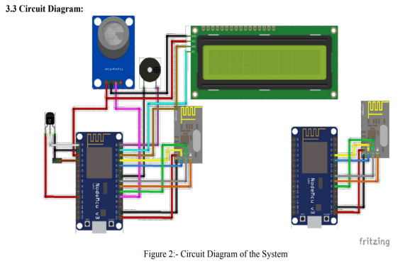

**5.TEMPERATURE SENSOR**

The DHT11 is a widely used temperature and humidity sensor. The sensor has a specialized NTC to detect temperature and an 8-bit microprocessor that outputs temperature and humidity measurements as serial data. The sensor is also factory calibrated and hence simple to link with other microcontrollers.   
  
The sensor accurately measures temperature from 0°C to 50°C and humidity from 20% to 90%. So, if you want to measure in this range, this sensor can be the best option for you.

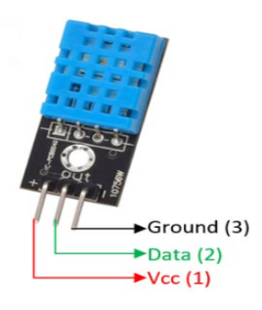

1. **MQ135 GAS SENSOR**

The MQ-135 gas sensors are utilized in air quality control systems and can detect or measure NH3, NOx, alcohol, benzene, smoke, and CO2. The MQ-135 sensor module includes a Digital Pin, allowing it to operate without a microcontroller, which is useful when just detecting one gas. If you need to monitor gases in PPM, the analog pin should be utilized. The analog pin is TTL driven and operates at 5 volts, making it compatible with the majority of microcontrollers.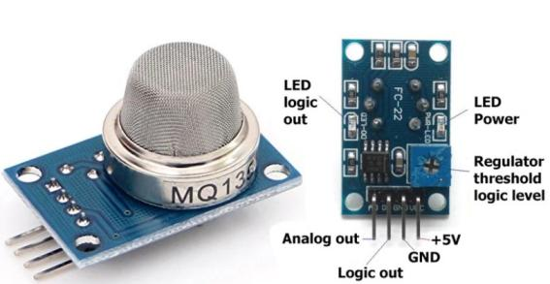

7**. MQ7 GAS SENSOR**

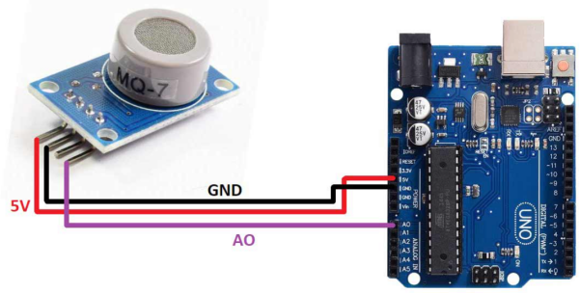

MQ7 sensor is a sensor having high sensitivity to carbon monoxide (CO).

The SnO2 semiconductor material is used in the MQ7 sensor for detecting gases. It has lower conductivity in clean air. It makes detection by method of cycle high and low temperature and detects CO when low temperature (heated by 1.5V). It helps in detecting the rising levels of gases through a rise in their conductivity. When the high temperature (is heated by 5.0V), it cleans the other gases adsorbed under low temperature. Users can convert the change of conductivity to gas concentration through a simple electronic circuit.

**8.TRANSFORMER**

A transformer is a device that transmits electric energy from one alternating-current circuit to one or more other circuits, either increasing (stepping up) or decreasing (stepping down).

We employ a step down transformer in the power supply. It converts 230V AC to 12V AC.

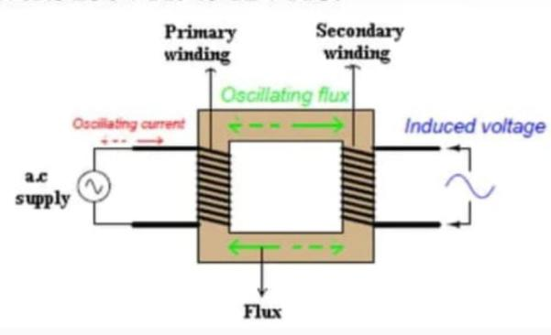

**9.Piezoelectric Buzzer:**

Audio signaling devices such as beepers and buzzers can be electromechanical, piezoelectric, or mechanical. The primary function of this is to transform the signal from audio to sound. DC voltage is typically used to power timers, alarm devices, printers, computers, and other equipment. Depending on the design, it may produce various sounds such as alarms, music, bells, and sirens. The system will provide auditory alerts and warning signals to inform miners and staff in hazardous circumstances or crises.

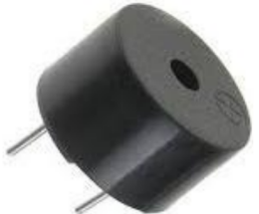

**Piezoelectric Buzzer**

**10.LCD DISPLAY**

**LIQUID CRYSTAL DISPLAY**

The most popular LCDs that are linked to a microcontroller are 16 x 2.

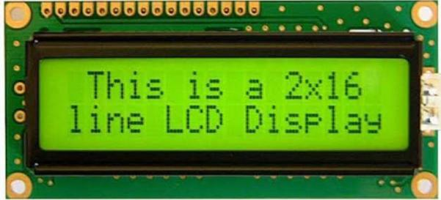

This translates to 16 characters per line by 2 lines. The standard is known as HD44780U, which refers to the regulator chip that takes data from an external source( and communicates directly with the TV).

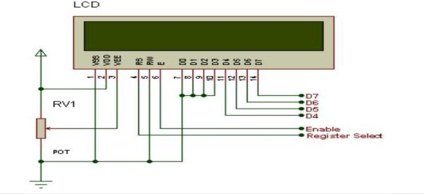

If an 8- bit data machine is used the TV will bear 11 data lines( 3 regulator lines plus the 8 lines for the data machine). The three control lines are appertained to as EN, RS, and RW

EN = Enable( used to tell the TV that you're transferring it data)

RS = Register elect( when RS is low( 0), data is treated as a command)

when RS is high( 1), data being transferred is textbook data)

R/ w = read/ write( when RW is low( 0), the data written to the TV)

( when RW is low( 0), the data reading to the TV)

**11.ESP8266 WIFI MODULE**

The ESP8266 is a low-cost, user-friendly WiFi module that establishes a basic TCP/IP connection and can be readily interfaced with microcontrollers via serial port. The first chip in this series, ESP-01, received a lot of attention in the market. This lesson will cover the ESP8266 WiFi module, including its pinout, features, specs, applications, and datasheet. Let's get started and cover all there is to know about this gadget.

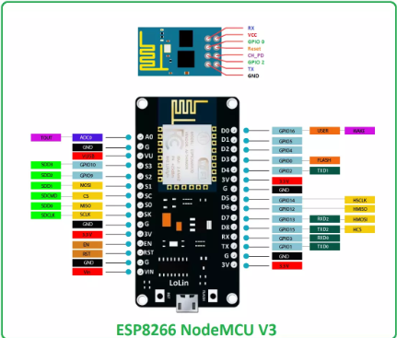

Espressif Systems invented the ESP8266 (also known as the ESP8266 Wireless Transceiver), a low-power, small, and cost-effective WiFi module that supports both TCP/IP and Serial Protocols.It is commonly utilized in IoT cloud-based embedded applications and is regarded as the most popular WiFi module due to its low cost and tiny size.   
It operates at 3V and can tolerate a maximum voltage of roughly 3.6 V, so if you use a 5V supply, you'll need an extra logic level converter.

.

**12. Arduino IDE**

The Arduino integrated development environment (IDE) is a cross-platform application (Windows, macOS, and Linux) built in Java. It allows you to develop and upload programs to the Arduino board.The IDE's source code is published under the GNU General Public License, version. The Arduino IDE supports C and C++ programming languages through the use of unique code structure guidelines. The Arduino IDE includes a software library from the Wiring project that contains many common input and output processes.

User-written code requires just two fundamental functions: initiating the sketch and the main program loop, which are built and linked with a program stub main() into an executable cyclic executive program using the GNU tool chain, which is also included in the IDE release.

The Arduino IDE uses the software avrdude to convert executable code into a text file in hexadecimal encoding, which is then loaded into the Arduino board by a loader program in the firmware. In our project, it is utilized to upload code to the ESP32 board.

1. **ThingSpeak**

According to the creators, "ThingSpeak is an open-source Internet of Things (IoT) application and API for storing and retrieving data from things via the HTTP and MQTT protocols over the Internet or a Local Area Network." ThingSpeak allows for the building of sensor recording apps, location tracking applications, and a social network of objects with status updates. ThingSpeak was first released by ioBridge in 2010 as a service to enable IoT applications. ThingSpeak offers inbuilt compatibility for MathWorks' numerical computing program MATLAB, allowing ThingSpeak users to analyze and display submitted data without the need to acquire a MATLAB license.

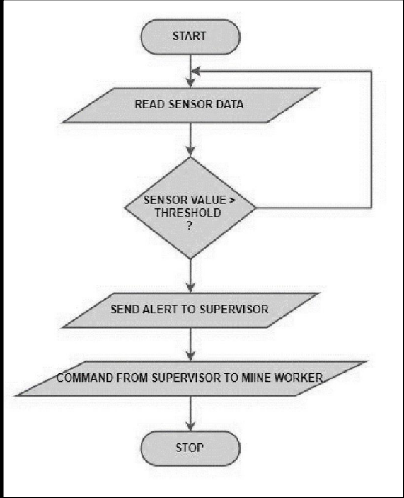

**FLOW CHART**

**15.CONCLUSION**

The study on real-time monitoring of poisonous gases and other factors in deep mines used a wireless sensor network.A real-time monitoring system is being developed to offer a more detailed and point-by-point view of the underground mine. This system displays the parameters on the LCD in the underground portion where the sensor unit is situated, as well as on the monitoring unit; this will assist all miners present inside the mine in saving their lives before any casualties occur. Alarms are triggered when sensor values exceed the threshold level. This technology also saves all data on the computer for future review.   
This is a low-cost, lifetime system. The total cost of this system is between 320 and 380 dollars when two sensor nodes are used, plus $250 for each additional sensor node.

**`17.FUTURE SCOPE**

1.Using additional sensors, any potential safety hazards, such as gasses, dust, vibrations, and fire, might be monitored.   
2.Zigbee may also be utilized to monitor mining activities, such as subsidence and water leaks.   
3.Other vital data may be exchanged with this method, making it possible in situations when cable connection is inconvenient.   
4.Thecontrolcanbegovernedfromthesurfaceitselfasthesystemprovideseasyaccess.

**REFERENCE**

Bin,G.,Huizong,L.(2011),“TheresearchonZigBee-basedMineSafetyMonitoringSystem”.

Bo,C.,Xiuqan,Q.,Budan,W.,Xiaokun,W.*etal.*(2012),“RestfulWebServiceMashup BasedCoalMineSafetyMonitoringandControlAutomationwithWirelessSensorNetwork”.

Boddu, R., Balanagu, P., Babu, N.S. (2012), “Zigbee based mine safety monitoring systemwith GSM”.

Borkar,C.,“Developmentofwirelesssensornetworksystemforindoorairqualitymonitoring”

Dange, K.M., Patil, R.T. (2013), “Design of Monitoring System for Coal Mine Safety Based on MSP430”.

Dubaniewicz,T.H.,Chilton,T.H.,Doboroski(1993),“Fiberopticforatmosphericmine monitoring. IEEE Transactions on Industry Applications”.