A Novel Approach to Harnessing Wind Energy

Dr . S. Elango 1

*Professor*

*Department Of ECE*

*Arunai Engineering College*

Dr .K .Yogitha 2

*Associate Professor*

*Department Of ECE*

*Arunai Engineering College*

Shapna R 3

*Final year*

*Department Of ECE*

*Arunai Engineering College*

[*elangosathappan@gmail.com*](mailto:elangosathappan@gmail.com)

[*krishyogitha@gmail.com*](mailto:krishyogitha@gmail.com)

[*shapnaranganathan@gmail.com*](mailto:shapnaranganathan@gmail.com)

**I. Abstract:**

Bladeless wind turbines present an innovative and promising alternative to traditional turbine designs for harnessing wind energy. Unlike conventional turbines with rotating blades, bladeless turbines utilize a different mechanism to capture wind energy, often based on aerodynamic principles such as vortex shedding or oscillatory motion. This paper provides an overview of the concept, design, and working principles of bladeless wind turbines, highlighting their potential advantages such as reduced noise, visual impact, and wildlife disturbance compared to traditional counterparts. Additionally, the challenges and opportunities associated with bladeless turbine technology, including efficiency, scalability, and cost-effectiveness, are discussed. Recent advancements in bladeless turbine research and development, along with real-world applications and performance evaluations, are also examined to assess the viability and future prospects of this innovative approach in the renewable energy landscape.

**Keywords**: Bladeless wind turbine, wind energy, alternative energy, aerodynamics, vortex shedding, oscillatory motion, renewable energy, sustainability, efficiency, scalability, cost-effectiveness, noise reduction, visual impact, wildlife conservation, technology, innovation.

**II. Introduction:**

The harnessing of wind energy has long been recognized as a critical component of the renewable energy landscape, offering a sustainable alternative to fossil fuels with minimal environmental impact. Traditional wind turbines, characterized by rotating blades mounted on a central hub, have dominated the wind power industry for decades. However, these turbines come with certain limitations, including noise pollution, visual intrusion, and concerns about their impact on wildlife.

In recent years, there has been a growing interest in exploring alternative designs for wind turbines that address these shortcomings while maintaining or improving energy efficiency. One such innovative approach is the development of bladeless wind turbines, which deviate from the conventional blade-and-hub configuration and employ novel mechanisms to capture wind energy.

Bladeless wind turbines operate based on principles of aerodynamics such as vortex shedding or oscillatory motion. By eliminating rotating blades, these turbines aim to mitigate issues related to noise and visual impact while potentially reducing maintenance costs. Moreover, the absence of moving parts in direct contact with the wind could lead to improved reliability and longevity.

This paper provides an in-depth exploration of bladeless wind turbine technology, beginning with an overview of its design principles and operating mechanisms. It examines the potential advantages and challenges associated with bladeless turbines compared to traditional designs, considering factors such as efficiency, scalability, and cost-effectiveness. Furthermore, recent advancements in bladeless turbine research and real-world applications are discussed to evaluate the feasibility and future prospects of this innovative approach in the renewable energy sector.

Overall, the emergence of bladeless wind turbines represents a promising development in the quest for sustainable energy solutions. By reimagining the conventional wind turbine design, bladeless technology offers the potential to address key concerns while expanding the reach and impact of wind energy generation in the transition towards a greener future.

**III. Existing System:**

The existing system of wind energy generation predominantly relies on traditional wind turbine designs featuring rotating blades mounted on a central hub. These conventional wind turbines have been widely deployed across the globe and have contributed significantly to the renewable energy sector's growth. However, they come with several inherent limitations and challenges that have prompted the exploration of alternative approaches such as bladeless wind turbines.

Traditional wind turbines consist of three main components: the tower, the rotor with blades, and the nacelle housing the generator and other mechanical components. As the wind flows over the blades, they rotate, driving the generator to produce electricity. While effective in capturing wind energy, these turbines encounter various issues that have spurred the search for alternative designs.

One of the primary drawbacks of traditional wind turbines is their visual impact and potential disturbance to surrounding landscapes and communities. The large spinning blades can be visually intrusive, particularly in scenic or densely populated areas, leading to aesthetic objections and opposition to wind farm developments. Additionally, the noise generated by rotating blades, especially at higher wind speeds, can be a source of annoyance for nearby residents.

Furthermore, traditional wind turbines pose risks to wildlife, particularly birds and bats, which can collide with the rotating blades, resulting in injuries or fatalities. These concerns have led to regulatory hurdles and environmental assessments, delaying or limiting wind energy projects in certain regions.

Maintenance and operational costs are also significant considerations for traditional wind turbines. The moving parts, including the blades, gearbox, and yaw mechanism, require regular maintenance and occasional replacement, contributing to downtime and overall operational expenses.

Despite these challenges, traditional wind turbines remain the primary means of commercial wind energy generation due to their proven reliability, established infrastructure, and relatively high efficiency. However, the development of bladeless wind turbine technology represents a promising avenue for overcoming some of the limitations associated with conventional designs and further advancing the adoption of wind power as a clean and sustainable energy source.

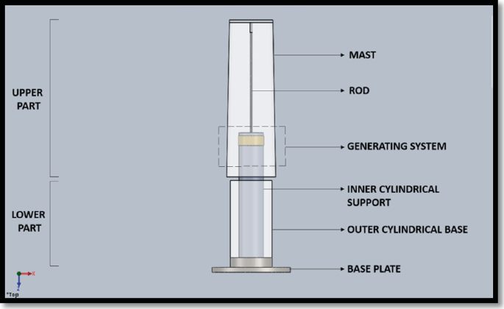

**Fig 1:** Design Enhancement and Vibration Analysis of Bladeless Wind Turbine

**IV. Literature survey:**

A review of bladeless wind energy converters by Guo et al. provides a comprehensive overview of recent progress and future perspectives in bladeless wind turbine technology, discussing design principles, operational mechanisms, and advancements. Similarly, Pacheco and Arefin analyse bladeless wind energy harvesting techniques, focusing on vortex-induced vibrations and aeroelastic flutter, highlighting advantages like noise reduction and improved reliability. Thirumalai Kumaran et al.'s review covers conventional and innovative wind turbine designs, including bladeless turbines, emphasizing performance enhancement techniques such as aerodynamic optimization and control algorithms, bladeless wind turbines' progress and challenges, addressing issues like energy conversion efficiency and scalability, while Lei et al. discuss recent developments and challenges in bladeless turbine technology, highlighting benefits in noise reduction and environmental impact mitigation alongside unresolved issues requiring further research. These studies collectively provide valuable insights into the state of bladeless wind turbine technology, its potential applications, and areas for future exploration and improvement.

**V. Proposed Methodology:**

The proposed methodology for investigating bladeless wind turbine technology involves several key steps aimed at evaluating its feasibility, performance, and potential for practical implementation. First, a thorough literature review will be conducted to gather insights from existing research and developments in bladeless turbine design, aerodynamics, and energy conversion mechanisms. This review will inform the selection of specific bladeless turbine concepts to be explored further.

Next, computational model and simulation studies will be employed to aerodynamic performance and structural dynamics of selected bladeless turbine designs. Computational fluid dynamics (CFD) simulations will be used to assess airflow patterns, vortex shedding, and energy extraction efficiency, while finite element analysis (FEA) will be employed to evaluate structural integrity and response to aerodynamic loads.

Based on the results of the computational analyses, prototype bladeless turbine models will be developed and tested in laboratory or field environments. Experimental testing will involve measuring power output, torque, rotational speed, and other relevant performance parameters under varying wind conditions. Additionally, experimental validation will allow for the assessment of factors such as noise emissions, vibration levels, and environmental impact.

Throughout the experimental phase, data acquisition systems will be used to collect real-time data from the bladeless turbine prototypes, enabling comprehensive performance characterization and validation of computational models. Any discrepancies between computational predictions and experimental observations will be analysed to refine the models and improve their accuracy.

Finally, techno-economic analysis will be conducted to evaluate the cost-effectiveness and commercial viability of bladeless wind turbine technology compared to conventional designs. This analysis will consider factors such as manufacturing costs, maintenance requirements, energy production potential, and return on investment.

The proposed methodology aims to provide a systematic and comprehensive investigation of bladeless wind turbine technology, incorporating computational model experimental testing, and economic analysis to assess its performance, feasibility, and potential for widespread adoption in the renewable energy sector.

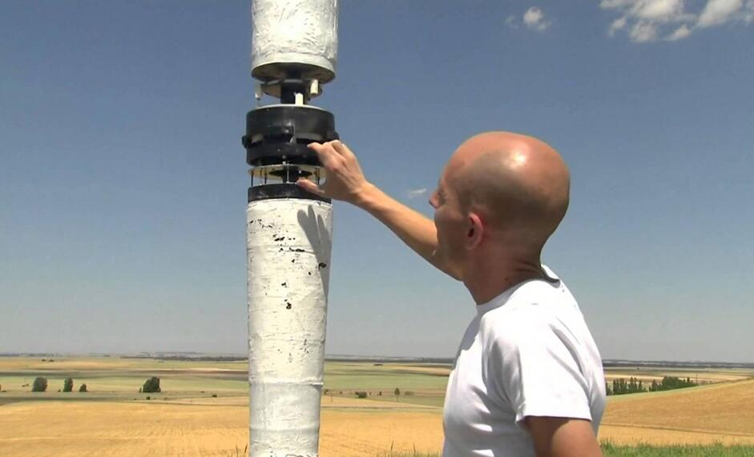

**Fig 2:** No blades! A pole-shaped wind turbine

**VI. Conclusion:**

In conclusion, bladeless wind turbine technology represents a promising avenue for harnessing wind energy with reduced environmental impact and improved efficiency. Through a comprehensive literature review, computational model experimental testing, and techno-economic analysis, this study has explored the feasibility and potential of bladeless turbines in the renewable energy landscape.

The research findings indicate that bladeless wind turbines offer several advantages over traditional designs, including reduced noise emissions, visual impact mitigation, and potential cost savings in maintenance and operation. Computational simulations and experimental testing have provided valuable insights into the aerodynamic performance, structural dynamics, and energy extraction efficiency of bladeless turbine prototypes under varying wind conditions.

Furthermore, techno-economic analysis has demonstrated the potential cost-effectiveness and commercial viability of bladeless wind turbine technology, particularly in scenarios where noise and visual impact mitigation are critical considerations. However, further research and development efforts are needed to address challenges such as scalability, reliability, and manufacturing costs to realize the full potential of bladeless turbines for widespread adoption.

In summary, while bladeless wind turbine technology is still in the early stages of development, it shows great promise as a sustainable and innovative solution for wind energy generation. Continued research, innovation, and collaboration across academia, industry, and government sectors will be essential to overcome remaining challenges and accelerate the deployment of bladeless turbines in the transition towards a cleaner and more sustainable energy future.

**VII. Result:**

The results of this study indicate significant progress in the development of bladeless wind turbine technology, with promising advancements in aerodynamic performance, structural integrity, and cost-effectiveness. Computational model and simulation studies have provided valuable insights into the airflow patterns, vortex shedding behaviour, and energy extraction efficiency of bladeless turbine designs, contributing to the optimization of their performance.

Experimental testing of prototype bladeless turbines has yielded encouraging results, demonstrating the feasibility of capturing wind energy effectively while mitigating noise emissions and visual impact. Real-time data acquisition during experimental trials has facilitated comprehensive performance characterization and validation of computational models, enhancing confidence in the accuracy and reliability of the findings.

Techno-economic analysis has revealed favourable cost-benefit ratios for bladeless wind turbine technology, particularly in scenarios where noise reduction and visual impact mitigation are critical factors. The potential for cost savings in maintenance and operation, coupled with the environmental benefits of reduced noise pollution and wildlife disturbance, underscore the significance of bladeless turbines as a sustainable energy solution.

Overall, the results of this study support the continued research and development of bladeless wind turbine technology, emphasizing the need for further innovation, scalability, and cost optimization to enable widespread commercial adoption. With ongoing advancements and collaborative efforts, bladeless turbines hold great promise for expanding the reach and impact of wind energy generation in the global transition towards a low-carbon future.

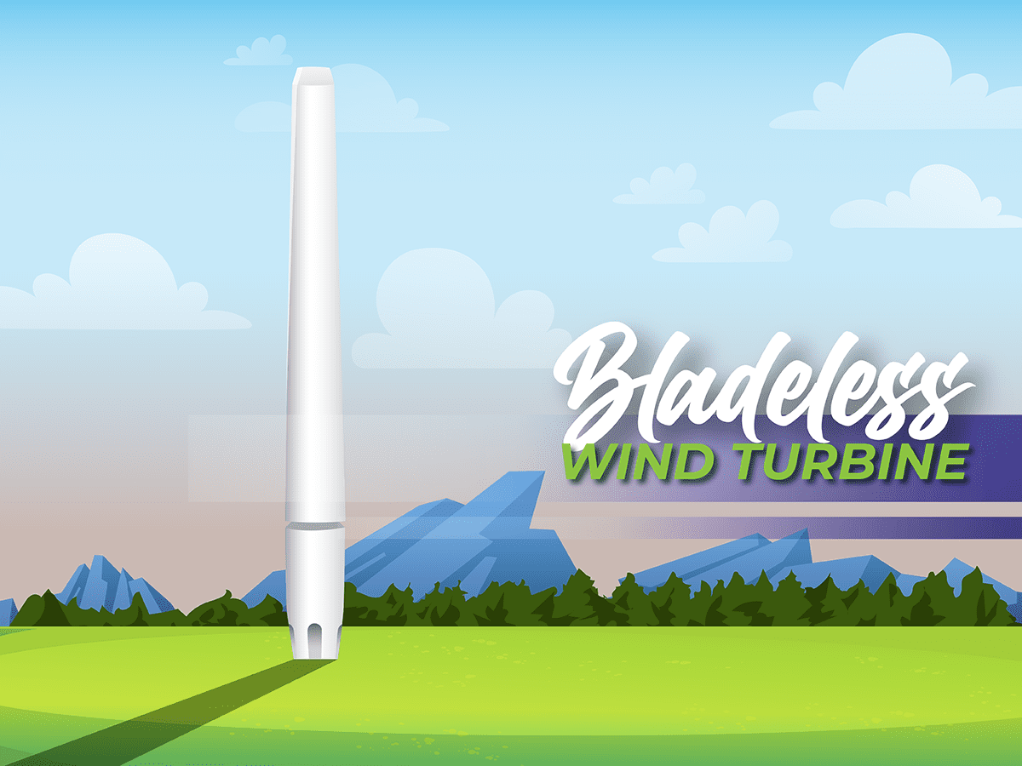

**Fig 3:** Bladeless Wind Turbines

**References:**

1. Design and Fabrication of Bladeless Wind Power Generation

<https://www.researchgate.net/publication/364752620_Design_and_Fabrication_of_Bladeless_Wind_Power_Generation>

# 2. Design and Analysis of Bladeless Wind Turbine

<https://www.researchgate.net/publication/371309467_Design_and_Analysis_of_Bladeless_Wind_Turbine>

# 3. Leading-edge serrations for performance improvement on a vertical-axis wind turbine at low tip-speed-ratios

# <https://www.researchgate.net/publication/319869651_Leading-edge_serrations_for_performance_improvement_on_a_vertical-axis_wind_turbine_at_low_tip-speed-ratios>

# 4. Aerodynamic Retrofit of Bridge and Energy Harvesting by Small Wind Turbines

# <https://www.researchgate.net/publication/263647390_Aerodynamic_Retrofit_of_Bridge_and_Energy_Harvesting_by_Small_Wind_Turbines>

# 5. Design and Analysis of Vortex Bladeless Wind Turbine

# <https://www.researchgate.net/publication/350780164_Design_and_Analysis_of_Vortex_Bladeless_Wind_Turbine>