**Prediction Graduate Student Use**

**Naive Bayes Classifier**

**Gayathri sri.R**

**M.Sc.,**

**Department of Computer Science,**

**Fatima College, Madurai**

**ABSTRACT:**

Student graduation is important in the accreditation assessment process. Because student graduation there are standards that must be Achieved by the Study Program items, namely a four-year study period and a 3.0GPA. Therefore we need a prediction that can Anticipate from the beginning of the graduation standard level that has been set. This study aims to predict student graduation using Naïve Bayes Classifier with a data mining approach. Naïve Bayes provides accurate prediction results with a minimum error rated compared to all other data mining components. With the prediction of the student, graduation can be used as input, especially the Information System Study Program in making policies for improvement in the future. The software used in data processing is WEKA. The test results showed that from the Information Systems Study Program Faculty of Computer Science Faculty of Sriwijaya University in 2015 as many as 141 students as training data and in 2016 as many as 127 students as testing data, the prediction accuracy was 97,6378%.

Keywords: predicted, data mining, Naïve Bayes classifier

**INTRODUCTION:**

Graduation is one of the supporters of the items in the assessment of study program accreditation. Especially for the Information Systems Studies Program Faculty of Computer Science, University of Sriwijaya has conducted accreditation in December 2018, with satisfactory results. Currently majoring in Information Systems have not been able to predict students who graduate on time or not, based on the number of students who entered should be proportional to the number of students who graduated in the class as well as the anticipation of students who do not graduate on time. Based on this, the challenge in this research is the difficulty of the university information system study program in Sriwijaya in processing data and extracting information from student data to get predictions of student graduation. With the graduation prediction handling students' academic monitoring would be more effective. This study will use the data mining approach in exploring the potential of the unknown information from the student data. This study uses data from students majoring in Information System at the Faculty of Computer Science, Sriwijaya University in 2015 and2016. The use of data mining approach is one of the oldest and most popular techniques that can be applied in the domain of education

1. It is also consistent with research conducted by

2 .using naïve Bayes classifier data mining to predict postgraduate student grade

3. The reason for choosing the naive Bayes classifier method is because Naïve Bayes is reported as the best text classifier have high accuracy and speed [4]. Naïve Bayes is one method that can classify probabilities easily [5].

**LITERATURE REFERENCES**

**State of the art:**

In this study, researchers explore information about theories related to the title used togeta foundation of scientific theory. As for some of the basis of scientific theory, namely: Research conducted by Shadab Adam Pattekari and Asma Parveen with the title "Prediction System For HeartDisease Using Naive Bayes". The main objective of this research is to develop an Intelligent System using the data mining modelling technique, namely, Naive Bayes. It is implemented as a web-based application in this user answers the predefined questions. The equation of this research with research by researchers is equally aiming to predict something using the Naive Bayes method. While the difference is this research is to predict heart disease,while research by researchers is to predict student graduation. Research conducted by Trilok Chand Sharma and Manoj under the heading "WEKA Approach for Comparative Study of Classification Algorithm". This paper explores the techniques of data mining to process a dataset and determine the importance of information from the classification study. Our work shows the method of WEKA analysis of file converts and selection of mining attributes and comparison with information Extraction of Evolutionary Learning not only, the classifications of data mining, but also the best efficient tool in learning is the biological, evolutionary algorithms. In this paper, the researcher obtains more data on WEKA framework as a method used by researchers to help predict student graduation.

**Data mining:**

Data mining is the process of finding a pattern or interesting information from large amounts of data stored in the database, data warehouse or can be stored in a storage area other information using pattern recognition techniques such as statistical and mathematical techniques [6]. Data mining is the process of discovering interesting patterns and knowledge from large amounts of data. Data mining sources include database, data warehouse, the

web, other information repositories[7].

**PREDICTION:**

Prediction is the process of estimating systematically something that is most likely to occur in the future based on past and present information. The predictive model is methods that produce predictions, regardless of its underlying approach: Bayesian or frequentist, parametric or nonparametric, a data mining algorithm or statistical model, etc.[8].

**Naïve Bayes Classifier**

A Naïve Bayes Classifier is a term dealing with a simple probabilistic classification based on applying Bayes' theorem. In simple terms, a Naïve Bayes Classifier assumes that the presence (or absence) of a particular feature of a class is unrelated to the presence (or absence) of any other feature [9]. Naïve Bayes is a statistical classification technique that can be used to design a possibility in the future of a class. The Naïve Bayes theorem comes from the classification technique of the same decision tree and neural network. Naïve Bayes is proven to have high accuracy and speed when used in large databases with data.

The advantages of Naïve Bayes [10] : A relatively simple algorithm to understand and design. A relatively fast algorithm produce class predictions, compared to all other classification algorithms. It can be easily trained using a small dataset.

**WEKA**

WEKA has been developed at Waikato University in NewZealand; the name is Waikato Environment for Knowledge Analysis The program is written in Java and distributed under the terms of the GNU General Public License [11]. Many classification methods have been developed with the help learning algorithms such as Bayesian, DecisionTree, K-NN (K-Nearest Neighbour), Support Vector Machine(SVM) and boosting, many classification methods have been developed. All these classifiers are are forms of training and set of rules are implemented. Bayesian classifier originates from the Theory of Bayesian Decision[12]. In this study, the software used in data processing that is using tools WEKA. WEKA is a software that implements various machine learning algorithms to perform several processes related to information retrieval or data mining. Features found on WEKA like Classification, Regression, Clustering, Association Rules, Visualization, and Data Preprocessing.

**Cross-Industry Standard Process (CRISPDM)**

In this study, researchers used the method Cross Industry Standard Process - Data Mining (CRISP-DM). For standard data mining process as well as research methods. CRISP-DM is a standard methodology for data mining, CRISP-DM methodology is the most referenced and used in the practice of the data mining methodology [13]. The steps in this method include:

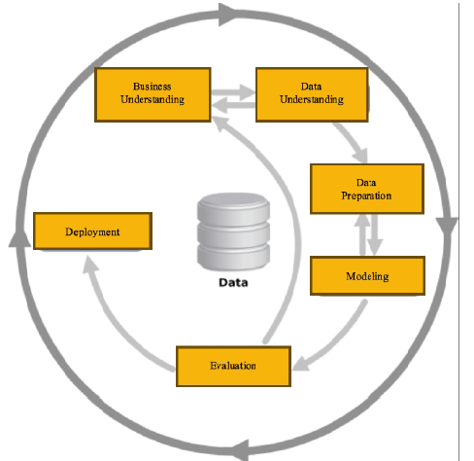

Figure 1. Figure Phase Method of CRISP-DM

CRISP-DM has 6 steps that are first business understanding, then data understanding, data preparation, modelling, evaluation and finally deployment.

**Data Preparation Phase**

At this stage, there are usually three steps are performed on the data, so that the data obtained can be processed to the research process. The steps are as follows:

**1. Data Cleansing**

Data have been obtained can not be directly used forresearch. such data must pass through a preprocessing stage first, to eliminate the inconsistent data, duplicate the data, or data that is not associated with the research. Usually on data obtained still contains a lot of data are missing or empty data. Steps that can be taken on an empty data is to fill the empty value (imputations) with a mean, median, min/max, and others. Handlers were performed on data containing noise by identifying the values that should not be in the data with simple statistical techniques (such as mean and standard deviation) and find and eliminate the wrong data.

**2. Select Cases or Variables**

In this stage, the selection of cases to be the focus of research.

**3. Transformation of Data**

In conducting data mining requires an appropriate data format before being able to process data processing. At this stage of transformation, the names of the variables used and the aggregation of variables are carried out.

**Phase Modelling**

After the data preparation phase then obtained attributes used to predict a student's graduation. The attribute is gender, origin high school, entrance, organizations, scholarship and GPA. Then the data is calculated using the Naïve Bayes method. To be counted, the attribute used will be transformed first.

1. Gender :

Man = 0

Women = 1

2. Origin High School :

Not Featured = 0

Seed = 1

3. GPA :

1.00 – 1.99 = 0

2.00 – 2..99 = 1

3.00 – 4.00 = 2

4. Entrance :

SNMPTN = 0

SBMPTN = 1

USM = 2

5. Scholarships :

Never = 0

Ever = 1

6. Organizations:

Never = 0

Ever = 1

Naïve Bayes method of calculation by using WEKA software, training data used were 114 and testing the data used was 127 data. Here are the results of data processing Training and Testing Data on WEKA:

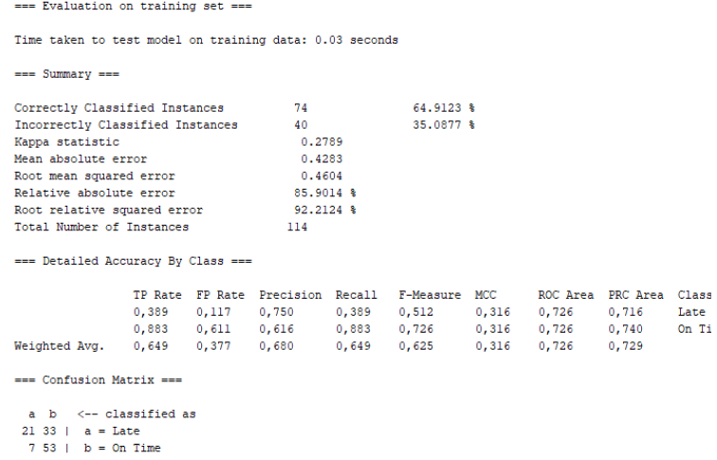

Figure 2. Figure Data Processing Training on WEKA

The figure 2, is the result or output from WEKA which is the result of training data (2015 students) which can be seen that incorrectly classified instances the percentage is 64.9123% while for incorrectly classified instances the percentage is 35.0877%.

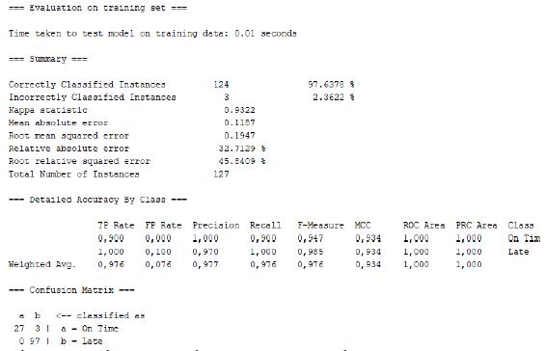

Figure 3. Figure Testing Data Processing on WEKA

After processing Data Training and Testing Data on the prediction results obtained WEKA graduation. Of the total amount to 127 student testing data obtained predicted 30 students graduate on time, while 97 other students predicted to pass late or on time.

Based on Figure 3, the process of calculating the average of agreed presentations using equation (1) and the error rate in the confusion matrix test will then be performed using equation (2) as follows:

Accuracy=the number of correct predictions

total number of predictions

x 100%

Accuracy= 27+97

27+3+0+97

x 100%=97.6378%

(1)

Error Rate=the number of incorrect predictions

totalnumber of predictions

x 100%

Error Rate= 3+0

27+3+0+97

x 100%=2.3622%

(2)

The accuracy (correctly classified instances) and error rate (incorrectly classified instances) of data testing using naive Bayes has an accuracy value of 97,6378% and anerror rate of 2,3622%.

**CONCLUSION**

Based on the analysis and testing that was done, it was concluded as follows:

Naïve Bayes classifier method can predict graduation students graduate on time and students who are a late pass.

By using the software WEKA, it can be predicted graduation students graduate on time and late pass so that the prediction results make it easier to create a policy study program to students who will graduate late or on time.

The process of predicting student graduation is influenced by several variables or fields, namely gender, origin high school, organizations, entrance, scholarships, GPA. From the results of data processing using WEKA tools with the naïve Bayes classifier method, the accuracy value is 97,6378%, the error rate is 2,3622%, precision is 90% and recall is 100%. This shows that the naïve Bayes classifier method is well used in predicting graduation of Information Systems Study Programs at the Faculty of Computer Science, Sriwijaya University.

**REFERENCES**

[1] L. T. Kunjumon, “An Intelligent System to predict Students academic performance using Data

Mining,” Int. J. Inf. Syst. Comput. Sci., vol. 8, no. 2, pp. 128–131, 2019.

[2] M. M. Abu Tair and A. M. El-Hales, “International Journal of Information and Communication Technology Research Mining Educational Data to Improve Students’ Performance: A

Case Study,” Int. J. Inf. Commun. Technol. Res., vol. 2, no. 2, pp. 140–146, 2012.

[3] S. L. Ting, W. H. Ip, and A. H. C. Tsang, “Is Naïve Bayes a good classifier for document

classification?,” Int. J. Softw. Eng. its Appl., vol. 5, no. 3, pp. 37–46, 2011.

[4] A. Kesumawati and D. Waikabu, “Implementation Naïve Bayes Algorithm for Student

Classification Based on Graduation Status,” Int. J. Appl. Bus. Inf. Syst., vol. 1, no. 2, pp. 6–12, 2018.

[5] C. C. Le, P. W. C. Prasad, A. Alsadoon, L. Pham, and A. Elchouemi, “Text classification: Naïve

Bayes classifier with sentiment Lexicon,” IAENG Int. J. Comput. Sci., vol. 46, no. 2, pp. 141–148, 2019.

[6] A. A. N. Mostafa, “Review of Data Mining Concept and its Techniques,” no. April 2016.

[7] A. R. L. Francisco, Data Mining Concepts Techniques, vol. 53, no. 9. 2013.

[8] G. Shmueli, “To explain or to predict?,” Stat. Sci., vol. 25, no. 3, pp. 289–310, 2010.

[9] U. N. Dulhare, “Prediction system for heart disease using Naive Bayes and particle swarm

optimization,” Biomed. Res., vol. 29, no. 12, pp. 2646– 2649, 2018.

[10] P. Kaviani and S. Dhotre, “International Journal of Advanced Engineering and Research Short

Survey on Naive Bayes Algorithm,” no. March, pp. 607–611, 2017.