**RAILWAY TRACK CRACK DETECTION SYSTEM**

Dr. N. Samba Siva Rao

Professor and Head of the Department of Electrical and Electronics Engineering (EEE).

NRI Institute of Technology (Autonomous), Vijayawada, India,

[nsraohodeee@gmail.com](mailto:nsraohodeee@gmail.com)

Mrs. S. Bhavani

Associate Professor of Electrical and Electronics Engineering (EEE).

NRI Institute of Technology (Autonomous), Vijayawada, India

[sampara.bhavani@gmail.com](mailto:sampara.bhavani@gmail.com)

Ch. Hemanth Reddy, G. Vijaya Durga, R. Likhitha , D. Ganesh, Md. Sardar Hussain

Department of Electrical and Electronics Engineering (EEE).

NRI Institute of Technology (Autonomous), Vijayawada, India

[chhemanth567@gmail.com](mailto:chhemanth567@gmail.com) , [vijaydurgagunduboina@gmail.com](mailto:vijaydurgagunduboina@gmail.com), [Raavilikhitha6@gmail.com](mailto:Raavilikhitha6@gmail.com)

[ganeshdasari202@gmail.com](mailto:ganeshdasari202@gmail.com), [sardaar0505@gmail.com](mailto:sardaar0505@gmail.com)

# Abstract

An IoT-based railway track crack and object detection system is an innovative solution for ensuring the safety and security of railway systems. The system uses a combination of sensors and cameras that are installed along the railway track to monitor it for any signs of damage or obstructions. The sensors can detect vibrations and changes in the track, which can indicate the presence of a crack or other type of damage. The cameras can capture images and video of the track, such as fallen branches, debris, or even people or animals. Once the system detects an issue, it can send an alert to the railway operators or maintenance personnel, allowing them to quickly address the problem before it causes any accidents or delays. An IoT-based railway track crack and object detection system can greatly improve the safety and efficiency of railway operations.

**Keywords-** Embedded system, Internet of things, ultrasonic sensor, IR detector, Arduino Uno, GPS

# Introduction

# 

Railway is one of the most significant transportation modes of our country but it's a matter of great anguish that, rail tracks of our country are veritably prone. The system uses a combination of sensors, communication devices, and software applications to detect and report faults in real-time. This helps system to descry only crack and helps to remove unwanted objects. Transport is truly important to carry the passengers and goods from one place to another. profitable position is mainly depending on adding the capacity and position of transport.

If our system can descry those objects or barricade and inform to the control room they can take necessary way 3 to avoid accident. Figure1 depicts the crack on track. The Rail transport is growing at a rapid- fire pace in India. It's one of the major modes of transport but still our installations are not that accurate, safer as compared to international morals. Hence, it is not safer for mortal Life. These goes unnoticed and the properly conservation of tracks is not done. To overcome this disadvantage, then detectors are used, which will descry the crack directly. The being system is slow, tedious and time consuming. This system has GSM and GPS module which will give the real time position or equals in the form of Short Communication Service (SMS) to the nearest rail station.

# 2. Existing Model

In the existing system, techniques such as visual inspection, video transmission, and Magnetic field methods can identify the cracks on the railway tracks. Physical checking is one of the earliest methods in which all the necessary components will be scanned manually. This process is commonly used in India, despite generating the worst outcome. A camera is used for continuous monitoring of the track while streaming content. In this procedure small cracks and a high-cost system cannot be seen. The current passes through the railway track for detection of flaws in the eddy current method and the results produced are not accurate. Many of these techniques require a lot of processing power and an extremely long period of time, making the robot's speed slow and therefore uncomfortable.

# 3. Proposed Model

Our design is used to descry the crack in the tracks by means of detector and nodemcu microcontroller, measuring distance for two rail road. In this design we use ultrasonic detector to descry the trains or objects in front and reverse of the train. It uses to measure the distance between the two objects. If any crack is passed in the track means a waking transferred to the nearest station or control room and ultrasonic detector measured the distance between the two objects if there's any small friction set up the communication which contains equals of that particular place will be transferred to the nearest station or control room.

An IoT-based fault detection system for railway tracks can help improve the safety and reliability of train operations by detecting and alerting the maintenance team about potential issues in real-time.

* **Sensor Network**: The system would consist of sensors installed along the railway tracks. These sensors would collect data about the condition of the tracks, such as changes in temperature, excessive vibrations, or pressure variations.
* **Data Transmission:** The data collected by the sensors would be transmitted wirelessly to a central hub or gateway using cellular, satellite, or Wi-Fi connectivity.
* **Alert System:** Once a fault or anomaly is detected, the system would trigger an alert to the maintenance team through SMS, email, or a mobile app. The alert could include the location of the fault, the severity of the issue, and recommendations for remedial action.
* **Maintenance Management:** The maintenance team would receive the alert and take the necessary steps to rectify the issue. They could also use the system's analytics and historical data to schedule preventive maintenance and reduce the likelihood of similar issues occurring in the future.

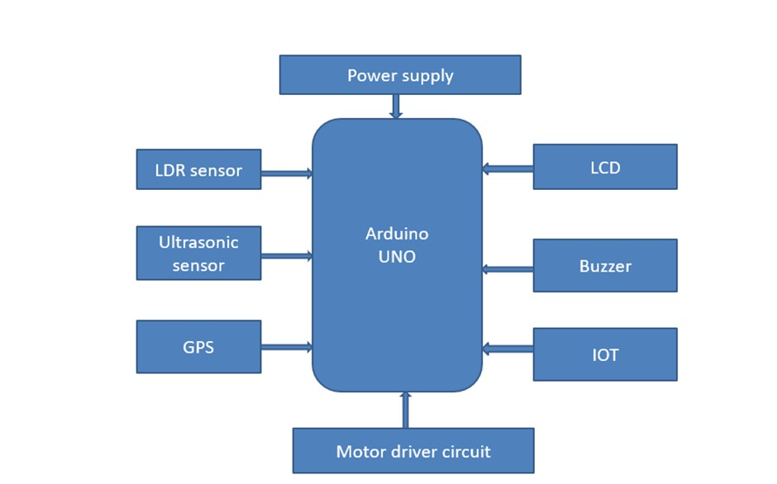

**Fig 1: Block Diagram**

# 4. Design and Implementation

## A. Arduino UNO

Arduino interface boards offer an affordable and user-friendly technology for engineers, artists, designers, hobbyists, and anyone who enjoys tinkering with technology to create interactive, creative, and practical projects. With this technology, a new generation of projects can be developed, which can be easily controlled from a computer. These boards enable the creation of interactive and innovative objects, useful projects, and a range of other applications that can be controlled from a computer. With Arduino boards, a whole new class of projects can now be built, opening a world of possibilities for creative expression and experimentation.

## DESIGN GOALS

* Compatibility with Mac computers, as they were commonly used by design students
* USB connectivity, since most MacBooks did not have serial ports
* Appealing appearance
* Low cost, around 20 Euros, which was equivalent to the cost of a pizza in Europe
* Greater power than a BASIC Stamp microcontroller

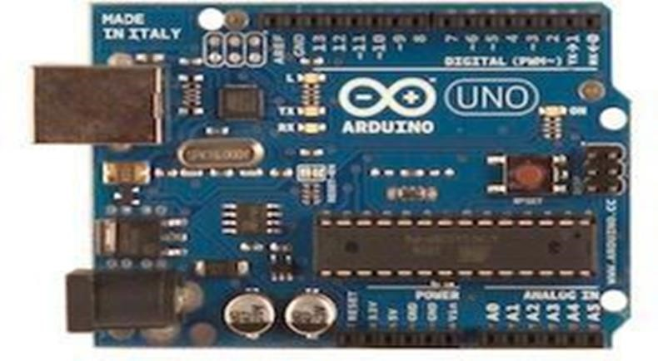

**Fig 2: Arduino Uno**

## B. LCD

Despite being limited to character-based modules, there is still a wide range of options available in terms of shape and size. Standard line lengths include 8, 16, 20, 24, 32, and 40 characters, with versions available in one, two, and four lines. For example, "Supertwist" types offer improved contrast and viewing angles. Some modules also come with backlighting, making them visible even in low-light conditions. The backlighting can be either "electroluminescent", which requires a high-voltage inverter circuit, or simple LED illumination.

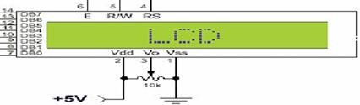

**Fig 3: LCD**

## C. Ultrasonic Sensor

Ultrasonic sensors wide range of applications, including robotics, automotive, industrial automation, and security systems.

1. Through-Beam Sensors: Through-beam sensors consist of two separate units, one that emits the ultrasonic sound waves and another that receives them. The two units and an object passing between them interrupts the sound waves, causing the sensor object.

1. Reflective Sensors: Reflective sensors use a single unit to emit and receive the ultrasonic sound waves.

The object and the sensor measure the time it takes for the sound waves to bounce sensor.

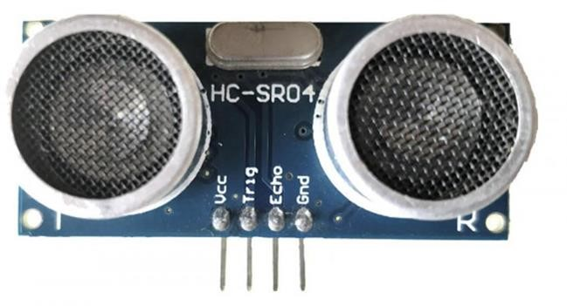

**Fig 4: Ultrasonic Sensor**

## D. Power Supply

A power supply provides electrical or other types of energy to an output load or group of loads. It converts an AC signal to a DC signal and reduces the amplitude of the signal. The power supply section is responsible for converting the available 230V/50Hz AC voltage signal from the mains to a DC voltage signal (with no frequency) with an amplitude of +5V and +12V for various applications.

The power supply section consists of a transformer, bridge rectifier, and voltage regulators for +5V and +12V (7805 and 7812), which are connected serially. A capacitor (1000µF) is connected in parallel to the voltage regulators. Each voltage regulator output is connected to capacitors of values (100µF, 10µF, 1 µF, 0.1 µF) that are connected in parallel. The corresponding output (+5V or +12V) is then taken into consideration

## E. LDR (Light Dependent Resistor)

The Light Dependent Resistor (LDR), Photoresistor, is a special type. They are easy to use on a breadboard or a perf board. The symbol for LDR is similar to a regular resistor but includes inward arrows that indicate the light signals, as shown in the LDR pinout diagram. A potential divider circuit in series, where a constant voltage is applied across both resistors and the output voltage is measured from the lower resistor.

In this setup, the lower resistor is **the LDR** and the constant voltage applied will be +5V.

**LDR FEATURES:**

* Easy to use on Breadboard or Perf Board
* Easy to use with Microcontrollers or even with normal Digital/Analog IC
* Small, cheap and easily available
* Available in PG5, PG5-MP, PG12, PG12-MP, PG20 and PG20-MP series

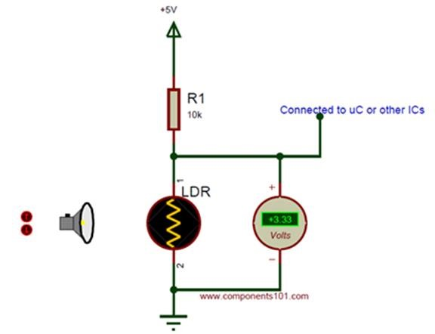

**Fig 5: LDR circuit diagram**

## F. L293D-IC

The L293D is a popular integrated circuit (IC) that is commonly used to direction and speed of small DC motors, especially in robotics and other similar applications. The L293D IC has two power supply pins, one for the logic circuitry (VCC1) and the other for the motor driver (VCC2). The input pins (IN1, IN2, IN3, and IN4) are used, while the output pins (OUT1, OUT2, OUT3, and OUT4) provide the necessary voltage and current to drive the motor. The L293D also has built-in protection features such as thermal shutdown, overvoltage protection, and output clamp diodes, which help to prevent damage to the IC and the connected motors. Overall, the L293D is a versatile and widely used IC for controlling DC motors, and is commonly found in hobbyist and educational robotics projects.

## G. GPS Module

GPS was developed by the United States Department of Defence and became fully operational in

1995. It consists of a network of 24 satellites orbiting the Earth, as well as ground-based control stations and GPS receivers that can be found in many devices, such as smartphones, cars, and airplanes. GPS has numerous applications, including navigation, surveying, mapping, and tracking. Each GPS segment plays a critical role in the overall functioning of the GPS system. The space segment provides the GPS signals, the control segment ensures the accuracy of those signals, and the user segment utilizes those signals to determine location and time.

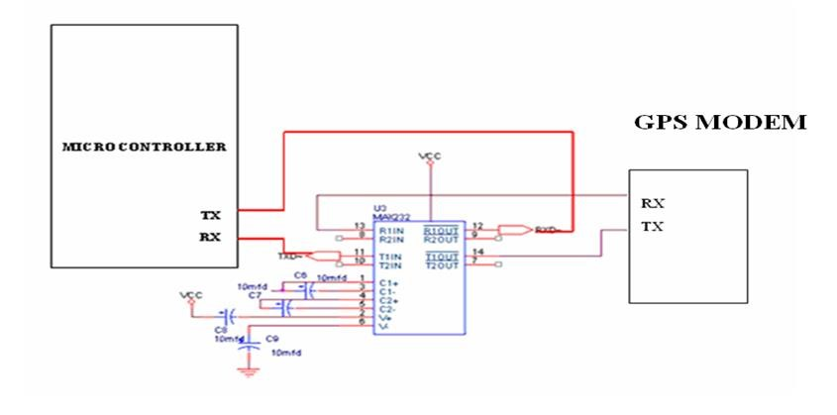

**Fig 6. GPS Interface**

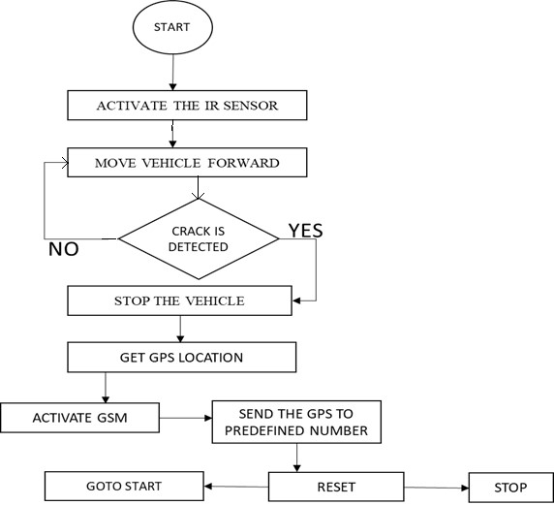

**Fig 7. Workflow**

# 5. Result and Discussion

Here the proposed module is made up of hardware which was previously explained in the description of the system design hardware.

* **At Normal Condition:**

LDR sensor involves the transmission of infrared rays which are received by the LDR receiver sensor. The transistor is used as an amplifier section and remains in an OFF state during normal conditions. Relay remains OFF and the vehicle continues to run uninterrupted.

* **At Crack Condition:**

The LDR sensor has a high resistance when it is detecting a crack on the track. When a crack is detected, the sensor output becomes high. The robot automatically stops when the reflection becomes zero, indicating the presence of a crack. The GPS then calculates the robot's location and determines spot.

* **At Object Detection:**

The time it takes for the sound to return calculate an object. If an object is detected, the GPS location is obtained using the IOT module, and the robot comes to a stop while alerting the authorities.

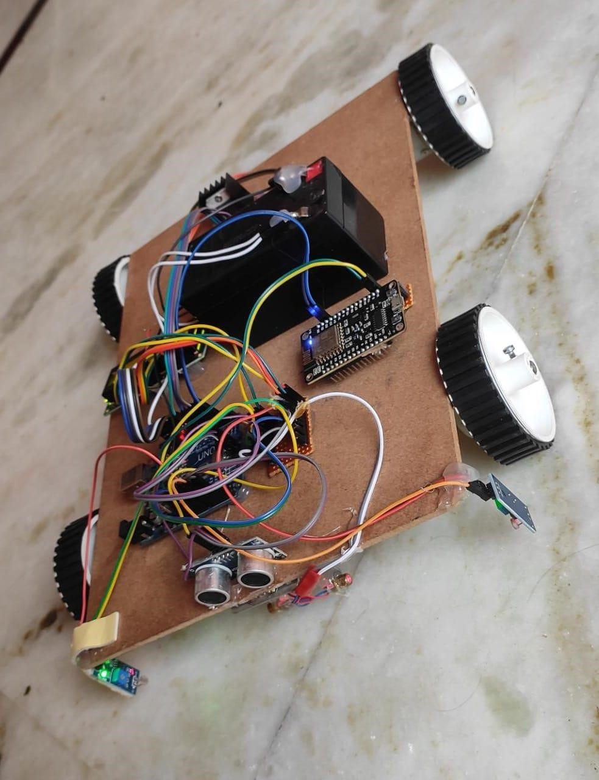

**Fig 8: Result when kit is ON**

The following figure shows that the SMS obtained on the mobile phone with the latitudinal and longitudinal position at the point where a crack or obstacle is detected.

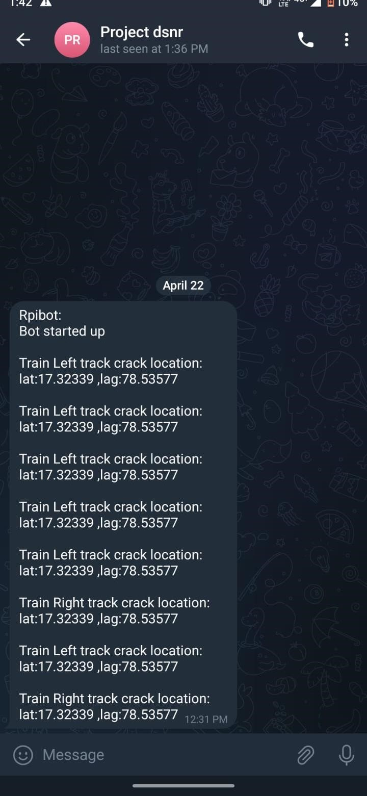

**Fig 9: Screenshot of application**

# 6. Conclusion

The IoT based fault and crack detection system in railway tracks is a promising solution to the problem of detecting faults and cracks in railway tracks, which can lead to accidents and disruption of rail services. The system utilizes a combination of sensors, wireless communication, and data analysis techniques. The system has the potential to significantly reduce the risk of accidents and improve the safety of rail transportation, while also reducing maintenance costs and improving the efficiency of railway operations. In conclusion, the IoT based fault and crack detection system in railway tracks is a promising technology that has the potential to improve the safety and efficiency of rail transportation.

# Acknowledgment

This project is supported by **NRI INSTITUTE OF TECHNOLOGY**. We would like to express our immense gratitude to our Internal guide **Ms. S.Bhavani**, Associate Professor who moderated this project and, in that line, improved the manuscript significantly.

We have to express our appreciation to **Dr. N.Samba Siva Rao**, Head of Department, EEE for their guidance and support with us during the course.

We express our thanks to Principal **Dr. C. Naga Bhaskar**, for extending his support and encouraging us throughout the major project.

We are also immensely grateful to all the faculty for their feedback on an earlier version of the project,

although any inaccuracies are ours and should not furnish the reputations of these esteemed professionals.

# References

1. Raghunandan Srinath, Jayavrinda Vrindavanam “Differential Sensor for Reliable Localization of Potential Cracks in Railway Tracks”,2020, vol. 12, no. 10, pp. 9645-9654, 2021.
2. Satya Srikanth Palle, Jijesh JJ. “Modernized compartment with safety measures in railway”,2020, (ICICSC), pp. 605-609, 2021.
3. Narate Vongserewattana, Wara Suwansin, Pattarapong Haruki, Punnavich Phatsornsiri “Validation of Acoustic Emission Railway Track Crack Analysis Using MFCC”,2019, (IACC), pp. 767-773, 2021.
4. Shubhankar Khaladkar, Srishti Gawande. “Internet of Trains – Oscillometer”,2019, (CSSE), pp. 125-128, 2021.
5. FU Shengwen, Jiang Zhanjun. Research on Image-based Detection and Recognition Technologies for Cracks on Rail Surface”,2019, (CSAI), pp. 199-203, 2021.
6. Suhas BN, Sushen Bhagavat, V Vimalanand, Suresh P. “Wireless Sensor Network based Monitoring of Railway Tracks”,2018, (CCWC), pp. 0923-0928, 2021.